Module 8 — Query Processing & Optimization
  - DBMS Mastery: SEBI IT / RBI / GATE / Interview — In-Depth Notes (with visuals)
Prepared for nidhi.sharma@forensiccybertech.com
2026
Table of Contents

Module 8 — Query Processing & Optimization
Where this module sits. Module 3 gave us relational algebra (what), Module 4 gave us SQL, Modules 6–7 gave us the cost model (block I/O) and access methods (indexes). Now we answer: how does the DBMS actually run a query, and how does it choose the fastest way? The same SQL can run 1000× faster or slower depending on the plan the optimizer picks. This module is the bridge from “a query” to “an efficient execution” — and the join-algorithm cost numericals are a GATE staple.
Importance ratings (out of 5):
Exam / Use | SEBI IT | RBI IT | GATE CS | Interview | Backend
This module | ★★★ | ★★★ | ★★★★ | ★★★ | ★★★★
Most-asked PYQ concepts (SEBI / RBI / GATE): join algorithm costs (nested-loop / block / indexed / sort-merge / hash); measures of query cost (block transfers + seeks); selection algorithm costs; external merge sort passes; materialization vs pipelining; heuristic optimization (push selection down) & equivalence rules; cost-based optimization & join order.

8.1 The Query Processing Pipeline
A query travels through four stages before producing results.
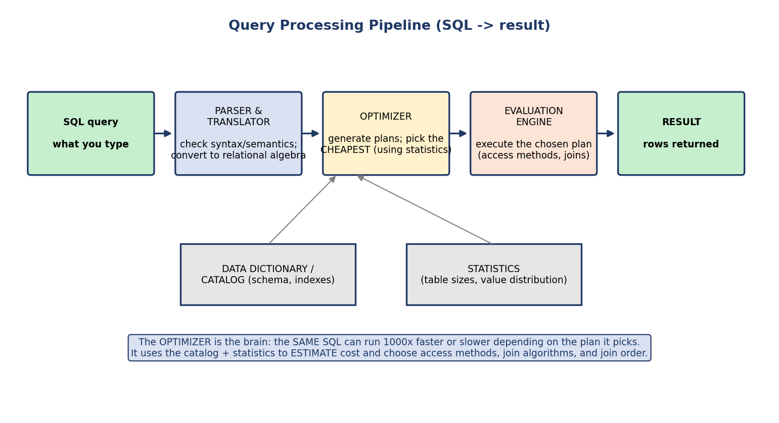
Query processing pipeline: SQL → parser/translator (to relational algebra) → optimizer (pick cheapest plan using statistics) → evaluation engine → result, with the catalog and statistics feeding the optimizer.
- Parser & translator — checks syntax/semantics (does the table exist? is the user allowed?) and converts the SQL into a relational-algebra expression.
- Optimizer — generates many equivalent plans and picks the cheapest using the catalog (schema, indexes) and statistics (table sizes, value distributions).
- Evaluation engine — executes the chosen plan (access methods + join algorithms).
- Result — rows returned.
First-principles point: a query (SQL) says what you want; a query plan (a.k.a. evaluation plan) is a specific annotated algebra tree saying exactly how — which index to use, which join algorithm, in what order. The optimizer’s job is to choose the best plan among many that all give the same answer.

8.2 Measuring Query Cost
We measure cost in disk I/O, because (Module 6) disk dominates. The standard cost model counts:
Cost = (#block transfers × transfer-cost) + (#seeks × seek-cost)
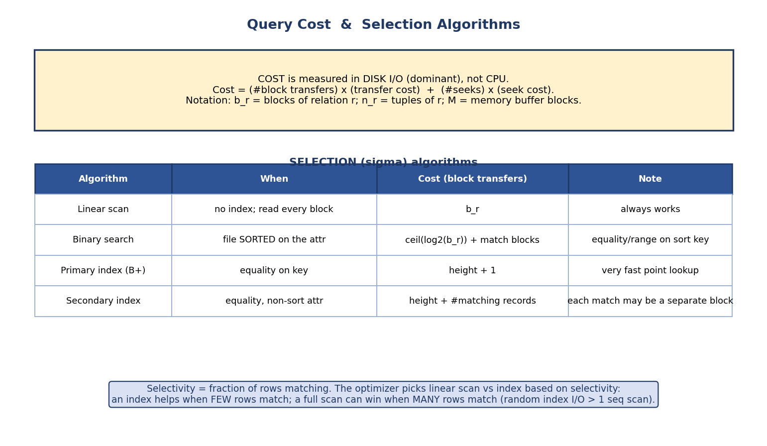
Query cost is measured in disk I/O (block transfers + seeks); selection algorithms (linear scan, binary search, primary/secondary index) with their block-transfer costs.
Notation (memorize — used in every formula): b_r = number of blocks of relation r; n_r = number of tuples of r; M = number of memory buffer blocks available.
We usually report cost as number of block transfers (sometimes also seeks). CPU cost is ignored because it’s tiny next to disk I/O.

8.3 Selection Algorithms (σ)
How the engine finds the rows matching a WHERE:
Algorithm | When usable | Cost (block transfers)
Linear scan | always (no index needed) | b_r (read every block)
Binary search | file sorted on the attribute | ⌈log₂(b_r)⌉ + matching blocks
Primary B+-tree index | equality on the indexed (sort) key | height + 1
Secondary index | equality on a non-sort attribute | height + (number of matching records)
Comparison / range selections (A ≥ v, A BETWEEN …): with a primary index or sorted file, locate the first matching block (≈ height) and scan forward from there (≈ height + matching blocks). With a secondary index a range scan does one random I/O per matching record, so for a wide range a linear scan is usually cheaper.
Why a full scan can beat an index (selectivity): selectivity = fraction of rows matching. A secondary index costs ~one random I/O per matching record. If many records match, that’s more expensive than one sequential full scan. So the optimizer uses an index only when few rows match (low selectivity), and prefers a scan when many match.

8.4 Sorting — External Merge Sort
Sorting underlies ORDER BY, GROUP BY, and sort-merge join. When data is bigger than RAM, we use external merge sort.
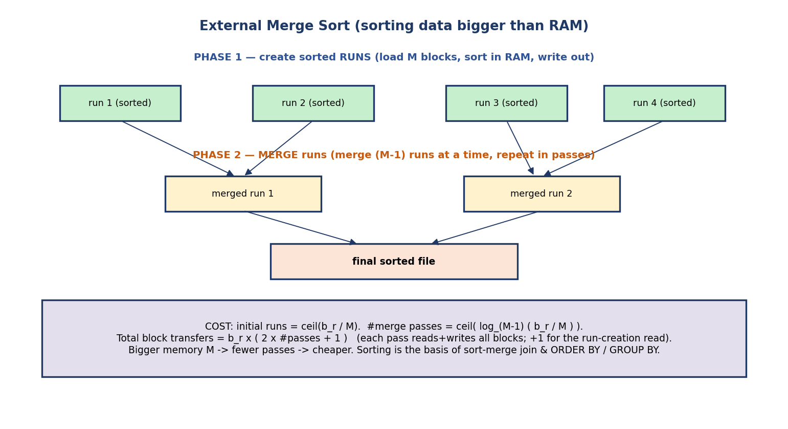
External merge sort: Phase 1 creates sorted runs (load M blocks, sort, write); Phase 2 merges (M−1) runs at a time over multiple passes into the final sorted file.
- Phase 1 (run creation): read M blocks at a time, sort them in RAM, write out a sorted run. Produces ⌈b_r / M⌉ runs.
- Phase 2 (merging): merge (M−1) runs at a time (one output buffer), repeating in passes until one sorted file remains.
Number of initial runs = ⌈ b_r / M ⌉
Number of merge passes = ⌈ log_(M−1) ( b_r / M ) ⌉
Total block transfers = b_r × ( 2 × (#merge passes) + 1 )
The +1 is the initial read during run creation; each merge pass reads and writes all b_r blocks (hence the 2×). More memory M → fewer passes → cheaper. A common GATE numerical asks for the number of passes/transfers. (Convention note: this counts block transfers only; some GATE variants also add the seek cost or count the final write separately — use your exam’s convention.)

8.5 Join Algorithms — the Heart of Query Processing
Joins are the most expensive and most optimized operation. Learn each algorithm’s cost and when to use it. (Convention: r = outer, s = inner.)

Nested-loop joins
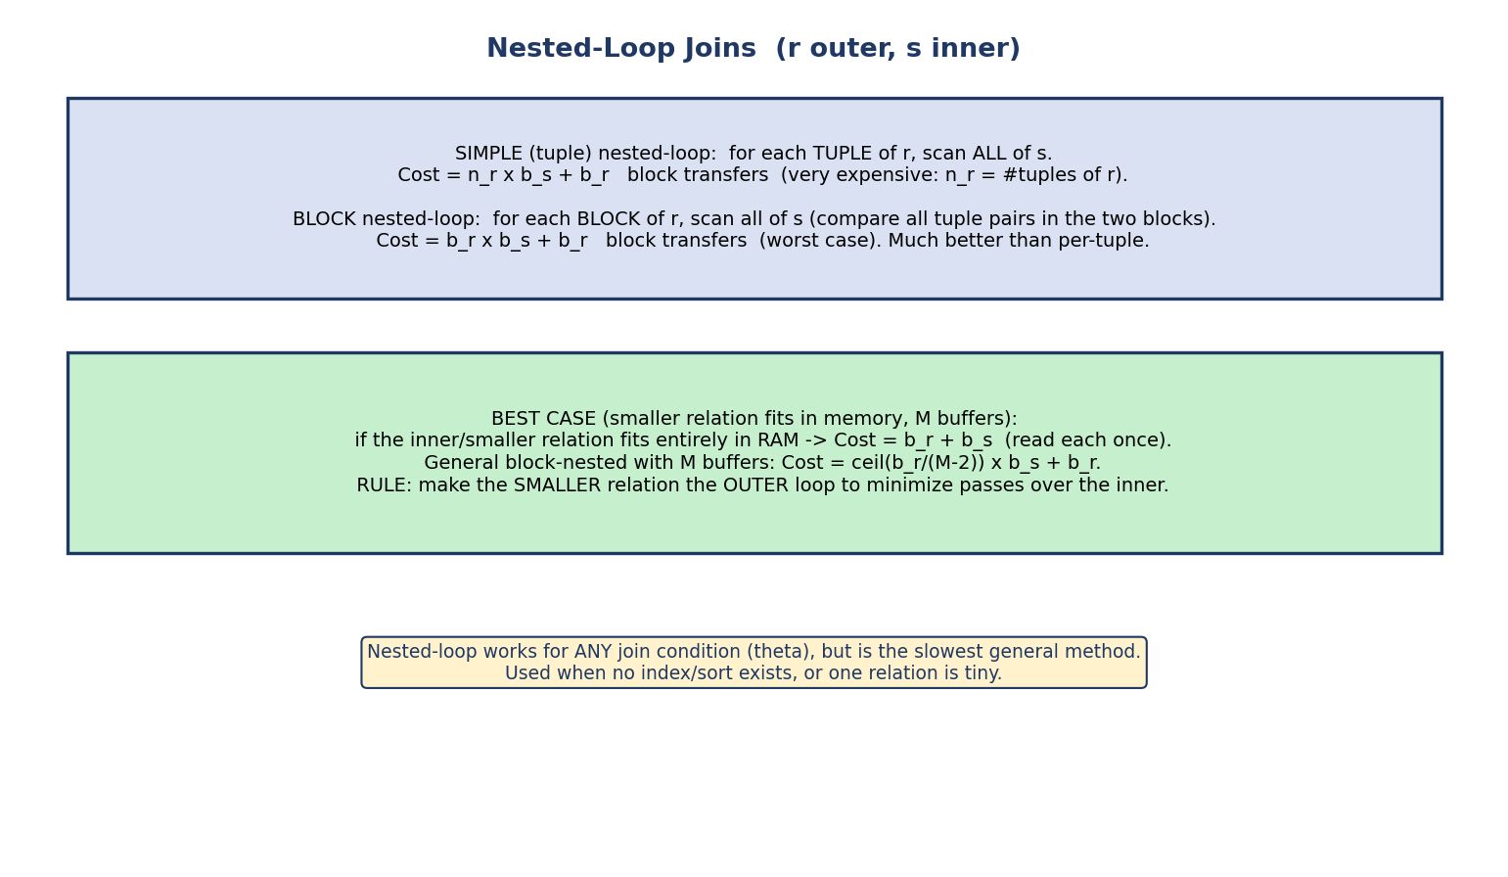
Nested-loop joins: simple (per-tuple) scans all of s for each tuple of r; block nested-loop scans s once per block of r; best case is when the inner relation fits in memory.
- Simple (tuple) nested-loop: for each tuple of r, scan all of s. Cost = n_r × b_s + b_r — expensive (note n_r, the tuple count).
- Block nested-loop: for each block of r, scan all of s. Worst-case Cost = b_r × b_s + b_r — far better than per-tuple.
- Best case (smaller relation fits in M buffers): b_r + b_s (read each once). With M buffers generally: ⌈b_r/(M−2)⌉ × b_s + b_r.
Rule: make the smaller relation the outer loop (fewer passes over the inner). Nested-loop is the only algorithm that handles any (theta) join condition (<, >, ≠), so it’s the fallback when no index/sort exists.

Indexed nested-loop & sort-merge join
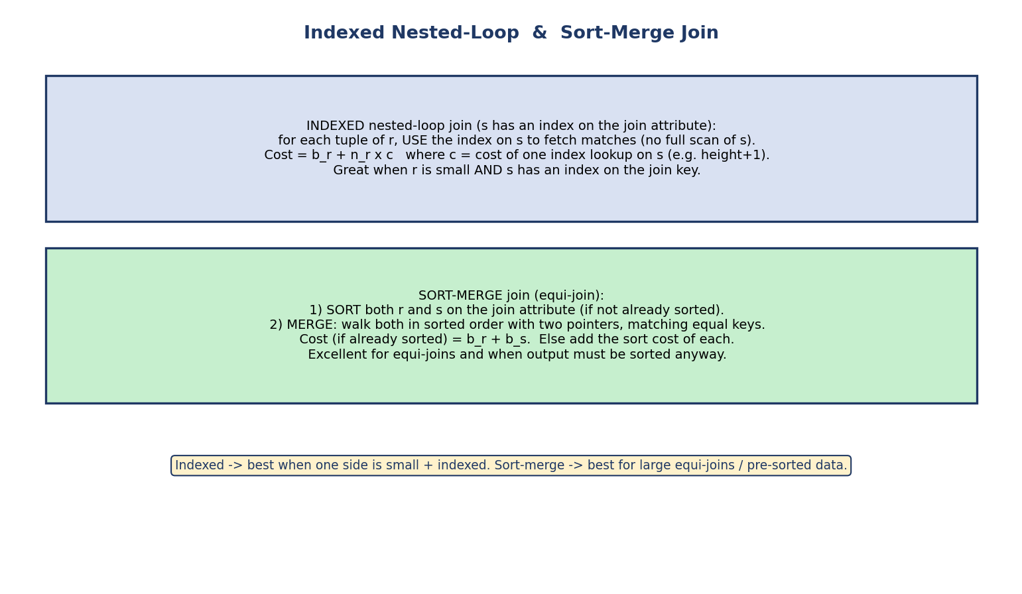
Indexed nested-loop uses an index on s to fetch matches per tuple of r; sort-merge sorts both relations then merges with two pointers.
- Indexed nested-loop join (s has an index on the join attribute): for each tuple of r, use the index on s to fetch matches (no full scan of s). Cost = b_r + n_r × c where c = cost of one index lookup. Best when r is small and s is indexed on the join key.
- Sort-merge join (equi-join): sort both relations on the join attribute, then merge with two pointers. Cost = b_r + b_s if already sorted (else add the sort cost). Excellent for large equi-joins and when the output must be sorted anyway.

Hash join
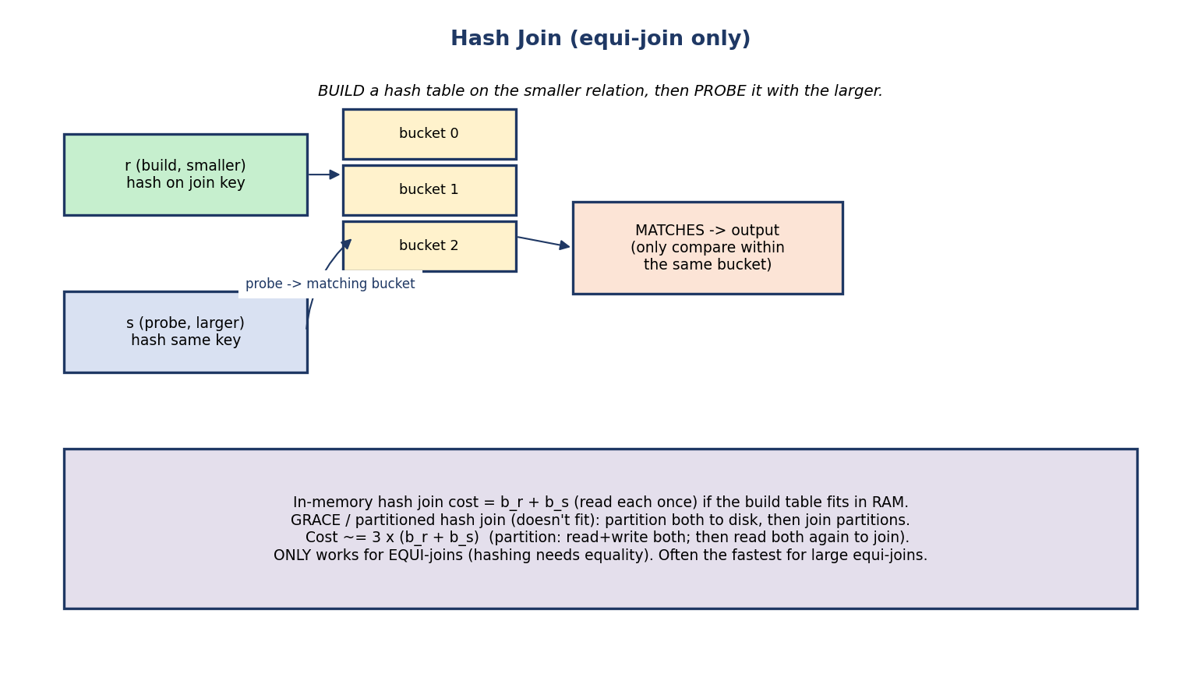
Hash join: build a hash table on the smaller relation by the join key, then probe it with the larger; only matching buckets are compared. Equi-join only.
- Hash join (equi-join only): build a hash table on the smaller relation (hash on the join key), then probe it with the larger relation; only tuples in the same bucket are compared.
  - In-memory (build fits in RAM): Cost = b_r + b_s.
  - Grace / partitioned hash join (doesn’t fit): partition both to disk, then join partitions. Cost ≈ 3 × (b_r + b_s) (partition reads+writes both, then reads both again).

Cost comparison (the summary table)
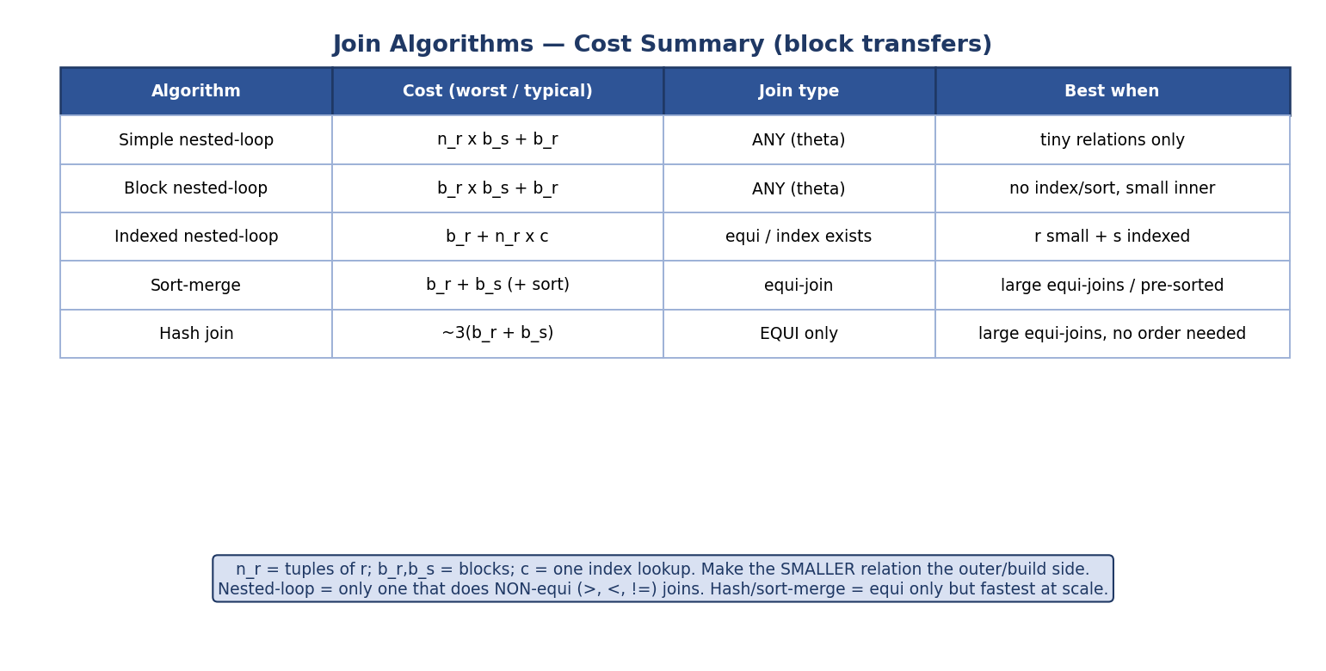
Join algorithm cost summary: simple/block nested-loop, indexed, sort-merge, hash — with cost formulas, join types, and best-use.
Algorithm | Cost | Join type | Best when
Simple nested-loop | n_r × b_s + b_r | any (theta) | tiny relations
Block nested-loop | b_r × b_s + b_r | any (theta) | no index/sort, small inner
Indexed nested-loop | b_r + n_r × c | equi or comparison (ordered index) | r small + s indexed
Sort-merge | b_r + b_s (+ sort) | equi | large equi-joins / pre-sorted
Hash join | ~3(b_r + b_s) | equi only | large equi-joins, order not needed
The two big exam facts: (1) nested-loop is the only one that does non-equi joins (>, <, ≠); (2) hash and sort-merge are equi-only but fastest at scale. Always make the smaller relation the outer/build side.

Other operations (projection, duplicate elimination, set operations)
Projection with DISTINCT, duplicate elimination, and set operations (∪, ∩, −) are all evaluated by sorting or hashing — the same machinery as sort-merge / hash join. Cost ≈ the underlying sort or hash (e.g. b_r(2·passes+1) for sort-based duplicate elimination). The set operations process both inputs much like an equi-join (∪ keeps all, ∩ keeps common, − keeps left-only). (Plain projection without DISTINCT is free — it pipelines with no extra I/O.)

8.6 Evaluating Expressions: Materialization vs Pipelining
A query is a tree of operations. How do results flow between them?
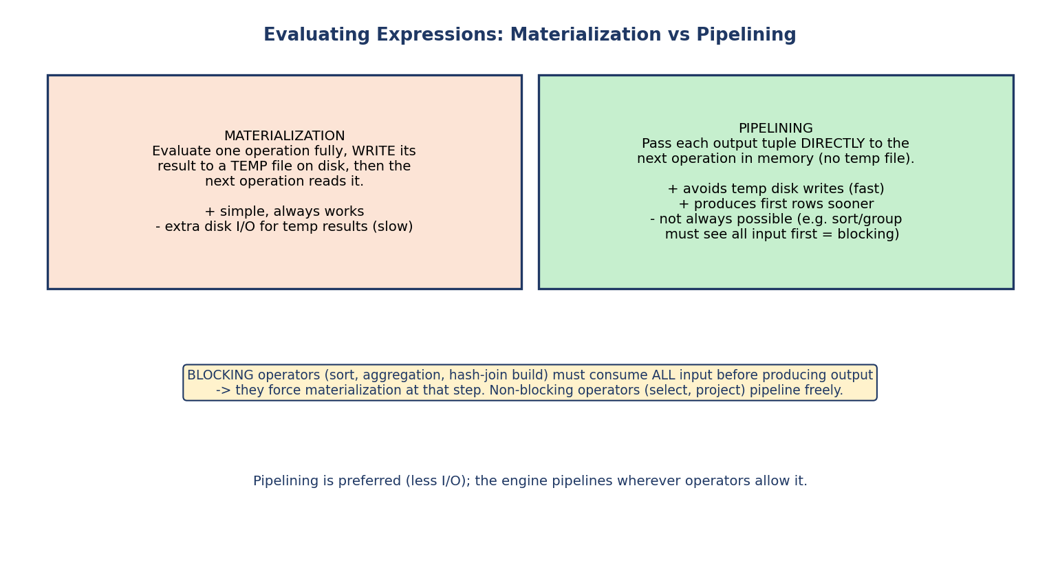
Materialization writes each operation’s result to a temp file that the next reads; pipelining passes tuples directly in memory; blocking operators (sort, aggregation) force materialization.
- Materialization: evaluate one operation fully, write its result to a temp file on disk, then the next operation reads it. Simple, but pays extra disk I/O for the temporary results.
- Pipelining: pass each output tuple directly to the next operation in memory (no temp file). Faster (no temp writes) and produces first rows sooner.
Blocking operators (sort, aggregation/GROUP BY, the build phase of hash join) must consume all input before producing any output — they force materialization at that step. Non-blocking operators (select, project) pipeline freely. The engine pipelines wherever the operators allow.

8.7 Query Optimization — Heuristic (Rule-Based)
The optimizer transforms the algebra tree into an equivalent but cheaper one using relational-algebra equivalence rules (introduced in Module 3 §3.4).
The core equivalence rules (these license each transformation — GATE asks them directly):
- Selection cascade: σ_{θ1 ∧ θ2}(R) = σ_{θ1}(σ_{θ2}(R)).
- Selection commutativity: σ_{θ1}(σ_{θ2}(R)) = σ_{θ2}(σ_{θ1}(R)).
- σ distributes over join: σ_θ(R ⋈ S) = (σ_θ(R)) ⋈ S when θ uses only R’s attributes (this is what lets us “push selection down”).
- Projection cascade: π_{L1}(π_{L2}(R)) = π_{L1}(R) when L1 ⊆ L2.
- σ–π commutativity: selection and projection can be reordered when the selection only uses retained attributes.
- Join commutativity & associativity: R ⋈ S = S ⋈ R; (R ⋈ S) ⋈ T = R ⋈ (S ⋈ T) — this is what enables join-order choices.
These rules preserve the result (the relations are equal) but change the cost; the heuristics below apply them in a beneficial direction.
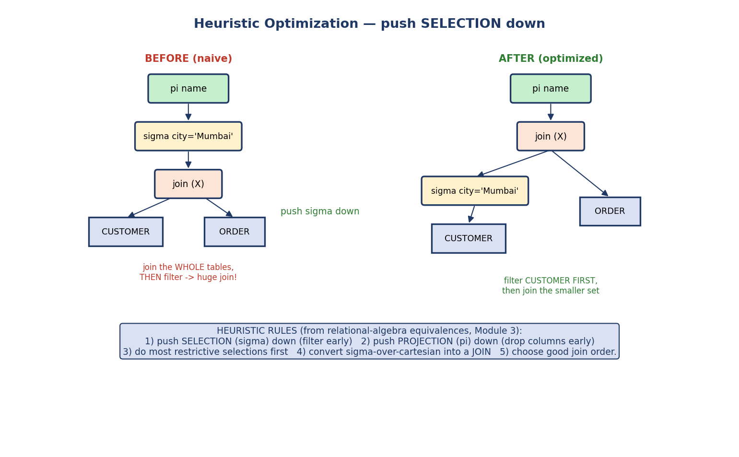
Heuristic optimization: pushing the selection below the join so we filter CUSTOMER first, then join the smaller result, instead of joining whole tables then filtering.
Heuristic rules (apply in roughly this order):
- Push SELECTION (σ) down — filter as early as possible (the single most important rule — shrinks inputs before expensive joins).
- Push PROJECTION (π) down — drop unneeded columns early (smaller tuples).
- Do the most restrictive selections first.
- Convert a σ over a Cartesian product into a JOIN (σ_θ(r × s) = r ⋈_θ s).
- Choose a good join order (small intermediate results first).
Worked idea (from the diagram): “names of customers in Mumbai who placed orders.” Naive: join the whole CUSTOMER and ORDER tables, then filter city='Mumbai'. Optimized: filter CUSTOMER to Mumbai first, then join the much smaller set. Same answer, dramatically less work.
Why it’s called “heuristic”: these rules usually help, applied without computing exact costs — fast to apply, “good enough” plans.

8.8 Query Optimization — Cost-Based
Heuristics aren’t always optimal. Cost-based optimization enumerates many plans, estimates each one’s cost from statistics, and picks the cheapest.
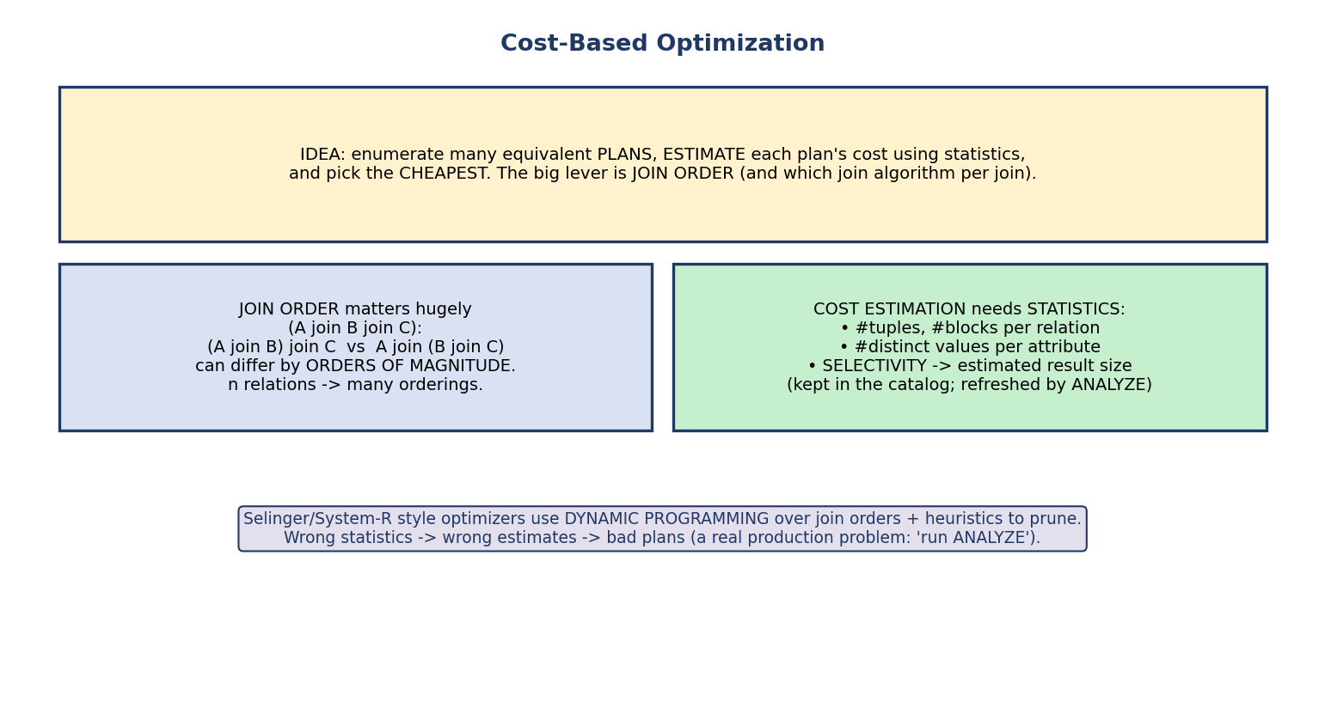
Cost-based optimization: enumerate plans, estimate cost using statistics (tuple/block counts, distinct values, selectivity), and pick the cheapest; join order is the biggest lever.
- Join order is the biggest lever: for A ⋈ B ⋈ C, the order (A ⋈ B) ⋈ C vs A ⋈ (B ⋈ C) can differ by orders of magnitude (because intermediate result sizes differ). With n relations there are many orderings.
- Cost estimation needs statistics: number of tuples/blocks, number of distinct values per attribute, and selectivity → estimated result size of each operation. These live in the catalog and are refreshed by ANALYZE.
- Classic System-R / Selinger optimizers use dynamic programming over join orders (plus pruning) to avoid checking every plan.
Real-world failure mode: stale statistics → wrong size estimates → the optimizer picks a bad plan (e.g. nested-loop on a huge table). The fix in production is literally run ANALYZE to refresh statistics.

Size estimation formulas (GATE numericals)
To cost a plan, the optimizer must estimate the output size of each operation. V(A, r) = number of distinct values of attribute A in r.
Operation | Estimated number of result tuples
Equality selection σ_{A = a}(r) | n_r / V(A, r)
Range selection σ_{A ≤ v}(r) | n_r × (v − min) / (max − min) (or n_r/2 if unknown)
Equi-join r ⋈ s on common attr A | (n_r × n_s) / max( V(A,r), V(A,s) )
Conjunction σ_{θ1 ∧ θ2} | multiply the individual selectivities
Cartesian product r × s | n_r × n_s
Worked example: STUDENT has n_r = 10,000 rows and V(dept, STUDENT) = 50 distinct departments. Estimated rows for σ_{dept = 'CSE'}(STUDENT) = 10000/50 = 200. For an equi-join of r (n_r = 1000) and s (n_s = 2000) on A with V(A,r) = 100, V(A,s) = 500: estimated = (1000 × 2000)/max(100,500) = 2,000,000/500 = 4,000 rows.
Why it matters: these estimates drive the cost comparison and join order. Wrong V(A,r) (stale stats) → wrong estimate → wrong plan.

8.9 Choosing a Join Algorithm
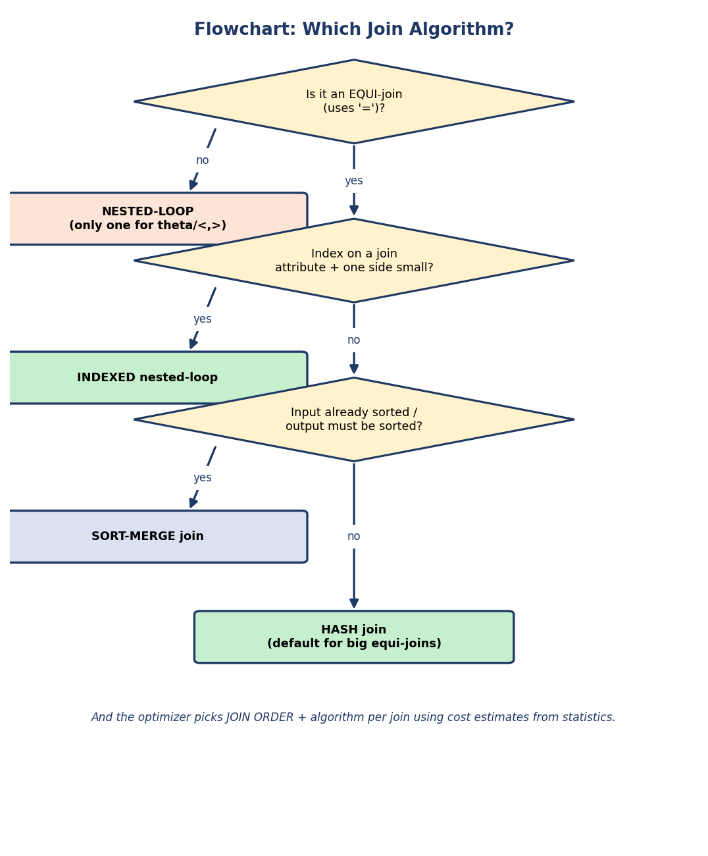
Flowchart: non-equi join → nested-loop; equi with index + small side → indexed nested-loop; sorted/needs-sort → sort-merge; otherwise → hash join.
- Non-equi (>, <, ≠) → nested-loop (the only option).
- Equi (or comparison, if the index is an ordered B+-tree) + index on join attr + one side small → indexed nested-loop.
- Input already sorted / output needs sorting → sort-merge.
- Large equi-join, order doesn’t matter → hash join (often the fastest).

8.10 Real-World & Backend Perspectives
- EXPLAIN / EXPLAIN ANALYZE prints the chosen plan — the algebra tree with the access methods and join algorithms the optimizer selected, plus estimated and actual costs. Reading it is the #1 SQL performance skill.
- “Seq Scan vs Index Scan vs Bitmap Heap Scan” in a Postgres plan = the §8.3 selection algorithms. “Hash Join / Merge Join / Nested Loop” = §8.5.
- ANALYZE / auto-vacuum keep statistics fresh so estimates are accurate.
- Why a query suddenly got slow: often stale stats or a plan flip after data growth — diagnosed by comparing EXPLAIN plans.

8.11 Tradeoffs, Common Mistakes, Edge Cases
Common mistakes (exam + real life) - Mixing up simple nested-loop cost (n_r × b_s, uses tuples) with block nested-loop (b_r × b_s, uses blocks). - Using hash/sort-merge for a non-equi join (they only do equality). - Making the larger relation the outer/build side (do the opposite). - Thinking an index always beats a scan (high selectivity → scan wins). - Forgetting blocking operators (sort, aggregation) force materialization. - Ignoring statistics — bad stats → bad plans.
Edge cases - If both relations are already sorted on the join key, sort-merge = b_r + b_s (no sort cost) — often the cheapest. - Hash join degrades if the build side doesn’t fit and partitions overflow (recursive partitioning). - Optimizer can choose a worse plan than a human if statistics are stale.
Tradeoffs
Choice | Gain | Cost
Pipelining | less temp I/O, faster first row | not possible across blocking ops
Heuristic optimization | fast to compute | may miss the optimal plan
Cost-based optimization | finds near-optimal plans | needs good statistics; more planning time
Index scan | great for low selectivity | random I/O hurts for high selectivity

8.12 Exam, Interview & Coding Perspectives
Exam (SEBI/RBI/GATE): join algorithm costs (nested-loop tuple vs block, indexed, sort-merge, hash); selection costs; external merge sort passes/transfers; materialization vs pipelining; heuristic rules (push σ down); cost-based & join order; which join handles non-equi.
Interview: “How would you speed up a slow query?” (read EXPLAIN, add/adjust index, fix join order, update stats); “nested-loop vs hash join?”; “why might the optimizer pick a full scan over an index?” (selectivity); “what is pipelining?”.
Coding/practical: - Run EXPLAIN ANALYZE on a join; see which join algorithm and access method were chosen; add an index and re-check. - Force a bad plan (disable index) to feel the cost difference.

8.13 Concept Checks & MCQs
- Cost is measured mainly in ___ → disk I/O (block transfers + seeks).
- Simple nested-loop cost? → n_r × b_s + b_r.
- Block nested-loop cost (worst)? → b_r × b_s + b_r.
- Which join algorithms do equi-only? → sort-merge and hash.
- Which join handles non-equi conditions? → nested-loop.
- Sort-merge cost if both already sorted? → b_r + b_s.
- Grace hash join cost? → ~3(b_r + b_s).
- Should the smaller or larger relation be the outer/build side? → smaller.
- Operation that forces materialization? → a blocking op (sort, aggregation).
- Single most important heuristic rule? → push selection (σ) down.
- Cost-based optimization’s biggest lever? → join order.
- Stale statistics cause ___ → bad cost estimates → bad plans (fix: ANALYZE).
- Estimated rows of σ_{A=a}(r)? → n_r / V(A, r).
- Estimated rows of equi-join r ⋈ s on A? → (n_r × n_s) / max(V(A,r), V(A,s)).
- σ_{θ1∧θ2}(R) = σ_{θ1}(σ_{θ2}(R)) is the ___ rule → selection cascade.
- How are DISTINCT / set operations evaluated? → by sorting or hashing.
True/False - Hash join works for r.a > s.b. → False (equi-only). - Pipelining avoids writing temp results to disk. → True. - Block nested-loop is cheaper than simple (tuple) nested-loop. → True. - The optimizer always finds the truly optimal plan. → False (depends on stats/search).
Numerical (do it): > r: b_r = 100 blocks, n_r = 1000 tuples. s: b_s = 500 blocks. Memory tiny. > - Block nested-loop (r outer): b_r × b_s + b_r = 100×500 + 100 = 50,100 transfers. > - Block nested-loop (s outer): b_s × b_r + b_s = 500×100 + 500 = 50,500. > → Making the smaller (r) the outer is cheaper. ✔ Simple nested-loop (r outer) > would be n_r × b_s + b_r = 1000×500 + 100 = 500,100 — 10× worse.

8.14 One-Page Revision Sheet
PIPELINE: SQL -> parse/translate (to RA) -> OPTIMIZER (pick cheapest plan via stats) -> EVAL engine -> result.
COST = disk I/O = (#block transfers) + (#seeks). b_r=blocks, n_r=tuples, M=memory blocks.
SELECTION: linear scan = b_r ; binary search (sorted) = ceil(log2 b_r)+matches ;
primary index = height+1 ; secondary index = height + #matches. (index wins only at LOW selectivity)
EXTERNAL MERGE SORT: runs=ceil(b_r/M); passes=ceil(log_(M-1)(b_r/M));
transfers = b_r*(2*passes + 1). more M -> fewer passes.
JOINS (r outer/build, s inner/probe):
simple nested-loop = n_r*b_s + b_r (ANY join; uses TUPLES)
block nested-loop = b_r*b_s + b_r (ANY join; uses BLOCKS) best: b_r+b_s if inner fits
indexed nested-loop = b_r + n_r*c (equi; s indexed; r small)
sort-merge = b_r+b_s (+sort) (EQUI; pre-sorted/needs sort)
hash join = ~3(b_r+b_s) grace (EQUI ONLY; big joins)
-> smaller relation = OUTER/BUILD. nested-loop = ONLY non-equi method.
MATERIALIZATION (temp file to disk) vs PIPELINING (tuple-by-tuple in RAM, faster).
blocking ops (SORT, AGGREGATION, hash-build) force materialization.
OPTIMIZATION:
HEURISTIC (rule-based): push SELECTION down (#1), push PROJECTION down, most-restrictive first,
sigma-over-cartesian -> JOIN, good join order.
COST-BASED: enumerate plans, estimate cost via STATISTICS (tuples, distinct values, selectivity),
pick cheapest. JOIN ORDER = biggest lever. System-R/Selinger DP. stale stats -> bad plan (ANALYZE).
EQUIVALENCE RULES: selection cascade/commutativity; sigma distributes over join (push down);
projection cascade; sigma-pi commute; join commutative+associative (-> join order).
SIZE ESTIMATION: sigma_{A=a}(r) = n_r/V(A,r); equi-join = n_r*n_s/max(V(A,r),V(A,s)); cross = n_r*n_s.
DISTINCT / set ops (union/intersect/minus) -> evaluated by SORTING or HASHING (cost ~= underlying sort/hash).

Flash cards
Front | Back
Cost metric? | Disk I/O (block transfers + seeks)
Simple vs block nested-loop cost? | n_r·b_s+b_r vs b_r·b_s+b_r
Only join for non-equi? | Nested-loop
Equi-only fast joins? | Sort-merge, hash
Sort-merge if pre-sorted? | b_r + b_s
Grace hash join cost? | ~3(b_r + b_s)
Outer/build side should be? | The smaller relation
#1 heuristic rule? | Push selection down
Biggest cost-based lever? | Join order
Blocking ops force? | Materialization
Index loses to scan when? | High selectivity (many matches)

Spaced repetition
- 24-hour: compute join costs for 3 (b_r, b_s, n_r) cases; redo MCQs.
- 7-day: draw the heuristic push-down transformation; list all 5 join costs.
- 30-day: given statistics, choose the join algorithm + order and justify with cost.

8.15 Summary
Query processing turns SQL into an efficient execution. The pipeline is parse → translate to algebra → optimize → evaluate, with cost measured in disk I/O (b_r blocks, n_r tuples, M buffers). We costed selection algorithms (scan vs index, governed by selectivity), external merge sort (runs = ⌈b_r/M⌉, transfers = b_r(2·passes+1)), and the five join algorithms — simple/block nested-loop (n_r·b_s vs b_r·b_s, the only ones for non-equi), indexed nested-loop (b_r + n_r·c), sort-merge (b_r+b_s if sorted), and hash (~3(b_r+b_s), equi-only) — always putting the smaller relation outer/build. We saw pipelining vs materialization (blocking operators force the latter), then the two optimizer styles: heuristic (push selection/projection down) and cost-based (enumerate plans, estimate via statistics, with join order the biggest lever).
Next, Module 9 — Transactions & Concurrency shifts from speed to correctness: how the DBMS keeps data consistent when many of these queries run at once and crashes happen.
You have mastered this module when you can: state and apply every join algorithm’s cost; explain when an index beats a scan (selectivity); compute external-merge-sort passes; contrast materialization and pipelining; and walk through heuristic vs cost-based optimization (push σ down; join order via statistics) — all without notes.

