Module 9 — Transactions & Concurrency Control
  - DBMS Mastery: SEBI IT / RBI / GATE / Interview — In-Depth Notes (with visuals)
Prepared for nidhi.sharma@forensiccybertech.com
2026
Table of Contents

Module 9 — Transactions & Concurrency Control
Where this module sits. Modules 1–8 made data fast to query. This module makes it correct when many users hit it at once and when crashes happen. It is the single most important and most heavily tested DBMS topic for SEBI Grade A IT, RBI, and GATE — the source video devotes its entire Chapter 1 to it. Master ACID, serializability (conflict & view), 2PL, deadlocks, timestamp ordering, and isolation levels, and you own the highest-value section of the whole subject.
Importance ratings (out of 5):
Exam / Use | SEBI IT | RBI IT | GATE CS | Interview | Backend
This module | ★★★★★ | ★★★★★ | ★★★★★ | ★★★★ | ★★★★★
Most-asked PYQ concepts (SEBI / RBI / GATE): ACID; conflict serializability + precedence graph (cycle test); view serializability; 2PL & its variants (strict/rigorous/conservative); deadlock (wait-die/wound-wait, wait-for graph); timestamp ordering + Thomas write rule; recoverable / cascadeless / strict schedules; isolation levels vs anomalies (dirty/unrepeatable/phantom); MVCC / snapshot isolation.

9.1 What Is a Transaction?
A transaction is a logical unit of work — a sequence of operations that the DBMS treats as a single, indivisible action (e.g. “transfer ₹500 from A to B” = debit A and credit B).
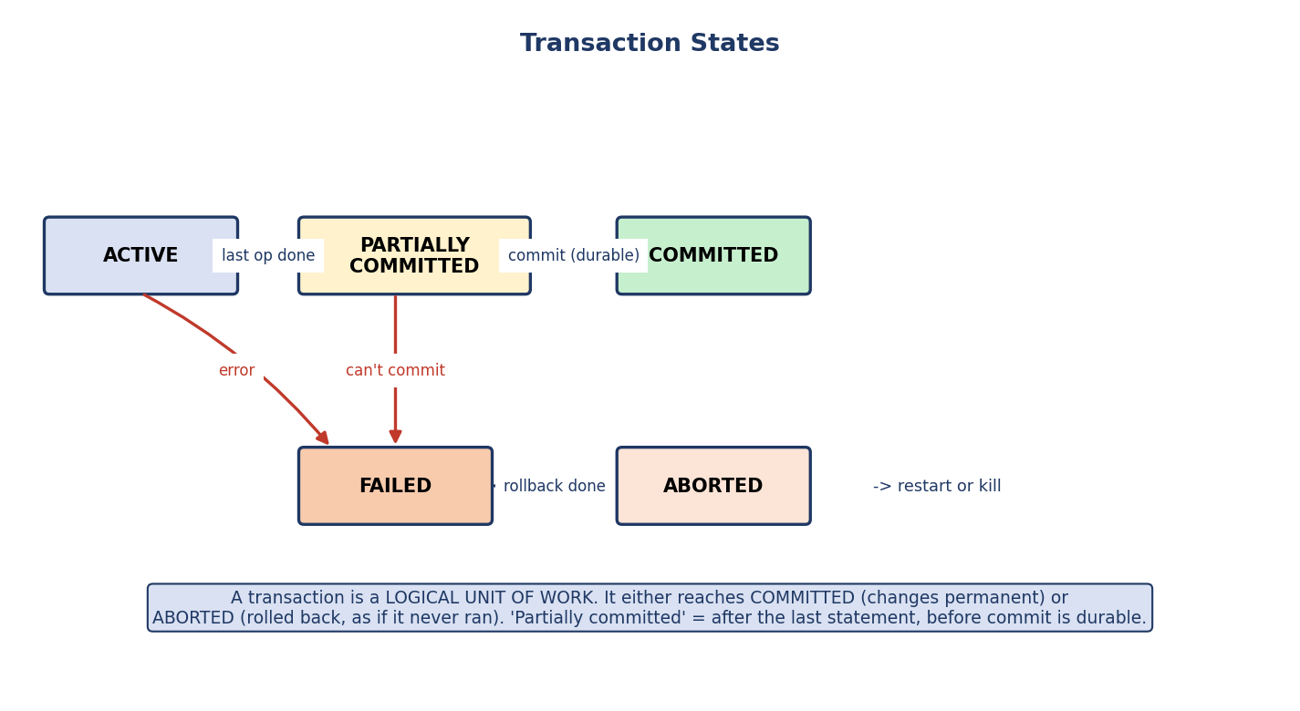
Transaction states: active → partially committed → committed; or active → failed → aborted.
Transaction states: active (executing) → partially committed (after the last operation) → committed (changes permanent); or → failed → aborted (rolled back, as if it never ran).
Two outcomes only: a transaction either commits (all changes durable) or aborts (all changes undone). There is no “half done” visible to others — that is the promise the rest of this module enforces.

9.2 ACID Properties
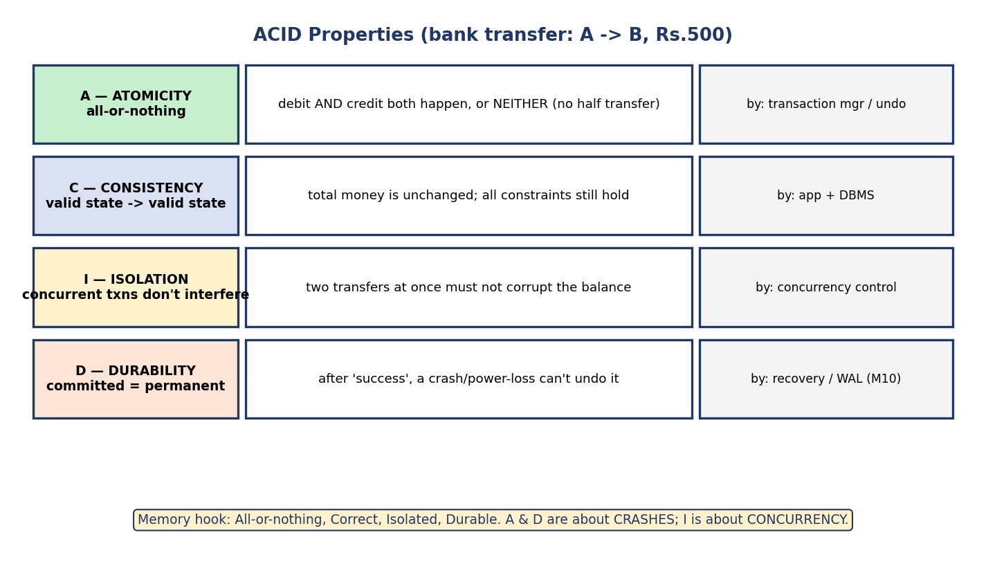
ACID: Atomicity (all-or-nothing), Consistency (valid→valid), Isolation (concurrent txns don’t interfere), Durability (committed=permanent), with the bank-transfer example.
Property | Meaning | Bank-transfer example | Enforced by
Atomicity | all-or-nothing | debit and credit both happen, or neither | transaction manager (undo)
Consistency | valid state → valid state | total money unchanged; constraints hold | application + DBMS
Isolation | concurrent txns don’t interfere | two transfers at once don’t corrupt balances | concurrency control
Durability | committed = permanent | a crash after “success” can’t undo it | recovery / WAL (Module 10)
The big mental split: A and D protect against crashes (Module 10 — recovery); I protects against concurrency (this module — the rest of it); C is the goal that A+I+D together preserve. Memory hook: All-or- nothing, Correct, Isolated, Durable.

9.3 Why Concurrency Control? The Anomalies
Running transactions concurrently boosts throughput, but uncontrolled interleaving causes four classic problems.
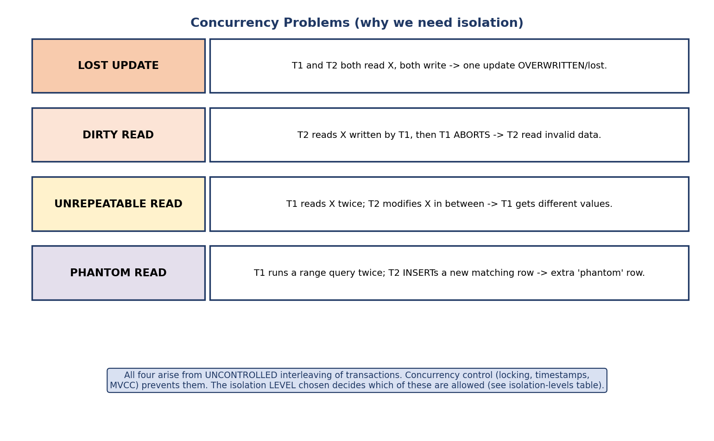
Concurrency problems: lost update, dirty read, unrepeatable read, phantom read.
Anomaly | What happens
Lost update | T1 and T2 both read X, both write → one update is overwritten/lost
Dirty read | T2 reads X written by T1, then T1 aborts → T2 used invalid data
Unrepeatable read | T1 reads X twice; T2 modifies X in between → T1 sees different values
Phantom read | T1 re-runs a range query; T2 inserts a new matching row → a phantom appears
The whole point of isolation: prevent these. Which ones are allowed is set by the isolation level (§9.13). Lower levels permit some anomalies for more speed.

9.4 Schedules — Serial vs Concurrent
A schedule is the order in which operations of multiple transactions execute.
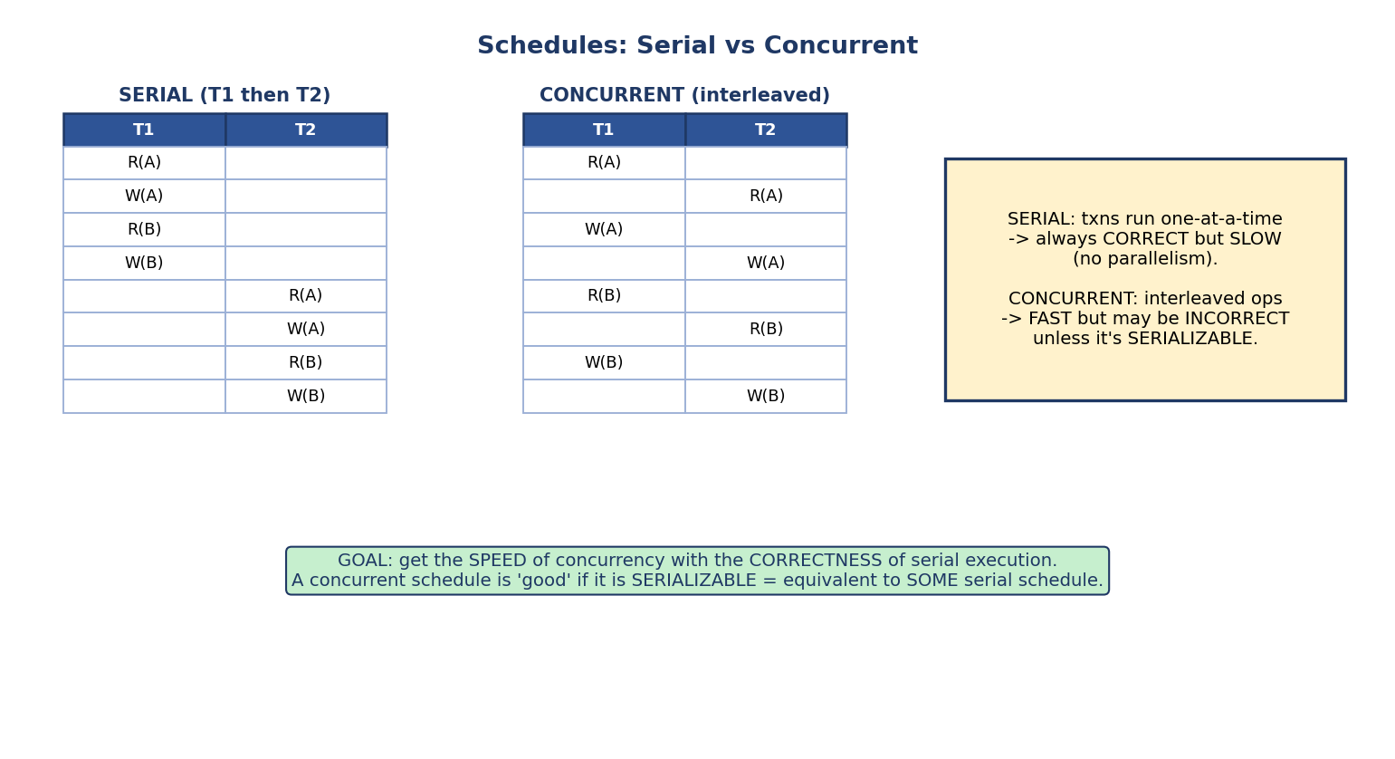
Serial schedule runs transactions one at a time (always correct, slow); concurrent schedule interleaves them (fast, but may be incorrect unless serializable).
- Serial schedule: transactions run one at a time, no interleaving — always correct, but no parallelism (slow).
- Concurrent (interleaved) schedule: operations interleave — fast, but may be incorrect.
The central goal of concurrency control: get the speed of concurrency with the correctness of serial execution. We accept a concurrent schedule if and only if it is serializable — i.e. equivalent to some serial schedule.

9.5 Conflict Serializability
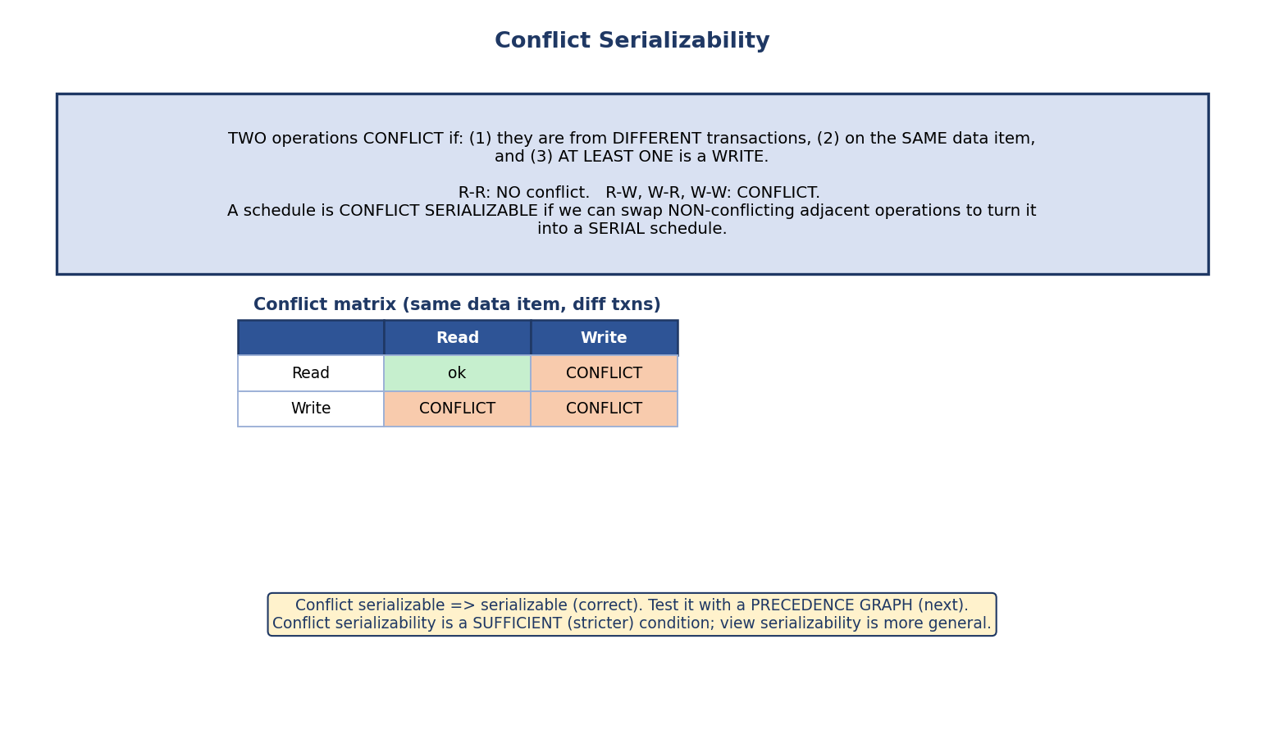
Two operations conflict if they are from different transactions, on the same data item, and at least one is a write; conflict matrix shows R-R is safe, R-W/W-R/W-W conflict.
Two operations conflict if they (1) belong to different transactions, (2) access the same data item, and (3) at least one is a write.
 | Read | Write
Read | no conflict | conflict
Write | conflict | conflict
A schedule is conflict serializable if we can swap non-conflicting adjacent operations to transform it into a serial schedule.
R-R never conflicts (two reads can be reordered freely). Any pair involving a write on the same item conflicts (their order changes the result).

9.6 Precedence Graph — Testing Conflict Serializability
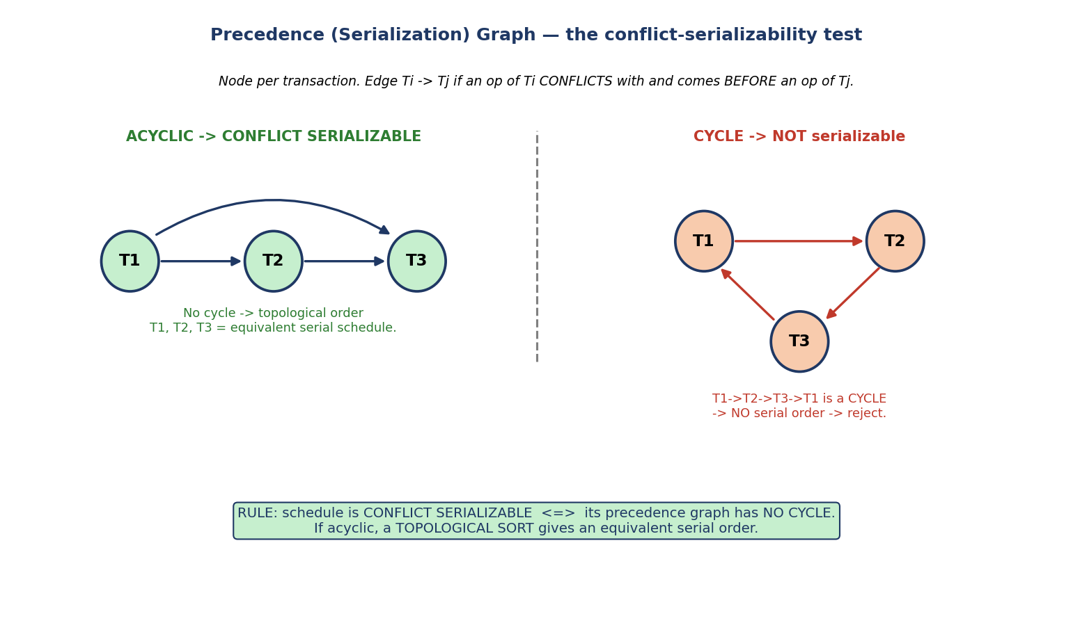
Precedence graph: a node per transaction, an edge Ti→Tj when an operation of Ti conflicts with and precedes one of Tj; acyclic ⇒ conflict serializable (topological sort gives the serial order), a cycle ⇒ not serializable.
Build the precedence (serialization) graph:
- One node per transaction.
- Add an edge Ti → Tj if an operation of Ti conflicts with and comes before an operation of Tj (on the same item).
THE RULE (memorize): a schedule is conflict serializable ⟺ its precedence graph has NO CYCLE. If acyclic, a topological sort of the graph gives an equivalent serial order.
Worked example: in schedule S, T1 writes A then T2 reads A (T1→T2); T2 writes B then T3 reads B (T2→T3); T3 writes C then T1 reads C (T3→T1). Edges T1→T2→T3→T1 form a cycle → not conflict serializable. Remove the last conflict and you’d get T1→T2→T3 (acyclic) → serializable, serial order T1, T2, T3.

9.7 View Serializability
A more general (looser) notion of correctness.
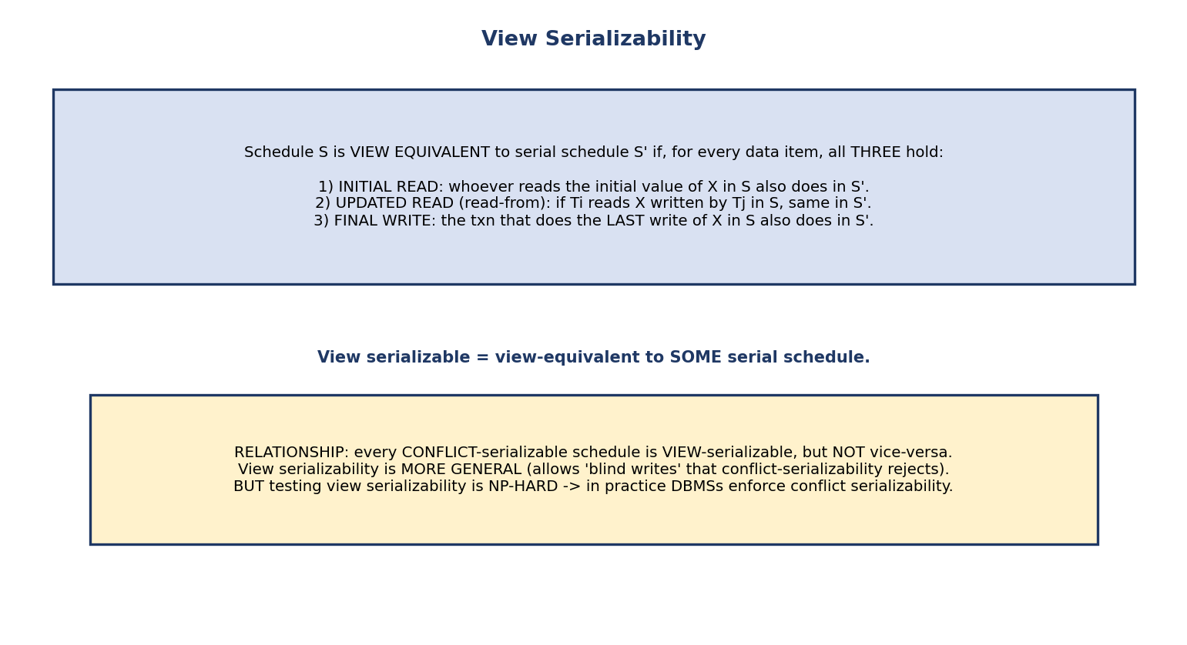
View serializability: two schedules are view-equivalent if they agree on initial reads, read-from (updated read) relationships, and final writes; conflict-serializable ⇒ view-serializable but not vice versa, and testing view serializability is NP-hard.
Schedule S is view equivalent to a serial schedule S′ if, for every data item, all three hold:
- Initial read: the txn that reads the initial value of X in S also does in S′.
- Updated read (read-from): if Ti reads X written by Tj in S, the same holds in S′.
- Final write: the txn doing the last write of X in S also does in S′.
S is view serializable if it is view-equivalent to some serial schedule.
The relationship (classic exam fact): every conflict-serializable schedule is view-serializable, but NOT vice-versa. View serializability is more general — it accepts some schedules with blind writes (a write without a prior read) that conflict-serializability rejects. But testing view serializability is NP-hard, so real DBMSs enforce the stricter, cheap-to-test conflict serializability.

9.8 Recoverable, Cascadeless & Strict Schedules
Serializability ensures concurrency correctness; recoverability ensures we can undo safely after an abort.
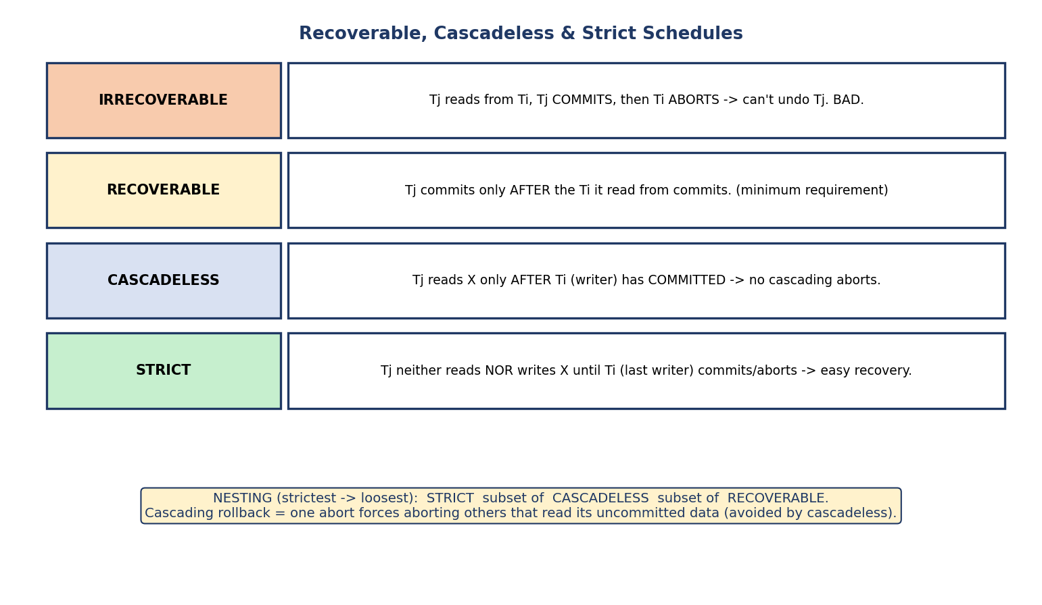
Recoverable schedules nest: strict ⊆ cascadeless ⊆ recoverable; irrecoverable schedules let a committed transaction depend on one that later aborts.
Schedule type | Condition
Irrecoverable | Tj reads from Ti, Tj commits, then Ti aborts → can’t undo Tj. BAD
Recoverable | Tj commits only after the Ti it read from commits (minimum requirement)
Cascadeless | Tj reads X only after the writer Ti has committed → no cascading aborts
Strict | Tj neither reads nor writes X until the last writer Ti commits/aborts → trivial recovery
Nesting (strictest → loosest): Strict ⊆ Cascadeless ⊆ Recoverable. Cascading rollback = one abort forces aborting every transaction that read its uncommitted data — expensive; cascadeless schedules avoid it. Strict schedules (used by Strict 2PL) make recovery simplest.

9.9 Lock-Based Protocols & Two-Phase Locking (2PL)
The most common way to enforce serializability is locking.
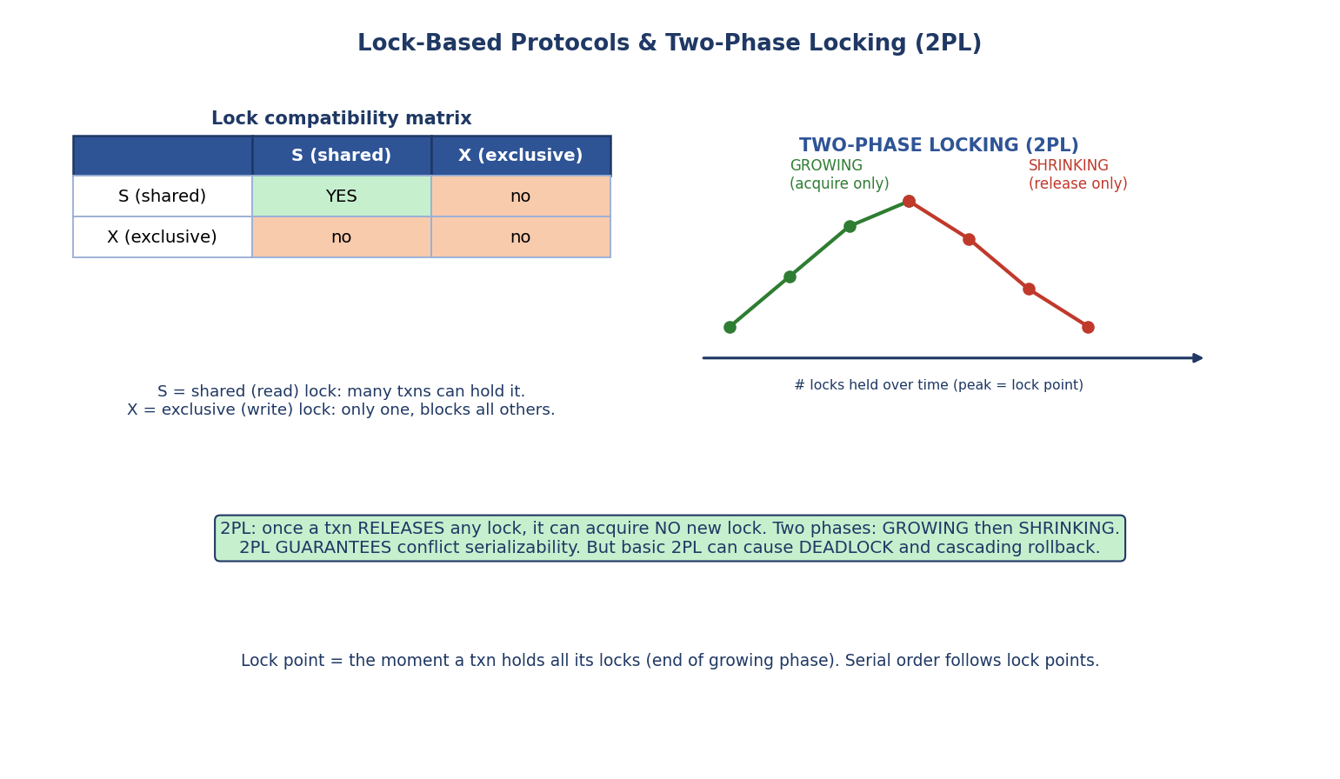
Lock compatibility matrix (S-S compatible, anything with X incompatible) and the two-phase locking growing/shrinking phases with the lock point at the peak.
Lock modes: Shared (S) = read lock (many txns may hold it); Exclusive (X) = write lock (only one, blocks all others).
 | S | X
S | ✅ compatible | ❌
X | ❌ | ❌
Two-Phase Locking (2PL): every transaction has two phases —
- Growing phase: may acquire locks, may not release any.
- Shrinking phase: may release locks, may not acquire any.
Once a transaction releases its first lock, it can never acquire another.
THE GUARANTEE: 2PL produces only conflict-serializable schedules. The lock point (the moment a txn holds all its locks = end of growing phase) determines the equivalent serial order. But basic 2PL does NOT prevent deadlock, and can cause cascading rollback.

Variants of 2PL
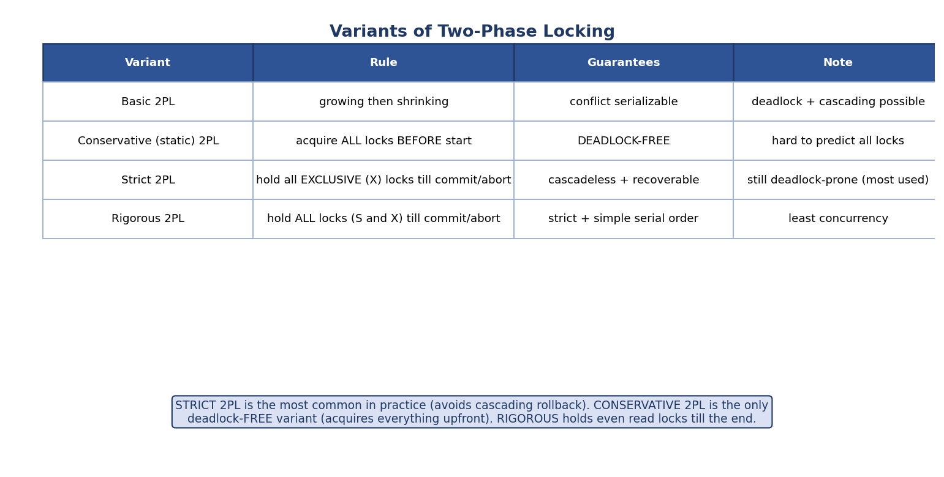
2PL variants: basic, conservative (deadlock-free), strict (holds X locks to commit, cascadeless), rigorous (holds all locks to commit).
Variant | Rule | Guarantees | Note
Basic 2PL | growing then shrinking | conflict serializable | deadlock + cascading possible
Conservative (static) | acquire all locks before starting | deadlock-free | must predict all locks
Strict 2PL | hold all X locks until commit/abort | cascadeless + recoverable | most used
Rigorous 2PL | hold all locks (S and X) until commit/abort | strict + simple serial order | least concurrency
Exam favourites: Strict 2PL is the practical default (no cascading rollback). Conservative 2PL is the only deadlock-free variant (it grabs everything upfront). Rigorous holds even read locks to the end.

Lock conversion (upgrade / downgrade)
A transaction can hold a weaker lock and convert it:
- Upgrade S → X (it read X, now wants to write) — allowed only in the growing phase.
- Downgrade X → S (done writing, will only read) — allowed only in the shrinking phase.
Why: taking a shared lock first and upgrading only when needed gives more concurrency than grabbing an exclusive lock immediately. The phase restriction keeps 2PL’s serializability guarantee intact.

Multiple-granularity locking (IS / IX / SIX)
Locking every row individually is expensive when a transaction touches a whole table. Multiple-granularity locking organizes data as a hierarchy (database → file/table → page → record) and lets a txn lock at the right level.
To do this it adds intention locks on ancestors:
Mode | Meaning
IS (intention-shared) | intend to take S locks somewhere below
IX (intention-exclusive) | intend to take S/X locks below
SIX (shared + intention-exclusive) | S on this node plus intend X below
The rule: to lock a node in S you must hold IS (or IX) on all its ancestors; to lock it in X you must hold IX (or SIX) on all ancestors. Locks are acquired root → leaf, released leaf → root. This lets the DBMS lock a whole table with one lock instead of millions of row locks, while still allowing fine-grained row locking elsewhere.

9.10 Deadlocks
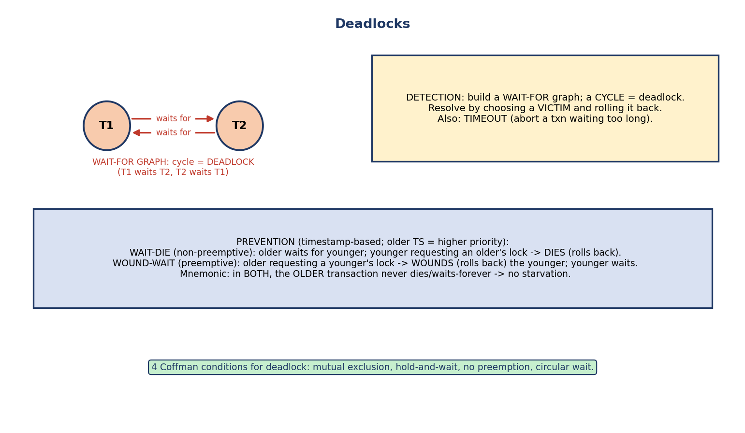
Deadlock: a cycle in the wait-for graph; prevention via wait-die / wound-wait timestamp schemes; detection via wait-for graph or timeout; the four Coffman conditions.
A deadlock is a cycle of transactions each waiting for a lock the next holds — none can proceed.
Detection: build a wait-for graph (node per txn, edge Ti→Tj if Ti waits for a lock Tj holds); a cycle = deadlock. Resolve by rolling back a victim. Or use timeout (abort a txn waiting too long).
Prevention (timestamp-based; older TS = higher priority):
- Wait-Die (non-preemptive): if an older txn requests a lock held by a younger one, it waits; if a younger requests an older’s lock, it dies (rolls back, restarts with same TS).
- Wound-Wait (preemptive): if an older requests a younger’s lock, it wounds (rolls back) the younger; if a younger requests an older’s lock, it waits.
Memory hook: in both schemes the older transaction never dies (it either waits or wins) — this guarantees no starvation (an old txn eventually gets priority). Wait-die: younger dies. Wound-wait: older wounds younger.
Four (Coffman) conditions for deadlock — all must hold: mutual exclusion, hold-and-wait, no preemption, circular wait. Breaking any one prevents deadlock.

9.11 Timestamp-Ordering (TO) Protocol
A lock-free alternative: order transactions by a timestamp assigned at start, and force conflicting operations to obey that order.
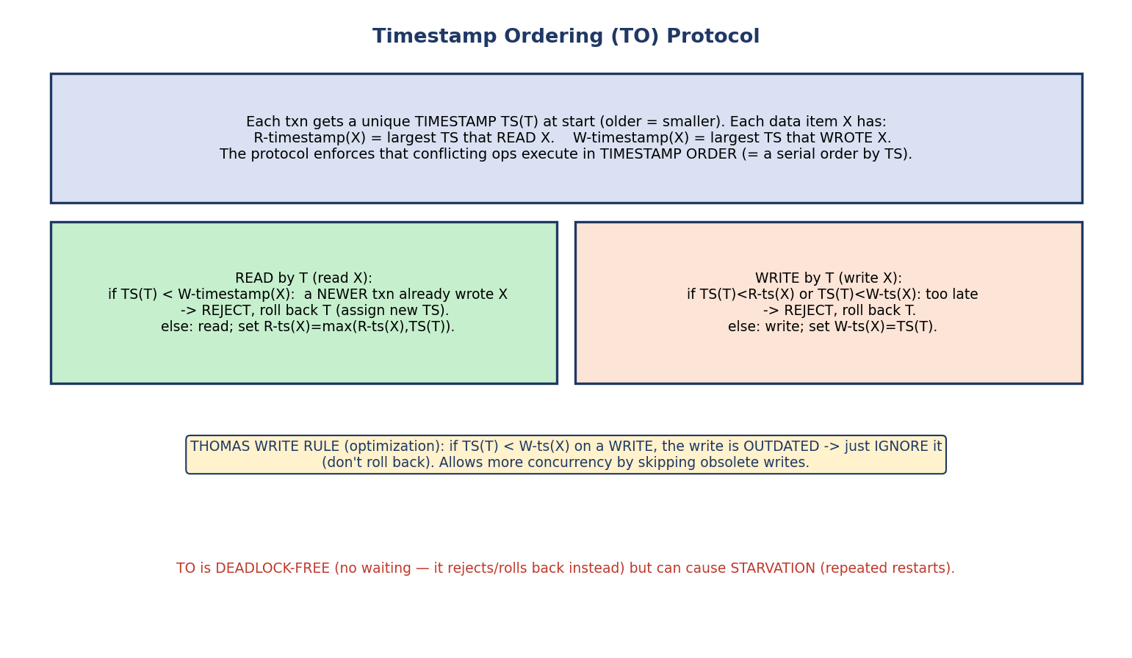
Timestamp ordering: each item has read- and write-timestamps; reads/writes that violate timestamp order are rejected and the transaction rolls back; Thomas write rule ignores outdated writes.
Each transaction T gets a unique TS(T) at start (older = smaller). Each item X keeps R-timestamp(X) (largest TS that read X) and W-timestamp(X) (largest TS that wrote X).
- Read X by T: if TS(T) < W-timestamp(X) (a newer txn already wrote X) → reject, roll back T. Else read, and set R-ts(X) = max(R-ts(X), TS(T)).
- Write X by T: if TS(T) < R-ts(X) or TS(T) < W-ts(X) → reject, roll back T. Else write, set W-ts(X) = TS(T).
Thomas Write Rule (optimization): if on a write TS(T) < W-ts(X), the write is obsolete (a newer write already exists) → ignore it instead of rolling back. Allows more concurrency.
Key property: TO is deadlock-free (it never waits — it rejects/rolls back), but can cause starvation (a txn repeatedly restarted). Locking (2PL) waits and risks deadlock; timestamp ordering rolls back and risks starvation — the classic trade-off.
Handling starvation: a transaction that keeps getting rolled back is eventually allowed to keep its original (oldest) timestamp on restart, so it gains the highest priority and finally succeeds — the same “the oldest never loses” idea used by wait-die / wound-wait.

Optimistic (Validation-Based) Concurrency Control
When conflicts are rare, even checking timestamps on every operation is wasteful. Optimistic Concurrency Control (OCC) assumes success and only checks at the end, in three phases:
- Read phase: the txn executes, reading freely and writing to a private, local copy (no changes visible to others yet).
- Validation phase: at commit, the DBMS checks whether this txn’s read/write set conflicts with transactions that committed concurrently (using start/validation/finish timestamps).
- Write phase: if validation passes, apply the local changes to the database; otherwise roll back and restart.
Trade-off: OCC is deadlock-free and has almost no locking overhead, so it’s excellent under low contention (e.g. mostly-read workloads). Under high contention it wastes work on rollbacks and can starve. It’s the conceptual cousin of MVCC/snapshot isolation (validate-at-commit).

9.12 MVCC — Multiversion Concurrency Control
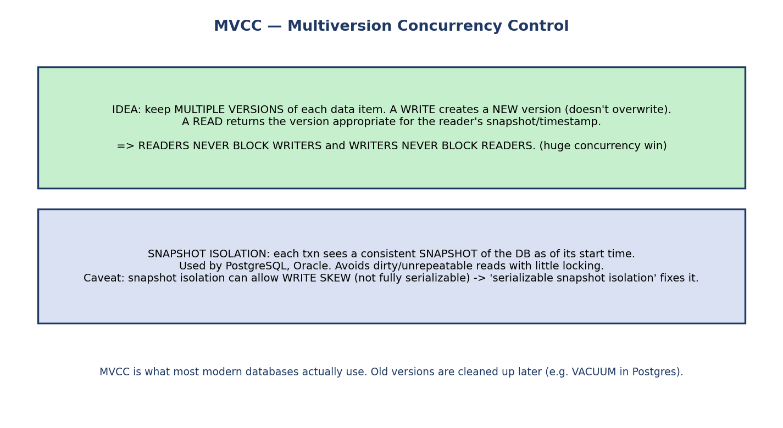
MVCC keeps multiple versions of each item so writes create new versions and reads see a consistent snapshot; readers never block writers and vice versa; snapshot isolation underlies PostgreSQL/Oracle.
MVCC keeps multiple versions of each data item. A write creates a new version (it doesn’t overwrite); a read returns the version appropriate to the reader’s snapshot.
The win: readers never block writers, and writers never block readers — a huge concurrency gain. This is what PostgreSQL, Oracle, and MySQL InnoDB actually use.
Snapshot isolation: each transaction sees a consistent snapshot of the database as of its start. Avoids dirty and unrepeatable reads with little locking.
Caveat: plain snapshot isolation can still allow write skew (it is not fully serializable); Serializable Snapshot Isolation (SSI) closes that gap. Old versions are garbage-collected later (e.g. VACUUM in PostgreSQL).

9.13 SQL Isolation Levels
The SQL standard exposes four isolation levels that trade correctness for concurrency by choosing which anomalies are allowed.
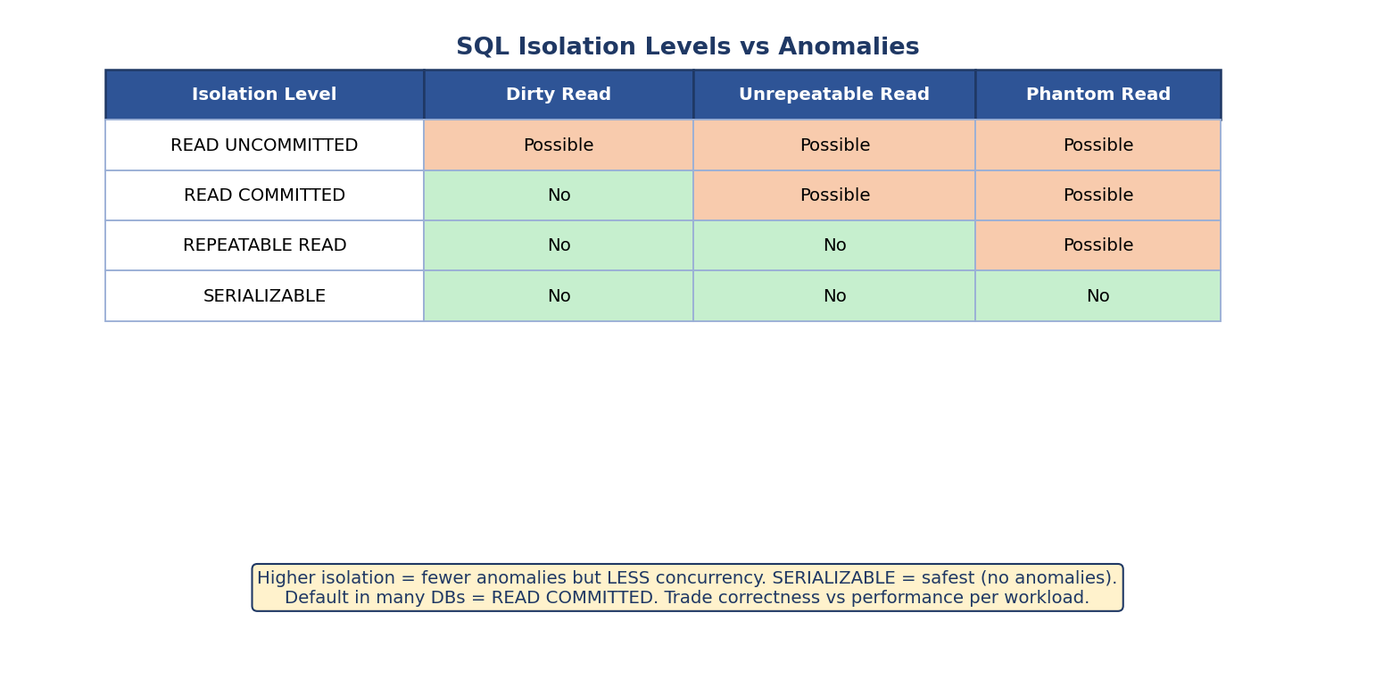
SQL isolation levels vs anomalies: Read Uncommitted allows all three; Read Committed blocks dirty reads; Repeatable Read also blocks unrepeatable reads; Serializable blocks all including phantoms.
Isolation Level | Dirty Read | Unrepeatable Read | Phantom Read
Read Uncommitted | possible | possible | possible
Read Committed | ❌ no | possible | possible
Repeatable Read | ❌ no | ❌ no | possible
Serializable | ❌ no | ❌ no | ❌ no
Higher isolation = fewer anomalies but less concurrency. Serializable is the safest (no anomalies). Many databases default to Read Committed (e.g. PostgreSQL, Oracle). You pick per workload: analytics may tolerate Read Committed; money movement wants Serializable.
Why phantoms are special (predicate / next-key locking): ordinary row locks only protect rows that already exist. A concurrent INSERT of a new row matching the query’s predicate had no row to lock, so it slips through and appears as a phantom on re-query. Preventing phantoms therefore needs predicate locks (lock the condition, e.g. salary > 50000) or index-range / next-key locks (MySQL InnoDB locks the gaps between index keys), or simply Serializable isolation. This is why phantoms persist up to Repeatable Read and only vanish at Serializable.

9.14 Deciding Serializability — the Test Flow
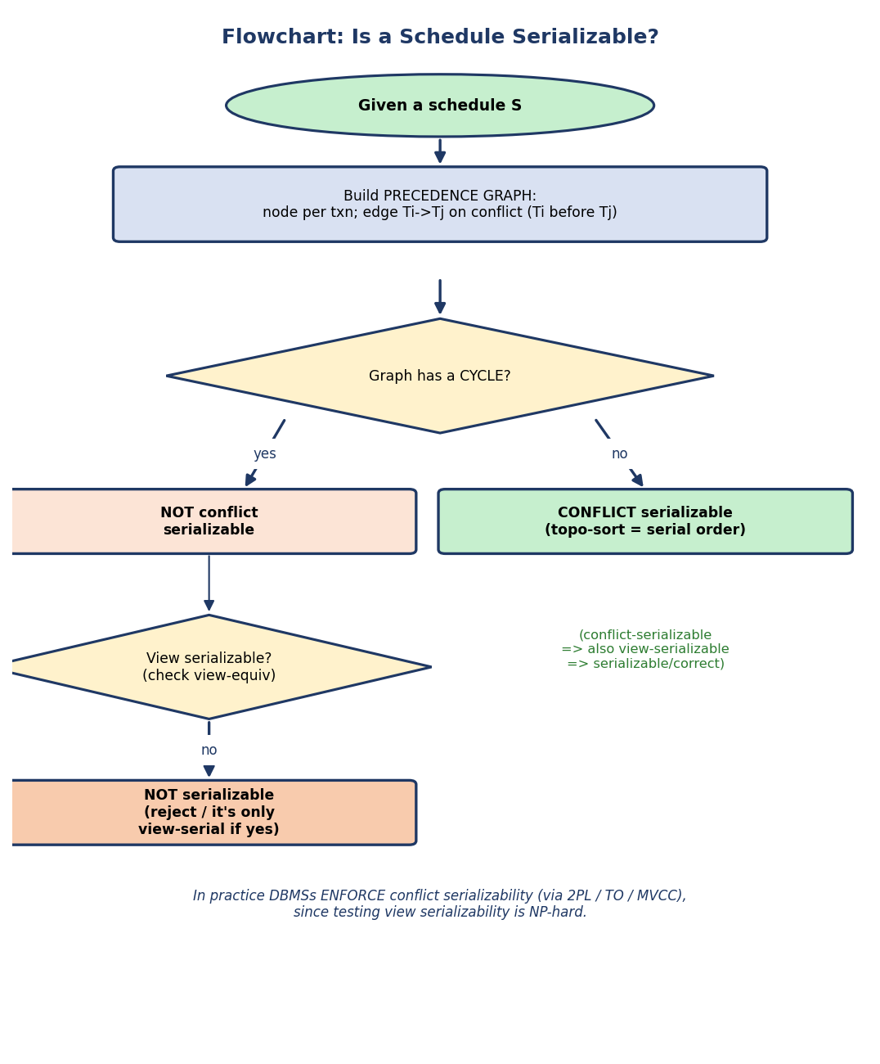
Flowchart: build the precedence graph; if it has a cycle it is not conflict serializable (possibly still view serializable); if acyclic it is conflict serializable and a topological sort gives the serial order.
- Build the precedence graph.
- Cycle? → not conflict serializable (might still be view serializable — but that’s NP-hard to test).
- Acyclic? → conflict serializable; topological sort = serial order.
In practice, DBMSs enforce conflict serializability proactively (via 2PL / timestamp ordering / MVCC) rather than testing schedules after the fact.

9.15 Real-World & Backend Perspectives
- BEGIN; … COMMIT; / ROLLBACK delimit transactions; SET TRANSACTION ISOLATION LEVEL … picks the level.
- PostgreSQL/Oracle/MySQL-InnoDB use MVCC — so “readers don’t block writers” is real; you mostly tune the isolation level.
- Deadlocks happen in production: the DB detects a cycle and aborts a victim; apps must retry the aborted transaction. Always order lock acquisition consistently to reduce deadlocks.
- SELECT … FOR UPDATE takes explicit row locks; long transactions hold locks longer → more contention.

9.16 Tradeoffs, Common Mistakes, Edge Cases
Common mistakes (exam + real life) - Saying R-R conflicts (it does not). - Thinking 2PL prevents deadlock (it does not — only conservative 2PL). - Confusing wait-die and wound-wait (younger dies vs older wounds). - Believing view ⊆ conflict — it’s the reverse (conflict ⊆ view). - Thinking serializable = serial (serializable means equivalent to some serial). - Forgetting timestamp ordering is deadlock-free but starvation-prone.
Edge cases - A schedule can be view-serializable but not conflict-serializable (blind writes). - A schedule can be serializable but not recoverable (correct concurrency, unsafe on abort) — both properties are needed. - Phantoms need range/predicate locks (or serializable isolation), not just row locks.
Tradeoffs
Mechanism | Strength | Weakness
2PL (locking) | simple, guarantees serializability | deadlocks, blocking
Timestamp ordering | deadlock-free | starvation, many rollbacks
MVCC | readers don’t block writers | version storage, write skew (SI)
Higher isolation | fewer anomalies | less concurrency

9.17 Exam, Interview & Coding Perspectives
Exam (SEBI/RBI/GATE): ACID; build a precedence graph and decide conflict serializability; view vs conflict (conflict ⊆ view, view NP-hard); 2PL + variants; wait-die/wound-wait; timestamp rules + Thomas write rule; recoverable/ cascadeless/strict; isolation level vs anomaly table.
Interview: “What are ACID properties?”; “How does the DB prevent two people overdrawing the same account?” (locking/isolation); “What’s a deadlock and how is it resolved?”; “Explain MVCC / why readers don’t block writers”; “difference between Read Committed and Serializable”.
Coding/practical: - Open two psql sessions, set isolation levels, and reproduce a dirty/unrepeatable read; then raise the level and see it disappear. - Force a deadlock with two sessions locking rows in opposite order; watch the DB abort a victim.

9.18 Concept Checks & MCQs
- A transaction ends in one of two states: ___ or ___ → committed / aborted.
- Which ACID property is about concurrency? → Isolation. About crashes? → Atomicity & Durability.
- Do two reads on the same item conflict? → No.
- Conflict serializable ⟺ precedence graph has ___ → no cycle.
- Conflict ⊆ view or view ⊆ conflict? → conflict ⊆ view (conflict is stricter).
- Why don’t DBMSs test view serializability? → it’s NP-hard.
- Does basic 2PL prevent deadlock? → No (only conservative 2PL does).
- Strict 2PL holds which locks till commit? → all exclusive (X) locks.
- In wait-die, who rolls back: older or younger? → younger (dies).
- In wound-wait, who rolls back: older or younger? → younger (older wounds it).
- Timestamp ordering: deadlock-free but suffers ___ → starvation.
- Thomas write rule: an outdated write is ___ → ignored.
- Nesting of schedules (strictest first)? → strict ⊆ cascadeless ⊆ recoverable.
- Which isolation level allows phantoms but not unrepeatable reads? → Repeatable Read.
- MVCC’s main benefit? → readers don’t block writers (and vice-versa).
- OCC’s three phases? → read, validation, write.
- Intention locks for multiple-granularity locking? → IS, IX, SIX.
- Upgrade S→X is allowed only in which 2PL phase? → growing.
- What prevents phantoms (besides Serializable)? → predicate / index-range (next-key) locks.
True/False - Every serializable schedule is serial. → False (equivalent to some serial). - 2PL guarantees conflict serializability. → True. - Read Committed prevents unrepeatable reads. → False. - A view-serializable schedule may not be conflict-serializable. → True.
Numerical (do it): > Schedule: r1(A); r2(A); w1(A); w2(A). Conflicts: r2(A)–w1(A) → T2→T1; > w1(A)–w2(A) → T1→T2; r1(A)–w2(A) → T1→T2. Edges T1→T2 and T2→T1 form a > cycle → NOT conflict serializable. ✔

9.19 One-Page Revision Sheet
TRANSACTION = logical unit of work. states: active -> partially committed -> committed | failed -> aborted.
ACID: Atomicity (all-or-nothing), Consistency (valid->valid), Isolation (concurrency), Durability (committed=permanent).
A,D = crash safety (M10 recovery). I = concurrency (this module). C = the goal.
ANOMALIES (uncontrolled interleaving): LOST UPDATE, DIRTY READ, UNREPEATABLE READ, PHANTOM.
SCHEDULE serial (correct, slow) vs concurrent (fast, maybe wrong). GOAL = SERIALIZABLE (= equiv to SOME serial).
CONFLICT: diff txns + same item + at least one WRITE. (R-R no; R-W,W-R,W-W yes.)
CONFLICT SERIALIZABLE <=> precedence graph ACYCLIC. edge Ti->Tj if Ti's op conflicts & precedes Tj's. topo-sort=order.
VIEW SERIALIZABLE: initial read + read-from + final write match a serial schedule.
conflict-serial SUBSET view-serial (NOT reverse). view test = NP-HARD -> DBMS uses conflict.
RECOVERABILITY: STRICT subset CASCADELESS subset RECOVERABLE. irrecoverable=committed txn read from later-aborted txn.
LOCKS: S (shared/read, many) , X (exclusive/write, one). compat: S-S yes, else no.
2PL: GROWING (acquire only) then SHRINKING (release only). once you release, no new lock. => conflict serializable.
basic 2PL: deadlock+cascading possible. CONSERVATIVE = deadlock-FREE (locks upfront).
STRICT = hold X till commit (cascadeless, most used). RIGOROUS = hold ALL locks till commit.
LOCK CONVERSION: upgrade S->X (growing phase only); downgrade X->S (shrinking phase only).
MULTIPLE GRANULARITY: lock hierarchy DB->table->page->row with INTENTION locks IS/IX/SIX
(to S-lock a node hold IS/IX on ancestors; to X-lock hold IX/SIX). lock root->leaf, release leaf->root.
OPTIMISTIC (OCC): 3 phases READ (local copies) -> VALIDATION (conflict check) -> WRITE. deadlock-free, low-contention best.
TO STARVATION fix: restart the victim with its OLDEST timestamp so it eventually wins priority.
DEADLOCK: cycle in WAIT-FOR graph. detect->rollback victim; or timeout. prevention (older=priority):
WAIT-DIE (non-preemptive): younger requesting older's lock DIES; older WAITS.
WOUND-WAIT (preemptive): older requesting younger's lock WOUNDS younger; younger WAITS.
(older never dies -> no starvation). Coffman: mutual excl, hold&wait, no preempt, circular wait.
TIMESTAMP ORDERING: TS at start. R-ts/W-ts per item. violate order -> reject+rollback. DEADLOCK-FREE, STARVATION-prone.
THOMAS WRITE RULE: outdated write (TS<W-ts) -> IGNORE (not rollback).
MVCC: many versions; write=new version; read=snapshot. readers don't block writers. snapshot isolation (PG/Oracle).
caveat: SI allows WRITE SKEW (not fully serializable) -> SSI fixes.
ISOLATION LEVELS (anomaly allowed?):
READ UNCOMMITTED: dirty Y, unrepeatable Y, phantom Y
READ COMMITTED: dirty N, unrepeatable Y, phantom Y (common default)
REPEATABLE READ: dirty N, unrepeatable N, phantom Y
SERIALIZABLE: dirty N, unrepeatable N, phantom N (safest)

Flash cards
Front | Back
ACID = ? | Atomicity, Consistency, Isolation, Durability
Which ACID for concurrency? | Isolation
Do two reads conflict? | No
Conflict serializable test? | Precedence graph has no cycle
Conflict vs view subset? | conflict ⊆ view
View serializability test cost? | NP-hard
Does 2PL prevent deadlock? | No (only conservative 2PL)
Most-used 2PL variant? | Strict 2PL
Wait-die: who rolls back? | Younger (dies)
Wound-wait: who rolls back? | Younger (older wounds it)
Timestamp ordering: deadlock? | Free, but starvation-prone
Thomas write rule? | Ignore an outdated write
Schedule nesting? | strict ⊆ cascadeless ⊆ recoverable
Repeatable Read allows? | Phantoms only
MVCC benefit? | Readers don’t block writers
OCC phases? | Read, validation, write
Intention lock modes? | IS, IX, SIX
Prevent phantoms how? | Predicate / next-key locks (or Serializable)

Spaced repetition
- 24-hour: build precedence graphs for 3 schedules; redo the isolation-levels table from memory.
- 7-day: explain 2PL variants + wait-die/wound-wait; trace a timestamp-ordering schedule.
- 30-day: given a schedule, decide conflict & view serializability, recoverability, and which 2PL/level would produce it.

9.20 Summary
Transactions make data correct under concurrency and crashes. A transaction is an all-or-nothing logical unit with ACID guarantees (A/D = crash safety, I = concurrency, C = the goal). Uncontrolled interleaving causes lost updates, dirty/unrepeatable reads, and phantoms, so we only accept serializable schedules. Conflict serializability is tested with a precedence graph (acyclic ⟺ serializable; topo-sort = order); view serializability is more general but NP-hard, so DBMSs enforce conflict serializability — via 2PL (growing/shrinking; strict/rigorous/conservative variants) which can deadlock (handled by wait-for graphs, wait-die/wound-wait), via timestamp ordering (deadlock-free, starvation-prone, Thomas write rule), or via MVCC/snapshot isolation (readers don’t block writers). Recoverability (strict ⊆ cascadeless ⊆ recoverable) ensures safe aborts, and SQL isolation levels trade anomalies for concurrency.
Next, Module 10 — Recovery & Backup completes the A and D of ACID: how the DBMS uses logs (WAL), checkpoints, and protocols like ARIES to restore a consistent state after a crash.
You have mastered this module when you can: state ACID and map each letter to what protects it; build a precedence graph and decide conflict (and view) serializability; explain 2PL and all its variants; contrast wait-die vs wound-wait; apply the timestamp-ordering rules with the Thomas write rule; and fill the isolation-level-vs-anomaly table — all without notes.

