Module 10 — Recovery & Backup
  - DBMS Mastery: SEBI IT / RBI / GATE / Interview — In-Depth Notes (with visuals)
Prepared for nidhi.sharma@forensiccybertech.com
2026
Table of Contents

Module 10 — Recovery & Backup
Where this module sits. Module 9 handled the I of ACID (isolation under concurrency). This module delivers the A and D — atomicity and durability across crashes. When the power dies mid-transfer, how does the database guarantee that committed money moves are never lost and half-finished ones never persist? The answer is the log + Write-Ahead Logging + a recovery algorithm (ARIES). It’s a focused, highly examinable topic (undo/redo logic and the deferred-vs-immediate classification are reliable GATE/SEBI questions).
Importance ratings (out of 5):
Exam / Use | SEBI IT | RBI IT | GATE CS | Interview | Backend
This module | ★★★★ | ★★★★ | ★★★★ | ★★★ | ★★★★
Most-asked PYQ concepts (SEBI / RBI / GATE): Write-Ahead Logging (WAL); deferred (NO-UNDO/REDO) vs immediate (UNDO/REDO) update; undo/redo lists after a crash; checkpoints; STEAL/NO-FORCE buffer policies; ARIES (analysis/redo/undo, LSN); shadow paging; log record format; backup types (full / incremental / differential).

10.1 Why Recovery? Failures & Storage
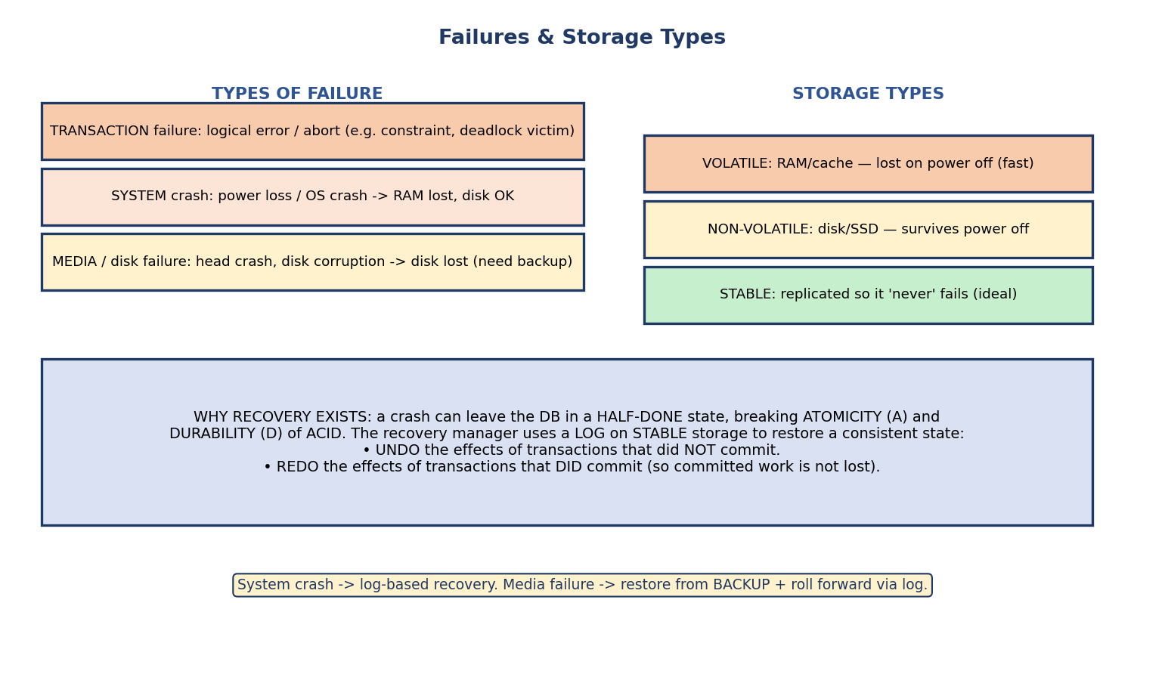
Failure types (transaction, system crash, media) and storage types (volatile, non-volatile, stable); recovery uses a log on stable storage to undo uncommitted and redo committed work.
Types of failure:
Failure | Cause | Effect
Transaction failure | logical error, abort, deadlock victim | one txn must be rolled back
System crash | power loss, OS crash | RAM lost, disk intact
Media failure | disk head crash, corruption | disk lost → need a backup
Storage types: volatile (RAM — lost on power off), non-volatile (disk/SSD — survives power off), stable (replicated so it “never” fails — an idealization we approximate with redundancy).
First principle: a crash can leave the database half-done, violating atomicity and durability. The recovery manager keeps a log on stable storage and, after a crash: - UNDO the effects of transactions that did not commit, and - REDO the effects of transactions that did commit (so committed work survives).

10.2 The Log & Write-Ahead Logging (WAL)
The log is an append-only sequence of records, on stable storage, describing every change.
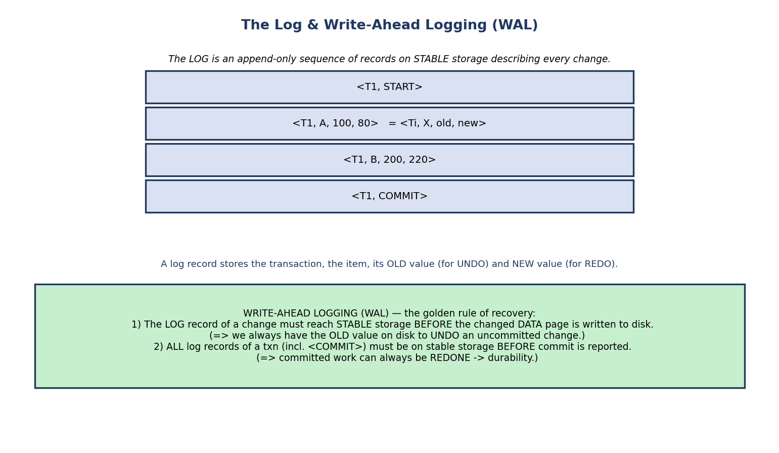
Log records of the form ⟨Ti, X, old, new⟩ plus start/commit; the Write-Ahead Logging rule writes the log before the data page and before reporting commit.
Log record types:
- ⟨Ti, START⟩ — transaction begins.
- ⟨Ti, X, old_value, new_value⟩ — Ti changed item X (old for undo, new for redo).
- ⟨Ti, COMMIT⟩ — transaction committed.
- ⟨Ti, ABORT⟩ — transaction aborted.
WRITE-AHEAD LOGGING (WAL) — the golden rule of recovery: 1. The log record of a change must reach stable storage BEFORE the changed data page is written to disk. (So the old value is always recoverable to UNDO an uncommitted change.) 2. All log records of a transaction (including ⟨COMMIT⟩) must be on stable storage before the commit is reported to the user. (So committed work can always be REDONE → durability.)
Why “write-ahead”: the log always runs ahead of the data. If the data page hit disk first and we crashed before logging, we’d have a change on disk with no way to undo it. WAL makes that impossible.
The log buffer (what “on stable storage” really means): for performance, log records first accumulate in an in-memory log buffer; a record only counts as “on stable storage” once that buffer is force-written (flushed/fsync) to disk. So WAL rule 1 means force the log up to a page’s update record before writing that data page, and WAL rule 2 is “force-log-at-commit” — flush the buffer through the ⟨COMMIT⟩ record before reporting success. This is exactly why commit latency is dominated by the log fsync.

10.3 Deferred vs Immediate Update
The recovery requirements depend on when modified pages are allowed to reach disk.
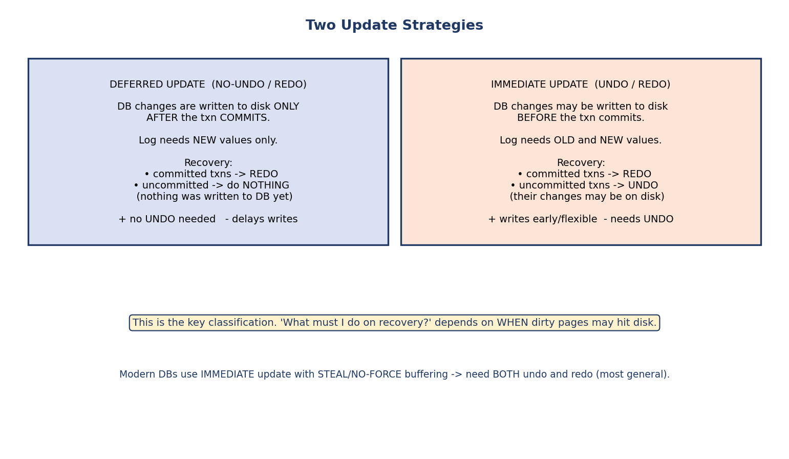
Deferred update (NO-UNDO/REDO) writes to disk only after commit; immediate update (UNDO/REDO) may write before commit; recovery actions differ accordingly.
 | Deferred update | Immediate update
Disk writes happen | only after commit | may happen before commit
Log stores | new values only | old + new values
Committed txns | REDO | REDO
Uncommitted txns | do nothing (DB untouched) | UNDO (changes may be on disk)
Nickname | NO-UNDO / REDO | UNDO / REDO
The intuition: in deferred update, an uncommitted txn never touched the disk, so there is nothing to undo. In immediate update, its dirty pages might be on disk, so we must undo. Both redo committed txns (their changes might not have been flushed yet).

Buffer policies that decide this (STEAL / FORCE — a GATE favourite)
Policy | Meaning | Implication
STEAL | buffer may write an uncommitted txn’s dirty page to disk | UNDO needed
NO-STEAL | uncommitted dirty pages are never written early | no UNDO
FORCE | all dirty pages flushed to disk at commit | no REDO
NO-FORCE | dirty pages not forced at commit | REDO needed
The practical choice: real databases use STEAL + NO-FORCE → they need both UNDO and REDO (the most general case), because it gives the best buffer performance (flush whenever convenient, don’t force at commit). NO-STEAL + FORCE needs neither undo nor redo but cripples buffer management.

10.4 Recovery: Which Transactions to UNDO vs REDO
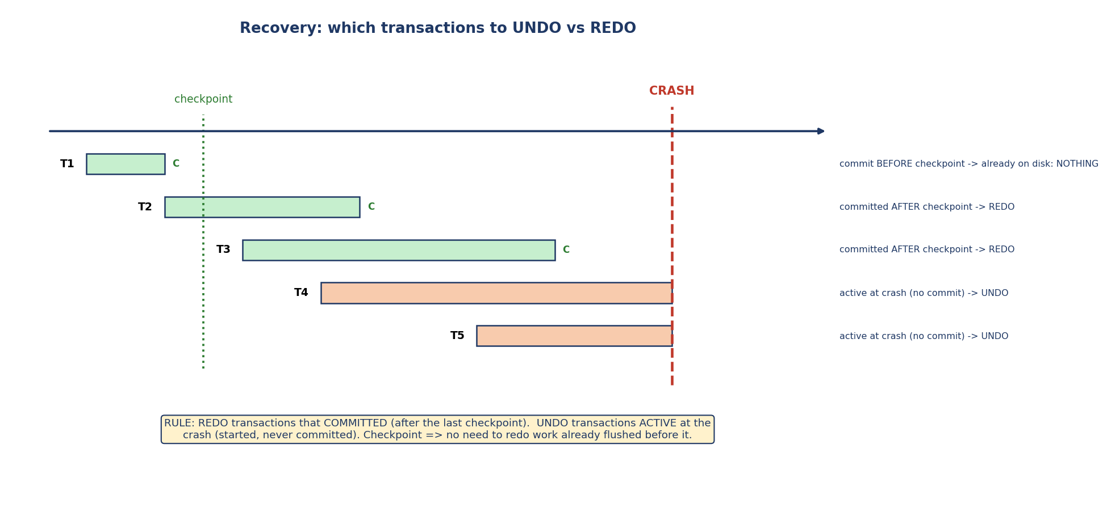
Crash timeline: transactions committed before the checkpoint need nothing; those committed after the checkpoint are redone; those active (uncommitted) at the crash are undone.
After a crash, scan the log and classify each transaction:
- Committed (has ⟨COMMIT⟩) after the last checkpoint → REDO (changes might not be flushed).
- Active at crash (⟨START⟩ but no ⟨COMMIT⟩) → UNDO (changes might be on disk).
- Committed before the last checkpoint → nothing (already safely on disk).
Order matters (immediate update): UNDO is done backward (latest change first), REDO forward (oldest first). Many algorithms redo first (repeat history), then undo — this is what ARIES does.

10.5 Checkpoints
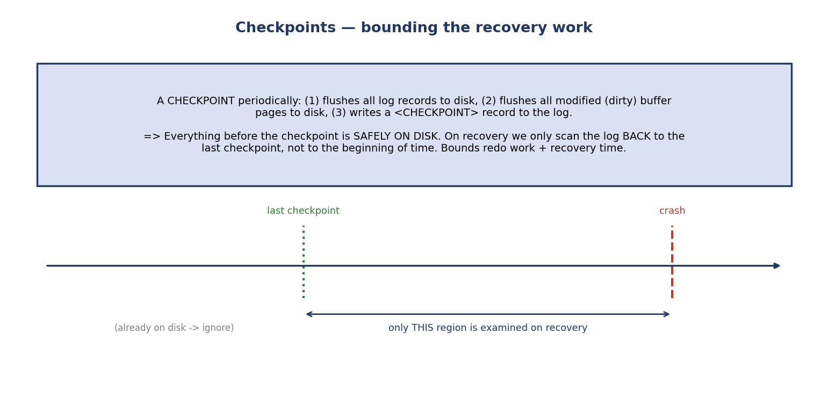
A checkpoint flushes the log and all dirty pages to disk and writes a checkpoint record, so recovery only needs to scan back to the last checkpoint.
Without checkpoints, recovery would scan the entire log from the beginning. A checkpoint periodically:
- flushes all log records to disk,
- flushes all modified (dirty) buffer pages to disk,
- writes a ⟨CHECKPOINT⟩ record to the log.
The payoff: everything before the checkpoint is safely on disk, so recovery only scans the log back to the last checkpoint — bounding redo work and recovery time. (A naïve checkpoint briefly pauses transactions; real systems use fuzzy checkpoints that don’t stop the world.)

10.6 ARIES — the Industry-Standard Algorithm
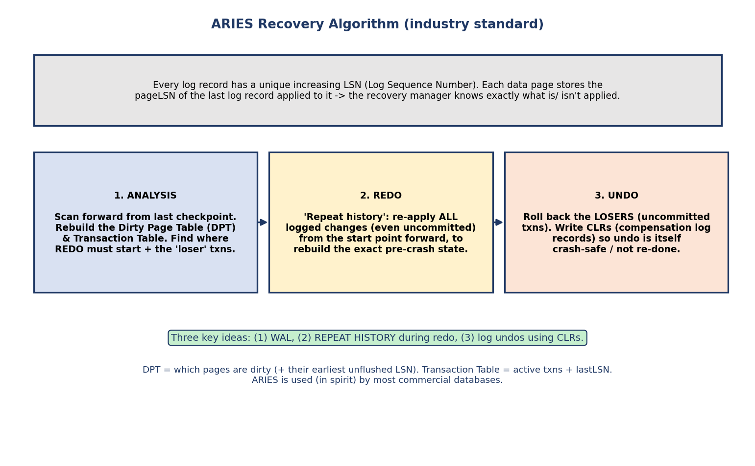
ARIES three phases — Analysis (rebuild dirty-page and transaction tables), Redo (repeat history), Undo (roll back losers with CLRs) — driven by LSNs.
Every log record gets a unique, increasing LSN (Log Sequence Number); each data page records the pageLSN of the last log record applied to it (so recovery knows exactly what is/isn’t applied). Recovery runs in three phases:
- Analysis: scan forward from the last checkpoint to rebuild the Dirty Page Table (DPT) and Transaction Table, find where REDO must start, and identify the loser transactions (active, uncommitted at crash).
- Redo (repeat history): re-apply all logged changes from the redo start point forward — even those of losers — to reconstruct the exact pre-crash state.
- Undo: roll back the losers, writing CLRs (Compensation Log Records) so that the undo work is itself logged and never redone if we crash again during recovery.
The two tables, in detail (GATE probes these): the Dirty Page Table stores a recLSN per dirty page (the LSN that first dirtied it); the smallest recLSN across all dirty pages is the RedoLSN — where the Redo phase begins. The Transaction Table stores a lastLSN per active txn, and every log record carries a prevLSN back-pointer; chaining these prevLSNs is how the Undo phase walks each loser’s changes backward.
The three big ARIES ideas (exam): (1) WAL, (2) repeat history during redo (redo everything, then selectively undo), (3) log undos with CLRs so recovery is idempotent (restart-safe). Most commercial databases follow ARIES in spirit.

10.7 Shadow Paging (a log-free alternative)
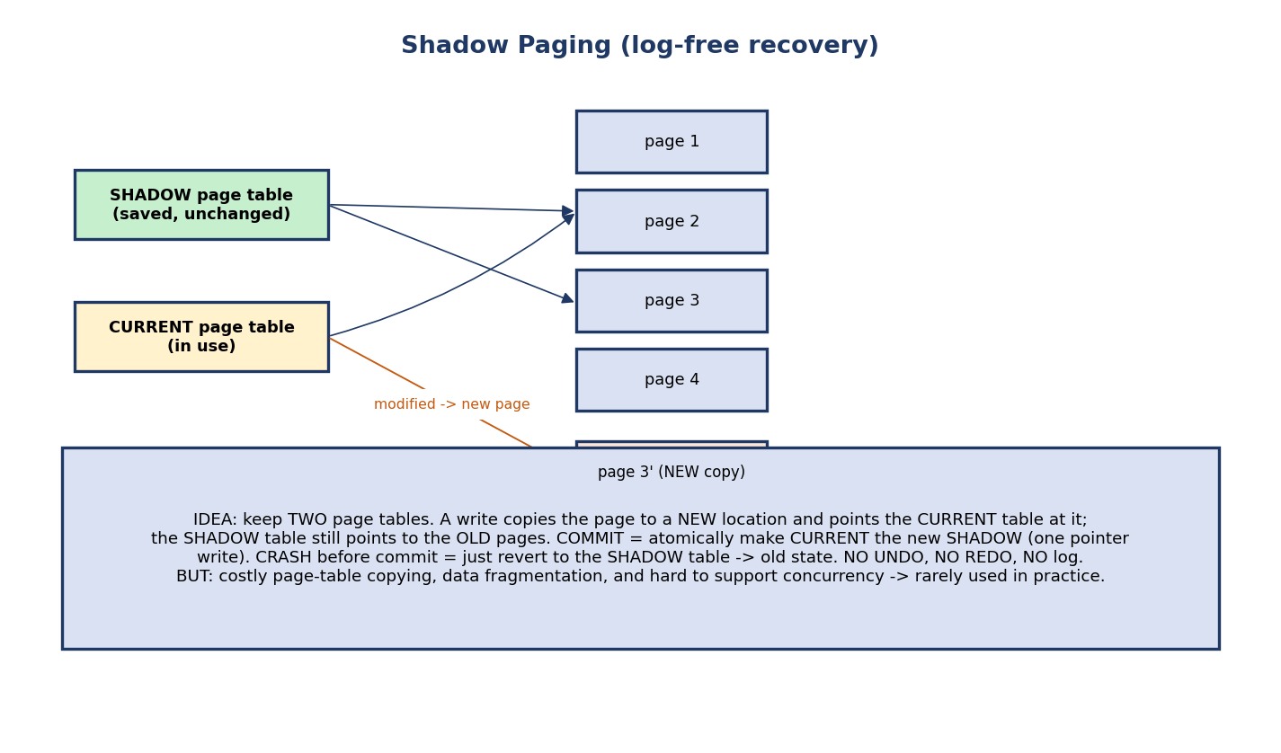
Shadow paging keeps a current and a shadow page table; writes go to new page copies, commit atomically swaps the pointer, and a crash reverts to the shadow.
Shadow paging keeps two page tables: a current one (in use) and a shadow one (saved). A write copies the page to a new location and points the current table at it, leaving the shadow pointing at the old page.
- Commit = atomically make the current table the new shadow (one pointer write).
- Crash before commit = revert to the shadow table → old state.
Pros: no log, no undo, no redo — recovery is trivial. Cons: expensive page-table copying, data fragmentation, hard to garbage-collect old pages, and poor concurrency support → rarely used in practice (WAL/ARIES won).

10.8 Backup & Media Recovery
A crash loses RAM; a media (disk) failure loses the data itself. Recovery from that needs backups plus the log.
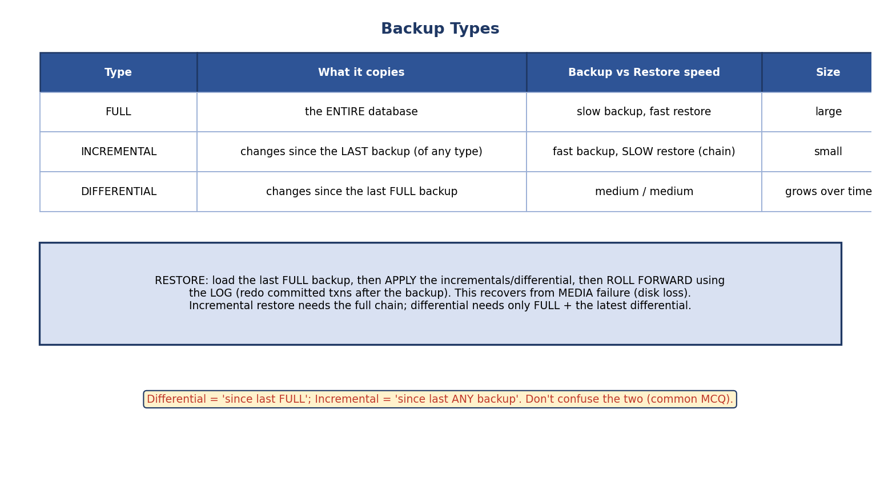
Backup types: full (entire DB), incremental (changes since last backup), differential (changes since last full backup), with their backup/restore trade-offs.
Type | Copies | Backup vs restore | Size
Full | the entire database | slow backup, fast restore | large
Incremental | changes since the last backup (of any type) | fast backup, slow restore (need the chain) | small
Differential | changes since the last full backup | medium / medium | grows over time
Media-recovery procedure: restore the last full backup → apply incrementals/differential → roll forward using the log (redo committed transactions after the backup).
Don’t confuse them (classic MCQ): Incremental = “since the last any backup”; Differential = “since the last full backup.” Differential restore needs only full + latest differential; incremental restore needs the whole chain.

10.9 The Recovery Decision Flow
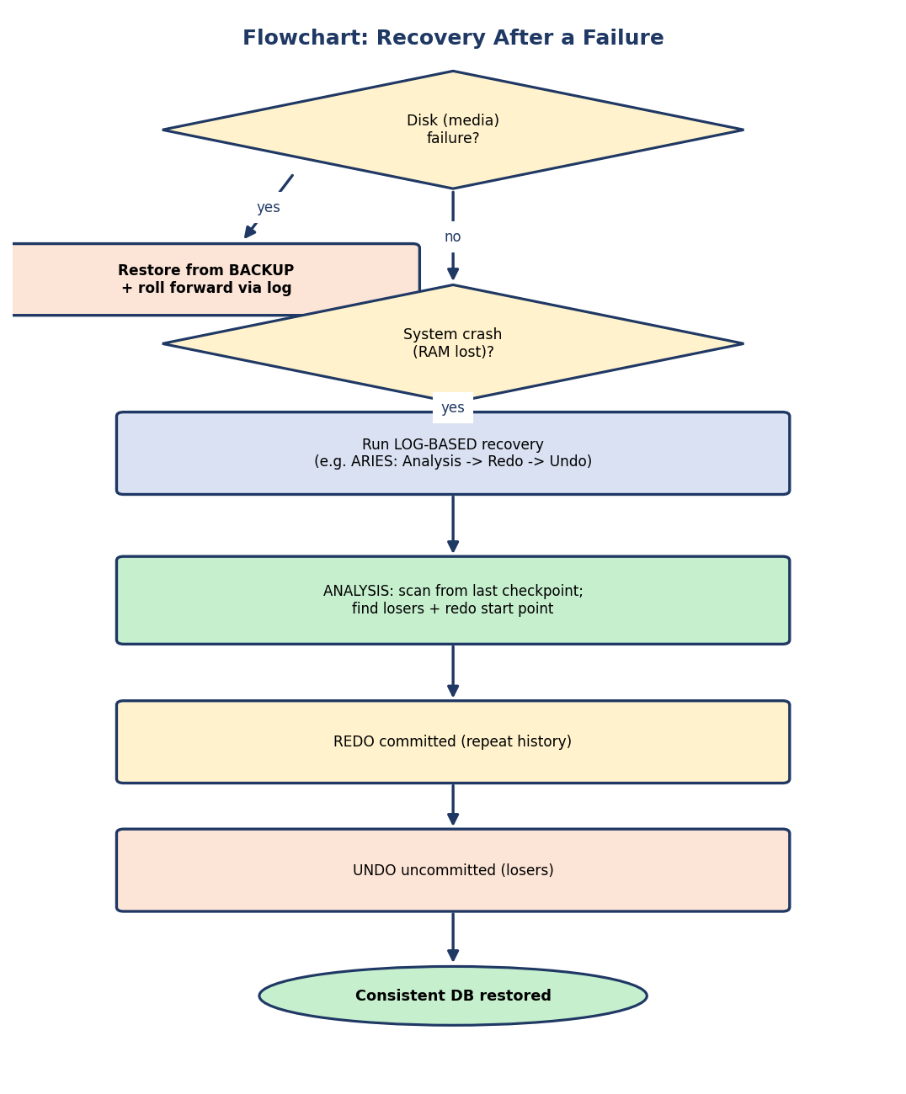
Flowchart: media failure → restore from backup + roll forward; system crash → log-based recovery (ARIES analysis → redo → undo) → consistent DB.
- Media (disk) failure → restore from backup + roll forward via log.
- System crash (RAM lost) → log-based recovery (ARIES: Analysis → Redo → Undo).
- Transaction failure (single abort) → undo just that transaction using its log records.

10.10 Real-World & Backend Perspectives
- PostgreSQL WAL (the pg_wal directory) is exactly this log; fsync enforces WAL ordering; CHECKPOINT is a real command.
- Point-in-Time Recovery (PITR): base backup + archived WAL lets you restore to any moment (e.g. “just before the bad DELETE”).
- Replication ships the WAL to standby servers — the same log that powers recovery powers high availability.
- COMMIT latency is dominated by the WAL fsync (rule 2 of WAL) — group commit batches these.

10.11 Tradeoffs, Common Mistakes, Edge Cases
Common mistakes (exam + real life) - Swapping deferred (NO-UNDO/REDO) and immediate (UNDO/REDO). - Violating WAL order (writing data before its log) — breaks recoverability. - Confusing incremental vs differential backup. - Thinking a checkpoint means “no recovery needed” (it only bounds the work). - Forgetting that ARIES redoes losers too (repeat history) before undoing them. - Believing shadow paging is widely used (it isn’t — WAL won).
Edge cases - Crash during recovery: ARIES is idempotent (LSNs + CLRs) → just restart recovery. - A transaction that committed but whose data pages weren’t flushed → REDO saves it (durability). - ⟨COMMIT⟩ written but the crash happened right after → still durable (WAL rule 2 guarantees the log is stable).
Tradeoffs
Choice | Gain | Cost
STEAL + NO-FORCE | best buffer performance | needs both undo + redo
Frequent checkpoints | faster recovery | runtime overhead
Shadow paging | no log/undo/redo | copying, fragmentation, poor concurrency
Incremental backup | small, fast backup | slow chained restore

10.12 Exam, Interview & Coding Perspectives
Exam (SEBI/RBI/GATE): WAL rules; deferred vs immediate (and their nicknames); undo/redo lists from a log + checkpoint; STEAL/FORCE matrix; ARIES three phases & LSN/CLR; shadow paging pros/cons; backup types and restore procedure.
Interview: “How does a DB guarantee durability?” (WAL + fsync at commit); “What happens on recovery after a crash?” (redo committed, undo uncommitted); “What is a checkpoint?”; “incremental vs differential backup”.
Coding/practical: - Inspect PostgreSQL pg_wal; run CHECKPOINT; do a base backup + PITR to a chosen time. - Simulate: kill the server mid-transaction, restart, and observe the uncommitted change is gone (undo) and committed ones survive (redo).

10.13 Concept Checks & MCQs
- ACID properties guaranteed by recovery? → Atomicity & Durability.
- WAL rule 1: write the ___ before the ___ → log record / data page.
- Deferred update needs undo? → No (NO-UNDO/REDO).
- Immediate update needs ___ and ___ → undo and redo.
- On crash, committed transactions are ___ → redone.
- On crash, uncommitted (active) transactions are ___ → undone.
- STEAL policy implies we need ___ → UNDO.
- NO-FORCE policy implies we need ___ → REDO.
- Real DBs use which buffer policy pair? → STEAL + NO-FORCE.
- A checkpoint lets recovery scan back only to ___ → the last checkpoint.
- ARIES three phases (in order)? → Analysis, Redo, Undo.
- ARIES “repeat history” means redo even ___ transactions → uncommitted (loser).
- CLRs make recovery ___ → idempotent / restart-safe.
- Differential backup copies changes since the last ___ → full backup.
- Recovery technique with two page tables and no log? → shadow paging.
- Log records are buffered in RAM and become durable only when ___ → force-written / flushed (fsync) to stable storage.
- In ARIES, the smallest recLSN in the Dirty Page Table gives the ___ → RedoLSN (where Redo starts).
True/False - WAL allows writing a data page before its log record. → False. - Deferred update requires undo. → False. - Differential restore needs the full backup plus the latest differential only. → True. - ARIES undoes losers before redoing committed transactions. → False (redo first, then undo).
Worked (do it): > Log: ⟨T1,COMMIT⟩, ⟨CHECKPOINT⟩, ⟨T2,start⟩, ⟨T2,A,10,20⟩, ⟨T2,COMMIT⟩, > ⟨T3,start⟩, ⟨T3,B,5,9⟩, then CRASH. > → T1 committed before the checkpoint → nothing. REDO T2 (committed > after the checkpoint). UNDO T3 (active at crash → set B back to 5). ✔

10.14 One-Page Revision Sheet
WHY: crashes break A (atomicity) + D (durability). recovery = UNDO uncommitted + REDO committed, via LOG.
FAILURES: transaction (abort) | system crash (RAM lost, disk ok) | media (disk lost -> need backup).
STORAGE: volatile (RAM) | non-volatile (disk) | stable (replicated, 'never' fails).
LOG record = <Ti,X,old,new> (+ start/commit/abort). buffered in RAM (log buffer), force-written/fsync to STABLE storage.
WAL (write-ahead logging):
1) log record on stable storage BEFORE its data page hits disk (-> can UNDO).
2) all log records (incl COMMIT) stable BEFORE commit reported (force-log-at-commit -> durability, fsync-bound latency).
UPDATE STRATEGY:
DEFERRED = NO-UNDO/REDO : write to DB only after commit. uncommitted -> nothing; committed -> REDO.
IMMEDIATE = UNDO/REDO : may write before commit. uncommitted -> UNDO; committed -> REDO.
BUFFER POLICY:
STEAL -> need UNDO ; NO-STEAL -> no undo. FORCE -> no REDO ; NO-FORCE -> need REDO.
real DBs = STEAL + NO-FORCE (need BOTH undo & redo; best performance).
RECOVERY: REDO committed-after-checkpoint ; UNDO active-at-crash ; before-ckpt-commit = nothing.
CHECKPOINT: flush log + dirty pages + write <CKPT>. recovery scans back only to last checkpoint.
ARIES (LSN per log rec; pageLSN per page; prevLSN back-pointer per record):
1) ANALYSIS: rebuild Dirty Page Table (recLSN/page; min recLSN = RedoLSN start) + Transaction Table (lastLSN/txn); find losers.
2) REDO: from RedoLSN, repeat history (redo ALL changes incl losers) -> exact pre-crash state.
3) UNDO: roll back losers backward via prevLSN chain, write CLRs (idempotent, restart-safe).
SHADOW PAGING: current + shadow page tables; write=new page; commit=swap pointer; crash=revert. no log/undo/redo.
BUT copying + fragmentation + poor concurrency -> rarely used.
BACKUP: FULL (whole DB) | INCREMENTAL (since last ANY backup; slow chained restore) |
DIFFERENTIAL (since last FULL; restore = full + latest diff). media recovery = restore + roll forward via log.

Flash cards
Front | Back
Recovery guarantees which ACID? | Atomicity & Durability
WAL rule 1? | Log record before data page on disk
WAL rule 2? | All log (incl commit) stable before commit reported
Deferred update = ? | NO-UNDO / REDO
Immediate update = ? | UNDO / REDO
STEAL needs? | UNDO
NO-FORCE needs? | REDO
Real-DB buffer policy? | STEAL + NO-FORCE
Committed txns on crash? | REDO
Active txns on crash? | UNDO
ARIES phases? | Analysis, Redo, Undo
ARIES redo scope? | Repeat history (incl losers)
CLR purpose? | Idempotent, restart-safe undo
Two-page-table recovery? | Shadow paging
Differential backup base? | Last full backup
RedoLSN comes from? | Smallest recLSN in Dirty Page Table
When is a log record durable? | After force-write (fsync) to stable storage

Spaced repetition
- 24-hour: from a sample log + checkpoint, list the undo and redo sets; redo MCQs.
- 7-day: explain WAL’s two rules and the STEAL/FORCE matrix from memory.
- 30-day: walk through ARIES’s three phases on a log; compare shadow paging vs WAL; pick a backup strategy.

10.15 Summary
Recovery delivers ACID’s atomicity and durability across crashes. The log on stable storage records every change as ⟨Ti, X, old, new⟩, and Write-Ahead Logging enforces two rules — log before data, and all log (incl. commit) stable before reporting commit — so we can always UNDO uncommitted and REDO committed work. Update strategy splits into deferred (NO-UNDO/REDO) and immediate (UNDO/REDO), determined by the STEAL/NO-FORCE buffer policies (real DBs use STEAL+NO-FORCE → need both). Checkpoints bound recovery to the log since the last checkpoint. ARIES — Analysis → Redo (repeat history) → Undo (with CLRs), driven by LSNs — is the industry standard and idempotent. Shadow paging avoids logs but lost on performance. Finally, backups (full / incremental / differential) plus log roll-forward recover from media failure.
That completes the internals half of the syllabus. Module 11 — Distributed, NoSQL & Modern Databases zooms out to data across many machines: the CAP theorem, replication & partitioning (sharding), the NoSQL families, and how the ACID guarantees of Modules 9–10 relax into BASE at scale.
You have mastered this module when you can: state the two WAL rules; classify deferred vs immediate and map STEAL/FORCE to undo/redo; produce the undo and redo sets from a log with a checkpoint; walk ARIES’s three phases and explain CLRs; and distinguish full/incremental/differential backups — all without notes.

