Module 11 — Distributed, NoSQL & Modern Databases
  - DBMS Mastery: SEBI IT / RBI / GATE / Interview — In-Depth Notes (with visuals)
Prepared for nidhi.sharma@forensiccybertech.com
2026
Table of Contents

Module 11 — Distributed, NoSQL & Modern Databases
Where this module sits. Modules 1–10 covered the single-machine relational database in depth. This finale zooms out to data spread across many machines: why we distribute, the unavoidable CAP trade-off, how ACID relaxes into BASE at scale, the four NoSQL families, sharding, and distributed transactions (2PC). For SEBI/RBI IT it’s conceptual (CAP, ACID-vs-BASE, SQL-vs-NoSQL are favourite MCQs); for backend engineering it’s everything — modern systems are distributed by default.
Importance ratings (out of 5):
Exam / Use | SEBI IT | RBI IT | GATE CS | Interview | Backend
This module | ★★★ | ★★★ | ★★★ | ★★★★ | ★★★★★
Most-asked PYQ concepts (SEBI / RBI / GATE): CAP theorem (pick 2; CP vs AP); ACID vs BASE; SQL vs NoSQL differences; NoSQL families (key-value / document / column / graph); fragmentation (horizontal/vertical) & replication; sharding / partitioning (range/hash/consistent hashing); two-phase commit (2PC); consistency models (strong vs eventual).

11.1 Why Distributed Databases?
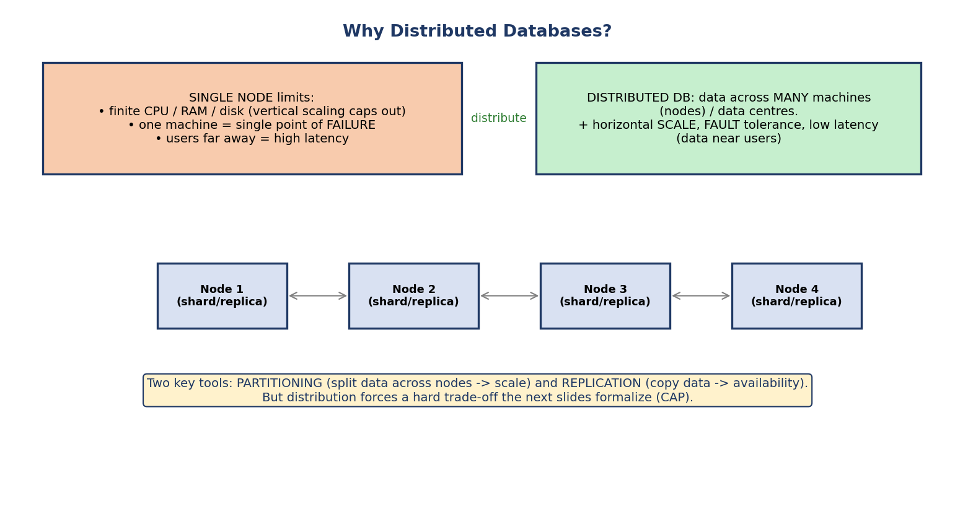
A single node has finite CPU/RAM/disk and is a single point of failure; a distributed database spreads data across many nodes for horizontal scale, fault tolerance, and lower latency, using partitioning and replication.
A single machine has finite CPU, RAM, and disk (vertical scaling caps out), is a single point of failure, and serves distant users with high latency. A distributed database spreads data across many nodes (and data centres).
- + Horizontal scale (add machines), fault tolerance (no single point of failure), low latency (data near users).
- Two core tools: partitioning (split data across nodes → scale) and replication (copy data → availability).
The catch: the moment data lives on multiple machines connected by an unreliable network, you hit a fundamental trade-off that the CAP theorem formalizes. Everything in this module flows from that tension.

11.2 Fragmentation & Replication
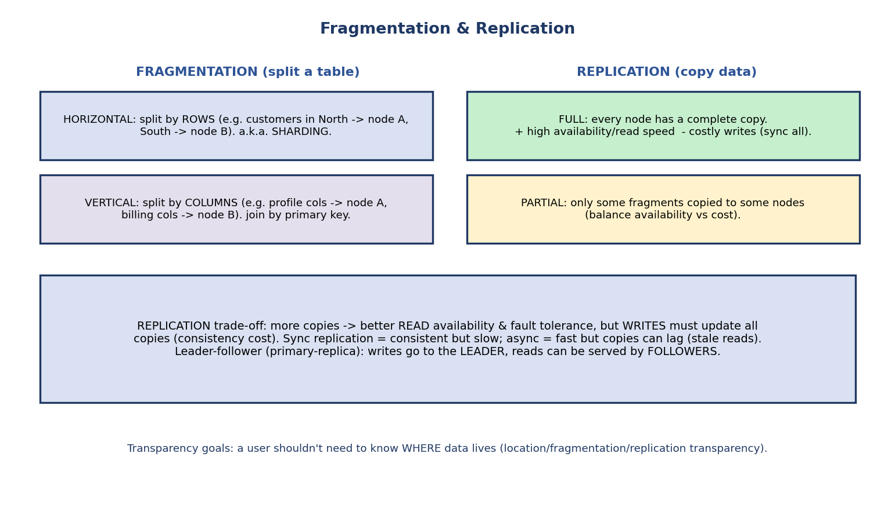
Fragmentation splits a table horizontally (by rows = sharding) or vertically (by columns); replication copies data fully or partially, trading read availability against write cost.
Fragmentation (splitting a table):
- Horizontal: split by rows (e.g. North-region customers → node A, South → node B). This is sharding.
- Vertical: split by columns (e.g. profile columns → node A, billing columns → node B); rejoin by primary key.
Replication (copying data):
- Full: every node holds a complete copy — great read availability, but writes must update all copies.
- Partial: only some fragments are copied to some nodes.
The replication trade-off: more copies → better read availability and fault tolerance, but every write must propagate to all copies. Synchronous replication is consistent but slow; asynchronous is fast but copies can lag (stale reads). A common pattern is leader–follower (primary–replica): writes go to the leader, reads can be served by followers.
Transparency goals: users shouldn’t need to know where data physically lives — location, fragmentation, and replication transparency.

11.3 The CAP Theorem
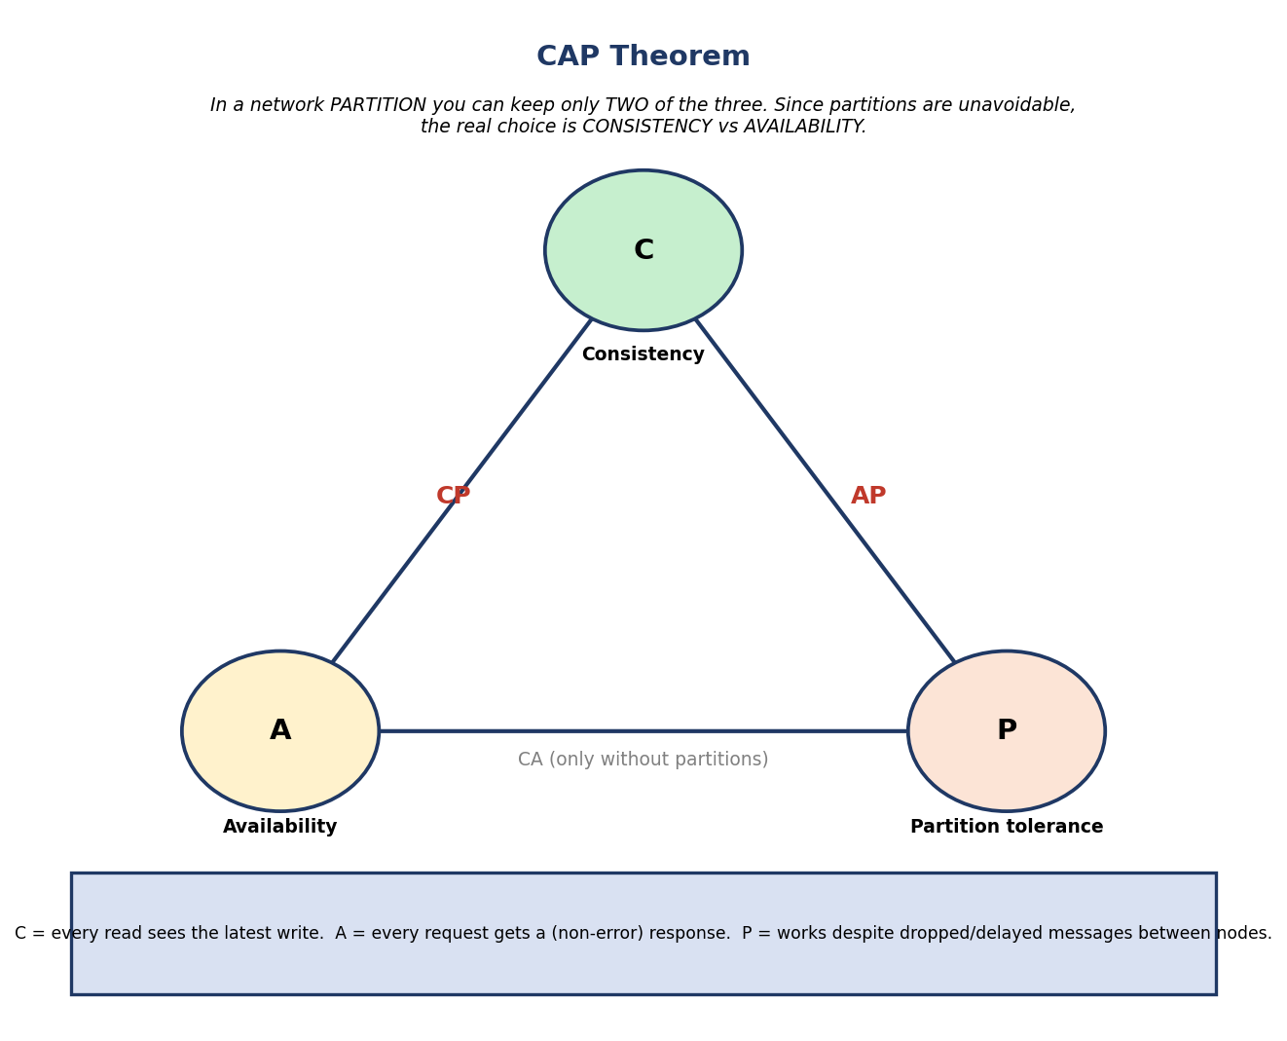
CAP theorem triangle: Consistency, Availability, Partition tolerance — during a network partition you can keep only two, so the real choice is CP vs AP (CA only exists without partitions).
In a distributed system you can guarantee at most two of:
- Consistency (C): every read sees the latest write (or an error).
- Availability (A): every request gets a non-error response (not necessarily the latest data).
- Partition tolerance (P): the system keeps working despite dropped/delayed messages between nodes.
The real-world reading (crucial): network partitions are unavoidable in a distributed system, so P is mandatory. That means during a partition you must choose between C and A: - CP (consistency over availability): refuse/block requests it can’t answer consistently. e.g. HBase, MongoDB (default), traditional distributed RDBMS. - AP (availability over consistency): always respond, possibly with stale data. e.g. Cassandra, DynamoDB, CouchDB. - CA exists only without partitions — i.e. a single-node system.
Caveat (so you don’t over-apply it): CAP is about behaviour only during a partition. When the network is healthy, a system can offer both C and A — which is what PACELC captures next.

11.4 ACID vs BASE (and PACELC)
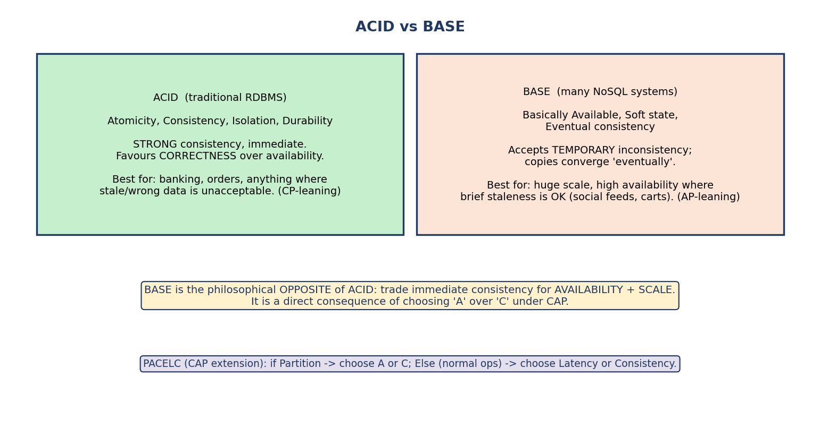
ACID (strong consistency, correctness-first, CP-leaning) versus BASE (basically available, soft state, eventual consistency, availability-first, AP-leaning); PACELC extends CAP to the no-partition case.
 | ACID (relational) | BASE (many NoSQL)
Stands for | Atomicity, Consistency, Isolation, Durability | Basically Available, Soft state, Eventual consistency
Consistency | strong, immediate | eventual (copies converge later)
Priority | correctness | availability + scale
Best for | banking, orders (stale = unacceptable) | feeds, carts (brief staleness OK)
CAP leaning | CP | AP
BASE is the philosophical opposite of ACID: it deliberately accepts temporary inconsistency so the system stays available and scalable — a direct consequence of choosing A over C under CAP. “Eventual consistency” means: if writes stop, all replicas eventually converge to the same value.
PACELC (the CAP extension, exam bonus): if there is a Partition, choose A or C; Else (normal operation), choose Latency or Consistency. It captures that even without partitions there’s a latency vs consistency trade-off (waiting to sync all replicas costs latency).

11.5 Consistency Models
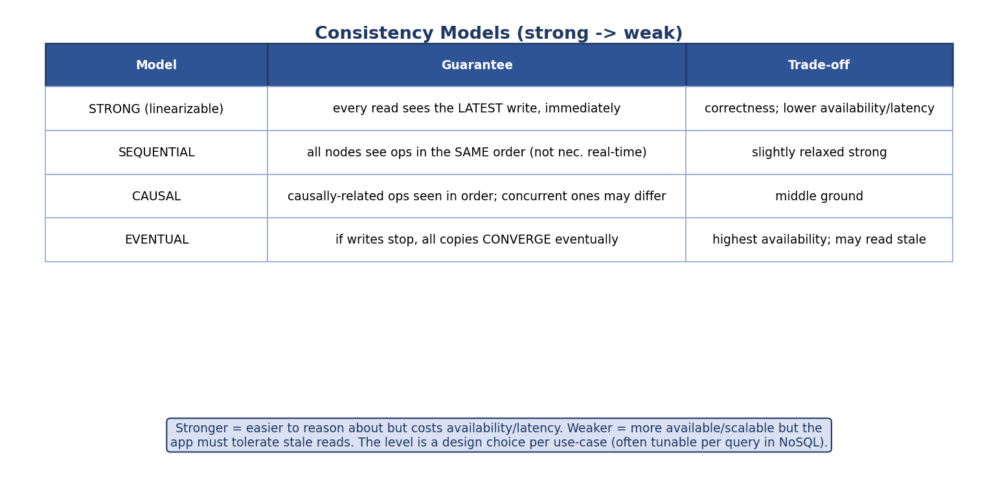
Consistency models from strong (linearizable — every read sees the latest write) through sequential and causal to eventual (replicas converge eventually), trading correctness for availability/latency.
Model | Guarantee | Trade-off
Strong (linearizable) | every read sees the latest write, immediately | correctness; lower availability, higher latency
Sequential | all nodes see ops in one global order consistent with each process’s program order, but not necessarily real-time order | drops the real-time recency guarantee that linearizability adds
Causal | causally-related ops seen in order; concurrent ones may differ | middle ground
Eventual | if writes stop, all copies converge | highest availability; may read stale
The spectrum: stronger = easier to reason about but costs availability and latency; weaker = more available/scalable but the application must tolerate stale reads. Many NoSQL stores make this tunable per query (e.g. Cassandra’s ONE / QUORUM / ALL read/write levels).
Session (client-centric) guarantees soften “eventual” for a single user: read-your-writes (you always see your own writes), monotonic reads (you never go backwards in time), monotonic writes (your writes apply in order), and consistent prefix (you see writes in a causally sensible order). These explain UX like “I posted a comment and I can see it, even if others don’t yet.”
The quorum rule (R + W > N) — how tunable consistency actually works: with N replicas, a write waits for W acknowledgements and a read queries R replicas. If R + W > N, the read set is guaranteed to overlap the latest write set → the read sees the most recent value (strong consistency on the replica set); if W > N/2, two concurrent writes can’t both succeed. Example: N=3, W=2, R=2 → R+W = 4 > 3 → strongly consistent yet tolerates one node down. Lowering R/W (e.g. ONE) trades consistency for lower latency / higher availability. This formula is Cassandra/Dynamo’s ONE/QUORUM/ALL.

11.6 The NoSQL Families
NoSQL = “Not Only SQL”: schema-flexible, horizontally-scalable stores for data and scale that don’t fit rigid relational tables. Four families:
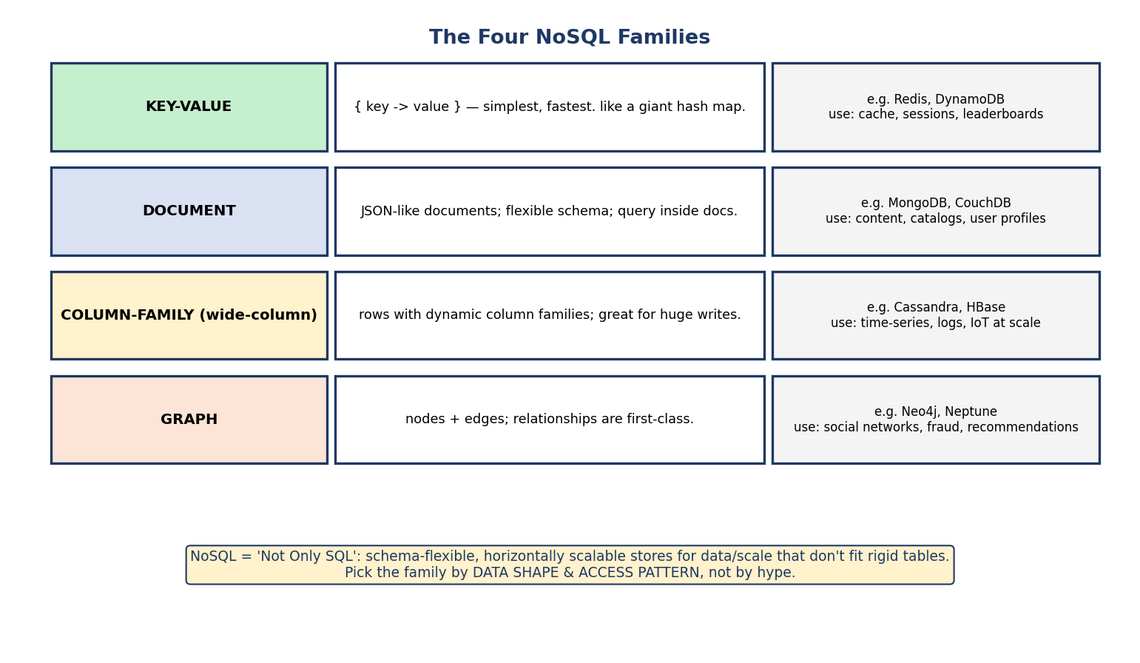
The four NoSQL families: key-value (Redis/DynamoDB), document (MongoDB/CouchDB), column-family (Cassandra/HBase), and graph (Neo4j/Neptune), each with typical use-cases.
Family | Model | Examples | Best for
Key-value | {key → value}, a giant hash map | Redis, DynamoDB | cache, sessions, leaderboards
Document | JSON-like documents, flexible schema | MongoDB, CouchDB | content, catalogs, profiles
Column-family (wide-column) | rows with dynamic column families | Cassandra, HBase | time-series, logs, IoT at scale
Graph | nodes + edges; relationships first-class | Neo4j, Neptune | social, fraud, recommendations
How to choose: by data shape and access pattern, not hype. Lots of simple lookups → key-value. Nested, varied records → document. Enormous write throughput / time-series → column-family. Richly connected data with relationship traversals → graph.

11.7 Partitioning / Sharding Strategies
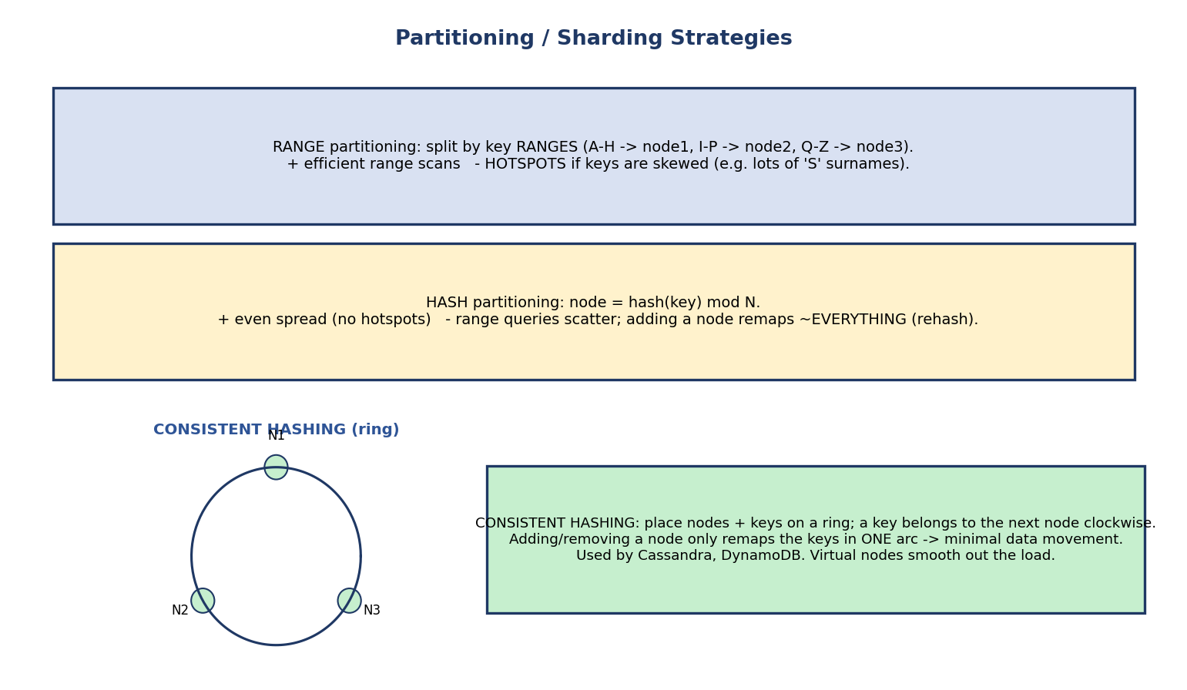
Sharding strategies: range partitioning (by key ranges, good for scans but risks hotspots), hash partitioning (even spread but scatters range queries and rehashes on resize), and consistent hashing (a ring that minimizes data movement when nodes change).
How do we decide which node stores a given key?
- Range partitioning: split by key ranges (A–H → node 1, …). + efficient range scans; − hotspots if keys are skewed.
- Hash partitioning: node = hash(key) mod N. + even spread (no hotspots); − range queries scatter, and adding a node forces remapping ~everything (full rehash).
- Consistent hashing: place nodes and keys on a ring; a key belongs to the next node clockwise. Adding/removing a node only remaps keys in one arc → minimal data movement. Used by Cassandra (and Amazon’s original Dynamo design); virtual nodes smooth out load.
Why consistent hashing matters: plain hash partitioning re-shuffles almost the whole dataset when the cluster grows. Consistent hashing moves only ~1/N of the keys — the property that makes elastic scaling practical.

11.8 Distributed Transactions — Two-Phase Commit (2PC)
When one transaction spans multiple nodes, how do we keep it atomic (all commit or all abort)? The two-phase commit protocol.
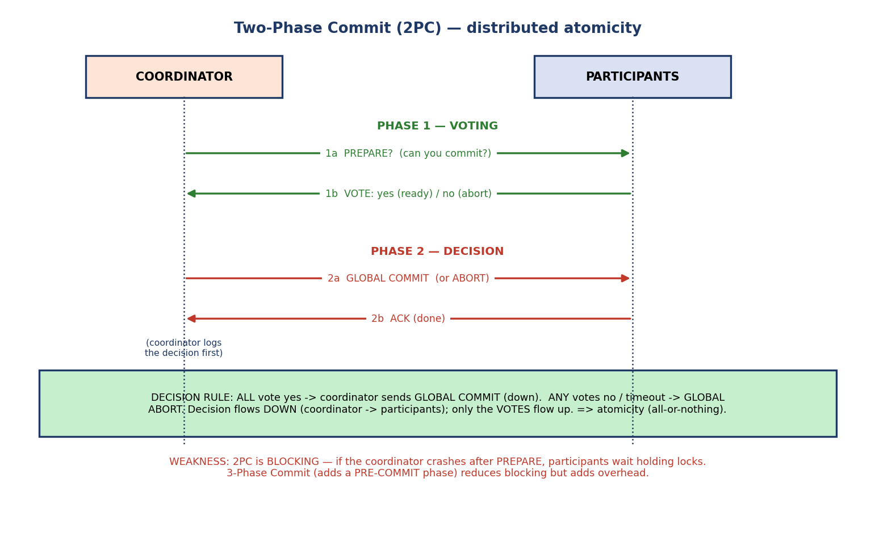
Two-phase commit sequence: Phase 1 (voting) — coordinator sends PREPARE, participants reply with a vote; Phase 2 (decision) — coordinator broadcasts global commit/abort, participants acknowledge.
- Phase 1 — Voting: the coordinator sends PREPARE to all participants; each writes to its log and replies VOTE-COMMIT (ready) or VOTE-ABORT.
- Phase 2 — Decision: if all voted commit, the coordinator broadcasts GLOBAL COMMIT; if any voted abort (or timed out), GLOBAL ABORT. Participants apply the decision and acknowledge.
Direction matters (exam): votes flow up (participants → coordinator); the decision flows down (coordinator → participants). The decision rule — all-yes ⇒ commit, otherwise abort — guarantees atomicity across nodes.
The weakness — 2PC blocks: if the coordinator crashes after PREPARE, participants are stuck holding locks, waiting for a decision that may never come. Three-Phase Commit (3PC) inserts a pre-commit phase to reduce blocking, at the cost of extra messages. Modern systems often use consensus protocols (Paxos/Raft) for fault-tolerant agreement.

11.9 SQL vs NoSQL & Modern (NewSQL)
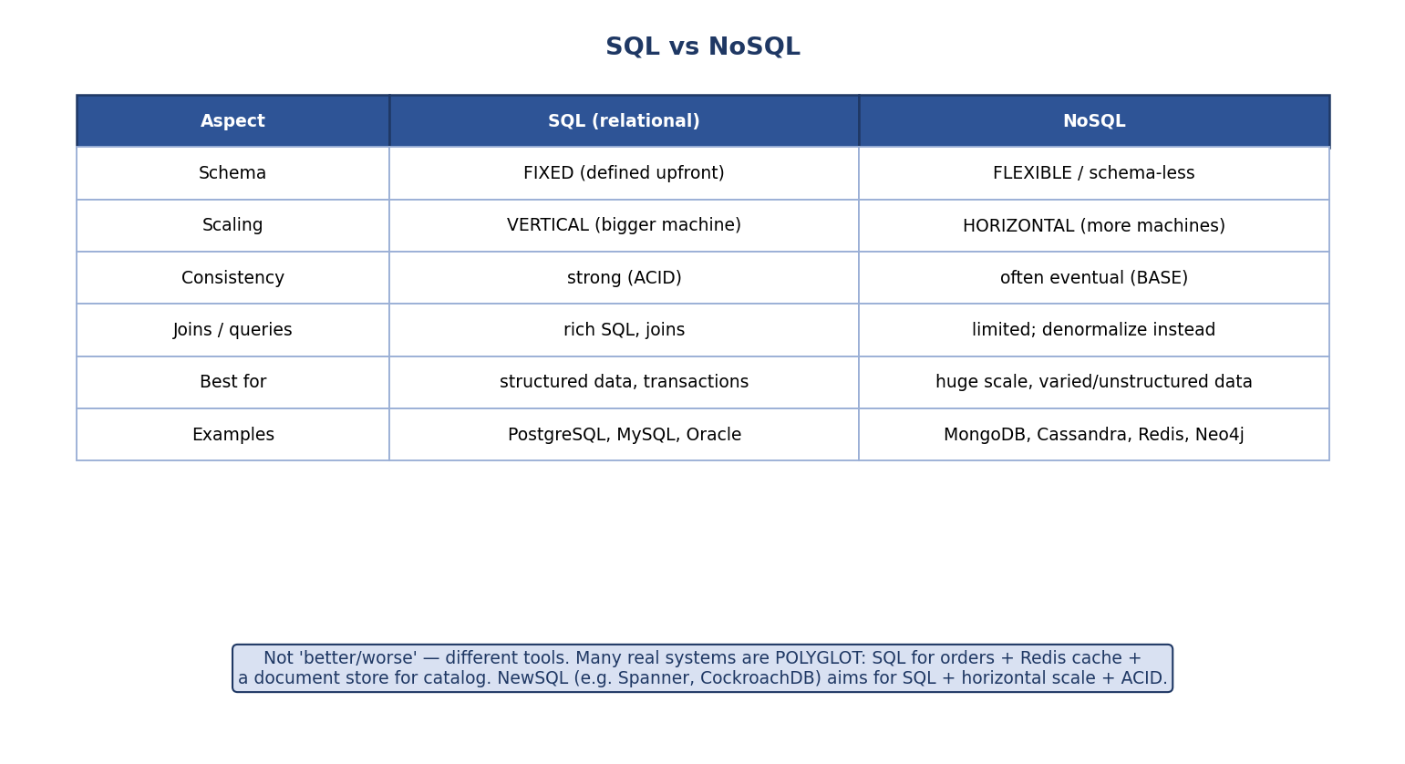
SQL vs NoSQL comparison across schema, scaling, consistency, queries, best-fit, and examples; modern systems are often polyglot, and NewSQL aims for SQL plus horizontal scale plus ACID.
Aspect | SQL (relational) | NoSQL
Schema | fixed (upfront) | flexible / schema-less
Scaling | vertical (bigger machine) | horizontal (more machines)
Consistency | strong (ACID) | often eventual (BASE)
Queries / joins | rich SQL, joins | limited; denormalize instead
Best for | structured data, transactions | huge scale, varied/unstructured data
Examples | PostgreSQL, MySQL, Oracle | MongoDB, Cassandra, Redis, Neo4j
Not “better/worse” — different tools. Real systems are often polyglot: a relational DB for orders, Redis for caching, a document store for the catalog. NewSQL (e.g. Google Spanner, CockroachDB) aims to give SQL + horizontal scale + ACID together — closing the historical gap.

Choosing a database
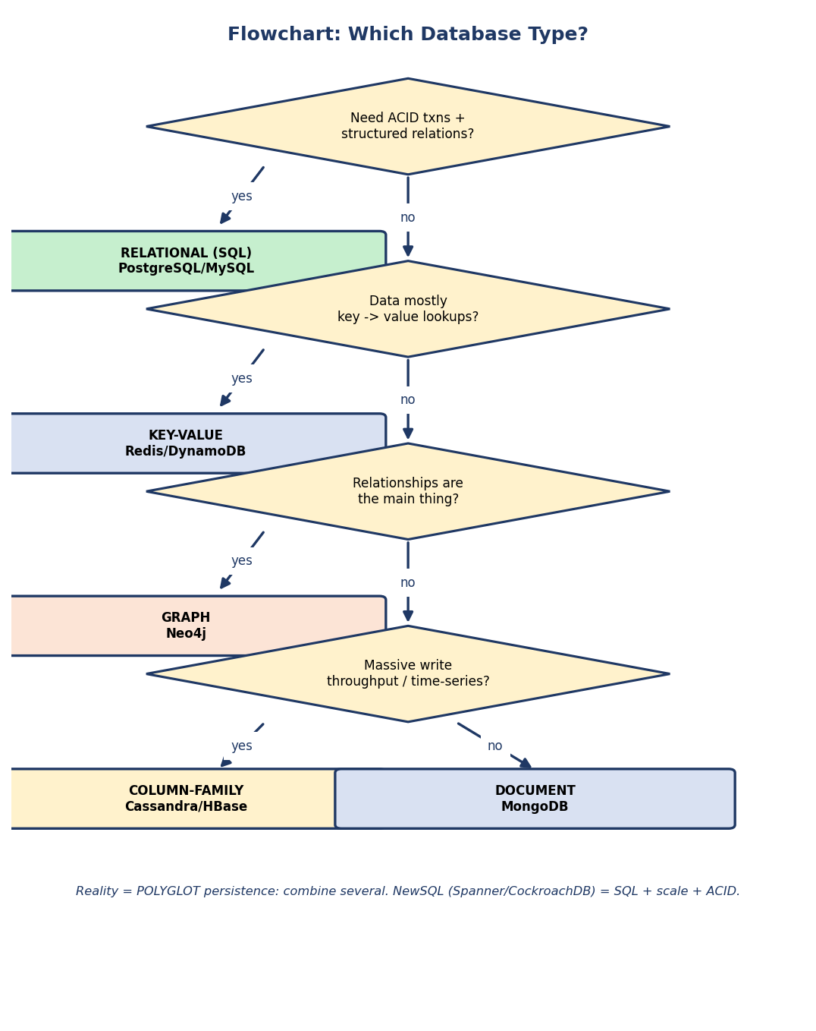
Flowchart: need ACID + relations → SQL; key→value lookups → key-value; relationships central → graph; massive writes/time-series → column-family; otherwise → document. Reality is polyglot; NewSQL combines SQL, scale, and ACID.
- ACID + structured relations → relational (SQL).
- Simple key → value lookups → key-value.
- Relationships are the point → graph.
- Massive write throughput / time-series → column-family.
- Nested, flexible records → document.

11.10 Real-World & Backend Perspectives
- Sharding in practice: MongoDB shard keys, Cassandra’s partition key + ring, Vitess for MySQL. A bad shard key (low cardinality / monotonic) creates hotspots.
- Eventual consistency you’ve used: a social post that takes a moment to appear for all friends; a shopping cart that briefly differs across devices.
- Read replicas scale reads; leader election (Raft) handles failover.
- Distributed transactions are expensive — microservices often avoid 2PC using the Saga pattern (a sequence of local transactions + compensating actions).
- CAP in product decisions: payment systems lean CP (never double-spend); shopping/social lean AP (stay up, reconcile later).

11.11 Tradeoffs, Common Mistakes, Edge Cases
Common mistakes (exam + real life) - Saying you “give up P” — in a distributed system P is mandatory; the choice is C vs A. - Reading CAP as “always pick 2 of 3” — the trade-off only bites during a partition (see PACELC). - Thinking NoSQL = no transactions/no schema ever (many now offer both). - Confusing horizontal (rows / sharding) with vertical (columns) fragmentation. - Forgetting 2PC blocks if the coordinator fails. - Believing eventual consistency means “inconsistent forever” (it converges).
Edge cases - A network partition with an AP store → two sides accept conflicting writes → need conflict resolution (last-write-wins, vector clocks, CRDTs). - Hash sharding makes range queries hit every node. - Cross-shard joins/transactions are slow → design to keep related data co-located.
Tradeoffs
Choice | Gain | Cost
Replication | availability, read scale | write cost, consistency lag
AP (eventual) | always available | stale reads, conflict handling
CP (strong) | correctness | may reject requests in a partition
Sharding | horizontal scale | cross-shard ops expensive
2PC | cross-node atomicity | blocking, latency

11.12 Exam, Interview & Coding Perspectives
Exam (SEBI/RBI/GATE): CAP (pick 2, CP vs AP, P mandatory); ACID vs BASE; SQL vs NoSQL; the four NoSQL families + examples; horizontal vs vertical fragmentation; replication trade-offs; sharding (range/hash/consistent hashing); 2PC phases & blocking.
Interview: “Explain CAP and where you’d land for a payment system”; “SQL vs NoSQL — when each?”; “What is eventual consistency?”; “How does consistent hashing help scaling?”; “Why is 2PC problematic, and what alternatives exist (Saga, Raft)?”.
Coding/practical: - Set up a MongoDB replica set or sharded cluster; observe failover and read preferences. - Use Redis as a cache in front of a SQL DB (polyglot); measure latency improvement. - Reason about a shard key choice and show a hotspot vs an even distribution.

11.13 Concept Checks & MCQs
- CAP stands for? → Consistency, Availability, Partition tolerance.
- In a distributed system, which CAP property is effectively mandatory? → Partition tolerance.
- During a partition, the real choice is between ___ and ___ → consistency and availability.
- Cassandra/DynamoDB lean toward ___ → AP. MongoDB(default)/HBase → CP.
- BASE stands for? → Basically Available, Soft state, Eventual consistency.
- ACID leans toward which CAP pair? → CP.
- Horizontal fragmentation splits by ; vertical by → rows / columns.
- Sharding = which fragmentation? → horizontal.
- Which sharding minimizes data movement when adding a node? → consistent hashing.
- Hash partitioning’s weakness? → range queries scatter; rehash on resize.
- The four NoSQL families? → key-value, document, column-family, graph.
- 2PC phases? → voting (prepare) and decision (commit/abort).
- 2PC’s main weakness? → blocking if the coordinator crashes.
- NewSQL aims to combine ___ → SQL + horizontal scale + ACID.
- Eventual consistency means copies ___ → converge eventually.
- Quorum rule for a read to see the latest write? → R + W > N.
- With N=3, which (W,R) is strongly consistent yet tolerates one node down? → W=2, R=2 (R+W=4>3).
- “You always see your own writes” is which guarantee? → read-your-writes.
True/False - In CAP you can have all three at once in a distributed system. → False. - BASE provides strong, immediate consistency. → False (eventual). - A graph database is best for key-value caching. → False (use key-value). - Consistent hashing remaps the whole dataset when a node is added. → False (only ~1/N).
Scenario (do it): > “Design storage for an e-commerce site.” → orders/payments: relational > (ACID/CP); product catalog: document (MongoDB); session/cart cache: > key-value (Redis); recommendations: graph (Neo4j). This is polyglot > persistence. ✔

11.14 One-Page Revision Sheet
WHY DISTRIBUTE: scale beyond one node, fault tolerance, low latency. tools = PARTITIONING + REPLICATION.
FRAGMENTATION: horizontal = by ROWS (=sharding); vertical = by COLUMNS (rejoin on PK).
REPLICATION: full/partial; sync (consistent, slow) vs async (fast, stale). leader-follower: write leader, read followers.
CAP THEOREM: pick 2 of {Consistency, Availability, Partition-tolerance}. P is MANDATORY (network fails) ->
during a partition choose C or A: CP (HBase, Mongo default) vs AP (Cassandra, DynamoDB). CA = single node only.
PACELC: if Partition -> A or C ; Else -> Latency or Consistency.
ACID (RDBMS, CP, strong) <-> BASE (NoSQL, AP): Basically Available, Soft state, Eventual consistency.
eventual consistency = if writes stop, replicas CONVERGE.
CONSISTENCY MODELS (strong->weak): STRONG/linearizable > SEQUENTIAL > CAUSAL > EVENTUAL. (often tunable per query)
NoSQL FAMILIES:
KEY-VALUE (Redis, DynamoDB) : hash map; cache/sessions.
DOCUMENT (MongoDB, CouchDB) : JSON docs; catalogs/profiles.
COLUMN-FAMILY (Cassandra, HBase) : wide rows; time-series/logs at scale.
GRAPH (Neo4j, Neptune) : nodes+edges; social/fraud/recommend.
SHARDING: RANGE (scan-friendly, hotspots) | HASH (even, but scatter + rehash) |
CONSISTENT HASHING (ring; add/remove node moves only ~1/N keys; Cassandra + Amazon Dynamo design; virtual nodes).
QUORUM: N replicas, read R + write W. R+W>N -> read sees latest write (strong); W>N/2 -> no conflicting writes.
e.g. N=3,W=2,R=2 (R+W=4>3) = strong + tolerate 1 node down. lower R/W (ONE) = faster/more available, weaker.
SESSION guarantees: read-your-writes, monotonic reads, monotonic writes, consistent prefix.
2PC (distributed atomicity): PHASE1 voting (coordinator PREPARE-> ; participants VOTE up) ;
PHASE2 decision (ALL yes -> GLOBAL COMMIT down ; any no/timeout -> ABORT). votes UP, decision DOWN.
WEAKNESS = BLOCKING if coordinator crashes. 3PC adds pre-commit. alt: Saga, Paxos/Raft.
SQL vs NoSQL: fixed vs flexible schema; vertical vs horizontal scale; strong vs eventual; joins vs denormalize.
POLYGLOT persistence = use several. NewSQL (Spanner, CockroachDB) = SQL + scale + ACID.

Flash cards
Front | Back
CAP = ? | Consistency, Availability, Partition tolerance
Mandatory CAP property (distributed)? | Partition tolerance
Partition → choose between? | Consistency vs Availability
AP examples? | Cassandra, DynamoDB
CP examples? | HBase, MongoDB (default)
BASE = ? | Basically Available, Soft state, Eventual consistency
ACID CAP leaning? | CP
Horizontal fragmentation? | By rows (sharding)
Vertical fragmentation? | By columns
Minimal-movement sharding? | Consistent hashing
Four NoSQL families? | Key-value, document, column-family, graph
2PC phases? | Voting (prepare), decision (commit/abort)
2PC weakness? | Blocking on coordinator failure
NewSQL goal? | SQL + scale + ACID
Eventual consistency? | Replicas converge eventually
Quorum strong-read rule? | R + W > N
Read-your-writes is a? | Session (client-centric) guarantee

Spaced repetition
- 24-hour: draw the CAP triangle and place 5 databases as CP/AP; redo MCQs.
- 7-day: explain ACID vs BASE and the four NoSQL families with examples; sketch 2PC.
- 30-day: design polyglot storage for a given app and justify each choice; compare sharding strategies.

11.15 Summary — and the Whole Syllabus
Distributed databases trade single-machine simplicity for scale, availability, and low latency, using partitioning (horizontal/vertical fragmentation = sharding) and replication. The CAP theorem says that, because partitions are unavoidable, you must choose consistency (CP) or availability (AP) when the network splits — and ACID (strong, CP-leaning) gives way to BASE (eventually consistent, AP-leaning) at scale, with PACELC adding the latency-vs-consistency trade in normal operation. We surveyed consistency models (strong → eventual), the four NoSQL families (key-value, document, column-family, graph), sharding strategies (range / hash / consistent hashing), and two-phase commit for cross-node atomicity (and its blocking weakness). Finally, SQL vs NoSQL is a tooling choice, real systems are polyglot, and NewSQL unites SQL, scale, and ACID.
The DBMS journey, end to end: we began with the relational model and SQL (M1–M4), made schemas sound via normalization (M5), made access fast with storage, indexing, and query optimization (M6–M8), made data correct under concurrency and crashes with transactions and recovery (M9–M10), and finally scaled out to distributed and NoSQL systems (M11). Together these are the complete mental model of how a modern database stores, finds, protects, and scales data — exactly what SEBI/RBI IT, GATE, and backend interviews test.
You have mastered this module when you can: state CAP and justify a CP/AP choice for a given app; contrast ACID and BASE; name the four NoSQL families with use-cases; explain horizontal vs vertical fragmentation and the three sharding strategies; and walk through 2PC including its blocking failure — all without notes.

