Module 1 — Programming Fundamentals
  - DSA Mastery: Google / FAANG / GATE / ICPC — In-Depth Notes (with visuals)
Prepared for nidhi.sharma@forensiccybertech.com
2026
Table of Contents

Module 1 — Programming Fundamentals
Why this module comes first. Every data structure and algorithm runs on a real machine. If you do not know where data lives, how a function call works, and how we measure speed, then recursion, trees, and DP will all feel like magic later. This module removes the magic. We start from bits and build up to Big-O, so you never have to memorise anything later — you will understand it.
This module is P0 (most important). It appears directly in GATE/ISRO and indirectly in every FAANG interview — the moment you say “this is O(n)”, you are using this module.

1.1 Computer & Memory Model (where does data live?)

Definition
A computer stores everything — numbers, characters, instructions — as bits (0/1). 8 bits = 1 byte. RAM (main memory) is basically one very long 1-dimensional array of bytes, and each byte has a unique address (0, 1, 2, …).
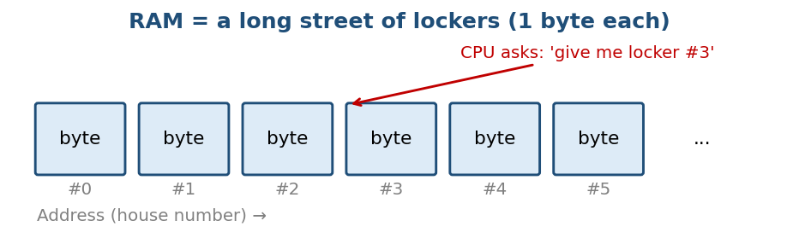
RAM is like a long street of lockers; each locker holds 1 byte and has a number (address).

Intuition (simple example)
Think of RAM as a long street of lockers. Each locker holds 1 byte and has a number (address). The CPU is a courier that does only two things:
- “Give me what is in locker #N” → read
- “Put this into locker #N” → write
Every data structure is, at heart, a clever scheme for which lockers to use and how to find them again.

Internal working — how int x = 5; is stored
When you write int x = 5;:
- The compiler reserves space for x (a 32-bit int = 4 bytes).
- It records in a table: name x → some address (say 1000).
- The value 5 is written in binary into those 4 bytes.
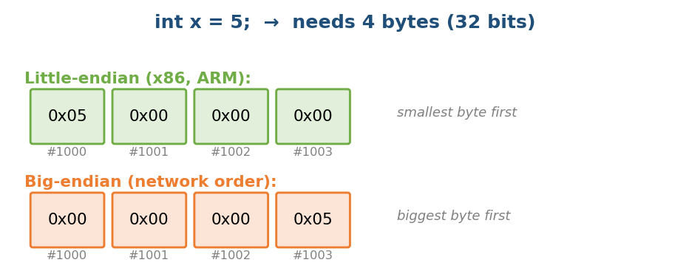
The same number 5 can be laid out in bytes two ways: little-endian and big-endian.

Endianness (an interview favourite)
The same integer 5 can be stored in its bytes in two ways:
- Little-endian (x86, ARM): smallest byte first → 05 00 00 00
- Big-endian (network / internet order): biggest byte first → 00 00 00 05
Why it matters: If a big-endian machine writes a file/packet and a little-endian machine reads it without converting, you get garbage. This is why network protocols define a fixed byte order (htonl, ntohl).

Two’s complement (how negative numbers work)
Signed integers use two’s complement: to negate a number, flip all bits and add 1.
5 = 0000 0101
-5 = 1111 1011 (flip 5's bits -> 1111 1010, then +1)
Why two’s complement? Because addition “just works” with no special cases, and there is only one representation of zero. A 32-bit int ranges from -2^31 to 2^31 - 1, i.e. -2,147,483,648 .. 2,147,483,647.
The most common bug: INT_MAX + 1 overflows and becomes INT_MIN. In competitive programming this silently breaks mid = (low + high) / 2. Fix: mid = low + (high - low) / 2.

Complexity
We treat one RAM access as O(1) (this is the “RAM model” used in CLRS and most analysis). In reality, speed depends on caches (see §1.6).

Common mistakes
- Assuming int is always 4 bytes — size is machine-dependent (use int32_t/int64_t when size matters).
- Forgetting overflow (e.g. n*n where n is an int but the product exceeds 2^31).
- Confusing an address with a value.

MCQs
- On a little-endian machine, how is 0x01020304 stored? (a) 01 02 03 04 (b) 04 03 02 01 → Answer: (b)
- Range of a signed 32-bit int? → -2^31 .. 2^31 - 1
- Why is (low+high)/2 risky? → possible integer overflow.

1.2 Stack vs Heap (the single most important memory concept)

Definition
A program’s memory is divided into segments. The two that matter most for DSA:
- Stack — the area for function calls: local variables, parameters, return address. Managed automatically (LIFO — last in, first out). It grows on a call and shrinks on return.
- Heap — the area for dynamic memory (malloc/new). Managed manually (C/C++) or by a garbage collector (Java/Python/Go). Its lifetime is controlled by you/the GC, not by scope.
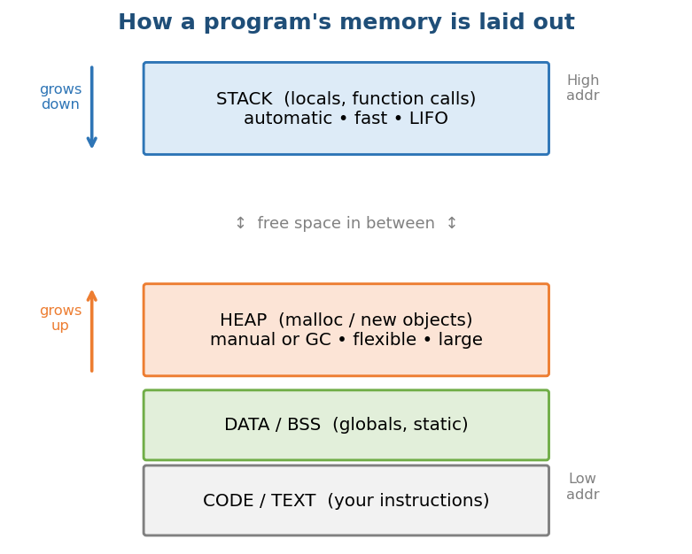
A program’s memory: Stack on top (grows down), Heap below (grows up), then globals and code.

Intuition (two simple examples)
- Stack = a pile of plates. A function call puts a plate (frame) on top. Returning removes the top plate. You can only touch the top plate. That is why it is fast (just move a pointer) and automatic.
- Heap = a big warehouse. You ask the manager (allocator) for a shelf of size N; it finds free space and gives you the address. You must return it (free/delete) — or the GC does it. Flexible, but slower and prone to leaks/fragmentation.

Why it exists
The stack is perfect when data’s lifetime matches the function call. But sometimes data must outlive the function that made it (e.g. a function that builds and returns a linked-list node), or its size is only known at runtime (e.g. an array of n elements where n comes from input). That is what the heap is for.

Comparison table
Property | Stack | Heap
Allocation | Move a pointer (1 instruction) | Find free space (allocator logic)
Speed | Very fast, cache-hot | Slower; may need a syscall
Lifetime | Automatic (scope/LIFO) | Manual (free) or GC
Size | Small (~1–8 MB) | Large (most of RAM)
Fragmentation | None | Possible
Threads | Each thread has its own stack | Shared across threads (needs locks)
Common error | Stack overflow (deep recursion) | Memory leak, dangling pointer

Dry run
int* make() {
int local = 10; // on the STACK (inside make())
int* p = malloc(4); // 4 bytes on the HEAP
*p = 99;
return p; // 'local' dies here; the heap block survives
} // returning &local would be a BUG (dangling pointer)
When make() returns, its stack frame (holding local and the pointer p) is destroyed. But the heap block that *p points to still exists — that is why returning p is fine, while returning &local is undefined behaviour.

Production usage
- C/C++: prefer the stack/RAII; use the heap (new, smart pointers) only when needed.
- Java/Python/Go: objects live on the heap; locals/primitives on the stack; a GC reclaims unreachable objects.
- Embedded/real-time: the heap is often banned (unpredictable timing + fragmentation) → everything is pre-allocated.

Common mistakes
- Dangling pointer: returning the address of a local.
- Memory leak: malloc with no matching free.
- Double free / use-after-free: classic security bugs (CWE-416/415).
- Stack overflow: unbounded / too-deep recursion.

Interview perspective
“Where does int a[1000000] live, and why might it crash?” — On the stack; 4 MB can exceed the default stack limit → segfault. Fix: allocate on the heap, or make it static/global. Google/Meta ask this to check that you know where memory comes from.

MCQs
- Recursion with no base case usually causes? → stack overflow
- Which memory must be freed manually in C? → heap
- Each thread gets its own ___? → stack (the heap is shared)

1.3 Variables, Functions & Pointers/References

What is a variable?
A variable is a named, typed box in memory. The type tells the compiler two things: (a) how many bytes, and (b) how to interpret those bytes (e.g. float and int are both 4 bytes but mean different things).

Pass by value vs pass by reference
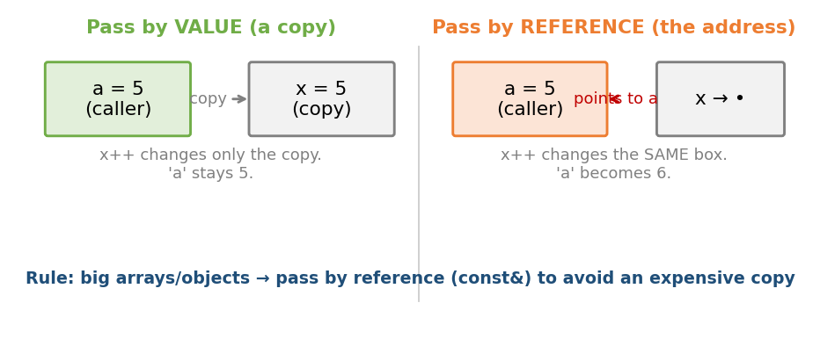
Pass by value makes a copy (caller unchanged); pass by reference passes the address of the same box (caller changes).
void inc_val(int x) { x++; } // a copy; caller is unaffected
void inc_ref(int* x){ (*x)++; } // a pointer; caller's variable changes
int a = 5;
inc_val(a); // a is still 5
inc_ref(&a); // a is now 6
Mechanism | What is passed | Cost | Caller changes?
By value | A copy of the data | O(data size) | No
By reference/ptr | The address (one word) | O(1) | Yes
Why this matters in DSA: Passing a large vector/array by value copies all n elements → an accidental O(n) per call, which can turn an O(n) algorithm into O(n²). In C++, pass big objects by const&. This is a real interview performance bug.

MCQs
- Passing a std::vector<int> by value n times in a loop? → a hidden O(n) copy each call.
- To change the caller’s variable in C, you pass? → its address (pointer).

1.4 Recursion (the heart of DSA)

Definition
Recursion is when a function solves a problem by calling itself on a smaller input, until it reaches a base case (the smallest input, solved directly).
Two required ingredients:
- Base case — the smallest input, solved without recursion (this stops the recursion).
- Recursive case — shrinks the problem toward the base case and combines the sub-results.

Intuition
Many structures are self-similar: a tree’s subtree is a tree; a list’s tail is a list; n! = n × (n−1)!. Recursion lets the code shape match the problem shape — short and clearly correct.
Mantra: “Assume the recursive call already works correctly for the smaller input” (the recursive leap of faith / induction). Then you only need to handle (a) the base case and (b) combining one level correctly.
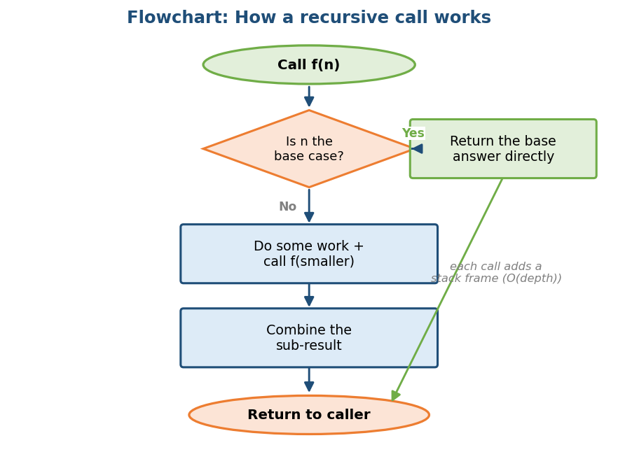
Flowchart: every recursive call first checks the base case; if not, it does work, calls itself on a smaller input, combines, and returns.

Internal working — the call stack & stack frames
Every function call pushes a stack frame (activation record) containing the parameters, local variables, the return address (where to continue in the caller), and saved registers. On return, the frame is popped. So recursion uses O(depth) stack memory — even if it returns a single number.
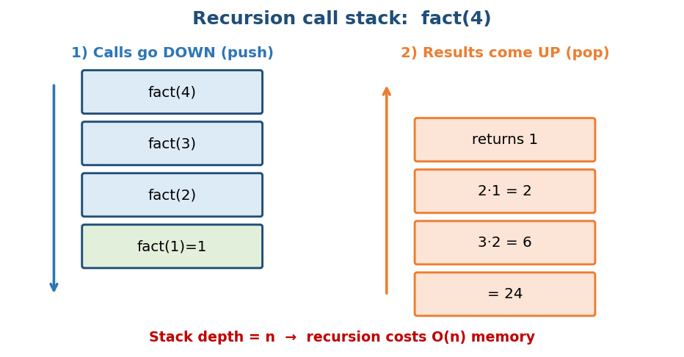
Factorial fact(4): calls go down (push), then results come up (pop). Depth = n.

Dry run — factorial
int fact(int n) {
if (n <= 1) return 1; // base case
return n * fact(n - 1); // recursive case
}
fact(4) is linear recursion → the recursion tree is a single chain of depth n. First the calls go 4→3→2→1 (push), then the results come back 1 → 2 → 6 → 24 (pop).

Branching recursion — naive Fibonacci
int fib(int n){ return n < 2 ? n : fib(n-1) + fib(n-2); }
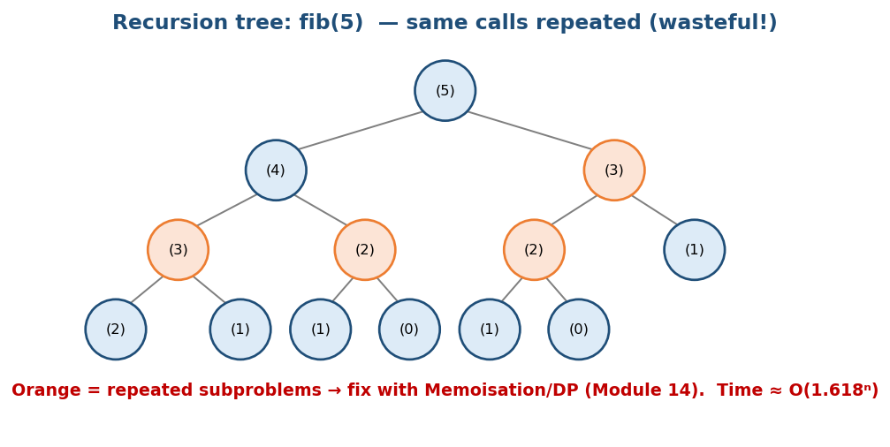
fib(5) tree: the orange nodes are calls that repeat — this wasted work is what DP fixes.
This tree has about 2^n nodes → O(φ^n) time (φ ≈ 1.618). But at any moment the stack depth is only O(n). Notice the same subproblems (fib(3), fib(2)…) are computed again and again — this is exactly what motivates Dynamic Programming (Module 14).

Brute force → Optimal (Fibonacci)
# BRUTE FORCE: plain recursion Time O(φ^n), Space O(n) stack
fib(n):
if n < 2: return n
return fib(n-1) + fib(n-2)
# BETTER: memoisation (top-down DP) Time O(n), Space O(n)
memo = {}
fib(n):
if n < 2: return n
if n in memo: return memo[n]
memo[n] = fib(n-1) + fib(n-2)
return memo[n]
# OPTIMAL: iterative, two variables Time O(n), Space O(1)
fib(n):
a, b = 0, 1
repeat n times:
a, b = b, a + b
return a
Why each step helps: memoisation removes the repeated subtrees (orange nodes); the iterative version also drops the recursion stack down to two variables.

Complexity (from the recurrence)
- fact: T(n) = T(n−1) + O(1) → O(n) time, O(n) stack
- fib: T(n) = T(n−1) + T(n−2) + O(1) → O(φ^n) time
- Halving recursion: T(n) = 2T(n/2) + O(n) → O(n log n) (merge sort) — solved by the Master Theorem (Modules 12/18).

Stack overflow
- Each frame costs some bytes; depth d → O(d) stack memory.
- The default stack is about 1 MB (Windows) / 8 MB (Linux). Recursing ~10⁵–10⁶ deep can overflow → crash. In CP, deep DFS on a 10⁶-node graph may need an explicit stack or a larger stack limit.

Tail recursion & converting to iteration
A call is tail-recursive if the recursive call is the last operation (nothing pending after it returns).
int fact_tail(int n, int acc) { // tail recursive
if (n <= 1) return acc;
return fact_tail(n - 1, n * acc); // nothing happens after this call
}
Some compilers do tail-call optimisation (TCO) (reuse the same frame → O(1) stack). C/C++ may (with -O2); Python and Java do not. Any recursion can be turned into iteration with an explicit stack — a key interview skill (iterative tree traversal, iterative DFS).

Common mistakes
- Wrong/missing base case → infinite recursion → overflow.
- Base case never reached (recurse on n but never decrease it).
- Recomputation (Fibonacci) — fix with memoisation.
- Changing shared state without restoring it (a backtracking bug — Module 13).

Production usage
Parsers, tree/graph traversal, divide-and-conquer (sort, FFT), file-system walks, JSON traversal. In production, depth is bounded or converted to iteration so adversarial input cannot crash it.

Interview / CP / Exam perspective
- Google/Meta: “Write it recursively, then convert to iterative.” Follow-up: stack depth and overflow.
- Amazon: clean base case + a complexity statement is a scored signal.
- GATE/ISRO: solve the recurrence; count the calls; find the stack depth.
- CP: iterative DFS / stack-size tricks; memoise to turn exponential into polynomial.

MCQs
- Naive fib(n) time? → O(φ^n) (exponential)
- Max stack depth of fact(n)? → O(n)
- Which language commonly does NOT optimise tail calls? → Python
- Missing base case → ? → stack overflow

Coding exercises (Easy → Hard)
- Easy: sum of first n natural numbers; reverse a string recursively; power x^n.
- Medium: Tower of Hanoi; generate all subsets; flatten a nested list.
- Hard: convert recursive DFS to iterative with an explicit stack; fib/grid-paths with memoisation; mutual recursion (is-even/is-odd).

1.5 Asymptotic Analysis — Big-O, Big-Θ, Big-Ω

Why it exists
We need to compare algorithms independent of hardware, language, and the input’s actual values — looking only at how cost grows with input size n. This notation answers: “As n gets large, how fast does the cost grow?”
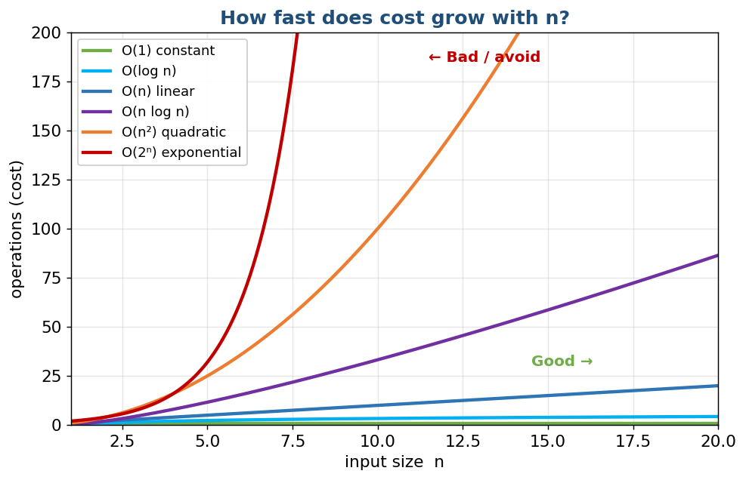
Different growth rates: O(1) and O(log n) stay flat; O(n²) and O(2ⁿ) shoot up fast.

Definitions (precise, GATE-level)
Let f(n) be the actual cost and g(n) a reference function:
- Big-O (upper bound): f(n) = O(g(n)) if constants c>0, n₀ exist so that 0 ≤ f(n) ≤ c·g(n) for all n ≥ n₀. “f grows no faster than g.”
- Big-Ω (lower bound): c·g(n) ≤ f(n). “f grows at least as fast as g.”
- Big-Θ (tight): f = O(g) and f = Ω(g). “f grows exactly like g.”
- little-o: strictly slower (lim f/g = 0).

Intuition — “drop constants and lower-order terms”
3n² + 5n + 100 is really Θ(n²): for large n, the n² term dominates; constants (3) and lower terms (5n, 100) are noise. Big-O cares about the shape of growth, not the exact count.
Subtle (for GATE): “worst case” and “Big-O” are different ideas. You can give the Big-O of the best case too. In casual interview talk, “O” means “tight worst case”, but remember the distinction.

The growth ladder (memorise this)
Notation | Name | n=10 | n=1000 | Example
O(1) | constant | 1 | 1 | array index, hashmap get
O(log n) | logarithmic | ~3 | ~10 | binary search
O(n) | linear | 10 | 1000 | single loop
O(n log n) | linearithmic | ~33 | ~10⁴ | merge sort, good sorts
O(n²) | quadratic | 100 | 10⁶ | nested loops, bubble sort
O(n³) | cubic | 1000 | 10⁹ | Floyd-Warshall, naive matmul
O(2ⁿ) | exponential | 1024 | huge | subsets, naive fib
O(n!) | factorial | 3.6M | huge | permutations, brute TSP
Order: 1 < log n < √n < n < n log n < n² < n³ < 2ⁿ < n!

Logarithm refresher (why log n keeps appearing)
A logarithm answers: “how many times do I divide n by 2 before I reach 1?” — that count is log₂ n. So anything that halves the problem each step is O(log n) (binary search, balanced trees, heap height).
Memory hook: log₂(1,000,000) ≈ 20. A million items → only ~20 steps to binary-search. That is why log n is almost as good as constant time.
Useful rules (handy for GATE):
- log(a·b) = log a + log b, log(a/b) = log a − log b, log(aᵏ) = k·log a
- Base doesn’t matter for Big-O: log₂ n and log₁₀ n differ by a constant, so both are just O(log n).
- 2^(log₂ n) = n. A tree of height h has up to 2^h nodes → n nodes ⇒ height log₂ n.

Proof example
Claim: 3n² + 5n + 100 = O(n²). Proof: take c = 5, n₀ = 10. For n ≥ 10: 5n ≤ n² and 100 ≤ n², so 3n² + 5n + 100 ≤ 3n² + n² + n² = 5n². Hence O(n²). (Also = Ω(n²), so Θ(n²).) ∎

Recipe to analyse code
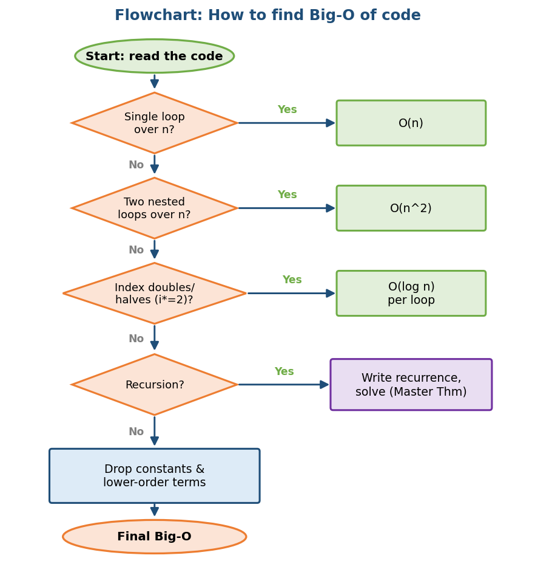
Flowchart: a quick decision tree to read off the Big-O of a piece of code.
- Sequential statements → add: O(a) + O(b) = O(max(a,b))
- A loop → multiply by the iteration count
- Nested loops → multiply the nesting
- Recursion → write a recurrence, then solve it
- Keep the dominant term; drop constants
// O(n^2): outer n times, inner n times
for (int i = 0; i < n; i++)
for (int j = 0; j < n; j++)
work();
// i doubles each step => log n iterations => O(log n)
for (int i = 1; i < n; i *= 2) work();
Space complexity — same recipe. Count the extra memory you allocate as a function of n (do not count the input itself unless asked). Recursion’s stack counts: a recursion of depth d uses O(d) space even if it returns one number. Example: building a hashset of all elements = O(n) space; an in-place two-pointer scan = O(1) space.

Recurrences & the Master Theorem (for divide-and-conquer)
When a function splits its input, its running time is a recurrence like T(n) = a·T(n/b) + f(n) — a sub-calls, each on size n/b, plus f(n) work to split/combine. The Master Theorem reads off the answer by comparing f(n) with n^(log_b a):
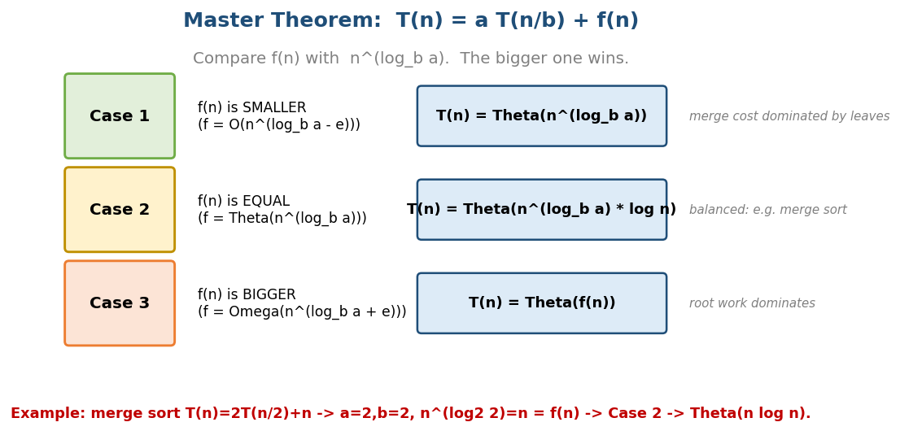
Master Theorem: compare f(n) with n^(log_b a); the three cases give the final bound.
The most useful case is merge sort: T(n) = 2T(n/2) + n. Here each level of the recursion tree costs n, and there are log n levels → O(n log n):
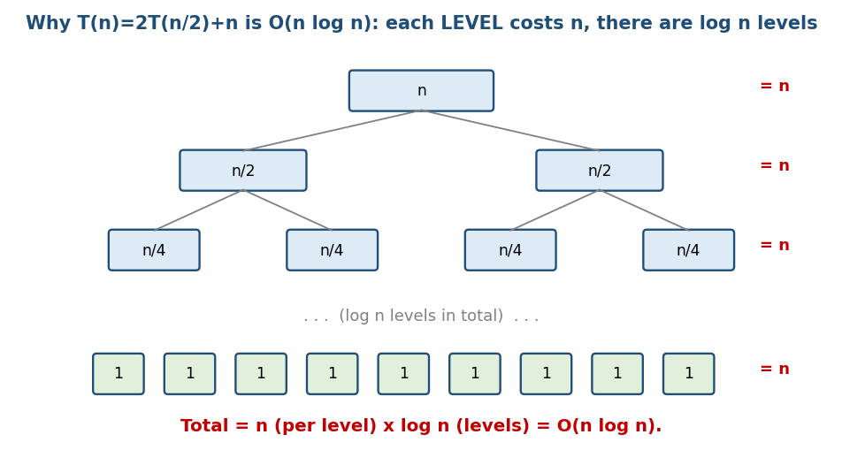
Merge-sort recurrence tree: each level totals n, and there are log n levels, so the total is n log n.
Memory hook: “work per level × number of levels.” For merge sort that is n × log n. This single picture explains why all good comparison sorts are O(n log n).

Time vs Space tradeoff
You can often buy speed with memory, or the reverse:
- A hash set makes lookups O(1) → costs O(n) extra space (Two-Sum).
- Memoisation stores sub-results → faster but more memory (DP).
- In-place algorithms save memory but may be slower or destroy the input.
A line that scores in interviews: “We can trade space for time here — a hashmap takes this from O(n²) to O(n), at the cost of O(n) memory.”

Amortised analysis (preview)
Some operations are occasionally expensive but cheap on average over a sequence. Classic: appending to a dynamic array — usually O(1), but O(n) when it doubles. Averaged over many appends → O(1) amortised. (Full treatment: Module 18.) Don’t confuse amortised (guaranteed average over a sequence) with average-case (probability over inputs).

Common mistakes
- Writing “O(2n)” — you forgot to drop the constant.
- Confusing worst vs average (quicksort: O(n²) worst, O(n log n) average).
- The “size” of a number m is log m bits → “pseudo-polynomial” algorithms (knapsack O(nW)).
- Forgetting space when only time was asked (interviewers expect both).

Production usage
Asymptotics decide scalability: an O(n²) function is fine at n=1000 but dies at n=10⁷. But for small n, an O(n²) algorithm with tiny constants can beat an O(n log n) one (that is why Timsort uses insertion sort on small runs).

MCQs
- T(n) = 2T(n/2) + n solves to? → Θ(n log n)
- Tight bound of n + log n? → Θ(n)
- Is n² = O(n³)? → Yes (O is an upper bound, not tight)
- Worst case of quicksort? → O(n²)
- for(i=1;i<n;i*=2) runs how many times? → ≈ O(log n)

1.6 Cache Friendliness (the hidden “constant”)

Why it matters
The RAM model says every access is O(1). Reality: memory has a hierarchy with very different speeds. Two algorithms with the same Big-O can differ 10× in wall-clock time, purely due to cache behaviour. FAANG senior/staff and NVIDIA/HFT interviews probe this.
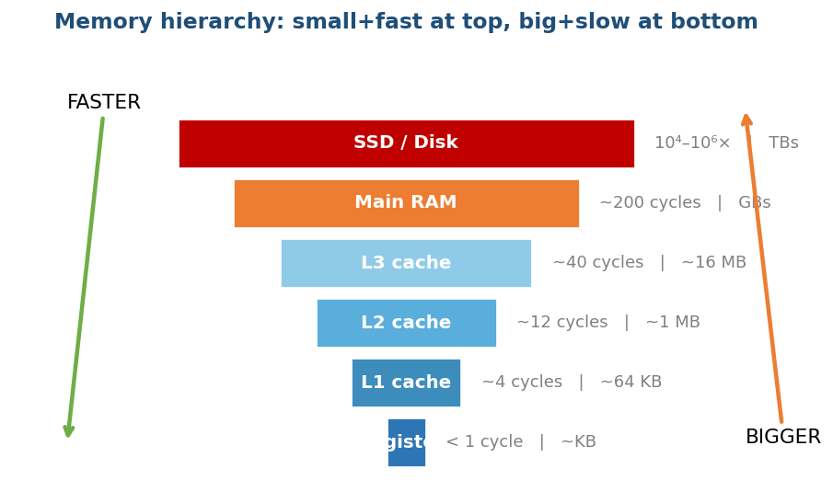
Memory hierarchy: small and fast at the top (registers/cache), big and slow at the bottom (RAM/disk).

Two principles of locality
- Spatial locality: if you access address X, you will likely access X+1 soon. The CPU loads a whole cache line (~64 bytes) at once.
- Temporal locality: recently used data is likely reused soon → keep it in cache.

Practical consequences (interview gold)
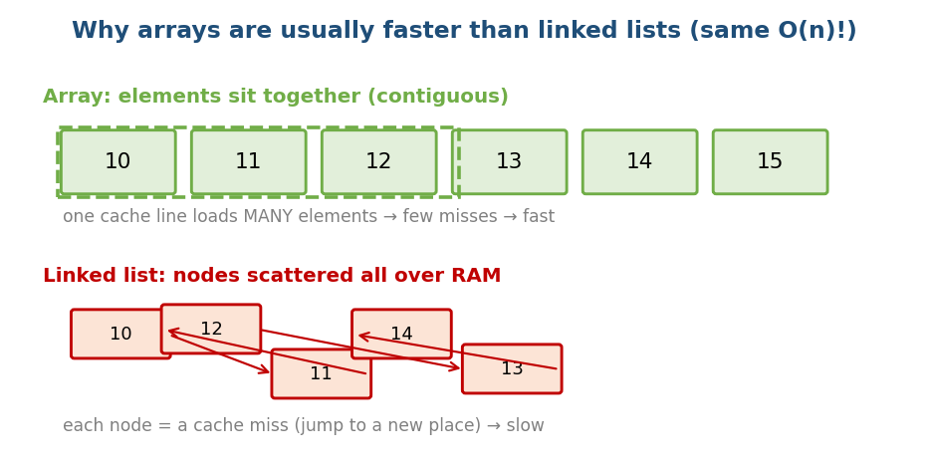
An array is contiguous (one cache line holds many elements); a linked list is scattered (each node is a cache miss).
- Array beats linked list for traversal even at the same O(n): array elements sit together (many per cache line), while list nodes are scattered (a cache miss per node). This is why std::vector usually beats std::list.
- Row-major vs column-major: in C, iterating a[i][j] with j in the inner loop is cache-friendly (row-major); swapping the loops can be 5–10× slower for the same Big-O.
// CACHE-FRIENDLY (row-major C/C++)
for (i...) for (j...) sum += a[i][j];
// CACHE-HOSTILE (same O(n^2), but much slower)
for (j...) for (i...) sum += a[i][j];

MCQs
- Why does vector beat list at the same O(n)? → contiguous memory → spatial locality → fewer cache misses.
- Cache-friendly 2D loop order in C? → i outer, j inner (row-major).

Module 1 — Concept Review (one page)
- Memory = addressable bytes; the type interprets the bytes; signed ints use two’s complement; beware overflow.
- Stack (auto, fast, LIFO, per-thread, small) vs Heap (manual/GC, flexible, large, can fragment). Returning a local’s address = bug.
- Pass-by-value copies (cost!); by-reference shares. Pass big objects by const&.
- Recursion = base case + smaller subproblem; uses O(depth) stack; recurrence gives the time; watch overflow and recomputation.
- Asymptotics: O (upper), Ω (lower), Θ (tight). Drop constants/lower terms. Memorise the growth ladder. Analyse with the recipe.
- Cache: same Big-O ≠ same speed; prefer contiguous, locality-friendly access.

Module 1 — Flash Cards (revision)
- Q: INT_MAX+1? A: INT_MIN (overflow).
- Q: Safe midpoint? A: low + (high-low)/2.
- Q: Where do locals live? A: stack. The heap needs free/GC.
- Q: Stack space for recursion depth d? A: O(d).
- Q: 2T(n/2)+n? A: Θ(n log n).
- Q: Growth order? A: 1 < log n < √n < n < n log n < n² < 2ⁿ < n!.
- Q: Array vs list speed at the same O(n)? A: array — cache locality.

Module 1 — Pattern Recognition
- “Change the caller’s variable” → pass a pointer/reference.
- “Self-similar problem (tree/list/n!)” → recursion.
- “Same subproblem computed again” → memoise → DP.
- “Nested loops over n” → suspect O(n²); look for hashing/two-pointer to cut it.
- “Need O(1) lookup” → trade space for time with a hashset/hashmap.

Module 1 — Interview Questions (with follow-ups)
- Explain stack vs heap. FU: where does int a[10⁶] go and why might it crash?
- What is two’s complement and why? FU: what is the negation of INT_MIN?
- Convert this recursion to iteration. FU: what is the stack depth?
- Define Big-O vs Big-Θ. FU: prove 3n²+5n = Θ(n²).
- Why is vector faster than list here? FU: what is a cache line?

Module 1 — GATE / SEBI / RBI / ISRO Perspective
- Very common: solving recurrences, identifying the Θ of code with loops, two’s-complement ranges, the contents of an activation record, recursion depth, and comparing growth rates.
- SEBI/RBI IT: conceptual MCQs on time complexity, stack vs heap, recursion.

End of Module 1. Next: Module 2 — Arrays (internals, prefix sums, two pointers, sliding window, Kadane, Dutch National Flag, matrix) — with visuals.

