Module 2 — Arrays
  - DSA Mastery: Google / FAANG / GATE / ICPC — In-Depth Notes (with visuals)
Prepared for nidhi.sharma@forensiccybertech.com
2026
Table of Contents

Module 2 — Arrays
Why arrays come first (after fundamentals). The array is the most basic and most important data structure. About 60–70% of interview and contest problems involve arrays in some form. Strings, stacks, queues, heaps, and hash tables are all built on arrays internally. Here we start with array internals and then learn the patterns (prefix sum, two pointers, sliding window) that you will reuse in every later module.
This module is P0. Roughly 70% of interviews start here.
How to read each technique below. For every problem we go Brute force → Better → Optimal, with pseudocode and complexity at each step, and we explain why each optimisation works.

Quick pattern selector (use this to pick a technique)
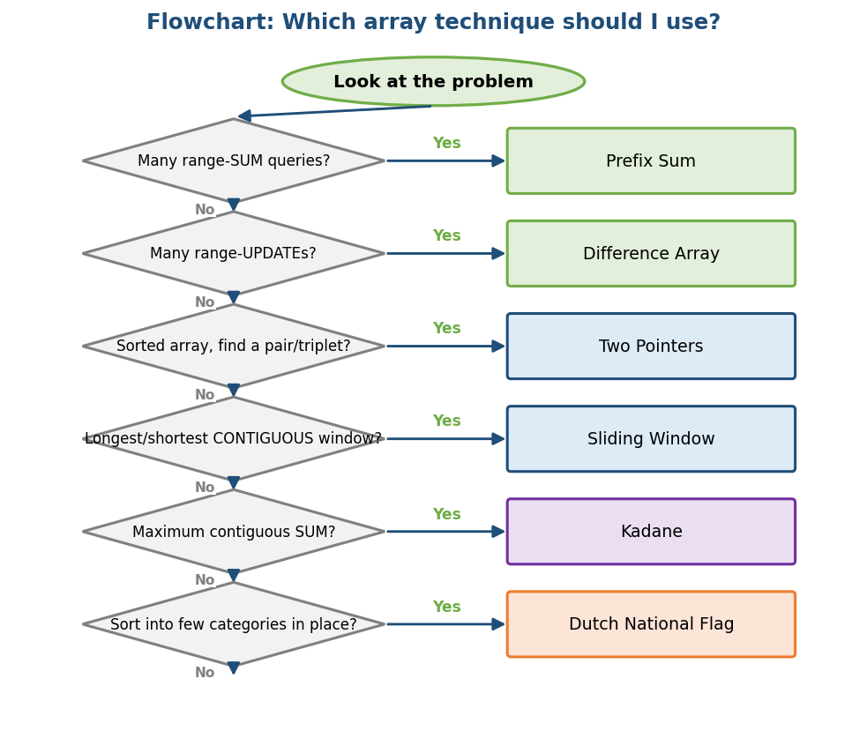
Flowchart: ask these questions in order to choose the right array technique.

2.1 Array Internals (what happens inside?)

Definition
An array is a contiguous (back-to-back) block of same-type elements, where each element is reached in O(1) using its index.
The address of an element comes from a simple formula:
address(arr[i]) = base_address + i * size_of_one_element
Because of this one-multiply-one-add formula, array access is O(1) — no searching, just a calculation.

Intuition (simple example)
Think of a train whose coaches are joined in a line, each coach the same size. If you know where the first coach is, the 5th coach = first + 5×(coach length). You just calculate — you never search. That is “random access”: you can jump straight to any index.

Static vs Dynamic arrays
 | Static array | Dynamic array (vector/ArrayList/list)
Size | Fixed at compile time | Can grow at runtime
Memory | Stack or a fixed block | On the heap; resizes when full
Example | int a[10]; | C++ vector, Java ArrayList, Python list

Internal working — dynamic array doubling
A dynamic array holds a normal array with a capacity. When it is full and you add one more element:
- Allocate a new array of double the capacity.
- Copy all old elements (O(n)).
- Add the new element.
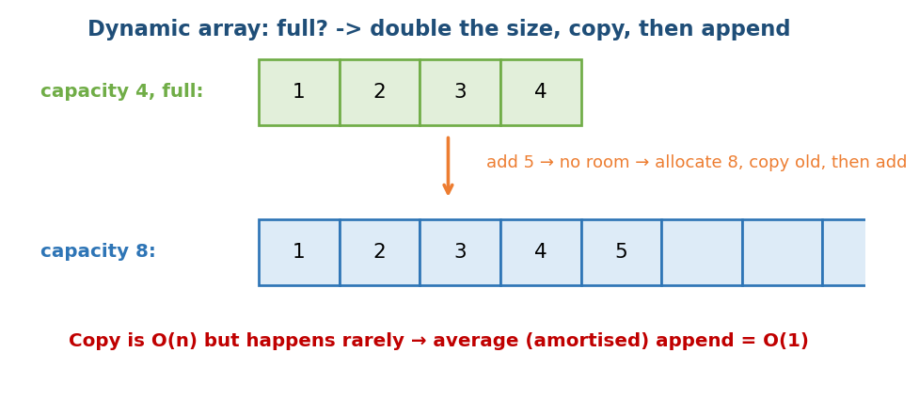
A dynamic array doubles its size when full, copies the old data, then appends.

Mathematical proof — amortised O(1) append
One copy is O(n), so how is append O(1)? Because copies happen rarely.
Suppose capacity starts at 1 and doubles. To add n elements, the total copy cost is 1 + 2 + 4 + … + n ≈ 2n = O(n) total. So the per-append average is 2n / n = O(1). We call this amortised O(1) (a guaranteed average over a sequence — Module 18).
Why double, not +1 or +10? If you grow by just +1 each time, n appends cost 1+2+…+n = O(n²). Doubling (×2) is what gives O(1) amortised. This is a classic interview question.

Complexity & memory
Operation | Time | Note
Access arr[i] | O(1) | from the formula
Update arr[i] | O(1)
Append (end) | O(1) amortised | doubling
Insert/delete (middle) | O(n) | everything else shifts
Search (unsorted) | O(n) | linear scan
Search (sorted) | O(log n) | binary search
Memory: n elements × element size, plus a little spare capacity in a dynamic array (up to ~2× in the worst case).

Cache-friendliness (link to Module 1)
Array elements sit together, so one cache line holds several of them → traversal is very fast (spatial locality). This is why arrays often beat linked lists at the same O(n).

Edge cases & common mistakes
- Out-of-bounds access (arr[n] when size is n) → undefined behaviour / crash / security bug.
- Off-by-one (loop <= n vs < n).
- Insert/delete in the middle is O(n) — doing it inside a loop accidentally makes it O(n²).
- Always test empty array and single element.

MCQs
- Why is arr[i] O(1)? → the address formula base + i*size.
- Append with doubling is? → O(1) amortised.
- n appends with +1 growth? → O(n²) total.

2.2 Prefix Sum (the king of range queries)

Definition
A prefix sum array pre is built so that pre[i] = the sum of the first i elements (arr[0] + … + arr[i-1]). Build it once (O(n)), then get any range sum in O(1).
sum(arr[L..R]) = pre[R+1] - pre[L]

Intuition (simple example)
Suppose you wrote down your earnings for each day and you keep being asked “what is the total from day 3 to day 7?” Adding it up each time is slow. Instead, keep a running total (total up to each day). Then “total up to day 7 − total up to day 2” gives the answer — just one subtraction!
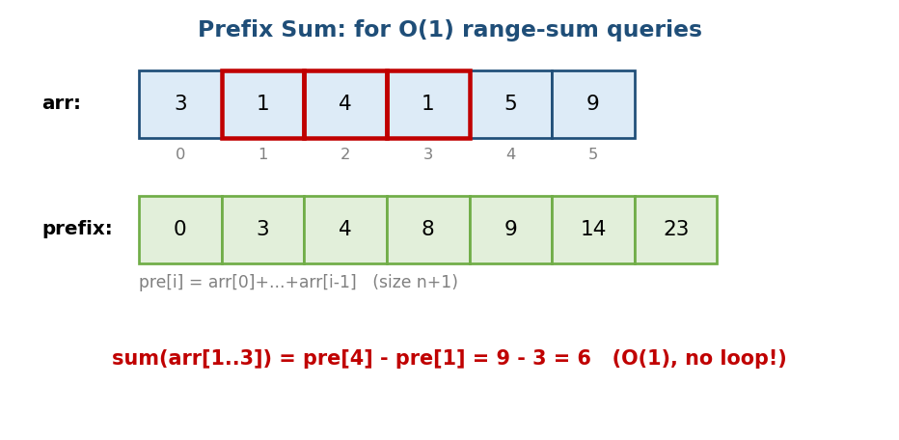
Prefix sum: running totals up to each element; a range sum is the difference of two prefix values.

Brute force → Optimal
# BRUTE FORCE: re-add for every query Time O(n) per query, O(n*q) total
rangeSum(L, R):
s = 0
for i = L..R: s += arr[i]
return s
# OPTIMAL: prefix sum Build O(n), each query O(1)
build:
pre[0] = 0
for i = 0..n-1: pre[i+1] = pre[i] + arr[i]
rangeSum(L, R):
return pre[R+1] - pre[L]
Why it helps: the running total is computed once; each query becomes a single subtraction instead of a loop. With many queries this changes O(n·q) into O(n + q).

Dry run
arr = [3, 1, 4, 1, 5, 9]
pre = [0]
for x in arr:
pre.append(pre[-1] + x)
# pre = [0, 3, 4, 8, 9, 14, 23]
# sum of arr[1..3] = 1+4+1 = 6
# = pre[4] - pre[1] = 9 - 3 = 6 ✓
Tip: make pre of size n+1 (an extra 0 at the front). Then L=0 works with no special case. This avoids off-by-one bugs.
Memory hook: prefix sum is like a bank passbook — it stores the running balance, so any “how much between two dates” question is just one subtraction.

2D Prefix Sum (matrix range sum)
In 2D, P[i][j] = the sum of the top-left rectangle. Any sub-rectangle’s sum is O(1) using inclusion-exclusion:
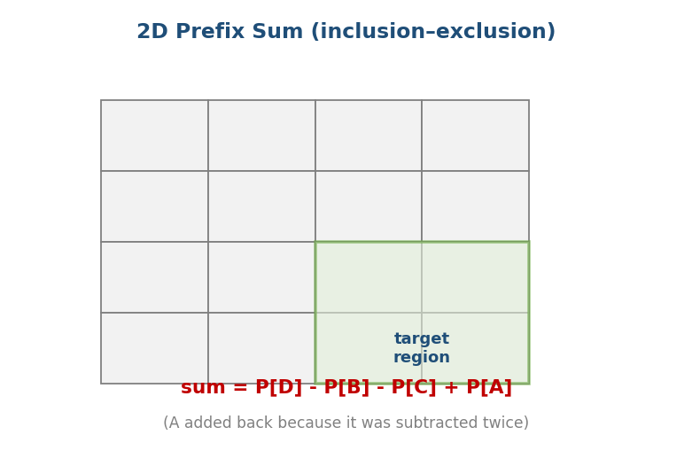
2D prefix sum: a region’s sum = P[D] − P[B] − P[C] + P[A] (A is added back because it was subtracted twice).
sum(rectangle) = P[D] - P[B] - P[C] + P[A]
Build O(n·m), each query O(1). (LeetCode 304 “Range Sum Query 2D”.)

Complexity
- Build: O(n) (1D), O(n·m) (2D)
- Query: O(1)
- Space: O(n) extra

Production usage
Analytics dashboards (cumulative metrics), image processing (integral images — used in Viola-Jones face detection), databases (running aggregates), range queries.

Common mistakes
- Making pre of size n (use n+1).
- Confusing inclusive vs exclusive ranges.
- Forgetting the +P[A] in the 2D inclusion-exclusion.

Interview / Exam perspective
- FAANG: “subarray sum equals k” → prefix sum + hashmap (Module 7). The first tool for any range-query problem.
- GATE: rarely direct, but cumulative-cost reasoning is common.

MCQs
- How to make a range sum O(1)? → prefix sum preprocessing.
- Size of the pre array? → n+1.
- Why add A in the 2D sub-rectangle sum? → it was subtracted twice.

Problems (Easy → Hard)
- Easy: Running Sum (LC 1480); Range Sum Query Immutable (LC 303).
- Medium: Subarray Sum Equals K (LC 560); Product Except Self (LC 238); Range Sum 2D (LC 304); Pivot Index (LC 724).
- Hard: Count subarrays with sum divisible by k; Max sum rectangle in 2D.

2.3 Difference Array (the king of range updates)

Definition
The reverse of prefix sum. A difference array lets you add a value to an entire range in O(1), and then one prefix-sum pass produces the final array. Perfect when there are many range updates.

Intuition
You want to add +v to a range [L, R]. Looping over the whole range is O(range). Instead, just mark two spots: diff[L] += v (start adding here) and diff[R+1] -= v (stop here). At the end, take the prefix sum of diff to get each position’s actual value.
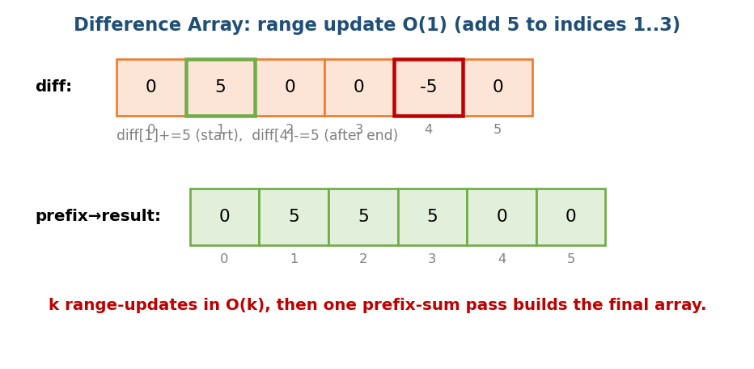
Difference array: +v at the range start, −v just after the range end; then a prefix sum builds the final array.

Brute force → Optimal
# BRUTE FORCE: loop each update over its range Time O(n) per update, O(n*k) total
for each update (L, R, v):
for i = L..R: arr[i] += v
# OPTIMAL: difference array k updates O(k), finalise O(n)
diff = array of zeros, size n+1
for each update (L, R, v):
diff[L] += v
diff[R+1] -= v
# finalise with a prefix sum
run = 0
for i = 0..n-1:
run += diff[i]
arr[i] = run
Why it helps: each range update touches only two cells instead of the whole range; the single prefix-sum pass “spreads” all updates at once.

Dry run
n = 6
diff = [0]*(n+1)
# add 5 to indices 1..3
diff[1] += 5
diff[4] -= 5 # R+1 = 4
res, run = [], 0
for i in range(n):
run += diff[i]
res.append(run)
# res = [0, 5, 5, 5, 0, 0] ✓

Complexity
- k range updates: O(k)
- Finalising: O(n) (one prefix pass)
- Total: O(n + k) vs brute force O(n·k)

Production usage
Booking/calendar systems (LC 731/732), traffic counts over time intervals, “car pooling” (LC 1094), histogram counting, range increments.

Common mistakes
- Writing diff[R] instead of diff[R+1] (off-by-one).
- Array bounds when R+1 = n (keep size n+1).

MCQs
- What is a difference array for? → range update in O(1).
- Prefix sum vs difference array? → one for range queries, one for range updates.

Problems
- Medium: Car Pooling (LC 1094); Corporate Flight Bookings (LC 1109); My Calendar I/II (LC 731/732); Range Addition (LC 370).

2.4 Two Pointers

Definition
Two index pointers move over the array (often from opposite directions, or at different speeds) to turn a nested loop (O(n²)) into O(n).
Two common forms:
- Opposite ends — L from the start, R from the end, meeting in the middle (sorted array, pair sum, palindrome).
- Same direction — both move forward at different speeds (slow/fast — dedup, window).

Intuition (simple example)
In a sorted array you want a pair with sum = target. Start from both ends:
- Sum is too big → make it smaller → R--
- Sum is too small → make it bigger → L++
- Found → done
Each step moves one pointer, so there are at most n steps → O(n).
Memory hook: two people walk toward each other from both ends of a sorted queue; if the pair is too “heavy”, the bigger one steps back (R−−); if too “light”, the smaller one steps up (L++).
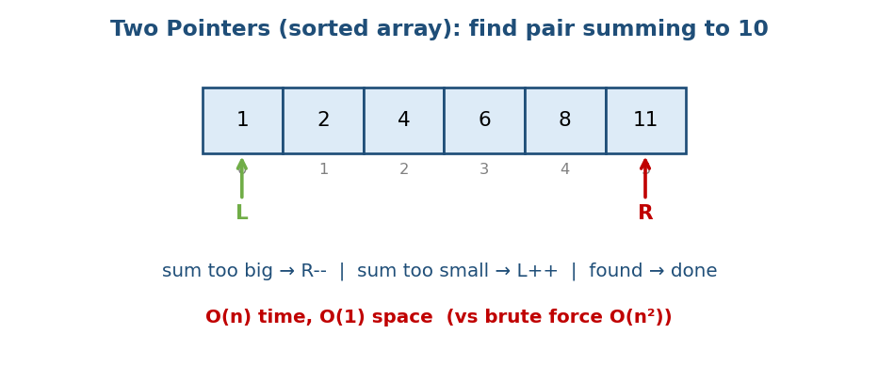
Two pointers: L at the start, R at the end of a sorted array; move inward based on the sum.

Why it works (proof intuition)
Because the array is sorted: when the sum is too big, moving L right only makes it bigger (useless) — so R-- is the only correct move. We never skip a valid pair. This monotonicity is what makes it correct.
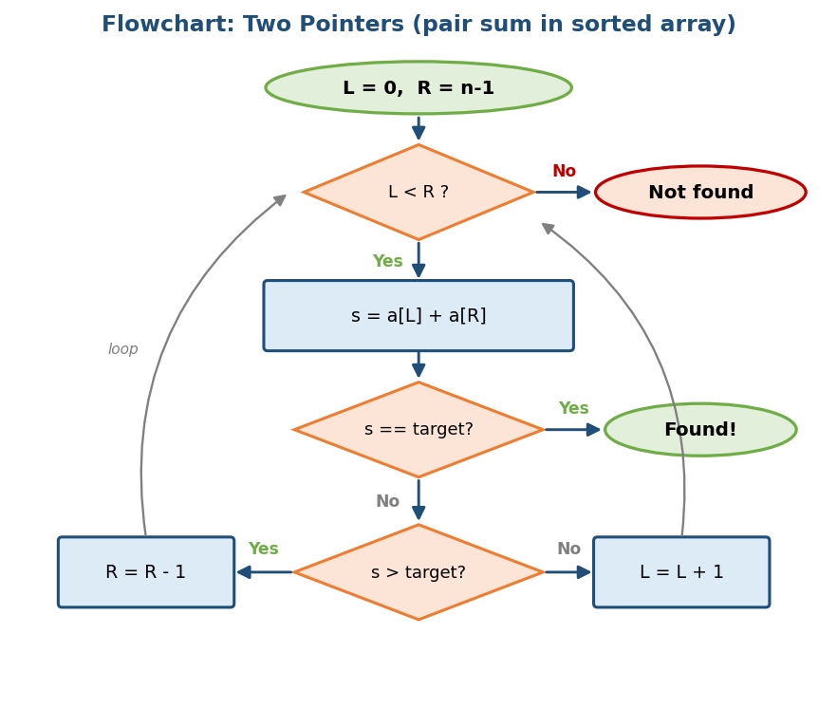
Flowchart: the two-pointer decision loop for finding a pair with a target sum.

Brute force → Better → Optimal (pair with target sum)
# BRUTE FORCE: try all pairs Time O(n^2), Space O(1)
for i = 0..n-1:
for j = i+1..n-1:
if arr[i] + arr[j] == target: return (i, j)
# BETTER: hash set (works on UNSORTED too) Time O(n), Space O(n)
seen = empty set
for i = 0..n-1:
if target - arr[i] in seen: return found
add arr[i] to seen
# OPTIMAL for a SORTED array: two pointers Time O(n), Space O(1)
L, R = 0, n-1
while L < R:
s = arr[L] + arr[R]
if s == target: return (L, R)
elif s > target: R -= 1
else: L += 1
Why each step helps: the hash set removes the inner loop by remembering what we have seen (space for time). If the array is already sorted, two pointers get the same O(n) time with O(1) space.

Complexity
- Time: O(n) (if sorted); if you must sort first → O(n log n)
- Space: O(1) (two-pointer version)

When NOT to use
- The array is unsorted and you must keep original indices → a hashmap is better (Two Sum LC 1).
- Conditions are not monotonic, so it is unclear which pointer to move.

Common mistakes
- L <= R vs L < R (double-counting a single element).
- Forgetting to skip duplicates (important in 3Sum).

Interview perspective
- Very common at FAANG: 3Sum (LC 15), Container With Most Water (LC 11), Trapping Rain Water (LC 42), Valid Palindrome (LC 125).

MCQs
- Two pointers turn which complexity into which? → O(n²) → O(n).
- Opposite-ends two pointers needs the array to be? → sorted.

Problems
- Easy: Valid Palindrome (125); Two Sum II sorted (167); Remove Duplicates (26).
- Medium: 3Sum (15); Container With Most Water (11); Sort Colors (75).
- Hard: Trapping Rain Water (42); 4Sum (18).

2.5 Sliding Window

Definition
A contiguous window (subarray/substring) that slides across the array. Its two edges are left and right. right moves forward to add an element; when a condition breaks, left moves forward to remove an element. It turns O(n²)/O(n³) brute force into O(n).
Two forms: fixed-size window (size k) and variable-size window (the longest/shortest that satisfies a condition).

Intuition (simple example)
“Longest substring without repeating characters” — checking every substring is O(n²). Instead keep a window:
- Move right forward, add the new character.
- If a duplicate appears, move left forward until the duplicate is gone.
- At each step, update the answer with the window length.
Memory hook: think of a bus with a stretchy length. The front (right) keeps moving to pick up passengers; if a rule breaks, the back (left) moves up to drop passengers. The bus never reverses.
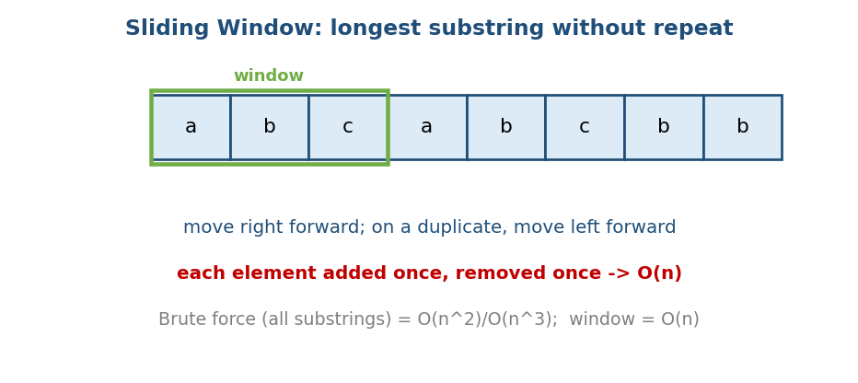
Sliding window: move right forward; on a duplicate move left; each element is added and removed once → O(n).

Why it is O(n) (proof intuition)
Both left and right only move forward, never backward. Each element is added at most once and removed at most once. Total moves ≤ 2n → O(n). (This is amortised reasoning.)
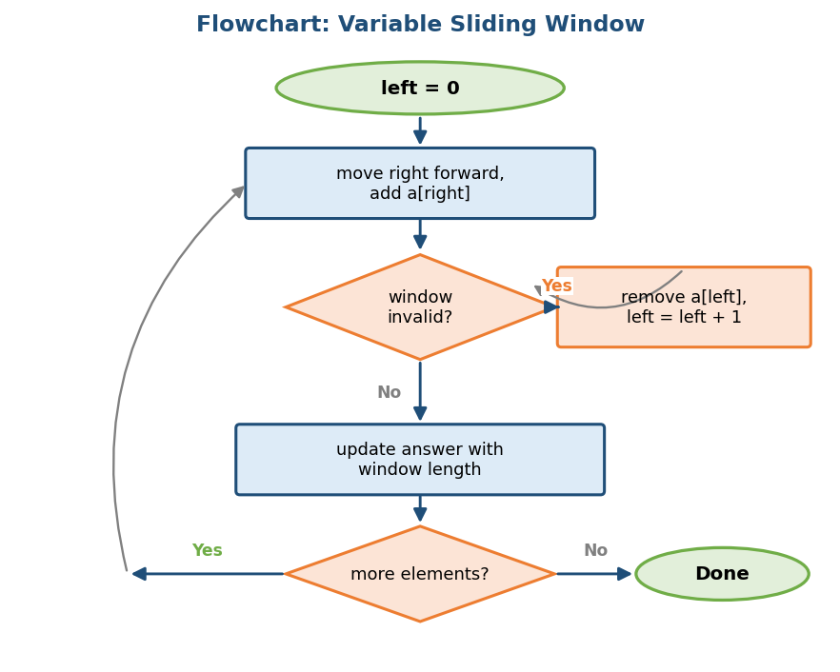
Flowchart: expand the window with right; shrink with left while invalid; update the answer.

Brute force → Optimal (longest substring without repeats)
# BRUTE FORCE: check every substring Time O(n^2) or O(n^3), Space O(n)
best = 0
for i = 0..n-1:
seen = empty set
for j = i..n-1:
if s[j] in seen: break
add s[j] to seen
best = max(best, j - i + 1)
# OPTIMAL: sliding window + last-seen map Time O(n), Space O(min(n, charset))
seen = empty map (char -> last index)
left = 0; best = 0
for right = 0..n-1:
c = s[right]
if c in seen and seen[c] >= left:
left = seen[c] + 1 # jump left past the duplicate
seen[c] = right
best = max(best, right - left + 1)
Why it helps: instead of restarting the scan from every i, the window keeps the work from the previous step and only slides left when needed.

Fixed vs variable window templates
# FIXED size k: build one window, then slide
window_sum = sum(a[:k]); best = window_sum
for i in range(k, len(a)):
window_sum += a[i] - a[i-k] # add new, remove old
best = max(best, window_sum)
# VARIABLE: expand right; shrink left while invalid
left = 0
for right in range(len(a)):
add(a[right])
while invalid():
remove(a[left]); left += 1
update_answer(right - left + 1)

Complexity
- Time: O(n) (each element in once, out once)
- Space: O(1) or O(k) (the window’s map/counts)

When NOT to use
- The target is not contiguous (a subsequence, not a subarray) → use DP.
- Negative numbers with “sum ≥ target” → the window is not monotonic; use prefix sum + a deque or binary search.

Common mistakes
- Setting left = seen[c] instead of seen[c]+1.
- Forgetting to remove the old element in a fixed window.
- Not shrinking the window when it becomes invalid.

Interview perspective
- Extremely common: Longest Substring Without Repeats (3), Minimum Window Substring (76), Longest Repeating Char Replacement (424), Max Sum Subarray of size k, Permutation in String (567).

MCQs
- Sliding-window time? → O(n) (each element in/out once).
- When do you shrink a variable window? → when it becomes invalid.

Problems
- Easy: Max Average Subarray I (643).
- Medium: Longest Substring Without Repeats (3); Longest Repeating Char Replacement (424); Permutation in String (567); Fruit Into Baskets (904).
- Hard: Minimum Window Substring (76); Sliding Window Maximum (239 — needs a monotonic deque, Module 6); Subarrays with K Distinct (992).

2.6 Kadane’s Algorithm (maximum subarray sum)

Definition
The maximum contiguous subarray sum in O(n). It is a tiny DP (a seed for Module 14).

Intuition (simple example)
Walk across the array keeping a “current running sum”. Key idea: if the running sum has gone negative, there is no point carrying it forward — it can only make any new element smaller. So start fresh.
cur = max(x, cur + x) # either start fresh at x, or extend the previous run
best = max(best, cur) # best so far
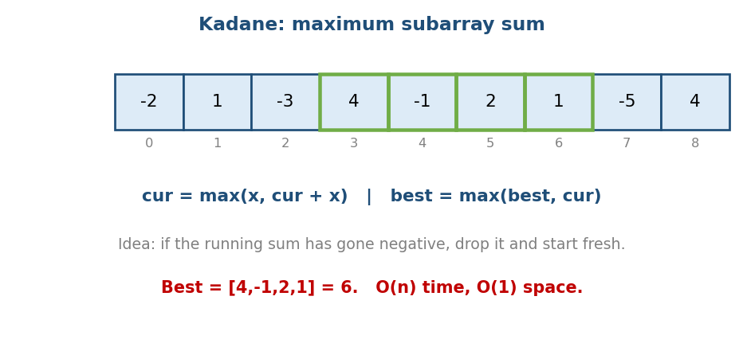
Kadane: drop a negative running sum (start fresh); track the best subarray.

Brute force → Better → Optimal
# BRUTE FORCE: every subarray Time O(n^3), Space O(1)
best = -inf
for i = 0..n-1:
for j = i..n-1:
s = sum(arr[i..j]) # inner loop again
best = max(best, s)
# BETTER: running sum for inner loop Time O(n^2), Space O(1)
for i = 0..n-1:
s = 0
for j = i..n-1:
s += arr[j]
best = max(best, s)
# OPTIMAL: Kadane Time O(n), Space O(1)
cur = best = arr[0]
for x in arr[1..]:
cur = max(x, cur + x)
best = max(best, cur)
Why it helps: the brute force recomputes overlapping sums; the better version reuses the running sum (drops one loop); Kadane keeps just the best run ending “here”, so a single pass suffices.

Why it works (DP view)
cur = “the max sum of a subarray ending at this index”. Recurrence: cur[i] = max(arr[i], cur[i-1] + arr[i]). The answer is the max over all cur[i]. Optimal substructure + one variable = an elegant DP.

Dry run
def kadane(a):
cur = best = a[0]
for x in a[1:]:
cur = max(x, cur + x)
best = max(best, cur)
return best
# [-2,1,-3,4,-1,2,1,-5,4] -> 6 (subarray [4,-1,2,1])

Edge cases (interview traps)
- All negative → the answer is the largest (least negative) element. Initialise best = a[0], not 0! (Common bug.)
- Empty array → define the behaviour.
- If you need the indices (not just the sum) → track start/end.

Variants / follow-ups
- Maximum product subarray (LC 152 — track both min and max, since negative × negative).
- Circular array maximum subarray (LC 918).
- Maximum sum with at most one deletion.

MCQs
- Initialising best=0 on an all-negative array? → bug; use best=a[0].
- Kadane time/space? → O(n) / O(1).

Problems
- Medium: Maximum Subarray (53); Maximum Product Subarray (152); Maximum Sum Circular Subarray (918); Best Time to Buy & Sell Stock (121).

2.7 Dutch National Flag (3-way partition)

Definition
Sort an array into three groups in one pass (classic: 0s, 1s, 2s). Designed by Edsger Dijkstra. It is the basis of quicksort’s 3-way partition.

Intuition
Three pointers:
- low — the 0s region ends here
- mid — the element we are currently looking at (the scanner)
- high — the 2s region starts here
Look at arr[mid]: if 0 → swap with low, move both forward; if 1 → leave it, mid++; if 2 → swap with high, high-- (do not move mid, because the swapped-in element has not been checked yet).
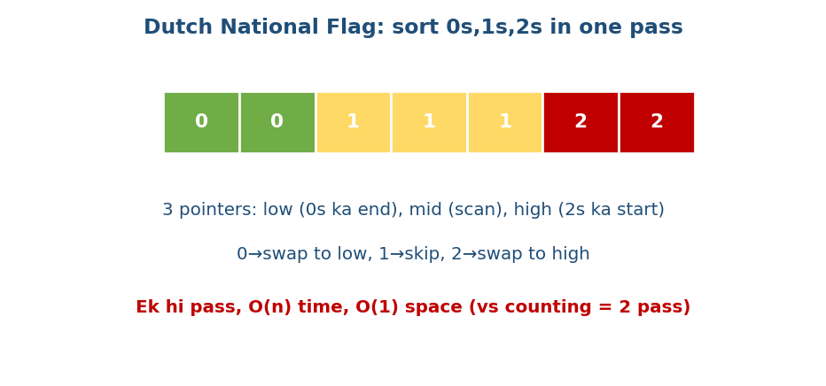
Dutch flag: 0s on the left, 1s in the middle, 2s on the right — one pass, three pointers.
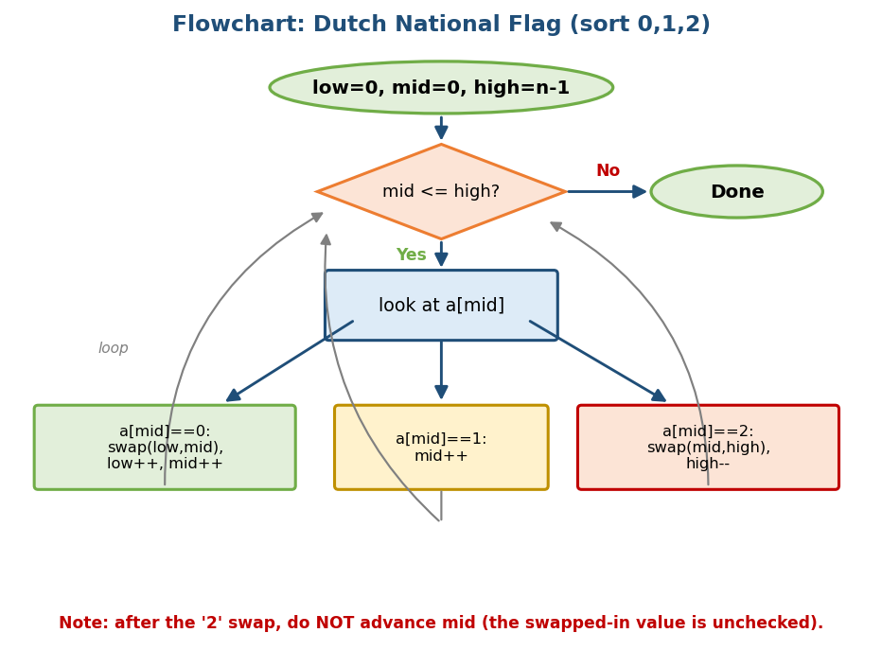
Flowchart: the Dutch National Flag decision loop for 0s, 1s, and 2s.

Brute force → Better → Optimal
# BRUTE FORCE: just sort Time O(n log n), Space O(1)
sort(arr)
# BETTER: counting sort (two passes) Time O(n), Space O(1), 2 passes
count zeros, ones, twos
overwrite arr with that many 0s, then 1s, then 2s
# OPTIMAL: Dutch national flag (one pass) Time O(n), Space O(1), 1 pass
low = mid = 0; high = n-1
while mid <= high:
if arr[mid] == 0: swap(arr[low], arr[mid]); low++; mid++
elif arr[mid] == 1: mid++
else: swap(arr[mid], arr[high]); high--
Why it helps: sorting ignores that there are only 3 values; counting needs two passes; Dutch flag places every element correctly in a single pass.

Dry run
def sort012(a):
low, mid, high = 0, 0, len(a) - 1
while mid <= high:
if a[mid] == 0:
a[low], a[mid] = a[mid], a[low]; low += 1; mid += 1
elif a[mid] == 1:
mid += 1
else: # a[mid] == 2
a[high], a[mid] = a[mid], a[high]; high -= 1
return a
# [2,0,2,1,1,0] -> [0,0,1,1,2,2]

Complexity
- Time: O(n) (single pass), Space: O(1)

Common mistakes
- Doing mid++ after the 2-swap (wrong — the swapped-in element is unchecked).
- Using mid < high instead of mid <= high (misses the last element).

Interview perspective
- Sort Colors (LC 75) — very common; “one pass, O(1) space” is expected.

MCQs
- How many passes does Dutch flag use? → one (1).
- After a 2-swap, do you advance mid? → no.

Problems
- Medium: Sort Colors (75); partition an array around a pivot; Wiggle Sort.

2.8 Matrix Problems

Common patterns
A matrix is a 2D array, internally often one 1D contiguous block (row-major: a[i][j] = a[i*cols + j]).

Rotate image 90° (in place)
Trick: Transpose (swap rows and columns), then reverse each row = a 90° clockwise rotation, with O(1) extra space.
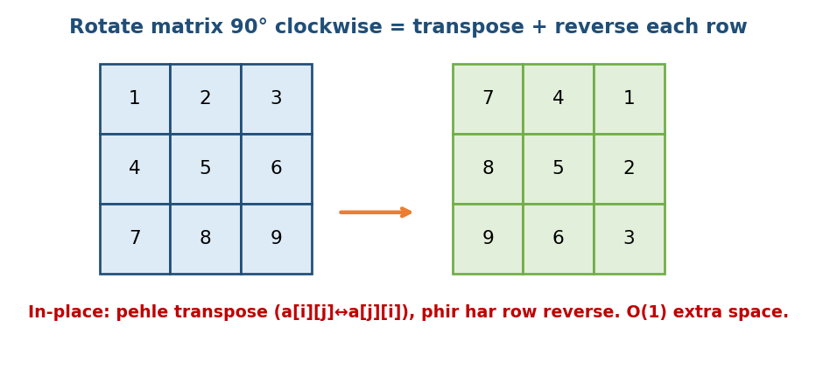
Rotate 90° clockwise = transpose + reverse each row, done in place.
# BRUTE FORCE: use a new matrix Time O(n^2), Space O(n^2)
new[j][n-1-i] = old[i][j]
# OPTIMAL: in place Time O(n^2), Space O(1)
transpose: for i, for j>i: swap(a[i][j], a[j][i])
then reverse each row
def rotate(m):
n = len(m)
for i in range(n): # transpose
for j in range(i+1, n):
m[i][j], m[j][i] = m[j][i], m[i][j]
for row in m: # reverse each row
row.reverse()

Other classics
- Spiral traversal (LC 54): shrink four boundaries (top/bottom/left/right).
- Search in a sorted matrix (LC 240): start at the top-right, O(m+n) — each step removes a row or a column.
- Set matrix zeroes (LC 73): use the first row/column as markers for O(1) extra space.

Cache note
Iterate a[i][j] with j in the inner loop (row-major friendly) — Module 1’s cache lesson applies directly here (a 5–10× speed difference).

Complexity
- Most matrix traversals: O(n·m) time.
- In-place rotate/zeroes: O(1) extra space (with the trick).

MCQs
- 90° clockwise rotate? → transpose + reverse each row.
- Where do you start searching a sorted matrix? → top-right (or bottom-left).

Problems
- Medium: Rotate Image (48); Spiral Matrix (54); Set Matrix Zeroes (73); Search 2D Matrix II (240); Game of Life (289).

2.9 More Essential Array Patterns (interview must-knows)
These three patterns appear constantly in interviews and GATE, and each has a clean O(n) or O(n log n) trick worth memorising.

A) Moore’s Voting Algorithm — Majority Element
Problem: find the element that appears more than n/2 times (guaranteed to exist).
Intuition (memory hook — “tug of war”): imagine two teams. Each majority element is +1 for its team; every other element is −1. Keep a candidate and a count. If the next element equals the candidate, count++; otherwise count--. When count hits 0, adopt the current element as the new candidate. Because the majority appears more than half the time, it always survives the cancelling.
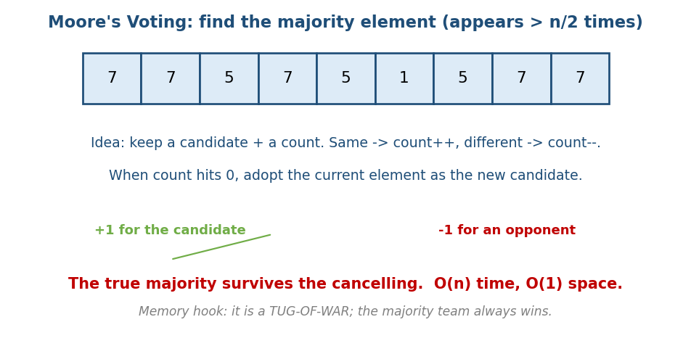
Moore’s voting: keep a candidate and a count; matching elements add, others subtract; the majority survives.
# BRUTE FORCE: count each value Time O(n^2) or O(n) with a hashmap, Space O(n)
for each value: count occurrences; return the one with count > n/2
# OPTIMAL: Moore's voting Time O(n), Space O(1)
candidate = none; count = 0
for x in arr:
if count == 0: candidate = x; count = 1
elif x == candidate: count += 1
else: count -= 1
return candidate # (optional: verify with a second pass if not guaranteed)
- Why it works: pairing each majority element with a different element cancels pairs; since the majority is > n/2, at least one copy is left uncancelled.
- Complexity: O(n) time, O(1) space.
- Edge case: if the majority is not guaranteed, do a second pass to verify the candidate’s count.
- Problems: Majority Element (LC 169); Majority Element II (LC 229 — keeps two candidates for elements > n/3).

B) Merge Intervals
Problem: given intervals like [[1,3],[2,6],[8,10]], merge all overlapping ones → [[1,6],[8,10]].
Intuition (memory hook — “sort, then sweep”): sort by start. Walk left to right keeping the “current” interval. If the next interval starts before or at the current end, they overlap → extend the current end. Otherwise close the current interval and start a new one.
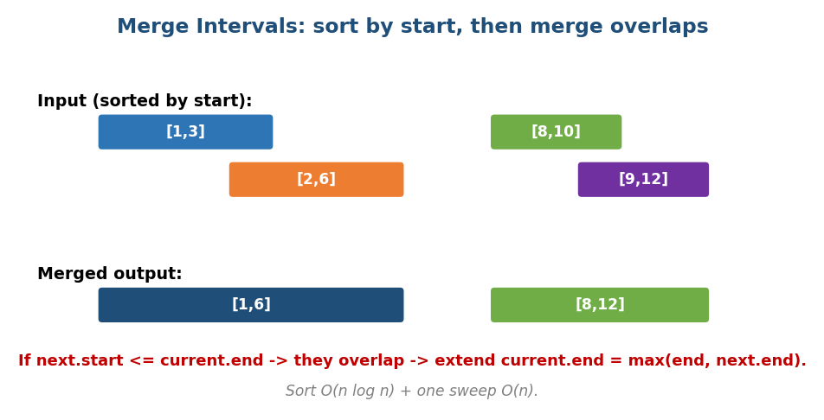
Merge intervals: sort by start; if the next starts at/before the current end, extend; else start a new interval.
# OPTIMAL Time O(n log n) (sort) + O(n) sweep, Space O(n)
sort intervals by start
result = [ intervals[0] ]
for each next in intervals[1..]:
if next.start <= result.last.end: # overlap
result.last.end = max(result.last.end, next.end)
else:
result.append(next)
return result
- Key test: overlap condition is next.start <= current.end.
- Complexity: dominated by the sort → O(n log n).
- Problems: Merge Intervals (LC 56); Insert Interval (LC 57); Non-overlapping Intervals (LC 435); Meeting Rooms I/II (LC 252/253).

C) Cyclic Sort
Problem family: the array holds numbers from a known range 1..n (or 0..n). Find the missing number, the duplicate, or sort in O(n) without extra space.
Intuition (memory hook — “everyone goes home”): the number v belongs at index v-1 (its “home”). Walk the array; while the current element is not at its home, swap it to where it belongs. After one pass, everything is in place, and any index i whose value isn’t i+1 reveals a missing/duplicate number.
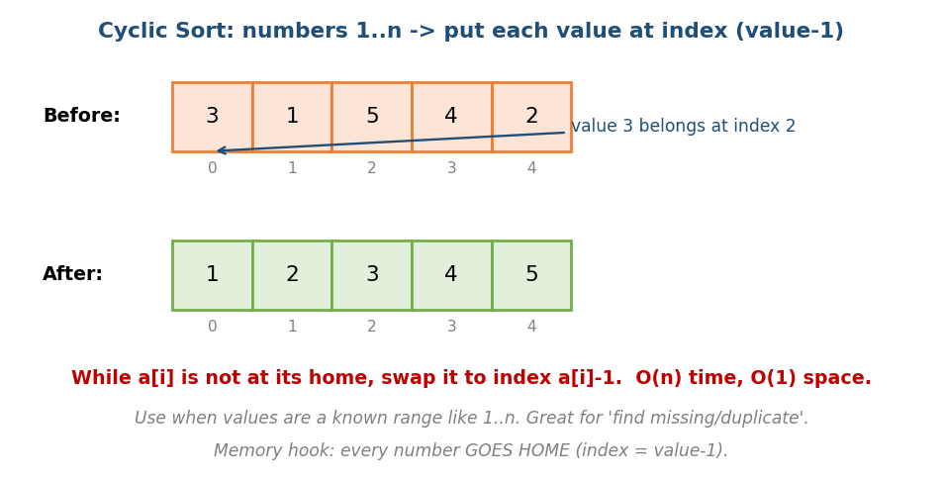
Cyclic sort: each value v is swapped to its home index v-1; mismatches reveal missing/duplicate numbers.
# OPTIMAL Time O(n), Space O(1)
i = 0
while i < n:
home = arr[i] - 1 # where arr[i] should sit
if arr[i] != arr[home]:
swap(arr[i], arr[home]) # send it home; do NOT advance i yet
else:
i += 1
# now scan: the first index i with arr[i] != i+1 gives the answer
- Why O(n) despite the inner swaps: each swap puts at least one number in its final home, so there are at most n swaps total.
- Use when: values are a contiguous range 1..n — this is the giveaway.
- Problems: Missing Number (LC 268); Find All Numbers Disappeared (LC 448); Find the Duplicate Number (LC 287); First Missing Positive (LC 41 — hard).

Module 2 — Concept Review (one page)
- Array = contiguous block; access O(1) via base + i*size; cache-friendly.
- Dynamic array doubles when full → append O(1) amortised (proof: 1+2+4+…+n = O(n) total).
- Prefix sum → range query O(1) (1D & 2D). Difference array → range update O(1).
- Two pointers → O(n²)→O(n) on sorted/monotonic input (pair sum, palindrome, 3Sum).
- Sliding window → contiguous subarray/substring, O(n) (each element in/out once); fixed vs variable.
- Kadane → max subarray O(n)/O(1); init best=a[0] (all-negative trap).
- Dutch flag → 3-way partition, one pass, O(1) space.
- Matrix → rotate = transpose+reverse; spiral; sorted search from a corner.
- Moore’s voting → majority (>n/2) in O(n)/O(1) (tug of war).
- Merge intervals → sort by start, then sweep merging overlaps.
- Cyclic sort → values in 1..n → put each at index value−1 (find missing/dup).

Module 2 — Flash Cards
- Q: Append amortised cost & why? A: O(1); doubling → 1+2+…+n = 2n.
- Q: Range sum O(1)? A: prefix sum, pre[R+1]-pre[L].
- Q: Range update O(1)? A: difference array.
- Q: Two pointers needs the array to be? A: sorted/monotonic.
- Q: Sliding window — why O(n)? A: each element added & removed once.
- Q: Kadane all-negative bug? A: init best=a[0], not 0.
- Q: Sort 0/1/2 in one pass? A: Dutch national flag (3 pointers).
- Q: Rotate 90° CW? A: transpose + reverse rows.
- Q: Majority element (>n/2) in O(1) space? A: Moore’s voting (tug of war).
- Q: Merge overlapping intervals? A: sort by start, sweep; overlap if next.start ≤ cur.end.
- Q: Values are 1..n, find missing/duplicate in O(1) space? A: cyclic sort.

Module 2 — Pattern Recognition (how to spot it in an interview)
- “Range sum / many queries” → prefix sum.
- “Range update many times” → difference array.
- “Sorted array + pair/triplet” → two pointers.
- “Longest/shortest contiguous subarray/substring with a condition” → sliding window.
- “Max contiguous sum” → Kadane.
- “Sort into a few categories in place” → Dutch flag / partition.
- “Subarray sum = k (unsorted)” → prefix sum + hashmap (Module 7).
- “Element appears more than n/2 times” → Moore’s voting.
- “Overlapping intervals / merge / meeting rooms” → sort + merge intervals.
- “Array contains 1..n, find missing/duplicate, O(1) space” → cyclic sort.

Module 2 — Interview Questions (with follow-ups)
- How is dynamic-array append O(1)? FU: what about +1 growth? → O(n²).
- Make range sum O(1). FU: for 2D? → inclusion-exclusion.
- Solve 3Sum. FU: handle duplicates; complexity? → O(n²).
- Longest substring without repeats. FU: prove it is O(n).
- Sort colors in one pass. FU: does it generalise to 4 colors?
- Max subarray; the all-negative case? FU: also return the indices.

Module 2 — GATE / SEBI / RBI / ISRO Perspective
- Common: address calculation (base + i*size, the 2D row-major formula), amortised analysis of dynamic arrays, time complexity of insert/delete/search, prefix-sum reasoning. The 2D array address formula is a GATE favourite.

End of Module 2. Next: Module 3 — Strings (hashing, KMP, Z-algorithm, Rabin- Karp, Trie basics) — with visuals.

