Module 3 — Strings
  - DSA Mastery: Google / FAANG / GATE / ICPC — In-Depth Notes (with visuals)
Prepared for nidhi.sharma@forensiccybertech.com
2026
Table of Contents

Module 3 — Strings
Why strings get their own module. A string is just an array of characters — so everything from Module 2 (two pointers, sliding window, prefix ideas) applies. But strings add their own superpowers: hashing (turn a substring into a number), and smart pattern matching (KMP, Z, Rabin-Karp) that avoid re-checking characters. These show up in search engines, editors, compilers, DNA analysis, and a huge share of interview questions.
This module is P0–P1: basics and hashing are must-know; KMP/Z/Boyer-Moore are “know the idea + when to use” for interviews, and directly tested in GATE/CP.
How to read each technique. We go Brute force → Better → Optimal with pseudocode + complexity, plus a memory hook to make it stick.

Quick technique selector
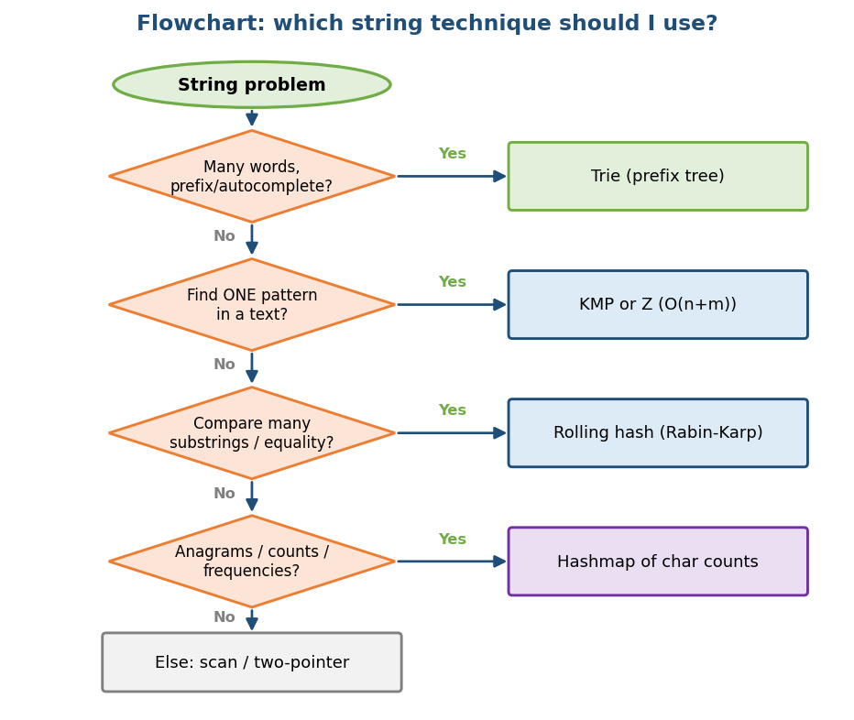
Flowchart: which string technique to use — trie, KMP/Z, rolling hash, or char-count hashmap.

3.1 String Basics

Definition
A string is a sequence of characters stored as an array. Each character is a number under the hood (its code point): 'A' = 65, 'a' = 97, '0' = 48 (ASCII). Unicode/UTF-8 extends this to every language and emoji.

Encodings (know the difference)
- ASCII: 1 byte, 128 characters (English letters, digits, symbols).
- UTF-8: variable length (1–4 bytes); the standard on the web. An emoji can be 4 bytes — so “length in characters” ≠ “length in bytes”. (A classic bug.)
Memory hook: 'a' - 'a' = 0, 'b' - 'a' = 1 … so c - 'a' gives a letter’s index 0–25. This one trick powers most “count letters” problems.

Immutability & the StringBuilder trap
In Java, Python, C#, strings are immutable — you cannot change a character in place; every “edit” makes a new string.
# BAD: building a string with += in a loop Time O(n^2)!
result = ""
for c in chars:
result += c # each += copies the whole string so far
# GOOD: use a list / StringBuilder, join once Time O(n)
parts = []
for c in chars:
parts.append(c)
result = "".join(parts) # Java: StringBuilder; C++: string is mutable
Why O(n²)? The i-th += copies i characters, so total = 1+2+…+n = O(n²). This is the most common hidden-cost bug in interviews. Always mention it.

Character frequency & anagrams (the bread-and-butter pattern)
Two strings are anagrams if they have the same letters with the same counts.
# OPTIMAL: count characters Time O(n), Space O(1) (26 letters)
count = int[26]
for c in s: count[c - 'a'] += 1
for c in t: count[c - 'a'] -= 1
return all counts == 0
- A fixed-size int[26] (or a hashmap for Unicode) is the key idea.
- Problems: Valid Anagram (LC 242); Group Anagrams (LC 49 — sort each word or use the count as a key); Find All Anagrams in a String (LC 438 — sliding window of counts).

Edge cases & common mistakes
- Building strings with += in a loop (O(n²)).
- Assuming 1 char = 1 byte (false for UTF-8).
- Case sensitivity, spaces, punctuation in palindrome/anagram problems.
- Empty string and single character.

MCQs
- s += c inside a loop on an immutable string is? → O(n²).
- c - 'a' gives? → the letter’s 0–25 index.
- Anagram check space with only lowercase letters? → O(1) (26 counts).

3.2 String Hashing (turn a substring into a number)

Definition
String hashing maps a string to a number so that comparing two strings becomes comparing two numbers (O(1) instead of O(length)). The standard is a polynomial rolling hash:
hash(s) = (s[0]·b^(m-1) + s[1]·b^(m-2) + … + s[m-1]·b^0) mod M
where b is a base (e.g. 31 or 131) and M is a large prime modulus.

Intuition
Think of the string as a number written in base b, just like 345 = 3·100 + 4·10 + 5. Two different strings usually get different numbers; the mod M keeps the value from overflowing.

Why a prime base and modulus?
- A prime base spreads values out and reduces accidental collisions.
- A large prime modulus keeps numbers in range and makes collisions rare.
- Using two different mods (“double hashing”) makes collisions astronomically unlikely — a common CP trick.

Prefix hashing → compare any substring in O(1)
Precompute prefix hashes once; then the hash of any substring s[L..R] is a quick formula (like prefix sums, but with powers of b). This lets you compare two substrings for equality in O(1).

Complexity
- Build prefix hashes: O(n)
- Compare any two substrings: O(1) (after precompute)

When NOT to use / risks
- Collisions: two different strings sharing a hash. Mitigate with a big prime mod (and double hashing). For guaranteed-correct matching, prefer KMP/Z.
- Adversarial inputs (anti-hash tests in CP) — randomise the base.

MCQs
- Why a prime modulus in hashing? → fewer collisions, value stays in range.
- Substring equality after prefix-hash precompute? → O(1).

Problems
- Longest Duplicate Substring (LC 1044 — binary search + hashing); Repeated DNA Sequences (LC 187); Distinct substrings count.

3.3 Pattern Matching — Naive (the baseline)

Problem
Find all positions where a pattern P (length m) occurs in a text T (length n).

Naive method
Try every shift 0..n-m; at each shift compare the pattern character by character.
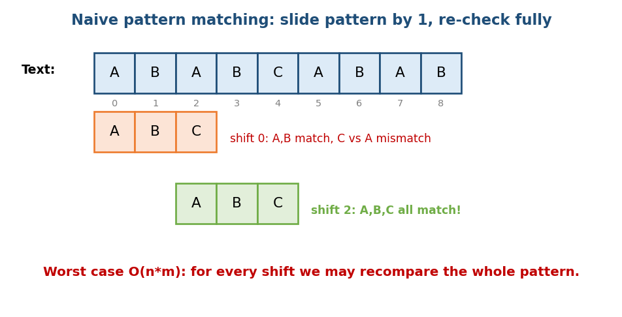
Naive matching: slide the pattern by one each time and re-check it fully against the text.
# BRUTE FORCE / NAIVE Time O(n*m) worst, Space O(1)
for shift = 0 .. n-m:
j = 0
while j < m and T[shift+j] == P[j]: j += 1
if j == m: report match at shift
- Worst case O(n·m): e.g. T = "aaaaaa…", P = "aaab" — every shift compares almost the whole pattern before failing.
- The waste: when a mismatch happens, naive throws away everything it just learned and restarts. KMP, Z, and Boyer-Moore each fix this waste differently.

3.4 Rabin-Karp (hashing for matching)

Idea
Instead of comparing the pattern to each window character by character, compare their hashes first (O(1)). Only when hashes match do a real character check (to rule out a collision). Use a rolling hash so each window’s hash updates in O(1).
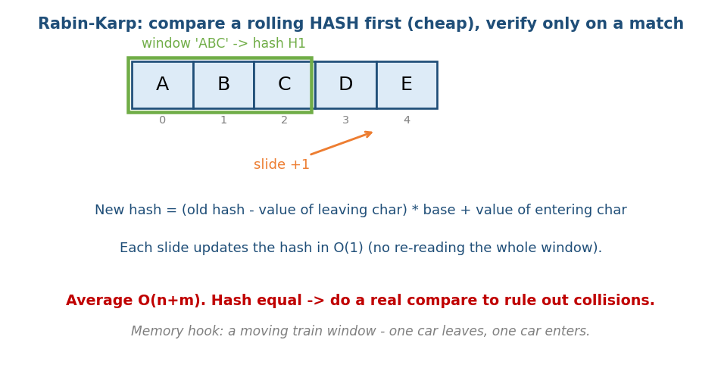
Rabin-Karp: keep a rolling hash of the text window; on a hash match, verify the actual characters.
# Rabin-Karp Avg O(n+m), worst O(n*m), Space O(1)
hp = hash(P)
hw = hash(T[0..m-1])
for shift = 0 .. n-m:
if hw == hp and T[shift..shift+m-1] == P: # verify on hash hit
report match
if shift < n-m:
hw = roll(hw, T[shift], T[shift+m]) # remove old char, add new char
- Rolling update: new = (old − leaving·b^(m-1))·b + entering (mod M).
- Average O(n+m); worst O(n·m) only with many hash collisions (rare with a good mod).
- Best for: multiple-pattern search, plagiarism/duplicate detection, 2D pattern search.
Memory hook: a moving train window — one car leaves the back, one enters the front; you don’t recount all the cars.

MCQs
- Rabin-Karp average time? → O(n+m).
- Why verify characters after a hash match? → to rule out a collision.

3.5 KMP (Knuth–Morris–Pratt)

The key insight
When a mismatch happens, we already know the characters that matched so far. KMP uses that knowledge to skip ahead without moving the text pointer backward. It precomputes an LPS array (Longest proper Prefix that is also a Suffix) for the pattern.
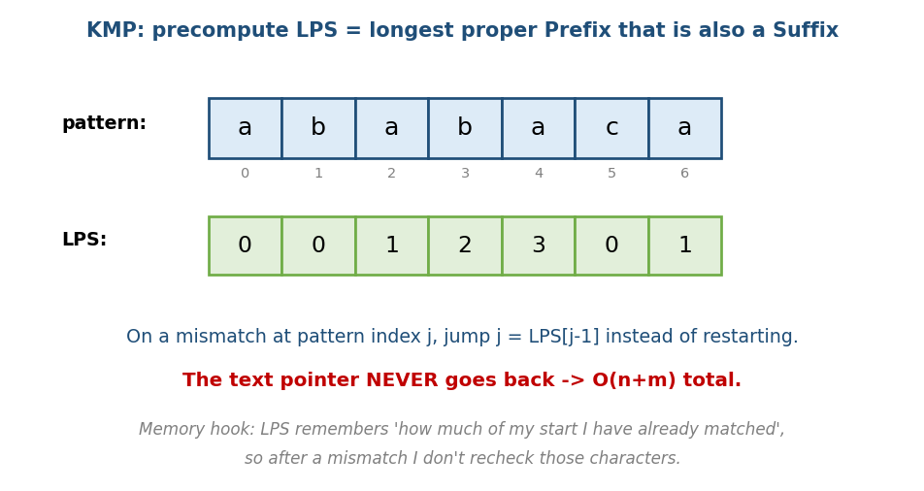
KMP LPS array: for each position, the length of the longest proper prefix that is also a suffix; mismatches jump using it.

What LPS means
LPS[i] = length of the longest proper prefix of P[0..i] that is also a suffix of P[0..i]. For P = "ababaca" → LPS = [0,0,1,2,3,0,1].
It answers: “if I fail after matching j characters, how many of them still form a valid prefix I can reuse?” — so I jump j = LPS[j-1] instead of restarting.

Brute force → Optimal
# BRUTE FORCE: naive matching O(n*m) (Section 3.3)
# OPTIMAL: KMP Build LPS O(m), search O(n) -> O(n+m)
build_lps(P):
lps = int[m]; length = 0; i = 1
while i < m:
if P[i] == P[length]: length += 1; lps[i] = length; i += 1
elif length > 0: length = lps[length-1] # fall back
else: lps[i] = 0; i += 1
search(T, P):
build lps; i = 0 (text); j = 0 (pattern)
while i < n:
if T[i] == P[j]: i += 1; j += 1
if j == m: report match at i-m; j = lps[j-1]
elif i < n and T[i] != P[j]:
if j > 0: j = lps[j-1] # jump using LPS, DON'T move i back
else: i += 1
- Why O(n+m): the text pointer i only ever moves forward.
- Memory hook: LPS remembers “how much of my own start I’ve already matched”, so after a mismatch I never recheck those characters.

MCQs
- What does KMP precompute? → the LPS / prefix function.
- KMP time? → O(n+m).
- On mismatch at pattern index j (j>0), set j = ? → LPS[j−1].

3.6 Z-Algorithm

Idea
The Z-array of a string: Z[i] = length of the longest substring starting at i that matches the prefix of the string. Build it in O(n) using a sliding [L,R] window (the “Z-box”).
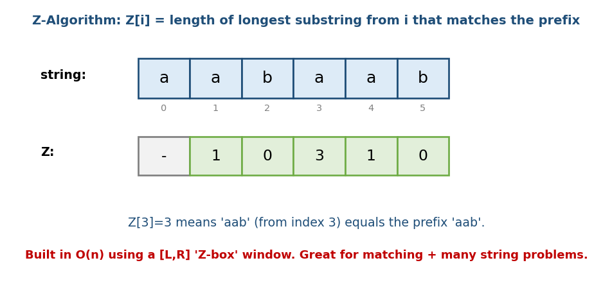
Z-array: each Z[i] is how far the substring from i matches the prefix; Z[3]=3 means ‘aab’ matches the prefix ‘aab’.

How to match with it
To find pattern P in text T: build the Z-array of P + '#' + T (a separator not in either). Any position where Z[i] == m (the pattern length) is a match.
# Z-based matching O(n+m) time, O(n+m) space
S = P + '#' + T
compute Z array of S
for each i: if Z[i] == m: match in T at (i - m - 1)
- KMP vs Z: both O(n+m). Z is often easier to code/remember; KMP is more standard in textbooks. Pick whichever you recall under pressure.

MCQs
- Z[i] measures? → match length with the prefix starting at i.
- Z-matching trick? → build Z of P + '#' + T, look for Z[i] == m.

3.7 Boyer-Moore (the fast one in practice)

Idea
Compare the pattern to the window right to left, and on a mismatch skip ahead by a lot using two heuristics:
- Bad character rule: align the mismatched text character with its last occurrence in the pattern (or skip past it entirely).
- Good suffix rule: reuse the suffix that already matched.

Why it matters
Boyer-Moore can be sub-linear in practice (it often skips characters it never even looks at) — which is why grep and many editors use it. Worst case is still O(n·m), but the average is excellent, especially for long patterns over large alphabets.
Interview takeaway: you usually won’t code full Boyer-Moore in an interview, but knowing “right-to-left + skip on mismatch → used by grep” is a great signal.

MCQs
- Boyer-Moore compares the pattern in which direction? → right to left.
- Which real tool famously uses it? → grep (and many text editors).

3.8 Trie (Prefix Tree)

Definition
A trie stores a set of strings as a tree where each edge is a character and each path from the root spells a prefix. Words that share a prefix share the same nodes. A flag marks the end of a complete word.
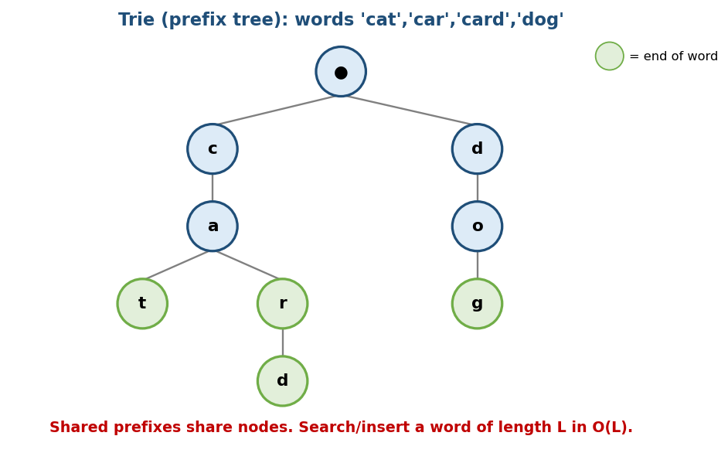
Trie storing cat, car, card, dog: shared prefixes share nodes; green nodes mark the end of a word.

Why it exists
A hashmap can check “is this exact word present?” But a trie also answers prefix questions instantly: “which words start with ca?”, “is ca a prefix of any word?” — perfect for autocomplete and spell-check.

Operations & complexity
insert(word): walk/create a node per character; mark last node as end
search(word): walk per character; true if path exists AND last node is end
startsWith(p): walk per character; true if the whole path exists
Operation | Time | Space
insert | O(L) | O(L·alphabet) per word worst case
search | O(L) | —
startsWith (prefix) | O(L) | —
(L = word length. Time does not depend on how many words are stored.)

Trie vs Hashmap (interview comparison)
 | Trie | Hashmap
Exact lookup | O(L) | O(L) average (to hash)
Prefix search | O(L) ✓ | not supported directly
Memory | more (many node pointers) | less
Ordering | sorted traversal possible | unordered
Memory hook: a trie is a shared family tree of prefixes — relatives (words) share ancestors (common starts).

Production usage
Autocomplete (search bars, IDEs), spell-checkers, IP routing tables, dictionary word games, and as a base for Aho-Corasick (multi-pattern search) and suffix trees (Module 8/17).

Common mistakes
- Forgetting the end-of-word flag → search("ca") wrongly true when only "cat" was inserted.
- Memory blow-up with 26-pointer arrays per node for sparse data → use a hashmap per node instead.

MCQs
- Trie search time for a word of length L? → O(L) (independent of word count).
- Prefix query a hashmap can’t do but a trie can? → startsWith / autocomplete.
- What marks a complete word in a trie? → the end-of-word flag.

Problems
- Medium: Implement Trie (LC 208); Replace Words (LC 648); Map Sum Pairs (LC 677); Design Add and Search Words (LC 211 — wildcard).
- Hard: Word Search II (LC 212 — trie + DFS on a grid); Stream of Characters (LC 1032).

3.9 Palindromes (a FAANG favourite)
A palindrome reads the same forwards and backwards ("racecar"). These are asked constantly at Google/Meta/Amazon, so know the three levels.

Check if a string is a palindrome — two pointers
# OPTIMAL Time O(n), Space O(1)
L = 0; R = n-1
while L < R:
if s[L] != s[R]: return false
L += 1; R -= 1
return true
(For “valid palindrome ignoring punctuation/case”, skip non-alphanumerics and lowercase as you go — LC 125.)

Longest Palindromic Substring — expand around centre
Intuition (memory hook — “grow from the middle”): every palindrome has a centre. There are 2n−1 centres (each character, and each gap between two characters). From each centre, expand outwards while both sides match.
# BRUTE FORCE: check every substring Time O(n^3)
for each (i,j): check if s[i..j] is a palindrome -> O(n^2) substrings * O(n) check
# OPTIMAL (interview standard): expand around centre Time O(n^2), Space O(1)
best = ""
for centre in 0 .. n-1:
expand(centre, centre) # odd-length palindrome
expand(centre, centre+1) # even-length palindrome
# expand(L,R): while L>=0 and R<n and s[L]==s[R]: grow; update best
# ADVANCED: Manacher's algorithm Time O(n)
# clever reuse of mirror info; rarely required to code, good to name-drop
- Interview note: “expand around centre” (O(n²)) is the expected answer; mentioning Manacher’s O(n) as the optimal shows depth.
- DP alternative: dp[i][j] = (s[i]==s[j]) and dp[i+1][j-1] — O(n²) time and space (covered in Module 14).
- Problems: Longest Palindromic Substring (LC 5); Palindromic Substrings count (LC 647); Valid Palindrome (LC 125); Palindrome Partitioning (LC 131 — backtracking, Module 13).

MCQs
- How many centres does expand-around-centre check? → 2n−1 (odd + even).
- Longest palindromic substring optimal time? → O(n) with Manacher (O(n²) expand-around-centre is the usual interview answer).

Module 3 — Concept Review (one page)
- A string is a char array; c - 'a' → 0–25 index; UTF-8 length ≠ byte length.
- Immutable strings: building with += in a loop is O(n²) → use a list/StringBuilder + join.
- Anagram/frequency → int[26] count, O(n)/O(1).
- Polynomial rolling hash → substring as a number; prefix hashing → O(1) substring compare; beware collisions.
- Naive matching O(n·m) wastes matched info. The fixes:
  - Rabin-Karp → rolling hash, avg O(n+m); great for multi-pattern.
  - KMP → LPS array, O(n+m); text pointer never goes back.
  - Z-algorithm → Z-array, O(n+m); often easiest to code.
  - Boyer-Moore → right-to-left + skip; sub-linear in practice (grep).
- Trie → tree of shared prefixes; insert/search/prefix all O(L); powers autocomplete.
- Palindromes → check with two pointers O(n); longest = expand around centre O(n²) (Manacher O(n)); 2n−1 centres.

Module 3 — Flash Cards
- Q: += in a loop on a string? A: O(n²); use join/StringBuilder.
- Q: Anagram check space (lowercase)? A: O(1), int[26].
- Q: What does KMP precompute? A: LPS (prefix function).
- Q: KMP / Z / Rabin-Karp time? A: O(n+m).
- Q: Rabin-Karp risk? A: hash collisions → verify on match.
- Q: Which matcher does grep use? A: Boyer-Moore (right-to-left skip).
- Q: Trie search time? A: O(L), independent of #words.
- Q: Prefix query structure? A: trie (hashmap can’t do prefixes).

Module 3 — Pattern Recognition
- “Count letters / anagrams / permutations of letters” → int[26] / hashmap.
- “Find a pattern in a text once” → KMP or Z (O(n+m)).
- “Compare many substrings / detect duplicates” → rolling hash.
- “Autocomplete / prefix / many words” → Trie.
- “Search many patterns at once” → Rabin-Karp / Aho-Corasick.
- “Longest/shortest substring with a condition” → sliding window (Module 2).
- “Palindrome / longest palindrome” → two pointers / expand around centre.

Module 3 — Interview Questions (with follow-ups)
- Check if two strings are anagrams. FU: Unicode? streaming?
- Find a substring in a string. FU: do it in O(n+m) → KMP/Z; explain LPS.
- Design autocomplete. FU: rank suggestions; memory at scale → trie (+heap).
- Detect a duplicate substring of length k. FU: rolling hash; collisions?
- Why is s += c in a loop slow? FU: fix it → join/StringBuilder.

Module 3 — GATE / SEBI / RBI / ISRO Perspective
- GATE favourites: computing the KMP LPS/failure function by hand, tracing naive vs KMP comparisons, and trie structure questions.
- Complexity: know naive O(nm) vs KMP/Z/Rabin-Karp O(n+m) cold.
- SEBI/RBI IT: conceptual MCQs on pattern matching and tries.

End of Module 3. Next: Module 4 — Linked Lists (singly/doubly/circular, fast & slow pointers, cycle detection, reversal, LRU cache) — with visuals.

