Module 4 — Linked Lists
  - DSA Mastery: Google / FAANG / GATE / ICPC — In-Depth Notes (with visuals)
Prepared for nidhi.sharma@forensiccybertech.com
2026
Table of Contents

Module 4 — Linked Lists
Why linked lists matter. An array stores items back-to-back, so inserting in the middle means shifting everything. A linked list stores each item in its own little box (a node) that also holds the address of the next box. Now inserting or deleting is just “rewire a couple of pointers” — O(1) — no shifting. The price: you lose O(1) random access (no arr[i]); to reach the 5th node you must walk from the start. Linked lists also teach pointer thinking, which powers trees and graphs later.
This module is P0 for interviews (pointer manipulation is a favourite test) and P0 for GATE (operations, complexity, and tracing).
How to read each technique. We go Brute force → Better → Optimal with pseudocode + complexity, plus a memory hook.

Quick technique selector
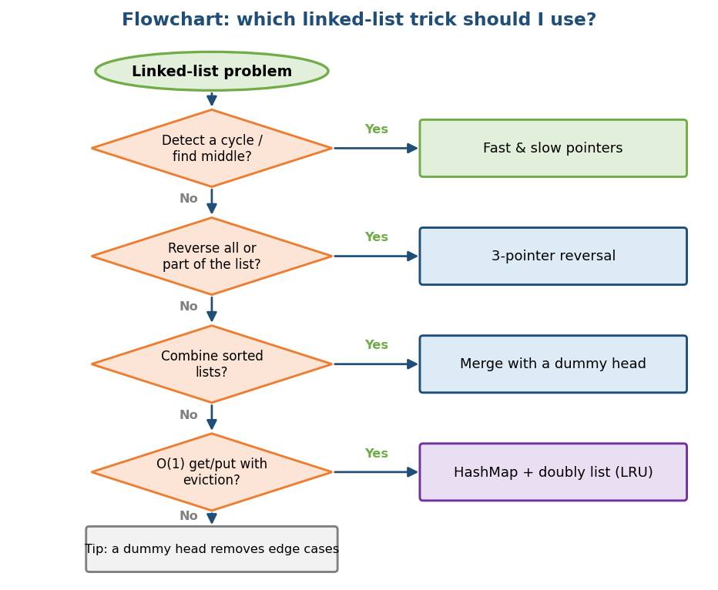
Flowchart: which linked-list trick to use — fast/slow, reversal, merge, or LRU.

4.1 What is a Linked List?

Definition
A linked list is a chain of nodes. Each node holds two things:
- data (the value), and
- next (the address/pointer of the next node).
The list is accessed through a head pointer (the first node). The last node’s next is NULL (nothing after it).
Memory hook: a treasure hunt — each clue (node) holds a value and tells you where to find the next clue. You must follow them in order; you cannot jump straight to clue #5.

Array vs Linked List (a key interview comparison)
 | Array | Linked List
Memory | one contiguous block | scattered nodes joined by pointers
Access i-th | O(1) (formula) | O(n) (must walk)
Insert/delete at front | O(n) (shift) | O(1) (rewire)
Insert/delete in middle | O(n) | O(1) if you already have the node
Extra memory | none | one pointer per node
Cache friendliness | great (contiguous) | poor (scattered → cache misses)
Interview line: “Use a linked list when you do many insert/deletes and rarely need random access; use an array when you need indexing and cache speed.” (Recall Module 1: arrays usually win on speed due to cache locality.)

MCQs
- Access the i-th element of a linked list? → O(n) (walk from head).
- Insert at the front of a linked list? → O(1).
- Why can arrays be faster than lists at the same O(n)? → cache locality.

4.2 Types of Linked Lists
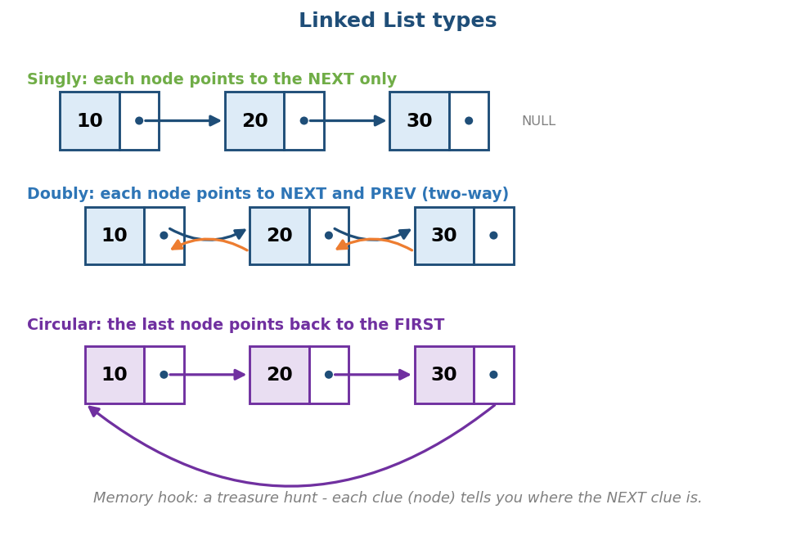
Three types: singly (next only), doubly (next + prev), circular (last points back to first).
- Singly linked: each node points to the next only. Light on memory; you can only go forward.
- Doubly linked: each node points to next and prev. Uses more memory but lets you go both ways and delete a node in O(1) when you have a pointer to it (you can reach its previous node). Used in LRU caches and browser history.
- Circular: the last node points back to the first. Great for round-robin scheduling and buffers.

The dummy (sentinel) node trick
A dummy head is a fake node placed before the real first node. It removes annoying “what if the list is empty / what if I delete the head” special cases, because every real node now always has a node before it.
Memory hook: a dummy node is a placeholder zero — like the extra 0 in a prefix-sum array (Module 2), it makes the edge cases disappear.

MCQs
- Which list lets you delete a known node in O(1)? → doubly linked.
- What problem does a dummy head solve? → head/empty edge cases.

4.3 Core Operations

Traversal, insert, delete
# Traverse O(n)
cur = head
while cur: visit(cur); cur = cur.next
# Insert after a node p O(1)
new.next = p.next
p.next = new
# Delete the node after p O(1)
p.next = p.next.next # (free the removed node in C/C++)

Edge cases & common mistakes (these are where interviews catch you)
- Losing the rest of the list: set the new node’s next before changing the previous node’s next. Order matters.
- NULL checks: always check cur and cur.next before using them.
- The head changing: inserting/deleting at the front changes head — return the new head (or use a dummy).
- Single node / empty list.

MCQs
- Insert/delete given the position pointer? → O(1).
- Best tool to avoid head edge cases? → a dummy node.

4.4 Reversing a Linked List

The idea
Walk the list and flip each next pointer to point backwards. You need three pointers: prev, cur, and nxt (to remember the rest before you overwrite).
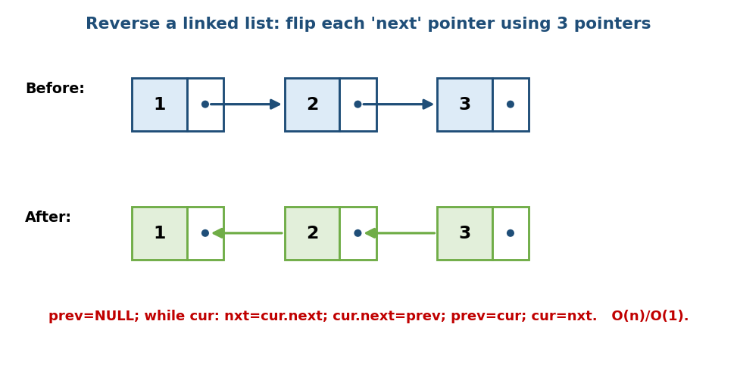
Reverse: use prev/cur/next to flip each arrow backwards, one node at a time.
# OPTIMAL: iterative reversal Time O(n), Space O(1)
prev = NULL; cur = head
while cur:
nxt = cur.next # save the rest
cur.next = prev # flip the pointer
prev = cur # advance prev
cur = nxt # advance cur
return prev # prev is the new head
# RECURSIVE version Time O(n), Space O(n) (call stack)
reverse(node):
if node is NULL or node.next is NULL: return node
newHead = reverse(node.next)
node.next.next = node # make the next node point back to me
node.next = NULL
return newHead
Memory hook: “save next → flip → step forward.” Say it out loud while coding; it prevents the classic lost-list bug.

Reverse in k-groups (a hard favourite)
Reverse the list in chunks of k (LC 25). Reverse the first k nodes, then recursively/iteratively connect to the reversed rest. Time O(n), Space O(1) (iterative). This tests whether you really understand the 3-pointer reversal.

MCQs
- Iterative reversal space? → O(1).
- Recursive reversal space? → O(n) (call stack).
- The three pointers used? → prev, cur, next.

Problems
- Easy: Reverse Linked List (LC 206).
- Medium: Reverse Linked List II / a sublist (LC 92); Swap Nodes in Pairs (LC 24).
- Hard: Reverse Nodes in k-Group (LC 25).

4.5 Fast & Slow Pointers (Tortoise and Hare)

The idea
Move two pointers at different speeds: slow by 1 node, fast by 2 nodes. This one trick solves a whole family of problems.
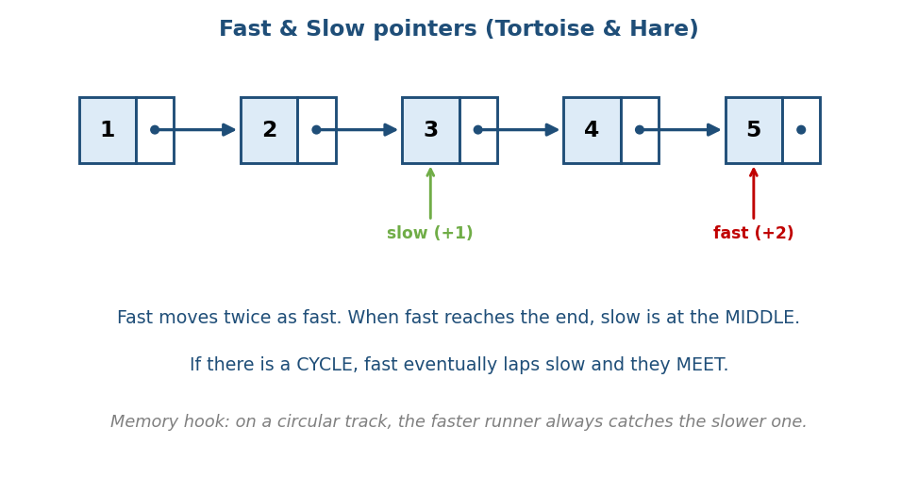
Fast & slow: fast moves 2 steps, slow moves 1; fast hits the end when slow is at the middle, and in a cycle they meet.

Use 1 — Find the middle node
When fast reaches the end, slow is exactly at the middle. One pass, O(n), O(1) space. (Used in “sort list”, “palindrome list”, etc.)

Use 2 — Detect a cycle (Floyd’s algorithm)
If the list has a loop, the fast pointer keeps going around and eventually laps the slow one — they meet. If fast reaches NULL, there is no cycle.
# Cycle detection Time O(n), Space O(1)
slow = fast = head
while fast and fast.next:
slow = slow.next
fast = fast.next.next
if slow == fast: return "cycle"
return "no cycle"
# Brute force alternative (for contrast) Time O(n), Space O(n)
seen = empty set
for each node: if node in seen: cycle; else add node
Floyd’s wins because it uses O(1) space instead of a hash set.

Use 3 — Find where the cycle starts
After slow and fast meet, reset one pointer to the head and move both one step at a time; they meet at the cycle’s start.
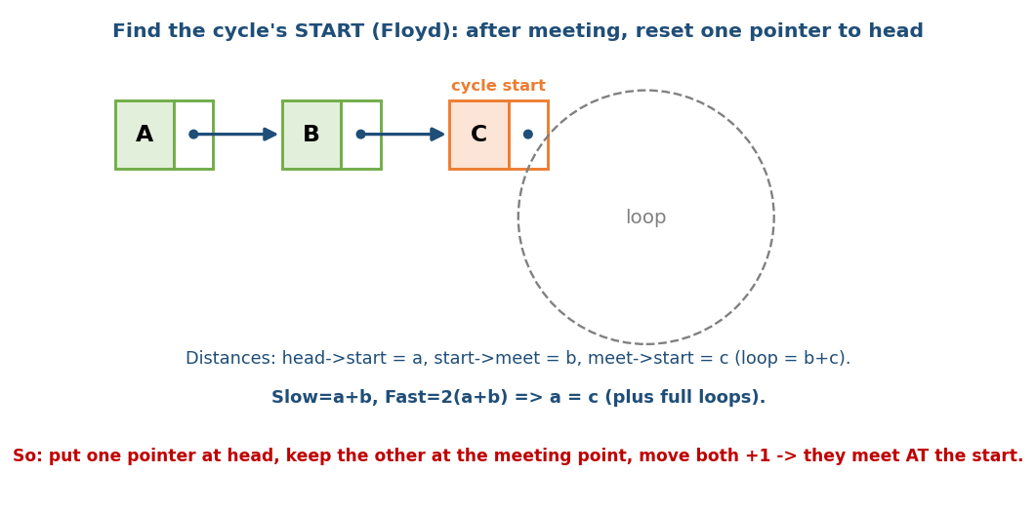
Why it works: with distances a (head→start), b (start→meet), c (meet→start), the math gives a = c, so resetting one pointer to head makes them meet at the start.
Why (short proof): let a = head→start, b = start→meeting point, c = meeting point→start (so loop length = b+c). Slow travelled a+b; fast travelled 2(a+b) and also a+b+(whole loops). Working it out gives a = c (plus full loops). So a pointer from the head and a pointer from the meeting point move the same distance to reach the start → they meet there.
Memory hook: on a circular running track, the faster runner always catches the slower one — and the leftover distance equals the head-to-start distance.

Use 4 — Palindrome linked list
Find the middle (fast/slow), reverse the second half, compare the two halves. O(n) time, O(1) space (LC 234).

MCQs
- Fast/slow space for cycle detection? → O(1).
- When fast hits the end, slow is at the? → middle.
- To find the cycle start, reset one pointer to? → the head, then move both by 1.

Problems
- Easy: Linked List Cycle (141); Middle of the List (876).
- Medium: Linked List Cycle II / start (142); Palindrome Linked List (234); Remove Nth Node From End (19 — two pointers k apart); Happy Number (202 — same trick on numbers!).

4.6 Merge Two Sorted Lists

The idea
Like the merge step of merge sort: keep a pointer to each list, repeatedly attach the smaller head to the result, and advance that list. Use a dummy head so you don’t special-case the first node.
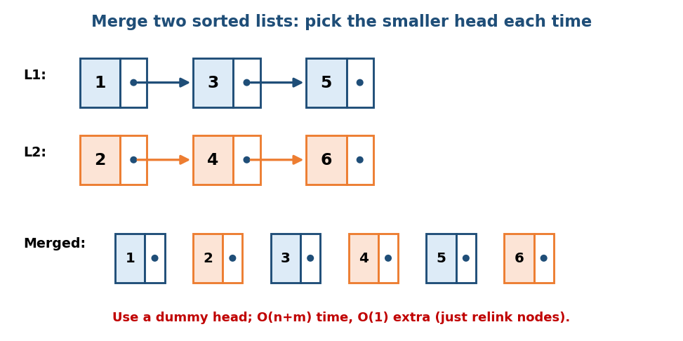
Merge two sorted lists: repeatedly pick the smaller of the two heads and relink it.
# OPTIMAL Time O(n+m), Space O(1)
dummy = new Node; tail = dummy
while L1 and L2:
if L1.val <= L2.val: tail.next = L1; L1 = L1.next
else: tail.next = L2; L2 = L2.next
tail = tail.next
tail.next = L1 if L1 else L2 # attach whatever is left
return dummy.next
- We relink existing nodes (no new data nodes) → O(1) extra space.
- Merge K sorted lists (LC 23): put the heads in a min-heap and always pull the smallest → O(N log k) (heaps come in Module 6/9).

MCQs
- Merge two sorted lists time? → O(n+m).
- Why a dummy head here? → avoids the first-node special case.

Problems
- Easy: Merge Two Sorted Lists (21).
- Hard: Merge k Sorted Lists (23); Sort List (148 — merge sort on a list, O(n log n)).

4.7 Application — LRU Cache (a top interview project)

The problem
Build a cache with a fixed capacity that supports get(key) and put(key, value) in O(1), and when full, evicts the Least Recently Used item.

The design (the classic answer)
Combine two structures:
- a HashMap key → node for O(1) lookup, and
- a Doubly Linked List ordered by recency: most recently used at the head, least recently used at the tail.
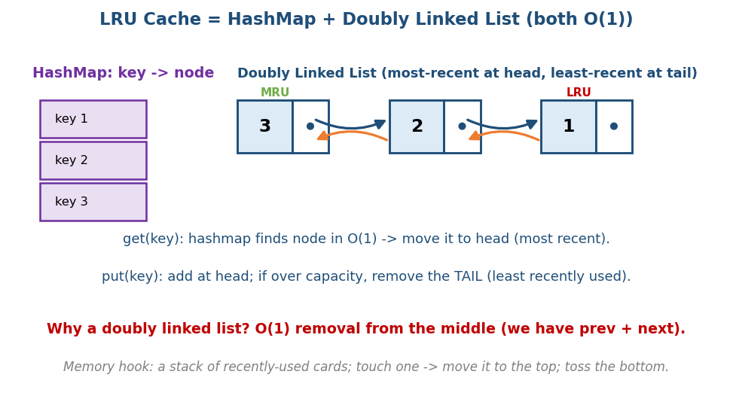
LRU cache = HashMap (O(1) find) + Doubly Linked List (O(1) move/evict); MRU at head, LRU at tail.
get(key):
if key not in map: return -1
node = map[key]; move node to head (most recent); return node.value
put(key, value):
if key in map: update value; move node to head
else:
if size == capacity: remove tail node; delete its key from map
create node at head; map[key] = node
- Why a doubly linked list? To remove a node from the middle in O(1), you need its previous node — a doubly linked list gives you that for free.
- Why the hashmap? Without it, finding a node would be O(n).
- Together: every operation is O(1).
Memory hook: a pile of recently-used cards — touch a card → move it to the top; when the pile is too tall → throw away the bottom card.
- LFU cache (LC 460): evict the least frequently used (harder — needs frequency buckets).

MCQs
- LRU cache uses which two structures? → HashMap + doubly linked list.
- Why doubly (not singly) linked? → O(1) removal from the middle.
- Where is the least-recently-used item? → at the tail.

Problems
- Medium: LRU Cache (146).
- Hard: LFU Cache (460); All O(1) Data Structure (432).

4.8 Other Classics (quick hits)
- Remove Nth node from end (LC 19): move one pointer n steps ahead, then move both together; when the front hits the end, the back is at the node to remove. One pass.
- Intersection of two lists (LC 160): two pointers that switch lists after reaching the end meet at the intersection (clever length-equaliser).
- Copy list with random pointer (LC 138): either a hashmap old → new, or the O(1)-space trick of weaving copies between originals.
- Add two numbers as lists (LC 2): walk both lists carrying a carry.

Module 4 — Concept Review (one page)
- A node = data + pointer to next; reach via head; last next = NULL.
- List vs array: list = O(1) insert/delete, O(n) access, poor cache; array = O(1) access, O(n) insert, great cache.
- Types: singly (forward), doubly (both ways, O(1) middle delete), circular (loops back). Dummy node kills edge cases.
- Reverse = save-next → flip → step forward (3 pointers), O(n)/O(1).
- Fast & slow (tortoise & hare): middle, cycle detect (Floyd, O(1) space), cycle start (reset to head), palindrome.
- Merge sorted = pick smaller head with a dummy, O(n+m).
- LRU cache = HashMap + doubly linked list → all O(1); evict the tail.

Module 4 — Flash Cards
- Q: Access i-th node? A: O(n). Insert at front? A: O(1).
- Q: Reverse a list — which pointers? A: prev, cur, next; O(1) space.
- Q: Detect a cycle in O(1) space? A: Floyd’s fast & slow.
- Q: Find the cycle start? A: after meeting, reset one pointer to head, move both +1.
- Q: Middle of a list in one pass? A: fast/slow.
- Q: Merge two sorted lists? A: dummy head, pick smaller, O(n+m).
- Q: LRU cache structures? A: HashMap + doubly linked list (O(1)).
- Q: Why doubly linked for LRU? A: O(1) middle removal.

Module 4 — Pattern Recognition
- “Cycle / middle / nth-from-end / palindrome list” → fast & slow pointers.
- “Reverse / reorder parts of a list” → 3-pointer reversal.
- “Combine sorted lists” → merge with a dummy head (k lists → min-heap).
- “O(1) get/put with eviction” → HashMap + doubly linked list (LRU).
- “Avoid head/empty special cases” → dummy node.

Module 4 — Interview Questions (with follow-ups)
- Reverse a linked list. FU: recursive too; reverse only nodes m..n.
- Detect a cycle. FU: find the start; prove why it works.
- Find the middle in one pass. FU: even length — which middle?
- Design an LRU cache. FU: why doubly linked? make it thread-safe?
- Merge k sorted lists. FU: complexity with a heap? → O(N log k).

Module 4 — GATE / SEBI / RBI / ISRO Perspective
- GATE favourites: time complexity of insert/delete/search at head/middle/end for singly vs doubly; tracing pointer updates; circular-list questions; “what does this pointer code do” snippets.
- Memory: doubly linked uses an extra pointer per node — sometimes asked.
- SEBI/RBI IT: conceptual MCQs (list vs array, types, complexity).

End of Module 4. Next: Module 5 — Stacks (monotonic stack, next greater element, largest rectangle in histogram, expression parsing) — with visuals.

