Module 5 — Stacks
  - DSA Mastery: Google / FAANG / GATE / ICPC — In-Depth Notes (with visuals)
Prepared for nidhi.sharma@forensiccybertech.com
2026
Table of Contents

Module 5 — Stacks
Why stacks matter. A stack is the simplest “remember and come back later” tool. It powers function calls (the call stack from Module 1!), undo buttons, expression evaluation, browser back, and — most importantly for interviews — the monotonic stack, which solves a whole family of “next greater / nearest smaller / largest rectangle” problems in O(n) that look O(n²) at first.
This module is P0. The monotonic stack is one of the highest-value interview patterns, and stacks/expression evaluation are common in GATE.
How to read each technique. We go Brute force → Better → Optimal with pseudocode + complexity, plus a memory hook.

Quick technique selector
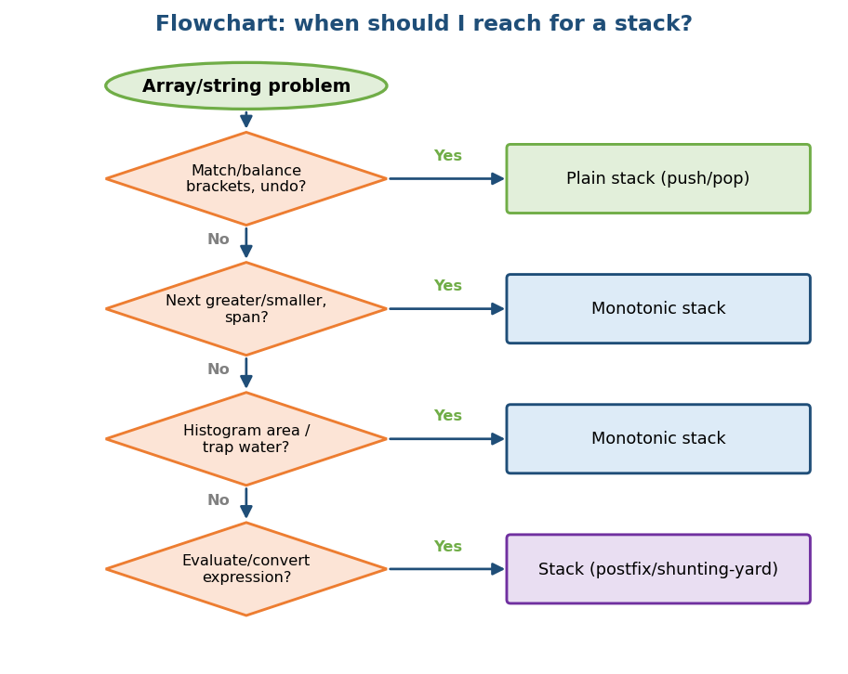
Flowchart: when to use a plain stack, a monotonic stack, or a stack for expressions.

5.1 Stack Fundamentals

Definition
A stack is a list where you add and remove only at one end (the top). This gives LIFO order: Last In, First Out. The two main operations are push (add to top) and pop (remove from top); peek/top looks at the top without removing.
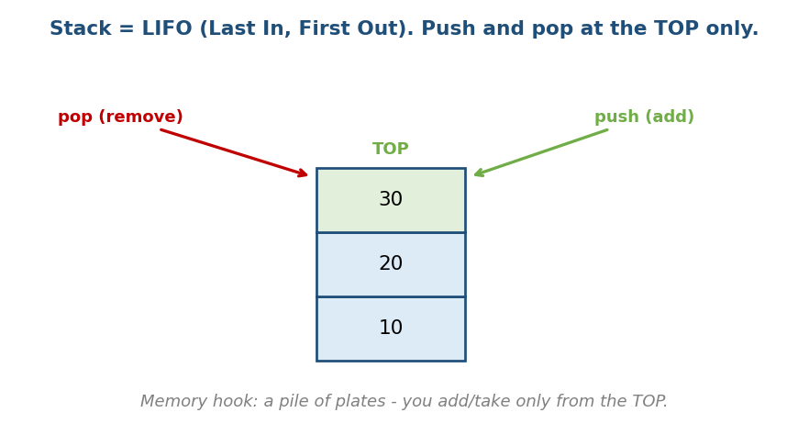
A stack is LIFO: push and pop happen only at the top, like a pile of plates.
Memory hook: a pile of plates — you put a new plate on top and take the top one off first. You never pull a plate from the middle.

Two ways to implement it
 | Array-based | Linked-list-based
push/pop | O(1) amortised (resize) | O(1) (add/remove at head)
Memory | contiguous, cache-friendly | a pointer per node
Downside | may resize | scattered memory
Both give O(1) push/pop. Arrays are usually preferred (cache locality — Module 1).

Where stacks are used (real life)
- Function calls (the call stack) — Module 1.
- Undo/redo in editors; browser back button.
- Expression evaluation and syntax checking in compilers.
- DFS (depth-first search) — Module 10 — is recursion = a stack.

Complexity
Operation | Time
push, pop, peek | O(1)
search | O(n)

MCQs
- Stack order? → LIFO.
- push/pop time? → O(1).
- Which traversal uses a stack? → DFS (recursion).

5.2 Valid Parentheses (the classic warm-up)

Problem
Given a string of brackets ()[]{}, decide if every opener has a correct, properly nested closer.

Idea
Scan left to right. Push every opener. On a closer, the top of the stack must be the matching opener — if it is, pop; if not (or the stack is empty), the string is invalid. At the end the stack must be empty.
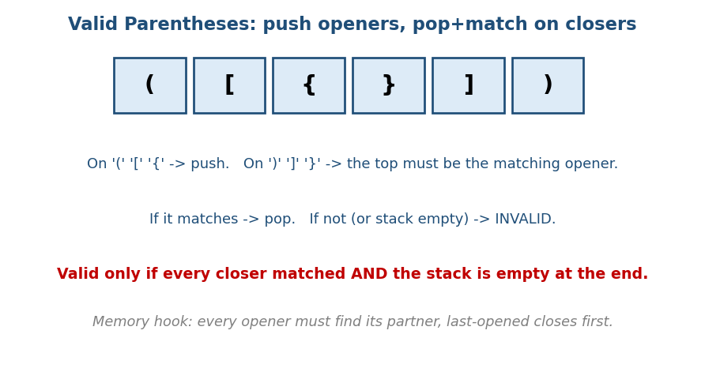
Valid parentheses: push openers, and each closer must match the top opener; the stack must end empty.
# OPTIMAL Time O(n), Space O(n)
match = { ')':'(' , ']':'[' , '}':'{' }
stack = []
for c in s:
if c is an opener: push c
else: # c is a closer
if stack empty or top != match[c]: return false
pop
return stack is empty
Memory hook: every opener must find its partner, and the last opened must be the first closed (LIFO).

MCQs
- What must be true at the end for validity? → the stack is empty.
- Time and space? → O(n) / O(n).

Problems
- Valid Parentheses (LC 20); Min Add to Make Valid (921); Remove Invalid Parentheses (301, hard); Longest Valid Parentheses (32, hard).

5.3 Expression Evaluation (infix, postfix, prefix)

The three notations
- Infix: 2 + 3 * 4 (operators between operands — what humans write; needs precedence and brackets).
- Postfix (RPN): 2 3 4 * + (operator after operands — what machines love; no brackets needed).
- Prefix: + 2 * 3 4 (operator before operands).

Evaluate postfix with a stack
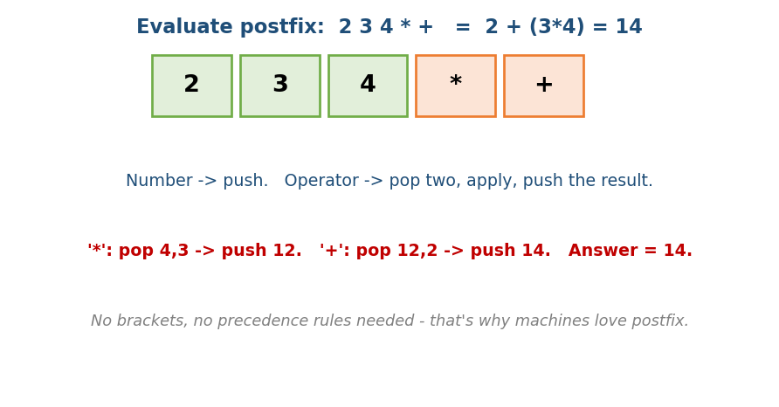
Evaluate postfix: push numbers; on an operator pop two, apply, and push the result.
# Evaluate postfix Time O(n), Space O(n)
stack = []
for token in expr:
if token is a number: push token
else: # an operator
b = pop; a = pop
push( apply(a, token, b) )
return pop
# "2 3 4 * +": push2, push3, push4, '*'->push12, '+'->push14 => 14

Convert infix → postfix (Shunting-Yard, by Dijkstra)
Use a stack to hold operators while you output operands:
for token in infix:
if operand: output it
if '(' : push
if ')' : pop to output until '('
if operator op:
while top is an operator with >= precedence: pop to output
push op
at end: pop all remaining operators to output
- Why postfix? No brackets, no precedence at evaluation time → a single stack pass. This is how calculators and compilers evaluate expressions.

MCQs
- Which notation needs no brackets? → postfix / prefix.
- On an operator in postfix evaluation, you pop how many operands? → two.
- Infix→postfix uses which algorithm? → Shunting-Yard.

Problems
- Evaluate Reverse Polish Notation (LC 150); Basic Calculator I/II/III (224/227/ 772); Decode String (394).

5.4 Monotonic Stack (the high-value pattern)

What it is
A monotonic stack keeps its elements in sorted order (always increasing, or always decreasing). Before pushing a new element, you pop everything that breaks the order. Those pops are exactly the answers to “what is the next/ previous greater/smaller element” — computed in O(n) total.
Key insight: each element is pushed once and popped once, so even though there is a while loop inside the for loop, the total work is O(n) (the same amortised idea as the sliding window in Module 2).

Next Greater Element
For each element, find the next element to its right that is bigger.
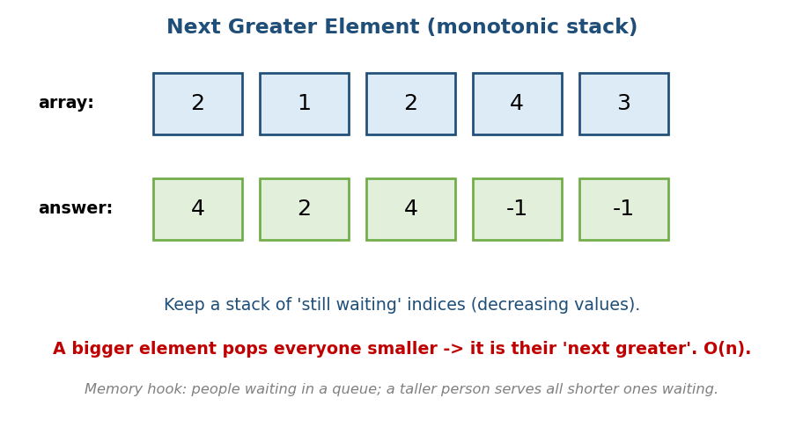
Next greater element: a decreasing stack of waiting indices; a bigger value pops and answers all smaller ones.
# BRUTE FORCE Time O(n^2), Space O(1)
for i in 0..n-1:
for j in i+1..n-1:
if a[j] > a[i]: answer[i] = a[j]; break
# OPTIMAL: monotonic (decreasing) stack Time O(n), Space O(n)
stack = [] # holds indices whose answer is still unknown
answer = [-1] * n
for i in 0..n-1:
while stack and a[stack.top] < a[i]:
answer[ stack.pop() ] = a[i] # a[i] is their next greater
stack.push(i)
return answer
Memory hook: people waiting in a line for “someone taller”. A tall person arriving serves (answers) everyone shorter who was waiting.

Variations (same template)
- Next smaller / previous greater / previous smaller: flip the comparison or scan right-to-left.
- Stock span (LC 901), daily temperatures (LC 739): “how many days until a warmer day” — same monotonic stack.

MCQs
- Monotonic stack total time? → O(n) (each element pushed/popped once).
- For “next greater”, the stack is kept? → decreasing.

Problems
- Daily Temperatures (739); Next Greater Element I/II (496/503); Online Stock Span (901); Remove K Digits (402); Sum of Subarray Minimums (907).

5.5 Largest Rectangle in Histogram (a hard favourite)

Problem
Given bar heights, find the area of the largest rectangle that fits inside the histogram.
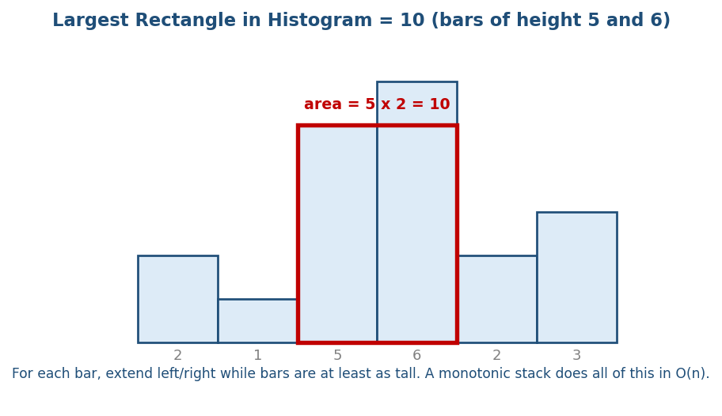
Largest rectangle in histogram: heights [2,1,5,6,2,3]; the best rectangle is height 5 across two bars = area 10.

Idea (why a stack)
For each bar, the biggest rectangle using that bar as the shortest one extends left and right until it hits a shorter bar. A monotonic increasing stack finds, for every bar, the nearest shorter bar on each side — in O(n).
# BRUTE FORCE Time O(n^2)
for each bar i: expand left & right while bars >= h[i]; area = h[i]*width
# OPTIMAL: monotonic increasing stack Time O(n), Space O(n)
stack = [] # indices with increasing heights
maxArea = 0
for i in 0..n: # one extra step with height 0
cur = (i == n) ? 0 : h[i]
while stack and h[stack.top] >= cur:
height = h[ stack.pop() ]
width = stack.empty ? i : i - stack.top - 1
maxArea = max(maxArea, height * width)
stack.push(i)
return maxArea
- The trailing height 0 flushes everything left in the stack at the end.
- Follow-up: “Maximal Rectangle” (LC 85) in a 0/1 matrix = run this histogram trick row by row.

Dry run (heights = [2,1,5,6,2,3] → answer 10)
When we reach the bar of height 2 (index 4), we pop 6 (area 6) and 5 (area 5 × 2 = 10). That 10 is the answer — a rectangle of height 5 over the two bars 5 and 6.

MCQs
- Largest-rectangle optimal time? → O(n) with a monotonic stack.
- Why push a final height of 0? → to flush the remaining bars.

Problems
- Largest Rectangle in Histogram (84); Maximal Rectangle (85).

5.6 Trapping Rain Water (stack / two-pointer)

Problem
Given an elevation map (bar heights), how much rain water is trapped between the bars?
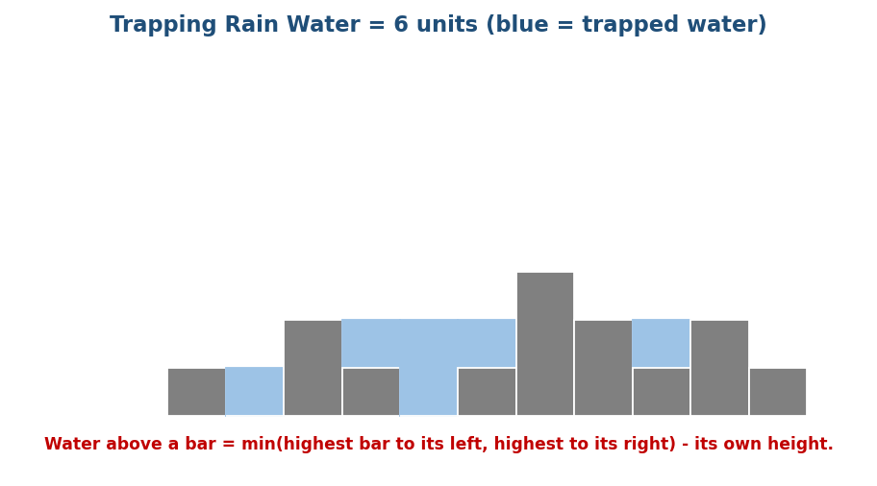
Trapping rain water: water above each bar = min(highest left, highest right) − its own height; total = 6.

Key formula
Water sitting on top of bar i = min(highestLeft[i], highestRight[i]) − h[i] (only if positive). Sum over all bars.
# BRUTE FORCE Time O(n^2)
for each i: leftMax = max(h[0..i]); rightMax = max(h[i..n-1])
water += max(0, min(leftMax,rightMax) - h[i])
# BETTER: precompute prefix max + suffix max Time O(n), Space O(n)
build leftMax[] and rightMax[]; then sum min(...) - h[i]
# OPTIMAL: two pointers Time O(n), Space O(1)
L=0; R=n-1; leftMax=rightMax=0; water=0
while L < R:
if h[L] < h[R]:
leftMax = max(leftMax, h[L]); water += leftMax - h[L]; L += 1
else:
rightMax = max(rightMax, h[R]); water += rightMax - h[R]; R -= 1
- A monotonic stack also solves it (add water layer by layer as bars pop).
- The two-pointer version is the cleanest: O(n) time, O(1) space.

MCQs
- Water above bar i? → min(leftMax, rightMax) − h[i].
- Optimal space for trapping rain water? → O(1) (two pointers).

Problems
- Trapping Rain Water (42); Container With Most Water (11 — two pointers, Module 2).

5.7 Min Stack — getMin() in O(1) (a common design question)

Problem
Design a stack that also returns its minimum element in O(1), alongside normal push/pop/top in O(1).

Idea
A normal stack can’t find its min without scanning (O(n)). The trick: keep a second stack that, at every level, stores the minimum so far. When you push x, also push min(x, currentMin). Now the min stack’s top is always the overall minimum.
# OPTIMAL All operations O(1), Space O(n)
push(x):
stack.push(x)
minStack.push( x if minStack empty else min(x, minStack.top) )
pop():
stack.pop(); minStack.pop()
top(): return stack.top
getMin(): return minStack.top
Memory hook: carry a “best score so far” sticker on every plate — the top sticker always shows the current minimum.
- Variation: store only when a new min appears (saves space), popping the min stack only when the popped value equals the current min.
- Problems: Min Stack (LC 155); Max Stack (LC 716).

Module 5 — Concept Review (one page)
- Stack = LIFO; push/pop/peek are O(1); used by call stack, undo, DFS, expression evaluation.
- Valid parentheses: push openers, match+pop on closers, end empty.
- Expressions: postfix needs no brackets → evaluate with one stack pass; infix→postfix via Shunting-Yard.
- Monotonic stack: keep increasing/decreasing order; each element pushed/ popped once → O(n). Solves next greater/smaller, stock span, daily temperatures.
- Largest rectangle in histogram: increasing stack, O(n); push a final 0 to flush.
- Trapping rain water: min(leftMax, rightMax) − h; best with two pointers O(1) space.

Module 5 — Flash Cards
- Q: Stack order & op cost? A: LIFO; O(1) push/pop/peek.
- Q: Valid string condition at the end? A: stack empty.
- Q: Postfix evaluation — operator pops how many? A: two.
- Q: Monotonic stack total time & why? A: O(n); each element pushed/popped once.
- Q: Next-greater uses which stack order? A: decreasing.
- Q: Largest rectangle trick? A: increasing stack + final height 0.
- Q: Trapping water optimal space? A: O(1) two pointers.
- Q: getMin() in O(1)? A: a second “min-so-far” stack.

Module 5 — Pattern Recognition
- “Balanced brackets / undo / valid nesting” → plain stack.
- “Next/previous greater or smaller, span, warmer day” → monotonic stack.
- “Histogram area / maximal rectangle” → monotonic (increasing) stack.
- “Trap water / two walls” → two pointers or stack.
- “Evaluate / convert an expression” → stack (postfix / Shunting-Yard).

Module 5 — Interview Questions (with follow-ups)
- Valid parentheses. FU: handle multiple bracket types; min insertions to fix.
- Daily temperatures / next greater. FU: prove it is O(n).
- Largest rectangle in histogram. FU: extend to a 0/1 matrix (LC 85).
- Trapping rain water. FU: do it in O(1) space.
- Evaluate an expression. FU: support brackets and precedence.

Module 5 — GATE / SEBI / RBI / ISRO Perspective
- GATE favourites: infix↔postfix↔prefix conversion and evaluation (very frequently asked), tracing stack push/pop sequences, “which output sequences are possible from a stack”, and stack-based DFS.
- SEBI/RBI IT: conceptual MCQs on LIFO, applications, and postfix evaluation.

End of Module 5. Next: Module 6 — Queues & Heaps intro (circular queue, deque, monotonic queue / sliding-window maximum, priority queue) — with visuals.

