Module 6 — Queues & Heaps (intro)
  - DSA Mastery: Google / FAANG / GATE / ICPC — In-Depth Notes (with visuals)
Prepared for nidhi.sharma@forensiccybertech.com
2026
Table of Contents

Module 6 — Queues & Heaps (intro)
Why queues and heaps together. A queue serves items in the order they arrived (FIFO) — the backbone of BFS, scheduling, and buffering. A heap (priority queue) always serves the most important item first, no matter when it arrived — the backbone of Dijkstra, top-K, and streaming medians. Together they cover “process in order” and “process by priority”, two of the most common needs in real systems and interviews.
This module is P0. Queues power BFS (Module 10); heaps power top-K, Dijkstra, and “K-th largest” — among the most asked interview patterns.
How to read each technique. We go Brute force → Better → Optimal with pseudocode + complexity, plus a memory hook.

Quick technique selector
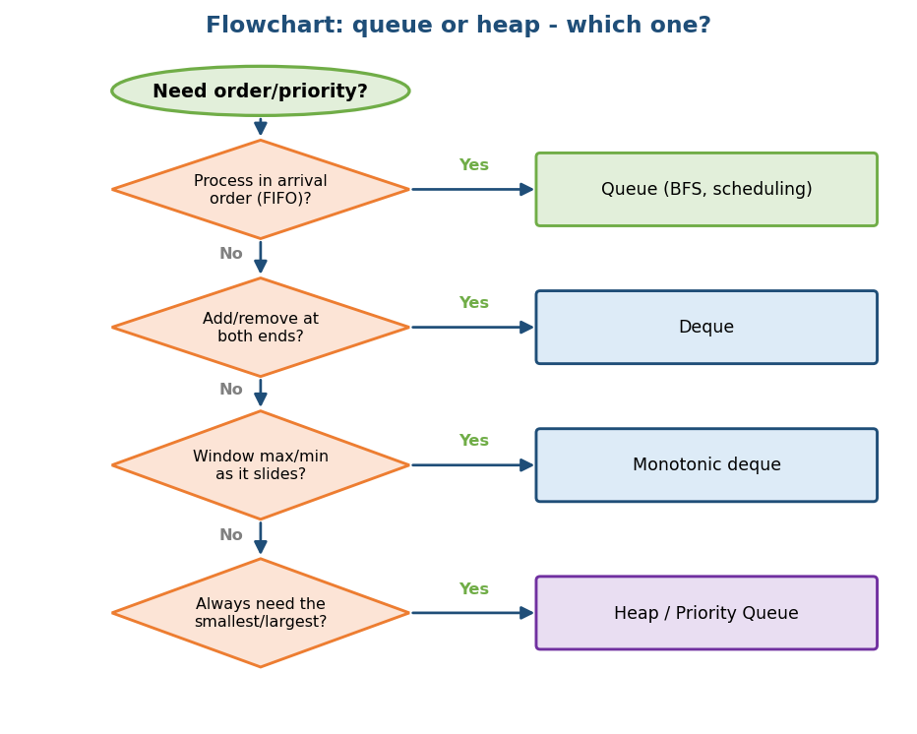
Flowchart: choose a queue, deque, monotonic deque, or heap based on the need.

6.1 Queue Fundamentals

Definition
A queue adds items at the rear and removes them from the front, giving FIFO order: First In, First Out. Core operations: enqueue (add at rear), dequeue (remove from front), front/peek.
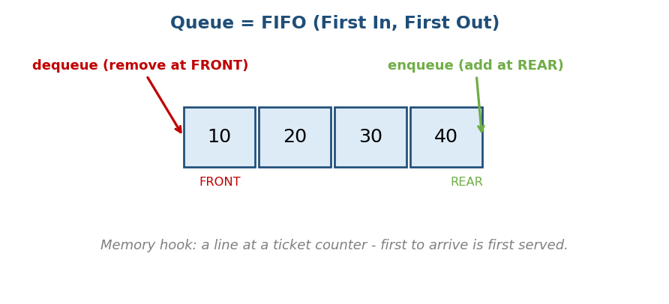
A queue is FIFO: enqueue at the rear, dequeue at the front, like a ticket line.
Memory hook: a line at a ticket counter — the first person to arrive is the first served. (Compare: a stack is a pile of plates, LIFO.)

Where queues are used
- BFS (breadth-first search) — Module 10.
- CPU / task scheduling, print queues, message queues (Kafka, RabbitMQ).
- Buffering streaming data (producer–consumer).

The problem with a simple array queue
If you dequeue by removing index 0 of an array, everything shifts → O(n). If you just move a front pointer forward without reusing space, the front of the array is wasted. The fix is a circular queue.

Complexity
Operation | Time
enqueue, dequeue, peek | O(1)
search | O(n)

MCQs
- Queue order? → FIFO.
- Which search uses a queue? → BFS.
- Dequeue by shifting an array costs? → O(n) (use a circular queue instead).

6.2 Circular Queue (ring buffer)

Idea
Treat the array as a circle: when rear reaches the end, it wraps back to index 0 using modulo. This reuses freed slots, so enqueue/dequeue stay O(1) with no shifting and no wasted space.
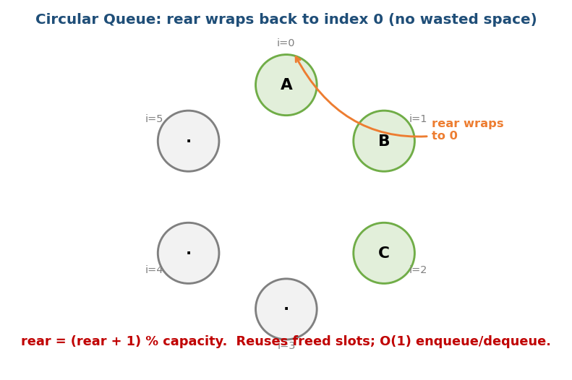
Circular queue: the rear wraps back to index 0 using modulo, reusing freed slots.
# Circular queue with a fixed capacity All ops O(1)
enqueue(x): if full -> reject
data[rear] = x; rear = (rear + 1) % capacity; size++
dequeue(): if empty -> reject
x = data[front]; front = (front + 1) % capacity; size--; return x
- Full vs empty both can look like front == rear — track a size counter (or leave one slot empty) to tell them apart. (Classic GATE trap.)
Memory hook: a circular running track — after the last lane you are back at lane 0.

Production usage
Ring buffers in audio/video streaming, network packet buffers, OS I/O buffers.

MCQs
- Circular queue wrap formula? → (index + 1) % capacity.
- How to distinguish full from empty? → keep a size counter (or leave one slot empty).

Problems
- Design Circular Queue (LC 622); Design Circular Deque (LC 641).

6.3 Deque (double-ended queue)

Idea
A deque lets you add and remove at both ends in O(1). It can act as a stack and a queue, and it is the engine behind the monotonic queue trick.
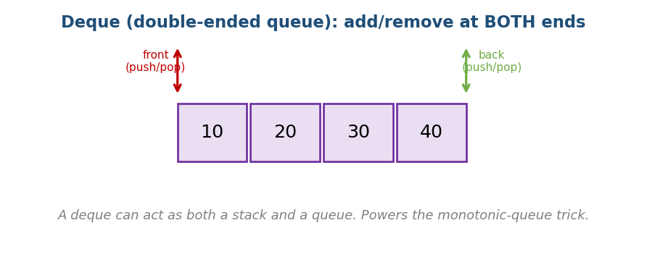
A deque allows push/pop at both the front and the back.
push_front, pop_front, push_back, pop_back # all O(1)

Queue using stacks / stack using queues (classic interview)
- Queue with two stacks: an in stack and an out stack. Push to in; to pop, if out is empty, pour everything from in into out (reversing order), then pop out. Amortised O(1).
- Stack with two queues: doable but one operation becomes O(n).

MCQs
- Deque op cost at both ends? → O(1).
- Queue from two stacks pop cost? → amortised O(1).

Problems
- Implement Queue using Stacks (LC 232); Implement Stack using Queues (LC 225); Design Circular Deque (LC 641).

6.4 Monotonic Queue → Sliding Window Maximum

Problem
Given an array and a window size k, find the maximum of every window as it slides. (The sliding-window sum was easy in Module 2; the maximum is harder because when the max leaves the window, you need the next-best instantly.)

Idea
Keep a deque of indices whose values are decreasing. The front is always the current window’s maximum. Before adding a new element, pop from the back every smaller value (they can never be the max while this bigger one is around). Also pop the front if it has slid out of the window.
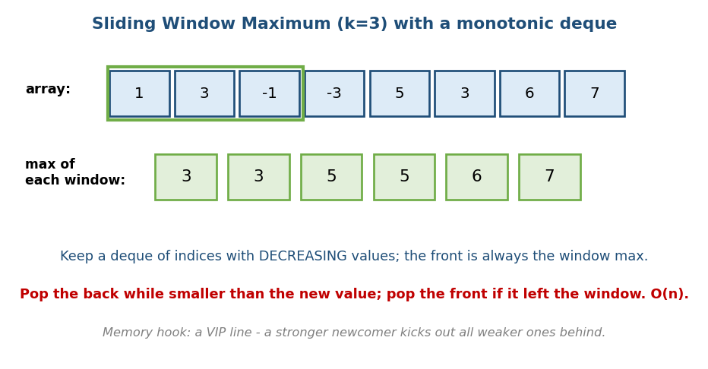
Sliding window maximum: a decreasing deque keeps the window max at its front; weaker values are popped from the back.
# BRUTE FORCE Time O(n*k)
for each window: scan k elements for the max
# OPTIMAL: monotonic deque Time O(n), Space O(k)
dq = deque of indices (values decreasing)
for i in 0..n-1:
if dq.front <= i - k: dq.pop_front() # drop indices out of window
while dq and a[dq.back] <= a[i]: dq.pop_back() # drop smaller values
dq.push_back(i)
if i >= k-1: output a[dq.front] # front is the window max
- Why O(n): each index is pushed once and popped once.
Memory hook: a VIP line — when a stronger person arrives, everyone weaker standing behind is sent away; the strongest is always at the front.

MCQs
- Sliding-window-maximum optimal time? → O(n) with a monotonic deque.
- The deque keeps values in what order? → decreasing (front = max).

Problems
- Sliding Window Maximum (LC 239); Shortest Subarray with Sum ≥ K (LC 862, hard); Jump Game VI (LC 1696).

6.5 Priority Queue & Binary Heap

What a heap is
A heap is a complete binary tree (filled level by level, left to right) with the heap property:
- Min-heap: every parent ≤ its children → the smallest is at the root.
- Max-heap: every parent ≥ its children → the largest is at the root.
A priority queue is the idea (“always give me the most important next”); a heap is the usual implementation.
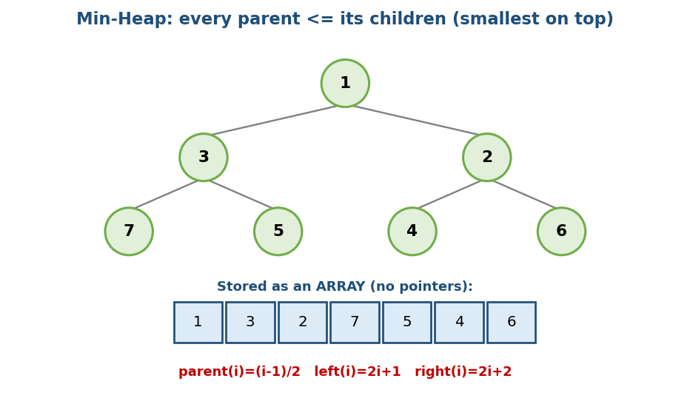
A min-heap is a complete tree where every parent is ≤ its children; stored compactly as an array.

Stored as an array (no pointers!)
Because the tree is complete, we store it in a plain array:
parent(i) = (i - 1) / 2 left(i) = 2i + 1 right(i) = 2i + 2
This is cache-friendly (Module 1) and needs no node pointers.

The two operations
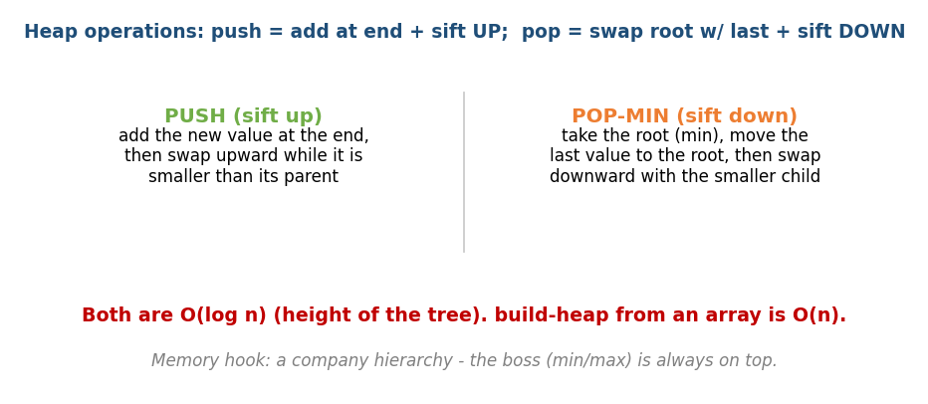
Heap push sifts a new value up; pop-min moves the last value to the root and sifts it down; both O(log n).
# push(x) O(log n)
add x at the end; while x < parent: swap up # "sift up"
# pop_min() O(log n)
save root (the min); move last element to root;
while it is bigger than its smaller child: swap down # "sift down"
return the saved min
- peek (min/max): O(1) — it’s the root.
- build-heap from an array: O(n) (not O(n log n)!) — a classic GATE result (the leaves need no work; only the upper nodes sift down a little).
- Heapsort: build a heap, then pop the root n times → O(n log n), in-place.
Memory hook: a company hierarchy — the boss (min or max) is always on top; promotions (sift up) and demotions (sift down) follow the chain.

Complexity summary
Operation | Time
peek (top) | O(1)
push / pop | O(log n)
build-heap | O(n)
heapsort | O(n log n)

MCQs
- Heap children of index i? → 2i+1 and 2i+2.
- build-heap time? → O(n).
- Min-heap root holds? → the minimum.

6.6 Heap Applications (the interview gold)

A) Top-K elements
Find the K largest (or smallest) elements.
# BRUTE FORCE: sort everything O(n log n)
sort, take the last K
# OPTIMAL: a heap of size K O(n log k), Space O(k)
keep a MIN-heap of size k (for K largest):
for x in arr:
push x; if heap size > k: pop the min
heap now holds the K largest
- Why a min-heap for K largest? The smallest of your current top-K sits at the root, ready to be kicked out when a bigger one arrives.

B) K-th largest / smallest
Same idea — the root of a size-K heap is the K-th largest (LC 215). Quickselect (Module 12) gives O(n) average as an alternative.

C) Merge K sorted lists/arrays
Put the first element of each of the K lists into a min-heap; repeatedly pop the smallest and push the next element from that list.
# Merge K sorted O(N log k) (N = total elements)
push the head of each list into a min-heap
while heap not empty:
pop smallest -> append to result; push the next node from that list

D) Median from a data stream (two heaps)
Keep a max-heap for the lower half and a min-heap for the upper half, balanced in size. The median is the top of one heap (odd total) or the average of both tops (even total). Each insert is O(log n); median is O(1). (LC 295.)
Memory hook: two heaps facing each other — the biggest of the small half and the smallest of the big half meet exactly at the median.

MCQs
- K largest elements efficiently? → a size-K min-heap, O(n log k).
- Merge K sorted lists time? → O(N log k).
- Streaming median structure? → two heaps (max-heap + min-heap).

Problems
- Kth Largest Element (215); Top K Frequent Elements (347); K Closest Points (973); Merge k Sorted Lists (23); Find Median from Data Stream (295); Task Scheduler (621).

Module 6 — Concept Review (one page)
- Queue = FIFO; enqueue rear, dequeue front, O(1); powers BFS & scheduling.
- Circular queue wraps with % capacity → O(1), no wasted space; track size to tell full from empty.
- Deque = both ends O(1); base for monotonic queue; queue-from-2-stacks is amortised O(1).
- Monotonic deque → sliding-window max/min in O(n) (decreasing deque, front = max).
- Heap / priority queue = complete tree, array-stored (2i+1, 2i+2); push/ pop O(log n), peek O(1), build O(n), heapsort O(n log n).
- Heap uses: Top-K (size-K heap, O(n log k)), K-th largest, merge K sorted (O(N log k)), streaming median (two heaps).

Module 6 — Flash Cards
- Q: Queue vs stack order? A: FIFO vs LIFO.
- Q: Circular queue wrap? A: (i+1) % capacity.
- Q: Sliding window max in O(n)? A: monotonic (decreasing) deque.
- Q: Heap children of i? A: 2i+1, 2i+2; parent (i-1)/2.
- Q: push/pop/peek/build costs? A: log n / log n / O(1) / O(n).
- Q: K largest efficiently? A: size-K min-heap, O(n log k).
- Q: Streaming median? A: two heaps (max-heap + min-heap).

Module 6 — Pattern Recognition
- “Process in arrival order / level-by-level (BFS)” → queue.
- “Add/remove at both ends” → deque.
- “Max/min of a sliding window” → monotonic deque.
- “Top-K / K-th largest / ‘closest K’” → heap (size K).
- “Always need the current smallest/largest” → priority queue.
- “Merge many sorted sequences” → min-heap of heads.
- “Median of a stream” → two heaps.

Module 6 — Interview Questions (with follow-ups)
- Implement a queue with two stacks. FU: prove amortised O(1).
- Sliding window maximum. FU: why O(n)? what does the deque store?
- K-th largest element. FU: heap vs quickselect trade-offs.
- Merge k sorted lists. FU: complexity with a heap? → O(N log k).
- Median from a data stream. FU: which heap holds which half?

Module 6 — GATE / SEBI / RBI / ISRO Perspective
- GATE favourites: circular-queue full/empty conditions and index formulas; heap array index formulas; build-heap is O(n) (not O(n log n)); heapsort complexity; number of swaps in heap operations; min/max-heap tracing.
- SEBI/RBI IT: conceptual MCQs on FIFO, priority queues, heap properties.

End of Module 6. Next: Module 7 — Hash Tables (hash functions, collisions: chaining vs open addressing, load factor, Bloom filters) — with visuals.

