Module 7 — Hash Tables
  - DSA Mastery: Google / FAANG / GATE / ICPC — In-Depth Notes (with visuals)
Prepared for nidhi.sharma@forensiccybertech.com
2026
Table of Contents

Module 7 — Hash Tables
Why hash tables are everywhere. A hash table gives O(1) average insert, delete, and lookup — the closest thing to magic in DSA. It is the secret weapon behind countless interview answers (“use a hashmap to go from O(n²) to O(n)”), and it underlies dictionaries, sets, database indexes, and caches. Knowing how it works (and when it degrades) separates a junior answer from a staff-level one.
This module is P0 for interviews (hashmap is the #1 optimisation tool) and P0 for GATE (collision strategies, load factor, probing).
How to read each technique. We go Brute force → Better → Optimal with pseudocode + complexity, plus a memory hook.

7.1 The Big Idea

Definition
A hash table stores key→value pairs in an array of buckets. A hash function turns a key into a bucket index: index = hash(key) % table_size. To find a key, you hash it again and jump straight to its bucket — no scanning.
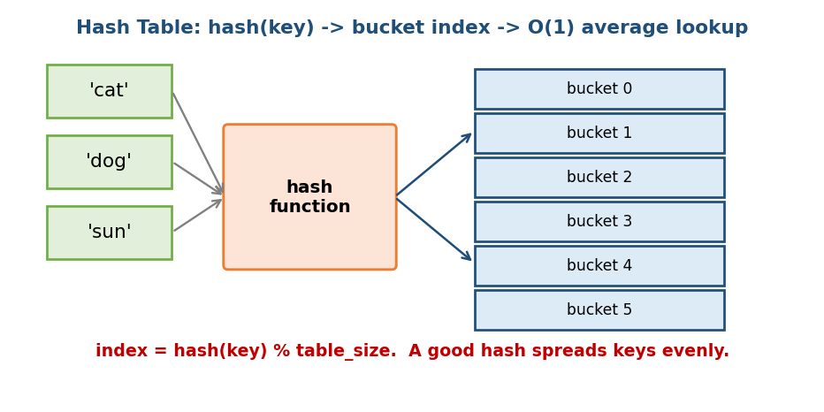
Hash table: a hash function maps each key to a bucket index for O(1) average lookup.
Memory hook: a library with a magic formula — instead of searching every shelf, the formula tells you the exact shelf for your book.

What makes a good hash function
- Deterministic — same key always gives the same index.
- Uniform — spreads keys evenly across buckets (few collisions).
- Fast — O(1) to compute.
For strings, the polynomial rolling hash from Module 3 is common.

Complexity (the headline)
Operation | Average | Worst case
insert / delete / search | O(1) | O(n) (all keys collide)
The worst case (everything in one bucket) is rare with a good hash + resizing, but adversarial inputs can trigger it (a real security topic: “hash flooding”).

MCQs
- Bucket index formula? → hash(key) % table_size.
- Average lookup time? → O(1).
- Three properties of a good hash? → deterministic, uniform, fast.

7.2 Collisions — when two keys want the same bucket
Two different keys can hash to the same index — a collision. There are two main ways to handle them.

Strategy 1 — Separate Chaining
Each bucket holds a list (or tree) of all keys that landed there. On collision, append to that bucket’s list.
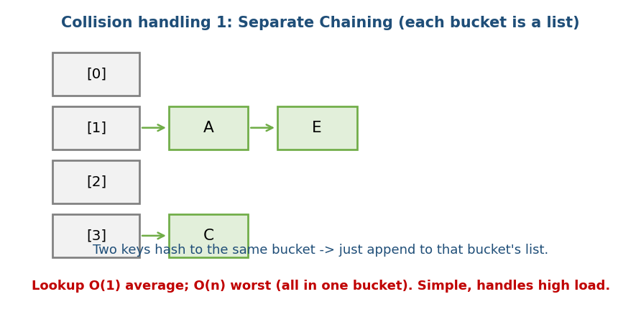
Separate chaining: each bucket is a linked list; colliding keys are appended.
- Pros: simple; handles a high load factor gracefully; easy deletes.
- Cons: extra memory for list pointers; poor cache locality.
- Java’s HashMap uses chaining, and converts a long chain to a balanced tree (O(log n)) to avoid worst-case O(n).

Strategy 2 — Open Addressing (probing)
Keep everything inside the array. On collision, probe for the next free slot:
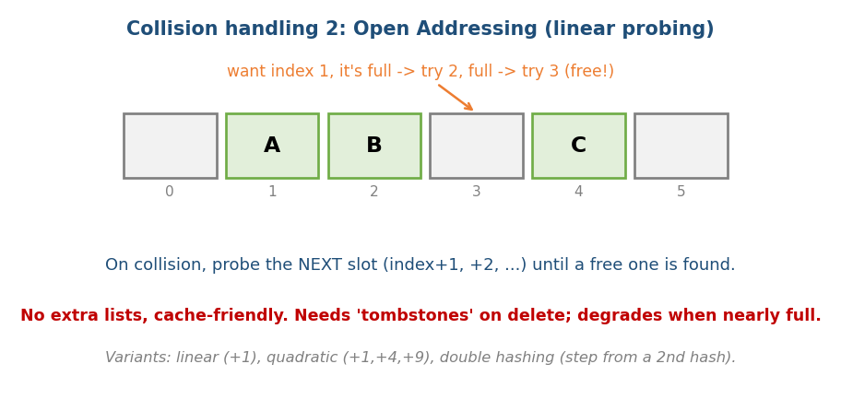
Open addressing (linear probing): on a collision, try the next slot until a free one is found.
- Linear probing: try i+1, i+2, … (cache-friendly but causes “clustering”).
- Quadratic probing: try i+1, i+4, i+9, … (less clustering).
- Double hashing: the step size comes from a second hash (best spread).
- Delete needs a “tombstone”: a special marker, because a truly empty slot would wrongly stop a future probe sequence.

Chaining vs Open Addressing (interview comparison)
 | Chaining | Open addressing
Memory | list pointers | none (in-array)
Cache | poor | good
High load factor | OK | degrades fast (keep α < ~0.7)
Delete | easy | needs tombstones

MCQs
- Two strategies for collisions? → chaining and open addressing.
- Why a tombstone in open addressing? → so deletes don’t break probe chains.
- Which is more cache-friendly? → open addressing.

7.3 Load Factor & Rehashing

Definition
Load factor α = (number of items) / (number of buckets). As α rises, collisions rise and operations slow down. When α crosses a threshold (e.g. 0.7 for open addressing, ~1 for chaining), the table rehashes: allocate a bigger array (usually 2×) and re-insert every item.
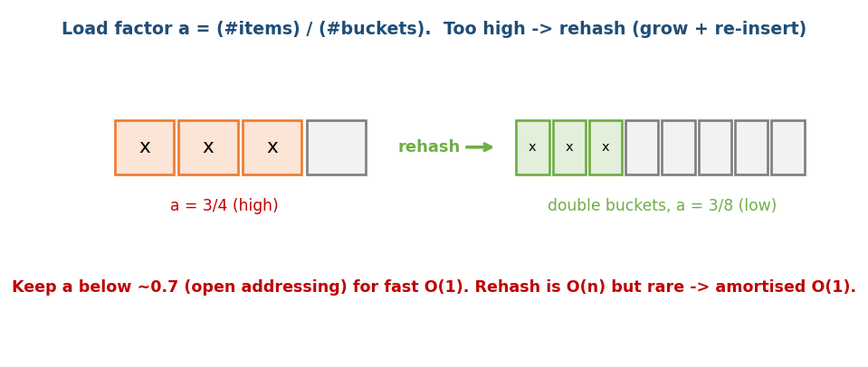
Load factor: when the table gets too full, it rehashes into a bigger array (doubling), lowering the load factor.
- Rehashing is O(n), but it happens rarely (like dynamic-array doubling, Module 2) → amortised O(1) per insert.
Memory hook: same as the dynamic array — when the room is too crowded, move to a hall twice as big and let everyone re-seat.

MCQs
- Load factor formula? → items / buckets.
- What happens at a high load factor? → rehash (grow + re-insert).
- Amortised insert cost despite O(n) rehash? → O(1).

7.4 Hash Table Applications (the interview workhorses)
The pattern is almost always: “a hashmap turns an O(n²) scan into O(n).”

Two Sum (the canonical example)
# BRUTE FORCE O(n^2)
for i, for j>i: if a[i]+a[j]==target: return (i,j)
# OPTIMAL: hashmap of seen values O(n) time, O(n) space
seen = {} # value -> index
for i, x in enumerate(a):
if target - x in seen: return (seen[target-x], i)
seen[x] = i
Why it helps: instead of searching for the complement, we remember every number we’ve seen, so each lookup is O(1).

Other classics
- Group Anagrams (LC 49): key = sorted word (or its 26-letter count); group by that key.
- Subarray Sum equals K (LC 560): store prefix sums in a hashmap; for each prefix P, check if P − k was seen (links Module 2 + Module 7).
- First unique character, frequency counts, dedup, two-list intersection — all hashmap/hashset in O(n).
- LRU Cache (Module 4): hashmap + doubly linked list.

MCQs
- Two Sum optimal time/space? → O(n) / O(n).
- “Subarray sum = k” tool? → prefix sum + hashmap.
- Group anagrams key? → sorted word or letter-count signature.

Problems
- Two Sum (1); Group Anagrams (49); Subarray Sum Equals K (560); Top K Frequent (347); Longest Consecutive Sequence (128); Contains Duplicate (217); LRU Cache (146).

7.5 Probabilistic Structures (Bloom Filter)

The idea
A Bloom filter is a tiny bit-array that answers “is x in the set?” with either “definitely NOT” or “maybe yes” — using far less memory than storing the items. It can give false positives but never false negatives.
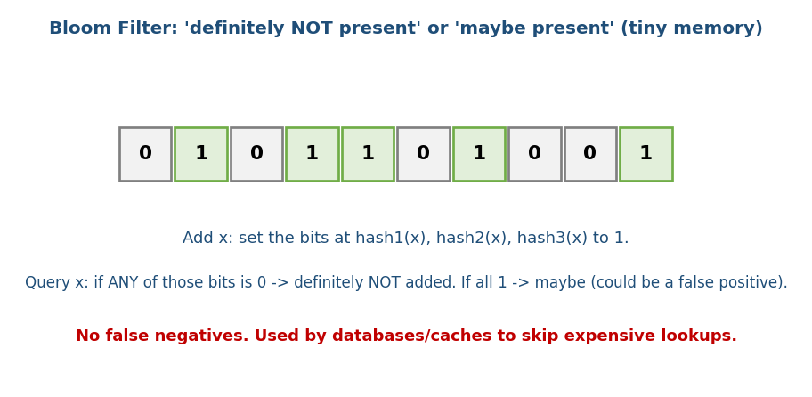
Bloom filter: several hashes set bits; if any bit is 0 the item is definitely absent, otherwise maybe present.
add(x): for each of k hash functions: set bit[ hash_i(x) ] = 1
query(x): if any bit[ hash_i(x) ] == 0 -> definitely NOT present
else -> maybe present (small false-positive chance)
- Use it to skip expensive work: databases (Cassandra, Bigtable) and caches check a Bloom filter first — if it says “not present”, they avoid a costly disk lookup.
- Cousins: Count-Min Sketch (approximate counts), HyperLogLog (approximate distinct-count) — great “system design + DSA” name-drops.
Memory hook: a bouncer with a fuzzy memory — “I’ve definitely never seen you” is reliable; “you look familiar” might be wrong.

MCQs
- Bloom filter error type? → false positives only (never false negatives).
- One real use? → skip disk lookups in databases/caches.

Module 7 — Concept Review (one page)
- Hash table = buckets + hash function; index = hash(key) % size; O(1) average, O(n) worst.
- Good hash = deterministic, uniform, fast.
- Collisions: chaining (bucket = list; cache-poor, high-load-friendly) vs open addressing (in-array probing; cache-good, needs tombstones, keep α<0.7).
- Load factor α = items/buckets; high α → rehash (2× + re-insert), amortised O(1).
- Applications: the universal “O(n²) → O(n)” tool — Two Sum, anagrams, subarray-sum-k (prefix+map), frequency, LRU.
- Bloom filter = bit-array, “definitely no / maybe yes”, false positives only.

Module 7 — Flash Cards
- Q: Hash table average op cost & worst? A: O(1) / O(n).
- Q: Two collision strategies? A: chaining, open addressing.
- Q: Why tombstones? A: keep probe chains intact after deletes.
- Q: Load factor & action when high? A: items/buckets; rehash (grow + re-insert).
- Q: Two Sum optimal? A: hashmap of seen, O(n).
- Q: Subarray sum = k? A: prefix sum + hashmap.
- Q: Bloom filter error? A: false positives only, never false negatives.

Module 7 — Pattern Recognition
- “Find a pair / complement / duplicate / count” → hashmap / hashset.
- “Subarray/substring sum or count = k” → prefix sum + hashmap.
- “Group things by a signature” → hashmap keyed by the signature.
- “Need O(1) get/put with recency” → hashmap + linked list (LRU).
- “Huge set, only need ‘probably present’” → Bloom filter.

Module 7 — Interview Questions (with follow-ups)
- Two Sum. FU: what if the array is sorted? → two pointers (Module 2).
- Design a hashmap from scratch. FU: collisions? resizing? load factor?
- Subarray sum equals K. FU: why does prefix-sum + map work?
- When does a hashmap degrade to O(n)? FU: how to defend (good hash, tree buckets)?
- Design a spell-checker / URL dedup at scale. FU: Bloom filter trade-offs.

Module 7 — GATE / SEBI / RBI / ISRO Perspective
- GATE favourites: linear/quadratic/double hashing probe sequences (trace where keys land), load factor effects, chaining vs open addressing, and “number of probes” calculations. Very frequently tested.
- SEBI/RBI IT: conceptual MCQs on hashing, collisions, and applications.

End of Module 7. Next: Module 8 — Trees (binary trees, BST, traversals, AVL / Red-Black, segment trees, Fenwick, Trie, B/B+ trees) — split across M08a & M08b, with visuals.

