Module 8a — Trees: Binary Trees & BST
  - DSA Mastery: Google / FAANG / GATE / ICPC — In-Depth Notes (with visuals)
Prepared for nidhi.sharma@forensiccybertech.com
2026
Table of Contents

Module 8a — Trees: Binary Trees & BST
Why trees matter so much. Arrays and lists are linear — one thing after another. A tree is the first hierarchical structure: it branches, like a family tree or a folder system. Trees give us O(log n) search/insert/delete (when balanced), power databases (B+ trees), file systems, compilers (parse trees), and a huge share of FAANG interview questions. This part covers binary trees, traversals, and the Binary Search Tree. Part M08b covers balancing (AVL, Red-Black) and range trees (Segment, Fenwick, B/B+).
This module is P0. Tree traversal and BST questions are interview staples and GATE favourites.
How to read each technique. Brute force → Better → Optimal with pseudocode + complexity, plus a memory hook.

8a.1 Tree Terminology

Definition
A tree is a set of nodes connected by edges, with exactly one root (top node) and no cycles. Each node has children below it and one parent above (except the root). A binary tree restricts each node to at most two children (left and right).
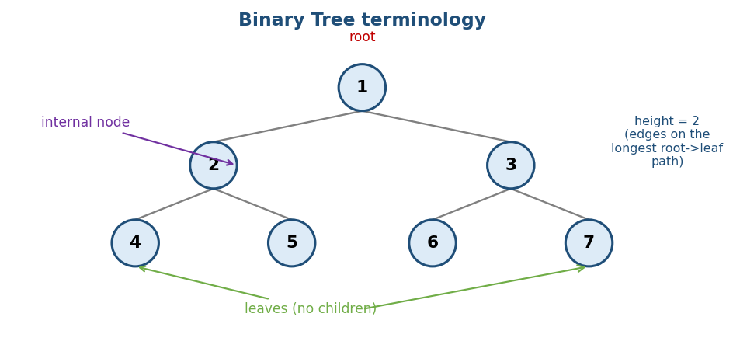
Binary tree terminology: root at top, internal nodes, leaves at the bottom, and height as the longest root-to-leaf path.
Term | Meaning
Root | the top node (no parent)
Leaf | a node with no children
Internal node | a node with at least one child
Depth of a node | edges from the root down to it
Height of a node | edges on the longest path down to a leaf
Height of tree | height of the root
Memory hook: an upside-down family tree — the ancestor (root) is on top, descendants branch downward; leaves are the youngest with no children.

Types of binary trees (know these names)
- Full: every node has 0 or 2 children.
- Complete: all levels full except possibly the last, filled left to right (this is what a heap uses — Module 6).
- Perfect: all internal nodes have 2 children and all leaves are at the same level.
- Balanced: height is O(log n) (no long thin branches).

Key fact (used everywhere)
A binary tree of height h has at most 2^(h+1) − 1 nodes; so n nodes need height ≥ log₂(n). Balanced ⇒ O(log n) height ⇒ fast operations. A degenerate tree (a straight line) has height n−1 → behaves like a linked list.

MCQs
- Max nodes in a binary tree of height h? → 2^(h+1) − 1.
- Which tree type does a heap use? → complete binary tree.
- Height of a balanced tree with n nodes? → O(log n).

8a.2 Tree Traversals
Visiting every node in some order. There are two families: DFS (depth-first, uses recursion/stack) and BFS (breadth-first, uses a queue).

DFS: preorder, inorder, postorder
The only difference is when you visit the root relative to its subtrees.
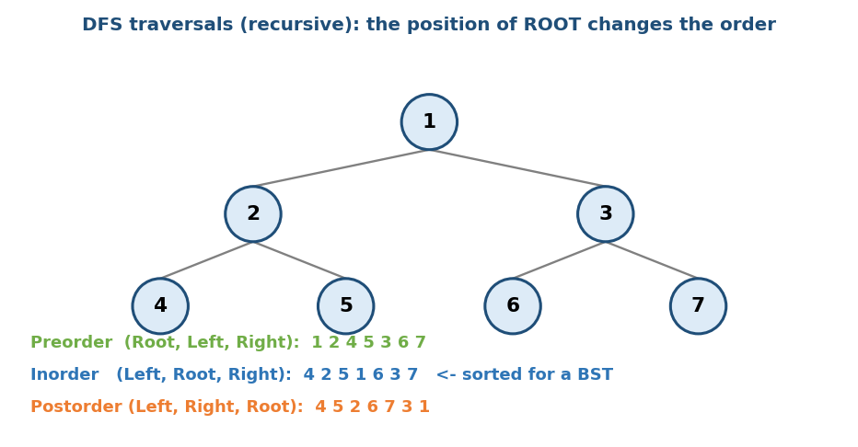
Three DFS orders on the same tree: preorder (Root,L,R), inorder (L,Root,R), postorder (L,R,Root).
preorder(node): visit(node); preorder(left); preorder(right) # Root first
inorder(node): inorder(left); visit(node); inorder(right) # Root middle
postorder(node): postorder(left); postorder(right); visit(node) # Root last
- Inorder of a BST gives sorted order — a hugely useful fact.
- Preorder is used to copy/serialize a tree; postorder to delete/free a tree (children before parent) or evaluate an expression tree.
- All are O(n) time, O(h) space (the recursion stack; h = height).
Memory hook: “pre/in/post” = where the Root sits: before, between, or after its children.

Iterative traversals (interview follow-up)
Any recursive traversal can be made iterative with an explicit stack (Module 1). Inorder iterative: push lefts, pop & visit, go right. Morris traversal even does inorder in O(1) space by temporarily threading the tree.

BFS: level-order (uses a queue)
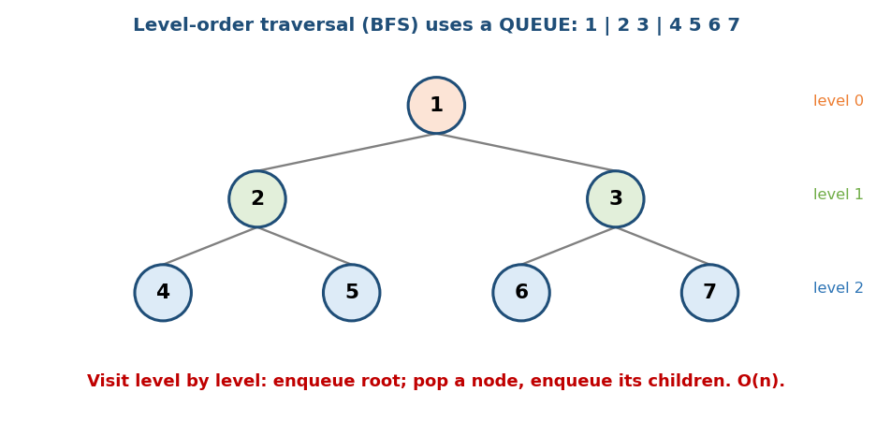
Level-order (BFS) visits the tree level by level using a queue.
# Level order Time O(n), Space O(n)
queue = [root]
while queue:
node = queue.pop_front()
visit(node)
if node.left: queue.push(node.left)
if node.right: queue.push(node.right)
- BFS is the tool for “level by level” questions: level averages, right-side view, zig-zag order, minimum depth.

MCQs
- Which traversal gives a BST in sorted order? → inorder.
- Level-order uses which structure? → a queue (BFS).
- Traversal space complexity (recursive)? → O(h).

Problems
- Binary Tree Inorder/Preorder/Postorder (94/144/145); Level Order (102); Zigzag Level Order (103); Right Side View (199); Max Depth (104); Diameter (543).

8a.3 Binary Search Tree (BST)

Definition
A BST is a binary tree with an ordering rule at every node:
all values in the left subtree < node’s value < all values in the right subtree.
This rule turns search into a series of “go left or go right” decisions.
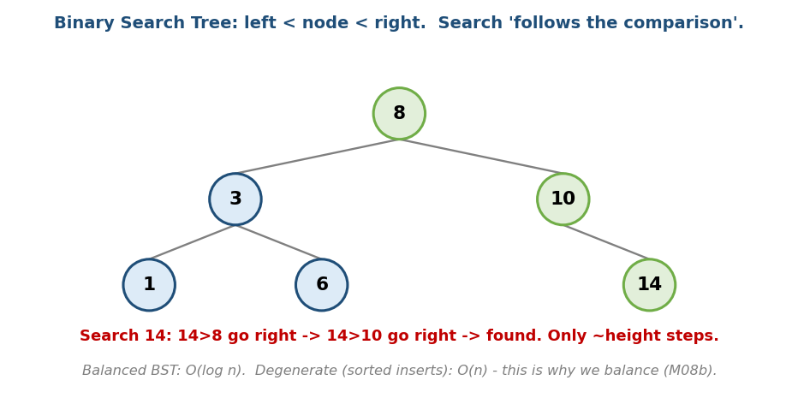
BST: left < node < right; searching for a value just follows the comparisons down one path.

Search / Insert (follow the comparison)
# Search / Insert O(h): O(log n) balanced, O(n) worst
search(node, key):
while node:
if key == node.val: return node
node = node.left if key < node.val else node.right
return null
# Insert: walk the same way; attach a new node where you fall off.
Memory hook: a BST is the “higher or lower?” guessing game — each comparison throws away half the remaining numbers (when balanced).

Delete (three cases)
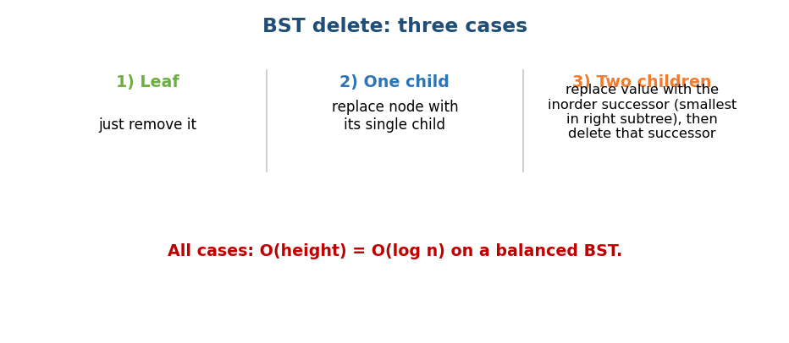
BST delete: leaf → just remove; one child → splice it in; two children → replace with inorder successor.
- Leaf: remove it.
- One child: replace the node with that child.
- Two children: replace the node’s value with its inorder successor (the smallest value in the right subtree), then delete that successor.

The catch: balance
A BST is only fast if it stays balanced. Inserting sorted data (1,2,3,4,5) makes a degenerate “linked list” → O(n). The fix is self-balancing trees (AVL, Red-Black) — Module M08b.

BST complexity
Operation | Balanced | Worst (degenerate)
search / insert / delete | O(log n) | O(n)

Classic BST interview problems
- Validate BST (LC 98): inorder must be strictly increasing (or pass min/max bounds down). Common bug: only checking immediate children, not the whole subtree range.
- Kth smallest (LC 230): inorder traversal, stop at k.
- Lowest Common Ancestor in a BST (LC 235): walk down; the split point (where one target is left and the other right) is the LCA — O(h).

MCQs
- BST search time when balanced vs degenerate? → O(log n) vs O(n).
- How to validate a BST? → inorder is strictly increasing (or min/max bounds).
- Two-children delete uses the? → inorder successor.

Problems
- Validate BST (98); Kth Smallest (230); LCA of BST (235); Insert/Delete/Search in BST (701/450/700); Convert Sorted Array to BST (108); Range Sum of BST (938).

8a.4 Common Binary-Tree Problems (patterns)
Most tree problems are solved with recursion that returns info up from the children (“postorder thinking”):
# Template: solve children first, then combine
solve(node):
if node is null: return base_value
L = solve(node.left)
R = solve(node.right)
return combine(L, R, node)
- Max depth / height (104): 1 + max(L, R).
- Diameter (543): longest path = best L_height + R_height over all nodes.
- Balanced check (110): return height, mark unbalanced if |L−R| > 1.
- Max path sum (124, hard): at each node, node + max(0,L) + max(0,R) is a candidate; return node + max(0, max(L,R)) upward.
- Lowest Common Ancestor (236): return the node where left and right searches both succeed.
- Serialize / Deserialize (297): preorder with null markers.
Memory hook: “ask the children, then decide” — almost every tree problem is postorder: gather answers from both subtrees, combine at the current node.

MCQs
- Tree height recurrence? → 1 + max(left, right).
- Diameter at a node uses? → left height + right height.
- Most tree problems follow which traversal style? → postorder (children first).

8a.5 Reconstructing a Tree from Traversals (a FAANG favourite)

The idea
Given two traversals, rebuild the unique tree. Preorder (or postorder) tells you the root; inorder tells you which nodes fall in the left vs right subtree. (Inorder is essential — preorder+postorder alone is not enough for a general binary tree.)
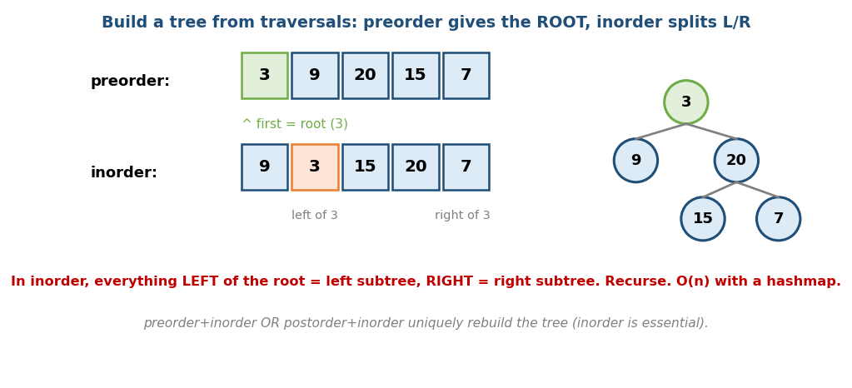
Build tree from preorder + inorder: preorder’s first element is the root; inorder splits left/right subtrees.
# Build from preorder + inorder Time O(n), Space O(n)
root = preorder[0] # first preorder element
i = index of root in inorder # use a hashmap: value -> index
left subtree = build(next preorder slice, inorder[:i])
right subtree = build(rest preorder slice, inorder[i+1:])
- The hashmap (value → inorder index) turns the repeated “find root in inorder” search from O(n) into O(1), giving overall O(n).
Memory hook: preorder shouts “I’m the root!”; inorder quietly says “these are on my left, those on my right.”

MCQs
- Which traversal identifies the root? → preorder (first) / postorder (last).
- Which traversal splits left/right subtrees? → inorder.
- Build time with a hashmap? → O(n).

Problems
- Construct Binary Tree from Preorder & Inorder (LC 105); from Inorder & Postorder (LC 106); from Preorder & Postorder (LC 889, not unique in general).

Module 8a — Concept Review (one page)
- Tree = hierarchical, one root, no cycles; binary = ≤ 2 children.
- Height h ⇒ ≤ 2^(h+1)−1 nodes; balanced ⇒ height O(log n).
- DFS traversals differ by root position: pre (R,L,R), in (L,R,R… i.e. L,Root,R), post (L,R,Root). Inorder of a BST = sorted. All O(n), O(h) space.
- BFS / level-order uses a queue → “level by level” problems.
- BST: left < node < right; search/insert/delete O(h); delete has 3 cases (leaf / one child / two children → inorder successor).
- BST degenerates to O(n) on sorted input → need balancing (M08b).
- Most tree problems = postorder recursion: combine children’s answers.

Module 8a — Flash Cards
- Q: Inorder of a BST? A: sorted order.
- Q: Level-order structure? A: queue (BFS).
- Q: Traversal time/space? A: O(n) / O(h).
- Q: BST search balanced vs worst? A: O(log n) vs O(n).
- Q: Validate a BST? A: inorder strictly increasing / min-max bounds.
- Q: Two-children delete? A: replace with inorder successor.
- Q: Tree height recurrence? A: 1 + max(L, R).

Module 8a — Pattern Recognition
- “Sorted output / kth smallest in a BST” → inorder.
- “Level by level / shortest path in an unweighted tree” → BFS (queue).
- “Height / diameter / balanced / path sum” → postorder recursion.
- “Copy or serialize a tree” → preorder.
- “Find a value fast in a dynamic ordered set” → BST (balanced).

Module 8a — Interview Questions (with follow-ups)
- Inorder traversal — recursive and iterative. FU: O(1) space (Morris)?
- Validate a BST. FU: why is checking only children wrong?
- Lowest common ancestor. FU: BST version vs general binary tree.
- Diameter / max path sum. FU: why postorder?
- Level order / right-side view. FU: do it in one BFS pass.

Module 8a — GATE / SEBI / RBI / ISRO Perspective
- GATE favourites: number of nodes/height relations, counting binary trees (Catalan numbers — Module 16), traversal output given a tree (and reconstructing a tree from two traversals), BST insert/delete tracing.
- SEBI/RBI IT: conceptual MCQs on traversals, BST properties, tree height.

End of Module 8a. Next: Module 8b — Balanced & Range Trees (AVL rotations, Red-Black trees, Segment Tree, Fenwick/BIT, B & B+ trees) — with visuals.

