Module 8b — Trees: Balanced & Range Trees
  - DSA Mastery: Google / FAANG / GATE / ICPC — In-Depth Notes (with visuals)
Prepared for nidhi.sharma@forensiccybertech.com
2026
Table of Contents

Module 8b — Trees: Balanced & Range Trees
Why this part matters. M08a showed that a BST is fast only when balanced — sorted inserts turn it into a slow O(n) chain. This part shows the self-balancing trees (AVL, Red-Black) that guarantee O(log n) forever, and the range-query trees (Segment, Fenwick) and disk-based trees (B, B+) that power competitive programming and real databases.
This module is P1–P2: AVL/Red-Black and segment/Fenwick are GATE + CP favourites; B/B+ trees are core for DBMS exams and system-design interviews.
How to read each technique. Brute force → Better → Optimal with pseudocode + complexity, plus a memory hook.

8b.1 AVL Trees (height-balanced BST)

The idea
An AVL tree is a BST that keeps itself balanced after every insert/delete. For each node it tracks a balance factor:
balance factor = height(left subtree) − height(right subtree)
It must stay in {−1, 0, +1}. If an insert/delete pushes it to ±2, a rotation restores balance.
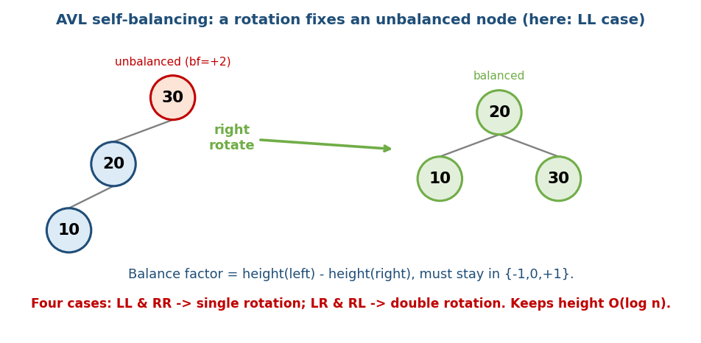
AVL rotation: a left-heavy (LL) node is fixed by a single right rotation, restoring balance.

The four rotation cases
Case | Shape | Fix
LL | left-left heavy | single right rotation
RR | right-right heavy | single left rotation
LR | left-right heavy | left rotate child, then right rotate
RL | right-left heavy | right rotate child, then left rotate
Memory hook: the case name tells you the heavy path; “single” rotations fix straight lines (LL/RR), “double” rotations fix zig-zags (LR/RL).

Complexity
Operation | Time
search / insert / delete | O(log n) guaranteed
AVL stays strictly balanced (height ≈ 1.44 log n), so lookups are very fast. The cost: more rotations on insert/delete than a Red-Black tree.

MCQs
- AVL balance factor allowed values? → −1, 0, +1.
- LL imbalance fix? → single right rotation.
- AVL guaranteed height? → O(log n).

8b.2 Red-Black Trees (the practical balancer)

The idea
A Red-Black tree is a BST where each node is coloured red or black, and a set of colour rules keeps it roughly balanced — height ≤ 2·log₂(n+1).
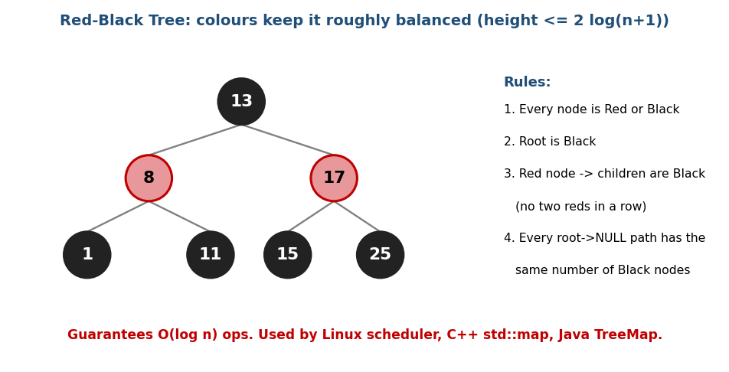
Red-Black tree: colour rules (no two reds in a row, equal black-height on every path) keep it balanced.

The five rules
- Every node is red or black.
- The root is black.
- All leaves (NULL) are black.
- A red node’s children are black (no two reds in a row).
- Every path from a node down to a NULL leaf has the same number of black nodes (the “black height”).

AVL vs Red-Black (a great interview comparison)
 | AVL | Red-Black
Balance | strict (faster lookups) | looser (taller, but fine)
Insert/delete | more rotations | fewer rotations
Best for | lookup-heavy | insert/delete-heavy
Real use | databases (some) | Linux scheduler (CFS), std::map, Java TreeMap
Memory hook: Red-Black trades a little extra height for fewer rotations, which is why general-purpose libraries prefer it.

MCQs
- Can a red node have a red child? → no.
- What is equal on every root-to-leaf path? → the black height.
- Which real systems use Red-Black trees? → Linux CFS, C++ std::map, Java TreeMap.

8b.3 Segment Tree (range queries + updates)

The problem it solves
Recall (Module 2): a prefix sum answers range-sum queries in O(1), but a single element update forces an O(n) rebuild. A segment tree handles both range queries and updates in O(log n).

The idea
Build a binary tree where each node stores an aggregate (sum / min / max / gcd…) of a range. The root covers the whole array; each child covers half.
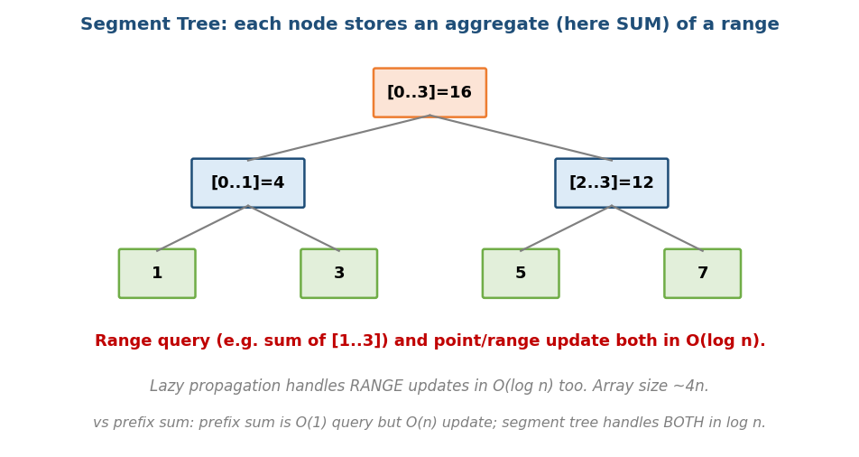
Segment tree: each node stores the aggregate of a range; queries and updates touch O(log n) nodes.
build: O(n) # array of size ~4n
query(L,R): O(log n) # combine a few covering segments
update(i,v): O(log n) # update the leaf, then fix ancestors
- Lazy propagation extends this to range updates (e.g. “add 5 to all of [L,R]”) in O(log n) by deferring updates to children until needed.

Prefix sum vs Segment tree vs Fenwick (when to use what)
Need | Best tool
Range query, no updates | Prefix sum (O(1) query)
Range sum query + point/range updates | Fenwick (BIT) — compact
Range min/max/gcd/… + updates | Segment tree (more general)

MCQs
- Segment tree query/update time? → O(log n).
- What enables range updates in O(log n)? → lazy propagation.
- Prefix sum’s weakness that a segment tree fixes? → slow (O(n)) updates.

Problems
- Range Sum Query – Mutable (LC 307); Range Minimum Query; Count of Smaller Numbers After Self (LC 315); many CP range problems.

8b.4 Fenwick Tree / Binary Indexed Tree (BIT)

The idea
A Fenwick tree is a compact array that supports prefix-sum query and point update, both in O(log n), using a neat lowest-set-bit trick.
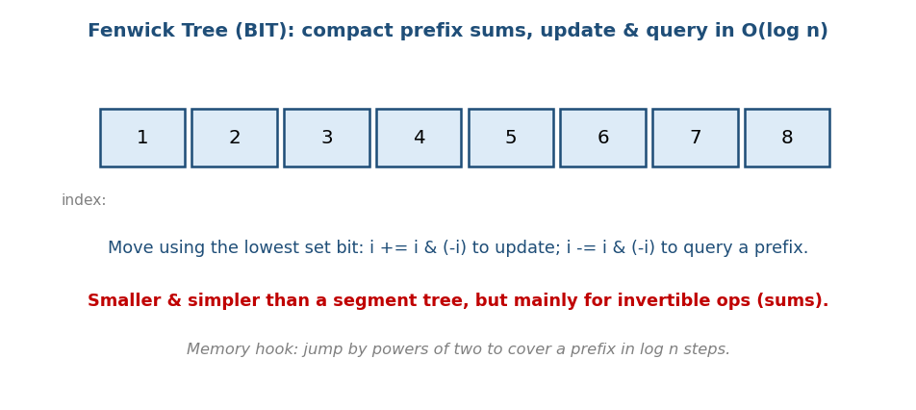
Fenwick tree: jump by the lowest set bit (i & −i) to cover a prefix in O(log n) steps.
update(i, delta): while i <= n: tree[i] += delta; i += i & (-i)
prefix_sum(i): s = 0; while i > 0: s += tree[i]; i -= i & (-i); return s
range_sum(L,R) = prefix_sum(R) - prefix_sum(L-1)
- i & (-i) isolates the lowest set bit — the size of the range each index is responsible for.
- Fenwick vs Segment tree: Fenwick is smaller, faster, simpler to code, but mainly for invertible operations (sums/counts). Segment tree is more general (min/max) and supports lazy range updates.
Memory hook: jump by powers of two — a prefix of length n is covered in ~log n binary “hops”.

MCQs
- Fenwick update/query time? → O(log n).
- What does i & (-i) give? → the lowest set bit.
- Fenwick vs segment tree trade-off? → smaller/simpler but mainly for sums (invertible ops).

Problems
- Range Sum Query – Mutable (307); Count of Smaller Numbers After Self (315); Reverse Pairs (493).

8b.5 B-Trees and B+ Trees (disk / database trees)

Why they exist
A binary tree node holds one key → for billions of records on disk, that is billions of slow disk reads. A B-tree is an m-way balanced tree: each node holds many keys and has many children, so the tree is wide and shallow — fewer levels means fewer disk reads.
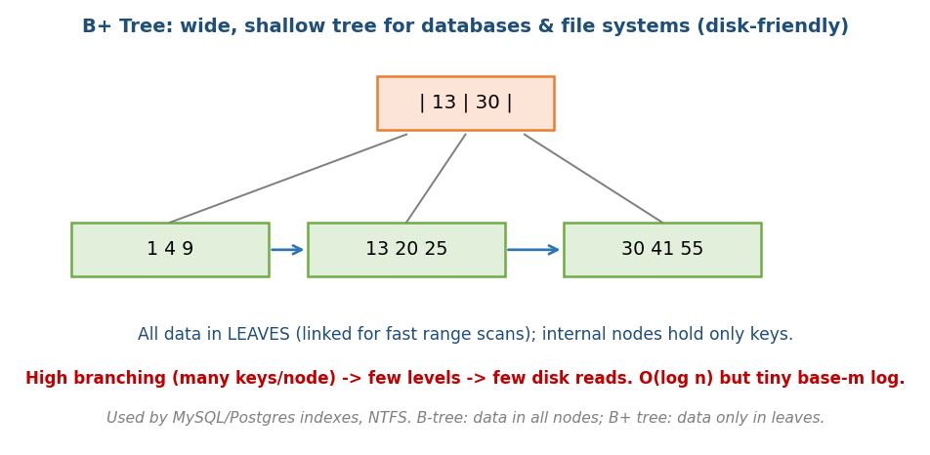
B+ tree: a wide, shallow tree; all data lives in linked leaves while internal nodes hold only keys.

B-tree vs B+ tree
 | B-tree | B+ tree
Data stored | in all nodes | only in leaves
Leaves | not linked | linked list (fast range scans)
Internal nodes | keys + data | keys only (so they hold more keys)
Used by | some file systems | MySQL/Postgres indexes, NTFS
- Why B+ for databases: keys-only internal nodes pack more keys per node → even shallower tree; linked leaves make range scans (WHERE age BETWEEN…) fast.
- Operations are O(log n), but with a large base (branching factor m), so the height is tiny (often 3–4 levels for millions of rows).
Memory hook: B+ tree = a library catalogue: the index cards (internal nodes) only point you toward the shelves; the actual books (data) sit on the linked shelves (leaves) you can walk along.

MCQs
- Why do databases use B+ trees over binary trees? → wide & shallow → fewer disk reads; linked leaves → fast range scans.
- Where is the data in a B+ tree? → only in the leaves.
- B-tree vs B+ tree key difference? → B+ keeps data only in leaves and links them.

Problems / context
- Mostly DBMS + system design: index design, “why B+ tree not hash index” (range queries!), page size and branching factor.

Module 8b — Concept Review (one page)
- AVL: strict balance (bf ∈ {−1,0,+1}); 4 rotation cases (LL/RR single, LR/RL double); O(log n), lookup-friendly.
- Red-Black: colour rules (no two reds; equal black-height) → height ≤ 2·log(n+1); fewer rotations → used by Linux CFS, std::map, Java TreeMap.
- Segment tree: range query and update in O(log n); lazy propagation for range updates; general (sum/min/max).
- Fenwick/BIT: compact prefix-sum + point update O(log n) via i & (-i); best for sums.
- B/B+ trees: wide, shallow, disk-friendly; B+ keeps data in linked leaves → database indexes (MySQL/Postgres).
- Tool choice: no updates → prefix sum; sum + updates → Fenwick; min/max + updates → segment tree; on-disk ordered data → B+ tree.

Module 8b — Flash Cards
- Q: AVL balance factor range? A: {−1, 0, +1}.
- Q: LR imbalance fix? A: double rotation (left then right).
- Q: Red node’s children? A: must be black (no two reds).
- Q: Red-Black real uses? A: Linux CFS, std::map, Java TreeMap.
- Q: Segment tree query/update? A: O(log n) (lazy → range updates).
- Q: Fenwick lowest-set-bit op? A: i & (-i).
- Q: Where is B+ tree data? A: only in linked leaves.

Module 8b — Pattern Recognition
- “Ordered set with guaranteed fast ops” → balanced BST (AVL / Red-Black).
- “Range sum, no updates” → prefix sum; “+ point updates” → Fenwick.
- “Range min/max/gcd with updates” → segment tree (+ lazy for range updates).
- “Billions of records on disk / database index / range scan” → B+ tree.

Module 8b — Interview Questions (with follow-ups)
- Why does a BST need balancing? FU: AVL vs Red-Black trade-offs.
- Design a structure for range-sum with updates. FU: Fenwick vs segment tree.
- Why do databases use B+ trees, not hash indexes? FU: range queries.
- Implement a segment tree. FU: add lazy propagation for range updates.

Module 8b — GATE / SEBI / RBI / ISRO Perspective
- GATE favourites: AVL rotations and balance factors (trace insertions), Red-Black properties, B/B+ tree order, number of keys/children, and insertions/splits (very frequently asked in DBMS too), segment/Fenwick complexity.
- SEBI/RBI IT + DBMS: B/B+ tree indexing is a core topic — see the DBMS notes.

End of Module 8b. Next: Module 9 — Heaps (binary heap deep-dive, heapsort, Fibonacci/pairing heaps, applications) — with visuals.

