Module 9 — Heaps (deep dive)
  - DSA Mastery: Google / FAANG / GATE / ICPC — In-Depth Notes (with visuals)
Prepared for nidhi.sharma@forensiccybertech.com
2026
Table of Contents

Module 9 — Heaps (deep dive)
Why a second heap module? Module 6 introduced the binary heap and its everyday uses (priority queue, top-K, merge-K, streaming median). This module goes deeper: the O(n) build-heap proof (a GATE classic), heapsort, d-ary heaps, and the advanced heaps (binomial, Fibonacci, pairing) that make algorithms like Dijkstra theoretically faster. Treat M6 as “how to use”, M9 as “how it works and its frontiers”.
This module is P1 (heapsort, build-heap proof — GATE) and P2 (advanced heaps — theory + CP).
Recap (Module 6): a binary heap is a complete tree stored in an array; parent=(i−1)/2, children=2i+1, 2i+2; push/pop O(log n), peek O(1).

9.1 Build-Heap in O(n) (the proof everyone gets wrong)

The claim
Turning an unsorted array into a heap by sifting down from the last internal node up to the root is O(n) — not O(n log n).
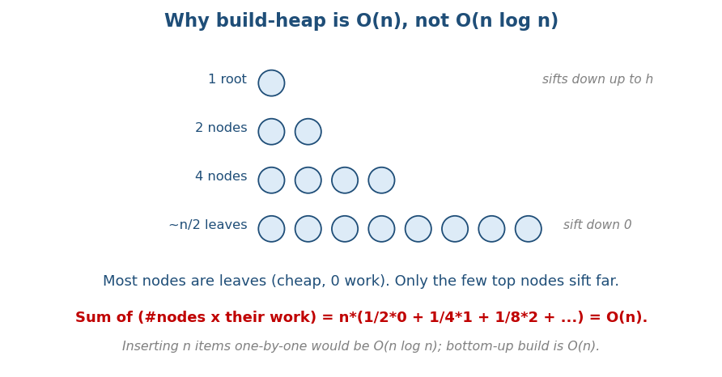
Build-heap is O(n): most nodes are leaves (zero work); only the few top nodes sift far.

Why (the intuition + the math)
If you instead insert n items one by one, each insert is O(log n) → O(n log n). But bottom-up build is cheaper because work depends on a node’s height, and most nodes are near the bottom (cheap):
- ~n/2 nodes are leaves → 0 work each.
- ~n/4 nodes sift down at most 1 level.
- ~n/8 nodes sift down at most 2 levels, and so on.
Total work = n·(1/2·0 + 1/4·1 + 1/8·2 + …) = n · Σ (k / 2^(k+1)). That sum converges to a constant (≈1), so the total is O(n). ∎
Memory hook: the expensive nodes (near the root) are few; the cheap nodes (leaves) are many. The cheap ones dominate the count, so the average is constant.

MCQs
- Build-heap time bottom-up? → O(n).
- Insert-one-by-one heap build? → O(n log n).
- Why is bottom-up cheaper? → most nodes are leaves (≈0 work).

9.2 Heapsort

The idea
Sort by using a heap: build a max-heap, then repeatedly swap the root (largest) with the last element, shrink the heap by one, and sift down the new root. After n steps the array is sorted — in place.
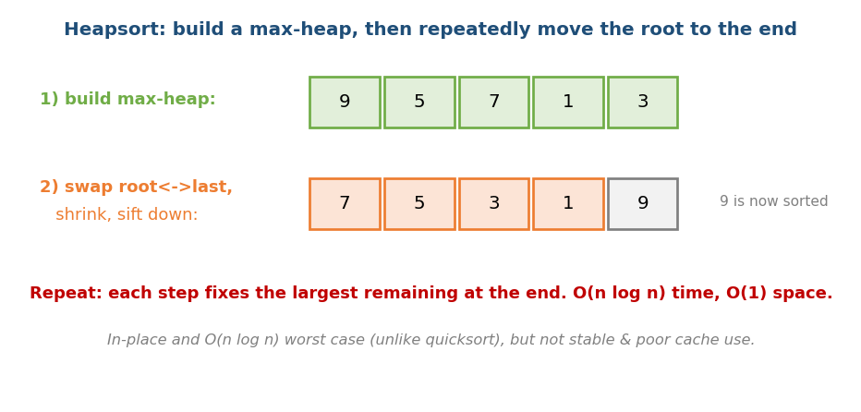
Heapsort: build a max-heap, then repeatedly move the max to the end and sift down.
# Heapsort Time O(n log n), Space O(1)
build_max_heap(a) # O(n)
for end = n-1 downto 1:
swap(a[0], a[end]) # largest goes to its final spot
sift_down(a, 0, end) # restore heap on a[0..end-1]

Heapsort vs other sorts (interview comparison)
 | Heapsort | Quicksort | Merge sort
Worst case | O(n log n) | O(n²) | O(n log n)
Space | O(1) in place | O(log n) | O(n)
Stable? | No | No | Yes
Cache | poor (jumps) | great | good
- Use heapsort when you need guaranteed O(n log n) and O(1) space. Quicksort is usually faster in practice (cache), so it’s the common default.

MCQs
- Heapsort time & space? → O(n log n) / O(1).
- Is heapsort stable? → no.
- Heapsort’s edge over quicksort? → O(n log n) worst case + O(1) space.

9.3 d-ary Heaps (a practical tweak)
A d-ary heap gives each node d children instead of 2. This makes the tree shallower (height log_d n), so decrease-key / insert are faster, but extract-min compares among d children (more work). A 4-ary heap is often fastest in practice for Dijkstra due to better cache behaviour.
Memory hook: more children = shorter tree = faster pushes, slightly slower pops. Tune d to your workload.

MCQs
- Height of a d-ary heap? → log_d n.
- Trade-off of larger d? → faster insert/decrease-key, slower extract-min.

9.4 Advanced Heaps (binomial, Fibonacci, pairing)
These exist to make merge (union) and decrease-key cheap — operations a binary heap does in O(log n) or O(n).
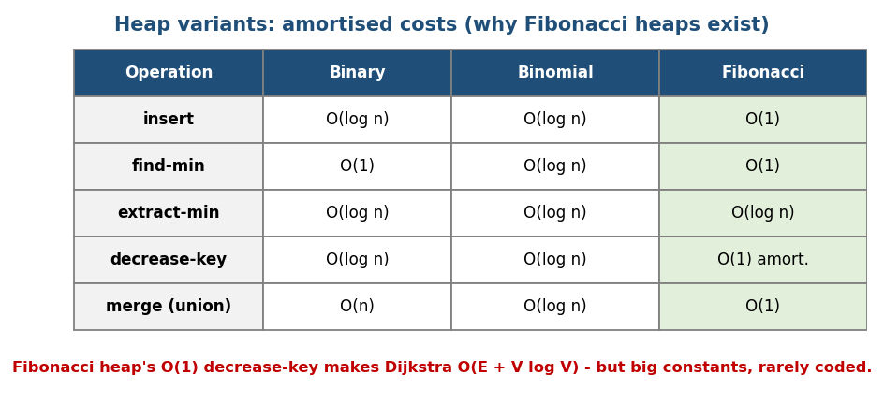
Heap variants and their amortised costs: Fibonacci heaps give O(1) insert, merge, and decrease-key.
Operation | Binary | Binomial | Fibonacci
insert | O(log n) | O(log n) | O(1)
find-min | O(1) | O(log n) | O(1)
extract-min | O(log n) | O(log n) | O(log n) amort.
decrease-key | O(log n) | O(log n) | O(1) amort.
merge | O(n) | O(log n) | O(1)

Why this matters: Dijkstra
Dijkstra’s shortest-path (Module 10) does many decrease-key operations. With a binary heap it is O((V+E) log V); with a Fibonacci heap the O(1) amortised decrease-key gives the theoretical best O(E + V log V).
Reality check (say this in interviews): Fibonacci heaps have large hidden constants and are complex, so in practice a binary heap (or 4-ary heap) usually wins. Fibonacci heaps are mostly a theoretical result.
- Pairing heap: much simpler than Fibonacci, great real-world performance, decrease-key O(log n) amortised (conjectured better). A common practical choice.
- Binomial heap: a forest of binomial trees; mergeable in O(log n).

MCQs
- Which heap gives O(1) amortised decrease-key? → Fibonacci.
- Dijkstra with a Fibonacci heap? → O(E + V log V).
- Why aren’t Fibonacci heaps used much in practice? → large constants / complexity.

Module 9 — Concept Review (one page)
- Build-heap = O(n) (not O(n log n)): most nodes are leaves; Σ k/2^k converges to a constant.
- Heapsort: build max-heap, repeatedly swap root→end + sift down; O(n log n), O(1) space, not stable, poor cache.
- d-ary heap: d children → height log_d n; faster insert, slower extract-min; 4-ary often best for Dijkstra.
- Advanced heaps: binomial (mergeable O(log n)), Fibonacci (O(1) insert/ merge/decrease-key amortised → Dijkstra O(E+V log V) in theory), pairing (simple + fast in practice).
- In practice: binary or 4-ary heaps win; Fibonacci is mostly theory.

Module 9 — Flash Cards
- Q: Build-heap time & why? A: O(n); leaves dominate, Σ k/2^k = const.
- Q: Heapsort time/space/stable? A: O(n log n) / O(1) / not stable.
- Q: d-ary heap height? A: log_d n.
- Q: O(1) amortised decrease-key heap? A: Fibonacci.
- Q: Dijkstra with Fibonacci heap? A: O(E + V log V).
- Q: Why Fibonacci heaps rare in practice? A: huge constants.

Module 9 — Pattern Recognition
- “Sort with guaranteed O(n log n) + O(1) space” → heapsort.
- “Lots of decrease-key (Dijkstra/Prim)” → heap choice matters (binary/4-ary in practice, Fibonacci in theory).
- “Merge many heaps cheaply” → binomial / Fibonacci / pairing.

Module 9 — Interview Questions (with follow-ups)
- Prove build-heap is O(n). FU: why is insert-based build O(n log n)?
- Implement heapsort. FU: max-heap vs min-heap; stability?
- Which heap for Dijkstra and why? FU: Fibonacci theory vs practice.

Module 9 — GATE / SEBI / RBI / ISRO Perspective
- GATE favourites: build-heap O(n) result, heapsort complexity & number of comparisons, heap array indexing, min/max-heap tracing. Very frequently tested.
- Advanced heaps appear in algorithm-analysis questions (amortised costs).

End of Module 9. Next: Module 10 — Graphs (representation, BFS/DFS, topological sort, union-find, shortest paths, MST, advanced) — split across M10a/b/c, with visuals.

