Module 10a — Graphs: Representation, BFS/DFS, Topo Sort, Union-Find
  - DSA Mastery: Google / FAANG / GATE / ICPC — In-Depth Notes (with visuals)
Prepared for nidhi.sharma@forensiccybertech.com
2026
Table of Contents

Module 10a — Graphs: Traversal, Topological Sort, Union-Find
Why graphs are the boss level. A graph models relationships: friends, roads, web links, course prerequisites, package dependencies. Trees are just special graphs (no cycles, one parent). Once you can think in graphs, a huge range of problems — mazes, networks, scheduling, maps — become the same few algorithms. Graphs are the #1 topic at Google/Meta and heavily tested in GATE.
This module is P0. Part a covers the foundation (representation, BFS/DFS, topological sort, union-find); b covers shortest paths & MST; c covers advanced (SCC, bridges, LCA, HLD).
How to read each technique. Brute force → Better → Optimal with pseudocode + complexity, plus a memory hook.

10a.1 What is a Graph & How to Store It

Definition
A graph G = (V, E) is a set of vertices (nodes) V and edges E connecting them. Edges can be:
- Undirected (two-way, like friendship) or directed (one-way, like a Twitter follow).
- Unweighted or weighted (each edge has a cost, like road distance).

Two ways to store a graph
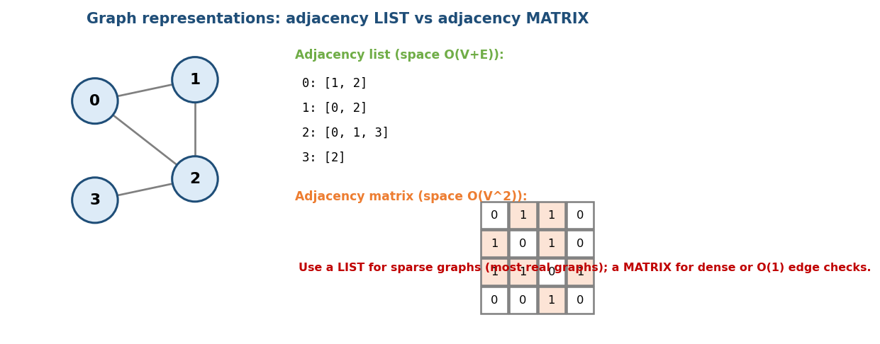
Adjacency list vs adjacency matrix for the same graph.
 | Adjacency list | Adjacency matrix
Space | O(V + E) | O(V²)
“Is there an edge u–v?” | O(degree) | O(1)
Iterate a node’s neighbours | O(degree) | O(V)
Best for | sparse graphs (most real ones) | dense graphs / fast edge checks
Memory hook: the list is a contact book (“who do I know?”); the matrix is a giant yes/no grid of every possible pair.

MCQs
- Space of an adjacency list? → O(V + E).
- O(1) edge existence check uses? → adjacency matrix.
- Best representation for a sparse graph? → adjacency list.

10a.2 BFS and DFS (the two core traversals)
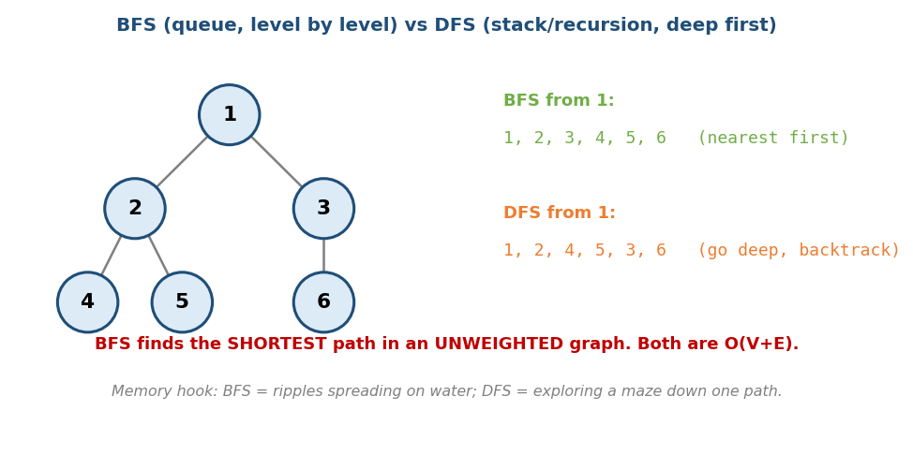
BFS explores level by level (queue); DFS goes deep then backtracks (stack/recursion).

BFS — Breadth-First Search (a queue)
Explore level by level: visit all neighbours, then their neighbours, etc. Key property: in an unweighted graph, BFS finds the shortest path (fewest edges) from the source.
# BFS Time O(V+E), Space O(V)
queue = [start]; visited = {start}
while queue:
u = queue.pop_front()
for v in neighbours(u):
if v not visited: visited.add(v); queue.push(v)

DFS — Depth-First Search (recursion/stack)
Go as deep as possible, then backtrack. Great for connectivity, cycle detection, topological sort, and exploring all paths.
# DFS (recursive) Time O(V+E), Space O(V)
dfs(u):
visited.add(u)
for v in neighbours(u):
if v not visited: dfs(v)
Memory hook: BFS = ripples spreading outward on water; DFS = walking a maze down one corridor until you hit a dead end, then backtracking.

What they solve
- Connected components / number of islands: run DFS/BFS from each unvisited node; count how many times you start.
- Shortest path (unweighted): BFS.
- Cycle detection: DFS (undirected: a visited non-parent neighbour; directed: a node currently on the recursion stack).
- Bipartite check (2-coloring): BFS/DFS coloring neighbours opposite colors.

Grid problems are graph problems
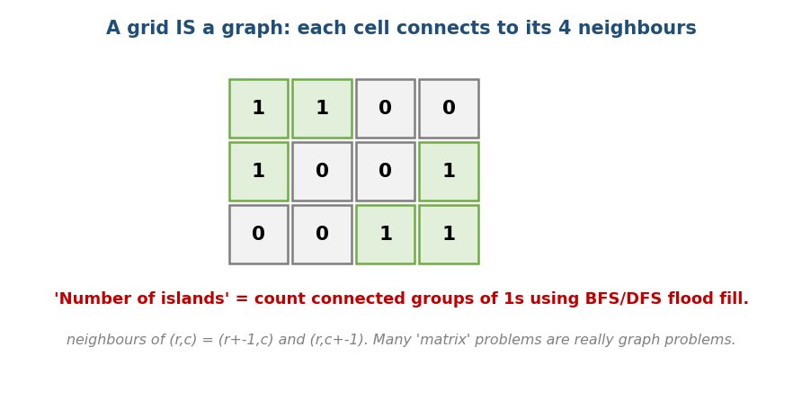
A grid is a graph: each cell connects to its 4 neighbours; islands = connected components.
Many “matrix” problems (islands, flood fill, shortest path in a maze, rotting oranges) are just BFS/DFS on a grid where each cell’s neighbours are (r±1, c) and (r, c±1).

MCQs
- BFS vs DFS data structure? → queue vs stack/recursion.
- Shortest path in an unweighted graph? → BFS.
- BFS/DFS time? → O(V + E).

Problems
- Number of Islands (200); Flood Fill (733); Rotting Oranges (994); Clone Graph (133); Word Ladder (127); Is Graph Bipartite (785); Pacific Atlantic (417).

10a.3 Topological Sort (ordering a DAG)

The problem
Given tasks with dependencies (“A must come before C”), produce a valid linear order. Only possible if the graph is a DAG (Directed Acyclic Graph) — a cycle means no valid order.
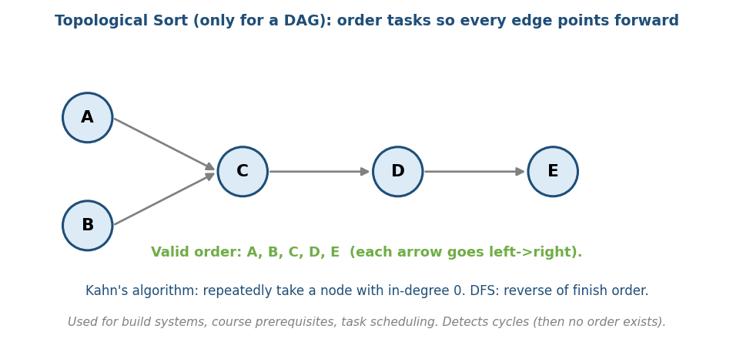
Topological sort: order the DAG so every edge points forward (A, B, C, D, E).

Two ways
# Kahn's algorithm (BFS with in-degrees) Time O(V+E)
compute in-degree of every node
queue = all nodes with in-degree 0
while queue:
u = queue.pop(); output u
for v in neighbours(u):
in_degree[v]--; if in_degree[v]==0: queue.push(v)
# if output has fewer than V nodes -> there was a CYCLE
# DFS method Time O(V+E)
DFS the graph; push each node on a stack when it FINISHES;
the reverse of finish order is a topological order.
Memory hook: Kahn’s = “do the tasks that have no remaining prerequisites first,” then unlock the next ones.

Uses
Build systems (Make, Maven), course prerequisites (LC 207/210), package managers, spreadsheet recalculation, task schedulers.

MCQs
- Topological sort needs the graph to be a? → DAG.
- Kahn’s algorithm starts with nodes of in-degree? → 0.
- How does topo sort detect a cycle? → fewer than V nodes get ordered.

Problems
- Course Schedule I/II (207/210); Alien Dictionary (269); Parallel Courses (1136); Minimum Height Trees (310).

10a.4 Union-Find (Disjoint Set Union, DSU)

The idea
Union-Find tracks a partition of items into disjoint groups and answers “are x and y in the same group?” and “merge the groups of x and y” — almost in O(1).
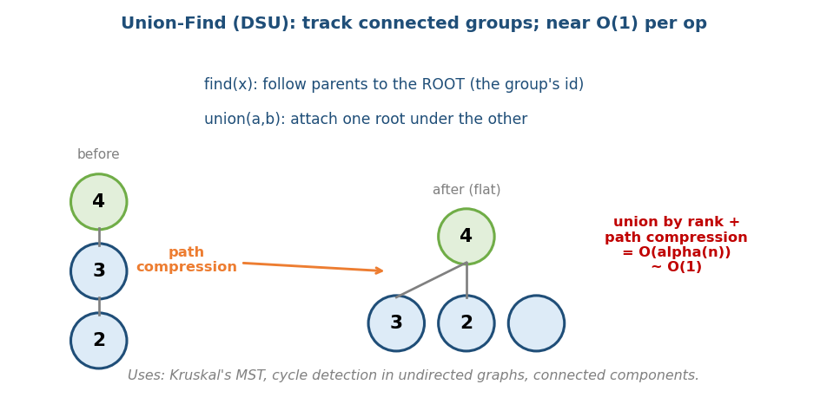
Union-Find: find follows parents to the root; path compression flattens the tree for near-O(1) operations.
# Union-Find with the two optimisations ~O(alpha(n)) per op ~ O(1)
find(x): while x != parent[x]:
parent[x] = parent[parent[x]] # path compression (halving)
x = parent[x]
return x
union(a,b):
ra, rb = find(a), find(b)
if ra == rb: return
attach the smaller-rank root under the larger # union by rank/size
- Two optimisations together — union by rank/size + path compression — give O(α(n)) amortised, where α is the inverse Ackermann function (≤ 4 for any practical n). Effectively constant.
Memory hook: everyone in a group points (eventually) to one group leader; “same group?” = “same leader?”. Path compression makes everyone point straight at the leader.

Uses
- Kruskal’s MST (Module 10b) — add edges, skip those that would form a cycle.
- Cycle detection in an undirected graph.
- Connected components, “number of provinces” (LC 547), “accounts merge”.

MCQs
- Union-Find amortised cost with both optimisations? → O(α(n)) ≈ O(1).
- The two optimisations? → path compression + union by rank/size.
- Which MST algorithm uses it? → Kruskal’s.

Problems
- Number of Provinces (547); Redundant Connection (684); Accounts Merge (721); Number of Connected Components (323); Most Stones Removed (947).

Module 10a — Concept Review (one page)
- Graph = vertices + edges (directed/undirected, weighted/unweighted).
- Store as: adjacency list O(V+E) for sparse (default); matrix O(V²) for dense / O(1) edge checks.
- BFS (queue, level-by-level) → shortest path in unweighted graphs; DFS (stack/recursion) → connectivity, cycles, paths. Both O(V+E).
- Grids are graphs (4-neighbour); islands = connected components.
- Topological sort (DAG only): Kahn’s (in-degree 0 queue) or DFS finish order; detects cycles.
- Union-Find: near-O(1) group merge/query with path compression + union by rank; powers Kruskal & connectivity.

Module 10a — Flash Cards
- Q: Adjacency list vs matrix space? A: O(V+E) vs O(V²).
- Q: Shortest path, unweighted? A: BFS.
- Q: BFS/DFS structure? A: queue / stack(recursion).
- Q: Topo sort needs? A: a DAG; Kahn’s uses in-degree 0.
- Q: Union-Find cost? A: O(α(n)) ≈ O(1) with both optimisations.
- Q: Detect cycle in undirected graph fast? A: union-find (or DFS).

Module 10a — Pattern Recognition
- “Shortest path / fewest steps, unweighted (incl. grids/mazes)” → BFS.
- “Explore all / connectivity / cycles / paths” → DFS.
- “Ordering with dependencies / prerequisites” → topological sort.
- “Group / connected / ‘are these joined?’ / merge sets” → union-find.
- “Count islands / regions in a matrix” → DFS/BFS flood fill.

Module 10a — Interview Questions (with follow-ups)
- Number of islands. FU: BFS vs DFS; in-place vs visited set.
- Course schedule (can you finish?). FU: return an order (topo sort).
- Detect a cycle. FU: directed vs undirected — how do they differ?
- Number of connected components. FU: union-find vs DFS.
- Word ladder. FU: why BFS; build the implicit graph.

Module 10a — GATE / SEBI / RBI / ISRO Perspective
- GATE favourites: BFS/DFS traversal orders & trees, counting edges/ degrees, topological orderings (how many valid?), graph representation space, union-find operations. Very frequently tested.
- SEBI/RBI IT: conceptual MCQs on BFS/DFS, representations, DAGs.

End of Module 10a. Next: Module 10b — Shortest Paths (Dijkstra, Bellman-Ford, Floyd-Warshall, 0-1 BFS, A) and MST (Kruskal, Prim) — with visuals.*

