Module 10b — Graphs: Shortest Paths & MST
  - DSA Mastery: Google / FAANG / GATE / ICPC — In-Depth Notes (with visuals)
Prepared for nidhi.sharma@forensiccybertech.com
2026
Table of Contents

Module 10b — Graphs: Shortest Paths & MST
Why this part is interview & GATE gold. “Find the cheapest route” is everywhere — maps, networks, flight prices, currency arbitrage. The trick is choosing the right algorithm for the constraints (negative edges? all pairs? unweighted?). This part covers the four shortest-path algorithms and the two MST algorithms, and exactly when to use each.
This module is P0. Dijkstra and “which algorithm when” are top FAANG + GATE topics.

Quick selector
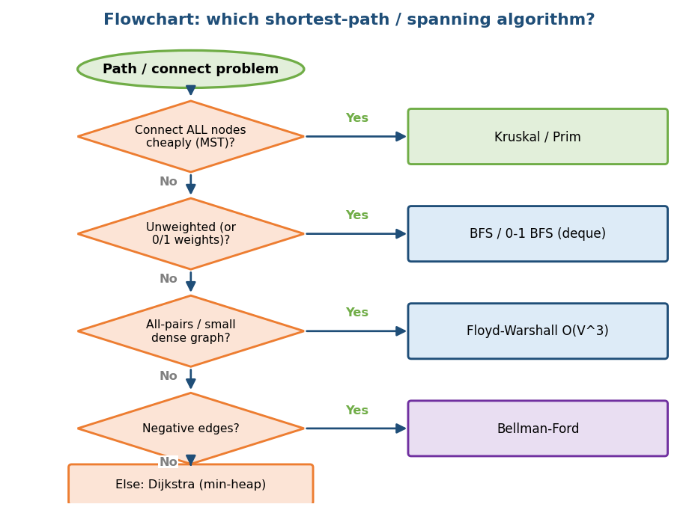
Flowchart: pick MST, BFS/0-1 BFS, Floyd-Warshall, Bellman-Ford, or Dijkstra based on the constraints.
First rule: unweighted graph → just BFS (Module 10a). Weighted → read on.

10b.1 Dijkstra’s Algorithm (non-negative weights)

The idea
Grow shortest distances outward from the source, always settling the closest unsettled node next (greedy), using a min-heap (priority queue). Once a node is settled, its distance is final.
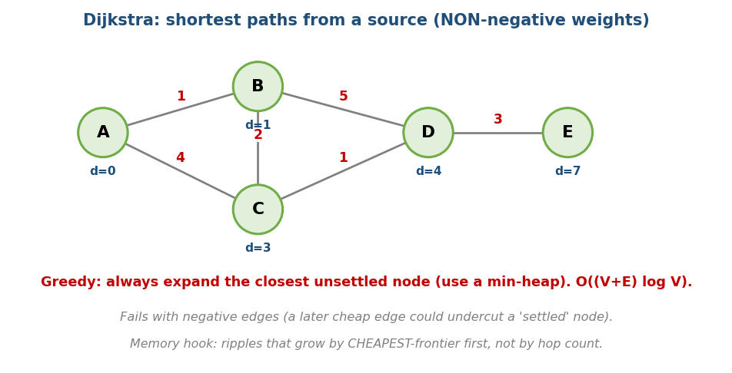
Dijkstra: greedily settle the closest node using a min-heap; non-negative weights only.
# Dijkstra Time O((V+E) log V), Space O(V)
dist[source] = 0; others = infinity
min-heap = {(0, source)}
while heap:
(d, u) = pop-min
if d > dist[u]: continue # stale entry
for (v, w) in neighbours(u):
if dist[u] + w < dist[v]:
dist[v] = dist[u] + w; push (dist[v], v)
- Crucial limitation: no negative edges. A negative edge could make a later path cheaper than an already-“settled” node, breaking the greedy assumption.
Memory hook: ripples that grow by cheapest frontier first (not by hop count like BFS).

MCQs
- Dijkstra time with a binary heap? → O((V+E) log V).
- Dijkstra fails when? → there are negative edges.
- What data structure drives it? → a min-heap / priority queue.

Problems
- Network Delay Time (743); Cheapest Flights Within K Stops (787); Path With Minimum Effort (1631); Swim in Rising Water (778).

10b.2 Bellman-Ford (negative edges allowed)

The idea
Relax every edge V−1 times. After V−1 rounds, all shortest paths are found (a shortest path has at most V−1 edges). If a V-th round still improves something, there is a negative cycle.
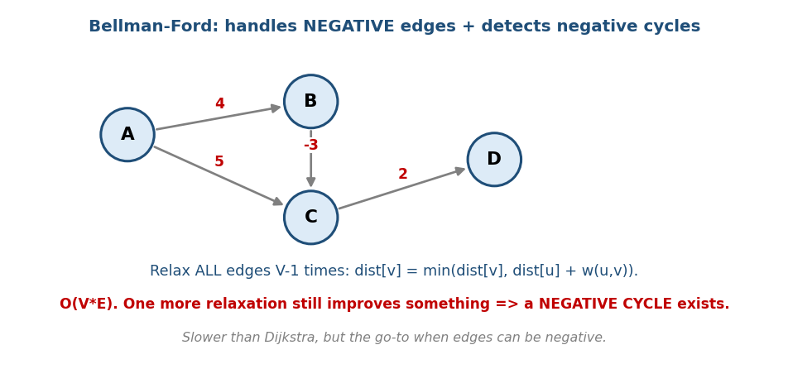
Bellman-Ford: relax all edges V−1 times; an extra improving round means a negative cycle.
# Bellman-Ford Time O(V*E), Space O(V)
dist[source] = 0; others = infinity
repeat V-1 times:
for each edge (u, v, w):
if dist[u] + w < dist[v]: dist[v] = dist[u] + w
# one more pass: if any edge still relaxes -> NEGATIVE CYCLE
- Slower than Dijkstra (O(VE)), but the go-to when edges can be negative, and the only simple way to detect negative cycles (e.g. currency arbitrage).

MCQs
- Bellman-Ford time? → O(V·E).
- How many relaxation rounds? → V − 1.
- What does a V-th improving round mean? → a negative cycle.

10b.3 Floyd-Warshall (all-pairs shortest paths)

The idea
Find the shortest path between every pair of nodes. For each possible intermediate node k, check if going through k improves each pair (i, j).
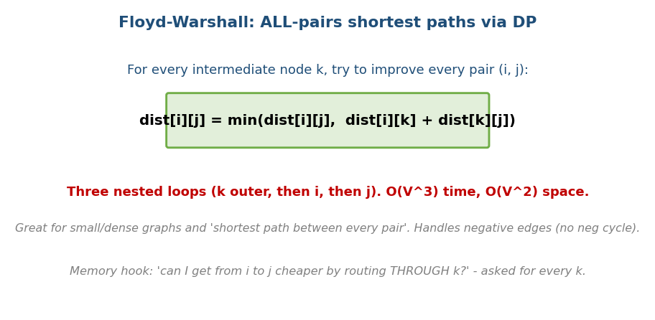
Floyd-Warshall: for each intermediate k, relax every pair (i,j); O(V³).
# Floyd-Warshall Time O(V^3), Space O(V^2)
dist[i][j] = edge weight (or infinity; 0 on the diagonal)
for k in V:
for i in V:
for j in V:
dist[i][j] = min(dist[i][j], dist[i][k] + dist[k][j])
- Handles negative edges (no negative cycle). Best for small/dense graphs or when you genuinely need all pairs. A negative value on the diagonal signals a negative cycle.
Memory hook: “can I get from i to j cheaper by routing through k?” — asked for every k.

MCQs
- Floyd-Warshall time/space? → O(V³) / O(V²).
- The relaxation core? → dist[i][j] = min(dist[i][j], dist[i][k]+dist[k][j]).
- When prefer it over Dijkstra-from-each-node? → small/dense, need all pairs.

10b.4 0-1 BFS and A* (the specialists)
- 0-1 BFS: when every edge weight is 0 or 1, use a deque: push 0-weight moves to the front, 1-weight to the back. Gives shortest paths in O(V+E) (faster than Dijkstra’s log factor).
- A* search: Dijkstra plus a heuristic h(n) estimating the distance to the goal. It expands nodes by dist + h, so it heads toward the target — much faster for single-target pathfinding (games, maps). Needs an admissible heuristic (never overestimates) to stay correct.
- Multi-source BFS: when you need the distance from the nearest of many sources (e.g. “rotting oranges” spreading, “walls and gates”, “distance to nearest 0”), just push ALL sources into the BFS queue at once with distance
  - One BFS then computes every cell’s distance to its closest source in O(V+E) — no need to run BFS from each source separately. (A super common grid pattern.)

MCQs
- Edge weights 0/1 → fastest? → 0-1 BFS (deque).
- A* = Dijkstra + ? → a heuristic toward the goal.
- Distance to the nearest of many sources? → multi-source BFS (push all sources first).

10b.5 Minimum Spanning Tree (MST)

The problem
Connect all nodes with the minimum total edge weight, using no cycles (a tree). Think: cheapest way to lay cable/roads connecting every city.
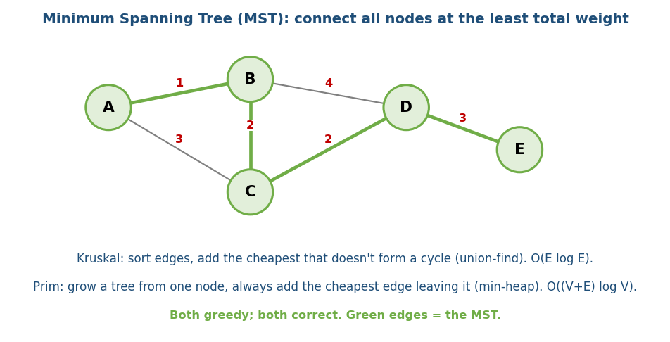
MST: the cheapest set of edges connecting all nodes (green); built by Kruskal or Prim.

Two greedy algorithms
# KRUSKAL: sort edges, add cheapest that doesn't make a cycle
sort all edges by weight
for each edge (u,v) in order:
if find(u) != find(v): # union-find: no cycle
add edge; union(u, v)
# Time O(E log E)
# PRIM: grow one tree from a start node
put start's edges in a min-heap
repeatedly pull the cheapest edge to a NEW node; add it; push its edges
# Time O((V+E) log V) with a heap
- Both are greedy and both give a correct MST. Kruskal (sort + union-find) shines on sparse graphs; Prim (grow + heap) on dense graphs.
- Cut property (why greedy works): the cheapest edge crossing any partition of the nodes is always safe to include.

MCQs
- Kruskal uses which structure to avoid cycles? → union-find.
- Kruskal vs Prim time? → O(E log E) vs O((V+E) log V).
- Why does greedy give the MST? → the cut property.

Problems
- Min Cost to Connect All Points (1584); Connecting Cities With Min Cost (1135); Optimize Water Distribution (1168).

Module 10b — Concept Review (one page)
- Unweighted shortest path → BFS (Module 10a).
- Dijkstra: non-negative weights, greedy + min-heap, O((V+E) log V); fails on negative edges.
- Bellman-Ford: negative edges OK, detects negative cycles, O(V·E) (relax all edges V−1 times).
- Floyd-Warshall: all-pairs, O(V³), dist[i][j]=min(…, dist[i][k]+dist[k] [j]).
- 0-1 BFS: 0/1 weights → deque, O(V+E). A*: Dijkstra + heuristic for single-target.
- MST: Kruskal (sort + union-find, O(E log E)) or Prim (grow + heap); both greedy, both correct (cut property).

Module 10b — Flash Cards
- Q: Dijkstra restriction & time? A: no negative edges; O((V+E) log V).
- Q: Negative edges / cycle detection? A: Bellman-Ford, O(VE), V−1 rounds.
- Q: All-pairs shortest path? A: Floyd-Warshall O(V³).
- Q: 0/1 weights fastest? A: 0-1 BFS (deque).
- Q: A* adds what to Dijkstra? A: an admissible heuristic.
- Q: MST algorithms? A: Kruskal (union-find), Prim (heap).

Module 10b — Pattern Recognition
- “Cheapest route, non-negative weights” → Dijkstra.
- “Edges can be negative / detect arbitrage” → Bellman-Ford.
- “Shortest path between every pair / small dense graph” → Floyd-Warshall.
- “Weights are only 0/1” → 0-1 BFS; “single target with a map” → A*.
- “Connect everything at minimum cost” → MST (Kruskal/Prim).

Module 10b — Interview Questions (with follow-ups)
- Network delay time. FU: why Dijkstra; what if weights were negative?
- Cheapest flights within K stops. FU: Bellman-Ford / modified BFS.
- Min cost to connect all points. FU: Kruskal vs Prim choice.
- Detect a negative cycle. FU: Bellman-Ford V-th round / Floyd diagonal.

Module 10b — GATE / SEBI / RBI / ISRO Perspective
- GATE favourites: Dijkstra/Bellman-Ford/Floyd-Warshall tracing and complexity, MST by Kruskal/Prim (and “is the MST unique?”), the cut property, and why Dijkstra fails on negative edges. Extremely frequently tested.

End of Module 10b. Next: Module 10c — Advanced Graphs (SCC, bridges & articulation points, Euler tour, LCA, Heavy-Light Decomposition) — with visuals.

