Module 10c — Graphs: Advanced (SCC, Bridges, LCA, HLD)
  - DSA Mastery: Google / FAANG / GATE / ICPC — In-Depth Notes (with visuals)
Prepared for nidhi.sharma@forensiccybertech.com
2026
Table of Contents

Module 10c — Advanced Graphs
Why this part. These topics are P2 — rarely needed in standard FAANG coding rounds, but they appear in competitive programming, hard interviews, and GATE. The goal here is to understand the idea and when each applies, not to memorise every line of code.
How to read. Each topic: the idea, the key complexity, and when to use it.

10c.1 Strongly Connected Components (SCC)

The idea
In a directed graph, an SCC is a maximal group of nodes where every node can reach every other node in the group. Condensing each SCC into a single node turns any directed graph into a DAG.
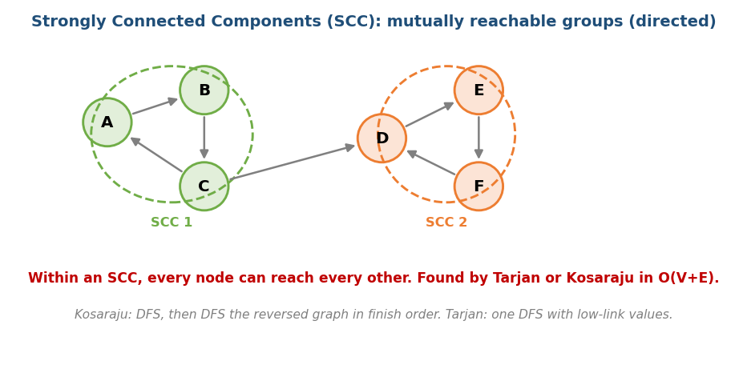
SCCs: maximal groups where every node reaches every other; condensing them yields a DAG.
- Kosaraju’s algorithm: DFS to get finish order → DFS the reversed graph in that order. Each tree in the second pass is an SCC. O(V+E).
- Tarjan’s algorithm: a single DFS tracking discovery time and a low-link value; pops an SCC off a stack when a “root” is found. O(V+E).
Uses: 2-SAT, dependency analysis, finding cycles/feedback in directed graphs, condensing a graph before further processing.

MCQs
- SCC definition? → maximal set with mutual reachability (directed).
- SCC algorithms & time? → Kosaraju / Tarjan, O(V+E).
- Condensing SCCs gives a? → DAG.

10c.2 Bridges & Articulation Points

The idea (network weak points)
In an undirected graph:
- A bridge is an edge whose removal disconnects the graph.
- An articulation point (cut vertex) is a node whose removal disconnects the graph.
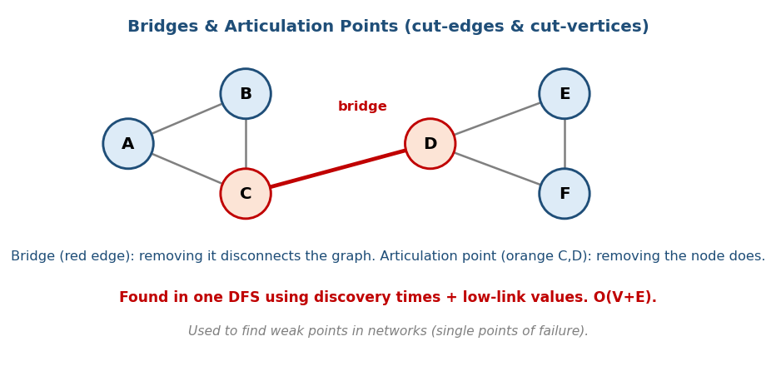
Bridges (cut-edges) and articulation points (cut-vertices) are single points of failure in a network.
Both are found in a single DFS using discovery times and low-link values (the earliest node reachable from a subtree). O(V+E).
Uses: finding single points of failure in networks (if this cable/router dies, who gets cut off?), and as building blocks for biconnected components.

MCQs
- A bridge is a? → an edge whose removal disconnects the graph.
- An articulation point is a? → a node whose removal disconnects it.
- Found using? → DFS discovery + low-link values, O(V+E).

10c.3 Euler Tour of a Tree

The idea
An Euler tour records the order in which DFS enters and leaves each node, flattening a tree into an array. This turns subtree queries into contiguous range queries (then a segment tree / Fenwick from Module 8b answers them in O(log n)).
Memory hook: walk around the tree’s outline; the entry/exit times turn “this whole subtree” into “this slice of the array”.
- Uses: “sum/min over a subtree”, “is u an ancestor of v?” (in[u] ≤ in[v] ≤ out[u]), and as the basis for one LCA method.

MCQs
- Euler tour turns subtree queries into? → range queries on an array.
- Ancestor check via tour times? → in[u] ≤ in[v] ≤ out[u].

10c.4 Lowest Common Ancestor (LCA)

The idea
The LCA of two nodes is their deepest common ancestor. Naively: bring both to the same depth, then move up together — O(height) per query.
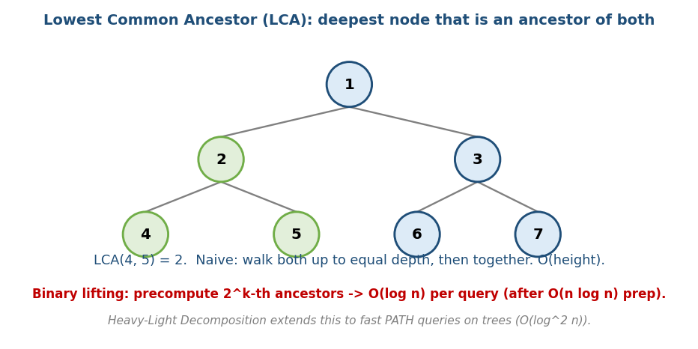
LCA(4,5)=2: the deepest node that is an ancestor of both; binary lifting answers queries in O(log n).
- Binary lifting: precompute each node’s 2^k-th ancestor (a table of size n log n). Then any LCA query jumps up in powers of two → O(log n) per query after O(n log n) preprocessing.
- Euler tour + RMQ: another classic O(1)-query approach (with O(n log n) preprocessing).

MCQs
- LCA = ? → the deepest common ancestor of two nodes.
- Binary lifting query time after prep? → O(log n).
- What does binary lifting precompute? → each node’s 2^k-th ancestors.

10c.5 Heavy-Light Decomposition (HLD)

The idea
HLD splits a tree into chains so that any root-to-node path crosses only O(log n) chains. Each chain is stored in a segment tree, so path queries (sum/max/update along a path between two nodes) run in O(log² n).
Memory hook: highways (heavy chains) connected by short ramps (light edges); any trip uses only a few highways.
- Uses: competitive-programming path-query problems (sum/max/update on tree paths). Almost never needed in standard interviews — know the name and purpose.

MCQs
- HLD makes any path cross how many chains? → O(log n).
- Path query time with HLD + segment tree? → O(log² n).

10c.6 Network Flow (Max-Flow / Min-Cut) & Bipartite Matching

The idea
Model a network of pipes: edges have capacities, and you want the maximum flow from a source s to a sink t. The famous Max-Flow Min-Cut theorem says the maximum flow equals the minimum cut — the cheapest set of edges that, if removed, disconnects s from t.
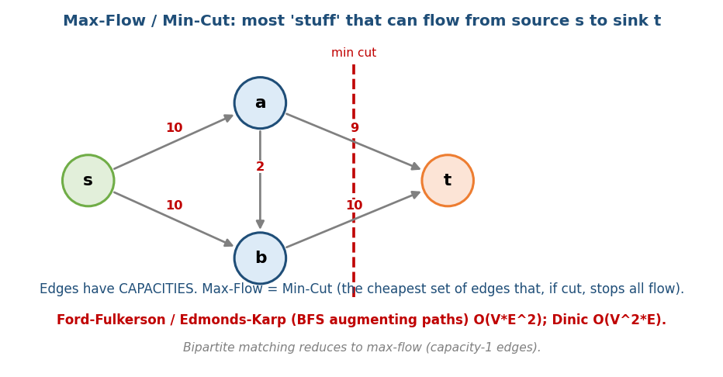
Max-flow / min-cut: most flow from s to t equals the cheapest cut separating them.
# Ford-Fulkerson / Edmonds-Karp idea Edmonds-Karp: O(V * E^2)
while there is an augmenting path s->t with spare capacity (find via BFS):
push flow equal to the path's bottleneck capacity
update residual capacities (forward down, backward up)
max flow = total pushed
- Edmonds-Karp (BFS augmenting paths): O(V·E²). Dinic’s algorithm: O(V²·E) (much faster in practice, the CP standard).
- Bipartite matching (assign workers↔jobs, students↔projects) reduces to max-flow with capacity-1 edges — or use Hopcroft-Karp in O(E·√V).
- Uses: scheduling, assignment, image segmentation, “minimum edges to cut”, baseball elimination, and many CP problems.
Memory hook: water pipes — the most water you can push from tap to drain is limited by the tightest bottleneck (the min cut).

When (not) to use
This is ICPC / advanced-interview territory — rarely needed in standard FAANG coding rounds. Recognise the reduction (“this assignment/matching problem is a flow problem”) even if you don’t code Dinic from memory.

MCQs
- Max-Flow equals? → Min-Cut (the theorem).
- Edmonds-Karp time? → O(V·E²); Dinic O(V²·E).
- Bipartite matching reduces to? → max-flow (capacity-1 edges).

Module 10c — Concept Review (one page)
- SCC (directed): mutual-reachability groups; Kosaraju/Tarjan, O(V+E); condensing → DAG.
- Bridges / articulation points (undirected): cut-edges / cut-vertices = single points of failure; DFS + low-link, O(V+E).
- Euler tour: flatten a tree → subtree queries become range queries (+ segment tree).
- LCA: deepest common ancestor; binary lifting → O(log n) per query after O(n log n) prep.
- HLD: tree into chains → path queries in O(log² n); CP-only.
- Network flow: Max-Flow = Min-Cut; Edmonds-Karp O(V·E²), Dinic O(V²·E); bipartite matching reduces to flow. ICPC/advanced.

Module 10c — Flash Cards
- Q: SCC algorithms? A: Kosaraju, Tarjan — O(V+E).
- Q: Bridge vs articulation point? A: cut-edge vs cut-vertex.
- Q: Euler tour enables? A: subtree queries as array ranges.
- Q: LCA via binary lifting? A: O(log n) query, O(n log n) prep.
- Q: HLD path query time? A: O(log² n).

Module 10c — Pattern Recognition
- “Mutually reachable groups in a directed graph” → SCC.
- “Single point of failure / critical connection” → bridges / articulation.
- “Queries over a subtree” → Euler tour + segment tree.
- “Common ancestor / distance between tree nodes (many queries)” → LCA (binary lifting).
- “Many path-sum/max/update queries on a tree” → HLD.

Module 10c — Interview / CP Questions
- Critical connections in a network (LC 1192). → bridges (Tarjan).
- Find SCCs / does a directed graph have a cycle reachable everywhere?
- LCA of a binary tree (LC 236) / many-query LCA. → binary lifting.
- Course/dependency analysis on a directed graph. → SCC condensation + topo.

Module 10c — GATE / SEBI / RBI / ISRO Perspective
- GATE: SCC concept, bridges/articulation as connectivity questions, LCA basics. These are less frequent than M10a/b but appear in advanced sets.
- For exams, prioritise M10a/M10b; treat M10c as “know the idea”.

End of Module 10 (Graphs complete: a + b + c). Next: Module 11 — Greedy Algorithms — with visuals.

