Module 11 — Greedy Algorithms
  - DSA Mastery: Google / FAANG / GATE / ICPC — In-Depth Notes (with visuals)
Prepared for nidhi.sharma@forensiccybertech.com
2026
Table of Contents

Module 11 — Greedy Algorithms
Why greedy matters (and why it’s dangerous). A greedy algorithm builds a solution one step at a time, always taking the choice that looks best right now, and never reconsidering. When it works, it’s beautifully simple and fast. The danger: it is often wrong, and the hard part of an interview/exam is proving it’s correct (or spotting that it isn’t). This module teaches the classic greedy algorithms, the theory of why greedy works (matroids), and how to tell when greedy is safe.
This module is P1: greedy + interval problems are common at FAANG, and greedy/exchange-argument proofs + Huffman numericals are GATE favourites.
How to read each technique. Brute force → Better → Optimal with pseudocode + complexity, plus a memory hook.

Quick “can I use greedy?” selector
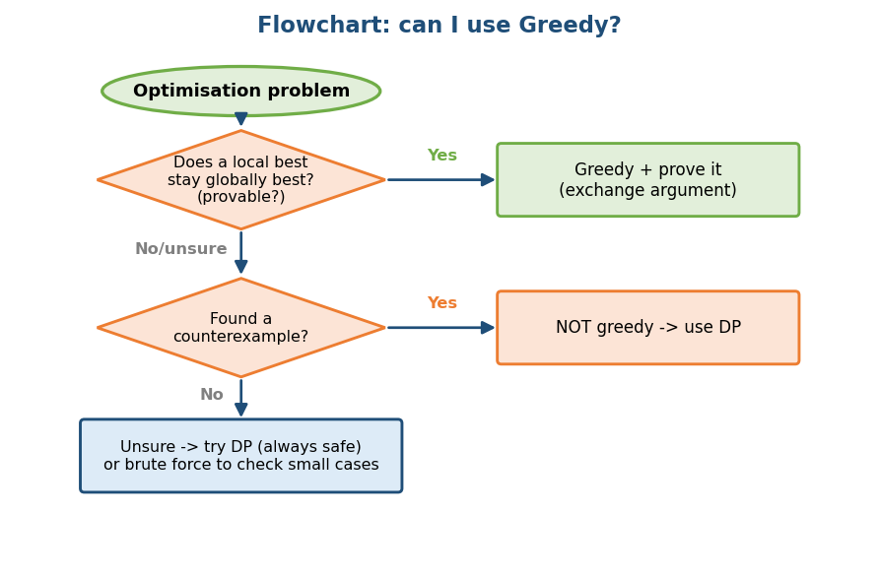
Flowchart: greedy is valid only if a local best stays globally best; otherwise use DP.

11.1 The Greedy Idea (and how to trust it)

Definition
A greedy algorithm makes a sequence of choices, each the locally optimal one, hoping to reach a globally optimal solution. It never backtracks.
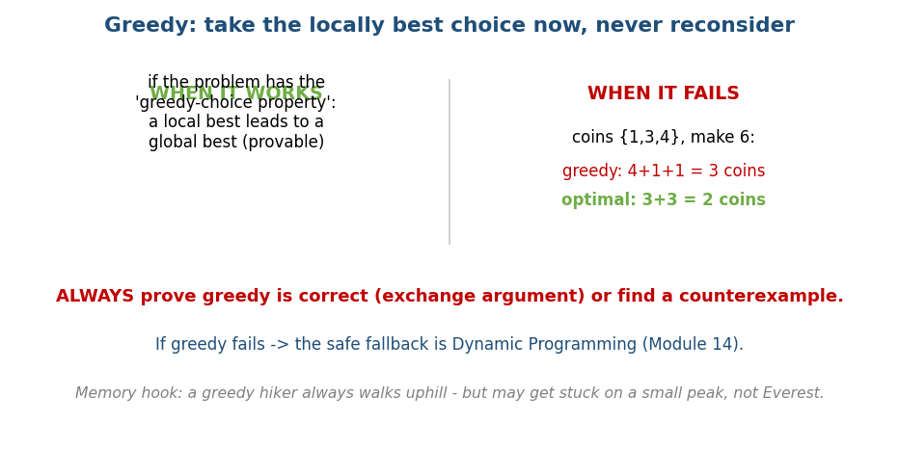
Greedy takes the locally best choice; it works only with the greedy-choice property, and can fail (coins {1,3,4} for 6).

When is greedy correct? (two properties)
- Greedy-choice property: a globally optimal solution can be reached by making locally optimal choices. (The local best is safe.)
- Optimal substructure: an optimal solution contains optimal solutions to subproblems.
If both hold, greedy is optimal. DP also needs optimal substructure, but DP additionally explores choices — greedy commits to one. So greedy is “DP that’s allowed to never look back”.

Two proof styles (know both)
- Exchange argument: take any optimal solution, swap one of its choices for the greedy choice, show it’s no worse; repeat until it becomes the greedy solution. (Used below for activity selection and Huffman.)
- “Greedy stays ahead”: by induction, after k steps greedy is at least as far along as any other solution. (The cleanest proof for earliest-finish activity selection.)

When greedy FAILS — always have a counterexample ready
- Coin change with coins {1, 3, 4} to make 6: greedy takes 4+1+1 (3 coins), but 3+3 (2 coins) is better. → needs DP (Module 14).
- 0/1 knapsack (can’t split items): greedy by ratio fails → DP (see §11.4 for the exact numbers).
The flip side — when greedy coin change WORKS: a coin system is canonical if greedy gives the fewest coins for every amount. Standard currencies like {1, 5, 10, 25} are canonical (each larger coin is a clean multiple), so greedy is optimal there. Arbitrary systems like {1, 3, 4} are not. Whether a system is canonical can be checked in polynomial time (Pearson’s test); in general, “fewest coins” needs DP.
Interview rule: never assume greedy works. Either give a one-line proof (exchange / stays-ahead) or test a counterexample. If it fails, fall back to DP.
Memory hook: a greedy hiker always steps uphill — great for reaching a nearby peak, but it can get stuck on a small hill instead of Everest (a local, not global, optimum).

MCQs
- Two properties that justify greedy? → greedy-choice + optimal substructure.
- Two standard greedy proof styles? → exchange argument + greedy stays ahead.
- Coins {1,3,4} make 6 — greedy vs optimal? → 3 coins vs 2 coins (greedy fails); but {1,5,10,25} is canonical (greedy works).

11.1b Matroids — the Theory Behind Greedy (why it works)
Greedy is not magic: there is a precise structure that guarantees greedy optimality, called a matroid.

Definition
A matroid is a ground set E with a family I of “independent” subsets satisfying:
- Hereditary (downward-closed): every subset of an independent set is independent.
- Exchange/augmentation: if A, B ∈ I with |A| < |B|, then some element of B \ A can be added to A keeping it independent.
Rado–Edmonds theorem: the greedy algorithm (sort elements by weight, add each if it keeps the set independent) finds a maximum-weight independent set if and only if the structure is a matroid. This is the deep reason greedy works.

The canonical example (ties to Module 10b)
- Graphic matroid: E = edges of a graph; “independent” = acyclic (a forest). Greedy on this = Kruskal’s MST! That is why Kruskal is correct.
- Activity selection and job-scheduling-with-deadlines also fit matroid-like structures.
Memory hook: a matroid is the “shape” of problems where greedy is guaranteed safe — and Kruskal’s MST is the poster child.

MCQs
- Theorem linking greedy and matroids? → Rado–Edmonds (greedy optimal ⇔ matroid).
- The graphic matroid’s greedy algorithm is? → Kruskal’s MST.

11.2 Interval Problems (scheduling, partitioning, merging)
There are three different interval problems — don’t confuse them.

(A) Interval Scheduling — maximise count (activity selection)
Select the maximum number of non-overlapping intervals (one resource). Sort by earliest finish time, then take each interval that starts after the last chosen one ends.
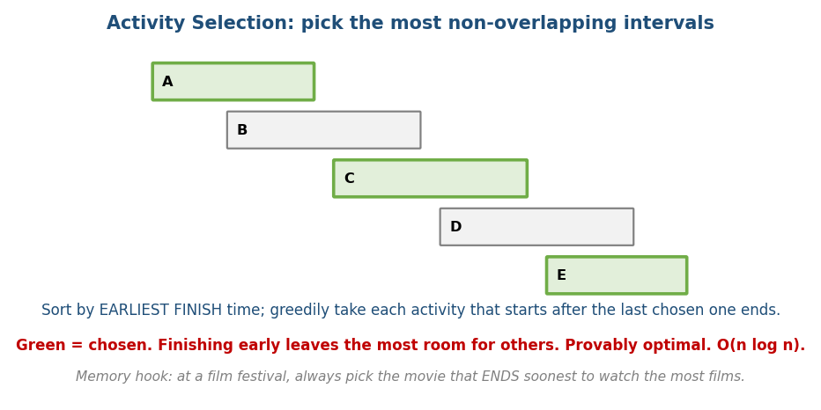
Activity selection: sort by earliest finish time, then greedily take each activity starting after the last one ends.
# OPTIMAL Time O(n log n) (sort), O(n) scan
sort intervals by finish time
last_end = -infinity; count = 0
for (start, end) in intervals:
if start >= last_end:
take it; count += 1; last_end = end
Worked example. Activities (start,finish): (1,4)(3,5)(0,6)(5,7)(3,9)(5,9)(6,10)(8,11)(8,12)(2,14)(12,16) — already sorted by finish. Trace last_end:
- take (1,4) → last_end=4 · skip (3,5),(0,6) · take (5,7) → 7 · skip (3,9),(5,9),(6,10) · take (8,11) → 11 · skip (8,12),(2,14) · take (12,16) → 16.
- Selected = {(1,4),(5,7),(8,11),(12,16)}, count = 4.
Why optimal (greedy stays ahead): the earliest-finishing activity leaves the most room. After each pick, greedy’s finish time is ≤ any other solution’s → greedy never falls behind.
Memory hook: at a film festival, always watch the movie that ends soonest to fit in the most movies.

(B) Interval Partitioning — minimise resources (meeting rooms)
Schedule ALL intervals using the fewest rooms. The answer equals the maximum overlap depth (most intervals active at one time) — and that’s a matching lower bound.
# Minimum meeting rooms (LC 253) Time O(n log n)
sort intervals by start time
min-heap of end times
for (start, end) in intervals:
if heap not empty and heap.top <= start: heap.pop() # a room freed up
heap.push(end)
answer = heap size at the end # = max simultaneous overlap

(C) Interval Merging (LC 56 / 57)
Merge all overlapping intervals. Sort by start, sweep, and extend the current interval when the next one starts at/before the current end.
# Merge Intervals Time O(n log n)
sort by start
result = [first]
for next in rest:
if next.start <= result.last.end:
result.last.end = max(result.last.end, next.end) # overlap -> extend
else:
result.append(next)
# Insert Interval (LC 57): merge the new interval into an already-sorted list in O(n)
Interview trap: unweighted interval scheduling is greedy (earliest finish). Weighted interval scheduling (each interval has a profit, maximise total profit) is NOT greedy — it needs DP (sort by finish + binary search for the last compatible interval). Same flavour as fractional-vs-0/1 knapsack.

MCQs
- Max non-overlapping intervals — sort by? → earliest finish time.
- Min rooms equals? → maximum overlap depth.
- Weighted interval scheduling? → DP, not greedy.

Problems
- Non-overlapping Intervals (435); Meeting Rooms I/II (252/253); Merge Intervals (56); Insert Interval (57); Minimum Arrows to Burst Balloons (452 — sort by end, count non-overlapping shots); Maximum Length of Pair Chain (646).

11.3 Huffman Coding (optimal prefix codes)

Problem
Compress data: give frequent characters short codes and rare ones long codes, with no code a prefix of another (so decoding is unambiguous). Minimise total bits.
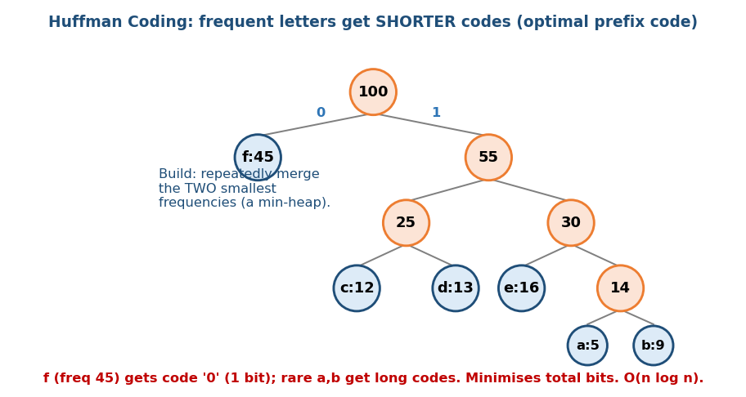
Huffman coding: repeatedly merge the two lowest-frequency nodes; frequent letters end up near the root with short codes.

The greedy choice + the two lemmas
Repeatedly merge the two lowest-frequency nodes (use a min-heap) into a new node with their summed frequency, until one tree remains. Left = 0, right = 1.
# Huffman Time O(n log n)
min-heap of all (frequency, node)
while heap has > 1 node:
a = pop-min; b = pop-min
merge into a node with frequency a.freq + b.freq; push it
the remaining node is the root; read codes off the paths
Why it’s optimal (two lemmas):
- The two lowest-frequency symbols can be made sibling leaves at maximum depth in some optimal tree (exchange argument on depth).
- Optimal substructure: merging them and optimally coding the smaller instance yields an optimal tree for the original.

Worked numeric example (the classic GATE numerical)
Frequencies: a:5, b:9, c:12, d:13, e:16, f:45 (total = 100). Merge the two smallest each step:
Step | Merge | New node
1 | a(5) + b(9) | 14
2 | c(12) + d(13) | 25
3 | 14 + e(16) | 30
4 | 25 + 30 | 55
5 | f(45) + 55 | 100 (root)
Resulting codes & lengths: f=0 (1), c=100 (3), d=101 (3), a=1100 (4), b=1101 (4), e=111 (3).
- Total bits = Σ(freq × len) = 45·1 + 12·3 + 13·3 + 5·4 + 9·4 + 16·3 = 45+36+39+20+36+48 = 224 bits.
- Fast trick (memorise for GATE): total bits = sum of all internal-node frequencies created during merging = 14+25+30+55+100 = 224. ✓ (same answer, no per-symbol arithmetic!)
- Average code length = 224 / 100 = 2.24 bits/symbol (vs a fixed 3-bit code for 6 symbols → 300 bits; Huffman saves 25%).

Key Huffman facts (exam)
- n symbols → n−1 merges, 2n−1 total nodes.
- The code is not unique (depends on tie-breaking), but the total bits / average length are unique.
- It produces an optimal prefix (prefix-free) code.

MCQs
- Huffman merges which two nodes each step? → the two smallest frequencies.
- Total-bits shortcut? → sum of all internal-node frequencies.
- n symbols → how many nodes/merges? → 2n−1 nodes, n−1 merges.

11.4 Fractional vs 0/1 Knapsack (the trap)

Fractional knapsack — greedy is OPTIMAL
A knapsack of capacity W; items have value and weight; you may take fractions. Sort by value/weight ratio (descending); take whole items, then a fraction of the last.
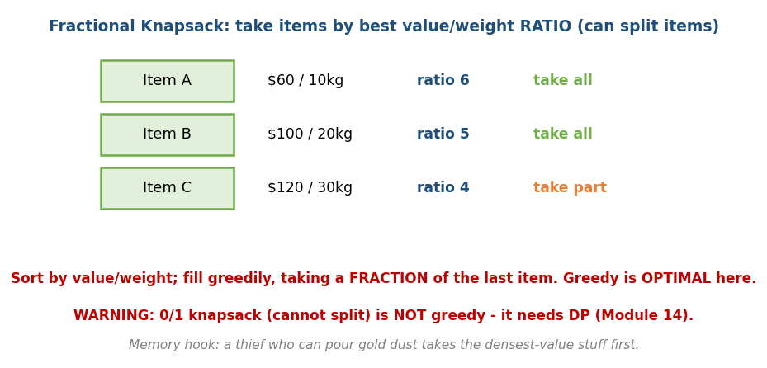
Fractional knapsack: sort by value/weight ratio and fill greedily, taking a fraction of the last item.
Worked example. W = 50; items A(v=60,w=10), B(v=100,w=20), C(v=120,w=30). Ratios: A=6, B=5, C=4 → order A,B,C.
- Take A (10kg, +$60) → used 10, value 60.
- Take B (20kg, +$100) → used 30, value 160.
- Room left = 20kg of C: take 20/30 of C → +$80 → total value = $240. ✅ (greedy optimal for fractional).

0/1 knapsack — greedy FAILS, use DP
Same items, but items are indivisible:
- Greedy by ratio takes A+B (30kg, $160), can’t fit C (30kg > 20 left) → $160.
- Optimal (DP) takes B+C (50kg exactly, $220) → $220 > $160. Greedy is wrong by $60.
This exact contrast is a favourite interview/exam trap. Splittable → greedy by ratio. Indivisible → DP (Module 14).
Memory hook: a thief stealing gold dust (pourable) grabs densest value first; a thief stealing whole statues (0/1) can’t — that needs DP.

MCQs
- Fractional knapsack sort key & complexity? → value/weight ratio, O(n log n).
- 0/1 knapsack greedy result vs optimal (above)? → $160 vs $220 → use DP.

11.5 Scheduling Greedy: Job Sequencing, Min Lateness, MST

Job sequencing with deadlines (maximise profit)
Each job: deadline + profit, takes 1 time unit. Sort by profit descending; place each job in the latest free slot ≤ its deadline.
Worked example. Jobs (deadline, profit): J1(2,100), J2(1,19), J3(2,27), J4(1,25), J5(3,15). Sort by profit (descending): J1(100), J3(27), J4(25), J2(19), J5(15). Use 3 time slots [1,2,3]:
- J1 d=2 → latest free slot ≤2 = slot 2. · J3 d=2 → latest free ≤2 = slot 1. · J4 d=1 → slot 1 taken → skip. · J2 d=1 → slot 1 taken → skip. · J5 d=3 → slot 3.
- Scheduled: J1, J3, J5 → profit = 100+27+15 = 142. Complexity O(n log n) with a slot array (≈ O(n·α(n)) with union-find for the “latest free slot”).

Minimize maximum lateness — Earliest Deadline First (EDF)
Single machine; each job has processing time t and deadline d; lateness Lⱼ = max(0, finishⱼ − dⱼ). To minimise the maximum lateness: sort by deadline ascending (EDF) and run jobs back-to-back with no idle time.
Why (exchange argument): an optimal schedule with no idle time and no “inversions” exists; swapping any adjacent out-of-deadline-order pair never increases the max lateness. (Different from job sequencing — that maximises profit and sorts by profit; this minimises lateness and sorts by deadline.)

MST is greedy (closing the loop with Module 10b)
Both MST algorithms are greedy, justified by the cut property (the cheapest edge crossing any partition is safe):
- Kruskal: repeatedly add the globally smallest edge that doesn’t form a cycle (union-find). This is exactly greedy on the graphic matroid (§11.1b).
- Prim: repeatedly add the smallest edge crossing the cut between the built tree and the rest.
MST has both the greedy-choice property and optimal substructure → greedy is provably optimal.

Other classic greedy problems (recognise the choice)
Problem | Greedy choice
Gas Station (134) | if total gas ≥ total cost, a valid start is right after the lowest running deficit
Jump Game (55) | track the farthest reachable index; reachable iff it never falls behind i
Jump Game II (45) | extend the current “level” like BFS; count levels
Best Time Buy/Sell II (122) | sum every positive day-to-day gain
Candy (135) | two passes (L→R, R→L), take the max
Task Scheduler (621) | schedule the most frequent task first; fill idle gaps
Reorganize String (767) | repeatedly place the most frequent remaining char (max-heap) — sibling of Task Scheduler
Partition Labels (763) | extend the partition to the last occurrence of each seen char
Assign Cookies (455) | sort both; give the smallest sufficient cookie
Gas Station correctness (1 line): if total gas ≥ total cost a solution exists; any prefix whose running tank goes negative cannot contain the start, so restart right after it. (Note: the start need not be unique — e.g. gas=cost everywhere gives several valid starts; the algorithm returns one.)
Jump Game correctness (1 line): induct on farthest = max(farthest, i + nums[i]); you can reach the end iff farthest never drops below the current index i.
Pattern: most greedy problems reduce to “sort by the right key, then make one pass.” Finding the right key (finish time, ratio, deadline, frequency) is the whole game.

MCQs
- Minimise max lateness — sort by? → deadline (EDF).
- Job sequencing — sort by? → profit, place in latest free slot ≤ deadline.
- Why are Kruskal/Prim greedy-correct? → the cut property (matroid).
- Best Time to Buy/Sell Stock II greedy? → sum all positive deltas.

Problems
- Gas Station (134); Jump Game I/II (55/45); Best Time Buy/Sell II (122); Candy (135); Task Scheduler (621); Reorganize String (767); Partition Labels (763); Assign Cookies (455); Job Sequencing (classic).

11.6 Stable Matching — Gale–Shapley (greedy-flavoured)

Problem
n proposers and n acceptors, each with a ranked preference list. Find a matching with no unstable pair — no two people who both prefer each other over their assigned partners. (Real use: the medical residency match / NRMP.)

Algorithm (propose-and-reject)
# Gale-Shapley Time O(n^2)
while some proposer is free:
p proposes to the next acceptor on p's list it hasn't tried
if that acceptor is free: tentatively match
else if the acceptor prefers p to its current match: switch (old one is freed)
else: reject p
Key facts: always terminates in ≤ n² proposals, always produces a stable matching, and is proposer-optimal (every proposer gets the best partner possible in any stable matching). It’s “greedy” in spirit: each proposer always goes for its best remaining option.

MCQs
- Gale–Shapley produces a? → stable matching (proposer-optimal).
- Time complexity? → O(n²).

Module 11 — Concept Review (one page)
- Greedy = locally best choice, never backtrack; correct only with the greedy-choice property + optimal substructure; prove via exchange argument or greedy-stays-ahead, or break it with a counterexample.
- Matroids (Rado–Edmonds) are the exact structures where greedy is guaranteed optimal; Kruskal’s MST = greedy on the graphic matroid.
- If greedy fails → DP (coins {1,3,4}→6; 0/1 knapsack; weighted interval scheduling). Canonical coin systems {1,5,10,25} are greedy-OK.
- Intervals: scheduling (max count → sort by finish); partitioning (min rooms = max overlap); merging (sort by start, sweep).
- Huffman: merge two smallest (min-heap), O(n log n); total bits = Σ(freq×len) = Σ(internal-node freqs); n symbols → 2n−1 nodes, n−1 merges.
- Fractional knapsack = greedy (ratio); 0/1 knapsack = DP.
- Scheduling: job sequencing (sort by profit, latest slot); min max lateness (EDF, sort by deadline).
- Theme: most greedy = sort by the right key + one pass.

Module 11 — Flash Cards
- Q: When is greedy correct? A: greedy-choice + optimal substructure (formally: a matroid).
- Q: Two proof styles? A: exchange argument; greedy stays ahead.
- Q: Greedy counterexample / when it works? A: coins {1,3,4}→6 fails; {1,5,10,25} canonical works.
- Q: Activity selection sort key? A: earliest finish time.
- Q: Min meeting rooms = ? A: max overlap depth (min-heap of end times).
- Q: Huffman total bits shortcut? A: sum of all internal-node frequencies.
- Q: Fractional vs 0/1 knapsack? A: ratio-greedy vs DP.
- Q: Min max lateness? A: EDF (sort by deadline).
- Q: Kruskal correct because? A: cut property (graphic matroid).

Module 11 — Pattern Recognition
- “Maximum non-overlapping intervals” → sort by finish; “fewest rooms” → max overlap / min-heap; “merge overlaps” → sort by start, sweep.
- “Optimal prefix code / compression” → Huffman (min-heap).
- “Maximise value, splittable” → fractional knapsack; not splittable or weighted intervals → DP.
- “Schedule by deadline/profit” → job sequencing (profit) / EDF (lateness).
- “Can I reach / fewest jumps / fill gaps” → greedy reachability.
- “Connect everything cheaply” → MST (greedy / cut property).
- “Stable pairing / matching” → Gale–Shapley.
- “Can’t prove the local choice is safe” → switch to DP.

Module 11 — Interview Questions (with follow-ups)
- Activity selection. FU: prove the earliest-finish choice via greedy-stays- ahead.
- Jump Game. FU: min jumps (II); why is it BFS-like? prove the invariant.
- Gas station. FU: prove the algorithm returns a valid start when total gas ≥ total cost (note: start need not be unique).
- Fractional vs 0/1 knapsack. FU: give numbers where 0/1 greedy is wrong.
- Meeting Rooms II. FU: min-heap solution; why does heap size = rooms?
- Huffman. FU: compute total bits & average length; prove the two-lemma optimality.

Module 11 — GATE / SEBI / RBI / ISRO Perspective
- GATE favourites: Huffman (build the tree, total bits / average code length — the internal-node-sum shortcut), proving/refuting greedy, activity selection traces, fractional-vs-0/1 knapsack contrast, MST as greedy / cut property, and matroid-based “why greedy works” theory. Exchange-argument reasoning recurs in analysis questions.

End of Module 11. Next: Module 12 — Divide & Conquer (merge sort, quicksort, quickselect, binary search, closest pair, master theorem in action) — with visuals.

