Module 12 — Divide & Conquer
  - DSA Mastery: Google / FAANG / GATE / ICPC — In-Depth Notes (with visuals)
Prepared for nidhi.sharma@forensiccybertech.com
2026
Table of Contents

Module 12 — Divide & Conquer
Why divide & conquer. The idea: split a problem into smaller independent pieces, solve each (usually by recursion), and combine the results. This single template gives the fastest general sorts (merge/quick sort), O(log n) search (binary search), O(n) selection (quickselect), fast multiplication (Karatsuba/FFT), and more. Mastering binary search and its “search the answer” cousin alone unlocks a huge slice of FAANG questions.
This module is P0: binary search is one of the most-asked interview tools; merge/quick sort + recurrences are GATE staples.
How to read each technique. Brute force → Better → Optimal with pseudocode + complexity, plus a memory hook.

Quick selector
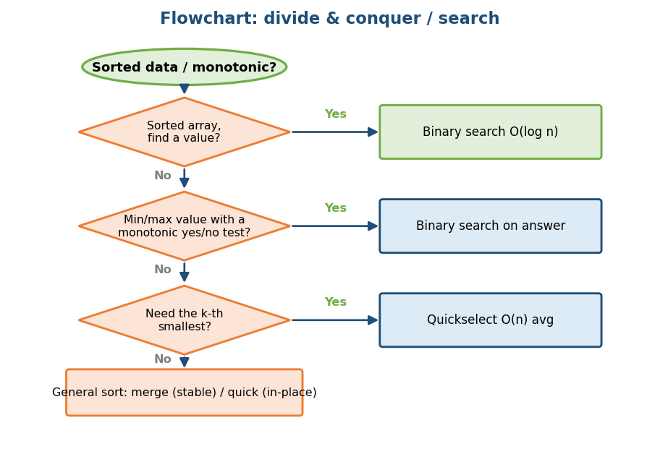
Flowchart: binary search, binary-search-on-answer, quickselect, or a general sort.

12.1 The D&C Template, Recurrences & Master Theorem

The three steps
- Divide the problem into smaller subproblems.
- Conquer each subproblem (recurse; the base case solves directly).
- Combine the sub-answers into the final answer.
The running time is a recurrence T(n) = a·T(n/b) + f(n) (a subproblems of size n/b, plus f(n) to divide+combine).

Master Theorem (self-contained recap)
Compare f(n) with n^(log_b a). The bigger one wins:
Case | Condition | Result
1 | f(n) smaller: f = O(n^(log_b a − ε)) | T(n) = Θ(n^(log_b a))
2 | f(n) equal: f = Θ(n^(log_b a)) | T(n) = Θ(n^(log_b a) · log n)
3 | f(n) bigger: f = Ω(n^(log_b a + ε)) (+ regularity) | T(n) = Θ(f(n))
Worked examples (GATE practice):
- T(n)=2T(n/2)+n: n^(log₂2)=n¹=f(n) → Case 2 → Θ(n log n) (merge sort).
- T(n)=4T(n/2)+n: n^(log₂4)=n² dominates n → Case 1 → Θ(n²).
- T(n)=2T(n/2)+n²: f=n² dominates n → Case 3 → Θ(n²).
- T(n)=T(n/2)+1: n^(log₂1)=n⁰=1=f → Case 2 → Θ(log n) (binary search).
- GATE trap: T(n)=2T(n/2)+n log n — f is between cases → Master Theorem (basic form) does not apply; the extended Case 2 gives Θ(n log² n).
When Master Theorem doesn’t apply: uneven splits (e.g. median-of-medians T(n)=T(n/5)+T(7n/10)+O(n)) or subtract-and-conquer (T(n)=aT(n−b)+f(n)) need the recursion-tree or substitution (guess & verify) methods (Module 1 §1.5).
When does D&C beat iteration? When splitting saves more work than the combine step costs, or the problem is naturally recursive (sorting, trees). For simple linear scans, iteration wins (no recursion overhead).

MCQs
- T(n)=2T(n/2)+n²? → Θ(n²) (Case 3).
- T(n)=2T(n/2)+n log n? → Θ(n log² n) (extended; basic MT fails).
- Which recurrences need recursion-tree/substitution? → uneven splits / subtract-and-conquer.

12.2 Merge Sort (and counting inversions)

The idea
Split in half, recursively sort each half, then merge the sorted halves (compare fronts, take the smaller).
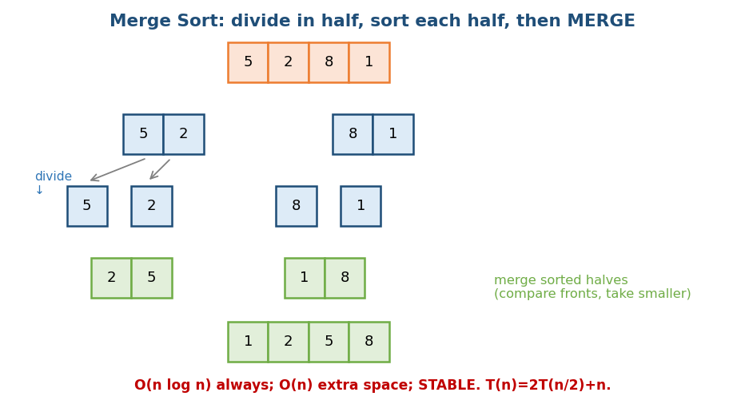
Merge sort: divide in half down to single elements, then merge sorted halves back up.
# Merge sort Time O(n log n) always, Space O(n)
sort(a):
if len(a) <= 1: return a
mid = len/2; L = sort(a[:mid]); R = sort(a[mid:])
return merge(L, R) # walk both, append smaller front each time
- O(n log n) in ALL cases; stable; O(n) extra space. Best for linked lists and external sorting (data too big for RAM).
- Comparison count: merging runs of size m, n takes between min(m,n) and m+n−1 comparisons (e.g. merging [1,3,5] & [2,4,6] = 5 comparisons). Total is Θ(n log n).

Counting inversions in O(n log n) (GATE + FAANG)
An inversion is a pair (i<j) with a[i] > a[j] (a measure of “unsortedness”). Brute force counts them in O(n²); merge sort does it in O(n log n) with one extra line.
Key insight: during the merge, when you take an element from the right half (because it’s smaller), it forms an inversion with every element still remaining in the left half — so add (remaining left count).
# Count inversions (augmented merge) O(n log n)
during merge of L and R:
if L[i] <= R[j]: take L[i]; i++
else: take R[j]; j++; inversions += (len(L) - i) # R[j] < all remaining L
Worked example. [2,4,1,3,5] → inversions are (2,1),(4,1),(4,3) = 3. Max inversions = n(n−1)/2 (reverse-sorted); min = 0 (sorted). (Ties to LC 315 Count of Smaller Numbers After Self, LC 493 Reverse Pairs.)

MCQs
- Merge sort time/space/stable? → O(n log n) / O(n) / stable.
- Count inversions efficiently? → merge sort, O(n log n).
- Max inversions in an array of n? → n(n−1)/2 (reverse-sorted).

Problems
- Sort an Array (912); Sort List (148); Count of Smaller Numbers After Self (315); Reverse Pairs (493); Count Inversions (classic).

12.3 Quicksort, Quickselect & Selection

Quicksort
Pick a pivot, partition (smaller left, larger right; pivot to its final spot), recurse on each side.
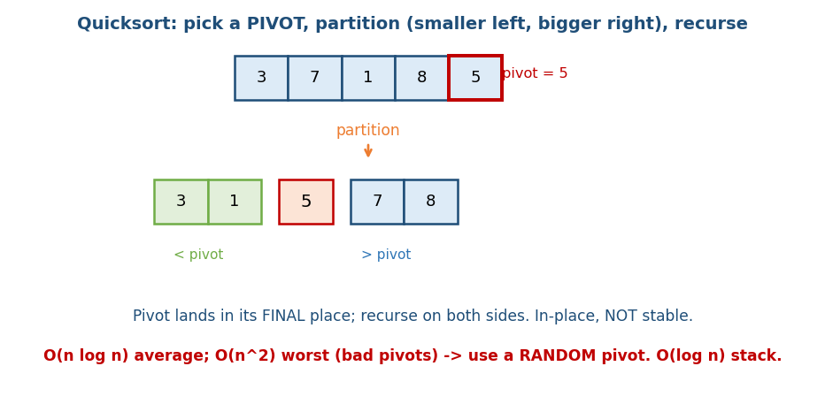
Quicksort: choose a pivot, partition around it, then recurse on the two sides.
# Quicksort Avg O(n log n), Worst O(n^2)
quicksort(a, lo, hi):
if lo >= hi: return
p = partition(a, lo, hi)
# recurse into the SMALLER side first to bound stack depth to O(log n)
quicksort(a, lo, p-1); quicksort(a, p+1, hi)
- In place; not stable. Stack depth is O(log n) expected, but O(n) worst-case unless you always recurse into the smaller partition first.
- Worst case O(n²) on already-sorted input with a first/last pivot → fix with a random pivot or median-of-three → expected O(n log n).
- Usually the fastest in practice (cache locality); libraries use introsort (quicksort + insertion sort for small parts + heapsort fallback).
Comparison counts (GATE):
- Worst case = sorted input with first/last pivot → partitions of size (n−1, 0) → comparisons (n−1)+(n−2)+…+1 = n(n−1)/2 = C(n,2). (n=5 sorted → 4+3+2+1 = 10.)
- Best/average = balanced splits → T(n)=2T(n/2)+(n−1) → Θ(n log n); average ≈ 1.386·n·log₂n.

Lomuto vs Hoare partition (know the difference)
 | Lomuto | Hoare
Pointers | one forward; pivot = last | two, from both ends
Swaps | more | ~3× fewer
Pivot final position | yes (returns pivot index) | no (returns a split)
Recursion split | lo..p−1, p+1..hi | lo..p, p+1..hi
Bug warning: the recursion bounds differ. Lomuto returns the pivot’s final index (recurse around it); Hoare returns a split where the pivot is not placed (recurse including p). Mixing them breaks the sort. For many duplicate keys, use 3-way (Dutch National Flag) partition (Module 2, LC 75).

Quickselect — k-th smallest in O(n) average
Same partition, but recurse into only the side containing the k-th element.
# Quickselect Avg O(n), Worst O(n^2)
after partition at index p:
if k == p: return a[p]
elif k < p: recurse left
else: recurse right

Quickselect vs heap (the interview follow-up)
 | Quickselect | Size-k heap
Time | O(n) avg, O(n²) worst | O(n log k)
Space / data | in-place, mutates input, needs all data | O(k), works on streams
Use when | one-shot, in-memory k-th element | small k, streaming, or don’t mutate

Median-of-medians (BFPRT) — guaranteed O(n) selection
Pick the pivot smartly to guarantee O(n) worst case: split into groups of 5, take each group’s median, recursively select the median of those medians as the pivot. That pivot discards ≥ 3n/10 elements → T(n) ≤ T(n/5) + T(7n/10) + O(n) = O(n) (since 1/5 + 7/10 < 1). Mostly theoretical (big constant); randomised quickselect is preferred in practice.

MCQs
- Quicksort worst-case comparisons? → n(n−1)/2 (sorted input, bad pivot).
- Quickselect vs heap for streaming k-th? → heap (O(n log k)).
- Guaranteed O(n) selection? → median-of-medians (BFPRT).
- Hoare vs Lomuto recursion split? → Hoare lo..p, p+1..hi; Lomuto lo..p−1, p+1..hi.

12.4 Binary Search — ONE template to rule them all

The core
On a sorted array (or any monotonic condition), halve the range each step.
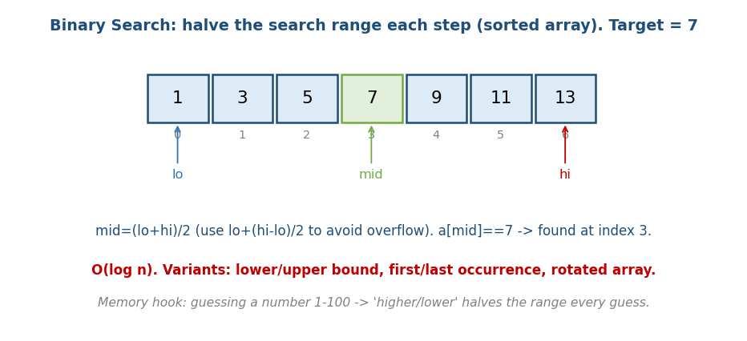
Binary search: lo/mid/hi narrow the range by half each step; O(log n).
The #1 binary-search bug is the loop boundary (< vs <=) and the update (mid vs mid±1). Fix: learn ONE canonical template (the half-open lower_bound below) and derive every variant from it.

The canonical template — lower_bound (half-open)
# first index i with a[i] >= target Time O(log n)
lo, hi = 0, n # hi = n (half-open; the answer can be n = "not found")
while lo < hi:
mid = lo + (hi - lo) // 2
if a[mid] < target: lo = mid + 1 # mid too small -> discard left incl mid
else: hi = mid # mid is a candidate -> keep, shrink right
return lo # in [0, n]; invariant: a[lo-1] < target <= a[lo]
Derive everything from this lo < hi / hi = mid style:
- upper_bound (first i with a[i] > target): change < to <=.
- first occurrence = lower_bound; last occurrence = upper_bound − 1.
- count of target = upper_bound − lower_bound.
The exact-match template (lo <= hi, return mid) is fine for “does it exist?”, but for boundaries/duplicates, always use the half-open one above so you never fight off-by-one again.

Comparison count (GATE)
Worst-case comparisons = ⌊log₂ n⌋ + 1 (= ⌈log₂(n+1)⌉). Examples: n=100 → ⌊6.64⌋+1 = 7; n=1000 → 9+1 = 10; a million → ~20.

The variants you MUST know
- Search in a rotated sorted array (LC 33): one half is always sorted; decide which half holds the target. With duplicates (LC 81): when a[lo]==a[mid] ==a[hi] you can’t tell which half is sorted → advance lo++ / hi-- (worst case O(n)).
- Find Minimum in rotated array (LC 153); duplicate variant LC 154.
- Find Peak Element (LC 162): works on an unsorted array! Compare a[mid] vs a[mid+1]; a peak must exist on the uphill side → binary search it in O(log n).
Memory hook: the “guess 1–100, higher/lower” game — each guess halves the possibilities.

MCQs
- Binary search worst-case comparisons for n=1000? → 10.
- lower_bound vs upper_bound? → < vs <= in the same template.
- Rotated array with duplicates worst case? → O(n) (ambiguous halves).
- Why does Find Peak work unsorted? → a peak always lies on the uphill half.

Problems
- Binary Search (704); Search Insert Position (35); First/Last Position (34); Rotated Array (33) + duplicates (81); Find Minimum Rotated (153) + dup (154); Find Peak (162); Single Element in Sorted Array (540 — index parity); Find K Closest Elements (658); Search a 2D Matrix (74); Time-Based Key-Value Store (981 — upper_bound).

12.5 Binary Search on the Answer (the FAANG power-move)

The idea
When you can’t binary-search an array directly, binary-search the answer itself — if “can we achieve value X?” is monotonic (F…F, T…T). Find the boundary.
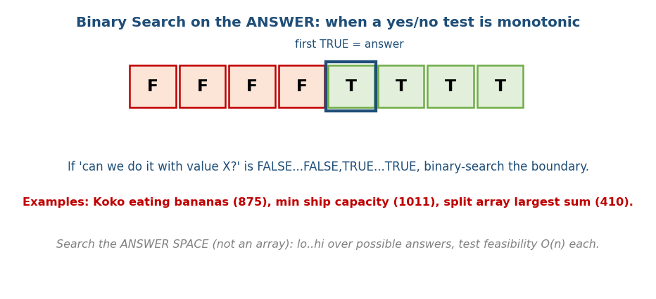
Binary search on the answer: a monotonic FFFF…TTTT predicate — binary-search the first TRUE.
# MINIMISE: smallest X that is feasible O(log(range) * cost(feasible))
lo, hi = min_answer, max_answer
while lo < hi:
mid = lo + (hi - lo) // 2
if feasible(mid): hi = mid # works -> try smaller
else: lo = mid + 1 # too small -> go bigger
return lo
# MAXIMISE: largest X that is feasible (mirror — note the CEILING mid!)
while lo < hi:
mid = lo + (hi - lo + 1) // 2 # +1 ceiling, else infinite loop
if feasible(mid): lo = mid # works -> try bigger
else: hi = mid - 1
return lo
Notorious bug: in the maximise mirror, you MUST use the ceiling mid = lo + (hi−lo+1)/2; the plain floor causes an infinite loop when hi = lo+1.
- Recognise it: “minimise the maximum…”, “maximise the minimum…”, “smallest capacity/speed/size such that …”.
- Classics: Koko Eating Bananas (875), Capacity to Ship in D Days (1011), Split Array Largest Sum (410), Min Days to Make Bouquets (1482), Kth Smallest in a Sorted Matrix (378), Aggressive Cows / Magnetic Force (1552 — maximise the minimum).

MCQs
- Precondition for BS-on-answer? → the feasibility test is monotonic.
- Maximise-variant midpoint? → ceiling lo+(hi−lo+1)/2 (avoids infinite loop).
- Koko/ship search over? → the answer space (speed/capacity), not an array.

12.6 More Classic D&C Algorithms

Fast (binary) exponentiation — O(log n)
Compute aⁿ by squaring: aⁿ = (a^(n/2))² (× a once more if n is odd). T(n)=T(n/2)+O(1) = O(log n).
# Fast power (iterative, bit-scanning) O(log n)
result = 1; base = a
while n > 0:
if n & 1: result *= base # for modular: result = result*base % m
base *= base # base = base*base % m
n >>= 1
return result
- Modular exponentiation aⁿ mod m (crypto, hashing, SEBI-IT) uses the same loop with % m.
- Matrix exponentiation: raise a transition matrix to the n-th power in O(log
  - — e.g. Fibonacci via [[1,1],[1,0]]ⁿ. (LC 50 Pow(x,n); LC 372.)

Closest Pair of Points (2D)
Sort by x; split; recursively find the closest pair in each half; then check a thin strip around the dividing line — each point compares against at most ~7 following points (a constant, by a packing argument). O(n log n) vs brute-force O(n²).

Maximum Subarray (D&C view)
The max subarray lies in the left half, the right half, or crosses the middle. The crossing case: scan left from mid for the best suffix sum, scan right from mid+1 for the best prefix sum, add them. answer = max(left, right, across) → T(n)=2T(n/2)+O(n) = O(n log n). (Kadane does it in O(n) — Module 2 — but this is the instructive D&C version.)

Ternary Search (unimodal functions)
When a function strictly increases then decreases (unimodal), binary search doesn’t apply but ternary search does: probe at the two trisection points m1=lo+(hi−lo)/3, m2=hi−(hi−lo)/3; discard the third that can’t hold the extremum. O(log n) probes. (Continuous analogue: golden-section search.)

Karatsuba / Strassen / FFT (fast multiplication)
- Karatsuba: multiply n-digit numbers with 3 half-size multiplications instead of 4 → T(n)=3T(n/2)+O(n) = O(n^1.585).
- Strassen: 7 instead of 8 recursive matrix multiplications → O(n^2.807).
- FFT: evaluate a polynomial at the n complex roots of unity by splitting into even/odd-indexed terms (P(x)=Pₑ(x²)+x·Pₒ(x²)), recursing, combining → T(n)=2T(n/2)+O(n) = O(n log n). Used for fast polynomial/bignum multiplication and convolution. (ICPC/advanced; optional for SEBI.)

MCQs
- Fast exponentiation time? → O(log n).
- Closest pair strip checks how many neighbours per point? → a constant (~7).
- Karatsuba / Strassen / FFT complexities? → O(n^1.585) / O(n^2.807) / O(n log n).
- Search a unimodal function’s max? → ternary search.

Module 12 — Concept Review (one page)
- D&C = divide + conquer + combine; analyse with the Master Theorem (3 cases by comparing f(n) vs n^(log_b a)); uneven/subtract recurrences need tree/substitution.
- Merge sort: O(n log n) always, stable, O(n) space; counts inversions in O(n log n).
- Quicksort: O(n log n) avg, O(n²) worst = n(n−1)/2 comparisons (random pivot fixes it); Lomuto vs Hoare differ in the recursion split.
- Quickselect: k-th smallest O(n) avg; vs heap (O(n log k), streaming); median-of-medians = guaranteed O(n).
- Binary search: learn ONE half-open lower_bound template; upper_bound = <=; worst comparisons ⌊log₂n⌋+1; know rotated (+dup), find-peak (unsorted).
- BS on the answer: monotonic feasibility; maximise needs a ceiling mid.
- Classics: fast/modular/matrix exponentiation O(log n); closest pair O(n log n); ternary search (unimodal); Karatsuba/Strassen/FFT.

Module 12 — Flash Cards
- Q: T(n)=2T(n/2)+n log n? A: Θ(n log² n) (basic MT fails).
- Q: Merge sort & inversions? A: O(n log n); add remaining-left on right-take.
- Q: Quicksort worst comparisons? A: n(n−1)/2 (sorted + bad pivot).
- Q: k-th smallest, streaming? A: size-k heap O(n log k); else quickselect.
- Q: Guaranteed O(n) select? A: median-of-medians (BFPRT).
- Q: lower vs upper bound? A: < vs <= in the same half-open template.
- Q: Maximise BS-on-answer pitfall? A: use ceiling mid (else infinite loop).
- Q: Fast exponentiation? A: square-and-multiply, O(log n).

Module 12 — Pattern Recognition
- “Sorted array, find/insert/boundary/count” → binary search (lower/upper bound).
- “Minimise max / maximise min / smallest X that works” → BS on the answer.
- “k-th smallest/largest / median, no full sort” → quickselect (streaming → heap).
- “Stable sort / linked list / external data / count inversions” → merge sort.
- “aⁿ or aⁿ mod m fast / fast Fibonacci” → binary / matrix exponentiation.
- “Max of a unimodal function” → ternary search.
- “Fast big-number / matrix / polynomial multiply” → Karatsuba / Strassen / FFT.

Module 12 — Interview Questions (with follow-ups)
- Search in a rotated sorted array. FU: with duplicates (LC 81) — why O(n)?
- Kth largest element. FU: quickselect vs heap; streaming data?
- Koko eating bananas / ship capacity. FU: why monotonic; minimise vs maximise template.
- Median of two sorted arrays. FU: partition the smaller array; O(log min(m,n)).
- Why can quicksort be O(n²)? Prevent it? FU: worst-case comparison count.
- Count inversions. FU: how does merge accumulate the count?

Module 12 — GATE / SEBI / RBI / ISRO Perspective
- GATE favourites: Master Theorem on new recurrences (incl. the n log n trap & subtract-and-conquer), quicksort best/worst/average comparison counts (n(n−1)/2, 1.39 n log n) and which input triggers each, merge sort comparisons/space/stability, binary search comparison count ⌊log₂n⌋+1, and counting inversions (max n(n−1)/2). Modular exponentiation appears in SEBI-IT/crypto contexts. Extremely frequently tested.

Median of Two Sorted Arrays (LC 4 — the partition sketch)
A top FAANG hard problem worth its own note. Binary-search the cut in the smaller array A so that the left side of both arrays together holds exactly (m+n+1)/2 elements. Maintain maxLeftA ≤ minRightB and maxLeftB ≤ minRightA; when both hold you’ve found the split. The median is max(maxLeftA, maxLeftB) (odd total) or the average of the two middle values (even total). Complexity: O(log min(m, n)) (binary-search the smaller array only).

End of Module 12. Next: Module 13 — Backtracking (subsets, permutations, combinations, N-Queens, Sudoku, word search) — with visuals.

