Module 13 — Backtracking
  - DSA Mastery: Google / FAANG / GATE / ICPC — In-Depth Notes (with visuals)
Prepared for nidhi.sharma@forensiccybertech.com
2026
Table of Contents

Module 13 — Backtracking
Why backtracking. Some problems ask for all solutions, or a valid arrangement, where you must try a choice, explore its consequences, and undo it if it fails. That is backtracking: a smart DFS over a “state-space tree” that prunes dead branches early. One “choose → explore → un-choose” skeleton solves subsets, permutations, N-Queens, Sudoku, word search, graph coloring, and more.
This module is P0 for interviews (one template, many problems) and appears in GATE as state-space / branch-and-bound questions.
How to read each technique. Brute force → Better → Optimal with pseudocode + complexity, plus a memory hook.

13.1 The Backtracking Framework

The idea
Build a solution incrementally. At each step choose an option, recurse to extend the partial solution, then un-choose (undo) to try the next. If a partial solution can’t possibly lead to a valid answer, prune that branch.
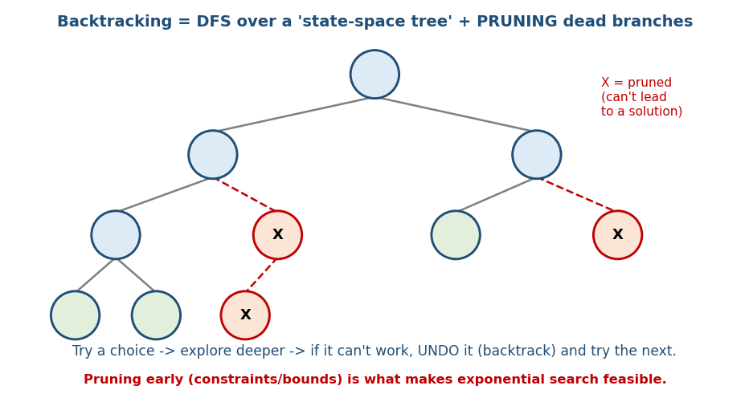
Backtracking is a DFS over a state-space tree; pruned branches (X) can’t lead to a solution.

The universal template
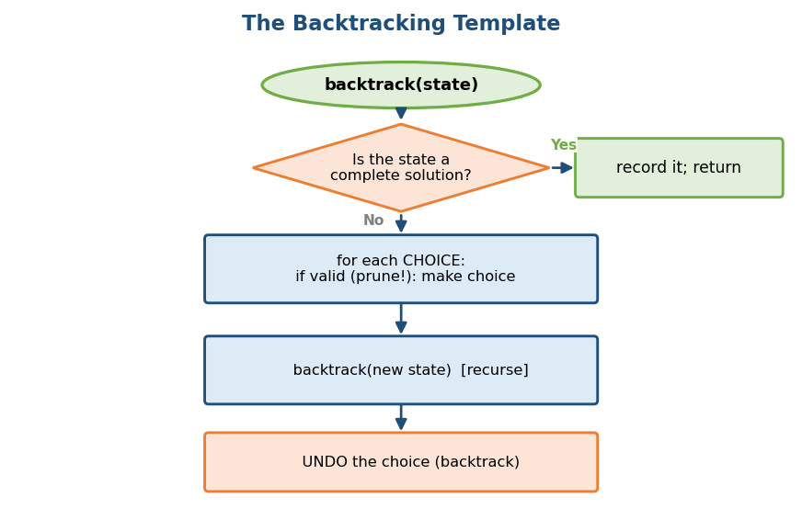
The backtracking template: if complete record it; else for each valid choice, choose → recurse → undo.
# Backtracking skeleton
backtrack(state):
if state is a complete solution:
record a COPY of it; return # COPY! path is mutated on the way back
for each choice in options(state):
if choice is valid (PRUNE here):
make the choice # choose
backtrack(new state) # explore
undo the choice # un-choose (backtrack)
Live-coding bug #1: “record it” means append a copy/snapshot of the path. Recording the path by reference yields all-empty or all-identical results because it keeps getting mutated.
Memory hook: exploring a maze with breadcrumbs — walk a path; if it’s a dead end, walk back (pick up the breadcrumb) and try another. Picking up the breadcrumb is the undo.

Worked dry-run — Subsets of [1, 2]
Watch path grow and shrink (● = record a snapshot):
Depth | Action | path
0 | start, record ● | []
1 | add 1, record ● | [1]
2 | add 2, record ● | [1,2]
2 | undo 2 | [1]
1 | undo 1 | []
1 | add 2, record ● | [2]
1 | undo 2 | []
Snapshots recorded: [] , [1] , [1,2] , [2] → the 4 = 2² subsets. The undo is what lets the same path object visit every branch.

Time vs space (a GATE distinction)
- Time = number of nodes in the state-space tree → exponential (2ⁿ subsets, n! permutations). Pruning shrinks this hugely in practice.
- Auxiliary space = recursion depth = number of decision stages = O(n) (n for subsets/permutations/N-Queens; #cells for Sudoku) — not exponential.
- Node counts (exam): the binary subset tree has 2^(n+1) − 1 total nodes (2ⁿ leaves); the permutation tree has Σ_{k=0..n} n!/(n−k)! nodes. “O(2ⁿ)” / “O(n!)” are leaf counts.

Backtracking vs Branch-and-Bound vs DP
 | Backtracking | Branch & Bound | DP
Purpose | enumerate / feasibility | optimisation (min/max) | optimisation with overlap
Prunes by | constraint violation | optimistic bound vs best-so-far | reuses subproblems (memo/table)
Typical cost | exponential | exponential (less w/ bounds) | polynomial

MCQs
- The three backtracking actions? → choose, explore, un-choose.
- Backtracking recursion depth (subsets/perms)? → O(n) (not exponential).
- Subset tree total nodes? → 2^(n+1) − 1 (2ⁿ leaves).

13.2 Subsets, Permutations, Combinations

The single most important decision: what to pass to recursion
Pass to recursion | Effect | Use for
i + 1 | each element used once, order doesn’t matter | subsets, combinations
i | element reusable | combination sum (with reuse)
used[], loop from 0 | revisit earlier indices, order matters | permutations
The hinge of the whole topic: a start index prevents reorderings (combinations/subsets); a used[] array (or in-place swap) allows revisiting earlier elements but forbids reusing the same index (permutations). Confusing them gives O(n!) when you wanted O(2ⁿ), or duplicate combinations.
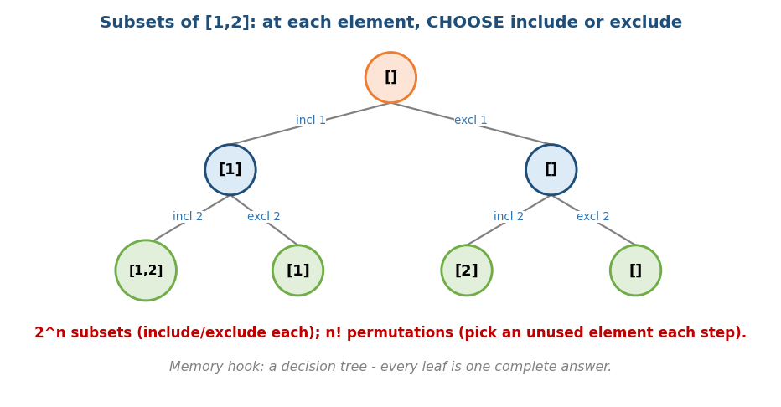
Subsets of [1,2]: at each element choose include/exclude; permutations pick an unused element each step.

Subsets — O(2ⁿ) (n=4 → 16 subsets)
backtrack(start, path):
record a copy of path # every node is a subset
for i in start..n-1:
path.add(a[i]); backtrack(i+1, path); path.removeLast()

Subsets II / Combination Sum II — dedup (the error-prone line)
# Sort first, then skip equal SIBLINGS at the same tree level
sort(a)
backtrack(start, path):
record a copy of path
for i in start..n-1:
if i > start and a[i] == a[i-1]: continue # <-- i > start, NOT i > 0
path.add(a[i]); backtrack(i+1, path); path.removeLast()
Critical: the guard is i > start (skip duplicates that are siblings at this level), not i > 0 (which would wrongly drop valid duplicates that legitimately appear deeper in the tree).

Permutations — O(n!) (n=4 → 24); and the different dedup
# Permutations
backtrack(path, used):
if path.size == n: record a copy; return
for i in 0..n-1:
if used[i]: continue
# Permutations II dedup (DIFFERENT condition!):
if i > 0 and a[i] == a[i-1] and not used[i-1]: continue
used[i]=true; path.add(a[i]); backtrack(path,used); path.removeLast(); used[i]=false
Permutations dedup ≠ subsets dedup. Here it is i>0 and a[i]==a[i-1] and not used[i-1] — the not used[i-1] part is unique to permutations. Sort first.

Combinations (n choose k) — with pruning
backtrack(start, path):
if path.size == k: record a copy; return
for i in start..n-1:
if k - path.size > n - i: break # not enough left -> prune
path.add(a[i]); backtrack(i+1, path); path.removeLast()
# C(5,2) = 10

Iterative subsets via bitmask (no recursion)
For n elements, every integer mask in 0 .. 2ⁿ−1 encodes one subset: bit j set ⇒ include a[j].
for mask in 0 .. (1<<n)-1:
subset = [ a[j] for j in 0..n-1 if mask has bit j set ]
(Links to Module 15 Bit Manipulation.)

MCQs
- #subsets / #permutations of n=4? → 16 / 24.
- Subsets dedup guard? → i > start (not i > 0).
- Permutations II dedup guard? → i>0 and a[i]==a[i-1] and **not used[i-1]**.
- Combination Sum (reuse) recurses with? → i (not i+1).

Problems
- Subsets (78); Subsets II (90); Permutations (46); Permutations II (47); Combinations (77); Combination Sum I/II (39/40); Letter Combinations of a Phone Number (17 — map each digit to letters, recurse by advancing the digit index).

13.3 Grid & Board Backtracking

N-Queens — place N queens, none attacking
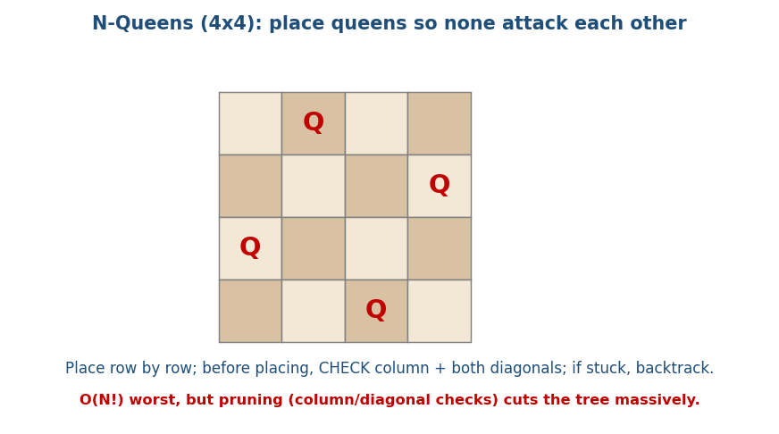
N-Queens 4×4: place queens row by row, checking column and both diagonals; backtrack when stuck.
# N-Queens Time O(N!), far less with pruning
place(row):
if row == N: record board; return
for col in 0..N-1:
if col, (row-col), (row+col) are all free: # O(1) checks via 3 sets
place queen; place(row+1); remove queen
- O(1) safety check with three hash sets: used columns, diagonals (row−col), anti-diagonals (row+col).
Solution counts (a GATE/ISRO favourite — memorise):
N | 1 | 2 | 3 | 4 | 5 | 6 | 7 | 8
distinct solutions | 1 | 0 | 0 | 2 | 10 | 4 | 40 | 92
(N=2 and N=3 are unsolvable; the 4×4 board has exactly 2 solutions; the classic 8×8 has 92.)

Sudoku Solver
Fill the first empty cell with a digit 1–9 that doesn’t violate its row, column, or 3×3 box; recurse; if stuck, undo and try the next digit. Use the minimum- remaining-values heuristic (fill the most-constrained cell first) to speed it up.

Word Search (LC 79)
DFS from each cell matching the word char by char. Order matters: check bounds + char match FIRST, then mark (overwrite the cell with a sentinel like #), recurse to the 4 neighbours, then restore the original character (not a generic unmark). Word Search II (LC 212) uses a Trie (Module 3) to search many words at once.

MCQs
- N-Queens solutions for N=4 and N=8? → 2 and 92 (N=2,3 → 0).
- N-Queens O(1) check uses? → column + (row−col) + (row+col) sets.
- Word Search undo restores? → the original character (not a generic mark).

Problems
- N-Queens (51/52); Sudoku Solver (37); Word Search (79); Word Search II (212); Rat in a Maze, Knight’s Tour (classic).

13.4 Graph Backtracking (coloring, Hamiltonian)

m-Coloring
Assign one of m colors to each vertex so no two adjacent vertices share a color (the basis of map coloring, register allocation, exam scheduling).
# m-coloring Time O(m^V)
color(v):
if v == V: record coloring; return true
for c in 1..m:
if no neighbour of v already has color c:
assign c; if color(v+1): ...; unassign c # backtrack
N-Queens is a special coloring/constraint problem; m-coloring generalises the “no conflict” idea.

Hamiltonian Path / Cycle
Build a path that visits every vertex exactly once (a cycle also returns to the start). Extend the path to an unvisited adjacent vertex; prune when no such vertex exists; for a cycle, require an edge back to the start.
# Hamiltonian path/cycle Time O(N!)
extend(path):
if path has all V vertices: (cycle? need edge back to start) record; return
for next adjacent unvisited vertex w:
add w; extend(path); remove w # backtrack
(Hamiltonian cycle is NP-complete — Module 18 — hence the exponential search.)

MCQs
- m-coloring complexity? → O(m^V).
- Hamiltonian cycle is in which complexity class? → NP-complete.
- N-Queens is a special case of? → graph coloring / constraint satisfaction.

13.5 String & Partition Backtracking
- Generate Parentheses (LC 22): place ( if opens < n, ) if closes < opens → only builds valid strings. Count = the Catalan number Cₙ = C(2n,n)/(n+1) → n=1:1, n=2:2, n=3:5, n=4:14.
- Palindrome Partitioning (LC 131): try each prefix; if palindrome, recurse on the rest (pre-compute palindrome DP to speed checks).
- Restore IP Addresses (LC 93): split into 4 valid octets (0–255, no leading zeros).
- Word Break II (LC 140): try each dictionary-word prefix; recurse on the rest; memoise to avoid recomputation.

MCQs
- Generate Parentheses for n=3 / n=4? → 5 / 14 (Catalan).
- Palindrome partitioning recurses on? → the remaining suffix.

13.6 Branch & Bound (optimisation, GATE-heavy)
Backtracking finds feasible / all solutions; Branch & Bound (B&B) finds the optimal one by pruning any branch whose optimistic bound can’t beat the best found so far.

0/1 Knapsack upper bound (for maximisation)
At a node, compute an optimistic upper bound by fractionally filling the remaining capacity with the best value/weight items (the LP relaxation). If that bound ≤ the best complete solution found, prune the node. (Items 60/10, 100/20, 120/30, W=50: the fractional bound at the root = 60+100+ (2/3)·120 = 240; any branch that can’t reach the current best is cut.)

TSP lower bound (for minimisation)
Reduce the cost matrix (subtract each row’s minimum, then each column’s minimum); the sum of reductions is a lower bound on any tour. Branch on including/ excluding edges; prune branches whose lower bound exceeds the best tour so far.

Search orders
- FIFO-BB (queue → BFS-like), LIFO-BB (stack → DFS-like), LC-BB (least-cost: expand the most promising node first, via a priority queue). LC is usually the most efficient.

MCQs
- B&B prunes using? → an optimistic bound vs the best-so-far.
- 0/1 knapsack B&B bound comes from? → the fractional (LP) relaxation.
- TSP B&B lower bound from? → cost-matrix row/column reduction.

13.7 Pruning & Optimisation Techniques
- Constraint checking early (don’t extend an invalid state) — the core idea.
- Choice ordering — try the most-constrained option first (minimum remaining values, e.g. the Sudoku cell with fewest candidates).
- Symmetry breaking — e.g. fix the first queen to the first half of row 0.
- Memoisation when subproblems repeat (Word Break) — backtracking → DP.
- Bounding — branch & bound for optimisation.

Module 13 — Concept Review (one page)
- Backtracking = DFS over a state-space tree with choose → explore → un-choose + pruning; record a copy of the path. Time exponential, space O(depth)=O(n).
- Recursion passing: i+1 (subsets/combos), i (reuse), used[] (permutations). Dedup: subsets i>start; permutations i>0 && a[i]==a[i-1] && !used[i-1].
- Counts: subsets 2ⁿ, perms n!, C(n,k); N-Queens(4)=2, (8)=92; Generate Parentheses = Catalan (n=3→5, n=4→14).
- Board/graph: N-Queens (3 sets), Sudoku (MRV), Word Search (sentinel + restore; +Trie), m-coloring O(m^V), Hamiltonian O(N!) (NP-complete).
- Branch & Bound = optimisation via bounds (knapsack LP bound, TSP matrix reduction; FIFO/LIFO/LC search).

Module 13 — Flash Cards
- Q: Backtracking space? A: O(depth)=O(n) (nodes visited is exponential).
- Q: Subsets vs permutations recursion? A: start index i+1 vs used[] from 0.
- Q: Subsets dedup vs perms dedup? A: i>start vs i>0 && !used[i-1].
- Q: N-Queens(4)/(8) solutions? A: 2 / 92 (N=2,3 → 0).
- Q: Generate Parentheses n=3/4? A: 5 / 14 (Catalan).
- Q: B&B vs backtracking? A: B&B optimises via bounds; backtracking enumerates.

Module 13 — Pattern Recognition
- “Generate ALL subsets/permutations/combinations” → backtracking template.
- “Place items with constraints (queens, colors, assignments)” → constraint backtracking + validity sets / m-coloring.
- “Fill a grid/board legally” → cell-by-cell backtracking (Sudoku, word search).
- “Visit every node/vertex once” → Hamiltonian path/cycle.
- “Partition a string into valid pieces” → prefix-try backtracking.
- “Find the BEST among exponentially many (optimise)” → branch & bound.
- “Choices repeat as subproblems” → add memoisation (→ DP, Module 14).

Module 13 — Interview Questions (with follow-ups)
- Subsets / permutations. FU: handle duplicates — show both (different!) guards.
- Combination Sum. FU: with/without reuse; avoid duplicate sets.
- N-Queens. FU: count solutions (N=8→92); O(1) diagonal checks.
- Word Search. FU: many words at once → Trie (Word Search II).
- Generate Parentheses. FU: why always valid? count = Catalan.
- Graph m-coloring. FU: relation to N-Queens; complexity O(m^V).

Module 13 — GATE / SEBI / RBI / ISRO Perspective
- GATE favourites: N-Queens solution counts, state-space tree node counts (2^(n+1)−1; permutation-tree nodes) and recursion depth, branch & bound for 0/1 knapsack (LP upper bound) and TSP (matrix-reduction lower bound), FIFO/LIFO/LC-BB, m-coloring, Hamiltonian cycle (NP-complete), and “which technique” (backtracking vs B&B vs DP) MCQs.

End of Module 13. Next: Module 14 — Dynamic Programming (the big one) — split across M14a (foundations, 1D, 2D), M14b (sequences, knapsack), M14c (advanced: tree/bitmask/digit/interval + optimisations) — with visuals.

