Module 14a — Dynamic Programming: Foundations, 1D, 2D
  - DSA Mastery: Google / FAANG / GATE / ICPC — In-Depth Notes (with visuals)
Prepared for nidhi.sharma@forensiccybertech.com
2026
Table of Contents

Module 14a — Dynamic Programming: Foundations, 1D & 2D
Why DP is the boss level. Dynamic Programming is the single most feared (and most asked) interview topic. The idea is simple once it clicks: a hard problem = the answer to smaller versions of itself, and we never solve the same small version twice. Master the thinking framework — define a state, write a recurrence, choose top-down or bottom-up — and DP stops being scary. This part builds the foundations and the 1D/2D patterns; M14b covers sequences & knapsack; M14c covers advanced DP.
This module is P0 — DP is the highest-leverage interview + GATE topic.
How to read each technique. Brute force → Better → Optimal with pseudocode + complexity, plus a memory hook.

Designing any DP (the 5-step recipe)
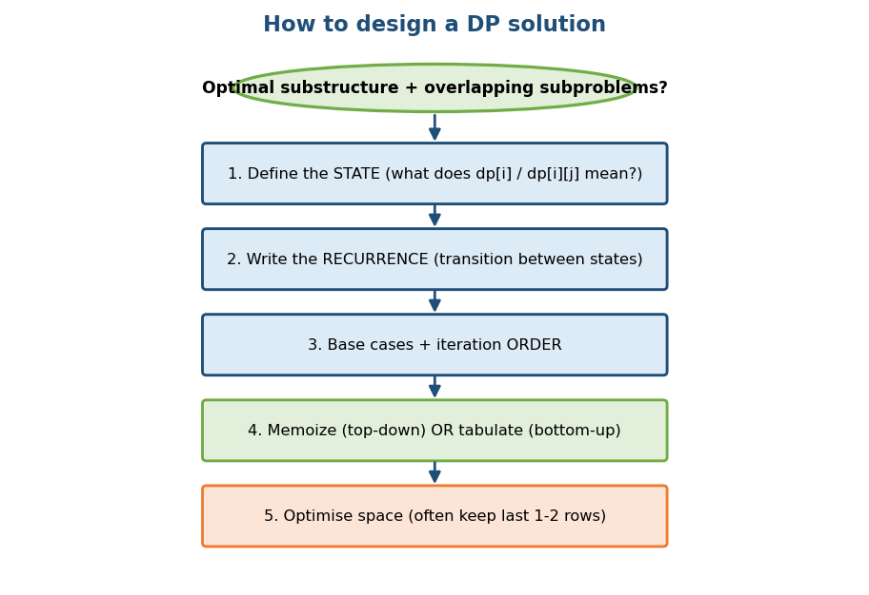
How to design a DP: state → recurrence → base cases + order → memoize/tabulate → optimise space.

14a.1 Foundations — when & how

The two requirements (same as greedy’s, plus overlap)
- Optimal substructure: the optimal answer is built from optimal answers to subproblems.
- Overlapping subproblems: the same subproblems recur many times (so caching pays off).
If you have optimal substructure but no overlap → use divide & conquer or greedy instead. DP’s whole value is reusing repeated subproblems.
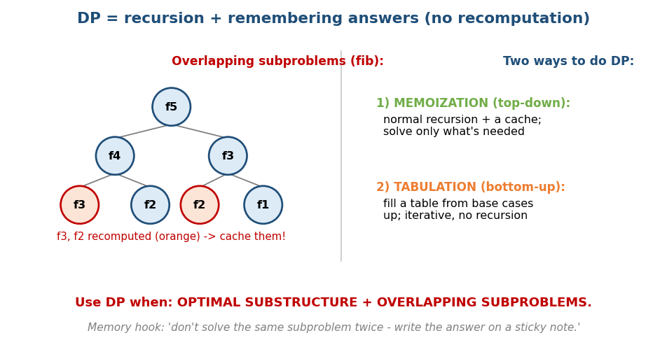
DP = recursion + remembering answers; fib recomputes f3/f2 (orange) — cache them. Two styles: memoization (top-down) and tabulation (bottom-up).

Memoization (top-down) vs Tabulation (bottom-up)
 | Memoization (top-down) | Tabulation (bottom-up)
Style | recursion + a cache | iterative table fill
Solves | only subproblems you need | all subproblems in order
Risk | recursion stack overflow (deep) | must get the fill order right
Ease | mirrors the recurrence (easy) | no recursion overhead (fast)
Both are same time complexity; pick whichever is clearer. Interviewers accept either, but often like “I’ll write it top-down first, then convert to bottom-up”.
Practical warning: when constraints reach ~10⁵+, deep top-down recursion can overflow the stack — there the bottom-up conversion becomes mandatory, not just a style choice. (This is why the “convert to iterative” follow-up exists.)

The 5-step DP recipe (say this out loud in interviews)
- State: what does dp[i] / dp[i][j] mean? (the hardest, most important step.)
- Recurrence: how does a state depend on smaller states (the transition)?
- Base cases + the iteration order (so dependencies are ready).
- Memoize or tabulate.
- Optimise space (often only the last 1–2 rows/values are needed).
Memory hook: “Don’t solve the same subproblem twice — write its answer on a sticky note.” DP = recursion + sticky notes.

MCQs
- Two requirements for DP? → optimal substructure + overlapping subproblems.
- Optimal substructure but NO overlap → use? → divide & conquer / greedy.
- Top-down vs bottom-up time? → same; differ in style/overhead.

14a.2 The Fibonacci ladder (memoization → tabulation → O(1))
# BRUTE FORCE: plain recursion Time O(φ^n), Space O(n) stack
fib(n): return n if n<2 else fib(n-1)+fib(n-2)
# BETTER: memoization (top-down) Time O(n), Space O(n)
memo={}; fib(n): if n<2 return n; if n in memo return memo[n]
memo[n]=fib(n-1)+fib(n-2); return memo[n]
# GOOD: tabulation (bottom-up) Time O(n), Space O(n)
dp[0]=0; dp[1]=1; for i in 2..n: dp[i]=dp[i-1]+dp[i-2]
# OPTIMAL: rolling variables Time O(n), Space O(1)
a,b=0,1; repeat n times: a,b = b, a+b; return a
This exact ladder (exponential → O(n) → O(1) space) is the template for almost every 1D DP.

14a.3 1D DP Patterns

Climbing Stairs / Fibonacci-shaped
dp[i] = dp[i-1] + dp[i-2] (ways to reach step i), with base cases dp[0]=1, dp[1]=1. (Note the off-by-one vs Fibonacci, where dp[0]=0 — Climbing Stairs counts the empty way as 1.) House robber, decode ways, and tiling all share this “depends on the last one or two states” shape.

House Robber — dp[i] = max(dp[i-1], dp[i-2] + nums[i])
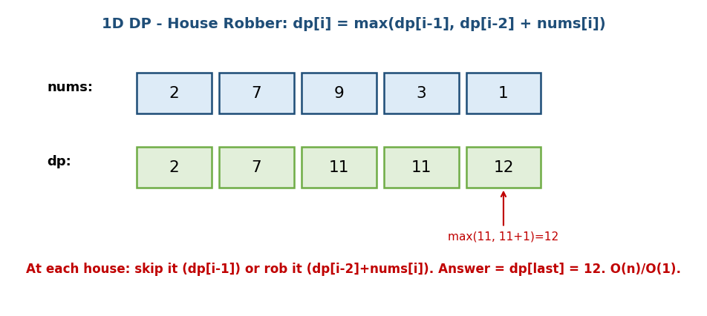
House robber 1D DP: dp[i] = max(skip = dp[i-1], rob = dp[i-2]+nums[i]); answer = dp[last].
At each house: skip it (carry dp[i-1]) or rob it (dp[i-2] + nums[i], can’t rob adjacent). nums=[2,7,9,3,1] → dp=[2,7,11,11,12] → 12. O(n)/O(1).
- House Robber II (LC 213): houses in a circle. Since house 0 and house n−1 are now adjacent, any valid plan must exclude at least one of them → answer = max( rob(nums[0..n-2]), rob(nums[1..n-1]) ) (run the line-DP twice).

Coin Change — fewest coins for an amount
# Coin Change (min coins) Time O(amount * #coins)
dp[0] = 0; dp[x] = infinity for x>0
for x in 1..amount:
for coin in coins:
if coin <= x: dp[x] = min(dp[x], dp[x-coin] + 1)
return dp[amount] (or -1 if still infinity)
Note: this is the DP that fixes the greedy failure from Module 11 (coins {1,3,4} → 6). DP tries all coins per amount, so it’s always optimal.

Coin Change II — COUNT ways (the loop-order gotcha)
A different problem: count the number of combinations that make the amount (unlimited coins).
# Coin Change II (count combinations) Time O(amount * #coins)
dp[0] = 1 # one way to make 0: take nothing
for coin in coins: # <-- coins OUTER loop
for x in coin..amount: # <-- amount inner
dp[x] += dp[x - coin]
return dp[amount]
Critical gotcha: the coin loop must be the OUTER loop to count combinations. If you loop amount-outer/coin-inner you count permutations (e.g. 1+2 and 2+1 separately) — the classic wrong answer. Contrast: the min-coins version (above) works with either order because min doesn’t double-count.

Decode Ways & Word Break (1D over a string)
# Decode Ways (LC 91): s of digits -> #ways to decode (A=1..Z=26)
dp[0] = 1
dp[i] += dp[i-1] if s[i-1] != '0' # single digit 1..9
dp[i] += dp[i-2] if "10" <= s[i-2..i-1] <= "26" # valid two-digit
# zero-handling is the whole difficulty: '0' alone is invalid; '30' invalid; '10','20' ok
# Word Break (LC 139): dp[i] = can the prefix of length i be segmented?
dp[0] = true
dp[i] = OR over j<i of ( dp[j] AND s[j..i-1] in dictionary )

Maximum Product Subarray (track two states)
Negatives flip sign, so track both the max and min product ending here: maxP = max(x, x*prevMax, x*prevMin), minP = min(...). (Kadane’s multiplicative cousin — Module 2.)

Longest Increasing Subsequence (LIS) — the #1 1D DP
The longest strictly-increasing (not necessarily contiguous) subsequence.
# O(n^2) answer = max(dp)
dp[i] = 1 + max(dp[j] for all j < i with nums[j] < nums[i], else 0)
There is also an O(n log n) method (a “tails” array + binary search). Full treatment, variants (Number of LIS, Russian Doll), and the n log n code are in Module 14b §14b.1 — but every reader of 14a should know the O(n²) recurrence above, since LIS is the most common 1D DP interview question.

MCQs
- House Robber recurrence? → dp[i]=max(dp[i-1], dp[i-2]+nums[i]).
- Coin Change (min coins) complexity? → O(amount × #coins).
- Max Product Subarray tracks? → both max and min (negatives flip sign).

Problems
- Climbing Stairs (70); House Robber I/II (198/213); Coin Change (322); Coin Change II (518 — count ways); Decode Ways (91); Word Break (139); Maximum Product Subarray (152); Min Cost Climbing Stairs (746).

14a.4 2D / Grid DP

Unique Paths — dp[i][j] = dp[i-1][j] + dp[i][j-1]
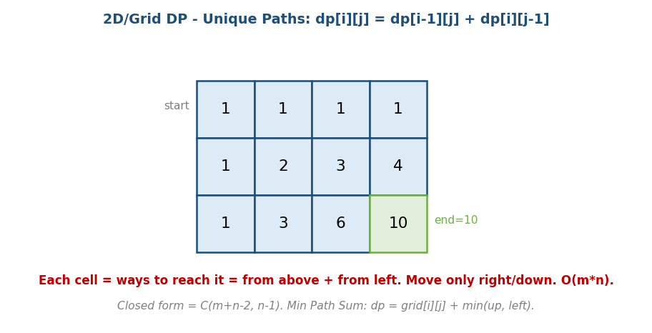
Unique Paths grid DP: each cell = ways to reach it = from above + from left; bottom-right = 10.
Move only right/down; each cell’s count = from above + from left. Closed form = C(m+n−2, n−1). Min Path Sum (LC 64): dp[i][j] = grid[i][j] + min(up, left). Unique Paths II (LC 63): obstacles set those cells to 0.

Edit Distance (Levenshtein) — the 2D classic
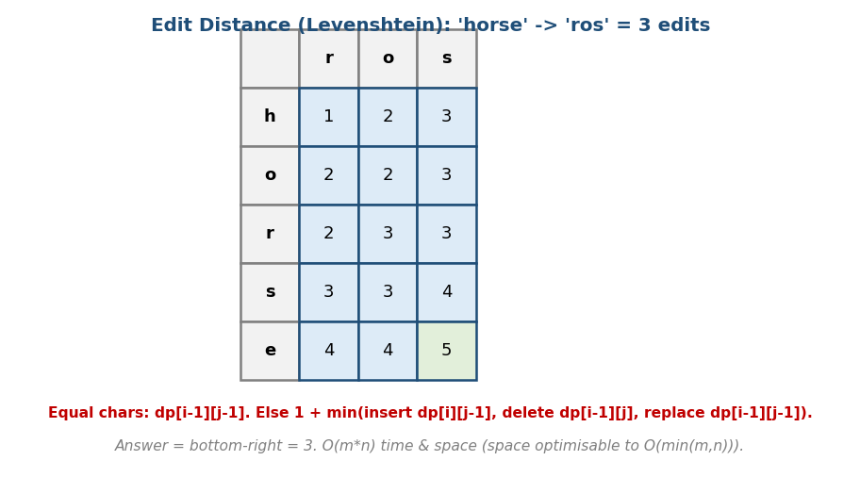
Edit Distance DP table for ‘horse’ → ‘ros’ = 3; equal chars copy the diagonal, else 1 + min(insert, delete, replace).
# Edit Distance Time O(m*n), Space O(m*n) -> O(min)
dp[i][j] = edits to turn first i chars of A into first j chars of B
base: dp[i][0]=i (delete all), dp[0][j]=j (insert all)
if A[i-1]==B[j-1]: dp[i][j] = dp[i-1][j-1] # match, no cost
else: dp[i][j] = 1 + min(dp[i][j-1], # insert
dp[i-1][j], # delete
dp[i-1][j-1]) # replace
"horse" → "ros" = 3 edits: replace h→r, delete r (2nd char of “horse”), delete e → leaves “ros”. (Trace it through the table; bottom-right = 3.)

Matrix Chain Multiplication (the #1 GATE interval DP)
Given matrices A₁…Aₙ with dimension array p[0..n] (so Aᵢ is p[i-1] × p[i]), parenthesise to minimise scalar multiplications.
# Matrix Chain Multiplication Time O(n^3), Space O(n^2)
m[i][i] = 0
m[i][j] = min over k in i..j-1 of:
m[i][k] + m[k+1][j] + p[i-1]*p[k]*p[j] # cost of the last multiply
# fill diagonal by diagonal (by chain length L = 2..n)
Worked example. Dimensions p = [10, 20, 30] (two matrices A₁=10×20, A₂=20×30): only one way → 10·20·30 = 6000 multiplications. For three matrices p=[10,20,30,40]: compare (A₁A₂)A₃ and A₁(A₂A₃) and take the min — this is exactly what m[1][3] computes. The s[i][j] table records the best split k to reconstruct the parenthesisation. (More interval DP in M14c.)

Other 2D / grid DP patterns (distinct recurrences)
- Maximal Square (LC 221): dp[i][j] = 1 + min(dp[i-1][j], dp[i][j-1], dp[i-1][j-1]) when grid[i][j]==1 → largest all-1 square. (min of three neighbours, not up+left.)
- Dungeon Game (LC 174): solved in reverse (bottom-right → top-left): dp[i][j] = max(1, min(dp[i+1][j], dp[i][j+1]) − grid[i][j]). The reverse direction is the whole insight.
- LCS / Distinct Subsequences / Interleaving String — dp[i][j] over two strings (full LCS in M14b).

Space optimisation (the standard follow-up)
Most 2D grid/string DPs only read the previous row (and current row), so you can drop from O(m·n) to O(min(m, n)) by keeping one or two rows. This is a classic “can you do better on space?” interview ask.

MCQs
- Unique Paths recurrence & closed form? → dp[i-1][j]+dp[i][j-1]; C(m+n−2, n−1).
- Edit Distance equal-char transition? → copy the diagonal dp[i-1][j-1].
- 2D DP space optimisation? → keep only the previous row → O(min(m,n)).

Problems
- Unique Paths I/II (62/63); Minimum Path Sum (64); Edit Distance (72); Longest Common Subsequence (1143); Maximal Square (221); Dungeon Game (174); Matrix Chain Multiplication (classic).

Module 14a — Concept Review (one page)
- DP needs optimal substructure + overlapping subproblems; otherwise use D&C/greedy.
- 5 steps: define state → recurrence → base+order → memoize/tabulate → optimise space.
- Top-down (memo) = recursion + cache; bottom-up (tab) = iterative table; same time.
- Fibonacci ladder: exponential → O(n) → O(1) space (rolling vars) — the 1D template.
- 1D: House Robber max(skip, rob); Coin Change min(dp[x-coin]+1); Max Product tracks max & min.
- 2D: Unique Paths up+left; Edit Distance diag or 1+min(3); space → O(min(m,n)).

Module 14a — Flash Cards
- Q: DP requirements? A: optimal substructure + overlapping subproblems.
- Q: Memo vs tab time? A: same; style differs.
- Q: Fibonacci optimal space? A: O(1) (two rolling variables).
- Q: House Robber recurrence? A: max(dp[i-1], dp[i-2]+nums[i]).
- Q: Coin Change time? A: O(amount × #coins).
- Q: Edit Distance match transition? A: copy diagonal dp[i-1][j-1].
- Q: 2D DP space cut? A: keep last row → O(min(m,n)).

Module 14a — Pattern Recognition
- “Count ways / min cost over a 1D sequence, depends on last few” → 1D DP.
- “Fewest/most to reach a target amount” → coin-change style DP.
- “Two strings → similarity/transform” → 2D DP (edit distance / LCS).
- “Grid, move right/down, count/min” → grid DP (up + left).
- “Greedy gave a wrong answer” → fall back to DP (it tries all choices).

Module 14a — Interview Questions (with follow-ups)
- Climbing stairs / house robber. FU: O(1) space; circular variant.
- Coin change. FU: count ways vs fewest coins; why not greedy?
- Edit distance. FU: recover the actual edit operations; O(min) space.
- Unique paths. FU: with obstacles; closed-form combinatorics.
- “Solve it top-down, then convert to bottom-up.” (common Google ask.)

Module 14a — GATE / SEBI / RBI / ISRO Perspective
- GATE favourites: filling a DP table by hand (edit distance, matrix chain, coin change), stating the recurrence, matrix chain multiplication order & cost, identifying optimal substructure, and memo-vs-tab trade-offs. Frequently tested numerically.

End of Module 14a. Next: Module 14b — Sequence DP (LIS, LCS) & Knapsack family — with visuals.

