Module 14b — Dynamic Programming: Sequences & Knapsack
  - DSA Mastery: Google / FAANG / GATE / ICPC — In-Depth Notes (with visuals)
Prepared for nidhi.sharma@forensiccybertech.com
2026
Table of Contents

Module 14b — DP: Sequence DP & the Knapsack Family
Why this part. Two of the most-asked DP families live here: sequence DP (LIS, LCS — the backbone of diff tools, DNA alignment, autocomplete) and the knapsack family (0/1, unbounded, subset-sum, partition — the backbone of resource-allocation problems). Recognise which family a problem belongs to and the recurrence almost writes itself.
This module is P0. LIS/LCS and 0/1 knapsack are interview + GATE staples.
How to read each technique. Brute force → Better → Optimal with pseudocode + complexity, plus a memory hook.

14b.1 Longest Increasing Subsequence (LIS)

Problem & two solutions
The longest subsequence (not necessarily contiguous) whose values strictly increase.
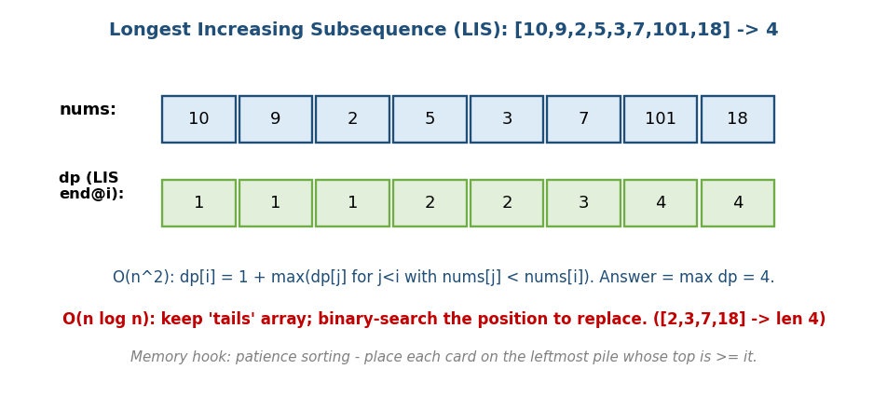
LIS of [10,9,2,5,3,7,101,18] = 4; dp[i] = 1 + max(dp[j] for j<i, nums[j]<nums[i]); O(n log n) via tails.
# O(n^2) DP
dp[i] = 1 + max(dp[j] for all j < i with nums[j] < nums[i], else 0)
answer = max(dp)
# O(n log n): maintain 'tails' (smallest possible tail of an LIS of each length)
for x in nums:
pos = lower_bound(tails, x) # first tail >= x
if pos == len(tails): tails.append(x) # x extends the longest LIS
else: tails[pos] = x # x improves an existing length
answer = len(tails)
- [10,9,2,5,3,7,101,18] → LIS length 4 (e.g. 2,3,7,18 or 2,5,7,101).
- Important: tails is not an actual LIS, only its length is correct.
Reconstructing the actual subsequence (a guaranteed follow-up): keep a parent[] array. In the O(n²) version, set parent[i] = the j that maximised dp[i]; track the index with the largest dp, then walk parent backwards and reverse. (In the O(n log n) version, store idx[pos]=i when you place x at pos, and parent[i]=idx[pos-1].)
- Number of LIS (LC 673): keep a second array count[i]: when dp[j]+1 == dp[i] add count[j]; when dp[j]+1 > dp[i] reset count[i]=count[j].
- Other variants: Longest Non-Decreasing (use upper_bound), Russian Doll Envelopes (2D LIS), Longest Bitonic.
Memory hook: patience sorting — deal each card onto the leftmost pile whose top is ≥ it; the number of piles = LIS length.

MCQs
- LIS O(n²) recurrence? → dp[i] = 1 + max(dp[j] : j<i, nums[j]<nums[i]).
- LIS in O(n log n) uses? → a tails array + binary search.
- Is the tails array a valid LIS? → No (only its length is correct).

Problems
- Longest Increasing Subsequence (300); Number of LIS (673); Russian Doll Envelopes (354); Longest Bitonic; Maximum Length of Pair Chain (646).

14b.2 Longest Common Subsequence (LCS) & friends

LCS — the 2D string-DP archetype
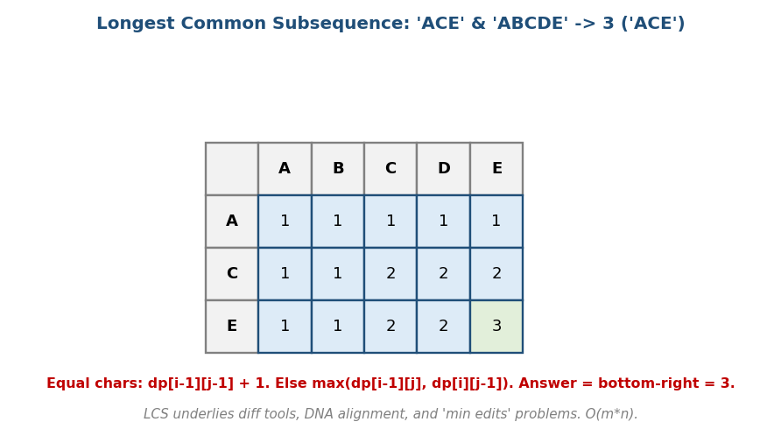
LCS of ‘ACE’ & ‘ABCDE’ = 3; equal chars add 1 to the diagonal, else take max of left/up.
# LCS Time O(m*n), Space O(m*n) -> O(min)
if A[i-1] == B[j-1]: dp[i][j] = dp[i-1][j-1] + 1 # match -> extend diagonal
else: dp[i][j] = max(dp[i-1][j], dp[i][j-1])
'ACE' & 'ABCDE' → 3 (ACE). LCS underlies diff, git, DNA alignment, and plagiarism detection.
Worked table (A=“ACE” rows, B=“ABCDE” cols; first row/col = 0):
"" A B C D E
"" 0 0 0 0 0 0
A 0 1 1 1 1 1
C 0 1 1 2 2 2
E 0 1 1 2 2 3 <- answer = dp[3][5] = 3
Printing the LCS (backtrack from dp[m][n]): if A[i-1]==B[j-1], prepend the char and go diagonal (i–, j–); else move toward the larger of dp[i-1][j] / dp[i][j-1]. Space note: two rolling rows give the length in O(min(m,n)) space — but then you can’t backtrack the string; to recover the LCS in O(min) space use Hirschberg’s algorithm (divide & conquer).

The LCS family (same table, different transition)
- Longest Common Substring (contiguous): reset to 0 on mismatch; track the max cell.
- Edit Distance (Module 14a): the “min operations” cousin.
- Longest Palindromic Subsequence (LC 516): LCS(s, reverse(s))!
- Shortest Common Supersequence, Distinct Subsequences, Interleaving String, Min Insertions/Deletions to make equal — all dp[i][j] over two sequences.
Memory hook: LCS = “how much of two sequences lines up in order”; matches step the diagonal, mismatches take the better neighbour.

MCQs
- LCS match vs mismatch transition? → diag+1 vs max(left, up).
- Longest Palindromic Subsequence = ? → LCS(s, reverse(s)).
- Longest common substring differs how? → reset to 0 on mismatch.

Problems
- Longest Common Subsequence (1143); Longest Palindromic Subsequence (516); Shortest Common Supersequence (1092); Distinct Subsequences (115); Interleaving String (97); Delete Operation for Two Strings (583).

14b.3 The Knapsack Family
This family = “pick items under a capacity/target constraint.” Learn the 0/1 base, then the variations are small tweaks.

0/1 Knapsack — each item used at most once
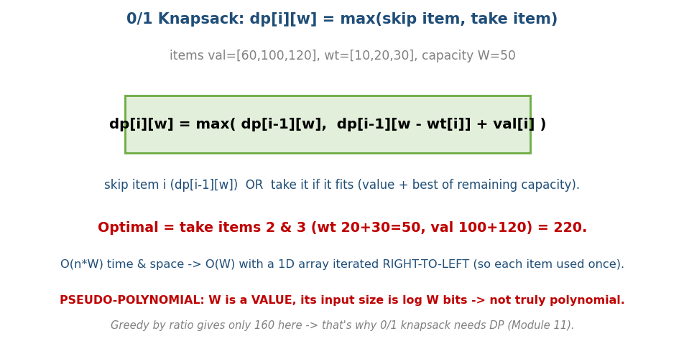
0/1 Knapsack: dp[i][w] = max(skip item, take item); val=[60,100,120], wt=[10,20,30], W=50 → 220.
# 0/1 Knapsack Time O(n*W), Space O(n*W) -> O(W)
dp[i][w] = max( dp[i-1][w], # skip item i
dp[i-1][w - wt[i]] + val[i] ) # take item i (if it fits)
# 1D space-optimised: iterate w RIGHT-TO-LEFT so each item is used once
for each item (wt, val):
for w in W down to wt:
dp[w] = max(dp[w], dp[w-wt] + val)
- val=[60,100,120], wt=[10,20,30], W=50 → 220 (items 2+3). Greedy-by-ratio gives only 160 → that’s why this needs DP (Module 11 contrast).
Worked table (compressed: wt=[1,2,3], val=[60,100,120], W=5 — same 220):
item\w 0 1 2 3 4 5
- 0 0 0 0 0 0
1 0 60 60 60 60 60
2 0 60 100 160 160 160
3 0 60 100 160 180 220 <- dp[3][5] = 220
Item recovery (backtrack): dp[3][5]=220 ≠ dp[2][5]=160 → item 3 taken; go to dp[2][5-3]=dp[2][2]=100 ≠ dp[1][2]=60 → item 2 taken; reach dp[1][0] → stop. Chosen = {2, 3}. - Pseudo-polynomial: O(n·W) looks polynomial, but W is a value whose input size is log W bits → not truly polynomial (a GATE/complexity subtlety). - Why right-to-left in 1D? So dp[w-wt] still refers to the previous item’s row (item used once). Left-to-right reads dp[w-wt] after it was already updated for this same item in this pass, so the item stacks on itself → unlimited copies → that’s exactly unbounded knapsack.

Unbounded Knapsack — unlimited copies (iterate left-to-right)
for each item:
for w in wt to W: # LEFT-TO-RIGHT -> item can be reused
dp[w] = max(dp[w], dp[w-wt] + val)
- Coin Change (Module 14a) is unbounded knapsack (each coin reusable). Count ways (Coin Change II, LC 518): loop coins outside, amount inside to count combinations (not permutations) — a classic loop-order gotcha.

Subset Sum / Equal Partition / Target Sum
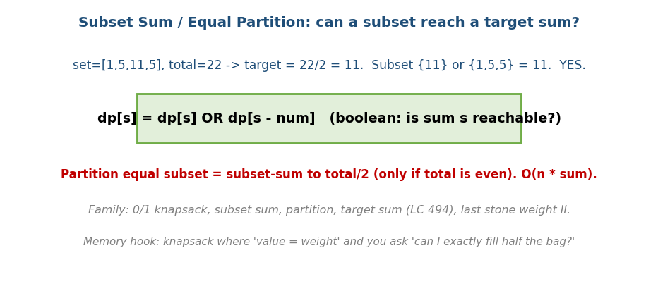
Subset Sum: dp[s] = dp[s] OR dp[s-num]; equal partition = subset-sum to total/2.
- Subset Sum: boolean DP, base dp[0]=true, iterate right-to-left (as in 0/1, so each number is used once): dp[s] = dp[s] or dp[s-num].
- Equal Partition (LC 416): subset-sum to total/2 (only if total is even).
- Target Sum (LC 494): assign +/− to reach target. Let P = sum of the + set, N = sum of the − set: P − N = target and P + N = sum ⇒ P = (sum + target) / 2. So count subsets summing to (sum+target)/2 (reject if sum+target is odd or negative). This algebra is the whole point.
- Last Stone Weight II, Ones and Zeroes — knapsack variants.
Memory hook: subset-sum = a 0/1 knapsack where value = weight and you ask “can I fill exactly this much?”

MCQs
- 0/1 knapsack recurrence? → max(dp[i-1][w], dp[i-1][w-wt]+val).
- 1D knapsack iterate direction (0/1 vs unbounded)? → right-to-left vs left-to-right.
- Equal partition reduces to? → subset-sum to total/2.
- Why is O(n·W) “pseudo-polynomial”? → W is a value (input size log W).

Problems
- 0/1: Partition Equal Subset Sum (416); Target Sum (494); Last Stone Weight II (1049); Ones and Zeroes (474). Unbounded: Coin Change (322); Coin Change II (518); Combination Sum IV (377); Perfect Squares (279).

Module 14b — Concept Review (one page)
- LIS: O(n²) dp[i]=1+max(dp[j]:nums[j]<nums[i]); O(n log n) via tails + binary search (length only).
- LCS: 2D string DP; match → diag+1, else max(left,up); family includes edit distance, LPS = LCS(s, reverse(s)), supersequence.
- 0/1 Knapsack: max(skip, take); 1D iterate right-to-left; pseudo- polynomial O(n·W).
- Unbounded knapsack (reuse) iterate left-to-right; coin change is unbounded; count-ways needs coins-outer loop order.
- Subset-sum / partition / target-sum = knapsack with value=weight; partition → sum to total/2.

Module 14b — Flash Cards
- Q: LIS in O(n log n)? A: tails array + binary search (length only).
- Q: LCS transitions? A: diag+1 (match) / max(left,up) (mismatch).
- Q: Longest palindromic subsequence trick? A: LCS(s, reverse(s)).
- Q: 0/1 vs unbounded 1D loop? A: right-to-left vs left-to-right.
- Q: Coin Change II loop order? A: coins outside, amount inside (combinations).
- Q: Equal partition? A: subset-sum to total/2 (total even).
- Q: Why knapsack pseudo-polynomial? A: W is a value, size log W bits.

Module 14b — Pattern Recognition
- “Longest increasing/chain subsequence” → LIS (n log n with tails).
- “Compare/align two sequences/strings” → LCS-family 2D DP.
- “Pick items under a capacity, each once” → 0/1 knapsack.
- “Unlimited copies / make an amount” → unbounded knapsack / coin change.
- “Can a subset reach/split to a sum?” → subset-sum / partition.

Module 14b — Interview Questions (with follow-ups)
- LIS. FU: O(n log n)? reconstruct the actual subsequence?
- LCS. FU: print the LCS; O(min) space; longest palindromic subsequence.
- 0/1 knapsack. FU: 1D space; why right-to-left? pseudo-polynomial meaning.
- Coin change (min) vs coin change II (count). FU: why loop order differs.
- Partition equal subset sum. FU: reduce to subset-sum; complexity.

Module 14b — GATE / SEBI / RBI / ISRO Perspective
- GATE favourites: filling LCS / 0/1-knapsack tables by hand, LIS length, knapsack as pseudo-polynomial, subset-sum/partition, and the loop-order distinction for count vs min. Frequently tested numerically.

End of Module 14b. Next: Module 14c — Advanced DP (tree DP, bitmask DP, digit DP, interval DP, DP optimisations) — with visuals.

