Module 14c — Dynamic Programming: Advanced
  - DSA Mastery: Google / FAANG / GATE / ICPC — In-Depth Notes (with visuals)
Prepared for nidhi.sharma@forensiccybertech.com
2026
Table of Contents

Module 14c — Advanced DP (Tree, Bitmask, Digit, Interval, Optimisations)
Why this part. Once you can define a state and a transition (M14a/b), the “advanced” DP topics are mostly about what the state is: a subtree (tree DP), a subset of bits (bitmask DP), a position in a number (digit DP), or a range (interval DP). The final piece — DP optimisations — speeds up a correct-but-slow recurrence. These are P2 (hard interviews + ICPC + GATE algorithm-design), so focus on recognising the state shape and the headline complexity.
How to read each technique. The state, the recurrence, the complexity, and when to reach for it.

14c.1 Tree DP (state = a subtree)

The idea
Run a post-order DFS: each node computes its answer from its children’s answers. The state is usually (node, small extra flag).
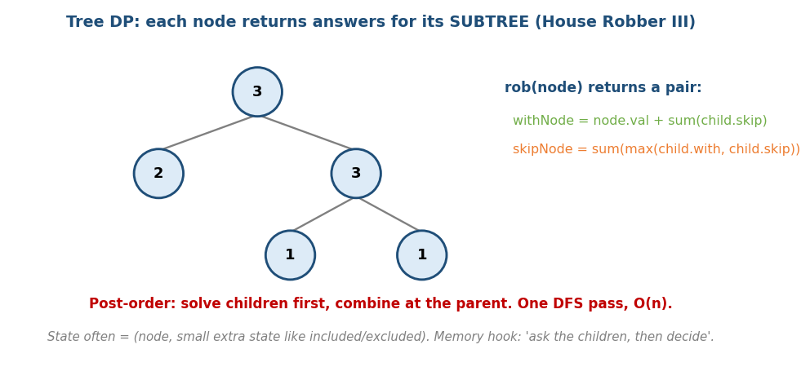
Tree DP: each node returns answers for its subtree; House Robber III returns (rob-this, skip-this).
# House Robber III (LC 337) — can't rob a node and its child
solve(node) returns (withNode, skipNode):
if node is null: return (0, 0)
L = solve(node.left); R = solve(node.right)
withNode = node.val + L.skip + R.skip
skipNode = max(L.with, L.skip) + max(R.with, R.skip)
return (withNode, skipNode)
answer = max(solve(root))
- One DFS pass → O(n). Returning the pair (with, skip) is the trick: the naive single-value rob(node) re-queries grandchildren (overlapping subproblems → needs a memo map); the pair eliminates that entirely → pure O(n), no memo.
- Other tree DP: Diameter / Max Path Sum (Module 8a), Binary Tree Cameras (968), Distribute Coins (979), counting subtrees.

Re-rooting (two-pass) — an answer for EVERY node as root, in O(n)
# Re-rooting DP (e.g. Sum of Distances in Tree, LC 834) O(n) total
pass 1 (post-order): down[v] = answer within v's subtree (+ subtree sizes)
pass 2 (pre-order from root): up[v] derived from the parent's total minus v's
own contribution -> answer[v] = down[v] combined with up[v]
Pass 1 gathers subtree info bottom-up; pass 2 pushes the parent’s contribution down to “re-root” at each child. Examples: Sum of Distances in Tree (834), tree-centroid / min-height framing (310).
Memory hook: “ask the children, then decide” — the postorder mantra from Module 8a, now carrying richer state.

MCQs
- Tree DP traversal order? → post-order (children first).
- House Robber III state? → (rob this node, skip this node).
- Tree DP time? → O(n) (one DFS).

14c.2 Bitmask DP (state = a subset)

The idea
When n is small (≤ ~20) and the state is “which subset is done”, encode the subset as the bits of an integer mask.
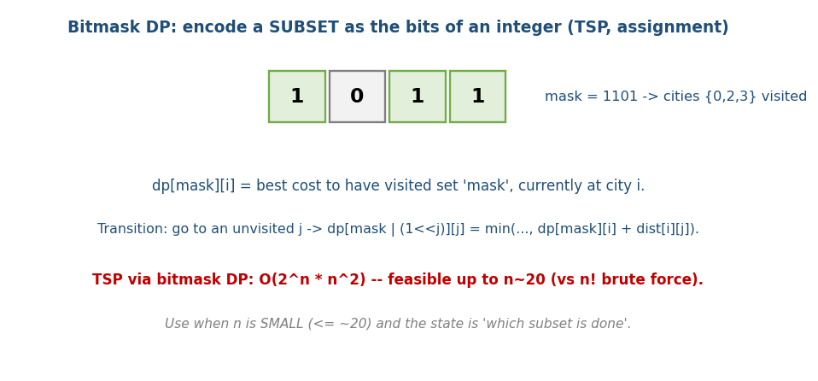
Bitmask DP: a subset is the bits of an integer; dp[mask][i] = best having visited ‘mask’, now at i.
# Travelling Salesman (Held-Karp) Time O(2^n * n^2), Space O(2^n * n)
dp[mask][i] = min cost to start at 0, visit exactly the set 'mask', end at city i
base: dp[1][0] = 0 (only city 0 visited), everything else = infinity
iterate masks in ASCENDING order (so every submask is filled before its supermask):
dp[mask | (1<<j)][j] = min(..., dp[mask][i] + dist[i][j]) # i in mask, j not
closed tour: answer = min over i of dp[full][i] + dist[i][0] # open path: drop the +dist[i][0]
# (keep a parent[] to reconstruct the actual tour)
- TSP drops from O(n!) brute force to O(2ⁿ·n²) — feasible to n ≈ 18–20.

Partition into k equal subsets (LC 698) — the single-dimension mask trick
# precheck: target = sum/k must be integer AND max(nums) <= target
dp[mask] = remaining capacity in the CURRENT bucket after placing items in 'mask'
dp[0] = target
for each mask, for each j not in mask with nums[j] <= dp[mask]:
dp[mask | (1<<j)] = (dp[mask] - nums[j]) % target # hitting 0 rolls to a fresh bucket
answer: dp[full] == 0 # Time O(2^n * n)
- Submask enumeration idiom (for “assign each element to one of several precomputed valid groups”, LC 1986/2305): for (sub = mask; sub; sub = (sub-1) & mask) iterates all submasks of mask in O(3ⁿ) total.
- Other bitmask DP: assignment (workers↔jobs), counting Hamiltonian paths, Shortest Superstring (943).
Trigger: small n + “subset of things already chosen/used” → think bitmask.

MCQs
- Bitmask DP applies when n is? → small (≤ ~20).
- TSP via bitmask DP time? → O(2ⁿ·n²).
- mask | (1<<j) does? → adds element j to the set.

14c.3 Interval DP (state = a range [i, j])

The idea
dp[i][j] = the best answer for the sub-range i..j. Fill by increasing interval length. The key trick: pick the last thing to handle in (i, j) so the two sides become independent.
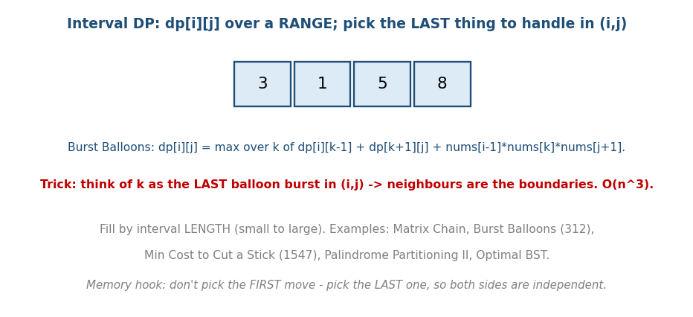
Interval DP: dp[i][j] over a range; choose the LAST item to handle so both sides are independent.
# Burst Balloons (LC 312) Time O(n^3)
# PAD nums with a virtual 1 at each end; (i,j) is an OPEN interval (boundaries survive)
dp[i][j] = max coins from bursting all balloons strictly inside (i, j)
dp[i][i+1] = 0 # nothing between adjacent boundaries
dp[i][j] = max over k in (i,j) of:
dp[i][k] + dp[k][j] + nums[i]*nums[k]*nums[j] # k = LAST burst inside
- Pick the last move, not the first — that keeps the two sides independent. The virtual 1s at both ends make nums[i]/nums[j] valid boundaries after everything inside is burst.

Two interval-DP cost shapes (don’t confuse them)
Cost added at the split | Example
multiply boundary/last nums[i]·nums[k]·nums[j] | Burst Balloons
add the range sum prefixSum(i, j) at each merge | Merge Stones (1000), Stone Game
p[i-1]·p[k]·p[j] (matrix dims) | Matrix Chain Mult. (M14a)
Matrix Chain recurrence (GATE-critical, restated here): dp[i][j] = min over k of dp[i][k] + dp[k+1][j] + p[i-1]·p[k]·p[j], base dp[i][i]=0, fill by increasing chain length → O(n³) time, O(n²) space (worked numeric example in M14a).
- Other interval DP: Min Cost to Cut a Stick (1547), Palindrome Partitioning II (132), Optimal BST.
Memory hook: parenthesisation problems — “which split / which last operation?” over a range.

MCQs
- Interval DP fill order? → by increasing interval length.
- Burst Balloons trick? → treat k as the last balloon burst.
- Interval DP typical time? → O(n³).

14c.4 Digit DP (state = position in a number)

The idea
Count numbers in [0, N] (or [L, R]) with some digit property (e.g. “no two equal adjacent digits”, “digit sum = s”). Build the number digit by digit; the state tracks (position, tight, extra) where tight = “are we still on the prefix of N?”.
# Digit DP skeleton Time O(digits * states * 10)
count(pos, tight, extra):
if pos == len(N): return 1 if extra is valid else 0
limit = N[pos] if tight else 9
total = 0
for d in 0..limit:
total += count(pos+1, tight and d==limit, update(extra, d))
return total
# answer for [L,R] = count(R) - count(L-1)
- tight is the heart: while tight, you can’t exceed N’s digit at this position. Memoise on (pos, tight, extra).
- Examples: count numbers with digit-sum k, numbers without consecutive 1s, “Numbers At Most N Given Digit Set” (902), Count Numbers with Unique Digits.

MCQs
- Digit DP counts numbers up to N with a? → digit property.
- The crucial state flag? → tight (still bounded by N’s prefix).
- [L,R] answer? → count(R) − count(L−1).

14c.5 DP Optimisations (speed up a correct DP)
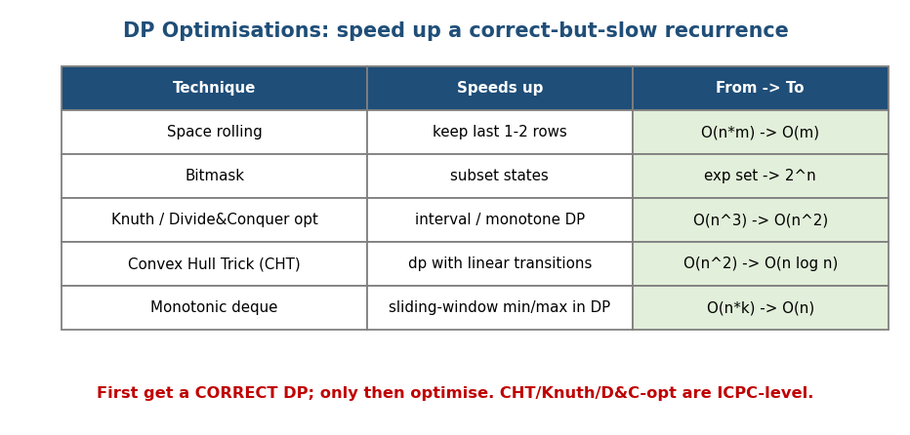
DP optimisations: rolling space, bitmask, Knuth/D&C-opt, convex hull trick, monotonic deque — and the from→to speedups.
Technique | Idea | Speedup
Rolling array | keep only last 1–2 rows | O(n·m) → O(m) space
Monotonic deque | sliding-window min/max in the transition | O(n·k) → O(n)
Knuth optimisation | for interval DP with the quadrangle inequality | O(n³) → O(n²)
Divide & Conquer opt | when the optimal split is monotonic | O(n²) → O(n log n)
Convex Hull Trick (CHT) | transitions of the form min(m·x + b) (lines) | O(n²) → O(n log n)/O(n)
Golden rule: first get a correct DP, then optimise. Knuth / D&C-opt / CHT are ICPC-level — recognise the transition shape (interval with QI; cost = line mx+b) rather than memorising the math.

MCQs
- First priority before optimising DP? → get a correct recurrence.
- Transitions min(m·x + b) → use? → Convex Hull Trick.
- Interval DP with quadrangle inequality → ? → Knuth optimisation (O(n²)).

Module 14c — Concept Review (one page)
- Tree DP: post-order DFS, state (node, flag); O(n); House Robber III, max path sum, re-rooting.
- Bitmask DP: subset = integer bits; small n (≤20); TSP O(2ⁿ·n²), assignment, partition-to-k.
- Interval DP: dp[i][j] by increasing length; pick the last move; Burst Balloons / Matrix Chain O(n³).
- Digit DP: state (pos, tight, extra); count numbers ≤ N with a digit property; [L,R] = f(R)−f(L−1).
- Optimisations: rolling space, monotonic deque, Knuth/D&C-opt, CHT — get correct first, then speed up.

Module 14c — Flash Cards
- Q: Tree DP order & time? A: post-order DFS, O(n).
- Q: When bitmask DP? A: small n (≤20), state = subset.
- Q: TSP DP complexity? A: O(2ⁿ·n²) (Held-Karp).
- Q: Interval DP key trick? A: choose the LAST operation in the range.
- Q: Digit DP key flag? A: tight (bounded by N’s prefix).
- Q: Transition min(mx+b) optimisation? A: Convex Hull Trick.

Module 14c — Pattern Recognition
- “Answer over a tree / subtree, choices per node” → tree DP.
- “Small n, ‘which subset is used/visited’” → bitmask DP (TSP/assignment).
- “Best over a range / parenthesisation / merge cost” → interval DP.
- “Count numbers with a digit property up to N” → digit DP.
- “Correct DP too slow (O(n²)/O(n³))” → CHT / Knuth / D&C-opt / deque.

Module 14c — Interview Questions (with follow-ups)
- House Robber III. FU: why return a pair; why post-order.
- TSP for n≤15. FU: bitmask DP; why O(2ⁿ·n²) beats n!.
- Burst Balloons. FU: why “last burst” makes sides independent.
- Count numbers ≤ N with no consecutive equal digits. FU: digit DP tight.

Module 14c — GATE / SEBI / RBI / ISRO Perspective
- GATE: TSP via DP complexity O(2ⁿ·n²), interval DP (matrix chain — also M14a), tree DP concepts. Bitmask/digit DP and CHT/Knuth are more ICPC than GATE; prioritise M14a/M14b for exams and treat M14c as “recognise the state shape”.

End of Module 14 (DP complete: a + b + c). Next: Module 15 — Bit Manipulation (XOR tricks, bitmasking, subsets, Gray code) — with visuals.

