Module 15 — Bit Manipulation
  - DSA Mastery: Google / FAANG / GATE / ICPC — In-Depth Notes (with visuals)
Prepared for nidhi.sharma@forensiccybertech.com
2026
Table of Contents

Module 15 — Bit Manipulation
Why bits matter. Under the hood everything is bits (Module 1). Working directly with bits gives O(1) tricks that replace loops: test/flip a flag, count set bits, find the odd one out, enumerate subsets, and pack a whole set into one integer (the basis of bitmask DP, Module 14c). Interviewers love bit tricks because they reveal whether you understand the machine; GATE tests them numerically.
This module is P0–P1: XOR tricks and the 4 basic operations are must-know; Gray code and advanced packing are P1/CP.
How to read each technique. The operation, the one-liner, the use, plus a memory hook.

15.1 Bitwise Operators
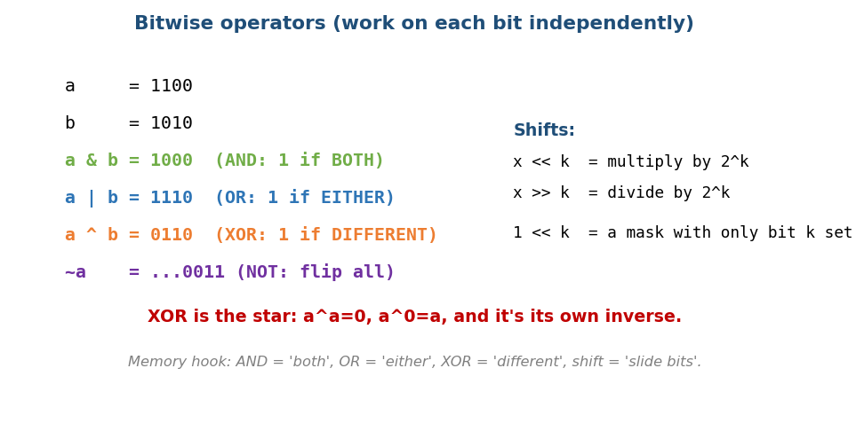
Bitwise AND/OR/XOR/NOT and shifts, each acting bit-by-bit; XOR is 1 when bits differ.
Op | Symbol | Result bit is 1 when…
AND | & | both bits are 1
OR | \| | either bit is 1
XOR | ^ | the bits differ
NOT | ~ | flips every bit (and the sign, two’s complement)
Left shift | << k | slide left = × 2ᵏ
Right shift | >> k | slide right = ÷ 2ᵏ (floor)
- 1 << k builds a mask with only bit k set — the workhorse of everything below.
- Caution: shifting by ≥ the type width, and right-shifting negatives (arithmetic vs logical), is implementation-defined — a common bug/GATE trap.
Memory hook: AND = “both”, OR = “either”, XOR = “different”, shift = “slide”.

MCQs
- x << 3 equals? → x × 8.
- XOR bit is 1 when? → the two bits differ.
- 1 << k gives? → a mask with only bit k set.

Two’s complement & right shift (GATE numerics)
For an n-bit two’s-complement number with bits b_{n-1}…b_0:
value = -b_{n-1}·2^(n-1) + Σ_{i=0..n-2} b_i·2^i , range = [ -2^(n-1) , 2^(n-1)-1 ]
to negate: invert all bits, then add 1
Worked examples (8-bit):
- 11010110₂ = -128 + 64 + 16 + 4 + 2 = −42.
- Represent −45: 45 = 00101101 → invert 11010010 → +1 → 11010011.
- Asymmetry: the most-negative value -2^(n-1) (e.g. −128) has no positive counterpart.
Right shift >> on negatives is two kinds:
- Arithmetic (Java >>, C on signed): copies the sign bit → for negatives it floors toward −∞ (e.g. -8 >> 1 = -4, -1 >> 1 = -1).
- Logical (Java >>>, unsigned types): fills with 0 → treats the value as unsigned. Mixing them up is a classic bug/GATE trap.

MCQs (two’s complement)
- Value of 11010110₂ (8-bit)? → −42.
- n-bit signed range? → [-2^(n-1), 2^(n-1)-1].
- -8 >> 1 (arithmetic)? → −4.

15.2 The 4 Essential Operations (on bit i)
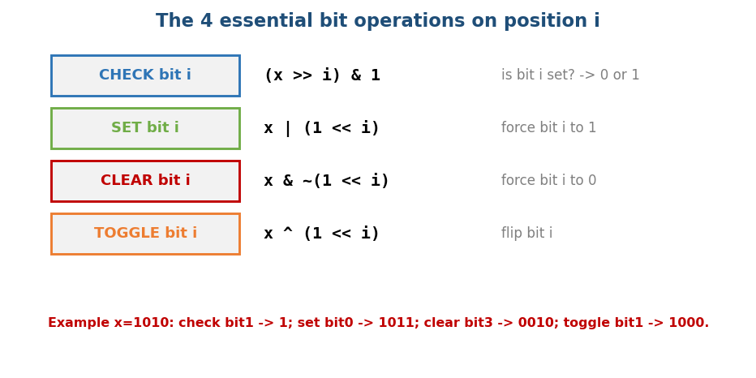
The four bit operations: check (x>>i)&1, set x|(1<<i), clear x&~(1<<i), toggle x^(1<<i).
CHECK bit i: (x >> i) & 1 # -> 0 or 1
SET bit i: x | (1 << i) # force to 1
CLEAR bit i: x & ~(1 << i) # force to 0
TOGGLE bit i: x ^ (1 << i) # flip
These four turn an integer into a compact set of up to 32/64 flags (a “bitset” / bitmask) — used for visited-states, permissions, feature flags, and bitmask DP.

MCQs
- Set bit i? → x | (1<<i). Clear bit i? → x & ~(1<<i).
- Toggle bit i? → x ^ (1<<i).
- Check bit i? → (x>>i) & 1.

15.3 XOR Tricks (the most loved)
XOR’s three properties make it magic: a ^ a = 0, a ^ 0 = a, and it is commutative & associative (order doesn’t matter).
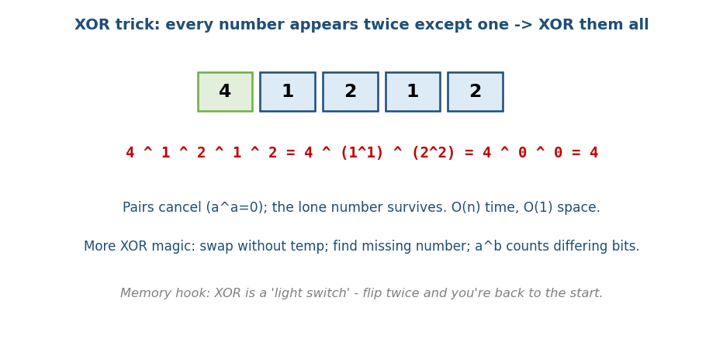
XOR trick: XOR all numbers; pairs cancel (a^a=0), leaving the single unique number.
- Single Number (LC 136): every element appears twice except one → XOR them all; pairs cancel, the lone one survives. O(n)/O(1).
- Missing Number (LC 268): XOR all indices 0..n with all values → the missing one remains.
- Swap without a temp: a^=b; b^=a; a^=b;.
- Single Number II (LC 137) — others appear 3×: either count set bits per position mod 3, or the O(1) two-mask automaton ones = (ones ^ x) & ~twos; twos = (twos ^ x) & ~ones.
- Single Number III (LC 260) — two singles a, b: xorAll = XOR of all; isolate a differing bit diff = xorAll & (-xorAll); split numbers into two buckets by (e & diff) and XOR each bucket → recovers a and b.
- a ^ b has a 1 in every position where a and b differ (→ Hamming distance = popcount(a^b)).

Add without +, and Maximum XOR
# Sum of Two Integers (LC 371) — no + or -
while b != 0:
carry = (a & b) << 1 # bits where both are 1 -> carry left
a = a ^ b # sum without carry
b = carry
return a # (in Python, mask with & 0xFFFFFFFF and fix the sign for 32-bit)
- XOR = sum without carry, (a & b) << 1 = the carry — loop until no carry.
- Maximum XOR of two numbers (LC 421): go MSB→LSB, greedily try to set each answer bit, checking a set of seen prefixes (or a binary trie of bits) for a value that XORs to the desired prefix. O(32·n).
Memory hook: XOR is a light switch — flip it twice and you’re back to the start; that’s why duplicates cancel.

MCQs
- Find the unique among pairs? → XOR everything.
- Hamming distance of a,b? → popcount(a ^ b).
- Why do pairs cancel? → a ^ a = 0.

15.4 Counting & Isolating Bits
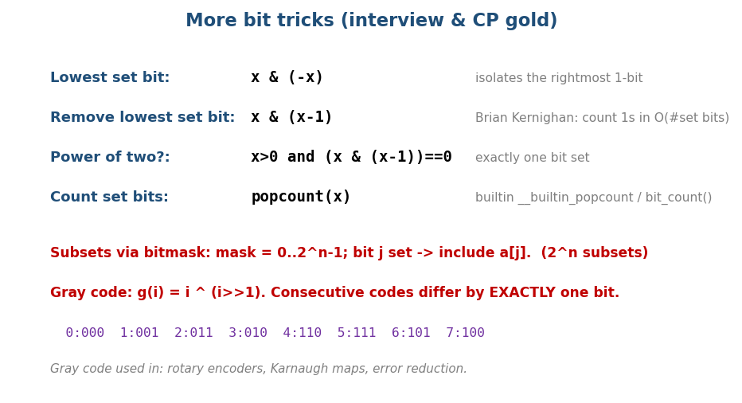
Bit tricks: lowest set bit x&(-x), remove lowest x&(x-1), power-of-two test, popcount, and Gray code.
Trick | One-liner | Use
Lowest set bit | x & (-x) | isolate the rightmost 1 (Fenwick tree!)
Remove lowest set bit | x & (x - 1) | Brian Kernighan’s bit count
Is power of two? | x > 0 && (x & (x-1)) == 0 | exactly one bit set
Count set bits (popcount) | builtin __builtin_popcount / Integer.bitCount / int.bit_count() | population count
# Brian Kernighan's set-bit count Time O(number of set bits)
count = 0
while x: x &= (x - 1); count++ # each step removes the lowest set bit
- x & (x-1) clears the lowest set bit; x & (-x) isolates it. (-x is ~x+1 in two’s complement, Module 1.)
- Counting Bits (LC 338): dp[i] = dp[i >> 1] + (i & 1) — a neat DP using bits.
- Power of four: power of two and the set bit is at an even index → x>0 && (x&(x-1))==0 && (x & 0x55555555) != 0.
- Reverse Bits (LC 190): process bits LSB→MSB, pushing into the result MSB→LSB (or swap symmetric halves).
- Bitwise AND of range [m,n] (LC 201): right-shift both ends until equal (counting shifts), then left-shift back — the result is the common prefix.

MCQs
- Isolate the lowest set bit? → x & (-x).
- Power-of-two check? → x>0 && (x & (x-1))==0.
- Kernighan’s count complexity? → O(#set bits) (not O(32)).

15.5 Subsets & Gray Code

Enumerate all subsets via bitmask
For n items, each integer mask in 0 .. 2ⁿ−1 is one subset: bit j set ⇒ include item j. (This is the iterative version of Module 13 subsets, and the core of bitmask DP, Module 14c.)
for mask in 0 .. (1<<n) - 1:
subset = [ a[j] for j in 0..n-1 if (mask >> j) & 1 ]
# iterate submasks of a mask: for (s=mask; s; s=(s-1)&mask) -> O(3^n) total

Gray Code
A Gray code orders the numbers 0..2ⁿ−1 so that consecutive codes differ in exactly one bit. The formula is beautiful:
gray(i) = i ^ (i >> 1)
0,1,2,3,4,5,6,7 → 000,001,011,010,110,111,101,100 (each step flips one bit).
- Uses: rotary/position encoders (one-bit change avoids misreads), Karnaugh maps, minimising switching errors.

MCQs
- #subsets of n items via masks? → 2ⁿ (mask 0..2ⁿ−1).
- Gray code formula? → i ^ (i >> 1).
- Gray-code neighbours differ by? → exactly one bit.

Problems
- Single Number I/II/III (136/137/260); Number of 1 Bits (191); Counting Bits (338); Missing Number (268); Sum of Two Integers (371 — add without +); Bitwise AND of Range (201); Subsets (78 — bitmask); Gray Code (89); Maximum XOR of Two Numbers (421 — trie of bits).

Module 15 — Concept Review (one page)
- Operators: & both, | either, ^ differ, ~ flip, <</>> ×/÷ 2ᵏ; 1<<k = mask.
- 4 ops on bit i: check (x>>i)&1, set x|(1<<i), clear x&~(1<<i), toggle x^(1<<i).
- XOR: a^a=0, a^0=a → single number, missing number, swap, Hamming distance.
- Isolate/clear lowest bit: x&(-x) / x&(x-1); power-of-two x&(x-1)==0; Kernighan count O(#set bits).
- Subsets via masks 0..2ⁿ−1; Gray code i ^ (i>>1) (one-bit change).

Module 15 — Flash Cards
- Q: Set / clear / toggle / check bit i? A: |(1<<i) / &~(1<<i) / ^(1<<i) / (x>>i)&1.
- Q: Find the unique among pairs? A: XOR all.
- Q: Lowest set bit / remove it? A: x&(-x) / x&(x-1).
- Q: Power of two test? A: x>0 && (x&(x-1))==0.
- Q: Gray code formula? A: i ^ (i>>1).
- Q: Hamming distance? A: popcount(a^b).

Module 15 — Pattern Recognition
- “Appears twice except one / missing / duplicate” → XOR.
- “Count / test / flip a flag, pack flags” → bit operations / bitmask.
- “All subsets / state = subset (small n)” → bitmask enumeration / DP.
- “Power of two, lowest set bit, range index” → bit identities (x&(x-1), x&(-x)).
- “Consecutive differ by one bit” → Gray code.

Module 15 — Interview Questions (with follow-ups)
- Single Number. FU: appears 3× (II), or two singles (III)?
- Number of 1 bits. FU: Kernighan O(#set bits) vs loop over 32.
- Counting Bits 0..n. FU: the dp[i]=dp[i>>1]+(i&1) trick.
- Sum of two integers without +. FU: XOR = sum-without-carry, AND<<1 = carry.
- Power of two / four. FU: bit-pattern tests.

Module 15 — GATE / SEBI / RBI / ISRO Perspective
- GATE favourites: two’s-complement arithmetic, shift = ×/÷ 2ᵏ, evaluating bitwise expressions, counting set bits, and number-system conversions (Module 1 links). Bit tricks appear in C-programming and digital-logic crossover questions.

End of Module 15. Next: Module 16 — Mathematics (GCD, modular arithmetic, sieve, prime factorisation, combinatorics, fast exponentiation) — with visuals.

