Module 16 — Mathematics for DSA
  - DSA Mastery: Google / FAANG / GATE / ICPC — In-Depth Notes (with visuals)
Prepared for nidhi.sharma@forensiccybertech.com
2026
Table of Contents

Module 16 — Mathematics for DSA
Why a math module. A surprising number of problems are really number-theory problems in disguise: GCD/LCM, primes, modular arithmetic (to keep huge answers small), and counting (combinatorics). These are everywhere in competitive programming, common in interviews (Pow, primes, GCD), and a major GATE topic. The good news: a handful of formulas and algorithms cover almost all of it.
This module is P1 (P0 for CP/GATE). Modular arithmetic + sieve + nCr show up constantly.
How to read each technique. The idea, the algorithm, the complexity, plus a memory hook.

16.1 GCD, LCM & the Euclidean Algorithm
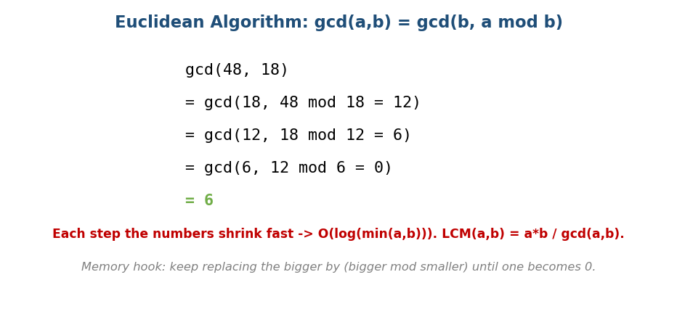
Euclidean algorithm: gcd(a,b)=gcd(b, a mod b); gcd(48,18)=6 in a few steps.
# Euclid's GCD Time O(log(min(a,b)))
gcd(a, b): return a if b == 0 else gcd(b, a % b)
lcm(a, b) = a / gcd(a,b) * b # divide first to avoid overflow
- gcd(48,18) → gcd(18,12) → gcd(12,6) → gcd(6,0) = 6.
- Iterative form (no recursion): while b: a, b = b, a % b; return a. GCD of an array folds left-to-right. “No division/modulo” variant = binary GCD (Stein’s).
- Extended Euclid finds x, y with a·x + b·y = gcd(a,b):
extgcd(a, b):
if b == 0: return (a, 1, 0) # gcd, x, y
(g, x1, y1) = extgcd(b, a % b)
return (g, y1, x1 - (a / b) * y1)
# modular inverse of b mod m: extgcd(b, m) -> if g==1, inverse = ((x % m) + m) % m
Memory hook: keep replacing the bigger number by (bigger mod smaller) until one becomes 0; the other is the GCD.

MCQs
- gcd(a,b) recurrence? → gcd(b, a mod b), base b=0.
- Euclid complexity? → O(log min(a,b)).
- LCM in terms of GCD? → a·b / gcd(a,b).

16.2 Modular Arithmetic (keep numbers small)
Answers in CP/crypto can be astronomically large, so we work mod m (often m = 10⁹+7, a prime). Apply mod after every operation.
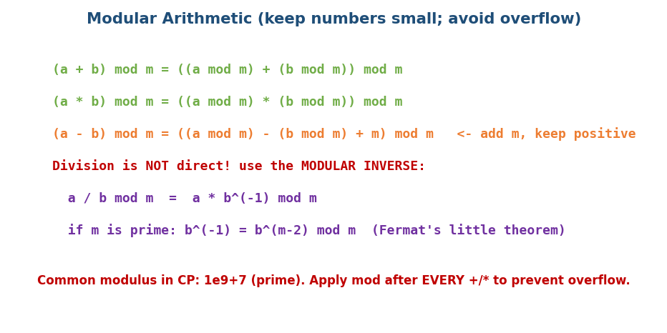
Modular arithmetic rules: add/mul distribute over mod; subtraction add m; division needs the modular inverse.
(a + b) mod m = ((a mod m) + (b mod m)) mod m
(a * b) mod m = ((a mod m) * (b mod m)) mod m
(a - b) mod m = ((a mod m) - (b mod m) + m) mod m # +m keeps it non-negative

Modular inverse (division under a modulus)
You can’t just divide. To compute a / b mod m, multiply by the modular inverse b⁻¹:
- If m is prime (Fermat’s little theorem): b⁻¹ = b^(m−2) mod m — compute with fast exponentiation (Module 12).
- General m: use the extended Euclidean algorithm (needs gcd(b,m)=1).

Fast exponentiation & Pow(x, n) (LC 50 — a top FAANG problem)
aⁿ (or aⁿ mod m) in O(log n) by square-and-multiply:
# Pow(x, n) — real-valued (LC 50)
long nn = n
if n < 0: x = 1 / x; nn = -nn # CAREFUL: negating INT_MIN overflows -> use long
result = 1
while nn > 0:
if nn & 1: result *= x
x *= x; nn >>= 1
return result # for modular pow: take % m after each * (Module 12 §12.6)
- Gotchas: negative n (invert and flip sign; INT_MIN negation overflow → widen to long); real-valued Pow vs modular pow aⁿ mod m.
- This powers modular inverse and RSA-style crypto (SEBI-IT relevant).

Key theorems (GATE — state them precisely)
- Fermat’s little theorem: if p is prime and gcd(a,p)=1, then a^(p−1) ≡ 1 (mod p) ⇒ inverse a^(p−2) mod p.
- Euler’s theorem: if gcd(a,n)=1, then a^φ(n) ≡ 1 (mod n).
- Chinese Remainder Theorem (CRT): for pairwise-coprime moduli m₁…m_k, the system x ≡ aᵢ (mod mᵢ) has a unique solution mod M = Πmᵢ: x = Σ aᵢ·Mᵢ·yᵢ (mod M) where Mᵢ = M/mᵢ, yᵢ = Mᵢ⁻¹ mod mᵢ. Example: x≡2(3), x≡3(5), x≡2(7) → x = 23 (mod 105).

MCQs
- Why work mod 10⁹+7? → keep numbers in range / avoid overflow (it’s prime).
- Modular inverse of b (m prime)? → b^(m−2) mod m (Fermat).
- Subtraction mod m safe form? → ((a−b) mod m + m) mod m.

16.3 Primes — Sieve & Factorisation

Sieve of Eratosthenes — all primes up to n
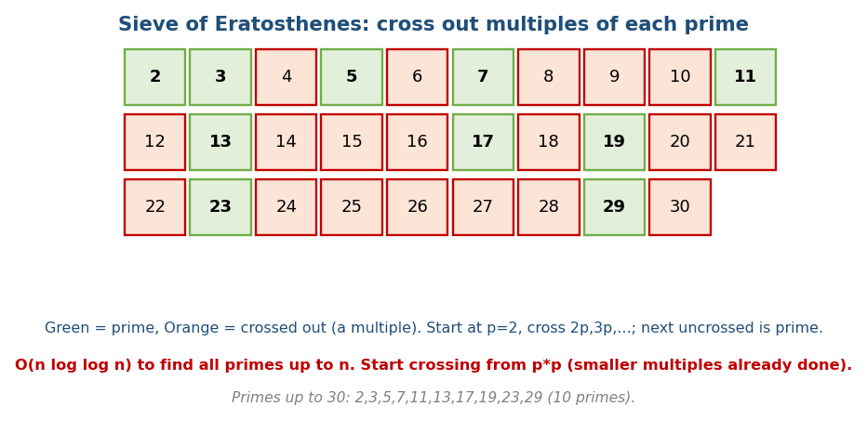
Sieve of Eratosthenes: cross out multiples of each prime; what remains are primes (10 primes ≤ 30).
# Sieve of Eratosthenes Time O(n log log n), Space O(n)
isPrime[2..n] = true
for p from 2 while p*p <= n:
if isPrime[p]:
for multiple in p*p, p*p+p, ... <= n: isPrime[multiple] = false
- Start crossing from p*p (smaller multiples were already crossed by smaller primes). Primes ≤ 30: 2,3,5,7,11,13,17,19,23,29.
- Count Primes (LC 204): count isPrime entries for indices in [2, n) (strictly < n — a common off-by-one). Memory follow-ups: odd-only or bitset sieve halves space; the linear (Euler) sieve runs in O(n).
- Smallest Prime Factor (SPF) sieve: store each number’s smallest prime factor → factorise any x ≤ n in O(log x).
- Segmented sieve: find primes in a range [L, R] when R is huge but R−L is small.

Single-number factorisation — trial division
# Factorise n Time O(sqrt(n))
for d from 2 while d*d <= n:
while n % d == 0: record d; n /= d
if n > 1: record n # leftover prime factor
- Euler’s totient φ(n) = count of integers ≤ n coprime to n; φ(n) = n · Π (1 − 1/p) over distinct prime factors p.

MCQs
- Sieve complexity? → O(n log log n).
- Why start crossing at p*p? → smaller multiples already crossed.
- Trial-division factorisation time? → O(√n).

16.4 Combinatorics

Counting basics
- Permutations: nPr = n!/(n−r)! (order matters).
- Combinations: nCr = n!/(r!(n−r)!) (order doesn’t).
- Pascal’s rule: C(n,r) = C(n−1,r−1) + C(n−1,r) → build Pascal’s triangle.
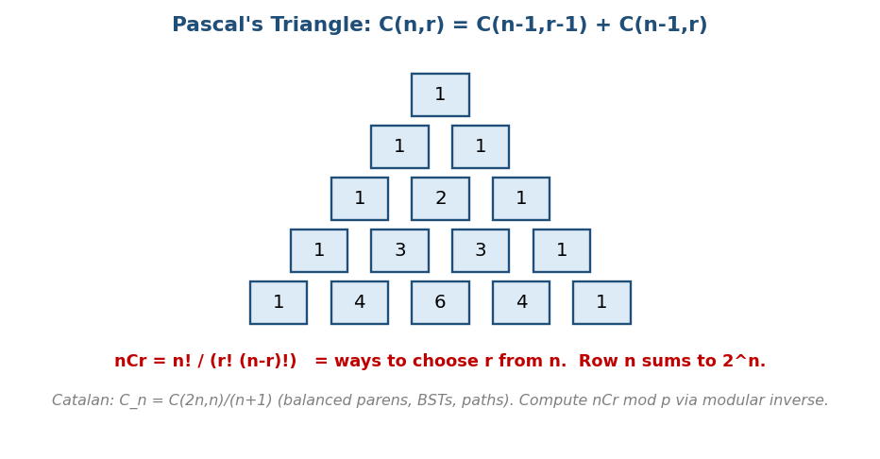
Pascal’s triangle: C(n,r)=C(n-1,r-1)+C(n-1,r); row n sums to 2ⁿ.
- Row n of Pascal’s triangle sums to 2ⁿ (the number of subsets — Module 13).
- nCr mod p: precompute factorials + inverse factorials (via modular inverse, §16.2), then nCr = fact[n]·invfact[r]·invfact[n−r] mod p. Lucas’ theorem handles nCr mod p when n is huge.
- Overflow-safe nCr (no modulus): compute iteratively, dividing as you go (the running product is always an integer): for i in 1..r: result = result * (n−r+i) / i. Used in Unique Paths (LC 62) and Pascal’s Triangle (118/119).

Famous sequences & principles
- Catalan numbers: Cₙ = C(2n,n)/(n+1) → balanced parentheses, BSTs with n nodes, triangulations, monotonic paths. 1,1,2,5,14,42,….
- Inclusion–Exclusion: |A∪B| = |A|+|B|−|A∩B| (generalises to n sets with alternating signs) — count “at least one of” by adding/subtracting overlaps.
- Pigeonhole principle: if n+1 items go into n boxes, some box has ≥ 2 → powers many existence proofs (e.g. two subarrays with equal sum mod n).

MCQs
- nCr formula & Pascal’s rule? → n!/(r!(n−r)!); C(n-1,r-1)+C(n-1,r).
- Catalan number formula? → C(2n,n)/(n+1).
- Inclusion–exclusion for two sets? → |A|+|B|−|A∩B|.

16.5 Number / Representation Problems (common FAANG warm-ups)
- Happy Number (LC 202): repeatedly sum the squares of digits; detect a cycle with Floyd’s fast/slow (Module 4) or a seen-set → happy iff it reaches 1.
- Ugly Number II (LC 264): the n-th number whose only prime factors are 2,3,5; three pointers i2,i3,i5 building the sequence in order (DP).
- Excel Column ↔ Number (LC 168/171): bijective base-26 (A=1…Z=26, no zero) → the classic off-by-one (n-- before each % 26).
- Integer ↔ Roman (LC 12/13): a descending value/symbol table processed greedily (include 900=CM, 400=CD, etc.).
- Digital root (Add Digits, LC 258): closed form 1 + (n−1) % 9.

16.6 Randomized Algorithms (a Google favourite)
- rand7 → rand10 (LC 470): rejection sampling — map (rand7−1)*7 + rand7 to 1..49, reject the top tail (41..49) so the kept range is a clean multiple of 10 → uniform.
- Reservoir Sampling (LC 382/398): pick a uniform item from a stream of unknown length — keep the i-th item with probability 1/i (replace the current pick). Each element ends with probability 1/n.
- Fisher–Yates shuffle (LC 384): for i from 0..n−1, swap a[i] with a random a[j], j∈[i,n) → every permutation equally likely. (The naive “random index each time” is biased.)

MCQs
- Uniform rand10 from rand7? → rejection sampling (reject the tail).
- Sample from an unknown-length stream? → reservoir sampling (keep i-th w.p. 1/i).
- Unbiased shuffle? → Fisher–Yates.

Module 16 — Concept Review (one page)
- GCD by Euclid gcd(b, a%b) O(log); LCM a·b/gcd; extended Euclid → modular inverse.
- Modular arithmetic: distribute over +/×; subtraction add m; division = multiply by modular inverse (b^(m−2) if m prime). Fast exponentiation O(log n).
- Primes: Sieve O(n log log n) (cross from p²); SPF sieve → O(log x) factorise; trial division O(√n); Euler φ.
- Combinatorics: nCr=n!/(r!(n−r)!), Pascal’s rule, row sum 2ⁿ; nCr mod p via inverse factorials (Lucas for huge n); Catalan C(2n,n)/(n+1); inclusion–exclusion; pigeonhole.

Module 16 — Flash Cards
- Q: GCD algorithm & time? A: Euclid gcd(b,a%b), O(log min).
- Q: Modular inverse (m prime)? A: b^(m−2) mod m (Fermat).
- Q: Sieve time & why start at p²? A: O(n log log n); smaller multiples done.
- Q: Factorise n by trial division? A: O(√n).
- Q: nCr & Pascal’s rule? A: n!/(r!(n−r)!); C(n-1,r-1)+C(n-1,r).
- Q: Catalan formula? A: C(2n,n)/(n+1).

Module 16 — Pattern Recognition
- “Reduce a fraction / sync cycles / common divisor” → GCD/LCM.
- “Huge answer, return mod 1e9+7” → modular arithmetic (+ inverse for ÷).
- “All primes up to n / many primality queries” → sieve; “factorise one n” → trial division / SPF.
- “Count ways / choose / arrange” → combinatorics (nCr, Catalan).
- “Count ‘at least one of’ overlapping sets” → inclusion–exclusion.
- “Must two of these collide?” → pigeonhole.

Module 16 — Interview Questions (with follow-ups)
- Pow(x, n). FU: negative n; modular version; O(log n).
- Count primes < n. FU: sieve; memory; segmented sieve.
- GCD / fraction reduction. FU: extended Euclid; LCM overflow.
- nCr mod p. FU: precompute inverse factorials; Lucas for huge n.
- Catalan-counting (BSTs / valid parentheses). FU: derive the recurrence.

Module 16 — GATE / SEBI / RBI / ISRO Perspective
- GATE favourites: GCD/Euclid steps, modular arithmetic & Fermat/Euler theorems, sieve complexity, counting (nCr, Catalan, inclusion–exclusion), pigeonhole proofs. SEBI/RBI-IT: modular exponentiation underlies RSA/crypto — know aⁿ mod m and modular inverse.

End of Module 16. Next: Module 17 — Advanced Data Structures (suffix array, treap, skip list, persistent structures, KD-tree, wavelet tree) — with visuals.

