Module 17 — Advanced Data Structures
  - DSA Mastery: Google / FAANG / GATE / ICPC — In-Depth Notes (with visuals)
Prepared for nidhi.sharma@forensiccybertech.com
2026
Table of Contents

Module 17 — Advanced Data Structures
Why this module (and how to use it). These are the “specialist tools” — rarely needed in a standard FAANG coding round, but they appear in competitive programming, hard/senior interviews, and a few GATE questions, and they show up in real systems (Redis, databases). Goal: recognise what each one is for and its headline complexity. Don’t memorise full implementations — know when you’d reach for it.
This module is P2.
How to read each technique. What it is, what it’s for, complexity.

17.1 Skip List
A skip list is a stack of linked lists: the bottom holds all elements; each higher level is an “express lane” skipping ~half the nodes. Search drops down a level when it would overshoot.
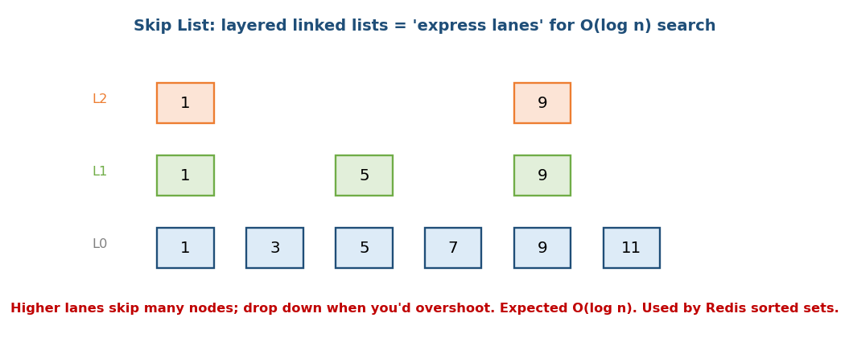
Skip list: express lanes on top let search skip many nodes, giving expected O(log n).
- Expected O(log n) search/insert/delete (randomised level per node) — a simpler, lock-friendlier alternative to balanced BSTs.
- Real use: Redis sorted sets (ZSET) = a skip list (ordered range/rank queries) + a hash table (O(1) score-by-member); tiny sets use a compact listpack and upgrade past a size threshold. Also Java ConcurrentSkipListMap.
Memory hook: highway exits — take the fastest lane, drop to a slower one only when you’re about to pass your exit.

17.2 Treap / Cartesian Tree
A treap is a BST on keys that is also a max-heap on random priorities assigned to each node. Random priorities keep it balanced in expected O(log n) — with much simpler code than AVL/Red-Black (no rotation cases to memorise; just rotate to fix the heap order).
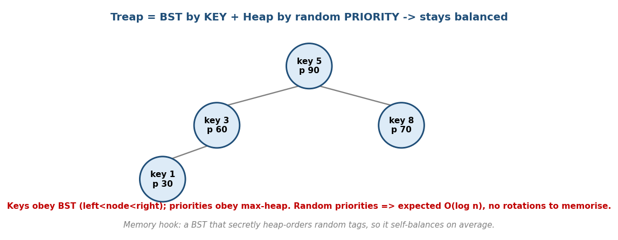
Treap: BST by key + heap by random priority → expected O(log n), self-balancing on average.
- Cartesian tree: the same idea where priorities come from the array values (used to build in O(n) and for range-minimum / LCA tricks).
- Implicit treap: keyed by position → supports insert/erase/reverse a subarray in O(log n) (a CP power-tool).

17.3 Suffix Array (+ LCP)
A suffix array is the sorted list of starting indices of all suffixes of a string. With the companion LCP array (longest common prefix of adjacent suffixes), it answers many string problems efficiently.
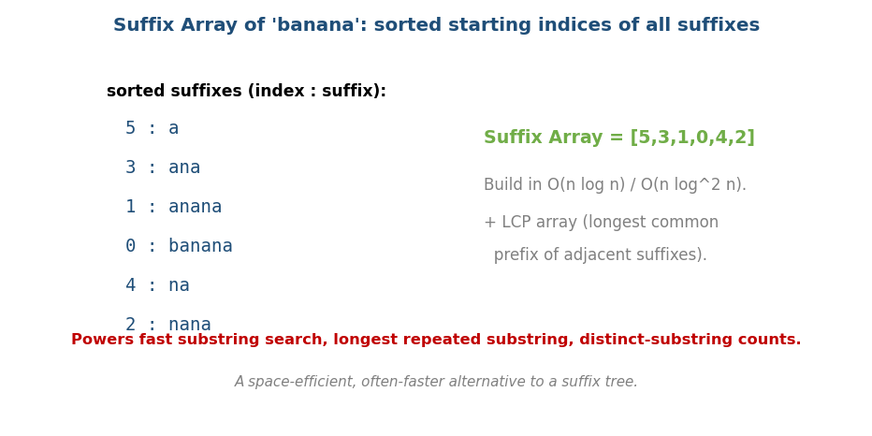
Suffix array of ‘banana’ = [5,3,1,0,4,2]; with the LCP array it powers fast substring queries.
- Build in O(n log n) (or O(n log² n) simply; O(n) with DC3/SA-IS).
- Uses: substring search, longest repeated substring, distinct-substring count, longest common substring of two strings.
- A space-efficient alternative to a suffix tree (same power, smaller constant, easier to code).

17.4 Persistent Data Structures
A persistent structure keeps every past version after an update (you can query old versions). The trick is path copying: an update copies only the O(log n) nodes on the changed path and shares the rest.
- Persistent segment tree (the common one): O(log n) per update/query, O(log
  - extra memory per update; powers “k-th smallest in a range”, versioned arrays.
- Functional/immutable structures (used in functional languages) are persistent by design.
Memory hook: like git for a data structure — each commit (update) shares most of the previous tree and only records what changed.
- Real use: copy-on-write B-trees (LMDB, CouchDB), filesystem snapshots (ZFS/Btrfs), immutable collections (Clojure/Scala) — all “persistence via structural sharing”.

17.5 KD-Tree (spatial)
A KD-tree partitions k-dimensional space, alternating the splitting axis by depth (x, then y, then z, …). It supports nearest-neighbour and range queries.
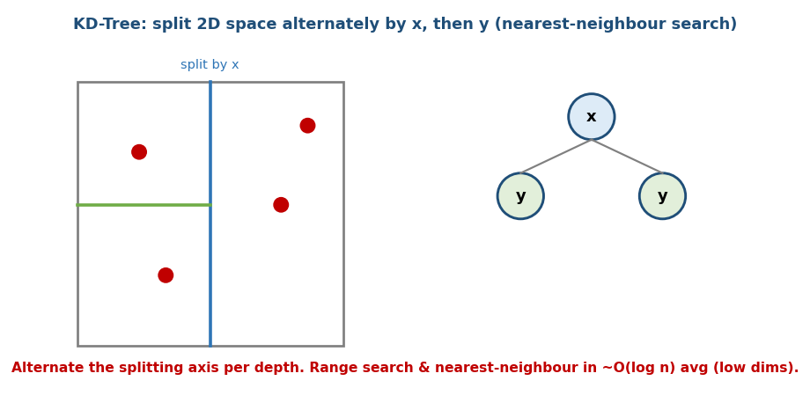
KD-tree: alternately split 2D space by x then y; supports nearest-neighbour and range search.
- ~O(log n) average per query in low dimensions; degrades in high dimensions (“curse of dimensionality”) → for high-D similarity search use Approximate Nearest Neighbour (ANN): HNSW graphs (the production default in Faiss/pgvector/Milvus/Pinecone), IVF + product quantization for scale, and the older LSH hashing family (Module 21).
- Uses: geometry, k-nearest-neighbour (ML), collision detection, maps.

17.6 Wavelet Tree & Aho-Corasick (brief)
- Wavelet tree: answers rank/select and “k-th smallest in a range” queries over a sequence of values in O(log σ) (σ = alphabet/value range). Powers compact text indexes.
- Aho-Corasick: a Trie + failure links (KMP generalised to many patterns) → find all occurrences of a set of patterns in O(text + matches). The multi-pattern matcher (virus scanners, keyword filters). (Links to Module 3.)
- Suffix automaton (SAM): an O(n) DAG of all substrings, built online; used for distinct-substring counting and longest common substring (another linear string structure alongside the suffix array).

17.7 System-Design & Range-Query Structures (senior-interview essentials)
- B+-tree vs LSM-tree (the two database index families):
  - B+-tree (Module 8b): read-optimised, balanced, in-place updates → relational DB indexes (MySQL/Postgres).
  - LSM-tree (Log-Structured Merge): write-optimised — buffer writes in a memtable, flush to sorted SSTables, compact in the background → Cassandra, RocksDB, LevelDB. Trade-off: LSM has higher read/space amplification but far better write throughput.
- Sqrt decomposition / Mo’s algorithm: split the array into ~√n blocks → O(√n) per range query/update; the bridge between brute force and a segment tree when a clean associative merge is hard. Mo’s algorithm reorders offline queries for O((n+q)√n).
- Probabilistic (cross-ref Module 7): approximate membership → Bloom / Cuckoo filter (SSTable Bloom filters skip disk reads); approximate distinct count → HyperLogLog (Redis PFADD/PFCOUNT).
- Base structures: segment tree / Fenwick (BIT) live in Module 8b; the persistent segment tree (§17.4) = that base + path copying.

MCQs
- Write-optimised DB index family? → LSM-tree (Cassandra/RocksDB).
- Range queries without a clean merge / offline? → sqrt decomposition / Mo’s.
- Approximate membership / distinct-count? → Bloom filter / HyperLogLog (M07).

Module 17 — Concept Review (one page)
- Skip list: layered lists, expected O(log n); Redis sorted sets.
- Treap: BST key + heap random priority → expected O(log n), simple; Cartesian/implicit treaps for arrays.
- Suffix array + LCP: sorted suffixes, O(n log n) build; substring / repeated- substring problems; lean suffix-tree alternative.
- Persistent structures: keep all versions via path copying (persistent segment tree); “git for data”.
- KD-tree: alternate-axis spatial partition, ~O(log n) low-D NN/range; high-D → HNSW/LSH.
- Wavelet tree (rank/select, k-th in range); Aho-Corasick (multi-pattern matching = Trie + failure links).

Module 17 — Flash Cards
- Q: Redis sorted sets use? A: skip list.
- Q: Treap = ? A: BST by key + heap by random priority (expected O(log n)).
- Q: Suffix array build time? A: O(n log n) (O(n) with SA-IS).
- Q: Persistent update memory/time? A: O(log n) via path copying.
- Q: KD-tree splits how? A: alternate axis per depth; low-D NN search.
- Q: Multi-pattern matching structure? A: Aho-Corasick (Trie + failure links).

Module 17 — Pattern Recognition
- “Ordered set, simple + concurrent” → skip list.
- “Balanced BST without rotation pain / reverse a subarray” → treap / implicit treap.
- “Many substring/repeated-substring queries on a fixed string” → suffix array + LCP.
- “Query old versions / k-th in a range with updates” → persistent segment tree.
- “Nearest neighbour / range in 2D-3D” → KD-tree (high-D → ANN, Module 21).
- “Match many patterns at once” → Aho-Corasick.

Module 17 — Interview / CP Questions
- Design Redis ZADD/ZRANGE. → skip list (or balanced BST) ordering.
- Longest repeated substring. → suffix array + LCP.
- k-th smallest in a subarray with updates / historical queries. → persistent segment tree / wavelet tree.
- k nearest points. → KD-tree (low-D) / heap; high-D → ANN.

Module 17 — GATE / SEBI / RBI / ISRO Perspective
- GATE: mostly conceptual — skip-list expected complexity, suffix structures, persistence idea. These are less frequent; prioritise M08 (trees), M10 (graphs), M14 (DP) for exams and treat M17 as “recognise the tool”.

End of Module 17. Next: Module 18 — Algorithm Design & Analysis (recurrences, Master theorem, amortized analysis, randomized & approximation, P/NP) — with visuals.

