Module 18 — Algorithm Design & Analysis
  - DSA Mastery: Google / FAANG / GATE / ICPC — In-Depth Notes (with visuals)
Prepared for nidhi.sharma@forensiccybertech.com
2026
Table of Contents

Module 18 — Algorithm Design & Analysis
Why this module. So far we learned algorithms; this module is about reasoning rigorously about them: solving recurrences, proving amortized bounds, using randomness, settling for approximate answers when exact is too hard, and the P vs NP landscape that tells you which problems are hopeless to solve exactly. This is the theory backbone of GATE and senior-interview “why” questions.
This module is P1 (P0 for GATE). Recurrences, amortized analysis, and P/NP are heavily tested in exams.
How to read each technique. The idea, the method, plus a memory hook.

18.1 Solving Recurrences
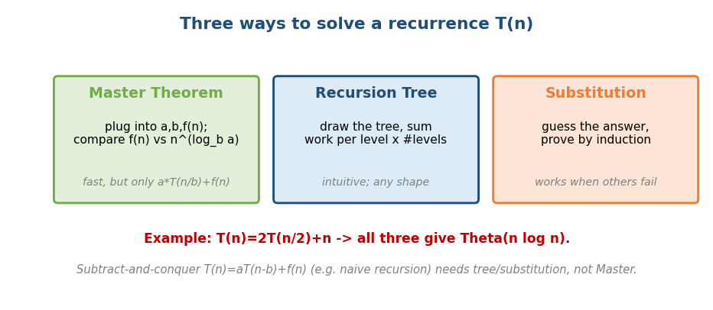
Three ways to solve a recurrence: Master Theorem, recursion tree, substitution.
Three tools (full Master Theorem in Module 1 §1.5 & Module 12 §12.1):
- Master Theorem — for T(n) = a·T(n/b) + f(n): compare f(n) with n^(log_b a) (3 cases). Fast, but only this exact shape.
- Recursion tree — draw the tree, sum work per level × number of levels. Intuitive, works for any shape (e.g. uneven splits).
- Substitution — guess the bound, prove by induction. The fallback when the others don’t apply.
Per-case intuition (compare leaf work n^(log_b a) with f(n)):
- Leaf-dominated (Case 1): the recursion’s leaves do the most work → Θ(n^(log_b a)).
- Balanced (Case 2): every level costs the same → multiply by log n.
- Root-dominated (Case 3): the top-level f(n) dominates → Θ(f(n)) (needs the regularity condition a·f(n/b) ≤ c·f(n)).
- Gap cases the basic theorem can’t solve (e.g. T(n)=2T(n/2)+n/log n, where f(n) sits within a polylog factor of the threshold) → use recursion-tree / Akra–Bazzi.
- Example: T(n) = 2T(n/2) + n → all three give Θ(n log n).
- Subtract-and-conquer T(n) = a·T(n−b) + f(n) (e.g. naive recursion) needs the tree/substitution method, not the Master Theorem. T(n)=T(n−1)+O(1) → O(n); T(n)=2T(n−1)+O(1) → O(2ⁿ).
- Akra–Bazzi generalises the Master Theorem to unequal splits.

MCQs
- T(n)=2T(n/2)+n? → Θ(n log n).
- T(n)=2T(n−1)+1? → Θ(2ⁿ) (subtract-and-conquer, not Master).
- Method when Master doesn’t apply? → recursion tree / substitution.

18.2 Amortized Analysis
Amortized cost = the average cost per operation over a worst-case sequence (a guarantee, unlike average-case which is probabilistic).
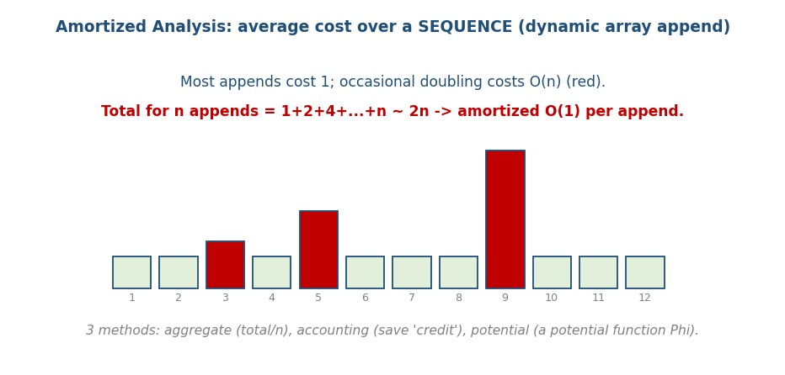
Amortized analysis: most appends cost O(1), rare doublings cost O(n); total 2n → O(1) amortized.
Three methods to prove it:
Method | Idea
Aggregate | total cost of n ops ÷ n
Accounting | overcharge cheap ops, store “credit” to pay for expensive ones
Potential (Φ) | define a potential function; amortized = actual + ΔΦ
- Classic example: dynamic-array append — usually O(1), but doubling costs O(n); total for n appends = 1+2+4+…+n ≈ 2n → O(1) amortized (Module 2).
- Other examples: Fenwick/splay operations, the Union-Find with path compression (O(α(n)) amortized), incrementing a binary counter.
Memory hook: amortized = “pay a little extra each cheap step into a piggy bank, so the occasional expensive step is already paid for.”
Senior caveat: amortized O(1) bounds a sequence, not a single operation — one append can still cost O(n). For latency-sensitive / real-time systems (p99 spikes during a rehash!), use de-amortized / incremental-resize variants that spread the rebuild work over many operations.

MCQs
- Amortized vs average-case? → amortized is a guarantee over a sequence; average-case is probabilistic.
- Three methods? → aggregate, accounting, potential.
- Dynamic array append amortized? → O(1) (total 2n).

18.3 Randomized Algorithms
Use randomness to get simplicity or good expected performance.
- Las Vegas algorithms: always correct, running time is random (e.g. randomized quicksort — expected O(n log n), avoids the sorted-input worst case by picking a random pivot).
- Monte Carlo algorithms: fixed running time, possibly wrong with small probability (e.g. Miller–Rabin primality test, Rabin-Karp hashing).
- Reservoir sampling, Fisher–Yates shuffle, rand7→rand10 (Module 16).
- Why it really helps (the key insight): the expectation is taken over the algorithm’s coin flips, not over the input. A deterministic algorithm has a fixed worst-case input an adversary can always feed it; with randomization the “bad” inputs depend on hidden coins, so no single input is reliably bad.
- Error amplification: a one-sided Monte Carlo algorithm with error ≤ p run k independent times has error ≤ pᵏ → that’s why “maybe wrong” is fine in practice. Miller–Rabin: each round errs with prob ≤ ¼, so k rounds ≤ 4⁻ᵏ.
- When to randomize: simpler code, breaking symmetry / adversarial inputs, or when an expected/high-probability bound suffices and worst-case is unaffordable.

MCQs
- Las Vegas vs Monte Carlo? → always-correct/random-time vs fixed-time/maybe-wrong.
- Random pivot in quicksort gives? → expected O(n log n) (defeats worst case).
- Miller–Rabin is which type? → Monte Carlo (tiny error probability).

18.4 Approximation Algorithms
When a problem is NP-hard (no known efficient exact algorithm), settle for a provably-close answer. An algorithm is a ρ-approximation if its answer is always within a factor ρ of optimal.
- Vertex Cover — 2-approximation: repeatedly pick both endpoints of any uncovered edge → at most 2× the optimal cover. Simple and provable.
- TSP (metric) — 2-approximation via MST (1.5× with Christofides).
- Set Cover — ln n approximation (greedy: always take the set covering the most uncovered elements).
Memory hook: “can’t solve it exactly fast → guarantee ‘no worse than ρ× optimal’.”

The “it’s NP-hard — now what?” pivot menu
- Exact but exponential (fine for small n): DP over subsets (Held-Karp TSP O(2ⁿ·n²)), meet-in-the-middle (Subset Sum O(2^(n/2))), branch & bound (Module 13).
- Pseudo-polynomial DP when numeric inputs are small (Knapsack O(nW) — §18.5).
- Approximation with a guarantee — ρ-approx, and the stronger tiers PTAS (any 1+ε) / FPTAS (also polynomial in 1/ε).
- Heuristics with NO guarantee — greedy, local search, simulated annealing, ILP solvers (fast in practice, no proven bound — different from approximation).
- Fixed-parameter tractable (FPT) — fast when a parameter k is small (e.g. f(k)·nᶜ).

MCQs
- ρ-approximation means? → answer within factor ρ of optimal.
- Vertex cover greedy (both endpoints) ratio? → 2.
- Greedy set cover ratio? → ln n.

18.5 P, NP, NP-complete, NP-hard
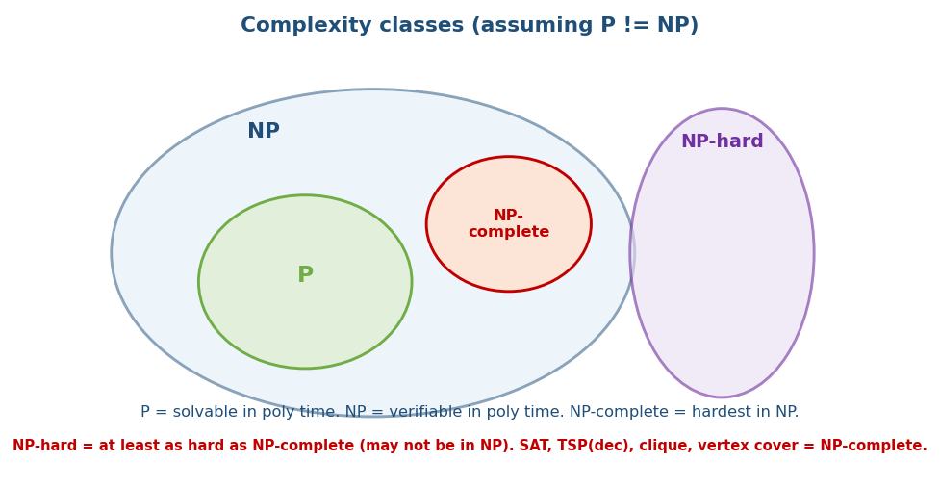
Complexity classes: P ⊆ NP, NP-complete = hardest in NP, NP-hard ⊇ NP-complete (assuming P ≠ NP).
- P — solvable in polynomial time (sorting, shortest path, matching).
- NP — a proposed solution can be verified in polynomial time (you may not be able to find it fast). P ⊆ NP.
- NP-complete — the hardest problems in NP: in NP and every NP problem reduces to them. If any NP-complete problem has a poly-time algorithm, then P = NP. Examples: SAT (Cook–Levin), 3-SAT, Clique, Vertex Cover, Hamiltonian Cycle, Subset Sum, Graph Coloring, TSP (decision).
- NP-hard — at least as hard as NP-complete, but need not be in NP (e.g. the optimisation/halting versions).
Reductions are the tool: to show problem X is NP-hard, reduce a known NP-complete problem to X in polynomial time (“if I could solve X fast, I could solve SAT fast”).
Memory hook: P = easy to solve; NP = easy to check; NP-complete = the hardest “checkable” problems; NP-hard = at least that hard (maybe not even checkable).

Pseudo-polynomial & weak vs strong NP-completeness
“Knapsack/Subset Sum are NP-complete, but DP solves them in O(nW)?” — the resolution: O(nW) is polynomial in the numeric value W, but exponential in its bit-length (log W) → pseudo-polynomial, not truly polynomial.
- Weakly NP-complete (Subset Sum, 0/1 Knapsack): admit a pseudo-poly DP and an FPTAS.
- Strongly NP-complete (3-SAT, TSP): no pseudo-poly algorithm unless P=NP.

Beyond NP — undecidable (GATE)
Some problems have no algorithm at all: the Halting Problem (does program P halt on input x?) is undecidable (Turing). Undecidable ≫ NP-hard: NP-hard means “no fast algorithm (likely)”; undecidable means “no algorithm, ever.” co-NP = problems whose no-answers are easily verified (e.g. “is this formula UNSAT?”).

MCQs
- P vs NP in one line? → solvable-in-poly vs verifiable-in-poly.
- First proven NP-complete problem? → SAT (Cook–Levin theorem).
- To prove X is NP-hard? → reduce a known NP-complete problem to X.
- NP-complete = ? → in NP and NP-hard.

18.6 Online vs Offline Algorithms (the competitive ratio)
- Offline: the whole input is known up front (everything so far in this course).
- Online: input arrives one piece at a time and each decision is irrevocable (you can’t see the future) — caching/eviction, ski-rental, load balancing.
Quality metric = the competitive ratio c: online_cost ≤ c · OPT_offline + constant for every input. (Parallel to the approximation ratio, but the limitation is missing future info, not computational hardness.)
- Ski-rental (“rent for $1/day or buy for $B?”): renting until day B then buying is 2-competitive (e/(e−1) ≈ 1.58 randomized).
- Paging / cache eviction: any deterministic policy is k-competitive (k = cache size); LRU achieves it; the offline optimum OPT evicts the page used farthest in the future (Bélády) — but that needs the future.
- List update: move-to-front is 2-competitive.
Interview link: “your cache is LRU — how good is that vs a clairvoyant optimum?” → competitive ratio; LRU is k-competitive, OPT = Bélády.

MCQs
- Online vs offline? → decide irrevocably as input arrives vs whole input known.
- Quality metric for online algorithms? → the competitive ratio.
- Optimal offline page replacement? → Bélády (evict farthest-future use).

Module 18 — Concept Review (one page)
- Recurrences: Master Theorem (a·T(n/b)+f(n), 3 cases) | recursion tree (work/level × levels) | substitution (guess+induct); subtract-and-conquer → not Master.
- Amortized: guaranteed average over a sequence; aggregate / accounting / potential; dynamic array O(1), Union-Find O(α(n)).
- Randomized: Las Vegas (correct, random time) vs Monte Carlo (fixed time, maybe wrong); random pivot, Miller–Rabin, reservoir.
- Approximation: ρ-approx for NP-hard; vertex cover 2×, set cover ln n, metric TSP 1.5× (Christofides).
- P/NP: P solve, NP verify, NP-complete = hardest in NP (SAT), NP-hard ≥ that; prove hardness by reduction.

Module 18 — Flash Cards
- Q: 3 recurrence methods? A: Master, recursion tree, substitution.
- Q: Amortized vs average? A: sequence-guarantee vs probabilistic.
- Q: Union-Find amortized? A: O(α(n)).
- Q: Las Vegas vs Monte Carlo? A: always-correct/random-time vs fixed/maybe-wrong.
- Q: Vertex cover approx ratio? A: 2.
- Q: First NP-complete problem? A: SAT (Cook–Levin).
- Q: Prove NP-hardness? A: reduce a known NP-complete problem to it.

Module 18 — Pattern Recognition
- “Solve T(n) = …” → Master / tree / substitution.
- “Average cost over many ops” → amortized (aggregate/accounting/potential).
- “Defeat worst-case input” → randomization (random pivot).
- “NP-hard, need some answer fast” → approximation / heuristic.
- “Is this problem even tractable?” → place it in P / NP / NP-complete.

Module 18 — Interview Questions (with follow-ups)
- Why is randomized quicksort O(n log n) expected? FU: what input breaks deterministic quicksort?
- Prove dynamic-array append is amortized O(1). FU: 3 methods.
- Is problem X solvable in poly time? FU: reduce from a known NP-complete problem.
- Give a 2-approximation for vertex cover. FU: prove the ratio.

Module 18 — GATE / SEBI / RBI / ISRO Perspective
- GATE favourites (very high yield): solving recurrences (Master theorem + tricky cases), amortized analysis, P/NP/NP-complete/NP-hard definitions and reductions, identifying which problems are NP-complete, approximation ratios. These appear almost every year.

End of Module 18. Next: Module 19 — Competitive Programming (contest strategy, fast I/O, templates, Codeforces/AtCoder/ICPC patterns) — with visuals.

