Module 19 — Competitive Programming
  - DSA Mastery: Google / FAANG / GATE / ICPC — In-Depth Notes (with visuals)
Prepared for nidhi.sharma@forensiccybertech.com
2026
Table of Contents

Module 19 — Competitive Programming
Why CP, even for interviews. Competitive programming (Codeforces, AtCoder, ICPC, LeetCode contests) sharpens the exact muscles FAANG interviews test: pattern recognition, fast bug-free coding, complexity reasoning under time pressure, and edge-case discipline. This module is strategy, not new algorithms — it shows how to use everything from M1–M18 to solve unseen problems fast.
This module is P2 (P0 for ICPC/Codeforces goals).
How to read. Strategy, the constraint→complexity reflex, language/IO setup, contest workflow, and per-platform patterns.

19.1 The #1 Reflex: Constraints → Complexity
Before writing any code, read n and work backwards to the intended complexity (assume ~10⁸ simple operations/second, 1–2 s limit):
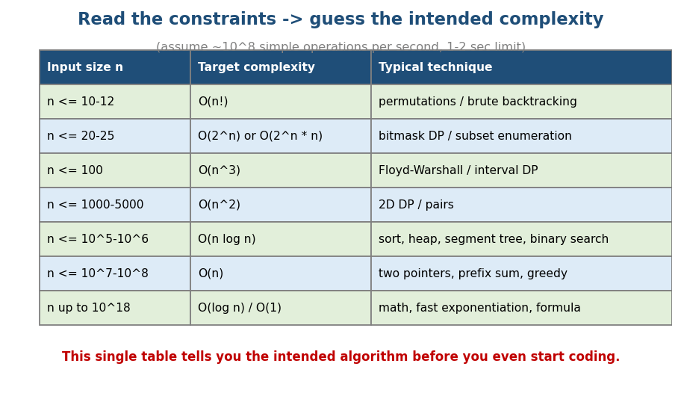
Constraint-to-complexity cheat sheet: n≤20 → O(2ⁿ), n≤500 → O(n³), n≤10⁵ → O(n log n), etc.
Input size n | Target | Typical technique
≤ 10–12 | O(n!) | permutations / brute backtracking
≤ 20–25 | O(2ⁿ), O(2ⁿ·n) | bitmask DP / subset enumeration
≤ 100 | O(n³) | Floyd-Warshall / interval DP
≤ 1000–5000 | O(n²) | 2D DP / all pairs
≤ 10⁵–10⁶ | O(n log n) | sort, heap, segment tree, binary search
≤ 10⁷–10⁸ | O(n) | two pointers, prefix sum, greedy
up to 10¹⁸ | O(log n)/O(1) | math, fast exponentiation, formula
This table is the single highest-value CP skill — it usually tells you the intended algorithm before you start. (10¹⁸ doesn’t fit in 32 bits → use 64-bit long long.)

MCQs
- n ≤ 20 suggests? → O(2ⁿ) (bitmask DP / subsets).
- n ≤ 10⁶ suggests? → O(n log n) or O(n).
- Answer up to 10¹⁸ needs what type? → 64-bit (long long).

19.2 Setup: Language, Fast I/O, Templates
- Language: C++ dominates CP (speed + STL); Python is fine for easier problems but risks TLE on tight limits (use fast I/O, PyPy on Codeforces).
- Fast I/O (the most common avoidable TLE):
  - C++: ios_base::sync_with_stdio(false); cin.tie(NULL); and prefer '\n' over endl.
  - Java: BufferedReader/StreamTokenizer + StringBuilder, not Scanner.
  - Python: sys.stdin.readline / read all input at once; sys.stdout.write.
- Template/library: keep a personal file with fast I/O, GCD, modpow, sieve, DSU, segment tree, Dijkstra, etc. (everything from M1–M18) ready to paste.
- 64-bit overflow: the #1 silent bug — use long long (C++) / long (Java) whenever products or sums can exceed ~2×10⁹.

MCQs
- Most common avoidable TLE cause? → slow I/O (endl/Scanner).
- Default CP language & why? → C++ (speed + STL).
- When to switch to long long? → products/sums beyond ~2×10⁹.

19.3 Contest Workflow & Time Management
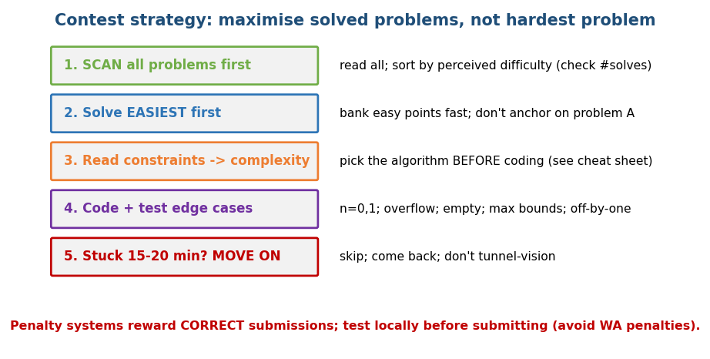
Contest strategy: scan all problems, solve easiest first, derive complexity from constraints, test edge cases, move on if stuck.
- Scan ALL problems first — sort by difficulty (Codeforces shows #solves; the most-solved is usually easiest). Don’t anchor on problem A.
- Solve the easiest first — bank quick points; build momentum.
- Constraints → complexity — pick the algorithm before coding.
- Code + test edge cases — n = 0/1, empty, max bounds, overflow, all-equal, negatives.
- Stuck 15–20 min? Move on — come back later; avoid tunnel vision.
- Test locally before submitting — wrong submissions cost penalty time; a quick local test beats a WA penalty.
Memory hook: a contest rewards most problems solved, not the hardest one attempted. Greedily grab the cheap points.

MCQs
- Which problem to attempt first? → the easiest (most #solves).
- Stuck for ~20 min? → move on, return later.
- Why test locally first? → avoid wrong-submission penalties.

19.4 Common Pitfalls (lose-the-problem bugs)
- Integer overflow (use 64-bit; mod after every op — Module 16).
- Off-by-one in loops/binary search (Module 12 template).
- Uninitialised / not reset state between test cases (multi-testcase problems — clear arrays!).
- Wrong complexity for the constraints (TLE) — re-check §19.1.
- Edge cases: empty input, single element, all-same, max/min values, n=0.
- Recursion depth / stack overflow on deep DFS (Module 1) — increase stack or go iterative.
- Floating point equality / precision — prefer integers or an epsilon.
- Reading input wrong (counts, 0- vs 1-indexed).

MCQs
- Multi-testcase silent bug? → not resetting global state between cases.
- Deep DFS risk? → stack overflow (go iterative / raise limit).
- Equality on floats? → avoid; use epsilon or integers.

19.5 Platform Patterns
- Codeforces (Div 2): A/B are observation/greedy/math; C/D need a clean algorithm (DP, graphs, number theory); E/F are hard. Rating ≈ difficulty; practice slightly above your level. Strong on constructive and greedy + proof problems.
- AtCoder (ABC): clean, math-leaning, well-tested; great for fundamentals; difficulty ramps smoothly A→F.
- ICPC (team, 5 hours, 1 computer): breadth + teamwork — one reads/finds problems, others code; share a printed team reference document (notebook); prioritise by #solves on the scoreboard.
- LeetCode contests: closest to interviews; 4 problems in ~1.5 h; speed + accuracy.

Practice approach
- Upsolve: after a contest, solve the problems you couldn’t — that’s where the learning is.
- Practice by topic (ladders) and by rating; track patterns you keep missing.
- Maintain your template library and a list of “tricks I forgot”.

MCQs
- Best way to improve after a contest? → upsolve the unsolved problems.
- ICPC format? → team of 3, 1 computer, ~5 hours; use a team notebook.
- Codeforces A/B problems are usually? → greedy/math/observation.

Module 19 — Concept Review (one page)
- Constraints → complexity is the master reflex (n≤20→2ⁿ, n≤500→n³, n≤10⁵→n log n, n≤10⁷→n, huge→log/formula).
- Setup: C++ + STL, fast I/O (sync_with_stdio / BufferedReader / sys.stdin), template library, 64-bit for overflow.
- Workflow: scan all → easiest first → derive complexity → test edge cases → move on if stuck → test locally before submit.
- Pitfalls: overflow, off-by-one, unreset state, wrong complexity, edge cases, recursion depth, float precision.
- Platforms: Codeforces (greedy/constructive + rating), AtCoder (clean math), ICPC (team/breadth), LeetCode (interview-like). Upsolve to improve.

Module 19 — Flash Cards
- Q: n ≤ 20 → ? A: O(2ⁿ) bitmask/subsets.
- Q: n ≤ 10⁵ → ? A: O(n log n).
- Q: #1 avoidable TLE? A: slow I/O.
- Q: Which problem first in a contest? A: easiest (most #solves).
- Q: Multi-testcase bug? A: forgot to reset state.
- Q: Best post-contest practice? A: upsolve.

Module 19 — Pattern Recognition (map constraints to M1–M18)
- “n tiny (≤20)” → bitmask DP (M14c) / backtracking (M13).
- “n ≤ few hundred” → O(n²)/O(n³) DP (M14) / Floyd (M10b).
- “n ≤ 10⁵, many queries” → sort + binary search (M12) / segment tree (M8b) / prefix sum (M2).
- “huge n / huge answer” → math, fast exponentiation, mod (M16).
- “shortest path / connectivity” → BFS/Dijkstra/DSU (M10).

Module 19 — Interview crossover
CP habits that win interviews: derive complexity from constraints out loud, enumerate edge cases first, test before claiming done, and recognise the pattern fast. (The interview craft itself is Module 20.)

Module 19 — GATE / SEBI / RBI / ISRO Perspective
- Not directly examined, but the complexity-from-constraints reflex and clean implementation help in any timed coding/aptitude round.

End of Module 19. Next: Module 20 — Google / FAANG Interview Preparation (Blind 75, Neetcode 150, company patterns, the interview framework) — with visuals.

