Module 20 — Google / FAANG Interview Preparation
  - DSA Mastery: Google / FAANG / GATE / ICPC — In-Depth Notes (with visuals)
Prepared for nidhi.sharma@forensiccybertech.com
2026
Table of Contents

Module 20 — Google / FAANG Interview Preparation
Why this module. M1–M18 gave you the toolbox. This module is about using it under interview conditions: a repeatable problem-solving framework, instant pattern recognition, the curated problem sets that cover ~90% of questions (Blind 75 / Neetcode 150 / Grind 169), and what each company actually optimises for. The bar isn’t “did you solve it” — it’s “did you communicate, justify complexity, handle edge cases, and write clean code.”
This module is P0 for your stated goal (Google/Meta/Amazon/…).
How to read. The framework, the pattern map, the curated lists, company specifics, and a study plan. (Track problems in the Excel “Top 300” tab.)

20.1 The Universal Interview Framework
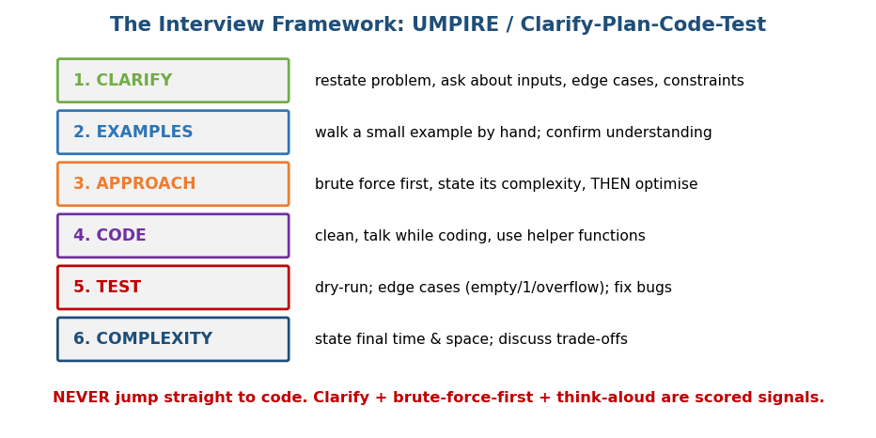
Interview framework: Clarify → Examples → Approach (brute force first) → Code → Test → Complexity.
Follow this every single time (never jump straight to code):
- Clarify — restate the problem; ask about input ranges, types, duplicates, empty/negative inputs, expected output. (Interviewers plant ambiguity.)
- Examples — walk one small example by hand to confirm understanding.
- Approach — state the brute force + its complexity first, then optimise. Think aloud; name the pattern.
- Code — clean, readable, helper functions, good names. Keep narrating.
- Test — dry-run your code; check edge cases (empty, size 1, overflow, duplicates, max bounds). Fix bugs calmly.
- Complexity — state final time and space, and discuss trade-offs.
Scored signals (what actually gets you hired): communication, brute-force- then-optimise, complexity analysis, edge-case discipline, clean code. A correct answer in silence often fails.

MCQs
- First step on any problem? → clarify (restate + ask constraints).
- Before optimising, state? → the brute force + its complexity.
- Biggest non-coding scored signal? → communication / think-aloud.

20.2 Pattern Recognition (classify in seconds)
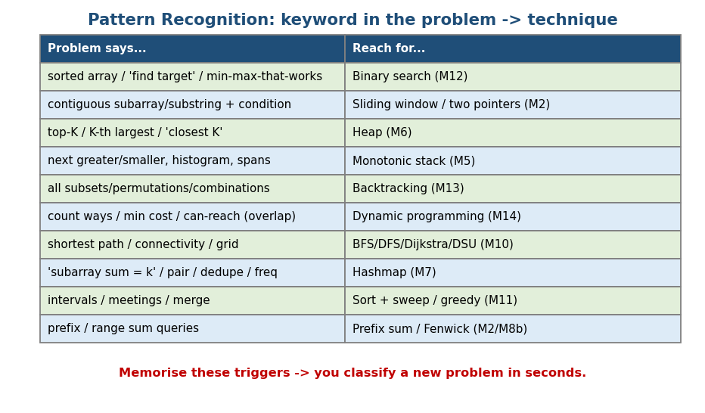
Pattern map: keyword in the problem → the technique and module (binary search, sliding window, heap, DP, graphs, hashmap, …).
The problem says… | Reach for…
sorted array / “find target” / “min-max that works” | Binary search (M12)
contiguous subarray/substring + condition | Sliding window / two pointers (M2)
top-K / K-th largest / “closest K” | Heap (M6)
next greater/smaller, histogram, spans | Monotonic stack (M5)
all subsets / permutations / combinations | Backtracking (M13)
count ways / min cost / can-reach (overlapping) | DP (M14)
shortest path / connectivity / grid / islands | BFS/DFS/Dijkstra/DSU (M10)
“subarray sum = k” / pair / dedupe / frequency | Hashmap (M7)
intervals / meetings / merge / scheduling | Sort + sweep / greedy (M11)
prefix / range-sum queries | Prefix sum / Fenwick (M2 / M8b)
string matching / autocomplete | KMP/Z / Trie (M3)
Drill this table until classification is automatic — most interview problems are a known pattern in disguise.

MCQs
- “Longest substring with ≤ k distinct” → ? → sliding window.
- “K-th largest in a stream” → ? → heap.
- “Number of ways to make change” → ? → DP.

20.3 The Curated Problem Sets
Don’t grind 2000 random problems — these cover the space:
- Blind 75 — the classic minimum set, ~75 problems across all core patterns. If you only do one list, do this.
- Neetcode 150 — Blind 75 + 75 more, grouped by pattern (arrays, two pointers, sliding window, stack, binary search, linked list, trees, tries, heap, backtracking, graphs, DP, greedy, intervals, math, bit). Best structured path.
- Grind 75 / 169 — schedule-based (adjustable by hours/week).
- LeetCode company tags — once a company is targeted, do its tagged “last 6 months” set.
Your Excel “Top 300 Problems” tab seeds this pattern-wise; mark Solved / Revisit there. Aim for breadth across patterns first, then depth.

Study sequence (recommended order)
Arrays & Hashing → Two Pointers → Sliding Window → Stack → Binary Search → Linked List → Trees → Tries → Heap → Backtracking → Graphs → 1-D DP → 2-D DP → Greedy → Intervals → Math & Bit. (Mirrors Neetcode’s grouping and this course’s module order.)

MCQs
- The single best minimal list? → Blind 75.
- Best structured-by-pattern path? → Neetcode 150.
- Breadth or depth first? → breadth across patterns, then depth.

20.4 Company-Specific Focus
Company | Coding focus | Other rounds / notes
Google | graphs, DP, trees, hard recursion; optimal + clean + complexity | “Googleyness”, system design (L5+); ask clarifying Qs
Meta | arrays/strings, BFS/DFS; fast pace (≈2 Qs/round) | behavioral signals, system design; communicate while coding
Amazon | trees, graphs, DP, heaps; clean working code | Leadership Principles (STAR) heavily; bar-raiser
Microsoft | arrays, strings, trees, linked lists; practical | design + behavioral; clarity valued, friendlier pace
Apple | domain + DSA, depth in your area | team-specific; strong fundamentals
Netflix | senior system design + DSA | culture (“freedom & responsibility”); fewer, senior rounds
Uber/Stripe | practical coding, API design, concurrency | Stripe: integration-style coding; system design
OpenAI/Anthropic | strong DSA + ML/AI eng + practical coding | research/eng depth (see Module 21)
NVIDIA | DSA + systems/CUDA/perf | cache/memory awareness valued (Module 1)
Databricks/Palantir | DSA + distributed/data systems | design; sometimes take-home
- Amazon LP tip: prepare ~10 STAR stories mapped to the Leadership Principles; every behavioral answer ties to one.
- Google tip: they want the optimal solution and a crisp complexity argument; partial/brute-only often isn’t enough at the bar.

MCQs
- Amazon’s signature non-coding round? → Leadership Principles (STAR).
- Meta interview pace? → fast (~2 problems/round).
- Google emphasises? → optimal solution + clean code + complexity.

20.5 A Realistic Study Plan
- Foundation (weeks 1–8): learn patterns (this course M1–M14) + ~100 problems across patterns.
- Volume (weeks 9–16): Neetcode 150 / Blind 75; ~150–200 problems; redo missed ones.
- Polish (weeks 17–24): mock interviews (Pramp/peers), company-tagged problems, behavioral prep, system design (for senior).
- Daily: 2–4 problems, always timed (35–45 min), always think-aloud.
- Weakness log: track every problem you missed and why (pattern? bug? edge case?) and re-drill it.
See the Excel “6-Month Roadmap” and “Interview Roadmap” tabs for the week-by-week and company-by-company plans.

MCQs
- Practice problems how? → timed + think-aloud.
- What to track? → a weakness log (what you missed and why).
- Senior rounds add? → system design + behavioral.

Module 20 — Concept Review (one page)
- Framework: Clarify → Examples → Approach (brute force first) → Code → Test → Complexity. Communication + complexity + edge cases are scored.
- Pattern map: learn keyword → technique (binary search, sliding window, heap, monotonic stack, backtracking, DP, graphs, hashmap, intervals, prefix sum).
- Lists: Blind 75 (minimum), Neetcode 150 (structured), Grind (scheduled); breadth → depth; track in the Excel Top-300 tab.
- Companies: Google (optimal+clean), Meta (fast pace), Amazon (LP/STAR), Microsoft (practical), AI labs (DSA+ML).
- Plan: patterns → volume → mocks; daily timed think-aloud; keep a weakness log.

Module 20 — Flash Cards
- Q: Steps before coding? A: clarify, examples, approach (brute force first).
- Q: Top scored signal? A: communication / think-aloud.
- Q: Best structured list? A: Neetcode 150.
- Q: Amazon’s key round? A: Leadership Principles (STAR).
- Q: Practice style? A: timed + think-aloud + weakness log.

Module 20 — Pattern Recognition
(See §20.2 table — the master keyword→technique map. This is the interview skill: classify the problem, then apply the right module.)

Module 20 — Interview Questions (meta-level)
- Walk me through how you’d approach an unfamiliar problem. → the framework.
- Give the brute force, then optimise. → always lead with brute + complexity.
- What’s the time/space complexity, and the trade-off? → state both, discuss.
- (Amazon) Tell me about a time you… → STAR story mapped to an LP.

Module 20 — GATE / SEBI / RBI / ISRO Perspective
- Different format (MCQ/written), but the pattern-recognition and complexity reflexes transfer directly. For exams, prioritise the module-by-module mastery (M1–M18) over interview-specific drills.

End of Module 20. Next: Module 21 — AI Engineering DSA (vector search, ANN, HNSW/FAISS, beam search, tokenization, RAG) — with visuals.

