Module 21 — AI Engineering DSA
  - DSA Mastery: Google / FAANG / GATE / ICPC — In-Depth Notes (with visuals)
Prepared for nidhi.sharma@forensiccybertech.com
2026
Table of Contents

Module 21 — AI Engineering DSA
Why this module. Modern AI systems (LLMs, RAG, recommendation, search) are built on classic data structures and algorithms applied at scale. If you’re targeting AI / ML engineering (OpenAI, Anthropic, NVIDIA, or any company shipping LLM features), you need the DSA behind embeddings, vector search, and decoding. This is the bridge from M1–M18 to AI infrastructure.
This module is P1 for AI roles, P2 otherwise.
How to read. The data structure / algorithm, what it powers, and the trade-offs.

21.1 Embeddings & Vector Search
Text, images, and audio are turned into embeddings — fixed-length vectors (e.g. 768 or 1536 dimensions) where semantic similarity = geometric closeness.
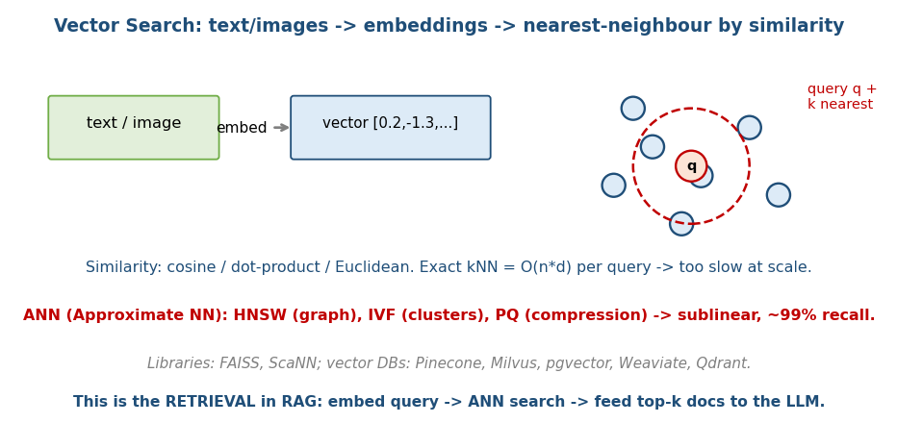
Vector search: embed inputs into vectors; find nearest neighbours by cosine/dot/Euclidean; ANN makes it scale.
- Similarity metrics: cosine (angle, the most common for text), dot product, Euclidean (L2).
- Exact k-NN is O(n·d) per query (n vectors, d dims) — fine for thousands, hopeless for billions.
- The fix: Approximate Nearest Neighbour (ANN) — trade a tiny bit of recall for sublinear search.

MCQs
- Most common text-similarity metric? → cosine similarity.
- Exact k-NN cost per query? → O(n·d) (too slow at scale).
- What does an embedding capture? → semantic similarity as geometric distance.

21.2 ANN Algorithms (the heart of vector DBs)
Method | Idea | Trade-off
HNSW | layered “small-world” graph; greedy search dropping levels | best recall/speed; production default; more memory
IVF (inverted file) | cluster vectors (k-means); search only the nearest clusters | fast; tune #clusters probed (nprobe)
PQ (product quantization) | compress vectors into codes | huge memory savings; some accuracy loss
LSH | hash so near vectors collide | older; simpler; lower recall

HNSW in detail
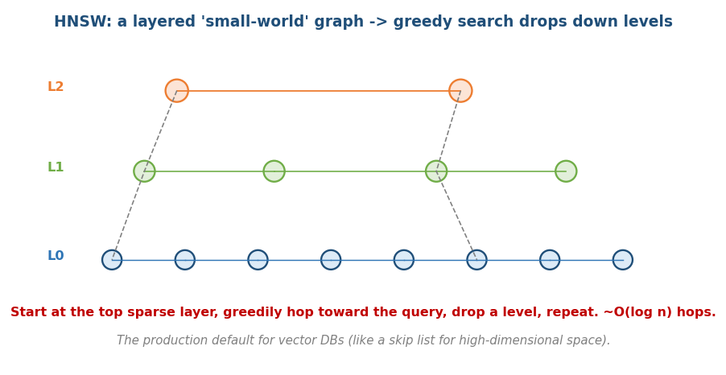
HNSW: a layered navigable small-world graph; start at the sparse top layer, greedily hop toward the query, drop down, repeat (~O(log n)).
A hierarchy of graphs: the top layer is sparse (long-range links), lower layers denser. Search starts at the top, greedily hops toward the query, drops a level, repeats → about O(log n) hops. It’s essentially a skip list for high-dimensional space (Module 17).
- Libraries: FAISS (Meta), ScaNN (Google); vector DBs: Pinecone, Milvus, Weaviate, Qdrant, pgvector.
- KD-trees (Module 17) fail in high dimensions (curse of dimensionality) → ANN graphs/quantization win.

MCQs
- Production-default ANN method? → HNSW.
- HNSW is analogous to which 1-D structure? → a skip list.
- PQ trades what for what? → memory for a little accuracy.

21.3 RAG (Retrieval-Augmented Generation)
The dominant pattern for grounding LLMs in your data:
1. Offline: chunk documents -> embed each chunk -> store vectors in an ANN index
2. Query time:
embed the user query -> ANN search (top-k similar chunks)
-> put those chunks in the prompt as context -> LLM generates an answer
- The DSA: chunking (sliding window over text), embedding store (vector DB + HNSW), top-k retrieval (heap / ANN), often re-ranking the candidates.
- Why it works: keeps the LLM’s context grounded + up-to-date without retraining; reduces hallucination.

MCQs
- RAG retrieval uses which search? → ANN (vector search).
- What does RAG avoid vs fine-tuning? → retraining the model.
- Top-k selection structure? → heap / ANN index.

21.4 Tokenization & LLM Decoding Data Structures

Tokenization (BPE)
LLMs read tokens, not characters. Byte-Pair Encoding (BPE) builds the vocabulary by repeatedly merging the most frequent adjacent pair of tokens — using hashmaps (pair frequencies) and often tries for the merge table. (Conceptually like Huffman’s “merge frequent things”, Module 11.)

Beam Search (decoding)
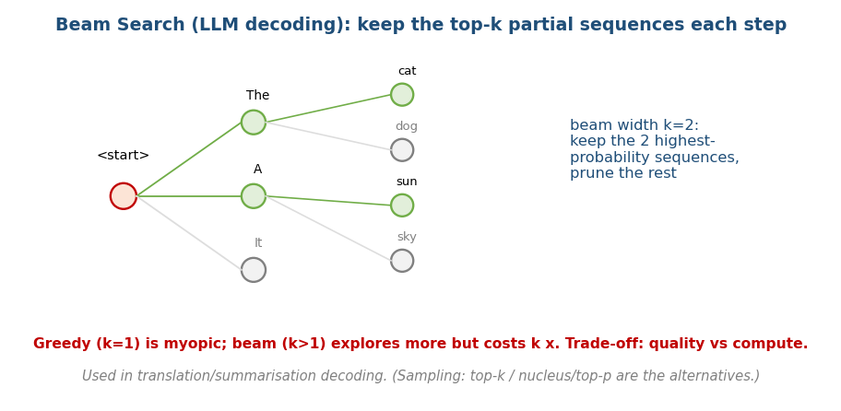
Beam search keeps the top-k highest-probability partial sequences at each step, pruning the rest.
At each step, an LLM has a probability over the next token. Beam search keeps the top-k partial sequences (beam width k), expands each, and again keeps the best k → better than greedy (k=1) but costs k×.
- Alternatives: top-k sampling, nucleus / top-p sampling (sample from the smallest set of tokens whose probability ≥ p) — used for creative output; beam search for deterministic tasks (translation).
- KV-cache: during generation, cache each layer’s key/value tensors so each new token is O(1) in attention over the past instead of recomputing — a classic memoization (Module 14) applied to transformers.

MCQs
- BPE merges what each step? → the most frequent adjacent pair (hashmap).
- Beam width k=1 is just? → greedy decoding.
- KV-cache is an instance of? → memoization.

21.5 Other AI-Infra DSA (brief)
- Recommendation: candidate generation via ANN + ranking; graphs for collaborative filtering; heaps for top-N.
- Feature stores / dedup: Bloom filters / HyperLogLog (Module 7) for “seen before?” and cardinality at scale.
- Streaming / counts: Count-Min Sketch for approximate frequencies.
- GPU/perf (NVIDIA): memory coalescing & cache locality (Module 1) decide kernel speed; data layout (SoA vs AoS) matters.

Module 21 — Concept Review (one page)
- Embeddings: semantic similarity = vector closeness (cosine/dot/L2); exact k-NN O(n·d) too slow.
- ANN: HNSW (graph, production default ≈ high-D skip list), IVF (clusters), PQ (compression), LSH (older); FAISS / vector DBs.
- RAG: chunk → embed → ANN retrieve top-k → LLM context; grounds the model without retraining.
- Tokenization: BPE merges frequent pairs (hashmap/trie). Decoding: beam search keeps top-k sequences; top-k/top-p sampling for creativity; KV-cache = memoization.
- Infra: ANN + heaps (recsys), Bloom/HLL/CMS (scale), cache locality (GPU).

Module 21 — Flash Cards
- Q: Why ANN over exact k-NN? A: exact is O(n·d); ANN is sublinear.
- Q: Production ANN method? A: HNSW (≈ high-D skip list).
- Q: RAG pipeline? A: embed query → ANN top-k → LLM context.
- Q: BPE merges? A: most frequent adjacent token pair.
- Q: KV-cache = ? A: memoization in transformer attention.
- Q: Beam width 1 = ? A: greedy decoding.

Module 21 — Pattern Recognition
- “Find similar items at scale” → embeddings + ANN (HNSW).
- “Ground an LLM in my docs” → RAG (vector retrieval).
- “Pick best next tokens / sequences” → beam search / sampling.
- “Seen-before / approximate counts at scale” → Bloom / HLL / Count-Min.
- “Top-N recommendations” → ANN + heap.

Module 21 — Interview Questions (AI-eng)
- Design semantic search over 1B documents. → embeddings + HNSW/IVF-PQ + sharding.
- Build a RAG pipeline. → chunk/embed/index/retrieve/re-rank/generate.
- Why does KD-tree fail for embeddings? → curse of dimensionality → ANN.
- Greedy vs beam vs sampling decoding — trade-offs?

Module 21 — GATE / SEBI / RBI / ISRO Perspective
- Not in classic syllabi, but vector search / ANN / RAG are increasingly relevant to applied-AI and data-engineering roles (and modern IT exams’ GK sections). The underlying DSA (graphs, heaps, hashing, memoization) is all from M1–M18.

End of Module 21. Next: Module 22 — System Design Connections (why Redis uses skip lists, DBs use B+ trees, Linux uses RB-trees, Git uses DAGs) — with visuals.

