Module 22 — System Design Connections
  - DSA Mastery: Google / FAANG / GATE / ICPC — In-Depth Notes (with visuals)
Prepared for nidhi.sharma@forensiccybertech.com
2026
Table of Contents

Module 22 — System Design Connections
Why this module. Interviewers love the question “why does this real system use that data structure?” — it proves you understand the trade-offs, not just the API. This module connects every structure from M1–M18 to the production system that relies on it. It’s the bridge between “DSA” and “system design”.
This module is P1 (great for senior interviews and the “why” round).
How to read. System → data structure → the trade-off that made it the choice.

22.1 The Big Picture
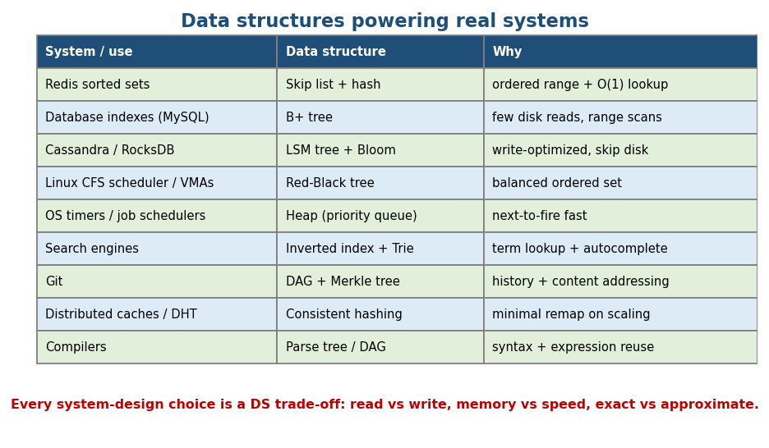
Data structures powering real systems: Redis/skip list, DB/B+ tree, Cassandra/LSM, Linux/RB-tree, schedulers/heap, search/trie, Git/DAG.
Every system-design decision is a data-structure trade-off: read-optimised vs write-optimised, memory vs speed, exact vs approximate, ordered vs unordered.

22.2 The Classic “Why” Stories

Why Redis sorted sets use a skip list
ZSET needs ordered range/rank queries (ZRANGE, leaderboards) and O(1) score lookup by member. A skip list gives O(log n) ordered ops with simple, concurrency-friendly code; a hash table alongside gives O(1) member→score. (Module 17.) A balanced BST would also work but is harder to implement lock-free; skip lists are simpler.

Why databases use B+ trees for indexes
Data lives on disk; the cost that matters is disk reads (page fetches). A B+ tree is wide and shallow (hundreds of keys per node) → a billion rows is ~3–4 levels deep → ~3–4 disk reads. Leaves are linked → fast range scans (WHERE age BETWEEN…), which a hash index can’t do. (Module 8b.)

Why write-heavy stores (Cassandra, RocksDB) use LSM trees
Random disk writes are slow. An LSM tree buffers writes in memory (memtable), flushes them as sorted SSTables, and compacts in the background → turns random writes into sequential ones (write-optimised). Bloom filters on SSTables skip disk reads for absent keys. (Modules 8b/17/7.)

Why Linux uses red-black trees
The CFS scheduler keeps runnable tasks in a red-black tree keyed by “virtual runtime” → always pick the leftmost (least-run) task in O(log n); insert/remove in O(log n). Also used for virtual memory areas and epoll. RB-trees balance with fewer rotations than AVL → better for insert/delete-heavy kernel use. (Module 8b.)

Why schedulers/timers use heaps
“What fires next?” = extract-min → a min-heap (priority queue) gives O(log n) insert and O(1) peek of the next event. Used in OS timers, event simulators, Dijkstra, and job schedulers. (Module 6.)

Why search engines use tries + inverted indexes
Autocomplete = prefix queries → trie (Module 3). Full-text search = map each term → list of documents (inverted index) → intersect/union posting lists for queries. Ranking adds heaps (top-N) and more.

Why Git uses a DAG + Merkle tree
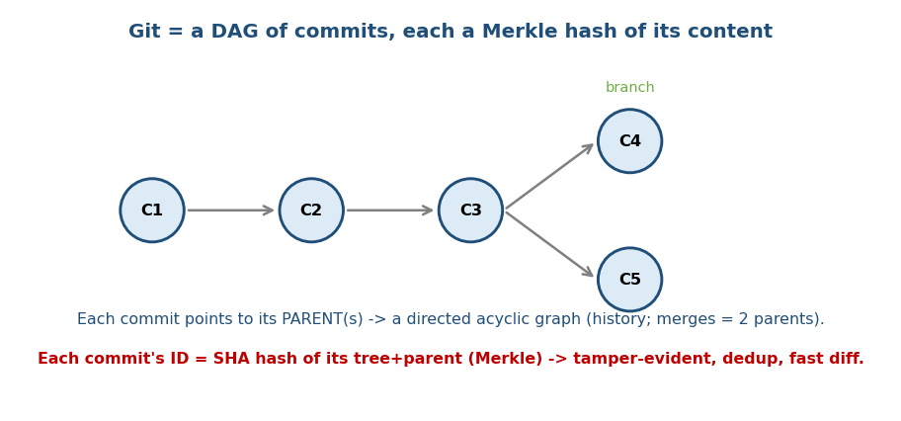
Git: a DAG of commits (each points to its parent(s)); each commit ID is a Merkle hash of its content.
Commit history is a Directed Acyclic Graph — each commit points to its parent(s) (a merge has two). Each object’s ID is a SHA hash of its content (a Merkle tree of trees/blobs) → tamper-evident, automatic dedup (identical content = same hash), and fast diff/sync. (Modules 10 + 3-hashing.)

Why distributed caches use consistent hashing
Plain hash(key) % N remaps almost everything when N changes (a node joins/leaves). Consistent hashing places nodes and keys on a ring → adding a node remaps only ~1/N of keys. Used in DynamoDB, Cassandra, CDNs, memcached clusters. (Module 7.)

MCQs
- Why B+ trees for DB indexes (not hash)? → shallow (few disk reads) + linked leaves for range scans.
- Why LSM trees for write-heavy stores? → turn random writes into sequential (write-optimised) + Bloom filters.
- Why consistent hashing? → adding/removing a node remaps only ~1/N of keys.

22.3 Quick Reference: DS → System
Data structure | Powers
Array / dynamic array | almost everything; columnar stores
Hash table | caches, DB hash indexes, dedup, sets
Skip list | Redis ZSET, concurrent maps
B+ tree | relational DB indexes, filesystems
LSM tree | Cassandra, RocksDB, LevelDB, time-series DBs
Red-Black tree | Linux CFS, C++ std::map, Java TreeMap
Heap / priority queue | schedulers, timers, Dijkstra, top-N
Trie / inverted index | autocomplete, search engines
Graph (DAG) | Git, build systems, task dependencies, package managers
Bloom filter / HLL | “seen before?”, cardinality (Cassandra, Redis)
Consistent hashing | sharding, distributed caches/DBs
HNSW / ANN | vector DBs, semantic search (Module 21)

MCQs
- C++ std::map / Java TreeMap use? → red-black trees.
- Build-system / package-manager dependency ordering? → DAG + topological sort.
- “Is this key probably present, cheaply?” → Bloom filter.

Module 22 — Concept Review (one page)
- Every system choice = a DS trade-off (read/write, memory/speed, exact/approximate).
- Redis ZSET = skip list + hash; DB index = B+ tree (shallow + range scans); write-heavy = LSM + Bloom; Linux CFS = red-black tree; schedulers = heap; search = trie + inverted index; Git = DAG + Merkle; sharding = consistent hashing; vector search = HNSW.

Module 22 — Flash Cards
- Q: Redis sorted set? A: skip list + hash table.
- Q: DB index structure & why? A: B+ tree — shallow + linked-leaf range scans.
- Q: Write-optimised store? A: LSM tree (+ Bloom filters).
- Q: Linux scheduler tree? A: red-black tree (CFS).
- Q: Git’s structure? A: DAG of commits + Merkle hashes.
- Q: Minimal remap on scaling? A: consistent hashing.

Module 22 — Pattern Recognition (system-design “why”)
- “Ordered + ranked + fast lookup” → skip list / balanced BST + hash.
- “On-disk index, range queries” → B+ tree; “write-heavy” → LSM.
- “What happens next / top-N” → heap.
- “Prefix / search” → trie / inverted index.
- “History / dependencies / content integrity” → DAG / Merkle.
- “Scale out without reshuffling everything” → consistent hashing.

Module 22 — Interview Questions
- Why does MySQL use a B+ tree, not a hash index? → range scans + few disk reads.
- Design a leaderboard. → Redis ZSET (skip list) / balanced BST + hash.
- Why does Cassandra write faster than a B-tree DB? → LSM (sequential writes).
- How does Git detect identical files instantly? → content hashing (Merkle).
- Why consistent hashing for a distributed cache? → minimal remap on add/remove.

Module 22 — GATE / SEBI / RBI / ISRO Perspective
- DBMS overlap (high-yield): B/B+ tree indexing, hashing, and these structure choices appear in DBMS and OS sections (CFS scheduler, paging). Ties directly to the DBMS notes.

End of Module 22. Next: Module 23 — Competitive Exams mapping (GATE / SEBI / RBI / ISRO / DRDO / C-DAC topic weightage) — with visuals.

