Module 23 — Competitive Exams Mapping (GATE / SEBI / RBI / ISRO / C-DAC)
  - DSA Mastery: Google / FAANG / GATE / ICPC — In-Depth Notes (with visuals)
Prepared for nidhi.sharma@forensiccybertech.com
2026
Table of Contents

Module 23 — Competitive Exams Mapping
Why this module. The same DSA content is tested very differently across exams. This module maps every topic to every exam and tells you what to prioritise, so you don’t waste time studying ICPC-only topics for SEBI, or skipping P/NP for GATE.
This module is P0 for exam-takers (you’re targeting SEBI/RBI IT + GATE).
How to read. The weightage table, then per-exam strategy.

23.1 Topic × Exam Relevance
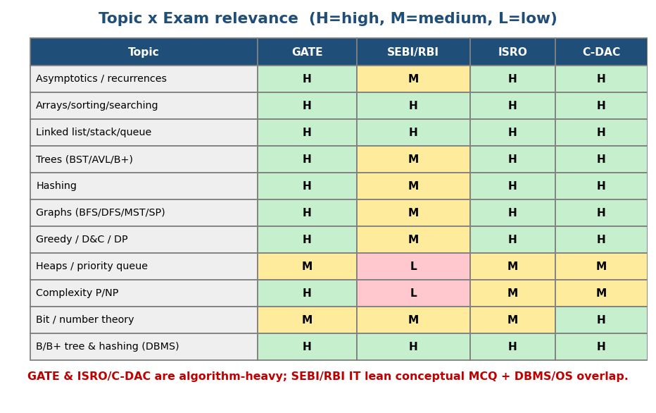
Topic × exam heatmap: GATE/ISRO/C-DAC are algorithm-heavy (mostly High); SEBI/RBI lean conceptual + DBMS/OS overlap.
Topic | GATE | SEBI/RBI IT | ISRO | C-DAC
Asymptotics / recurrences / Master thm | High | Medium | High | High
Arrays / sorting / searching | High | High | High | High
Linked list / stack / queue | High | High | High | High
Trees (BST/AVL/B/B+) | High | Medium | High | High
Hashing (collisions, probing) | High | Medium | High | High
Graphs (BFS/DFS/MST/shortest path) | Very High | Medium | High | High
Greedy / Divide & Conquer / DP | High | Medium | High | High
Heaps / priority queue | Medium | Low | Medium | Medium
Complexity classes (P/NP) | High | Low | Medium | Medium
Bit manipulation / number theory | Medium | Medium | Medium | High
B/B+ tree & hashing (DBMS overlap) | High | High | High | High

23.2 Per-Exam Strategy

GATE CS (algorithm-heavy, numerical)
- Format: MCQ + NAT (numerical answer). Algorithms + Programming & DS are a major chunk (~13–15 marks combined with related areas).
- Highest-yield: recurrences & Master Theorem, graph algorithms (BFS/DFS/MST/Dijkstra/Bellman-Ford traversal & complexity), DP (table-fill: LCS, matrix chain, knapsack), greedy (Huffman numericals), hashing (probing sequences), B/B+ trees (order, splits), P/NP definitions & reductions, quicksort/mergesort comparison counts, heap (build O(n)).
- Style: they give you a concrete instance and ask you to trace/compute (table values, #comparisons, #nodes). Practice doing, not just reading.

SEBI Grade A / RBI Grade B (IT stream) — your target
- Format: objective MCQs across IT (DSA + DBMS + OS + Networks + Cyber + emerging tech). DSA is conceptual, not heavy table-filling.
- Highest-yield DSA: complexity (Big-O of common algorithms), stack/queue/LL, tree traversals & BST, hashing, sorting basics, B/B+ trees (big DBMS overlap), graph basics. Plus DBMS indexing (ties to Module 8b / the DBMS notes).
- Strategy: breadth + accuracy on definitions and complexities; don’t over- invest in ICPC-only topics (suffix automaton, HLD, flows).

ISRO / DRDO / C-DAC
- ISRO CS: GATE-like, slightly more direct; same DSA core + OS/DBMS/networks.
- C-DAC (CCAT): aptitude + CS fundamentals; C programming + DSA + number theory/bit matter.

MCQs
- Highest-yield GATE algorithm area? → graph algorithms (+ DP, recurrences).
- SEBI/RBI DSA style? → conceptual MCQ (+ DBMS indexing overlap).
- Which DSA topic spans all exams strongly? → trees + hashing (esp. B/B+ trees).

23.3 Frequently-Asked Concepts (memorise cold)
- Time complexities of all sorts (bubble/insertion/selection/merge/quick/heap/ counting) — best/avg/worst + stable?
- Master Theorem application; recurrence → Θ.
- BST/AVL/B/B+ tree operations & heights; number of nodes/keys.
- Hashing: load factor, linear/quadratic/double probing, chaining.
- Graph: BFS/DFS order, MST (Kruskal/Prim), Dijkstra/Bellman-Ford/Floyd complexity & applicability (negative edges!).
- DP: LCS, matrix chain, 0/1 knapsack table-fill; greedy Huffman total bits.
- Heap: build-heap O(n), heapsort O(n log n), array indices.
- P/NP/NP-complete/NP-hard definitions; SAT; reductions; undecidability.

MCQs
- Build-heap complexity (favourite trap)? → O(n), not O(n log n).
- Dijkstra with negative edges? → fails (use Bellman-Ford).
- Which sorts are stable? → merge, insertion, counting (not quick/heap/selection).

Module 23 — Concept Review (one page)
- GATE/ISRO/C-DAC = algorithm-heavy, trace/compute style → master recurrences, graphs, DP table-fill, hashing, B/B+ trees, P/NP, sort comparisons, build-heap O(n).
- SEBI/RBI IT (your target) = conceptual MCQ across IT; DSA complexities + trees + hashing + DBMS indexing overlap; breadth + accuracy.
- Use the Excel “Exam Mapping” tab to track exam-specific focus.

Module 23 — Flash Cards
- Q: GATE highest-yield? A: graphs, DP, recurrences, hashing, B+ trees, P/NP.
- Q: SEBI/RBI DSA style? A: conceptual MCQ + DBMS indexing.
- Q: build-heap? A: O(n).
- Q: Dijkstra + negative edges? A: fails → Bellman-Ford.
- Q: stable sorts? A: merge, insertion, counting.

Module 23 — Pattern Recognition (exam triage)
- “Trace this algorithm / fill this table” → GATE/ISRO numerical.
- “Which is true about X complexity” → SEBI/RBI conceptual MCQ.
- “B/B+ tree order / splits / index” → all exams + DBMS.

Module 23 — GATE / SEBI / RBI / ISRO Perspective
This module is the exam perspective. Pair it with the per-module “GATE/SEBI…” sections throughout M1–M18, and the Excel Exam-Mapping + 6-Month Roadmap tabs.

End of Module 23. Next: Module 24 — Interview Question Bank (1000+ questions by topic, follow-ups, debugging) — with visuals.

