Module 25 — Projects (Build to Cement)
  - DSA Mastery: Google / FAANG / GATE / ICPC — In-Depth Notes (with visuals)
Prepared for nidhi.sharma@forensiccybertech.com
2026
Table of Contents

Module 25 — Projects
Why build projects. Reading about a data structure ≠ owning it. Building a small system forces you to handle the edge cases, the API, and the trade-offs — and it’s the strongest signal on a resume and in a “tell me about something you built” interview. Each project below is a direct application of earlier modules.
This module is P1 (do 2–3 well rather than all 8 shallowly).
How to read. For each: what it is, the core DS, the key design decisions, and the modules it exercises.

25.1 Project → Data Structure Map
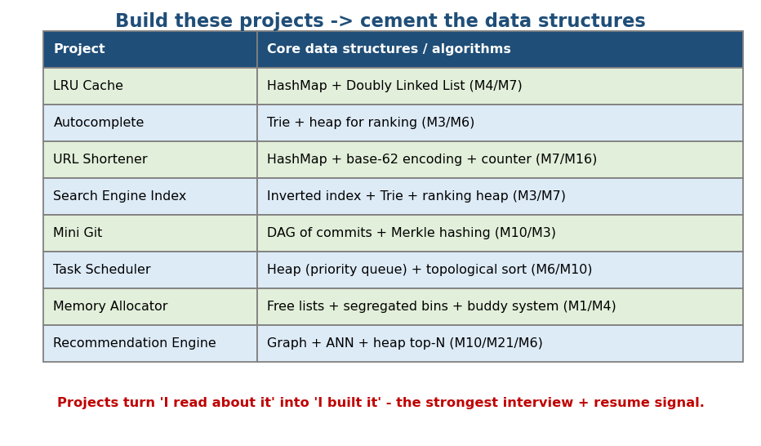
Projects and their core data structures: LRU (hashmap+DLL), autocomplete (trie+heap), mini-Git (DAG+Merkle), etc.

25.2 The Projects

1. LRU Cache (start here)
- DS: HashMap + Doubly Linked List (Module 4/7).
- Design: map key→node for O(1) lookup; DLL ordered by recency (MRU head, LRU tail); get/put move the node to head; evict the tail when full. All O(1).
- Extend: LFU (frequency buckets), TTL expiry, thread-safety (locks / sharding). Interview-classic (LC 146).

2. Autocomplete / Typeahead
- DS: Trie + a heap for top-k ranking (Module 3/6).
- Design: insert words (with frequencies); on a prefix, walk to the prefix node, then collect/rank the top-k completions (precompute top-k per node for speed). Extend: fuzzy match (edit distance), weighted by popularity.

3. URL Shortener (TinyURL)
- DS: HashMap + base-62 encoding of an auto-increment counter (Module 7/16).
- Design: counter → base-62 string (a–z A–Z 0–9) = short code; store code↔URL; handle collisions/custom aliases; scale with sharding + caching. Classic system-design + DSA crossover.

4. Search Engine Index (mini)
- DS: Inverted index (term → posting list) + Trie (autocomplete) + heap (top-N ranking) (Module 3/7/6).
- Design: tokenize/normalize docs → build term → sorted doc IDs; query = intersect/union posting lists; rank by TF-IDF/BM25; return top-N via a heap.

5. Mini Git
- DS: DAG of commits + Merkle/content hashing (Module 10/3).
- Design: blob/tree/commit objects, each addressed by SHA of its content; a commit points to its parent(s) → history is a DAG; diff compares trees; branches are pointers. Exercises: hashing, graphs, deduplication.

6. Task Scheduler / Job Queue
- DS: Heap (priority queue) + topological sort for dependencies (Module 6/10).
- Design: min-heap keyed by run-time/priority → next job in O(log n); a DAG of dependencies → run in topological order; handle retries, delays, cron.

7. Memory Allocator (malloc)
- DS: free lists, segregated bins, buddy system (Module 1/4).
- Design: track free blocks (linked lists by size class); malloc finds a fit (first/best-fit); free coalesces neighbours; the buddy system splits/ merges power-of-two blocks. Exercises: pointers, fragmentation, the heap (Module 1) from the implementer’s side.

8. Recommendation Engine
- DS: graph (user-item) + ANN (embeddings) + heap (top-N) (Module 10/21/6).
- Design: collaborative filtering on a bipartite graph, or embed users/items and ANN-retrieve similar ones (HNSW), then rank and take top-N with a heap.

MCQs
- LRU cache core structures? → HashMap + doubly linked list.
- Autocomplete core structure? → Trie (+ heap for ranking).
- Mini-Git’s history is a? → DAG (with Merkle hashing).
- URL shortener code generation? → base-62 of a counter.

25.3 How to Approach a Project
- Define the API first (get/put, insert/search, commit/diff).
- Pick the DS from the trade-offs (this whole course).
- Build the happy path, then edge cases (empty, full, eviction, missing).
- Test (unit tests + a stress test).
- Write a short README: the design, the DS choice + why, complexity, and what you’d do at scale. (That README is your interview talking points.)

Module 25 — Concept Review (one page)
- Projects = applied DSA + the strongest signal. Map: LRU (hashmap+DLL), autocomplete (trie+heap), URL shortener (hashmap+base62), search index (inverted index+trie+heap), mini-Git (DAG+Merkle), scheduler (heap+topo), allocator (free lists/buddy), recsys (graph+ANN+heap).
- Build 2–3 deeply; write a README explaining the DS choice, complexity, and scaling.

Module 25 — Flash Cards
- Q: LRU cache? A: hashmap + doubly linked list (O(1)).
- Q: Autocomplete? A: trie + top-k heap.
- Q: Mini-Git? A: DAG of commits + Merkle hashing.
- Q: Search index core? A: inverted index (+ trie + ranking heap).
- Q: Allocator structures? A: free lists / segregated bins / buddy system.

Module 25 — Pattern Recognition
- “O(1) get/put with eviction” → hashmap + DLL.
- “Prefix suggestions” → trie (+ heap).
- “Short unique IDs” → base-62 of a counter.
- “Version history / content integrity” → DAG + Merkle.
- “Run jobs by priority/dependency” → heap + topological sort.

Module 25 — Interview Questions
- Design an LRU cache. (then LFU, TTL, thread-safety.)
- Design TinyURL. (encoding, collisions, scale.)
- Design autocomplete at scale. (trie + precomputed top-k + sharding.)
- How does Git store and dedupe objects? (content hashing / Merkle.)

Module 25 — GATE / SEBI / RBI / ISRO Perspective
- Projects aren’t directly examined, but building a memory allocator, scheduler, or B+-tree index deeply reinforces OS/DBMS exam topics.

End of Module 25. Next: Module 26 — Revision Kit (cheat sheets, complexity tables, roadmaps, the dependency graph, and the Top-300 plan) — the finale.

