Module 26 — Revision Kit (The Finale)
  - DSA Mastery: Google / FAANG / GATE / ICPC — In-Depth Notes (with visuals)
Prepared for nidhi.sharma@forensiccybertech.com
2026
Table of Contents

Module 26 — Revision Kit
Why this module. This is your one-page-everything — the sheets you skim the night before an interview or exam, the roadmaps that tell you what to do for the next 6 months, and the dependency map of the whole course. Treat the rest of the course as learning; treat this as revisiting.
This module is P0 for retention. Use it with the Excel tracker (roadmap, Top-300, progress tabs).

26.1 Master Complexity Cheat Sheet
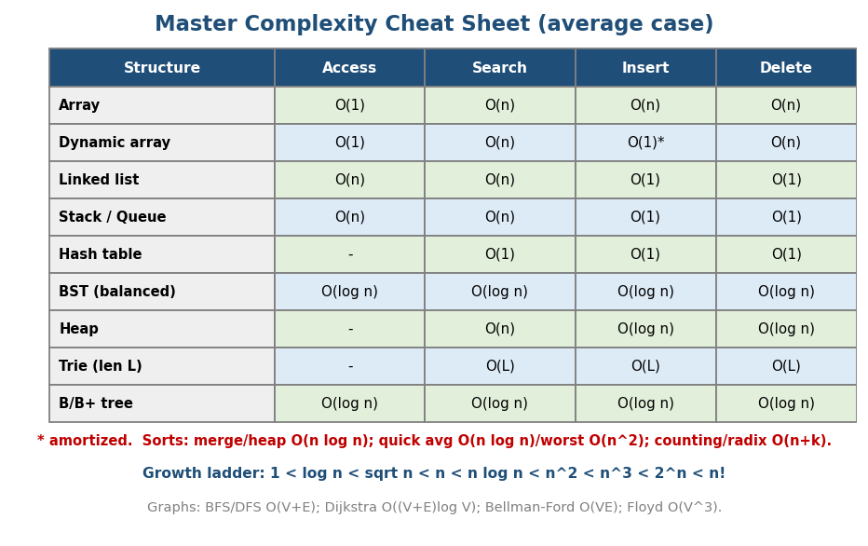
Master complexity cheat sheet: data-structure operations + sorts + graph algorithms + the growth ladder.
Structure | Access | Search | Insert | Delete
Array | O(1) | O(n) | O(n) | O(n)
Dynamic array | O(1) | O(n) | O(1)* | O(n)
Linked list | O(n) | O(n) | O(1) | O(1)
Stack / Queue | O(n) | O(n) | O(1) | O(1)
Hash table | — | O(1) | O(1) | O(1)
Balanced BST | O(log n) | O(log n) | O(log n) | O(log n)
Heap | — | O(n) | O(log n) | O(log n)
Trie (len L) | — | O(L) | O(L) | O(L)
B / B+ tree | O(log n) | O(log n) | O(log n) | O(log n)
* amortized. Worst-case hash table = O(n).
Sorting: merge / heap O(n log n) (merge stable, O(n) space; heap in-place); quicksort avg O(n log n) / worst O(n²) (random pivot, in-place); insertion O(n²) (great for tiny/nearly-sorted); counting/radix O(n+k).
Graphs: BFS/DFS O(V+E) · Dijkstra O((V+E) log V) · Bellman-Ford O(VE) · Floyd-Warshall O(V³) · MST (Kruskal/Prim) O(E log E).
Growth ladder: 1 < log n < √n < n < n log n < n² < n³ < 2ⁿ < n!.

26.2 Topic Dependency Graph
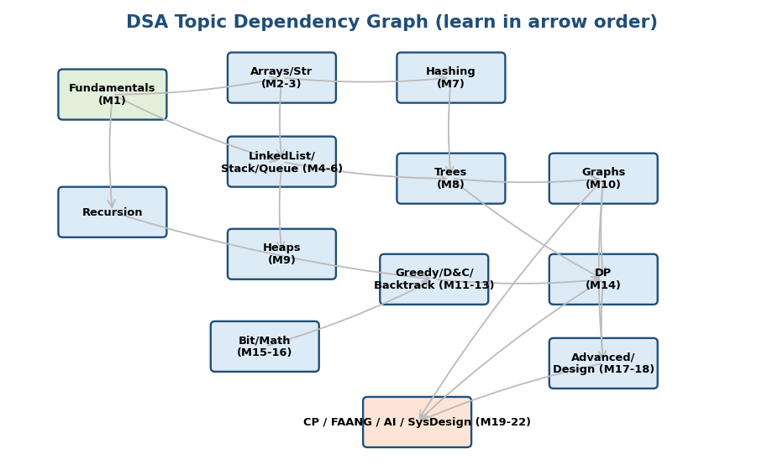
Dependency graph: Fundamentals → Arrays/Strings/Lists → Hashing/Trees/Heaps → Graphs → Greedy/D&C/Backtracking → DP → Advanced → Applications.
Learn in this order (each builds on the last): Fundamentals → Arrays/Strings → Linked List/Stack/Queue → Hashing → Trees → Heaps → Graphs → Recursion → Greedy/ D&C/Backtracking → DP → Bit/Math → Advanced/Design → Applications (CP / FAANG / AI / System Design).

26.3 Pattern Recognition — The Master Cheat Sheet
Signal in the problem | Technique (module)
sorted array / “min value that works” | binary search / BS-on-answer (M12)
contiguous subarray/substring + condition | sliding window / two pointers (M2)
pair summing to target / dedupe / freq | hashmap (M7)
“subarray sum = k” | prefix sum + hashmap (M2/M7)
range sum queries (static / with updates) | prefix sum / Fenwick / segment tree (M2/M8b)
top-K / K-th / “closest K” / stream median | heap (M6)
next greater/smaller, histogram | monotonic stack (M5)
sliding-window max/min | monotonic deque (M6)
all subsets / permutations / combinations | backtracking (M13)
count ways / min cost / can-reach (overlap) | DP (M14)
longest increasing/common subsequence | sequence DP (M14b)
pick items under capacity | knapsack DP (M14b)
shortest path / connectivity / grid / islands | BFS/DFS/Dijkstra/DSU (M10)
ordering with prerequisites | topological sort (M10a)
“are these connected / merge groups” | union-find (M10a)
intervals / meetings / merge | sort + sweep / greedy (M11)
prefix/autocomplete/pattern match | trie / KMP / Z (M3)
huge number / mod / combinatorics | math (M16)
“appears once/twice”, flags | bit manipulation (M15)
small n (≤20), “which subset” | bitmask DP (M14c)
This single table is the core interview skill. Print it. Internalise it.

26.4 The 6-Month Roadmap
(Full week-by-week in the Excel “6-Month Roadmap” tab. Summary:)
- Month 1–2 (Foundations): M1–M7 — fundamentals, arrays, strings, linked lists, stacks, queues, hashing. ~80 problems.
- Month 3 (Non-linear): M8–M10 — trees, heaps, graphs. ~70 problems.
- Month 4 (Paradigms): M11–M14 — greedy, D&C, backtracking, DP. ~80 problems (DP is the biggest).
- Month 5 (Breadth + polish): M15–M18 + Blind 75 / Neetcode 150. ~80 problems.
- Month 6 (Interview/exam mode): mocks, company tags, weak-area drills, system design / exam papers. Revision passes.
- Daily: 2–4 timed problems + flashcards; weekly: one mock + weakness review.

26.5 FAANG Interview Roadmap
- Patterns first (M1–M14) — recognise, don’t memorise.
- Neetcode 150 grouped by pattern (Module 20 order).
- Mock interviews (think-aloud, timed) — the communication rep.
- Company-tagged problems for your target (Module 20 table).
- Behavioral (esp. Amazon LP / STAR) + system design (senior).
- Week before: re-skim this Revision Kit + your weakness log; light practice; sleep.

26.6 SEBI / GATE Revision Roadmap
- GATE/ISRO: drill trace/compute — recurrences, graph algos, DP tables, hashing, B+ trees, sort comparisons, P/NP; solve past papers timed.
- SEBI/RBI IT (your target): breadth of conceptual MCQs — complexities, DS properties, DBMS indexing (B+ trees), OS, networks; pair these DSA notes with the DBMS notes. (Module 23 has the full mapping.)

26.7 Top-300 Problems Plan
The Excel “Top 300” tab seeds a pattern-wise list (Blind 75 / Neetcode core). Plan: breadth across all patterns first (one or two per pattern), then depth (mediums), then hards in your weak patterns. Mark Solved / Revisit; target ~60–70% green before interviews.

26.8 Spaced-Repetition Revision Schedule
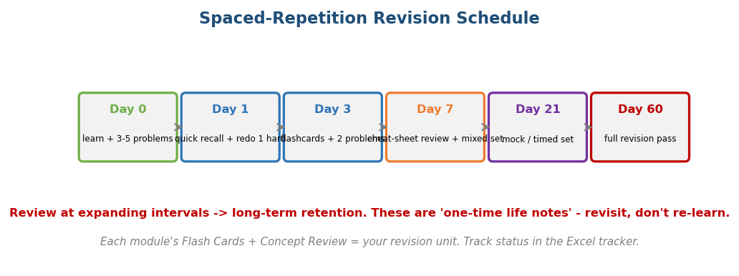
Spaced repetition: review at Day 0, 1, 3, 7, 21, 60 at expanding intervals for long-term retention.
Review each topic at expanding intervals (Day 0 → 1 → 3 → 7 → 21 → 60). Each module’s Flash Cards + Concept Review is one revision unit. These are “one-time life notes” — revisit, don’t re-learn.

26.9 Formula & Identity Sheet (quick recall)
- Master Theorem: T(n)=aT(n/b)+f(n) → compare f(n) vs n^(log_b a).
- Safe midpoint: lo + (hi−lo)/2. · Sum 1..n = n(n+1)/2. · 1+2+4+…+n ≈ 2n.
- nCr = n!/(r!(n−r)!); Pascal C(n,r)=C(n-1,r-1)+C(n-1,r); Catalan C(2n,n)/(n+1).
- GCD gcd(b, a%b); LCM a·b/gcd. · Fermat inverse a^(p−2) mod p.
- Bit: set x|(1<<i), clear x&~(1<<i), toggle x^(1<<i), lowest x&(-x), power-of-2 x&(x-1)==0.
- Binary tree height h → ≤ 2^(h+1)−1 nodes; balanced height O(log n).
- Two’s complement n-bit range: [-2^(n-1), 2^(n-1)-1].

Module 26 — Final Word
You now have an end-to-end course: 26 modules from bits to Big-O to DP to system design, each with intuition, visuals, brute→optimal pseudocode, complexity, edge cases, interview & exam perspectives, MCQs, problems, and flash cards — plus an Excel command-centre (syllabus, roadmap, Top-300, progress).
The method that wins: learn the pattern → solve timed & think-aloud → review & log weaknesses → revisit on a schedule. Breadth of patterns first, then depth.
Consistency beats intensity. A few quality reps daily, revisited on a schedule, turns these one-time notes into permanent skill. All the best — go get that offer. 🚀

Module 26 — Flash Cards (the meta-set)
- Q: Learn order? A: Fundamentals → Arrays → Lists → Hash → Trees → Heaps → Graphs → Greedy/D&C/Backtrack → DP → Advanced → Apps.
- Q: Core interview skill? A: pattern recognition (the §26.3 table).
- Q: Practice method? A: timed + think-aloud + weakness log + spaced revision.
- Q: Breadth or depth first? A: breadth across patterns, then depth.
- Q: Worst-case hash table? A: O(n). Build-heap? A: O(n).
End of Module 26 — and the end of the course. Revisit, practice, and win.

