Module 12 — Modern Networking: SDN, CDN & Cloud
  - Computer Networks Mastery: SEBI IT / RBI / NABARD / GATE / C-DAC / Interview / Backend — In-Depth Notes (with visuals)
Prepared for nidhi.sharma@forensiccybertech.com
2026
Table of Contents

Module 12 — Modern Networking: SDN, CDN & Cloud
Where this module sits. Modules 1–11 covered the classic protocol stack. But the Internet you use today is shaped by a few modern ideas layered on top: SDN (software-defined networking), CDNs and load balancing (how services scale to billions), cloud/virtual networks, and new transport like QUIC/HTTP-3. These tie the theory to how real systems are built — high value for interviews and backend roles, and increasingly appearing in exams.
Importance ratings (out of 5):
Exam / Use | SEBI IT | RBI IT | GATE CS | Interview | Backend
This module | ★★ | ★★ | ★★ | ★★★★ | ★★★★★
Most-asked concepts: SDN (control vs data plane, controller, OpenFlow); CDN (edge caching, why latency); load balancing (L4 vs L7, algorithms); NAT/VPC/cloud networking; QUIC / HTTP-3; network virtualization (overlays, VXLAN); anycast.

12.1 Software-Defined Networking (SDN)
Traditionally every router/switch runs both the control logic (deciding routes) and the forwarding (moving packets). SDN separates them:
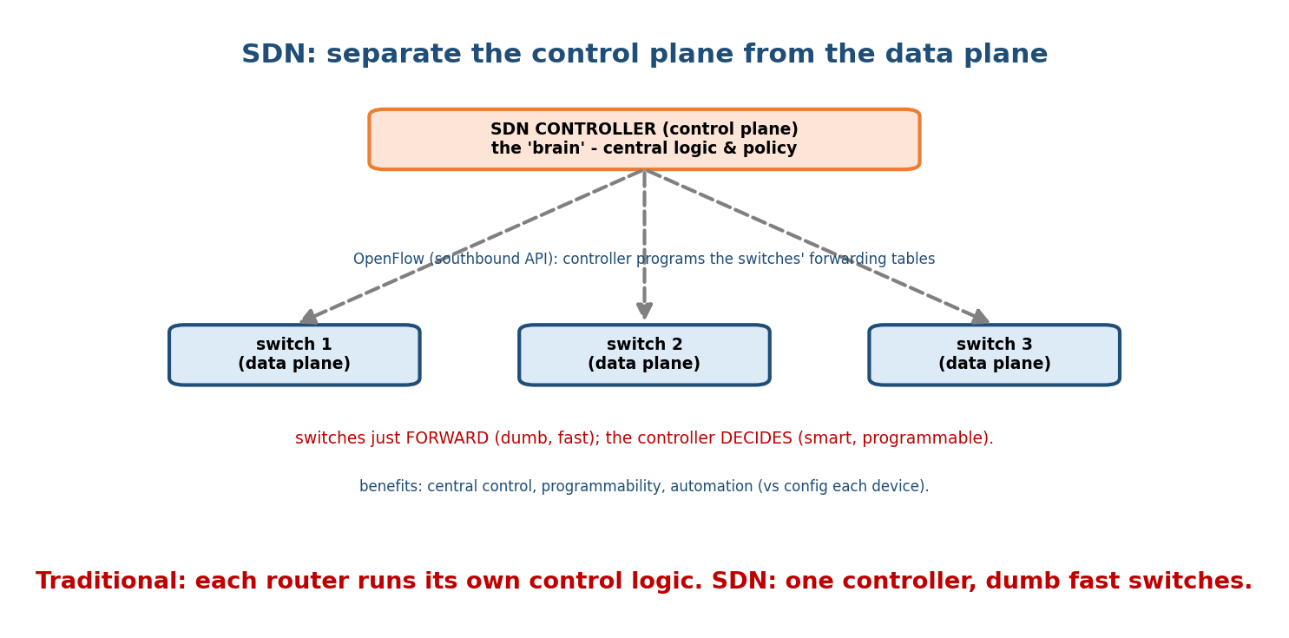
SDN separates the control plane (a central programmable controller) from the data plane (dumb, fast switches), programmed via a southbound API like OpenFlow.
- Control plane → a central SDN controller (the “brain”): programmable, holds the global view and policy.
- Data plane → dumb, fast switches: they just forward, following tables the controller installs (via a southbound API like OpenFlow).
- Northbound API: apps/orchestrators tell the controller what they want.
Benefits: central control, programmability/automation, faster changes, vendor independence. NFV (Network Function Virtualization) is the cousin: run firewalls/ load-balancers as software on commodity servers instead of dedicated boxes.
Memory hook: SDN = “smart central brain + dumb fast switches.” Decouple the decision (control plane) from the forwarding (data plane).

MCQs
- SDN separates which two planes? → control and data.
- Protocol the controller uses to program switches? → OpenFlow (southbound).
- Running network functions as software = ? → NFV.

12.2 CDN & Anycast — Beating Latency
Latency has a hard floor (speed of light), so you can’t make a far server fast — you move the content closer. A CDN (Content Delivery Network) caches static content at edge servers (PoPs) around the world.
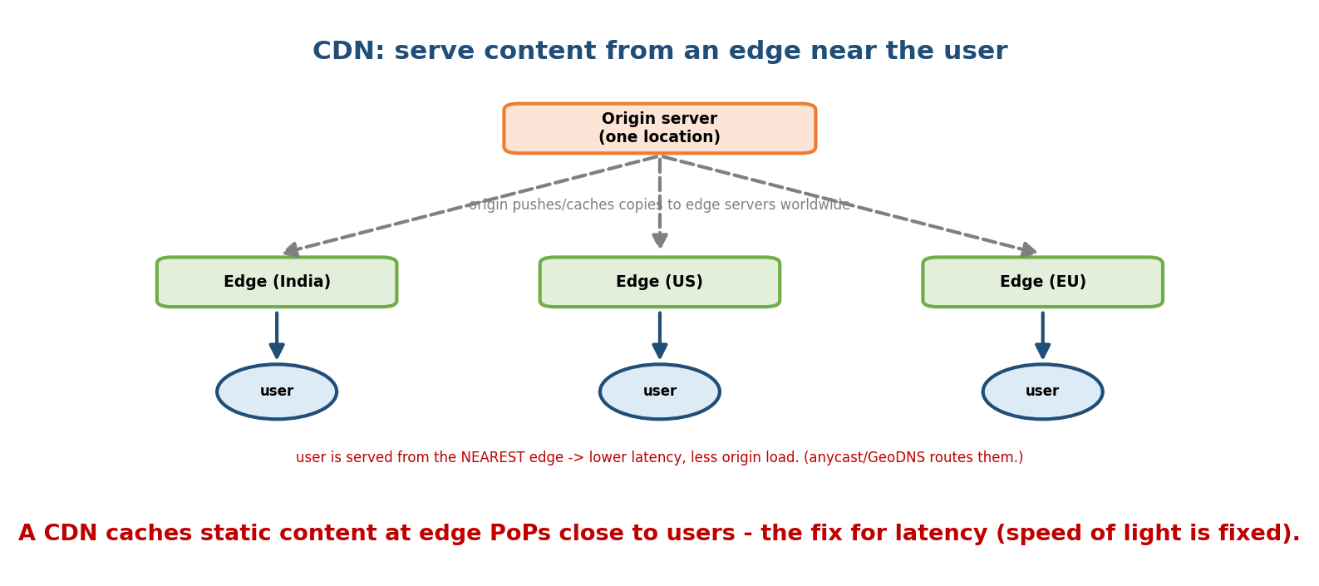
A CDN caches copies at edge PoPs worldwide; each user is served from the nearest edge, cutting latency and offloading the origin.
- Users are routed to the nearest edge via anycast or GeoDNS.
- Benefits: lower latency, less origin load, DDoS absorption, higher availability. Examples: Cloudflare, Akamai, CloudFront.
Memory hook: you can’t beat the speed of light — so cache the content next door. CDN = the Internet’s local warehouses.

MCQs
- A CDN reduces latency by? → serving from an edge near the user.
- How are users sent to the nearest edge? → anycast / GeoDNS.
- A CDN also helps against? → DDoS and origin load.

12.3 Load Balancing
A load balancer (LB) spreads incoming requests across many backend servers for scale and availability.
- L4 (transport) LB: routes by IP + port (fast, protocol-agnostic; e.g. AWS NLB, LVS). Doesn’t see the HTTP content.
- L7 (application) LB: routes by HTTP content (URL path, host, cookies) — enables smart routing, TLS termination, caching (e.g. Nginx, HAProxy, AWS ALB).
- Algorithms: round-robin, least-connections, weighted, IP-hash (sticky sessions).
- Health checks remove dead servers; this is how services stay up.
Memory hook: L4 = route by IP:port (fast, blind); L7 = route by URL/headers (smart, HTTP-aware).

MCQs
- L4 vs L7 load balancer routes by? → IP:port vs HTTP content (URL/headers).
- Which LB can do TLS termination & path routing? → L7.
- What removes a failed backend from rotation? → health checks.

12.4 Cloud & Virtual Networking
Cloud networking recreates all the classic concepts in software:
- VPC (Virtual Private Cloud): your own isolated network in the cloud — a CIDR block (M5) split into subnets (public/private) per availability zone.
- Overlays / tunnelling: VXLAN, GRE, and SDN build virtual networks on top of the physical one (multi-tenant isolation).
- Security groups / NACLs = cloud firewalls (M10). NAT gateways, elastic IPs, private links, and DNS-based service discovery wire it together.
Memory hook: the cloud is your networking course, virtualized — VPC = your network, subnets = M5, security groups = firewalls, overlays = SDN tunnels.

MCQs
- Your isolated cloud network defined by a CIDR block? → a VPC.
- Cloud firewall at the instance level? → security group.
- Tech that builds virtual L2 networks over L3? → VXLAN (overlay).

12.5 Modern Transport — QUIC & HTTP/3
QUIC is a transport built on UDP (in user space) that powers HTTP/3:
- Faster setup: combines transport + TLS handshake → 0-/1-RTT connections.
- No head-of-line blocking: independent streams (TCP would stall all streams on one lost packet).
- Connection migration: survives an IP change (Wi-Fi → cellular) via a connection ID.
This is why big providers moved to HTTP/3 — lower latency, better on lossy/mobile links.

MCQs
- QUIC runs over? → UDP (user space).
- HTTP version over QUIC? → HTTP/3.
- QUIC’s advantage over TCP for many streams? → no head-of-line blocking.

12.6 Real-World & Backend Perspectives
- This is the day-to-day of backend/SRE: DNS → CDN → L7 load balancer → API gateway → services (M13). SDN/overlays run inside every cloud; QUIC/HTTP-3 is default for Google/Meta/Cloudflare.
- Anycast + CDN + BGP (M6) is how content gets to you fast and survives outages.
- Observability (latency, p99, retries) is how you actually operate all this.

12.7 Tradeoffs, Common Mistakes, Edge Cases
- Mistake: thinking a CDN speeds up dynamic/personalised content — it mainly caches static assets (though edge compute is changing this).
- Mistake: L4 can inspect URLs — no, only L7 sees HTTP content.
- Trap: SDN centralizes the control plane, not the forwarding — switches still forward at line rate.
- Edge case: QUIC over UDP can be blocked/throttled by some middleboxes → clients fall back to TCP/HTTP-2.

12.8 Exam, Interview & Coding Perspectives
- Exams: SDN control/data plane + OpenFlow, CDN purpose, L4 vs L7, QUIC/HTTP-3 basics.
- Interview (backend-heavy): “how would you scale a web service?” (CDN + LB + caching + horizontal scaling), “L4 vs L7 LB?”, “why HTTP/3?”, “what’s a VPC?”.

12.9 Concept Checks & MCQs (test yourself)
- SDN planes separated? → control vs data.
- Southbound protocol? → OpenFlow.
- CDN reduces latency how? → edge caching near users.
- L4 vs L7 LB? → IP:port vs HTTP content.
- Cloud isolated network? → VPC (a CIDR block).
- QUIC transport & HTTP version? → UDP, HTTP/3.
- QUIC benefit over TCP? → no head-of-line blocking + faster handshake.
- NFV means? → network functions as software.
- Route users to nearest edge via? → anycast / GeoDNS.
- Overlay tech for virtual networks? → VXLAN.

12.10 One-Page Revision Sheet
SDN: separate CONTROL plane (central programmable CONTROLLER = brain) from DATA plane (dumb fast switches).
southbound=OpenFlow (controller -> switches); northbound=apps -> controller. NFV = net functions as software.
CDN: cache STATIC content at EDGE PoPs near users (anycast/GeoDNS route to nearest). cuts latency + origin load + DDoS.
(latency floor = speed of light -> move content closer.)
LOAD BALANCER: L4 = route by IP:port (fast, blind) | L7 = route by URL/headers (smart, TLS term, path routing).
algos: round-robin, least-conn, weighted, IP-hash(sticky). health checks remove dead servers.
CLOUD NET: VPC = your CIDR network -> subnets (public/private). security groups/NACL = firewalls. VXLAN/GRE overlays. NAT gw.
QUIC/HTTP-3: transport over UDP (user space). 0/1-RTT handshake (transport+TLS), independent STREAMS (no HoL blocking),
connection migration (Wi-Fi<->cellular). = HTTP/3.

Flash cards
Front | Back
SDN planes | control (controller) vs data (switches)
SDN southbound API | OpenFlow
CDN benefit | edge caching → low latency
Route to nearest edge | anycast / GeoDNS
L4 vs L7 LB | IP:port vs HTTP content
VPC | cloud CIDR network
QUIC transport | UDP (user space)
HTTP/3 over | QUIC
QUIC vs TCP win | no head-of-line blocking
VXLAN | network overlay

Spaced repetition
- 24-hour: SDN control/data split; L4 vs L7; QUIC over UDP.
- 7-day: CDN + anycast; VPC/security groups; HTTP/3 benefits.
- 30-day: design “scale a web app” using CDN + LB + cache + VPC — without notes.

12.11 Summary
Modern networking layers powerful ideas on the classic stack. SDN splits the control plane (a central programmable controller, via OpenFlow) from the data plane (dumb fast switches), enabling automation; NFV virtualizes network functions. CDNs cache static content at edge PoPs, routing users to the nearest via anycast/GeoDNS to beat the speed-of-light latency floor. Load balancers (L4 by IP:port, L7 by HTTP content) scale services with health checks. Cloud networking re-implements the course in software (VPC, subnets, security groups, VXLAN overlays). And QUIC/HTTP-3 (over UDP) delivers faster handshakes, stream independence, and connection migration.
Next, Module 13 — The Backend/Distributed-Systems Perspective shows exactly how all these networking pieces assemble into a real, scalable system.
You have mastered this module when you can: explain SDN’s control/data split and OpenFlow; say why CDNs cut latency and how users reach the nearest edge; contrast L4 vs L7 load balancing; describe a VPC; and list QUIC/HTTP-3’s advantages — all without notes.

