Module 13 — The Backend & Distributed-Systems Networking Perspective
  - Computer Networks Mastery: SEBI IT / RBI / NABARD / GATE / C-DAC / Interview / Backend — In-Depth Notes (with visuals)
Prepared for nidhi.sharma@forensiccybertech.com
2026
Table of Contents

Module 13 — The Backend & Distributed-Systems Networking Perspective
Where this module sits. Everything in Modules 1–12 was “networking theory.” This module shows how it all assembles into a real backend system — the request path, service-to-service communication, and the distributed-systems realities (latency, partial failure, consistency) that networking forces on us. It’s the bridge from CN to System Design, and it’s where interviewers spend most of their time.
Importance ratings (out of 5):
Exam / Use | SEBI IT | RBI IT | GATE CS | Interview | Backend
This module | ★★ | ★★ | ★★ | ★★★★★ | ★★★★★
Most-asked concepts: the request path (DNS → CDN → LB → gateway → services); REST vs gRPC/RPC; synchronous vs async (message queues); the fallacies of distributed computing; latency numbers; idempotency, retries, timeouts, circuit breakers; caching; CAP (from DBMS) applied to networked services.

13.1 The Anatomy of a Request
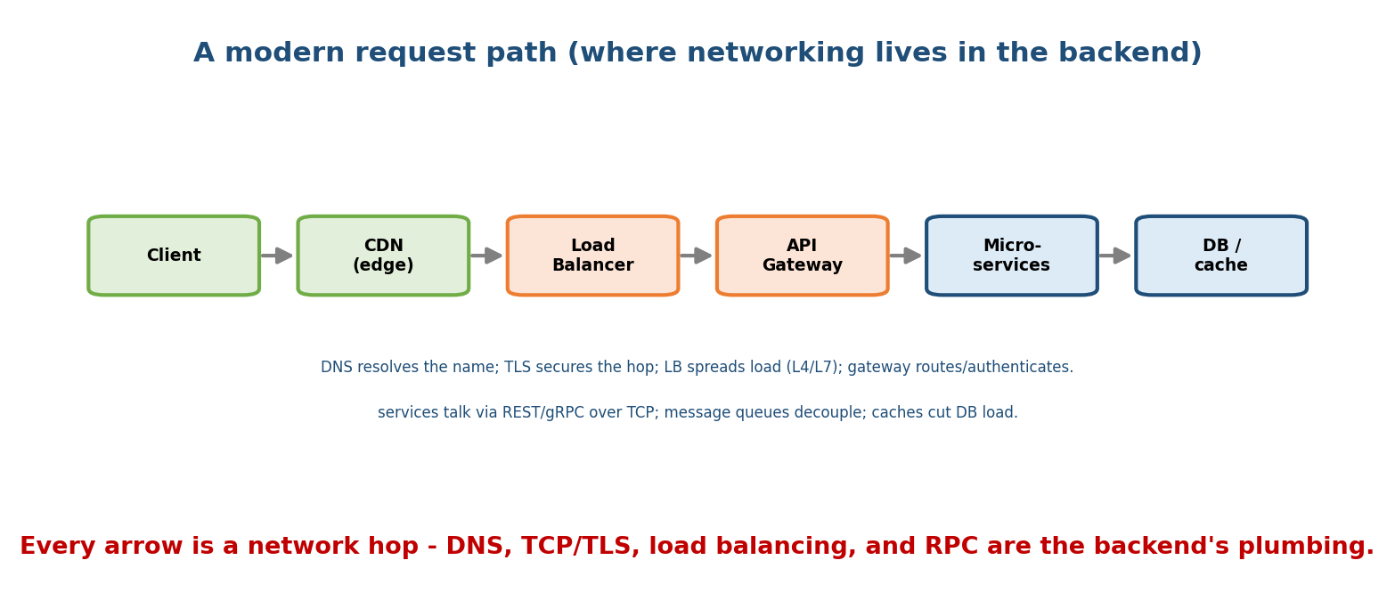
A modern request flows client → CDN → load balancer → API gateway → microservices → DB/cache; every arrow is a network hop secured and balanced along the way.
A typical request path:
- DNS resolves the domain (M9) → IP (often a CDN/LB anycast address).
- CDN (M12) serves static assets from the edge; dynamic requests continue.
- Load balancer (M12) spreads traffic across servers (L4/L7), terminates TLS (M10).
- API gateway authenticates, rate-limits, and routes to the right service.
- Microservices talk to each other (REST/gRPC over TCP) and to DB/caches.
Every arrow is a network hop — subject to latency, loss, and failure. Good backends are designed around that fact.

MCQs
- First step of almost every request? → DNS resolution.
- Where is TLS usually terminated? → the load balancer / gateway.
- What authenticates & rate-limits at the edge of your services? → the API gateway.

13.2 Service-to-Service Communication
- REST (HTTP/JSON): simple, human-readable, ubiquitous; stateless; good for public APIs.
- gRPC (HTTP/2 + Protocol Buffers): binary, fast, strongly-typed, streaming; great for internal microservice calls.
- RPC in general: make a remote call look like a local function (but it isn’t — it can fail, time out, and be slow).
- Message queues (async): Kafka, RabbitMQ, SQS decouple producer and consumer — the producer doesn’t wait; work is buffered and processed later. Enables resilience and spikes-handling.
Synchronous (request-response, caller waits) vs asynchronous (fire-and-forget / event-driven) is a core design axis.
Memory hook: REST = readable & universal; gRPC = fast & typed (internal); queues = decouple & absorb spikes. Sync waits; async doesn’t.

MCQs
- Binary, typed, HTTP/2-based internal RPC? → gRPC.
- What decouples producer from consumer? → a message queue (async).
- REST typically uses which format/protocol? → JSON over HTTP.

13.3 The Fallacies of Distributed Computing (must-know)
Networked systems fail when designers assume the network is perfect. The classic 8 fallacies (assume the opposite of each):
- The network is reliable. 2. Latency is zero. 3. Bandwidth is infinite.
- The network is secure. 5. Topology doesn’t change. 6. There is one admin.
- Transport cost is zero. 8. The network is homogeneous.
Reality: packets drop, latency is real and variable, links change, and security is not free. Design for partial failure.
Memory hook: “the network is NOT reliable, fast, infinite, secure, or free.” Every distributed bug traces back to assuming one of these.

MCQs
- First fallacy of distributed computing? → “the network is reliable.”
- What should you design for? → partial failure (assume things fail).

13.4 Reliability Patterns (how backends survive the network)
- Timeouts: never wait forever for a remote call.
- Retries with backoff + jitter: retry transient failures, but back off to avoid overload (thundering herd).
- Idempotency: make a retried operation safe to repeat (idempotency keys) — because the network may deliver a request twice.
- Circuit breaker: stop calling a failing service to let it recover (fail fast).
- Bulkheads / rate limiting / load shedding: contain failures and shed excess load (token bucket, M8).
- Health checks + graceful degradation: remove sick instances; serve a reduced experience rather than none.
Memory hook: timeout → retry (with backoff+jitter) → but be idempotent → and trip a circuit breaker if it keeps failing.

MCQs
- Safe-to-repeat operation property? → idempotency.
- Pattern that stops calling a failing service? → circuit breaker.
- Why add jitter to retries? → avoid a synchronized thundering herd.

13.5 Latency Numbers & Caching
Rough latency ladder (order-of-magnitude, “numbers every engineer should know”):
L1/L2 cache ~1 ns
main memory (RAM) ~100 ns
SSD read ~100 us (microseconds)
network same DC ~0.5 ms
disk (HDD) seek ~10 ms
network cross-continent ~100+ ms (speed of light!)
Because remote > local by orders of magnitude, backends cache aggressively: browser cache → CDN → in-memory cache (Redis/Memcached) → DB. Cache strategies: cache-aside, write-through, write-back; watch for invalidation and stampedes.
Memory hook: RAM ~100 ns, same-DC network ~0.5 ms, cross-continent ~100 ms. The network is the slow part → cache and keep data close (CDN, M12).

MCQs
- Same-datacenter round trip is roughly? → ~0.5 ms (vs ~100 ns RAM).
- Cross-continent latency floor is set by? → the speed of light.
- Common in-memory cache? → Redis / Memcached.

13.6 Distributed Data & CAP (networking meets consistency)
The network’s unreliability forces trade-offs on distributed data (from DBMS, applied here):
- CAP theorem: during a network partition (P), you must choose Consistency or Availability — you can’t have both. CP (refuse stale reads) vs AP (stay up, maybe stale).
- Consistency models: strong vs eventual consistency (many web systems choose AP
  - eventual for availability).
- Consensus (Raft/Paxos) keeps replicas agreeing despite message loss/reordering — expensive network coordination.
Memory hook: a partition is a network failure — CAP says pick C or A when it happens. Money → CP; feeds/likes → AP + eventual.

MCQs
- During a partition, CAP forces a choice between? → Consistency and Availability.
- “Stay up, maybe stale” is? → AP (availability + eventual consistency).
- Algorithm to agree despite unreliable messages? → consensus (Raft/Paxos).

13.7 Real-World & Backend / Interview Perspectives
- This module is the systems-design interview: “design a URL shortener / news feed / chat” all reduce to DNS + CDN + LB + gateway + services + cache + queue + DB, wired over an unreliable network with timeouts/retries/idempotency.
- Know the latency ladder and CAP cold; be able to justify sync vs async and REST vs gRPC.
- Observability (metrics/tracing/logs) and p99 latency are how you run it.

13.8 Tradeoffs, Common Mistakes, Edge Cases
- Mistake: treating a remote call like a local one (RPC hides the network, but not its failures) — always set timeouts.
- Mistake: retrying non-idempotent operations → duplicates (double charge). Add idempotency keys.
- Trap: you can’t have C and A during a partition (CAP) — pick per use case.
- Edge case: aggressive retries without backoff cause a retry storm that worsens an outage.

13.9 Concept Checks & MCQs (test yourself)
- Typical request path? → DNS → CDN → LB → gateway → services → DB/cache.
- gRPC is built on? → HTTP/2 + Protocol Buffers.
- Async decoupling tool? → message queue (Kafka/RabbitMQ/SQS).
- Name three fallacies of distributed computing. → network reliable / latency zero / bandwidth infinite (any).
- Retry safety property? → idempotency.
- Pattern to fail fast on a broken dependency? → circuit breaker.
- RAM vs same-DC network latency? → ~100 ns vs ~0.5 ms.
- CAP choice during a partition? → C or A.
- Cache patterns? → cache-aside, write-through, write-back.
- Why jitter in retries? → prevent thundering herd.

13.10 One-Page Revision Sheet
REQUEST PATH: DNS -> CDN(edge, static) -> LOAD BALANCER(L4/L7, TLS term) -> API GATEWAY(auth/rate-limit/route)
-> MICROSERVICES (REST/gRPC over TCP) -> DB / CACHE. every arrow = a network hop.
COMMS: REST(HTTP/JSON, readable, public) | gRPC(HTTP2+protobuf, fast/typed, internal) | RPC(looks local, isn't).
SYNC(caller waits) vs ASYNC(message queue: Kafka/RabbitMQ/SQS -> decouple, absorb spikes).
8 FALLACIES (assume the OPPOSITE): reliable, zero latency, infinite bw, secure, fixed topology,
one admin, zero transport cost, homogeneous. => DESIGN FOR PARTIAL FAILURE.
RELIABILITY PATTERNS: timeout -> retry(backoff+JITTER) -> IDEMPOTENCY(safe repeat) -> CIRCUIT BREAKER(fail fast)
-> bulkhead / rate-limit(token bucket) / load-shed / health checks / graceful degradation.
LATENCY LADDER: RAM ~100ns | SSD ~100us | same-DC net ~0.5ms | HDD seek ~10ms | cross-continent ~100ms(light).
CACHE: browser -> CDN -> Redis/Memcached -> DB. strategies: cache-aside / write-through / write-back.
CAP: partition(P=network failure) -> choose C (consistent, refuse stale) or A (available, eventual). consensus=Raft/Paxos.

Flash cards
Front | Back
Request path | DNS → CDN → LB → gateway → services → DB/cache
REST vs gRPC | HTTP/JSON readable vs HTTP2/protobuf fast typed
Async decoupling | message queue (Kafka/RabbitMQ)
1st fallacy | network is reliable (it isn’t)
Safe-to-repeat op | idempotency
Fail-fast pattern | circuit breaker
Same-DC vs cross-continent | ~0.5 ms vs ~100 ms
CAP under partition | pick C or A
Consensus algorithms | Raft / Paxos
Retry jitter reason | avoid thundering herd

Spaced repetition
- 24-hour: draw the request path; list the reliability patterns (timeout→…→circuit breaker).
- 7-day: 8 fallacies; latency ladder; CAP CP vs AP.
- 30-day: design a scalable service end-to-end citing each networking piece — without notes.

13.11 Summary
A real backend is the whole CN course assembled: a request flows DNS → CDN → load balancer → API gateway → microservices → DB/cache, every hop crossing an unreliable network. Services talk via REST (readable) or gRPC (fast/typed), or decouple via async message queues. Because the fallacies of distributed computing are real, backends design for partial failure with timeouts, retries (backoff + jitter), idempotency, and circuit breakers, and fight latency with caching (the latency ladder: RAM ~100 ns vs cross-continent ~100 ms). Finally, the network’s partitions force CAP trade-offs (C or A) and consensus for agreement.
Next, Module 14 — AI & Data-Center Networking zooms into the network that trains and serves modern AI: spine-leaf fabrics, RDMA, GPU interconnects, and all-reduce.
You have mastered this module when you can: trace a request through the backend path; choose REST vs gRPC vs a queue; recite the fallacies and the reliability patterns that answer them; quote the latency ladder; and apply CAP to a networked service — all without notes.

