Module 14 — AI & Data-Center Networking
  - Computer Networks Mastery: SEBI IT / RBI / NABARD / GATE / C-DAC / Interview / Backend — In-Depth Notes (with visuals)
Prepared for nidhi.sharma@forensiccybertech.com
2026
Table of Contents

Module 14 — AI & Data-Center Networking
Where this module sits. Modern AI is a networking problem as much as a compute problem. Training a large model spreads work across thousands of GPUs that must exchange gradients every step — so the network fabric often decides how fast (and how big) you can train. This module covers the data-center network (spine-leaf), the fast transports (RDMA/RoCE/InfiniBand), GPU interconnects (NVLink), and collective communication (all-reduce). It ties the AI-infra story to everything you’ve learned.
Importance ratings (out of 5):
Exam / Use | SEBI IT | RBI IT | GATE CS | Interview | Backend / AI
This module | ★ | ★ | ★ | ★★★ | ★★★★★
Most-asked concepts (interview / AI-infra): spine-leaf (Clos) topology & east-west traffic; RDMA / RoCE / InfiniBand (kernel-bypass, why); GPU interconnect (NVLink/NVSwitch); collective ops (all-reduce) for distributed training; network as the training bottleneck; congestion control in DCs (ECN/PFC).

14.1 Why Data-Center Networking Is Different
- East-west dominates: traditional networks optimised north-south (user ↔ server) traffic. AI/cloud DCs are dominated by east-west (server ↔ server) traffic — GPUs constantly exchanging data.
- Ultra-low latency & high bandwidth are required (microseconds, 100s of Gbps).
- Lossless matters: dropped packets stall collective operations, so DCs use congestion control that avoids loss (ECN, PFC).
Memory hook: the Internet is north-south (users↔servers); an AI data center is east-west (GPUs↔GPUs) — that flips the whole network design.

MCQs
- Dominant traffic direction in an AI DC? → east-west (server↔server).
- Two requirements DC networks emphasise? → low latency + high bandwidth (and lossless).
- Why avoid packet loss in AI DCs? → drops stall collective ops (all GPUs wait).

14.2 Spine-Leaf (Clos) Topology
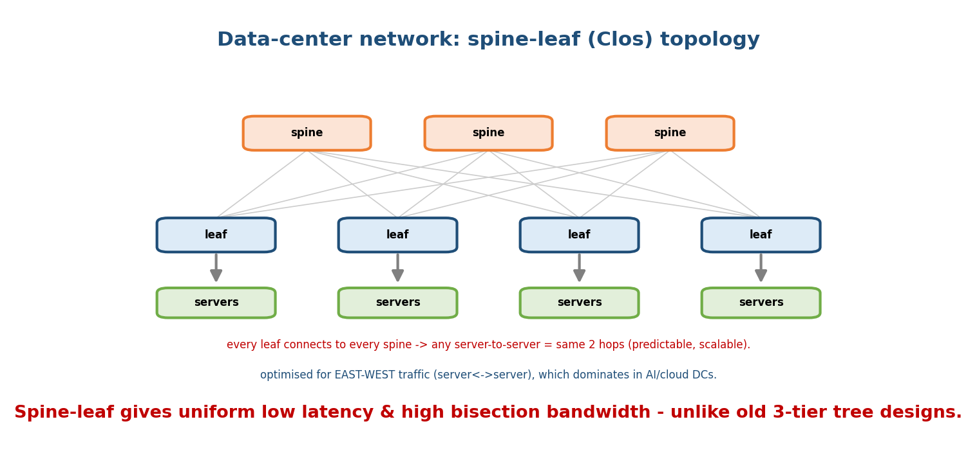
Spine-leaf: every leaf switch connects to every spine, so any server-to-server path is the same two hops — uniform low latency and high bisection bandwidth.
- Every leaf connects to every spine. Any server-to-server path is leaf → spine → leaf — the same 2 hops, giving predictable latency and high bisection bandwidth.
- Replaces the old 3-tier tree (core/aggregation/access), which bottlenecked east-west traffic and had uneven path lengths.
- Scales by adding spines (more bandwidth) or leaves (more servers).
Memory hook: spine-leaf = “everyone is 2 hops from everyone” — flat, uniform, and easy to scale, unlike the tall old tree.

MCQs
- Server-to-server hop count in spine-leaf? → 2 (leaf → spine → leaf).
- What does spine-leaf maximise? → bisection bandwidth (uniform, non-blocking).
- Add bandwidth by adding? → spines (servers by adding leaves).

14.3 Fast Transports — RDMA, RoCE, InfiniBand
Normal TCP/IP copies data through the kernel and CPU — too slow for GPU-scale traffic. RDMA (Remote Direct Memory Access) lets one machine read/write another’s memory directly, bypassing the kernel and CPU (zero-copy, ultra-low latency).
- InfiniBand: a dedicated high-speed interconnect with native RDMA (common in HPC/AI supercomputers).
- RoCE (RDMA over Converged Ethernet): RDMA on standard Ethernet (needs lossless config — PFC/ECN).
- Benefit: microsecond latency and CPU offload, essential for collective ops.
Memory hook: RDMA = “write straight into the other machine’s RAM, skip the OS kernel.” InfiniBand = dedicated fabric; RoCE = RDMA on Ethernet.

MCQs
- What does RDMA bypass? → the kernel/CPU (zero-copy, direct memory).
- RDMA on standard Ethernet is called? → RoCE.
- Dedicated RDMA fabric common in AI clusters? → InfiniBand.

14.4 GPU Interconnects (inside & across nodes)
- Within a server: NVLink / NVSwitch connect GPUs directly at TB/s, far faster than PCIe — so 8 GPUs act almost like one.
- Across servers: InfiniBand / RoCE NICs (often GPUDirect RDMA — NIC reads GPU memory directly, skipping the CPU).
- Hierarchy of speeds: GPU memory (HBM) > NVLink (intra-node) > InfiniBand/RoCE (inter-node) > general Ethernet. Training performance depends on keeping data in the fastest tier possible.

MCQs
- Intra-server GPU-to-GPU link? → NVLink / NVSwitch.
- Inter-server GPU transport? → InfiniBand / RoCE (GPUDirect RDMA).
- Fastest memory tier for a GPU? → its own HBM.

14.5 Collective Communication — All-Reduce
Data-parallel training replicates the model on every GPU; each computes gradients on its data shard, then all GPUs must average their gradients every step — a collective operation called all-reduce.
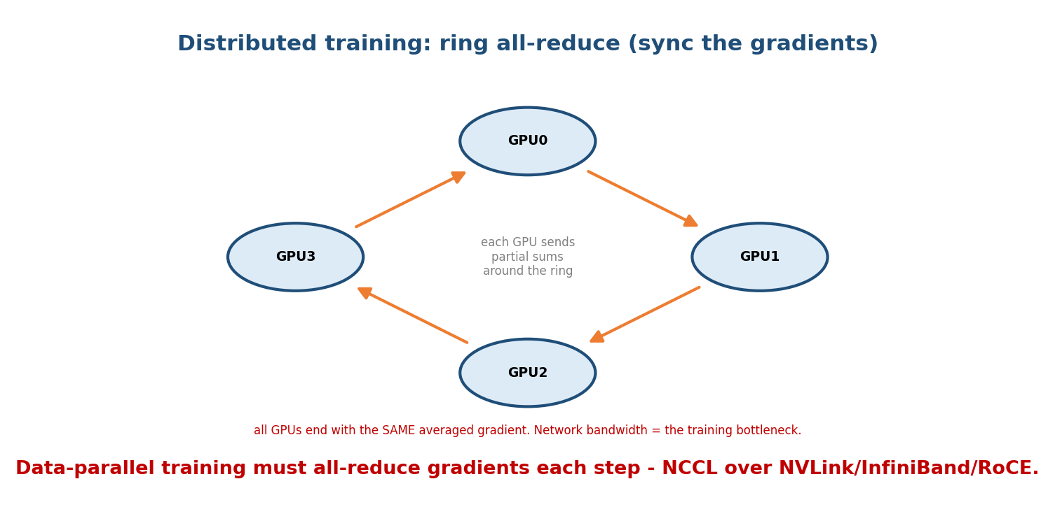
Ring all-reduce: each GPU passes partial sums around a ring until every GPU holds the same averaged gradient; the interconnect bandwidth caps how fast this completes.
- Ring all-reduce (used by NCCL): GPUs form a ring and pass partial sums around, so bandwidth use is optimal and independent of GPU count.
- Other collectives: broadcast, all-gather, reduce-scatter.
- This is the bottleneck: as models/clusters grow, network bandwidth for all-reduce — not raw GPU FLOPs — often limits training speed. Hence NVLink + InfiniBand + lossless fabrics.
Parallelism strategies (why the network is stressed): data parallelism (each GPU a data shard, all-reduce gradients), model/tensor parallelism (split a layer across GPUs), pipeline parallelism (split layers across GPUs). All require heavy inter-GPU communication.
Memory hook: training = compute a gradient, then all-reduce it across every GPU, every step. The faster the fabric, the faster (and bigger) you can train.

MCQs
- Op that averages gradients across GPUs? → all-reduce.
- Library implementing ring all-reduce? → NCCL.
- Common training bottleneck at scale? → network bandwidth (all-reduce), not FLOPs.

14.6 Serving & Inference Networking (brief)
- LLM inference is latency-sensitive: KV-cache memory and fast token streaming matter; requests are load-balanced across GPU servers (M12).
- Model/tensor parallel serving spreads a huge model across GPUs → inter-GPU communication on the critical path of every token.
- Edge/CDN + 5G (M11–M12) push inference closer to users for low latency.

MCQs
- What’s load-balanced across GPU servers for inference? → requests (M12 LB).
- Serving a model too big for one GPU needs? → model/tensor parallelism (inter-GPU comms).

14.7 Real-World & Interview Perspectives
- AI-infra interviews ask: “why InfiniBand/RDMA?”, “what’s all-reduce?”, “why spine-leaf?”, “what bottlenecks large-scale training?” — the answers are all here.
- The network is a first-class citizen of AI systems — cluster design (fabric, topology, lossless config) directly determines training throughput and cost.
- Ties to the OS notes’ AI module (GPU scheduling, CUDA, NCCL) — networking is the inter-node half of that story.

14.8 Tradeoffs, Common Mistakes, Edge Cases
- Mistake: assuming GPUs are the only bottleneck — at scale, the network (all-reduce bandwidth) often is.
- Mistake: using plain TCP for GPU traffic — too much CPU/kernel overhead; use RDMA.
- Trap: RoCE needs a lossless Ethernet (PFC/ECN) — drops devastate collectives.
- Edge case: north-south-optimised (3-tier) designs bottleneck AI’s east-west traffic → spine-leaf.

14.9 Concept Checks & MCQs (test yourself)
- Traffic direction dominating AI DCs? → east-west.
- Server-to-server hops in spine-leaf? → 2.
- What does RDMA bypass? → kernel/CPU (direct memory).
- RDMA on Ethernet? → RoCE; dedicated fabric? → InfiniBand.
- Intra-node GPU link? → NVLink/NVSwitch.
- Gradient-averaging collective? → all-reduce (NCCL, ring).
- Common large-scale training bottleneck? → network bandwidth.
- Three parallelism strategies? → data, model/tensor, pipeline.
- Why lossless fabric for AI? → drops stall collectives.
- Old topology that bottlenecks east-west? → 3-tier tree.

14.10 One-Page Revision Sheet
AI/DC NETWORKING: traffic is EAST-WEST (GPU<->GPU), needs ultra-low latency + high bw + LOSSLESS.
SPINE-LEAF (Clos): every leaf <-> every spine => any server-server = 2 hops (leaf-spine-leaf).
uniform latency, high BISECTION bandwidth. scale: +spines(bw) / +leaves(servers). replaces 3-tier tree.
FAST TRANSPORT: RDMA = read/write remote RAM directly, BYPASS kernel/CPU (zero-copy, microseconds).
InfiniBand = dedicated RDMA fabric ; RoCE = RDMA over (lossless) Ethernet (needs PFC/ECN).
GPU INTERCONNECT: intra-node NVLink/NVSwitch (TB/s) > PCIe ; inter-node InfiniBand/RoCE + GPUDirect RDMA.
speed tiers: HBM > NVLink > InfiniBand/RoCE > Ethernet.
COLLECTIVES: data-parallel training -> ALL-REDUCE gradients EVERY step (ring all-reduce, NCCL).
parallelism: DATA(shard data, all-reduce) | MODEL/TENSOR(split a layer) | PIPELINE(split layers).
BOTTLENECK at scale = network bandwidth (all-reduce), not GPU FLOPs.
INFERENCE: requests load-balanced across GPU servers; big models -> tensor-parallel (inter-GPU on token path).

Flash cards
Front | Back
AI DC traffic direction | east-west (GPU↔GPU)
Spine-leaf hop count | 2 (leaf→spine→leaf)
RDMA bypasses | kernel/CPU (direct memory)
RDMA on Ethernet / dedicated | RoCE / InfiniBand
Intra-node GPU link | NVLink / NVSwitch
Gradient sync op | all-reduce (NCCL ring)
Scale-training bottleneck | network bandwidth
Parallelism types | data / model-tensor / pipeline
Why lossless fabric | drops stall collectives
Replaces 3-tier tree | spine-leaf (Clos)

Spaced repetition
- 24-hour: east-west vs north-south; spine-leaf 2-hop; RDMA bypasses kernel.
- 7-day: InfiniBand vs RoCE; NVLink; ring all-reduce + NCCL.
- 30-day: explain why the network (not GPUs) bottlenecks large-scale training — without notes.

14.11 Summary
AI is a networking story: training spreads across thousands of GPUs that must all-reduce gradients every step, so the fabric often bounds performance. AI data centers are east-west dominated and use spine-leaf (Clos) topologies for uniform 2-hop paths and high bisection bandwidth. To move data fast they use RDMA (kernel-bypass, zero-copy) over InfiniBand or RoCE (lossless Ethernet), with NVLink/NVSwitch connecting GPUs inside a node. Collective operations — especially ring all-reduce (NCCL) — synchronise gradients, and at scale the network bandwidth, not GPU FLOPs, is the bottleneck. The same fabric serves latency-sensitive inference.
Next, Module 15 — Competitive Exams consolidates the whole subject into a topic × exam map, high-yield facts, and solved MCQs.
You have mastered this module when you can: explain east-west vs north-south; describe spine-leaf and its 2-hop property; say what RDMA bypasses and contrast InfiniBand vs RoCE; explain all-reduce and the three parallelism strategies; and state why the network bottlenecks large-scale AI training — all without notes.

