Module 1 — Introduction to Object-Oriented Programming
  - OOP with Python Mastery: FAANG Interviews / GATE / SEBI-RBI IT / Backend — In-Depth Notes (with visuals)
Prepared for nidhi.sharma@forensiccybertech.com
2026
Table of Contents

Module 1 — Introduction to Object-Oriented Programming
Why this module comes first. Before we write a single class, we must answer three questions that trip up almost everyone: What problem does OOP actually solve? Why did programmers invent it? And when should I NOT use it? If you skip this, you end up writing “Java-style” classes for everything — wrapping one function in a class, making getters for everything — which is cargo-cult OOP. This module builds the mental model from first principles so that every later feature (inheritance, polymorphism, dunder methods, metaclasses) feels like an obvious answer to a real problem, not a rule to memorise.
Importance ratings (out of 5):
Exam / Use | FAANG Interview | GATE CS | SEBI/RBI IT | Backend Dev | LLD Rounds
This module | ★★★★ | ★★★ | ★★★★ | ★★★★ | ★★★★★
Most-asked concepts: the four pillars (Encapsulation, Abstraction, Inheritance, Polymorphism) and one-line definitions of each; class vs object; procedural vs OOP (with a code example); why OOP (the four benefits); “is everything in Python an object?”; message passing (obj.method()); and the classic “model this real-world thing as a class” design opener.
What you must be able to do after this module: explain in plain English what an object is (identity + state + behaviour), rewrite a small procedural program in OOP style and justify why, name and define the four pillars with a concrete example each, and decide out loud whether a given problem even deserves classes.

1.1 What Is a “Paradigm”? (setting the stage)
A programming paradigm is a style of structuring code — a set of ideas about how to organise data and instructions. It is not a language; one language (like Python) can support several paradigms.
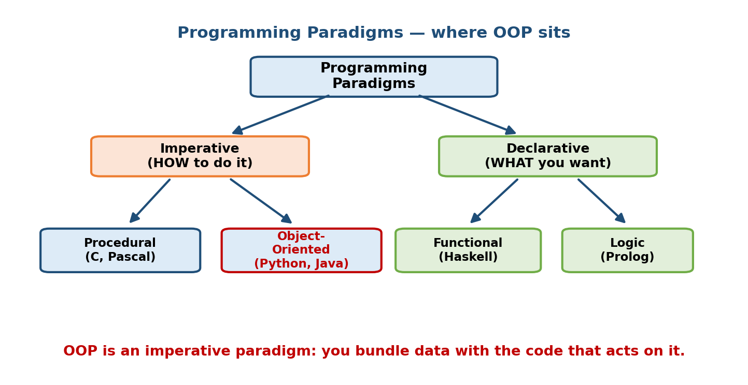
A tree of programming paradigms: imperative splits into procedural and object-oriented; declarative into functional and logic. OOP is an imperative style.
The two big families:
- Imperative — you write how to do something, step by step, changing state as you go. Sub-styles: procedural (organise around procedures/functions) and object-oriented (organise around objects).
- Declarative — you describe what you want and let the system figure out how. Sub-styles: functional (Haskell, and Python’s map/filter) and logic (Prolog).
Key point: OOP is a way to organise an imperative program around objects — bundles of data and the operations on that data. Python is multi-paradigm: you can write procedural scripts, functional pipelines, and full OOP — often in the same file.

1.2 The Problem OOP Solves (first principles)
Let’s feel the problem before we name the solution. Imagine a tiny banking program written procedurally (functions + loose data):
# Procedural style — data and functions live apart
balance = 1000 # just a global number
def deposit(amount):
global balance
balance += amount
def withdraw(amount):
global balance
balance -= amount # BUG WAITING TO HAPPEN: no overdraft check enforced
deposit(500)
balance = -99999 # <-- ANYONE can corrupt the data directly. Nothing stops this.
Two accounts? Now you need balance1, balance2, or a dict, and every function must be told which account it operates on. Ten accounts, each with an owner, a currency, and an interest rate? The loose variables explode and nothing guarantees the rules (no negative balance) are ever applied. The data and the rules that protect it are not glued together.
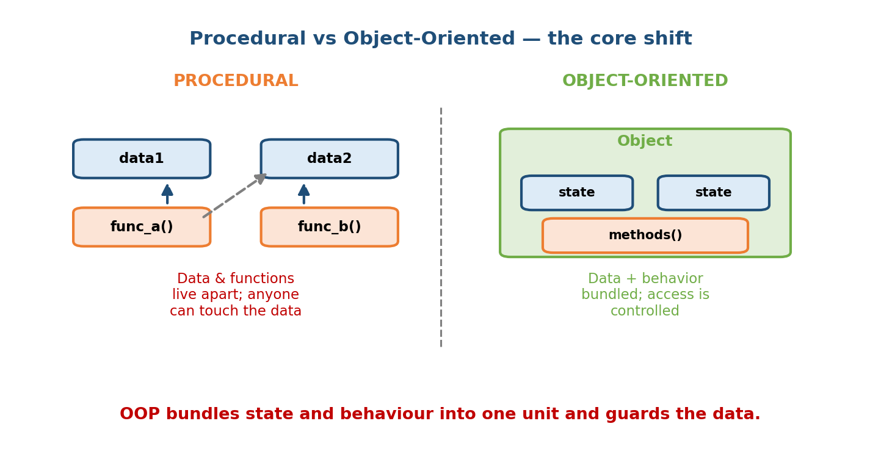
Procedural keeps data and functions apart so anything can mutate the data; OOP bundles state and behaviour into one guarded unit.
Now the object-oriented version:
# OOP style — data + the rules that protect it live together
class BankAccount:
def __init__(self, owner, balance=0):
self.owner = owner # state
self._balance = balance # "_" hints: internal, don't touch directly
def deposit(self, amount): # behaviour
if amount <= 0:
raise ValueError("deposit must be positive")
self._balance += amount
def withdraw(self, amount):
if amount > self._balance: # the RULE is enforced HERE, always
raise ValueError("insufficient funds")
self._balance -= amount
def balance(self):
return self._balance
acc = BankAccount("Nidhi", 1000)
acc.deposit(500)
print(acc.balance()) # 1500
# acc._balance = -99999 <-- possible, but clearly marked as "off-limits"; the
# normal API (withdraw) can never make it negative.
Each BankAccount object carries its own balance, and the only intended way to change it goes through methods that enforce the rules. Ten accounts? Ten objects — each self-contained. This is the whole point of OOP.
The four benefits (exam-ready):
- Modularity — each object is a self-contained unit; fix one class without breaking others.
- Reusability — reuse a class in many programs; extend it via inheritance.
- Maintainability — rules live in one place, so bugs have one home.
- Data protection (encapsulation) — invariants (“balance never negative”) are guarded by the object, not by discipline.

1.3 Class vs Object (the single most important distinction)
A class is a blueprint / template — it describes what attributes and methods a kind of thing has, but is not itself a thing. An object (or instance) is a concrete thing built from that blueprint, with its own copy of the data.
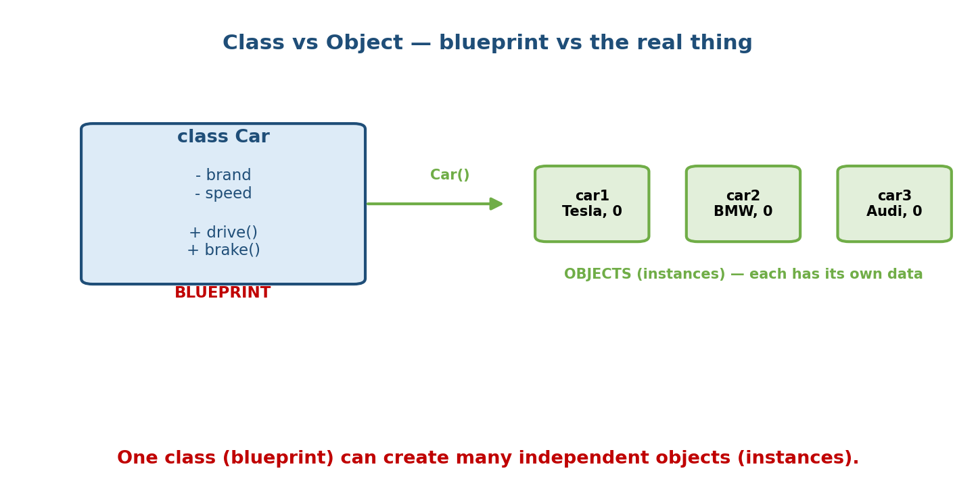
A single class Car acts as a blueprint from which many independent car objects are instantiated, each with its own data.
Analogy: the class is the architect’s blueprint for a house; the objects are the actual houses built from it. One blueprint → many houses, each painted a different colour, each with its own furniture.
class Car: # the blueprint
def __init__(self, brand):
self.brand = brand
self.speed = 0
car1 = Car("Tesla") # an object (instance)
car2 = Car("BMW") # another, fully independent object
car1.speed = 80
print(car1.speed, car2.speed) # 80 0 -> separate state, as expected
print(type(car1)) # <class '__main__.Car'>
print(isinstance(car1, Car)) # True
Interview one-liner: “A class is a definition; an object is an instance of that definition living in memory with its own state.”

1.4 Anatomy of an Object: Identity, State, Behaviour
Every object, in any OO language, has three facets. In Python this is literally true and inspectable:
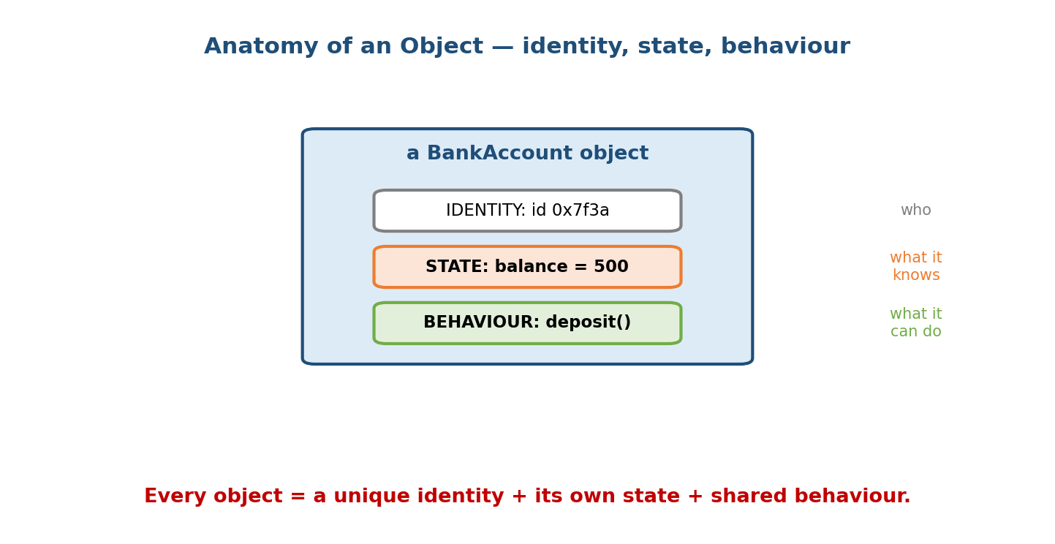
An object has an identity (its id in memory), state (its attribute values), and behaviour (its methods).
Facet | Meaning | Python
Identity | which object it is (unique, unchanging) | id(obj) / the is operator
State | what it currently knows (data) | its attributes, e.g. obj.balance
Behaviour | what it can do (operations) | its methods, e.g. obj.deposit()
acc = BankAccount("Nidhi", 1000)
print(id(acc)) # identity: e.g. 140234... (address-like, unique)
print(acc.owner) # state: 'Nidhi'
acc.deposit(500) # behaviour: changes state via a method
Two objects can have identical state yet be different objects (different identity) — this is exactly why == (compares state, if defined) and is (compares identity) are different questions. We formalise this in Module 2.

1.5 Attributes vs Methods (state vs behaviour, named)
- Attribute — a variable attached to an object (or class). Represents state. Real-world: the nouns describing the thing (a car’s brand, colour).
- Method — a function attached to a class, operating on an object. Represents behaviour. Real-world: the verbs the thing can do (drive(), brake()).
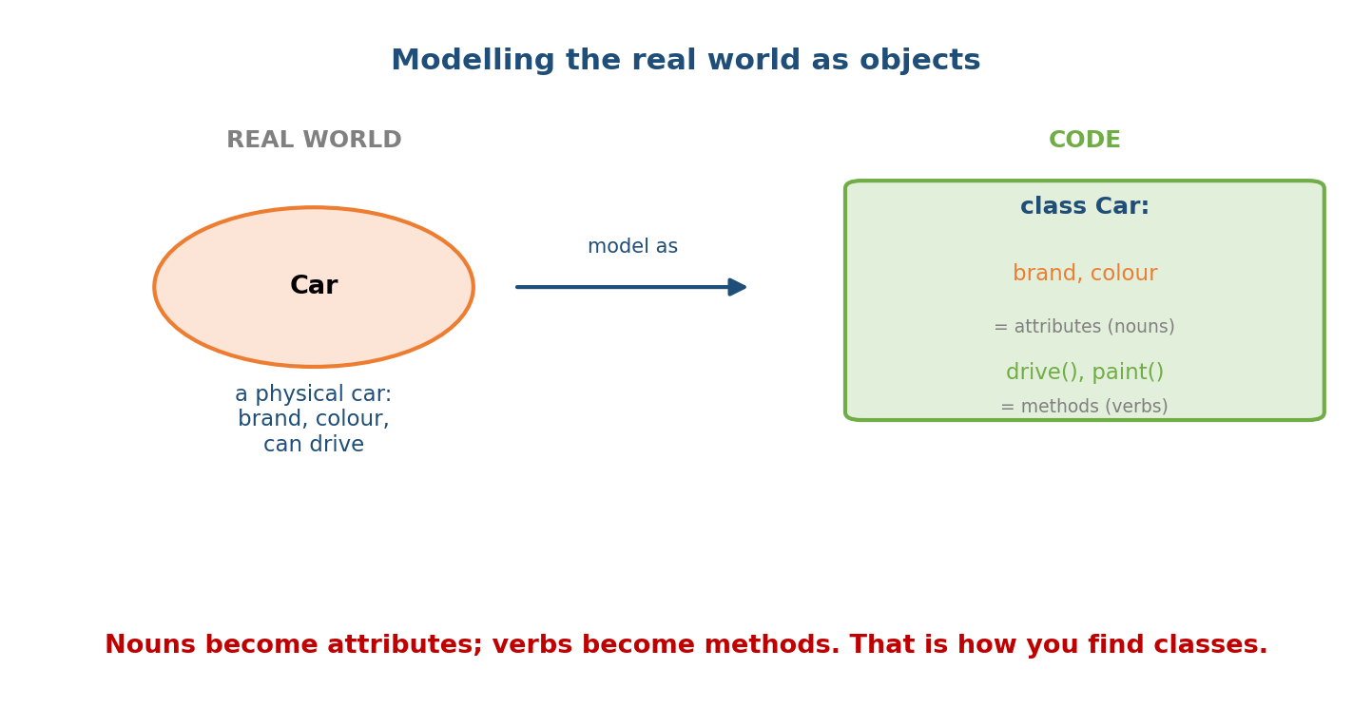
To find classes from a problem statement, turn the nouns into attributes and the verbs into methods.
Design heuristic (used in every LLD interview): read the problem statement; nouns → candidate classes/attributes, verbs → candidate methods. “A user can place an order and pay for it” → classes User, Order, Payment; methods place_order(), pay().

1.6 Message Passing — How Objects Collaborate
Objects rarely work alone; they collaborate by calling each other’s methods. The original OOP vocabulary (from Smalltalk) calls this sending a message: receiver.message(arguments). Crucially, the caller does not reach inside the other object — it only asks it to do something.
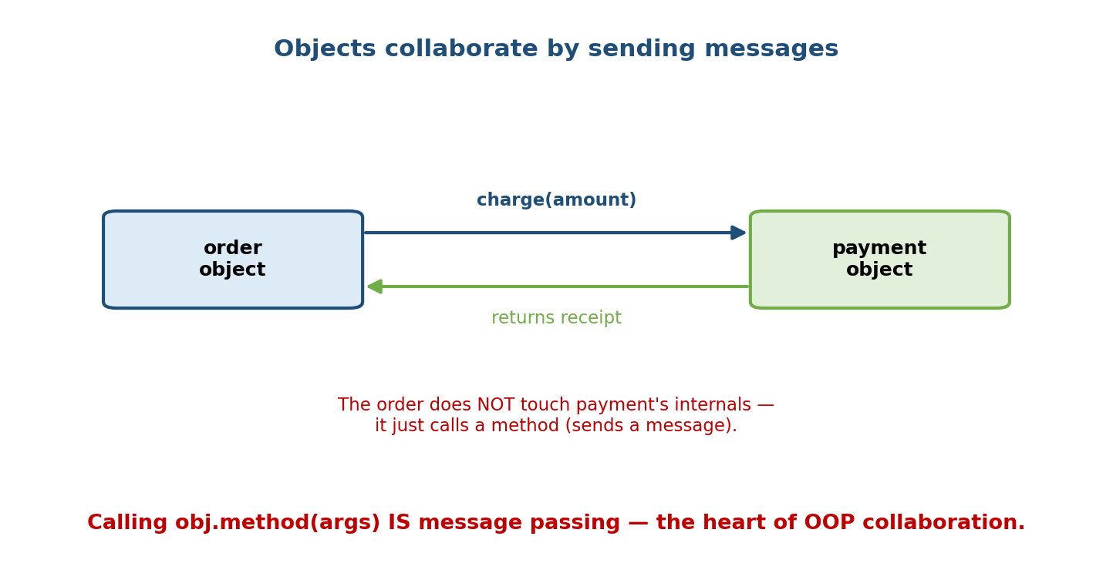
Two objects collaborate: an order object calls charge() on a payment object and gets a receipt back, without touching the payment object’s internals.
class Payment:
def charge(self, amount):
# ...talks to a gateway internally; caller need not know how...
return f"receipt#{amount}"
class Order:
def __init__(self, payment): # Order collaborates WITH a Payment
self.payment = payment
def checkout(self, total):
return self.payment.charge(total) # sends a "message"
order = Order(Payment())
print(order.checkout(999)) # receipt#999
Order depends only on the public method charge(), not on how Payment works. Swap in a MockPayment for testing and Order doesn’t change — this loose coupling is a direct payoff of OOP (and the seed of dependency injection, Module 18).

1.7 The Four Pillars of OOP (the map for the whole course)
Nearly every OOP concept is one of four big ideas. We introduce them here in one line each; each gets its own deep-dive module later.
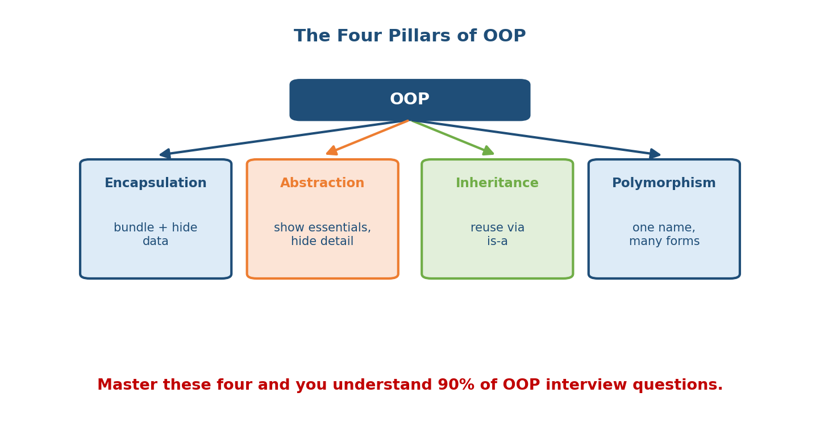
The four pillars of OOP: Encapsulation, Abstraction, Inheritance, Polymorphism, each with a one-line meaning.
Pillar | One line | Everyday analogy | Module
Encapsulation | bundle data + methods; hide internals | a capsule/pill — contents sealed inside | M04
Abstraction | expose what, hide how | a car’s steering wheel — you steer, not touch the engine | M04, M07
Inheritance | a new class reuses/extends an existing one (is-a) | a child inherits traits from a parent | M05
Polymorphism | one interface, many implementations | a “+” that adds ints and joins strings | M06
A 30-second taste of each in Python:
# ENCAPSULATION: internals hidden behind a method (the _balance is guarded)
acc.deposit(100) # you don't touch _balance directly
# ABSTRACTION: you call a simple method; the messy "how" is hidden
len([1, 2, 3]) # you don't care HOW length is computed
# INHERITANCE: SavingsAccount reuses BankAccount and adds to it
class SavingsAccount(BankAccount):
def add_interest(self, rate):
self.deposit(self.balance() * rate)
# POLYMORPHISM: the SAME len() works on many different types
len("abc"); len({1, 2}); len((1,)) # 3, 2, 1 — one name, many forms
Memory hook — “A PIE”: Abstraction, Polymorphism, Inheritance, Encapsulation. If you can define these four and give one example each, you can answer the most common opening OOP interview question.

1.8 “Is Everything in Python an Object?” (yes — and it matters)
In Python, everything is an object — integers, strings, functions, even classes themselves. Each has a type, an identity, and attributes/methods.
print((5).bit_length()) # 3 -> even an int has methods
print("hi".upper()) # HI -> strings are objects
def f(): pass
print(f.__name__) # f -> functions are objects with attributes
print(type(int)) # <class 'type'> -> classes are objects too (Module 9)
This is why Python OOP feels so uniform: there is no split between “primitive types” and “real objects” like in some languages (e.g. Java’s int vs Integer). We unpack the deep consequences of this in Module 2 (Python Object Model).

1.9 When to Use OOP — and When NOT To
OOP is a tool, not a religion. Overusing it (a class for every tiny function) is a real anti-pattern (see M19).
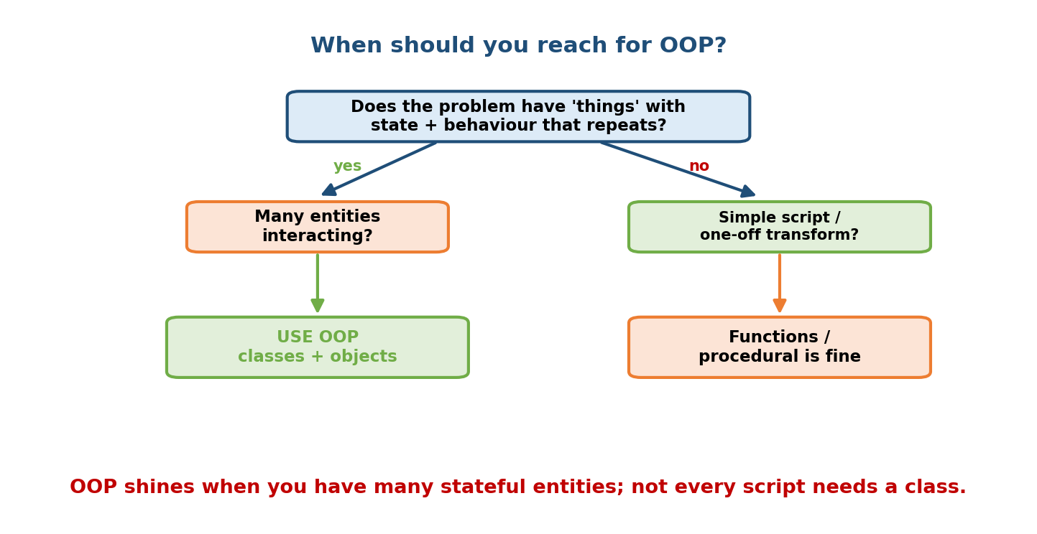
A decision flowchart: if the problem has many stateful entities that interact, use OOP; if it is a simple one-off script or pure transform, functions are fine.
Reach for OOP when:
- You have many entities with state that changes over time (users, orders, game characters, connections).
- Several variants share behaviour (different payment methods, shapes, file formats) — inheritance/polymorphism shine.
- You want to protect invariants (a balance must never go negative).
Prefer functions / procedural / functional when:
- It’s a short script or a pure data transformation (parse a file, do a calculation) — a function is clearer and lighter than a class.
- The “class” would have one method and no state — that’s just a function wearing a costume.
Pythonic wisdom: “Don’t create a class when a function will do.” A class with only __init__ and one run() method is usually better as a plain function. Reach for a class when there is genuine state + behaviour to bundle.

1.10 A Brief History (context that occasionally shows up)
- 1960s — Simula 67 introduced classes and objects (for simulations).
- 1970s — Smalltalk made everything an object and coined “message passing”.
- 1980s–90s — C++, then Java brought OOP to the mainstream (with static typing and strict access control).
- 1991 — Python built OOP in from the start but kept it optional and dynamic: duck typing over strict interfaces, and access control by convention (_name) rather than hard private keywords.
Knowing this explains Python’s “flavour” of OOP: pragmatic, dynamic, and convention-based rather than ceremony-heavy.

Module 1 — Interview Mapping
Question style | Junior answer | Senior answer
“What is OOP?” | “Programming with objects and classes.” | “A paradigm that organises code around objects — bundles of state + behaviour — to get modularity, reuse, and protected invariants; contrasted with procedural code where data and functions are separate.”
“Class vs object?” | “Class is blueprint, object is instance.” | Adds: object has its own state + identity; one class → many independent instances; shows type()/isinstance().
“Four pillars?” | Lists the four names. | Defines each and gives a Python one-liner and when each helps.
“Why not use OOP everywhere?” | (often stuck) | “For a one-off script or a pure transform a function is clearer; a single-method stateless class is an anti-pattern — Python favours functions when there’s no state to bundle.”
The evergreen opener — “Model a ___ (parking lot / library / deck of cards) as classes” — is really testing §1.5: nouns→classes/attributes, verbs→methods. We drill full versions in Module 18 (LLD).

Module 1 — Exam Mapping
- GATE CS: definitions of the four pillars; class vs object; identifying paradigms. Usually 1-mark conceptual MCQs.
- SEBI / RBI / NABARD IT: direct one-liners — “which is NOT an OOP feature”, “OOP language examples”, pillar definitions. High-frequency, easy marks.
- FAANG / product interviews: less about definitions, more about applying them — model a system, justify class boundaries, spot when OOP is overkill.
- Interview-only (rare in written exams): message passing terminology, “is everything an object in Python”, multi-paradigm nature.

Module 1 — Common Mistakes & Misconceptions
- “OOP = using classes.” No — OOP is using classes to bundle state and behaviour. Wrapping one function in a class is not OOP; it’s clutter.
- Confusing class and object. The class is the type; the object is the instance. Car is the class; car1 is an object.
- Thinking OOP is always better. For simple scripts and pure functions, procedural/functional is often cleaner. Python is multi-paradigm on purpose.
- “Encapsulation = private variables.” Encapsulation is the bundling + hiding idea; private variables are one mechanism for it (and Python’s are only by convention — Module 4).
- Believing Python has real private. It does not — _x is a hint, __x triggers name mangling, not true privacy (Module 4).

Module 1 — MCQs (with answers & explanations)
Q1. Which is NOT one of the four pillars of OOP? a) Encapsulation b) Abstraction c) Compilation d) Polymorphism
Answer
c. The four pillars are Encapsulation, Abstraction, Inheritance, Polymorphism. Compilation is unrelated.
Q2. A class is best described as: a) an object in memory b) a blueprint/template for objects c) a function d) a module
Answer
b. A class defines structure/behaviour; objects are concrete instances built from it.
Q3. In Python, which of these is an object? a) an int b) a string c) a function d) all of the above
Answer
d. In Python everything is an object — ints, strings, functions, and classes themselves.
Q4. Bundling data with the methods that operate on it, and hiding internals, is: a) Inheritance b) Polymorphism c) Encapsulation d) Abstraction
Answer
c. That is the definition of encapsulation. Abstraction is the related idea of exposing what while hiding how.
Q5. “One interface, many implementations (e.g. len() works on lists, strings, dicts)” describes: a) Encapsulation b) Polymorphism c) Inheritance d) Abstraction
Answer
b. Polymorphism — the same operation behaves appropriately for different types.
Q6. Which situation is the weakest case for using a class? a) modelling users with changing balances b) several payment types sharing behaviour c) a one-off script that reads a file and prints its line count d) a game with many characters
Answer
c. A stateless one-off transform is clearer as a function; a class here is over-engineering.
Q7. car1 = Car("Tesla"). Here car1 is a(n) ____ and Car is a(n) ____. a) class, object b) object, class c) method, attribute d) instance, method
Answer
b. car1 is an object (instance); Car is the class.
Q8. Which paradigm family does OOP belong to? a) declarative b) logic c) imperative d) functional
Answer
c. OOP is an imperative style (you mutate object state step by step), as opposed to declarative styles like functional/logic.

Module 1 — Design/Practice Exercises (easy → hard)
- (easy) Rewrite this procedural snippet as a class Counter with increment(), reset(), and a value you read via a method: count = 0 … count += 1.
- (easy) From the sentence “A student enrols in a course and submits an assignment”, list the candidate classes, attributes, and methods.
- (medium) Write a Rectangle class with width, height, and methods area() and perimeter(). Create three rectangles and print their areas — confirm each keeps its own state.
- (medium) Give a concrete Python example of each pillar in five lines total.
- (hard) Take a 40-line procedural “to-do list” program (global list + free functions) and refactor it into Task and TodoList classes. Write two sentences on what improved and what got heavier.
- (hard, interview-style) Argue both sides: for a “resize every image in a folder” tool, when would you keep it as functions, and when would a class earn its place? What state would justify the class?

Module 1 — Concept Review (one page)
OOP organises an imperative program around objects — bundles of state (attributes) and behaviour (methods). It exists to fix procedural pain: data and the rules protecting it drift apart, and duplicating variables for each entity doesn’t scale. A class is a blueprint; an object is an instance with its own state + identity + shared behaviour. Objects collaborate by message passing — calling each other’s public methods without touching internals. The four pillars — Encapsulation, Abstraction, Inheritance, Polymorphism (“A PIE”) — are the recurring ideas. In Python, everything is an object, and the language is multi-paradigm: use OOP when you have many stateful, interacting entities or shared-behaviour variants; use plain functions for short scripts and pure transforms.

Module 1 — Flash Cards (Q → A)
Front | Back
Four pillars (mnemonic) | Encapsulation, Abstraction, Inheritance, Polymorphism (“A PIE”)
Class vs object | Class = blueprint/type; object = instance with its own state
Three facets of an object | Identity, State, Behaviour
Encapsulation (1 line) | Bundle data + methods; hide internals behind an API
Abstraction (1 line) | Expose what, hide how
Inheritance (1 line) | New class reuses/extends another (is-a)
Polymorphism (1 line) | One interface, many implementations
Message passing | receiver.method(args) — asking an object to act
Is everything an object in Python? | Yes — ints, strings, functions, classes
Nouns → ? , Verbs → ? | Nouns → attributes/classes; Verbs → methods
When NOT to use OOP | One-off scripts, pure transforms, stateless single-method “classes”
OOP’s paradigm family | Imperative

Module 1 — Pattern Recognition
- See “model / design a real-world system” → nouns→classes/attributes, verbs→methods (§1.5); then think pillars.
- See “several things that are almost the same but differ slightly” → reach for inheritance + polymorphism (M05/M06).
- See “this data must always stay valid” → encapsulation (guard it behind methods, M04).
- See “a class with just one method and no state” → stop — use a function.
- See “I keep passing the same 3 variables to every function” → those variables + functions want to be an object.

Module 1 — Revision Notes / Mini Cheat Sheet
OOP = organise an IMPERATIVE program around OBJECTS (state + behaviour).
WHY: procedural pain -> data & rules drift apart; per-entity vars don't scale.
BENEFITS: modularity, reusability, maintainability, data protection.
CLASS = blueprint / type (definition).
OBJECT = instance built from a class, with its OWN state + identity.
OBJECT = IDENTITY (id/is) + STATE (attributes) + BEHAVIOUR (methods).
FIND CLASSES: nouns -> attributes/classes ; verbs -> methods.
COLLABORATION: message passing = receiver.method(args); don't touch internals.
FOUR PILLARS ("A PIE")
Encapsulation bundle + hide (M04)
Abstraction what, not how (M04/M07)
Inheritance reuse via is-a (M05)
Polymorphism one name, many forms (M06)
PYTHON: everything is an object; multi-paradigm; access control by CONVENTION.
USE OOP: many stateful, interacting entities / shared-behaviour variants.
AVOID : one-off scripts, pure transforms, stateless single-method classes.
Next module: Module 2 — The Python Object Model. We go under the hood: how everything is an object actually works — id/type/value, the difference between a variable (a name) and an object (a value in memory), references vs copies, mutable vs immutable, and why is and == answer two different questions. This is the bedrock every later Python-OOP feature stands on.

Module 1 — Summary
Object-oriented programming organises an imperative program around objects: bundles of state (attributes) and behaviour (methods) that model real-world “things”. It arose to cure procedural pain — data and the rules that protect it living apart, and per-entity variables that don’t scale — delivering modularity, reusability, maintainability, and data protection. A class is a blueprint; an object is a concrete instance with its own state, identity, and shared behaviour. Objects collaborate by message passing. The four pillars — Encapsulation, Abstraction, Inheritance, Polymorphism (“A PIE”) — are the ideas we will spend the rest of the course mastering. In Python, everything is an object and the language is multi-paradigm, so the mark of skill is knowing when OOP earns its keep and when a plain function is better.
You have mastered this module when you can: define OOP and contrast it with procedural code using a small example; explain class vs object and the three facets of an object; name and illustrate the four pillars in Python; extract classes/attributes/methods from a problem statement; and argue when not to use OOP — all without notes.

