Module 3 — Classes & Objects (the mechanics)
  - OOP with Python Mastery: FAANG Interviews / GATE / SEBI-RBI IT / Backend — In-Depth Notes (with visuals)
Prepared for nidhi.sharma@forensiccybertech.com
2026
Table of Contents

Module 3 — Classes & Objects (the mechanics)
Why this module matters. Module 1 gave the idea of classes; Module 2 gave the object model. Now we write real classes correctly. Ninety percent of everyday Python OOP is here: __init__ and self, instance vs class attributes (and the shared-mutable trap that reuses Module 2’s aliasing lesson), and the three method types (instance, @classmethod, @staticmethod). Get these exactly right and the advanced modules become easy; get them fuzzy and you’ll fight subtle bugs forever.
Importance ratings (out of 5):
Exam / Use | FAANG Interview | GATE CS | SEBI/RBI IT | Backend Dev | LLD Rounds
This module | ★★★★★ | ★★★ | ★★★ | ★★★★★ | ★★★★★
Most-asked concepts: what is self (and why explicit); instance vs class attribute difference + the mutable-class-attribute bug; @classmethod vs @staticmethod vs instance method (when to use each); __init__ vs __new__; factory methods; __dict__.
What you must be able to do after this module: write a correct class with a constructor, instance state, and methods; explain self; choose the right method type for a job; explain and avoid the shared-mutable-class-attribute bug; and add a @classmethod “alternative constructor.”

3.1 Defining a Class — the anatomy
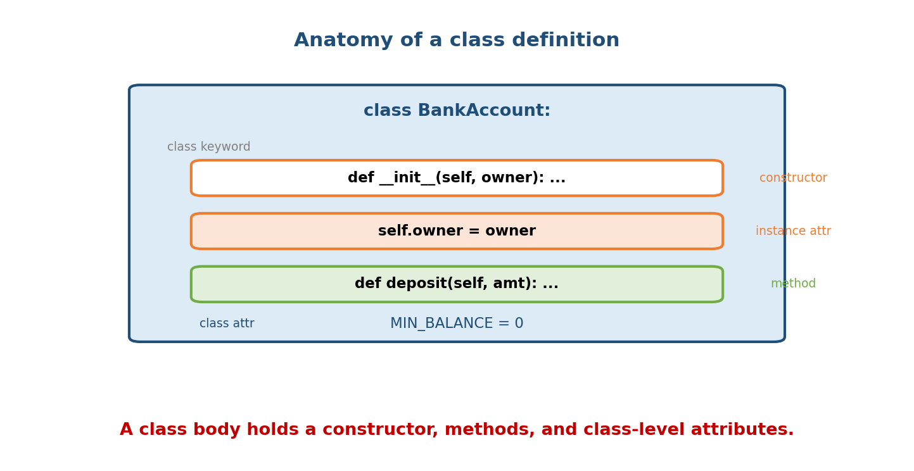
Anatomy of a class: the class keyword, the init constructor, self-assigned instance attributes, methods, and a class-level attribute.
class BankAccount: # 1. class statement + name (PascalCase)
MIN_BALANCE = 0 # 4. class attribute (shared by all instances)
def __init__(self, owner, balance=0): # 2. constructor (initialiser)
self.owner = owner # 3. instance attribute (per object)
self.balance = balance
def deposit(self, amount): # a method (behaviour)
self.balance += amount
- class BankAccount: — introduces a new type. Convention: PascalCase.
- __init__ — the initialiser, run automatically right after a new object is created; it sets up the object’s starting state.
- self.owner = owner — creates an instance attribute on this object.
- MIN_BALANCE = 0 — a class attribute, shared by all instances.
Create objects by “calling” the class:
acc = BankAccount("Nidhi", 1000) # builds an object, runs __init__
print(acc.owner, acc.balance) # Nidhi 1000

3.2 self — the most-asked beginner question
self is the current object — the specific instance the method is working on. When you call acc.deposit(100), Python rewrites it to BankAccount.deposit(acc, 100) — the object before the dot is passed as the first argument, which we conventionally name self.
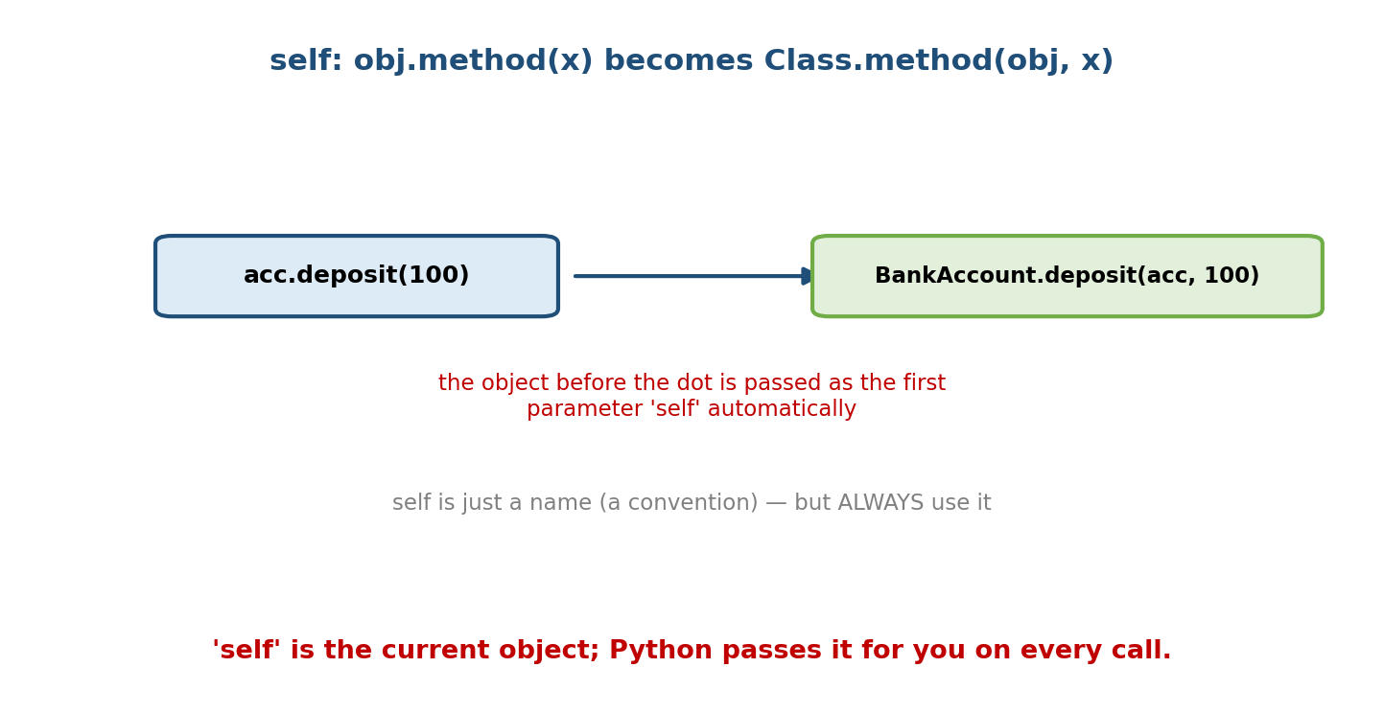
obj.deposit(100) is transformed by Python into BankAccount.deposit(obj, 100); the object becomes the self parameter automatically.
acc.deposit(100) # you write this...
BankAccount.deposit(acc, 100) # ...Python effectively runs this
Key facts:
- self is not a keyword — it’s a naming convention. You could name it anything, but always use self (readers expect it).
- Python makes the object-passing explicit (unlike Java’s implicit this) because “explicit is better than implicit” — it makes method resolution and binding obvious.
- Inside a method, every access to the object’s own state goes through self: self.balance, self.deposit(...).
Interview one-liner: “self is the instance the method was called on; Python passes it automatically as the first parameter.”

3.3 Instance Attributes vs Class Attributes
- Instance attribute — belongs to one object; set via self.x = ... (usually in __init__). Each object has its own copy.
- Class attribute — belongs to the class; shared by all instances; defined in the class body.
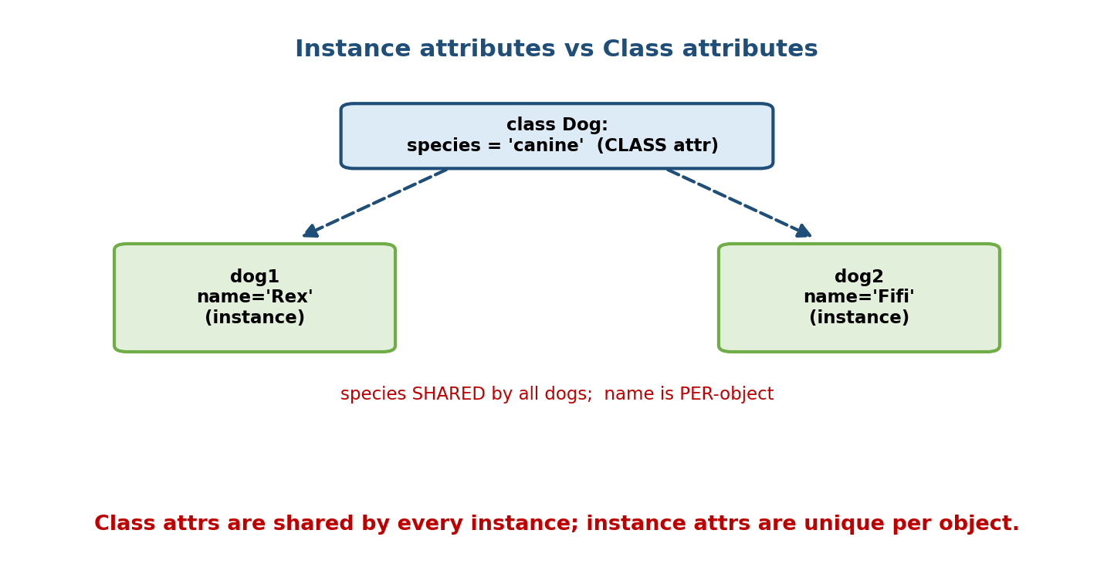
A class attribute species=‘canine’ is shared by every Dog, while each dog has its own instance attribute name.
class Dog:
species = "canine" # class attribute (shared)
def __init__(self, name):
self.name = name # instance attribute (per dog)
a = Dog("Rex"); b = Dog("Fifi")
print(a.species, b.species) # canine canine (shared)
print(a.name, b.name) # Rex Fifi (independent)
Dog.species = "Canis familiaris" # change the class attr -> affects all
print(a.species) # Canis familiaris
Reading vs writing (the subtle rule): reading a.species falls back to the class if the instance has no such attribute. But assigning a.species = "wolf" creates a new instance attribute that shadows the class one — it does not change the class attribute:
a.species = "wolf" # creates an INSTANCE attr on a, shadowing the class attr
print(a.species) # wolf
print(b.species) # canine (b still sees the class attr)
print(Dog.species) # canine (class attr untouched)
This shadowing behaviour is a direct consequence of the lookup order below.

3.4 Attribute Lookup Order (and __dict__)
When you access obj.x, Python searches in order: the instance’s __dict__, then the class’s __dict__, then parent classes (the MRO, Module 5), and finally raises AttributeError.
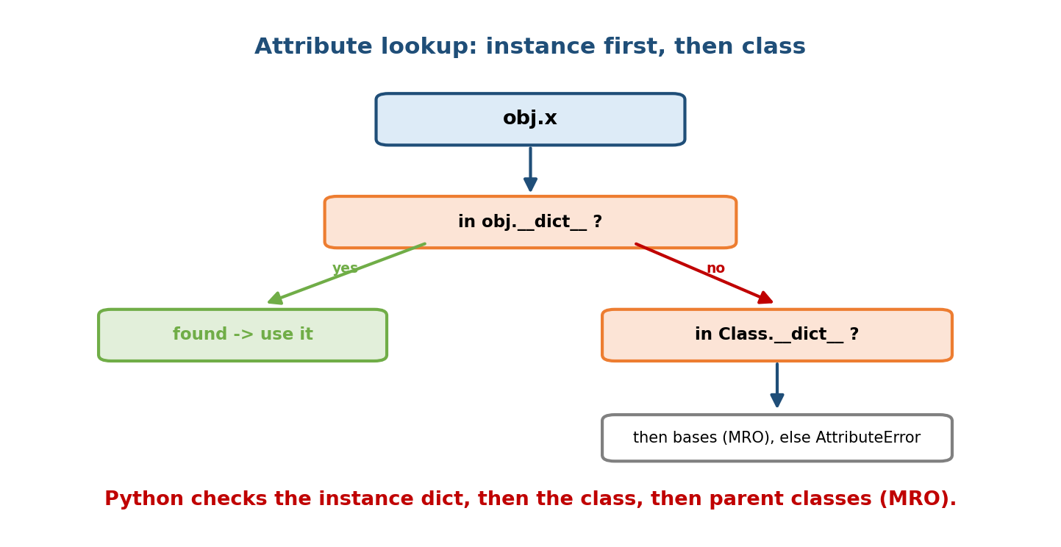
Attribute lookup: check the instance dict first; if missing, the class dict; then base classes via the MRO; else AttributeError.
d = Dog("Rex")
print(d.__dict__) # {'name': 'Rex'} -> instance namespace
print(Dog.__dict__.keys())# dict_keys([... 'species', '__init__', ...])
Every object stores its instance attributes in __dict__ (a plain dict). This is why Python objects are so dynamic — you can add attributes at runtime:
d.color = "brown" # add a new attribute on the fly
print(d.__dict__) # {'name': 'Rex', 'color': 'brown'}
(Module 8 shows how __slots__ turns this off to save memory and lock the attribute set.)

3.5 The Shared Mutable Class Attribute Bug (must-know)
Combine §3.3 with Module 2’s aliasing lesson and you get a famous bug: a mutable class attribute is one object shared by every instance.
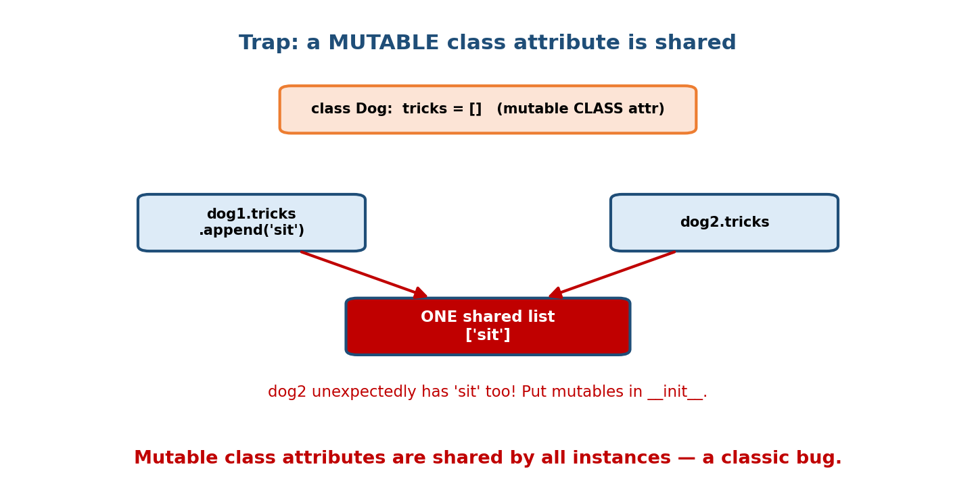
A mutable class attribute tricks=[] is a single shared list; dog1 appending ‘sit’ makes dog2 see it too.
class Dog:
tricks = [] # BUG: one list shared by ALL dogs
def __init__(self, name):
self.name = name
def add_trick(self, t):
self.tricks.append(t) # mutates the SHARED class list!
a = Dog("Rex"); b = Dog("Fifi")
a.add_trick("sit")
print(b.tricks) # ['sit'] <-- Fifi has Rex's trick!
Fix: give each object its own mutable state in __init__:
class Dog:
def __init__(self, name):
self.name = name
self.tricks = [] # fresh list per dog
Rule: class attributes are fine for constants / shared immutables (MAX_SPEED = 120), but never put mutable state (lists, dicts, sets) at class level unless you deliberately want it shared. This is the class-level twin of the mutable-default-argument bug (Module 2).

3.6 Three Kinds of Methods
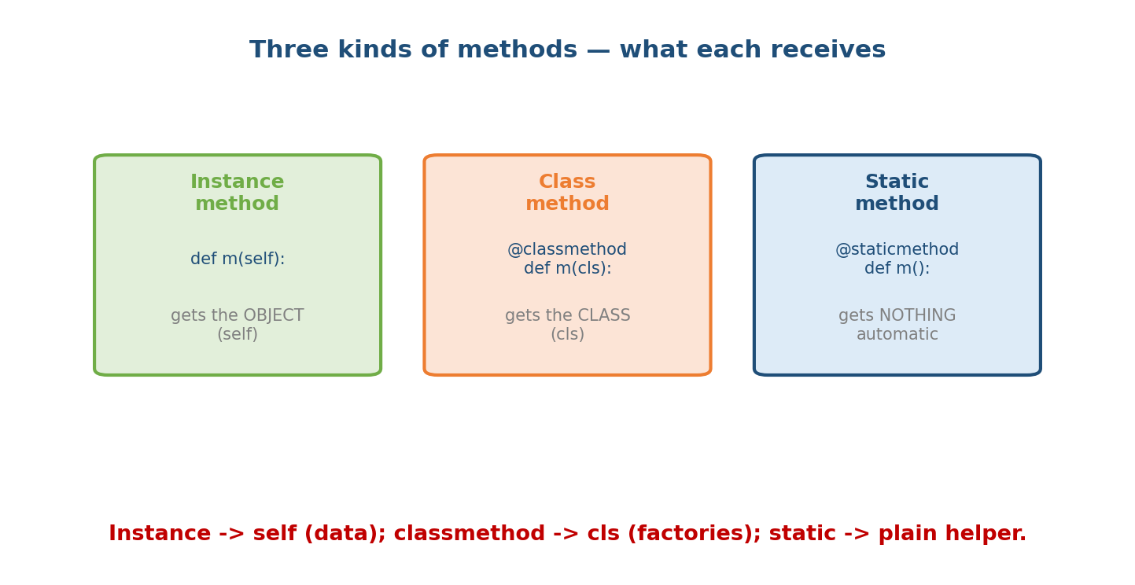
Three method kinds: an instance method receives self (the object); a classmethod receives cls (the class); a staticmethod receives nothing automatically.
Kind | Decorator | First arg | Use when…
Instance method | (none) | self | you need the object’s state (the default)
Class method | @classmethod | cls | you need the class — factories, per-class data
Static method | @staticmethod | none | it’s a helper logically grouped with the class but uses neither self nor cls
class Pizza:
sizes = {"S": 8, "M": 10, "L": 12}
def __init__(self, size, toppings):
self.size = size
self.toppings = toppings
def price(self): # instance: uses self (state)
return Pizza.sizes[self.size] + 2 * len(self.toppings)
@classmethod
def margherita(cls, size): # classmethod: alt constructor (factory)
return cls(size, ["tomato", "mozzarella"])
@staticmethod
def is_valid_size(size): # staticmethod: pure helper
return size in Pizza.sizes
p = Pizza.margherita("M") # factory, returns a Pizza
print(p.price()) # 10 + 2*2 = 14
print(Pizza.is_valid_size("XL")) # False
Decision rule: use self if you touch instance data; cls if you build/ query the class (factories, subclass-aware); @staticmethod if you touch neither (and ask yourself whether it should just be a module-level function).

3.7 @classmethod as an Alternative Constructor (factory)
A very common Pythonic pattern: __init__ takes the “canonical” arguments, and @classmethod factories build objects from other inputs. Because they receive cls, they build the right subclass automatically.
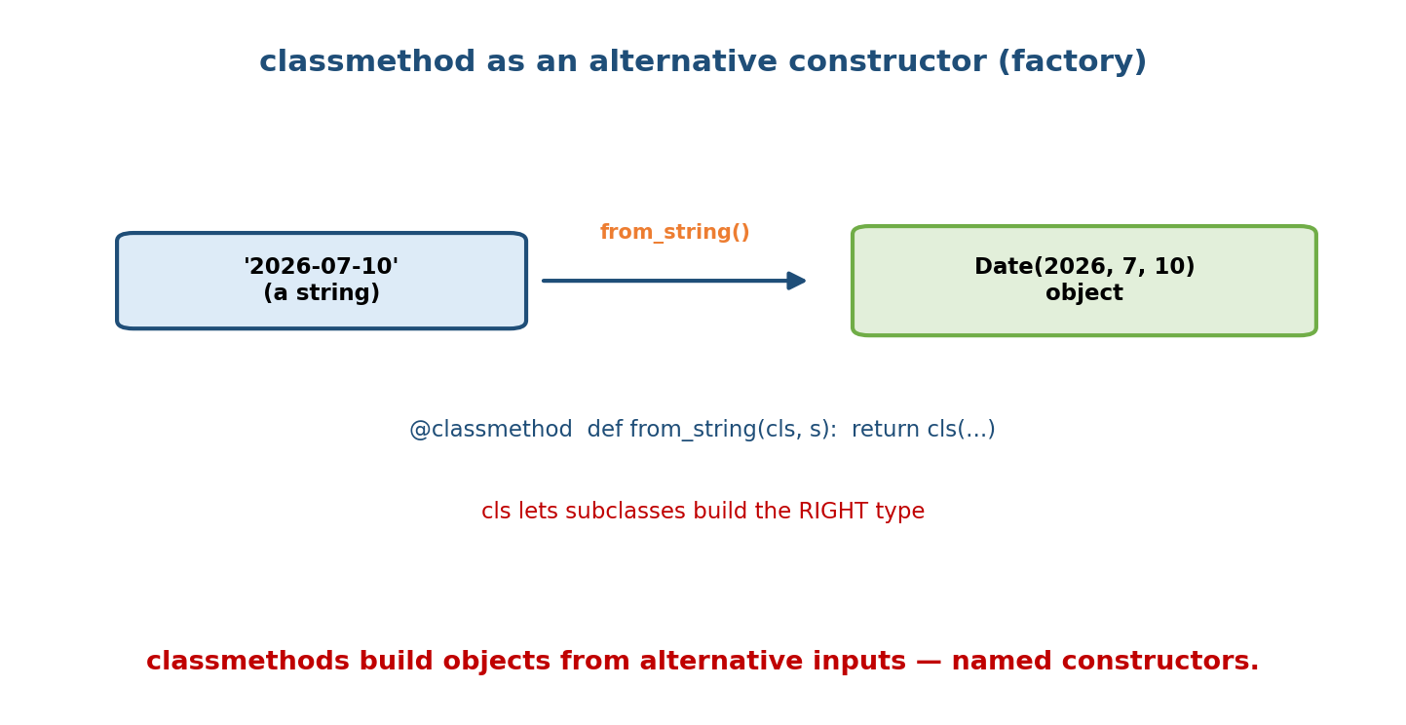
A classmethod from_string parses ‘2026-07-10’ and returns a Date object; using cls means subclasses get the correct type.
class Date:
def __init__(self, y, m, d):
self.y, self.m, self.d = y, m, d
@classmethod
def from_string(cls, s): # "2026-07-10" -> Date
y, m, d = map(int, s.split("-"))
return cls(y, m, d) # cls, not Date -> subclass-friendly
@classmethod
def today(cls):
import datetime
t = datetime.date.today()
return cls(t.year, t.month, t.day)
d = Date.from_string("2026-07-10")
The standard library uses this everywhere: dict.fromkeys(...), datetime.fromtimestamp(...), int.from_bytes(...).

3.8 Object Creation: __init__ vs __new__
Creating an object is two steps:
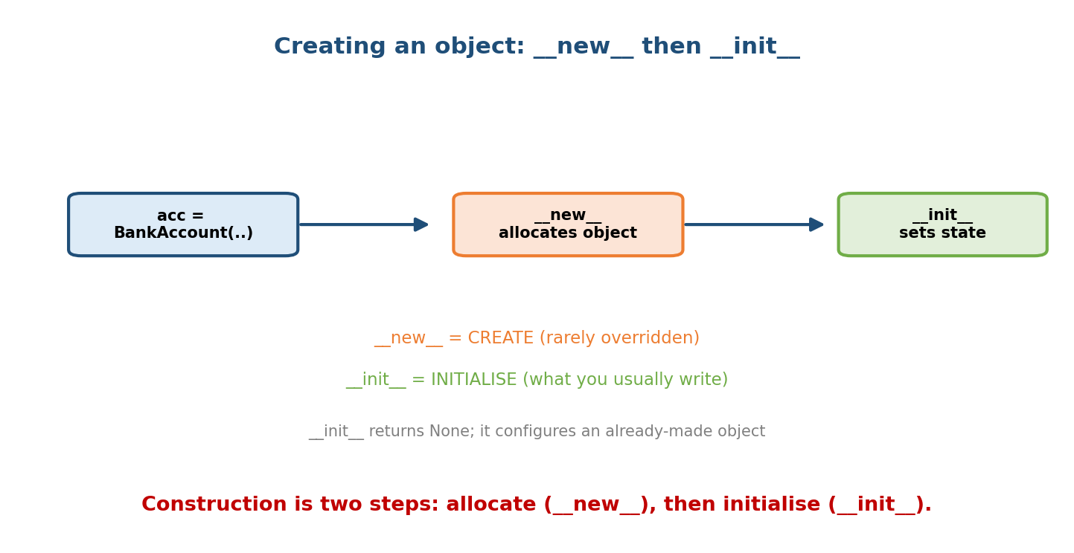
Object creation runs new (allocate the object) then init (initialise its state); init returns None.
- __new__(cls, ...) — allocates and returns a new, empty object. Rarely overridden (used for immutables, singletons, metaclasses — Module 9).
- __init__(self, ...) — initialises the already-created object’s state. Returns None (returning anything else is a TypeError).
class Point:
def __new__(cls, *args):
print("allocating")
return super().__new__(cls) # make the object
def __init__(self, x, y):
print("initialising")
self.x, self.y = x, y
p = Point(1, 2) # prints: allocating, then initialising
Interview trap: “Is __init__ the constructor?” Precisely, __new__ is the constructor (it creates); __init__ is the initialiser (it configures). In everyday speech people call __init__ “the constructor,” which is fine, but know the distinction.

3.9 Deleting & Inspecting Attributes
del acc.balance # remove an instance attribute
hasattr(acc, "balance") # False
getattr(acc, "owner") # 'Nidhi' (like acc.owner)
setattr(acc, "owner", "X")# like acc.owner = "X"
vars(acc) # same as acc.__dict__
getattr/setattr/hasattr are the dynamic, string-keyed versions of dot access — useful for frameworks, serialisation, and plugins (and the basis for Module 8’s __getattr__ hooks).

Module 3 — Interview Mapping
Question | Junior answer | Senior answer
“What is self?” | “The object.” | “The instance the method was called on; passed automatically as the first arg; a convention, not a keyword; explicit by design.”
“Instance vs class attribute?” | “One per object vs shared.” | Adds the read-fallback + write-shadowing rule and the mutable class attribute bug.
“@classmethod vs @staticmethod?” | “cls vs nothing.” | “classmethod for factories/subclass-aware behaviour (gets cls); staticmethod for a namespaced helper touching neither state nor class — often better as a function.”
“__init__ vs __new__?” | “init sets values.” | “__new__ allocates/returns the object (the real constructor); __init__ initialises it and returns None.”

Module 3 — Exam Mapping
- GATE CS: output prediction with class vs instance attributes; method-binding questions; __dict__ lookups.
- SEBI / RBI IT: definition of constructor; self; class vs object.
- FAANG: the mutable-class-attribute bug, classmethod factories, and clean choice of method type in a design.

Module 3 — Common Mistakes & Misconceptions
- Forgetting self in a method signature (def deposit(amount):) → TypeError on call.
- Mutable class attributes for per-object state → shared-state bug (§3.5).
- Thinking a.species = x changes the class attribute — it creates an instance attribute that shadows it.
- Using @staticmethod when you need cls (breaks subclass factories).
- Believing __init__ creates the object — __new__ does; __init__ only initialises.
- Returning a value from __init__ → TypeError.

Module 3 — MCQs (with answers & explanations)
Q1. self is: a) a keyword b) a conventional name for the current instance c) a class d) global
Answer
b. It’s the instance passed automatically as the first parameter; not a keyword.
Q2. A mutable class attribute (tricks = []) shared by all instances is: a) fine b) a bug — put per-object mutables in __init__ c) impossible d) faster
Answer
b. All instances share one list; give each object its own in __init__.
Q3. Which method should be a @classmethod? a) one using self.balance b) an alternative constructor from_string c) a pure math helper d) __init__
Answer
b. Factories that build instances (and should respect subclasses) take cls.
Q4. a.species = "wolf" when species is a class attribute: a) changes it for all instances b) errors c) creates an instance attr shadowing the class attr d) deletes it
Answer
c. Assignment creates/updates an instance attribute; the class attribute is untouched.
Q5. The real object-creation hook is: a) __init__ b) __new__ c) __call__ d) __create__
Answer
b. __new__ allocates and returns the object; __init__ initialises it.
Q6. @staticmethod receives: a) self b) cls c) nothing automatically d) both
Answer
c. It’s a plain function namespaced under the class.
Q7. Where are an instance’s attributes stored (by default)? a) Class.__dict__ b) instance.__dict__ c) a global table d) __slots__
Answer
b. In the per-instance __dict__ (unless __slots__ is used).
Q8. Calling acc.deposit(100) is equivalent to: a) deposit(100) b) BankAccount.deposit(acc, 100) c) deposit(acc) d) acc(100)
Answer
b. The instance is passed as self.

Module 3 — Design/Practice Exercises (easy → hard)
- (easy) Write a Circle class with radius, an instance method area(), and a class attribute PI = 3.14159.
- (easy) Add a @staticmethod is_positive(r) and a @classmethod unit_circle(cls) to Circle.
- (medium) Demonstrate the shared-mutable-class-attribute bug with a Team class holding members = [], then fix it.
- (medium) Add @classmethod from_diameter(cls, d) to Circle and show it returns the correct type when subclassed.
- (hard) Implement a Temperature class storing Celsius, with class methods from_fahrenheit and from_kelvin, and an instance method to_fahrenheit.
- (hard, interview) Given a bug report “all users share the same shopping cart,” identify the likely cause in class code and fix it in two lines.

Module 3 — Concept Review (one page)
A class bundles class attributes (shared) and methods; each object built from it has its own instance attributes (set via self in __init__). self is the current instance, passed automatically; acc.m(x) ≡ Class.m(acc, x). Attribute access searches instance __dict__ → class → bases (MRO); reading a class attribute falls back to the class, but assigning creates a shadowing instance attribute. Putting mutable state at class level shares one object across all instances — a classic bug; keep per-object mutables in __init__. Methods come in three kinds: instance (self), @classmethod (cls, for factories/subclass-aware code), and @staticmethod (a namespaced helper). Object creation is __new__ (allocate) then __init__ (initialise).

Module 3 — Flash Cards (Q → A)
Front | Back
self is… | the current instance, passed automatically as first arg
acc.deposit(100) ≡ | BankAccount.deposit(acc, 100)
Instance vs class attribute | per-object (via self) vs shared (class body)
Reading vs writing a class attr on an instance | read falls back to class; write creates shadowing instance attr
Mutable class attribute danger | one object shared by all instances (bug)
Instance method gets | self
@classmethod gets | cls (factories, subclass-aware)
@staticmethod gets | nothing automatically (namespaced helper)
Real constructor hook | __new__ (allocates); __init__ initialises
Where instance attrs live | instance.__dict__
Alternative constructor pattern | @classmethod from_x(cls, ...) returning cls(...)

Module 3 — Pattern Recognition
- See “build an object from a string / timestamp / other type” → @classmethod factory.
- See “helper that uses neither self nor cls” → @staticmethod (or a module function).
- See “all instances unexpectedly share data” → mutable class attribute; move to __init__.
- See “constant used by every instance” → class attribute (MAX_SIZE = ...).
- See “add/read attributes by name at runtime” → getattr/setattr/hasattr.

Module 3 — Revision Notes / Mini Cheat Sheet
CLASS body: class attributes (shared) + methods. Instance attrs via self in __init__.
self = current instance, auto-passed. acc.m(x) == Class.m(acc, x). (convention, not keyword)
ATTR LOOKUP: instance __dict__ -> class __dict__ -> bases (MRO) -> AttributeError.
READ class attr via instance -> fallback OK. WRITE -> makes shadowing INSTANCE attr.
MUTABLE CLASS ATTR = shared by all instances (BUG). Constants OK; mutables -> __init__.
METHODS:
instance def m(self): uses object state (default)
@classmethod def m(cls): factories / subclass-aware / per-class data
@staticmethod def m(): helper, no self/cls (consider a plain function)
CREATION: __new__ (allocate, rare to override) -> __init__ (initialise, returns None).
DYNAMIC: getattr/setattr/hasattr/delattr; vars(obj) == obj.__dict__.
Next module: Module 4 — Encapsulation & Abstraction. We take the class we can now write and protect it: public/_protected/__private conventions, name mangling, @property for computed and validated attributes, and abstract base classes to define interfaces — turning “a bag of attributes” into a well-guarded, well-abstracted type.

Module 3 — Summary
A class defines shared class attributes and methods; each object carries its own instance attributes, set through self (the current instance, passed automatically) inside __init__. Attribute access follows instance → class → bases, so reading a class attribute falls back to the class while assigning creates a shadowing instance attribute. Never place mutable state at class level unless you mean to share it — otherwise every instance shares one object. Python offers three method kinds: instance methods (self), class methods (cls, ideal for factories), and static methods (namespaced helpers). Finally, object creation is really __new__ (allocate) followed by __init__ (initialise). These mechanics are the everyday grammar of Python OOP.
You have mastered this module when you can: write a correct class with a constructor, instance state, and methods; explain self and method binding; choose instance/class/static methods correctly; reproduce and fix the shared-mutable-class-attribute bug; and add a @classmethod factory that works under subclassing.

