Module 4 — Encapsulation & Abstraction
  - OOP with Python Mastery: FAANG Interviews / GATE / SEBI-RBI IT / Backend — In-Depth Notes (with visuals)
Prepared for nidhi.sharma@forensiccybertech.com
2026
Table of Contents

Module 4 — Encapsulation & Abstraction
Why this module matters. Two of the four pillars live here. Encapsulation is bundling data with the methods that guard it and hiding the internals; Abstraction is exposing a simple “what” while hiding the complex “how”. In Python both are done differently from Java/C++ — there is no real private — so the interesting question is how Python achieves protection by convention, when to reach for @property, and when NOT to (writing Java-style getters everywhere is an anti-pattern here). This module also introduces Abstract Base Classes, the tool for defining interfaces.
Importance ratings (out of 5):
Exam / Use | FAANG Interview | GATE CS | SEBI/RBI IT | Backend Dev | LLD Rounds
This module | ★★★★ | ★★★ | ★★★ | ★★★★★ | ★★★★
Most-asked concepts: encapsulation vs abstraction (the difference!); _x vs __x and name mangling; “does Python have private variables?”; @property (getters/setters/validation, read-only); ABCs and @abstractmethod; abstract class vs interface.
What you must be able to do after this module: explain encapsulation vs abstraction crisply; describe _protected/__private and what name mangling does (and doesn’t) protect; convert a plain attribute into a validated @property without changing caller code; and define an interface with an ABC.

4.1 Encapsulation — bundle + hide
Encapsulation = putting data and the methods that operate on it in one unit (the class) and restricting direct access to the data, exposing a controlled API instead. The goal: protect invariants (rules that must always hold, e.g. “balance ≥ 0”) by funnelling all changes through methods.
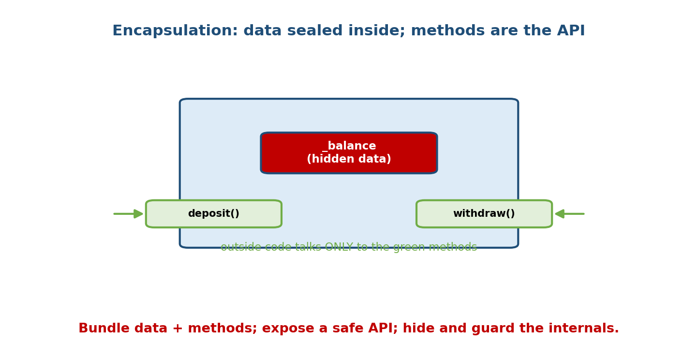
An object like a capsule: the balance data is sealed inside; outside code interacts only through deposit()/withdraw() methods.
class BankAccount:
def __init__(self, balance=0):
self._balance = balance # hidden state (by convention)
def deposit(self, amount):
if amount <= 0:
raise ValueError("must be positive")
self._balance += amount # the ONLY sanctioned way to change it
@property
def balance(self): # read-only view
return self._balance
Without encapsulation, any code could do acc._balance = -1_000_000 and break the invariant. Encapsulation makes the intended path the guarded path.
Analogy: a medicine capsule — the active ingredients (data) are sealed inside; you interact via the capsule (the API), not by touching the powder.

4.2 Access Levels in Python (all by convention)
Unlike Java/C++, Python has no private/protected/public keywords. It uses naming conventions plus one mild mechanism (name mangling).
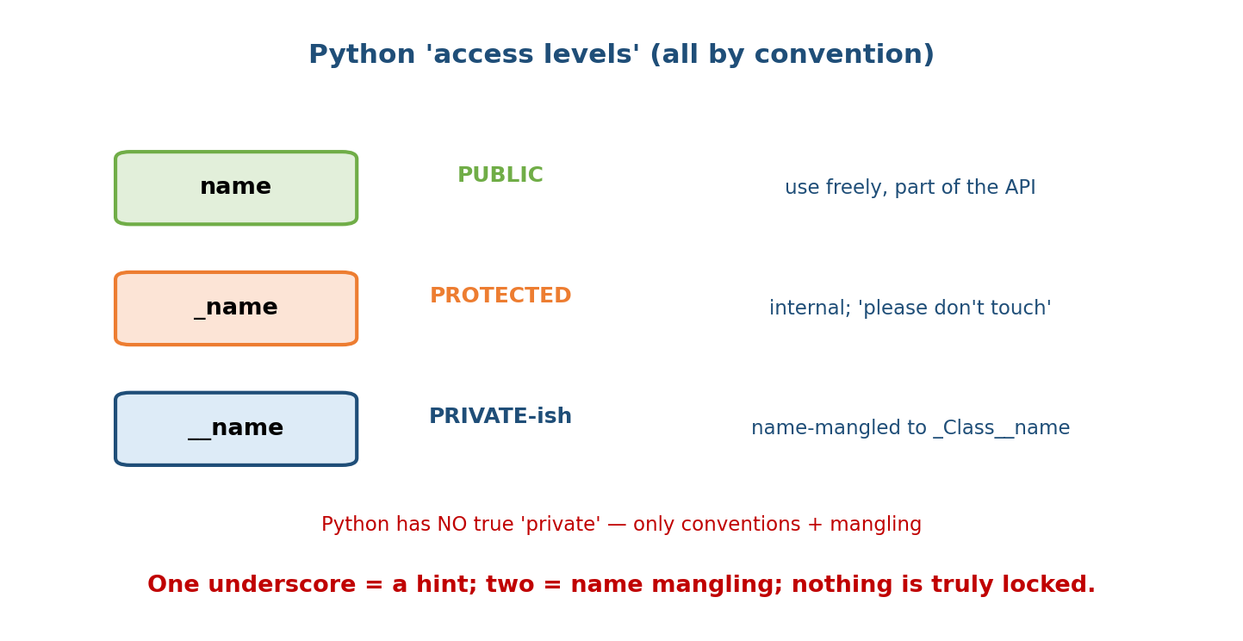
Three conventions: public ‘name’ (use freely), _name (protected, internal), __name (private-ish, name-mangled); none is truly locked.
Convention | Meaning | Enforced?
name | public — part of the intended API | —
_name | “protected” — internal; “please don’t touch from outside” | No (convention only)
__name | “private-ish” — triggers name mangling | Partially (mangled, not locked)
class Demo:
def __init__(self):
self.public = 1
self._internal = 2 # convention: don't rely on this from outside
self.__mangled = 3 # becomes _Demo__mangled
The Python philosophy (PEP 8): “We’re all consenting adults here.” The language trusts you rather than locking doors. _x communicates intent; it does not prevent access.

4.3 Name Mangling — what __x really does
A name with two leading underscores (and at most one trailing) is mangled by the compiler to _ClassName__name. Its purpose is not security — it is to avoid accidental name clashes between a class and its subclasses.
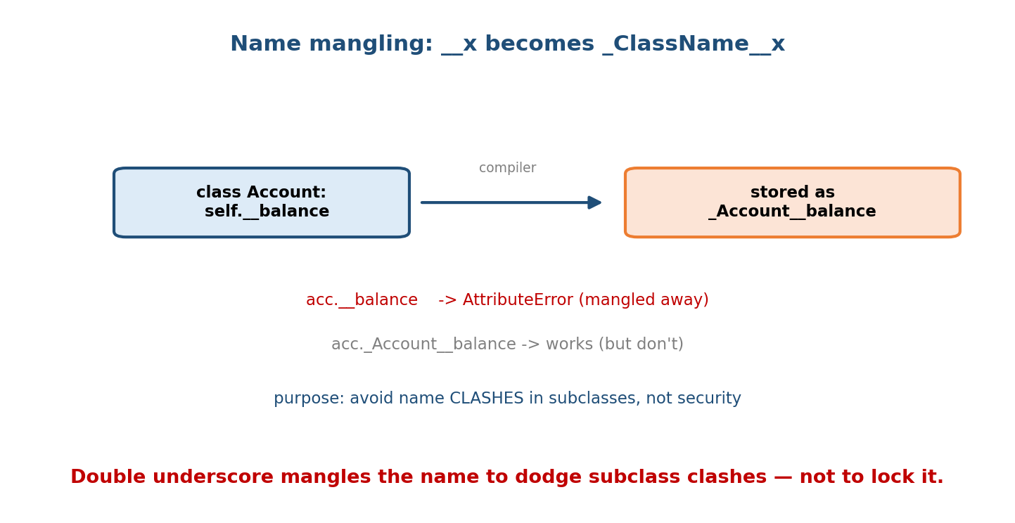
self.__balance in class Account is stored as _Account__balance; acc.__balance raises AttributeError, but acc._Account__balance still works.
class Account:
def __init__(self):
self.__balance = 100 # stored as _Account__balance
acc = Account()
# print(acc.__balance) # AttributeError
print(acc._Account__balance) # 100 -> still reachable (not truly private)
print(acc.__dict__) # {'_Account__balance': 100}
Why it helps subclasses: if a base class uses self.__id and a subclass also uses self.__id, mangling keeps them as _Base__id and _Sub__id — no collision.
Interview answer: “__x is name-mangled to _Class__x to prevent subclass name clashes, not to enforce privacy. Python has no true private members; _x is a convention and __x is mangling.”

4.4 @property — attribute syntax, method power
Often you start with a plain public attribute, then later need validation or a computed value. In Java you’d have written getters/setters up front “just in case.” In Python you don’t — you start public and upgrade to a @property later without changing any caller code.
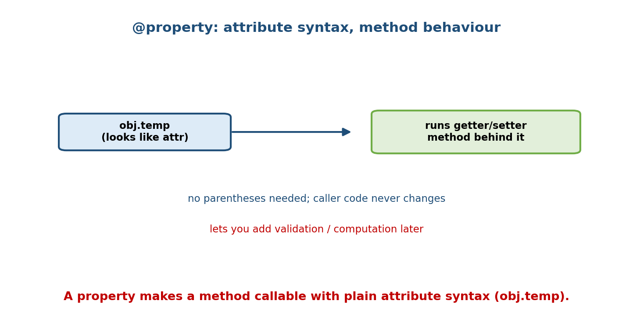
obj.temp looks like a plain attribute access but runs a getter/setter method behind it; callers never use parentheses or change.
A @property turns a method into something accessed like an attribute:
class Circle:
def __init__(self, radius):
self.radius = radius
@property
def area(self): # accessed as circle.area (NO parentheses)
return 3.14159 * self.radius ** 2
c = Circle(10)
print(c.area) # 314.159 -> computed on access, read-only

Getter + setter + validation
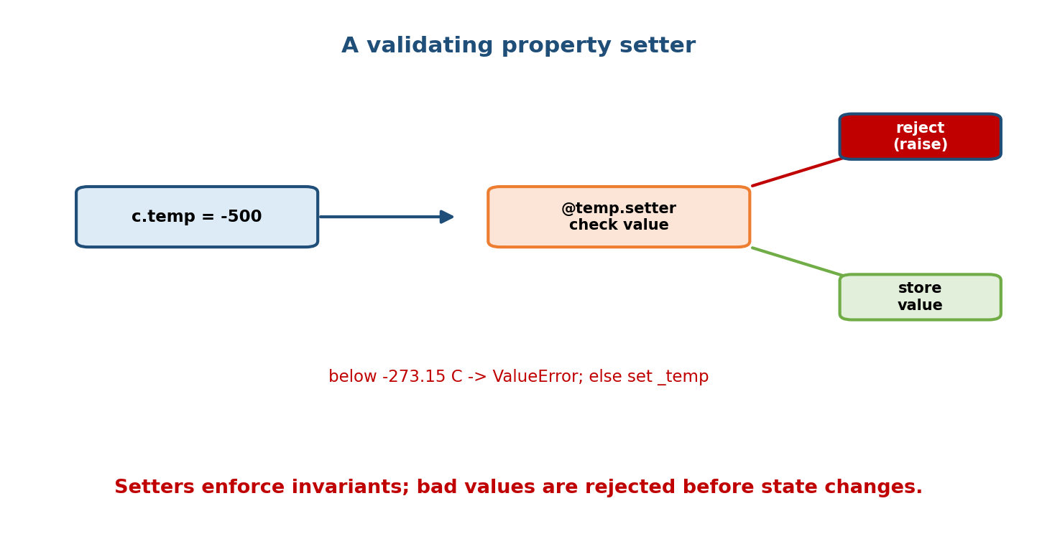
Assigning c.temp = -500 routes through the @temp.setter, which validates: below -273.15 it raises, otherwise it stores the value.
class Temperature:
def __init__(self, celsius=0):
self.celsius = celsius # goes through the setter below
@property
def celsius(self): # getter
return self._celsius
@celsius.setter
def celsius(self, value): # setter with validation
if value < -273.15:
raise ValueError("below absolute zero")
self._celsius = value
@property
def fahrenheit(self): # computed, read-only
return self._celsius * 9 / 5 + 32
t = Temperature(25)
print(t.fahrenheit) # 77.0
t.celsius = 100 # validated on the way in
# t.celsius = -500 # ValueError
- Read-only property: define only a getter (like fahrenheit/area).
- Deleter: @celsius.deleter handles del obj.celsius.
Golden rule: don’t write get_x()/set_x() in Python. Expose the attribute publicly; if logic is needed later, convert it to a @property — callers keep writing obj.x.

4.5 Abstraction — expose what, hide how
Abstraction is presenting a simple, essential interface and hiding the complex implementation behind it. You call list.sort(); you neither know nor care that it runs Timsort.
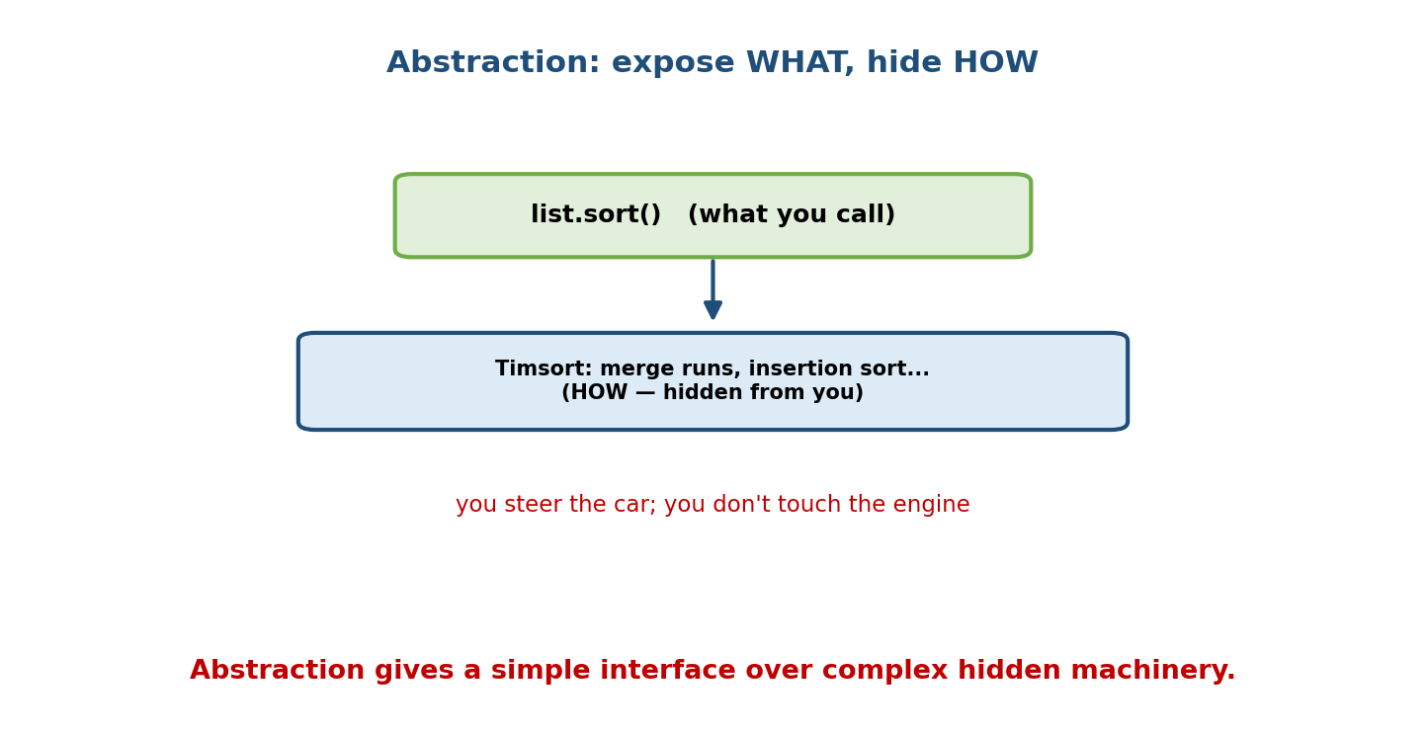
list.sort() is the simple ‘what’ you call; the Timsort algorithm underneath is the ‘how’, hidden from you.
- Encapsulation answers “who can touch the data?” (bundling + hiding).
- Abstraction answers “what does the user need to see?” (simplify + hide complexity).
They’re related but distinct — a favourite interview distinction:
 | Encapsulation | Abstraction
Focus | data protection (access control) | design simplicity (hide complexity)
Level | implementation detail | design/interface level
Achieved by | _/__, properties, methods | ABCs, interfaces, clean method APIs
Question | “how do I protect state?” | “what should the caller see?”

4.6 Abstract Base Classes (ABCs) — defining an interface
An abstract class cannot be instantiated; it defines a contract (methods subclasses must implement). Use the abc module.
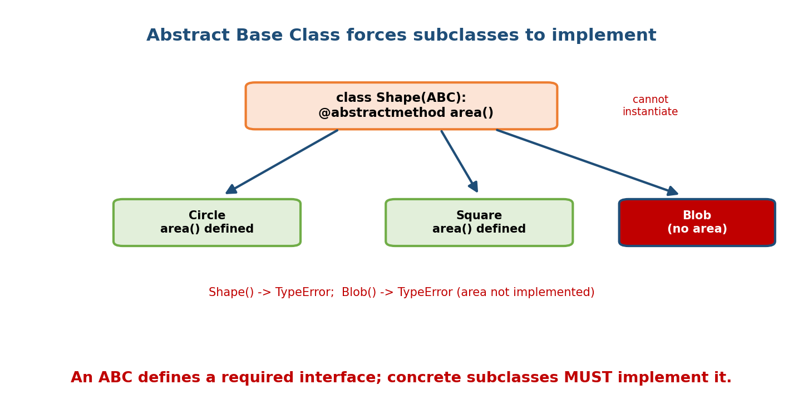
An ABC Shape with an abstractmethod area() cannot be instantiated; Circle and Square implement area() and work, but a Blob without area() raises TypeError.
from abc import ABC, abstractmethod
class Shape(ABC): # inherit ABC
@abstractmethod
def area(self): # no body — subclasses MUST define it
...
def describe(self): # ABCs may also have concrete methods
return f"A shape with area {self.area()}"
class Circle(Shape):
def __init__(self, r): self.r = r
def area(self): return 3.14159 * self.r ** 2
# Shape() # TypeError: Can't instantiate abstract class Shape
c = Circle(10)
print(c.describe()) # A shape with area 314.159
class Blob(Shape): # forgot to implement area()
pass
# Blob() # TypeError: abstract method 'area' not implemented
Why ABCs help: they turn “I hope subclasses implement area” into a guaranteed, checked contract — you find missing methods at instantiation time, not deep in production. They also enable isinstance checks against an interface and can register virtual subclasses. (Structural alternatives — Protocols — come in Module 11.)
- Abstract class = a base with at least one @abstractmethod; may hold shared concrete methods + state.
- “Interface” = (informally) an abstract class whose methods are all abstract — Python has no interface keyword; ABCs and Protocols fill that role.

4.7 When NOT to Over-Encapsulate (Pythonic balance)
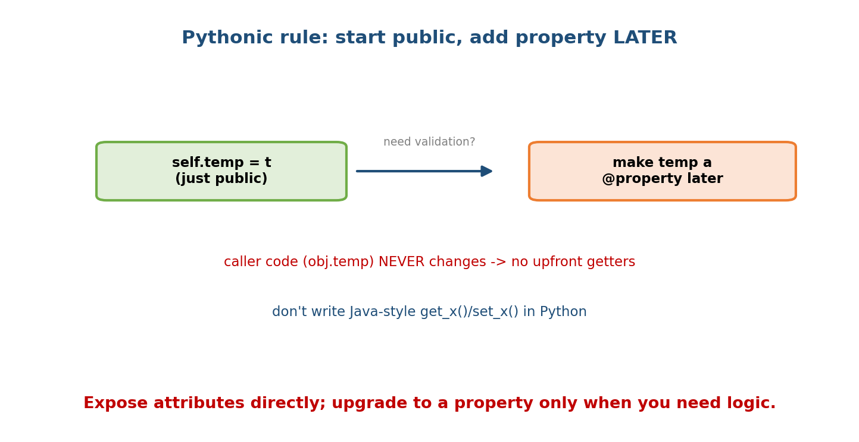
Pythonic rule: start with a public attribute; only if you later need validation, convert it to a @property — caller code (obj.temp) never changes.
- Don’t wrap every attribute in a getter/setter “for safety.” Start public.
- Do switch to @property the moment you need validation, computation, or a read-only view — callers are unaffected.
- Don’t use __x reflexively; reserve it for genuine subclass-clash avoidance. _x is the usual “internal” marker.
This restraint is a hallmark of Pythonic code and a thing senior interviewers listen for: “In Python I’d expose it directly and promote to a property if I need logic, rather than writing boilerplate accessors.”

Module 4 — Interview Mapping
Question | Junior answer | Senior answer
“Encapsulation vs abstraction?” | “Hiding data vs hiding complexity.” | Adds the table: encapsulation = access control (implementation); abstraction = simple interface (design); one protects state, the other simplifies use.
“Does Python have private?” | “Use __.” | “No true private. _x is convention; __x is name mangling to _Class__x to avoid subclass clashes, still reachable. Privacy is by convention — ‘consenting adults.’”
“Why @property?” | “Getters/setters.” | “To add validation/computation/read-only behind attribute syntax without changing callers — so you avoid upfront Java-style accessors.”
“What’s an ABC for?” | “A base class.” | “To define a checked interface: abstract methods that subclasses must implement; can’t instantiate the ABC; failures surface at instantiation.”

Module 4 — Exam Mapping
- GATE CS: definitions and differences of encapsulation/abstraction; access specifiers (careful — Python differs from C++/Java theory).
- SEBI / RBI IT: encapsulation definition; access modifier concepts.
- FAANG: properties with validation in live code; ABC-based design; the Pythonic “start public” judgment; name-mangling trivia.

Module 4 — Common Mistakes & Misconceptions
- “__x makes it private.” It’s name-mangled, still accessible via _Class__x.
- Confusing encapsulation with abstraction. Access control vs interface simplicity.
- Writing get_x()/set_x() everywhere. Un-Pythonic; use public attrs → @property when needed.
- Calling a property with () — c.area() fails; it’s c.area.
- Instantiating an ABC — TypeError; ABCs are contracts, not concrete types.
- Putting validation in __init__ only — direct later assignment bypasses it; a @property setter validates every assignment.

Module 4 — MCQs (with answers & explanations)
Q1. In Python, __balance inside class Account is stored as: a) __balance b) _Account__balance c) hidden/inaccessible d) private_balance
Answer
b. Name mangling rewrites it to _Account__balance.
Q2. The main purpose of name mangling is: a) security b) speed c) avoiding name clashes in subclasses d) encryption
Answer
c. It prevents accidental attribute collisions between base and subclass.
Q3. Encapsulation is best described as: a) hiding complexity behind a simple interface b) bundling data with methods and controlling access to it c) inheritance d) overloading
Answer
b. That’s encapsulation; option (a) is abstraction.
Q4. You access a @property named area via: a) obj.area() b) obj.area c) obj.get_area() d) area(obj)
Answer
b. Properties use attribute syntax — no parentheses.
Q5. Trying to instantiate an ABC with an unimplemented abstract method: a) works b) warns c) raises TypeError d) returns None
Answer
c. Python refuses to instantiate until all abstract methods are implemented.
Q6. The Pythonic approach to a field that might later need validation: a) write getters/setters now b) expose it publicly, convert to @property later c) use __field d) make it global
Answer
b. Callers keep obj.field; you add logic transparently later.
Q7. Which enforces a checked interface contract? a) _method b) a docstring c) @abstractmethod in an ABC d) a comment
Answer
c. Abstract methods must be implemented by concrete subclasses.
Q8. A read-only property is created by: a) @property.readonly b) defining only a getter (no setter) c) using __ d) final
Answer
b. With no setter, assignment raises AttributeError.

Module 4 — Design/Practice Exercises (easy → hard)
- (easy) Give BankAccount a read-only balance property and a deposit method that validates positivity.
- (easy) Show that __x is reachable via _Class__x and print __dict__.
- (medium) Convert a public Rectangle.width into a validated property that rejects non-positive values — without changing existing caller code.
- (medium) Define an ABC PaymentMethod with abstract pay(amount); implement CardPayment and UpiPayment; prove PaymentMethod() fails.
- (hard) Add a computed, read-only Rectangle.area and a settable Rectangle. diagonal that adjusts width/height proportionally, all via properties.
- (hard, interview) Explain to a Java developer why you wouldn’t add getters and setters to every field in Python, and demonstrate the “promote to property” upgrade path.

Module 4 — Concept Review (one page)
Encapsulation bundles data with the methods that guard it and controls access to protect invariants; abstraction presents a simple interface while hiding complex implementation. Python has no real access modifiers: name is public, _name is a “please don’t touch” convention, and __name is name-mangled to _Class__name to avoid subclass clashes (still reachable — privacy is by convention). @property lets a method be used with attribute syntax, enabling validation, computed values, and read-only fields without changing callers — so Python code starts with public attributes and promotes to properties only when logic is needed (never upfront getters/setters). Abstract Base Classes (abc module, @abstractmethod) define checked interfaces: they can’t be instantiated, and concrete subclasses must implement every abstract method.

Module 4 — Flash Cards (Q → A)
Front | Back
Encapsulation (1 line) | bundle data + methods; control access to protect invariants
Abstraction (1 line) | expose a simple interface; hide complex implementation
_x means | “internal / protected” by convention (not enforced)
__x does what | name mangling to _Class__x (avoid subclass clashes)
Does Python have private? | No true private; convention + mangling only
@property gives you | method logic behind attribute syntax (validate/compute/read-only)
Access a property | obj.x (no parentheses)
Read-only property | define only a getter
ABC purpose | define a checked interface; can’t instantiate; forces implementation
Abstract method decorator | @abstractmethod
Pythonic accessor rule | start public → promote to @property when logic is needed

Module 4 — Pattern Recognition
- See “this value must always be valid” → @property setter with validation.
- See “computed from other fields, no storage” → read-only @property.
- See “several classes must all provide method X” → ABC with @abstractmethod.
- See “internal helper attribute” → prefix _.
- See “base and subclass both use __id” → mangling keeps them separate.
- See Java-style get_/set_ in Python → refactor to public attr / property.

Module 4 — Revision Notes / Mini Cheat Sheet
ENCAPSULATION = bundle data + methods + control access (protect invariants).
ABSTRACTION = simple interface, hide complexity. (encaps=access; abstr=design)
ACCESS (convention only):
name public (API)
_name "protected" internal hint
__name name-mangled -> _Class__name (avoid subclass clashes; NOT private)
Python has NO true private -> "we're all consenting adults".
@property: method used as attribute (obj.x, no parens).
getter only -> read-only / computed
@x.setter def x(...) -> validate on assignment
@x.deleter -> handle del obj.x
RULE: start public; promote to property later; NO upfront getters/setters.
ABC (abc module): class Shape(ABC); @abstractmethod def area(self): ...
- cannot instantiate ABC or subclass missing an abstract method (TypeError)
- defines a CHECKED interface; may include concrete methods/state.
Next module: Module 5 — Inheritance & Composition. With encapsulated, abstracted classes in hand, we reuse and extend them: single/multiple inheritance, super(), the Method Resolution Order (MRO) and the diamond problem, and the crucial design maxim “favour composition over inheritance.”

Module 4 — Summary
Encapsulation and abstraction are two of OOP’s four pillars. Encapsulation bundles data with the methods that guard it and controls access to protect invariants; abstraction hides complex implementation behind a simple interface. Python enforces neither with keywords — it uses conventions (_name for internal, __name for name mangling that dodges subclass clashes) under the “consenting adults” philosophy. The @property decorator provides validation, computed values, and read-only fields behind ordinary attribute syntax, so Python code favours public attributes upgraded to properties on demand rather than upfront accessors. Abstract Base Classes define checked interfaces that concrete subclasses must fulfil. Together these give you classes that are safe to use, clean to read, and reliable to extend.
You have mastered this module when you can: state the difference between encapsulation and abstraction; explain _x, __x, and name mangling accurately; convert a plain attribute into a validated property with zero caller changes; and define and use an ABC as an interface.

