Module 5 — Inheritance & Composition
  - OOP with Python Mastery: FAANG Interviews / GATE / SEBI-RBI IT / Backend — In-Depth Notes (with visuals)
Prepared for nidhi.sharma@forensiccybertech.com
2026
Table of Contents

Module 5 — Inheritance & Composition
Why this module matters. Inheritance is how classes reuse and extend each other — and it is where Python’s OOP gets genuinely deep because Python allows multiple inheritance, which forces a precise answer to “if two parents define the same method, which wins?” That answer is the MRO (Method Resolution Order) computed by C3 linearisation — a guaranteed FAANG interview topic. Just as important is the design wisdom that balances it: “favour composition over inheritance.” Get both the mechanism (MRO, super()) and the judgment (is-a vs has-a) and you can design class hierarchies that don’t rot.
Importance ratings (out of 5):
Exam / Use | FAANG Interview | GATE CS | SEBI/RBI IT | Backend Dev | LLD Rounds
This module | ★★★★★ | ★★★★ | ★★★ | ★★★★ | ★★★★★
Most-asked concepts: super() and cooperative inheritance; the diamond problem and MRO/C3; single vs multiple inheritance; composition vs inheritance (“favour composition”); aggregation vs composition; mixins; isinstance/issubclass; method overriding.
What you must be able to do after this module: write a subclass that overrides and extends via super(); compute and explain an MRO for a diamond; decide is-a vs has-a for a design; and explain why composition is usually safer than deep inheritance.

5.1 Inheritance Basics — the “is-a” relationship
Inheritance lets a subclass (child) reuse and extend a superclass (parent). The child automatically gets the parent’s attributes and methods, and can add new ones or override existing ones. The relationship is “is-a”: a Dog is an Animal.
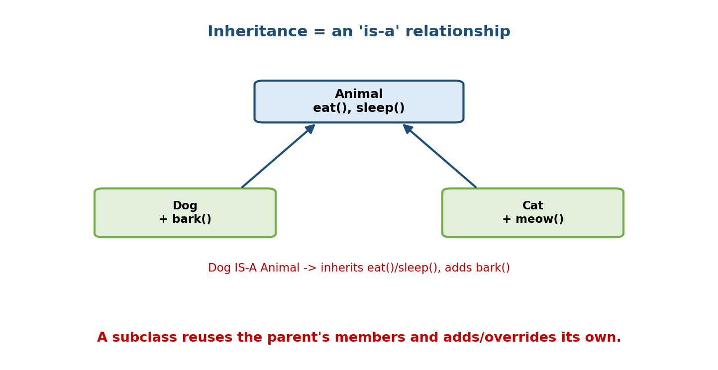
Animal defines eat() and sleep(); Dog and Cat inherit those and each add their own method (bark, meow) — an is-a relationship.
class Animal:
def __init__(self, name):
self.name = name
def eat(self):
return f"{self.name} is eating"
class Dog(Animal): # Dog inherits from Animal
def bark(self):
return "Woof!"
d = Dog("Rex")
print(d.eat()) # inherited: "Rex is eating"
print(d.bark()) # own method: "Woof!"
print(isinstance(d, Animal)) # True — a Dog IS-A Animal
print(issubclass(Dog, Animal)) # True
Every class implicitly inherits from object, the root of all types.

5.2 Overriding + super()
A subclass can override a method by redefining it. Usually you don’t want to replace the parent’s work but extend it — call super() to run the parent’s version, then add to it.
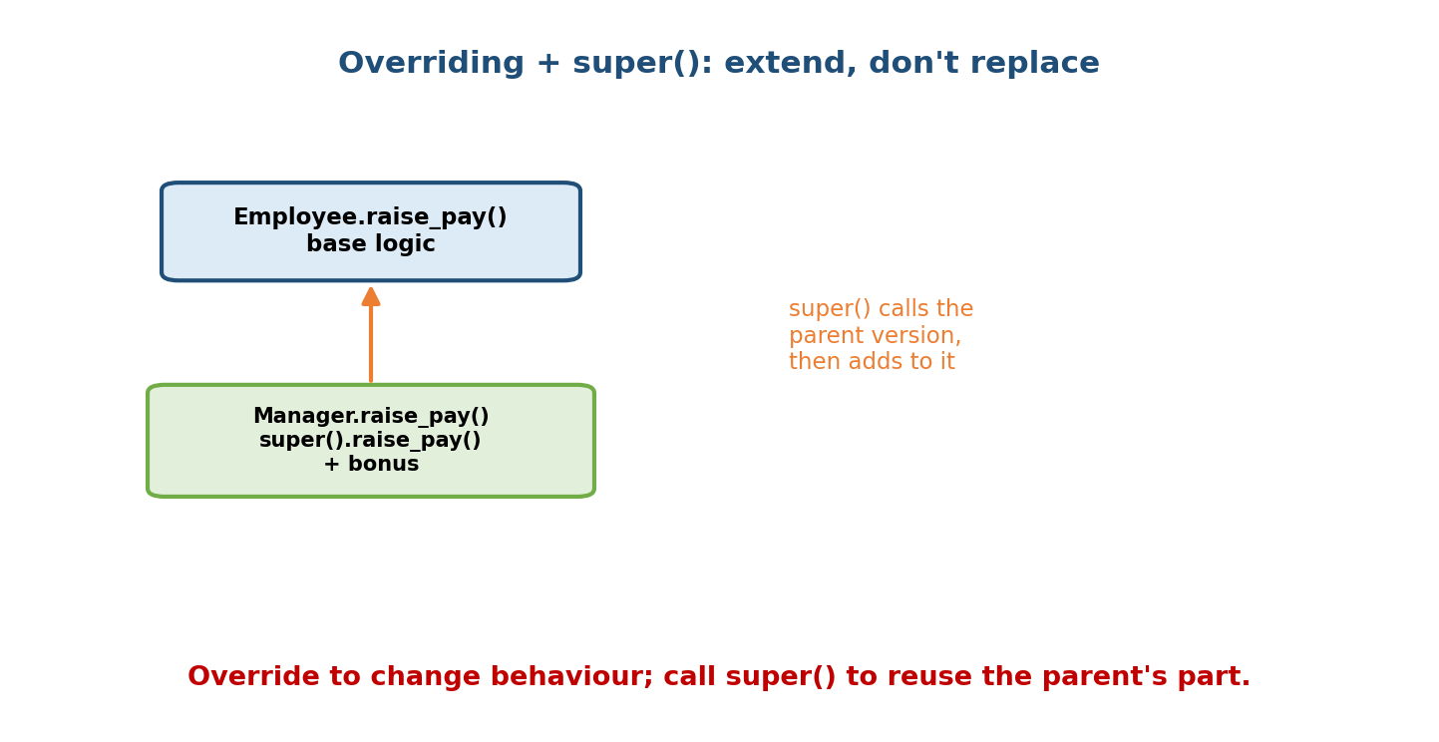
Manager.raise_pay() overrides Employee.raise_pay() but calls super().raise_pay() to reuse the base logic, then adds a bonus.
class Employee:
def __init__(self, name, salary):
self.name = name
self.salary = salary
class Manager(Employee):
def __init__(self, name, salary, reports):
super().__init__(name, salary) # reuse parent's __init__
self.reports = reports # then add manager-specific state
m = Manager("Asha", 200000, ["Rob", "Sam"])
print(m.name, m.salary, m.reports) # Asha 200000 ['Rob', 'Sam']
super() returns a proxy that dispatches to the next class in the MRO (§5.4) — not necessarily the literal parent. This matters enormously under multiple inheritance. Always prefer super().__init__(...) over Parent.__init__(self, ...) — the latter breaks cooperative multiple inheritance.

5.3 Types of Inheritance
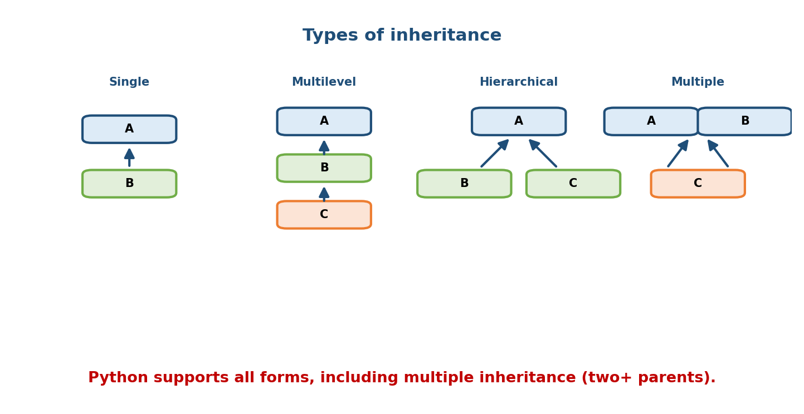
Four inheritance shapes: single (B from A), multilevel (C from B from A), hierarchical (B and C both from A), and multiple (C from both A and B).
Type | Shape | Example
Single | one parent | Dog(Animal)
Multilevel | chain | Puppy(Dog(Animal))
Hierarchical | many children, one parent | Dog(Animal), Cat(Animal)
Multiple | two+ parents | class C(A, B)
Hybrid | a mix (often creates diamonds) | combos of the above
Python supports all of these — including multiple inheritance, which Java/C# deliberately forbid (they allow multiple interfaces only). Multiple inheritance is powerful (mixins) but introduces the diamond problem.

5.4 The Diamond Problem & the MRO
The diamond problem: D inherits from B and C, both of which inherit from A. If you call d.method() and every class defines it, which one runs?
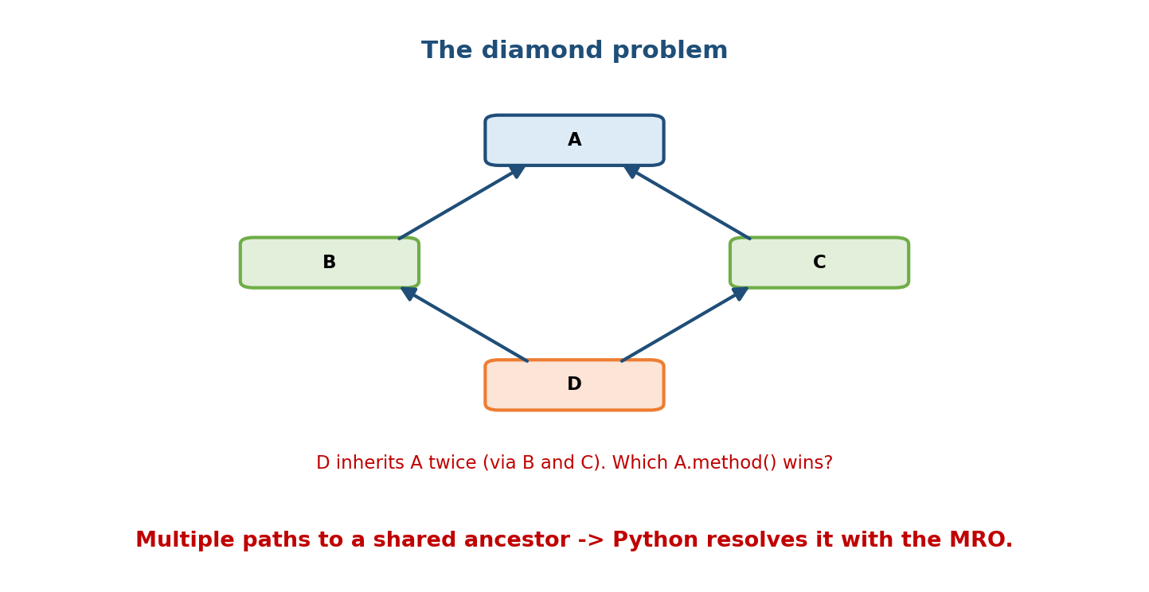
D inherits from B and C, which both inherit from A: a diamond. Calling a method D inherits along two paths raises the question of which ancestor’s version wins.
Python answers with the MRO (Method Resolution Order) — a single, deterministic ordering of all ancestors, computed by the C3 linearisation algorithm.
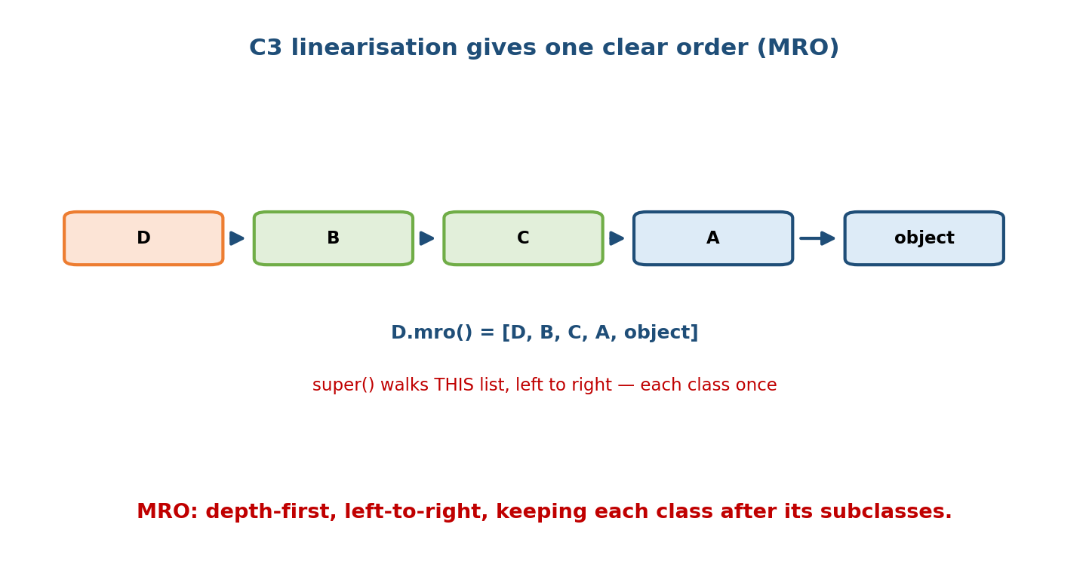
The MRO for the diamond is [D, B, C, A, object]; super() walks this list left to right, visiting each class exactly once.
class A:
def who(self): return "A"
class B(A):
def who(self): return "B -> " + super().who()
class C(A):
def who(self): return "C -> " + super().who()
class D(B, C):
def who(self): return "D -> " + super().who()
print(D.__mro__) # (D, B, C, A, object)
print(D().who()) # D -> B -> C -> A <-- each class once, in MRO order
C3 rules (intuition): the MRO is depth-first, left-to-right, but with the constraint that a class always appears before its parents, and each class appears exactly once. Crucially, A comes after both B and C — super() in B goes to C (not straight to A), which is why every class’s contribution runs exactly once. This is cooperative multiple inheritance, and it only works if everyone uses super().
Interview gold: “How does Python resolve the diamond problem?” → “With a deterministic MRO via C3 linearisation; super() follows the MRO, so each ancestor runs once. Check it with Class.__mro__ or Class.mro().”

5.5 Mixins — capability injection via (multiple) inheritance
A mixin is a small class that provides one focused capability to be “mixed into” other classes via inheritance. Mixins aren’t meant to be instantiated alone and usually hold no state.
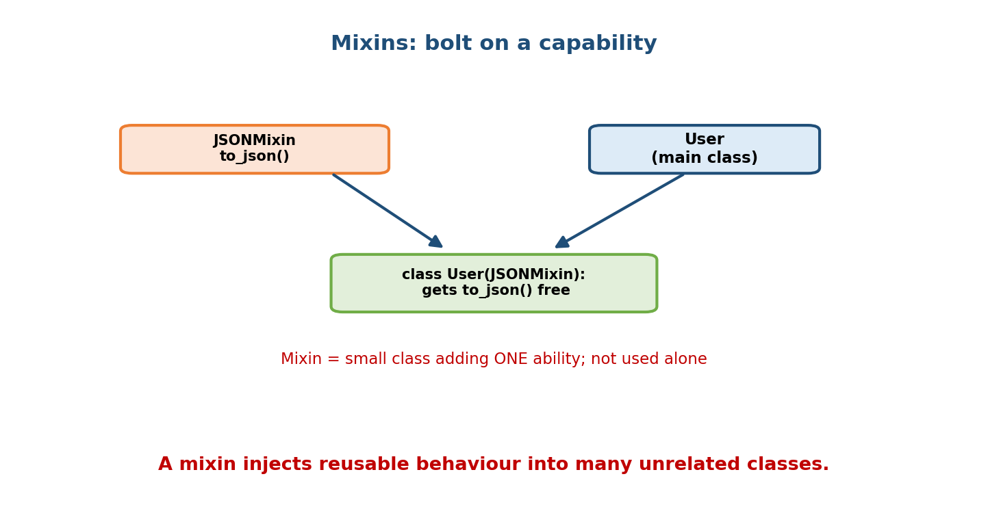
A JSONMixin providing to_json() is mixed into a User class via class User(JSONMixin, …), giving User serialisation for free.
class JSONMixin:
def to_json(self):
import json
return json.dumps(self.__dict__)
class User(JSONMixin): # User gains to_json() for free
def __init__(self, name):
self.name = name
print(User("Nidhi").to_json()) # {"name": "Nidhi"}
Django and DRF (LoginRequiredMixin, ListModelMixin) use this heavily. Mixins are the good face of multiple inheritance: small, orthogonal, super()-friendly.

5.6 Composition — the “has-a” relationship
Composition builds complex objects by containing other objects rather than inheriting from them. The relationship is “has-a”: a Car has an Engine.
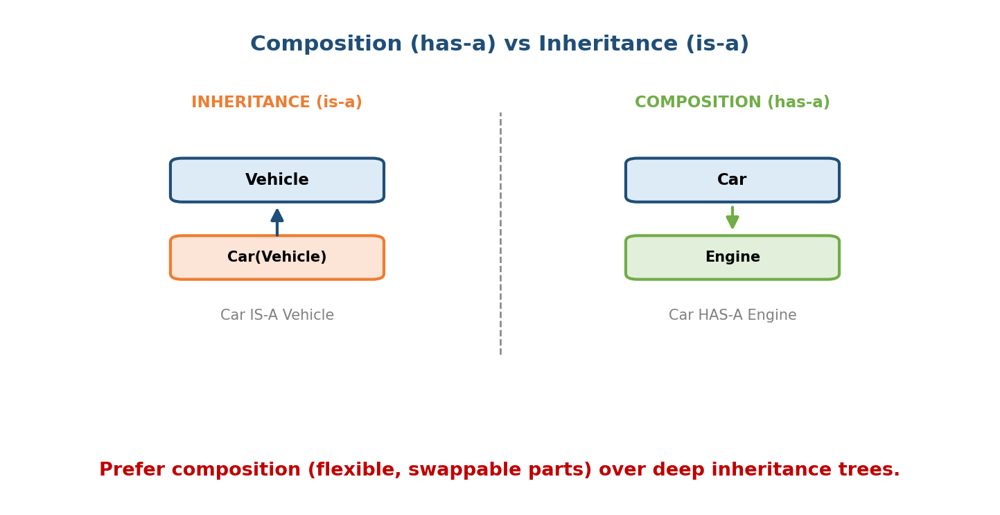
Inheritance models ‘is-a’ (Car is-a Vehicle); composition models ‘has-a’ (Car has-a Engine) by holding a reference to another object.
class Engine:
def start(self): return "engine started"
class Car:
def __init__(self):
self.engine = Engine() # Car HAS-A Engine (composition)
def start(self):
return self.engine.start() # delegate to the part

Why “favour composition over inheritance”
Concern | Deep inheritance | Composition
Coupling | tight (subclass depends on parent internals) | loose (talks via the part’s API)
Flexibility | fixed at class-definition time | swap parts at runtime
Fragility | “fragile base class” — parent change breaks children | isolated
Reuse | only along the is-a axis | any part, any class
The maxim: use inheritance for genuine is-a relationships with shared behaviour; use composition for has-a and for combining behaviours. Deep inheritance trees are a top source of unmaintainable OOP (see M13 Strategy pattern, which replaces inheritance with composition).

5.7 Aggregation vs Composition (a UML distinction)
Both are “has-a”, but they differ in ownership / lifecycle:
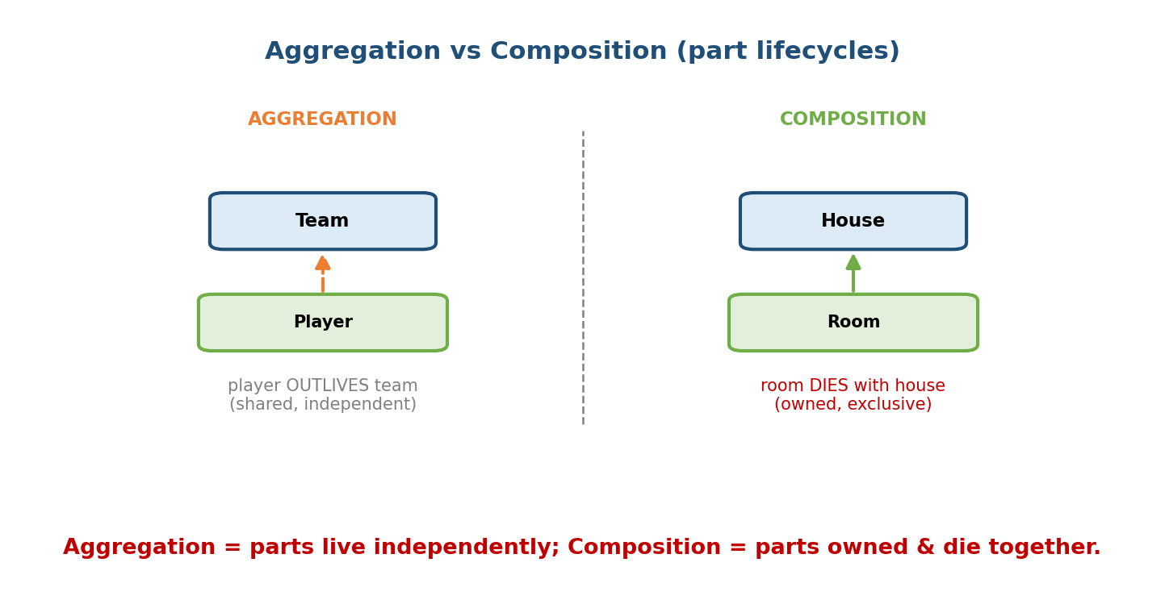
Aggregation: a Team has Players who outlive the team (shared, independent). Composition: a House has Rooms that are destroyed with the house (owned, exclusive).
 | Aggregation (“has-a”, weak) | Composition (“owns-a”, strong)
Lifecycle | part outlives the whole | part dies with the whole
Ownership | shared / independent | exclusive
Example | Team has Players (players exist without the team) | House has Rooms (rooms gone if house demolished)
UML | hollow diamond ◇ | filled diamond ◆
# Aggregation: players passed in, live independently
class Team:
def __init__(self, players):
self.players = players # references to external objects
# Composition: rooms created and owned by the house
class House:
def __init__(self):
self.rooms = [Room(), Room()] # created + owned here

5.8 isinstance, issubclass, and object
isinstance(d, Animal) # True — instance check (respects inheritance)
issubclass(Dog, Animal) # True — class relationship
type(d) is Dog # True — EXACT type (does NOT respect inheritance)
Prefer isinstance over type(x) == ... because isinstance honours subclasses (a Puppy is an Animal). Everything ultimately derives from object, which supplies default __init__, __str__, __eq__, etc. (Module 7).

Module 5 — Interview Mapping
Question | Junior answer | Senior answer
“Diamond problem?” | “Two parents, ambiguity.” | “Python resolves it with a deterministic MRO via C3 linearisation; super() follows the MRO so each ancestor runs once — cooperative inheritance.” + shows __mro__.
“super() — what does it do?” | “Calls the parent.” | “Returns a proxy to the next class in the MRO (not always the literal parent); essential for cooperative multiple inheritance; use it over Parent.__init__.”
“Composition vs inheritance?” | “has-a vs is-a.” | Adds why composition is favoured: loose coupling, runtime swap, avoids fragile base class; inheritance only for true is-a.
“Aggregation vs composition?” | (often blurred) | Lifecycle/ownership: composition parts die with the whole; aggregation parts live independently.

Module 5 — Exam Mapping
- GATE CS: MRO computation; types of inheritance; super() behaviour; is-a vs has-a.
- SEBI / RBI IT: definitions; single vs multiple inheritance; which languages allow multiple inheritance.
- FAANG: compute an MRO live; refactor an inheritance smell into composition; design with mixins; justify design choices.

Module 5 — Common Mistakes & Misconceptions
- Using Parent.__init__(self, ...) instead of super().__init__(...) — breaks cooperative multiple inheritance and can skip classes in the MRO.
- Thinking super() always means the immediate parent — it means the next class in the MRO.
- Overusing inheritance (“everything extends a base”) → fragile, deep trees; prefer composition.
- Confusing aggregation and composition (lifecycle is the key).
- type(x) == Cls for type checks — misses subclasses; use isinstance.
- Forgetting the child’s __init__ must call super().__init__ — parent state goes uninitialised.

Module 5 — MCQs (with answers & explanations)
Q1. For class D(B, C) where B(A) and C(A), the MRO is: a) D, A, B, C b) D, B, C, A, object c) D, C, B, A d) D, B, A, C
Answer
b. C3 linearisation: subclass first, left-to-right, ancestor after all its descendants; A comes after both B and C.
Q2. super() dispatches to: a) the base object b) the literal parent always c) the next class in the MRO d) a random parent
Answer
c. It follows the MRO, which is why cooperative inheritance works.
Q3. “A Car has an Engine” is: a) inheritance b) composition c) polymorphism d) an interface
Answer
b. has-a = composition; is-a would be inheritance.
Q4. Which best fits aggregation? a) House–Room b) University–Student (students exist without the university) c) Car–Engine d) Body–Heart
Answer
b. Students outlive/exist independently of the university — weak ownership.
Q5. Python allows multiple inheritance of: a) interfaces only b) classes c) neither d) abstract classes only
Answer
b. Unlike Java, Python allows multiple inheritance of concrete classes.
Q6. “Favour composition over inheritance” is advised mainly because: a) it’s faster b) it reduces coupling and avoids fragile base classes c) Python requires it d) it uses less memory
Answer
b. Composition is more flexible and less fragile than deep inheritance.
Q7. A mixin is: a) a large base class b) a small class adding one focused capability via inheritance c) a metaclass d) a decorator
Answer
b. Mixins inject orthogonal behaviour and aren’t used standalone.
Q8. To inspect a class’s method resolution order: a) Cls.order() b) Cls.__mro__ / Cls.mro() c) mro(Cls) d) Cls.__bases__ only
Answer
b. __mro__ (tuple) or mro() (list). __bases__ shows only direct parents.

Module 5 — Design/Practice Exercises (easy → hard)
- (easy) Create Animal with speak(); subclass Dog/Cat overriding it; confirm isinstance and issubclass.
- (easy) Add super().__init__ to a Manager(Employee) and show parent state is set.
- (medium) Build a diamond A/B/C/D, print D.__mro__, and trace the output of a cooperative who() chain.
- (medium) Write a TimestampMixin adding a created_at and mix it into two unrelated classes.
- (hard) Refactor a 3-level inheritance hierarchy (Vehicle → Car → ElectricCar) that’s becoming fragile into a composition design with a swappable Engine/Battery part.
- (hard, interview) Given class Duck(Flyer, Swimmer) where both define move() calling super().move(), predict the output and explain via the MRO.

Module 5 — Concept Review (one page)
Inheritance models is-a: a subclass reuses and extends a superclass, overriding methods and calling super() to reuse the parent’s part. super() dispatches to the next class in the MRO, not necessarily the literal parent — critical under multiple inheritance, which Python allows. When hierarchies form a diamond, Python resolves method lookup with a deterministic MRO computed by C3 linearisation (subclass first, left-to-right, ancestor after all descendants, each class once), enabling cooperative inheritance where every ancestor runs once — the basis of mixins. Composition models has-a by containing other objects and delegating to them; it is favoured over inheritance because it’s loosely coupled, runtime-swappable, and avoids fragile base classes. Aggregation vs composition differ by ownership/lifecycle: composed parts die with the whole; aggregated parts live independently.

Module 5 — Flash Cards (Q → A)
Front | Back
Inheritance relationship | “is-a” (Dog is-a Animal)
Composition relationship | “has-a” (Car has-a Engine)
super() dispatches to | the next class in the MRO
Diamond problem solution | deterministic MRO via C3 linearisation
MRO of D(B,C), B(A), C(A) | D, B, C, A, object
Inspect MRO | Cls.__mro__ / Cls.mro()
Does Python allow multiple inheritance? | Yes (of concrete classes)
Mixin | small class adding one capability via inheritance
Aggregation vs composition | parts independent vs parts owned & die with whole
Favour composition because | loose coupling, runtime swap, no fragile base class
isinstance vs type() == | isinstance respects subclasses; type == is exact
Root of all classes | object

Module 5 — Pattern Recognition
- See “X is a kind of Y with extra behaviour” → inheritance (class X(Y)).
- See “X is built from / uses a Y” → composition (hold a Y instance).
- See two parents defining the same method → reason via the MRO.
- See “add logging/serialisation/timestamps to many classes” → a mixin.
- See a deep, fragile class tree → refactor toward composition (Strategy, M15).
- See “part must be destroyed with the owner” → composition; else aggregation.

Module 5 — Revision Notes / Mini Cheat Sheet
INHERITANCE = is-a. class Child(Parent): ... reuse + override.
OVERRIDE + super().method() -> extend parent instead of replacing it.
ALWAYS super().__init__(...) (not Parent.__init__) for cooperative MI.
TYPES: single, multilevel, hierarchical, multiple (2+ parents), hybrid.
Python ALLOWS multiple inheritance of classes (Java: interfaces only).
DIAMOND: D(B,C), B(A), C(A) -> MRO via C3 linearisation:
rule: subclass before parents; left-to-right; ancestor after ALL descendants; each once.
D.__mro__ = (D, B, C, A, object). super() walks it -> each ancestor runs once.
MIXIN = small capability class mixed in via inheritance (LoginRequiredMixin...).
COMPOSITION = has-a. Hold another object + delegate. FAVOUR over inheritance:
loose coupling, runtime swap, no fragile base class.
AGGREGATION (weak, part independent, ◇) vs COMPOSITION (strong, part owned, ◆).
isinstance() respects subclasses; type(x) is C is exact. Root = object.
Next module: Module 6 — Polymorphism. With inheritance in place, we study the pillar that makes it pay off: one interface, many implementations — method overriding, duck typing (“if it quacks like a duck…”), operator overloading, and the difference between compile-time and run-time polymorphism (and why Python has no true method overloading).

Module 5 — Summary
Inheritance expresses is-a: a subclass reuses a superclass, overrides methods, and calls super() to extend rather than replace parent behaviour. Because Python permits multiple inheritance, it needs a precise Method Resolution Order, computed by C3 linearisation, which resolves the diamond problem deterministically and enables cooperative inheritance and mixins — provided everyone uses super(). Composition expresses has-a by containing and delegating to other objects, and is generally favoured over inheritance for its loose coupling and flexibility; the finer aggregation-vs-composition distinction turns on whether the part’s lifecycle is independent of, or owned by, the whole. Mastering both the mechanism (MRO/super()) and the judgment (is-a vs has-a) is what separates durable class designs from fragile ones.
You have mastered this module when you can: write cooperative subclasses with super(); compute and explain any diamond’s MRO; choose is-a vs has-a for a design and justify it; and articulate why composition is usually the safer default.

