Module 6 — Polymorphism
  - OOP with Python Mastery: FAANG Interviews / GATE / SEBI-RBI IT / Backend — In-Depth Notes (with visuals)
Prepared for nidhi.sharma@forensiccybertech.com
2026
Table of Contents

Module 6 — Polymorphism
Why this module matters. Polymorphism (“many forms”) is the pillar that makes inheritance and abstraction pay off: you write code against one interface, and it works for many different types — present and future — without if/elif type-checking. In Python this is supercharged by duck typing: an object doesn’t even need to inherit from anything — it just needs the right method. This module also clears up two things interviewers probe: why Python has no method overloading, and the difference between compile-time and run-time polymorphism.
Importance ratings (out of 5):
Exam / Use | FAANG Interview | GATE CS | SEBI/RBI IT | Backend Dev | LLD Rounds
This module | ★★★★★ | ★★★★ | ★★★ | ★★★★ | ★★★★★
Most-asked concepts: definition + types of polymorphism (ad-hoc, parametric, subtype, coercion); duck typing; method overriding = runtime polymorphism; operator overloading (dunders); “does Python support method overloading?” (no — and the workarounds); compile-time vs run-time.
What you must be able to do after this module: write polymorphic code using a shared method name across types; explain duck typing with an example; overload an operator with a dunder; explain why Python lacks overloading and show singledispatch/default-arg alternatives; and classify a given example by polymorphism type.

6.1 What Is Polymorphism?
Polymorphism = the ability of one interface (name/operation) to work with objects of many different types, each responding in its own way. The calling code stays the same; the behaviour varies with the object.
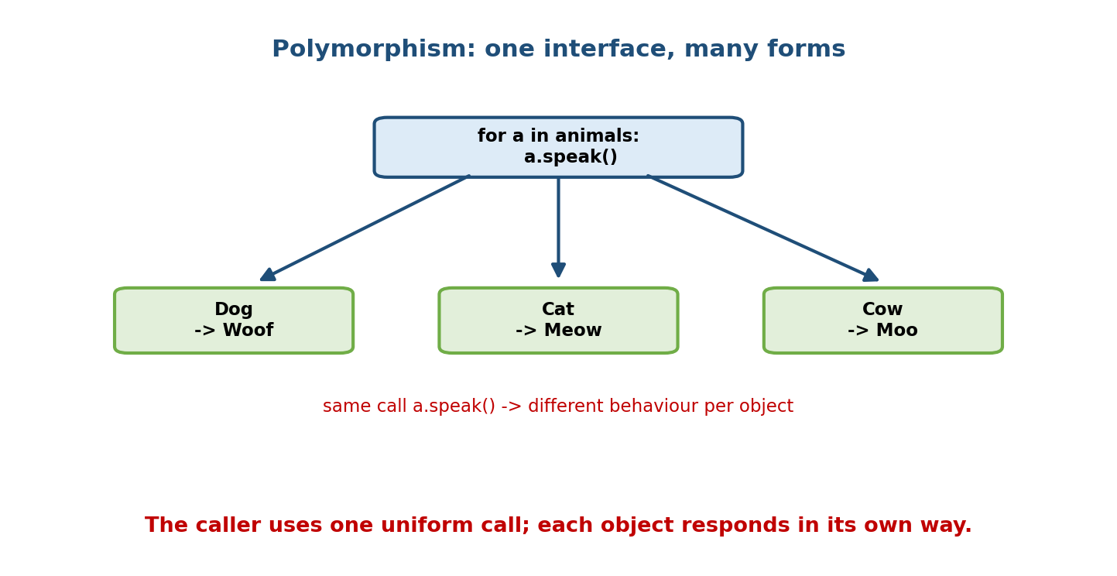
A single loop calling a.speak() produces Woof, Meow, or Moo depending on whether a is a Dog, Cat, or Cow — one interface, many forms.
class Dog:
def speak(self): return "Woof"
class Cat:
def speak(self): return "Meow"
class Cow:
def speak(self): return "Moo"
for animal in [Dog(), Cat(), Cow()]:
print(animal.speak()) # Woof / Meow / Moo — same call, many forms
The loop doesn’t check types or branch — it just calls speak(). Add a new animal tomorrow and the loop works unchanged. That absence of type-checking ifs is the whole point.

6.2 The Four Kinds of Polymorphism
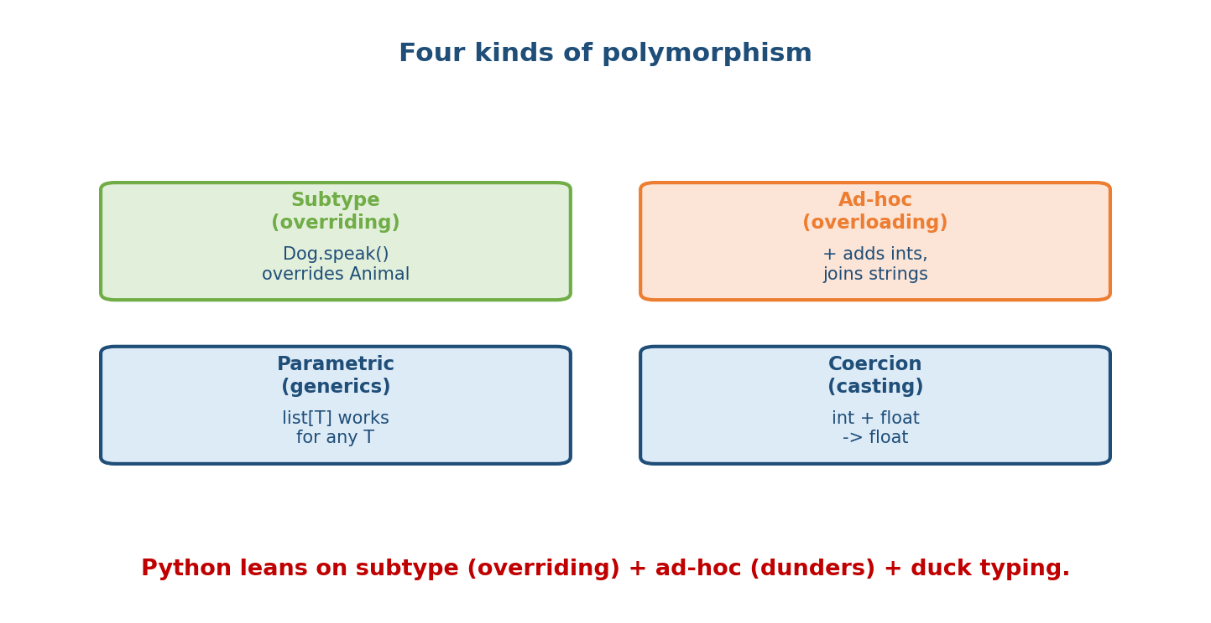
Four kinds: subtype (overriding), ad-hoc (overloading / operators), parametric (generics), and coercion (implicit casting).
Kind | Meaning | Python example
Subtype (inclusion) | subclass overrides a base method; resolved at runtime | Dog.speak() overriding Animal.speak()
Ad-hoc (overloading) | same operator/name, type-specific behaviour | + on ints vs strings (__add__)
Parametric (generics) | one implementation works for any type | list, dict, TypeVar (Module 11)
Coercion | implicit type conversion | 1 + 2.0 → float; truthiness
Python emphasises subtype (overriding) and ad-hoc (dunder operators), generalised by duck typing.

6.3 Subtype Polymorphism — overriding (runtime dispatch)
When a subclass overrides a method, calling it on an object runs the version matching the object’s actual runtime type — dynamic dispatch.
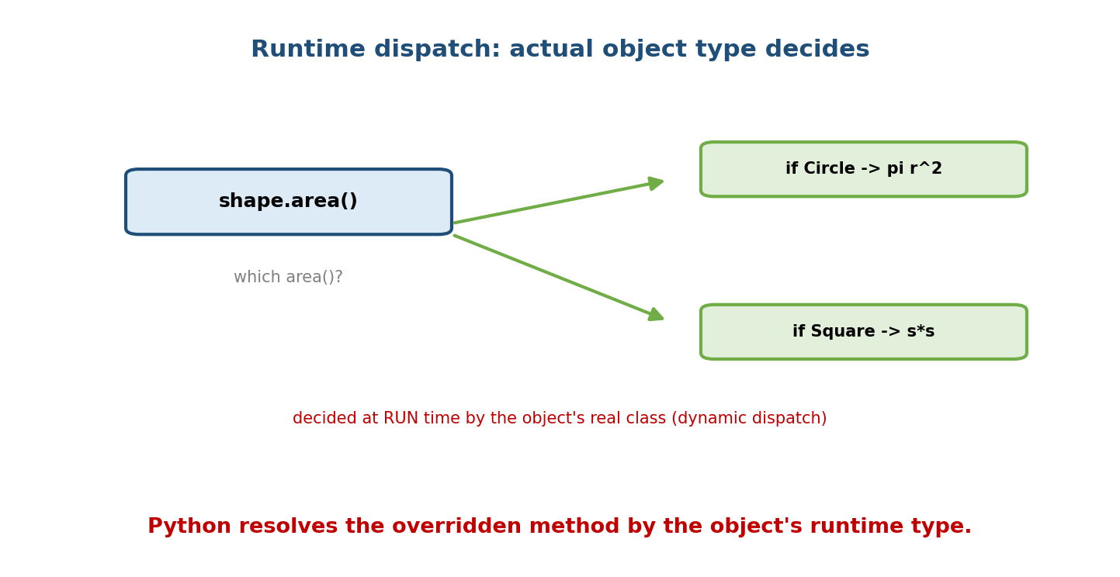
shape.area() dispatches at run time: if the object is a Circle it computes pir^2, if a Square it computes ss — decided by the object’s real class.
from abc import ABC, abstractmethod
class Shape(ABC):
@abstractmethod
def area(self): ...
class Circle(Shape):
def __init__(self, r): self.r = r
def area(self): return 3.14159 * self.r ** 2
class Square(Shape):
def __init__(self, s): self.s = s
def area(self): return self.s ** 2
def total_area(shapes):
return sum(s.area() for s in shapes) # polymorphic — no type checks
print(total_area([Circle(1), Square(2)])) # 3.14159 + 4
total_area neither knows nor cares which concrete shapes it gets — it relies on the shared area() interface. This is the engine behind the Open/Closed Principle (M13): add a new Shape subclass and total_area still works.

6.4 Duck Typing — Python’s superpower
“If it walks like a duck and quacks like a duck, it’s a duck.”
Duck typing means Python cares about what an object can do (its methods), not what it is (its class). No shared base class or interface is required — just the right method.
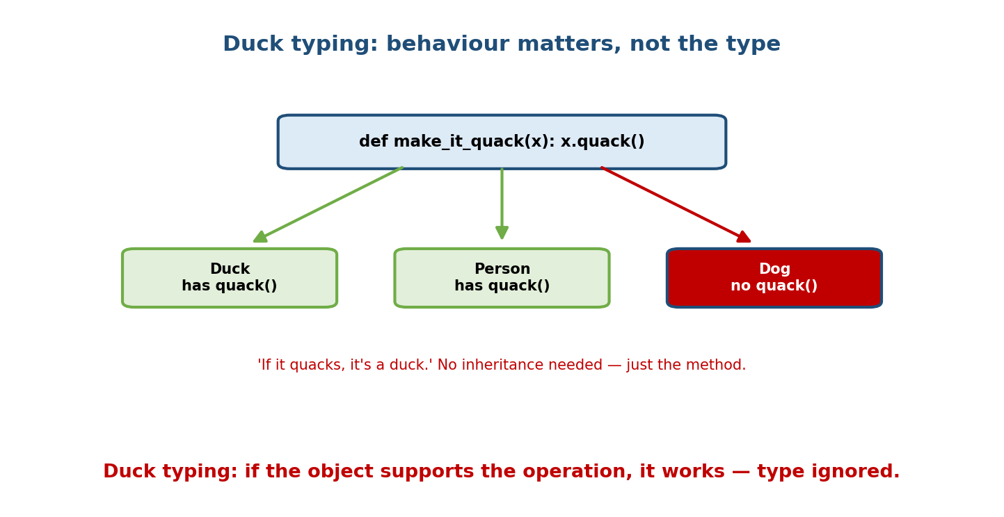
make_it_quack(x) calls x.quack(); a Duck and a Person both have quack() so both work, while a Dog without quack() fails — type is irrelevant, behaviour matters.
class Duck:
def quack(self): return "Quack!"
class Person:
def quack(self): return "I'm imitating a duck!"
def make_it_quack(thing):
return thing.quack() # no isinstance check; just needs .quack()
print(make_it_quack(Duck())) # Quack!
print(make_it_quack(Person())) # I'm imitating a duck! (unrelated class!)
This is why Python’s file-like objects, iterables, and context managers work so uniformly: any object implementing the right dunder methods (__iter__, read, __enter__, …) “is” that kind of thing. EAFP (“Easier to Ask Forgiveness than Permission”) is the matching style: just try the operation and catch failure, rather than checking types first.
try:
thing.quack()
except AttributeError:
print("can't quack")

6.5 Operator Overloading — ad-hoc polymorphism
The same operator behaves differently by type because operators dispatch to dunder methods (Module 7). a + b really calls a.__add__(b).
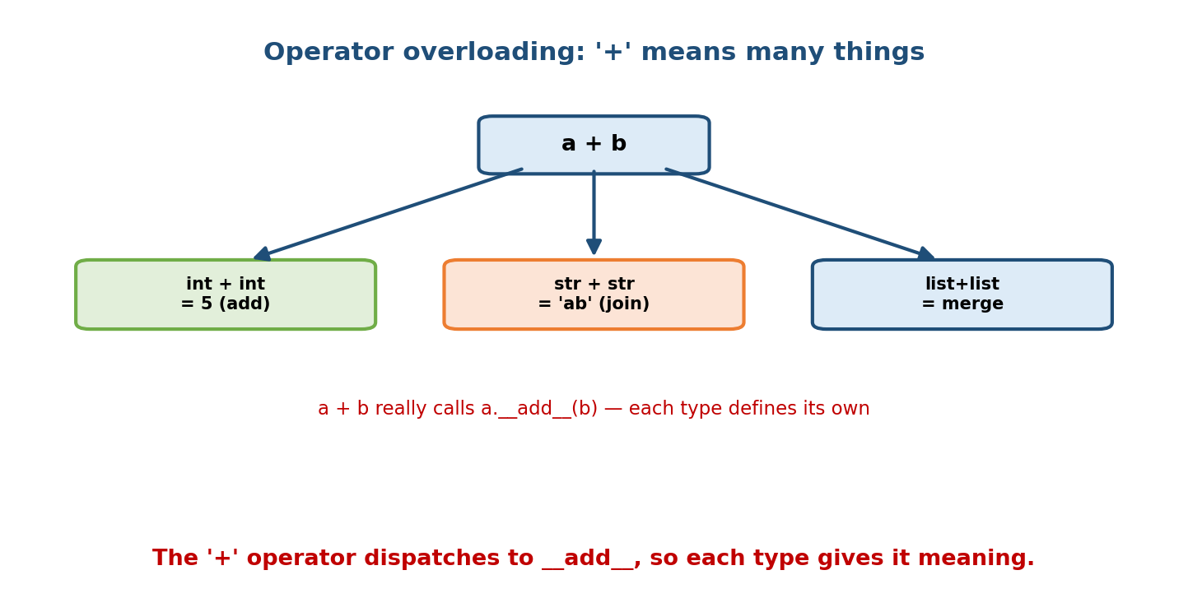
The ‘+’ operator: int + int adds, str + str joins, list + list merges — each type defines its own add, so one symbol has many meanings.
print(1 + 2) # 3 -> int.__add__
print("a" + "b") # 'ab' -> str.__add__
print([1] + [2]) # [1,2] -> list.__add__
class Vector:
def __init__(self, x, y): self.x, self.y = x, y
def __add__(self, other): # define + for our type
return Vector(self.x + other.x, self.y + other.y)
def __repr__(self):
return f"Vector({self.x}, {self.y})"
print(Vector(1, 2) + Vector(3, 4)) # Vector(4, 6)
You overload +, ==, <, [], len(), and more for your own classes by implementing the matching dunder — covered fully in Module 7.

6.6 Python Has NO Method Overloading
In Java/C++, you can define several methods with the same name but different parameter lists; the compiler picks by argument types (compile-time / ad-hoc polymorphism). Python does not do this — a second def with the same name simply replaces the first.
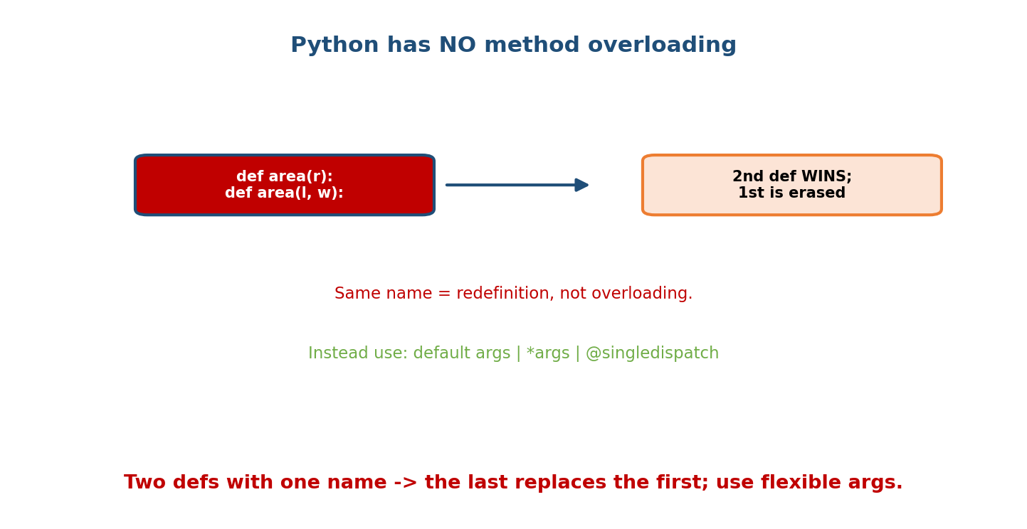
Two defs named area with different parameters: the second definition wins and erases the first — Python has no overloading; use default args, *args, or singledispatch instead.
class Calc:
def area(self, r): # this is...
return 3.14159 * r * r
def area(self, l, w): # ...silently REPLACED by this
return l * w
# Calc().area(5) -> TypeError: missing 'w' (only the 2nd area exists)
Pythonic alternatives:
# 1) default arguments
def area(l, w=None):
return l * l if w is None else l * w
# 2) *args / **kwargs for variable signatures
def area(*dims):
return dims[0] ** 2 if len(dims) == 1 else dims[0] * dims[1]
# 3) functools.singledispatch — dispatch by first-arg TYPE
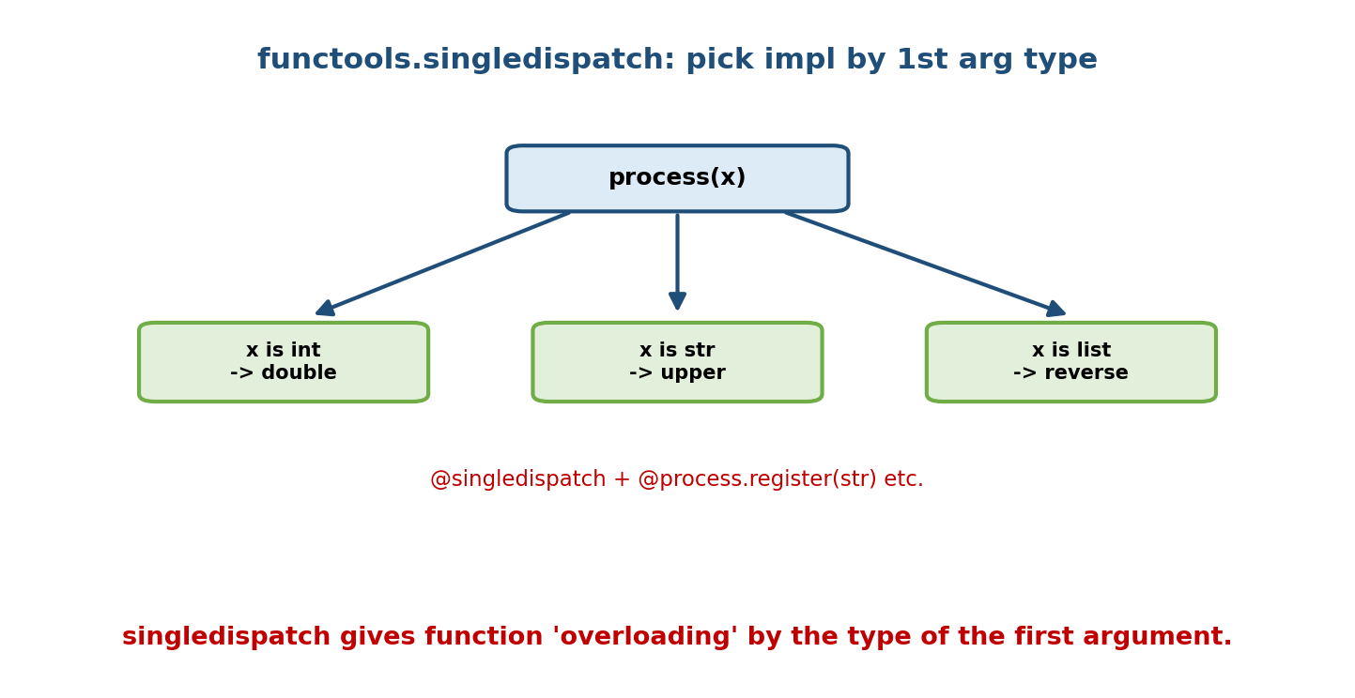
functools.singledispatch routes process(x) to different implementations by the type of x: int doubles, str uppercases, list reverses.
from functools import singledispatch
@singledispatch
def process(x):
raise TypeError("unsupported")
@process.register
def _(x: int): return x * 2
@process.register
def _(x: str): return x.upper()
@process.register
def _(x: list): return x[::-1]
print(process(10), process("hi"), process([1, 2])) # 20 HI [2, 1]
Interview answer: “Python doesn’t support method overloading — the last definition wins. Use default/keyword/*args for flexible signatures, or functools.singledispatch for type-based dispatch.”

6.7 Compile-time vs Run-time Polymorphism
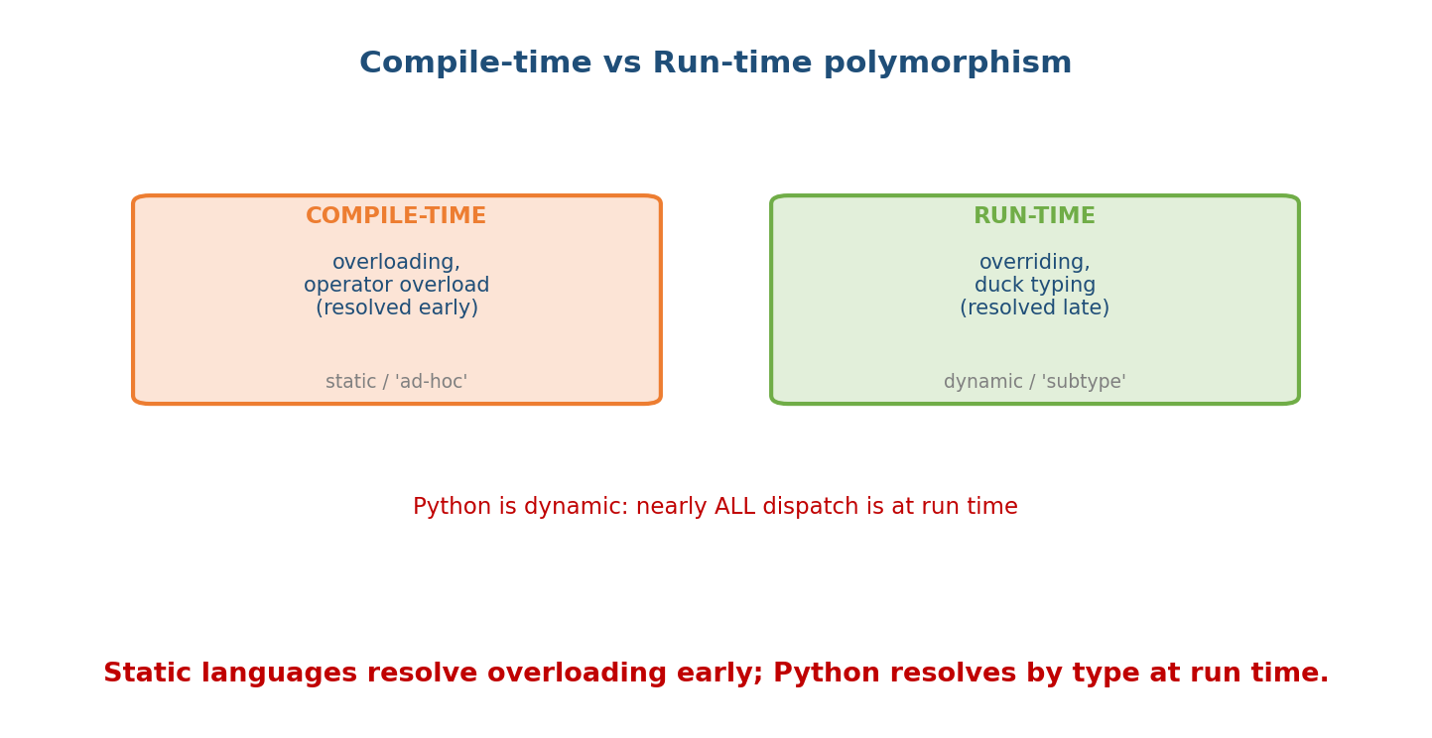
Compile-time (static, ad-hoc): overloading and operator resolution decided early. Run-time (dynamic, subtype): overriding and duck typing decided late. Python resolves almost everything at run time.
 | Compile-time (static) | Run-time (dynamic)
A.k.a. | ad-hoc | subtype / inclusion
Mechanism | overloading, operator resolution | overriding, duck typing
Decided | at compile time (in static langs) | at run time, by object’s type
Python | mostly N/A (interpreted, dynamic) | this is Python’s world
Because Python is dynamically typed and interpreted, method dispatch happens at run time by the object’s actual type. There’s no compile step choosing overloads. This makes Python overwhelmingly a run-time (subtype + duck-typed) polymorphism language.

Module 6 — Interview Mapping
Question | Junior answer | Senior answer
“What is polymorphism?” | “One name, many forms.” | “One interface working across many types; caller code is uniform, behaviour varies by object; eliminates type-checking ifs and enables Open/Closed.”
“Duck typing?” | “If it quacks it’s a duck.” | Adds: cares about behaviour not class; no base class needed; underpins Python’s iterables/file-likes; pairs with EAFP.
“Does Python have overloading?” | “No.” | “Correct — last def wins. Use defaults/*args or functools.singledispatch for type dispatch.”
“Runtime vs compile-time?” | (unsure) | “Overriding + duck typing = run-time (dynamic dispatch by real type); overloading/operator resolution = compile-time in static langs. Python is almost all run-time.”

Module 6 — Exam Mapping
- GATE CS: classify polymorphism types; overriding vs overloading; static vs dynamic binding.
- SEBI / RBI IT: definition; examples of polymorphism; operator overloading.
- FAANG: write duck-typed/polymorphic code; explain no-overloading + fixes; connect polymorphism to Open/Closed and Strategy.

Module 6 — Common Mistakes & Misconceptions
- Thinking Python supports method overloading — it doesn’t; the last def wins.
- Confusing overriding (runtime, subclass) with overloading (compile-time, same class, different params).
- Adding isinstance ladders where duck typing/overriding would remove the branching.
- Believing duck typing needs inheritance — it needs only the method.
- Forgetting __add__ etc. must return a value (often a new object), not mutate in place (unless it’s __iadd__).

Module 6 — MCQs (with answers & explanations)
Q1. Method overriding is which kind of polymorphism? a) ad-hoc b) subtype (runtime) c) parametric d) coercion
Answer
b. Overriding is subtype polymorphism, resolved at run time by the object’s type.
Q2. Duck typing means: a) checking isinstance b) caring about behaviour (methods), not the class c) casting types d) using ABCs
Answer
b. If the object has the needed method, it works — regardless of its type.
Q3. Defining two same-named methods with different parameters in one class: a) overloads them b) errors c) keeps only the last definition d) merges them
Answer
c. Python has no overloading; the second def replaces the first.
Q4. a + b on custom objects calls: a) a.plus(b) b) a.__add__(b) c) add(a, b) d) a.concat(b)
Answer
b. Operators dispatch to dunder methods.
Q5. For type-based function dispatch in Python, use: a) method overloading b) if isinstance only c) functools.singledispatch d) macros
Answer
c. singledispatch selects an implementation by the first argument’s type.
Q6. Polymorphism helps most by: a) saving memory b) removing type-checking branches and enabling extension c) enforcing privacy d) speeding compilation
Answer
b. Uniform interface → no if type == ladders; new types slot in (Open/Closed).
Q7. 1 + 2.0 == 3.0 demonstrates which polymorphism? a) subtype b) parametric c) coercion d) overriding
Answer
c. The int is coerced to float before addition.
Q8. Python method dispatch happens: a) at compile time b) at run time by the object’s type c) never d) at import only
Answer
b. Dynamic dispatch — decided at run time.

Module 6 — Design/Practice Exercises (easy → hard)
- (easy) Write Dog, Cat, Duck each with speak(); loop and print polymorphically.
- (easy) Write describe(x) that calls x.area() and works for any shape with an area method (duck typing) — no base class.
- (medium) Add __add__ and __eq__ to a Money class so Money(5) + Money(3) == Money(8).
- (medium) Replace an if isinstance(x, int)/str/list ladder with functools.singledispatch.
- (hard) Implement a Vector supporting +, -, * (scalar), ==, and len-style magnitude; make it print nicely.
- (hard, interview) Explain, with code, the difference between overriding and “overloading” in Python, and show two Pythonic ways to fake overloading.

Module 6 — Concept Review (one page)
Polymorphism lets one interface serve many types: the caller writes uniform code and each object responds in its own way, eliminating type-checking branches. Its kinds are subtype (overriding, resolved at run time by the object’s real type — dynamic dispatch), ad-hoc (operator/name overloading via dunder methods), parametric (generics), and coercion. Python generalises subtype polymorphism with duck typing — behaviour, not class, decides compatibility, so no shared base is required (pairs with the EAFP style). Operators are overloaded by implementing dunders like __add__. Python has no method overloading (the last def wins); use default/*args or functools.singledispatch instead. Because Python is dynamic, dispatch is a run-time decision — it is overwhelmingly a run-time-polymorphism language.

Module 6 — Flash Cards (Q → A)
Front | Back
Polymorphism (1 line) | one interface, many types/forms
Overriding is which type | subtype / run-time
Duck typing | behaviour (methods) matters, not the class
EAFP | try the op, catch failure (vs check-first LBYL)
Operator overloading via | dunder methods (__add__, __eq__, …)
Does Python overload methods? | No — last def wins
Overloading alternatives | default args, *args, functools.singledispatch
Overriding vs overloading | subclass-runtime vs same-name-different-params (compile-time)
Coercion example | 1 + 2.0 → float
Dispatch timing in Python | run time, by object’s actual type
Polymorphism enables which SOLID principle | Open/Closed

Module 6 — Pattern Recognition
- See if isinstance(x, A): ... elif isinstance(x, B): ... → replace with overriding or singledispatch.
- See “make this work for any object that can X” → duck typing (call the method).
- See “same operator for my custom type” → operator overloading via dunders.
- See “one function, several argument shapes” → default/*args or singledispatch (not overloading).
- See “add new types without touching existing code” → polymorphism + Open/Closed.

Module 6 — Revision Notes / Mini Cheat Sheet
POLYMORPHISM = one interface, many types. Uniform caller; behaviour varies by object.
KINDS: subtype(overriding, RUNTIME), ad-hoc(overloading/operators), parametric(generics), coercion.
SUBTYPE: override base method -> dynamic dispatch by object's real class.
DUCK TYPING: needs only the METHOD, not a shared base. "quacks -> duck." EAFP style.
OPERATOR OVERLOAD: a + b -> a.__add__(b). Define dunders for your type (M7).
NO METHOD OVERLOADING in Python (2nd def replaces 1st). Instead:
- default args: def f(a, b=None)
- *args/**kwargs
- functools.singledispatch (dispatch by first arg TYPE)
COMPILE-TIME (ad-hoc: overloading) vs RUN-TIME (subtype: overriding, duck typing).
Python = dynamic -> nearly all dispatch is RUN TIME. Powers Open/Closed (M13).
Next module: Module 7 — Dunder (Magic) Methods & the Data Model. We go deep on the special methods that made this module’s operator overloading and duck typing possible: __repr__/__str__, __eq__/__hash__, comparison and arithmetic operators, containers (__len__, __getitem__), iterators, callables, and context managers — the protocols that let your objects behave like built-ins.

Module 6 — Summary
Polymorphism — “many forms” — lets one interface work across many types so the caller writes uniform code while each object behaves appropriately, removing type-checking branches and enabling extension (Open/Closed). Its main flavours are subtype (method overriding, resolved at run time via dynamic dispatch) and ad-hoc (operator overloading through dunder methods), with parametric and coercion rounding out the theory. Python’s signature twist is duck typing: compatibility depends on having the right method, not the right class, so no shared base is needed. Python deliberately lacks method overloading (the last def wins), offering default/*args and functools.singledispatch instead. Since Python is dynamic, method resolution is a run-time decision — making it, above all, a run-time-polymorphism language.
You have mastered this module when you can: write polymorphic and duck-typed code without isinstance ladders; overload an operator with a dunder; explain why Python has no overloading and demonstrate two workarounds; and correctly classify overriding vs overloading and run-time vs compile-time.

