Module 7 — Dunder (Magic) Methods & the Data Model
  - OOP with Python Mastery: FAANG Interviews / GATE / SEBI-RBI IT / Backend — In-Depth Notes (with visuals)
Prepared for nidhi.sharma@forensiccybertech.com
2026
Table of Contents

Module 7 — Dunder (Magic) Methods & the Data Model
Why this module matters. This is where Python OOP becomes magical: dunder methods (“double underscore”, also called magic or special methods) are the hooks that let your objects behave like built-ins — support len(), +, [], ==, iteration, with, and even being called like a function. Python’s whole “data model” is: syntax and built-ins quietly delegate to dunders. Learn these and you can make objects that feel native — and you’ll ace the very common interview task “make this class support == / sorting / in / iteration.”
Importance ratings (out of 5):
Exam / Use | FAANG Interview | GATE CS | SEBI/RBI IT | Backend Dev | LLD Rounds
This module | ★★★★★ | ★★ | ★★ | ★★★★★ | ★★★★
Most-asked concepts: __repr__ vs __str__; the __eq__/__hash__ contract (and why overriding __eq__ alone makes objects unhashable); comparison + functools.total_ordering; container protocol (__len__, __getitem__); iterator protocol (__iter__/__next__); context managers (__enter__/__exit__); __call__.
What you must be able to do after this module: implement __repr__, __eq__+__hash__, ordering, container and iterator protocols, a context manager, and a callable — correctly and idiomatically.

7.1 The Data Model — syntax delegates to dunders
Python’s operators and built-ins are syntactic sugar over method calls. len(x) calls x.__len__(); x + y calls x.__add__(y); x[i] calls x.__getitem__(i). Implement the dunder, and the syntax “just works” for your type.
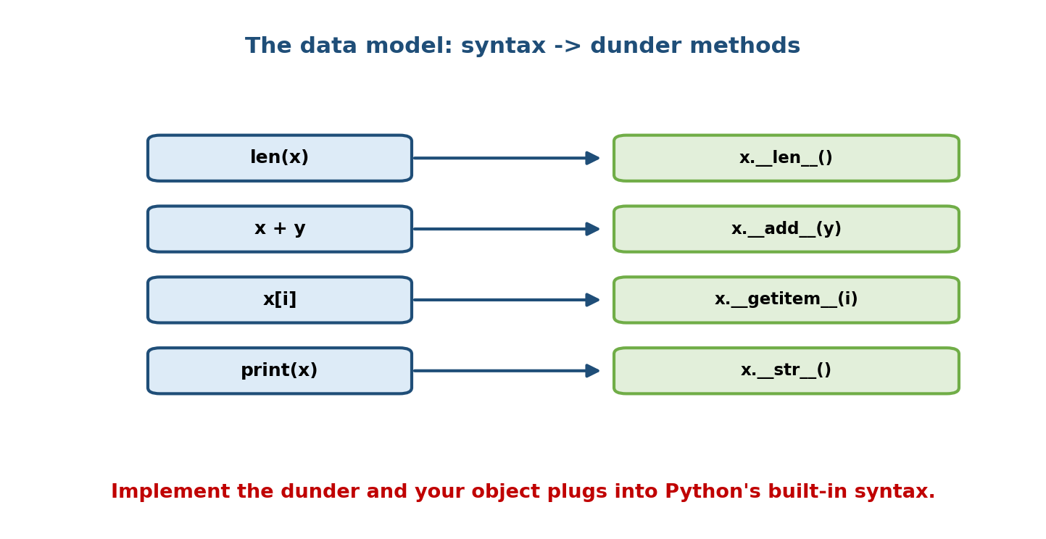
Python syntax maps to dunder methods: len(x) -> x.__len__(), x+y -> x.__add__(y), x[i] -> x.__getitem__(i), print(x) -> x.__str__().
Mental model: you don’t call dunders directly (x.__len__()); you use the syntax (len(x)) and Python calls the dunder for you. Defining them makes your object a first-class citizen of the language.

7.2 __repr__ vs __str__ — always define __repr__
Both produce a string form of an object, for different audiences:
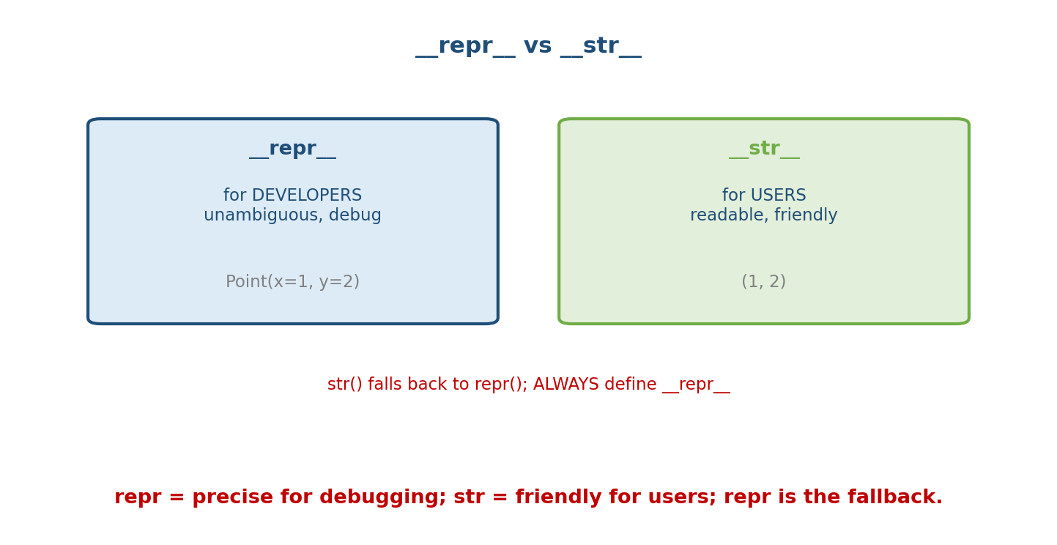
repr is for developers (unambiguous, e.g. Point(x=1, y=2)); str is for users (readable, e.g. (1, 2)); str() falls back to repr().
- __repr__ — unambiguous, for developers/debugging. Ideally looks like valid code to recreate the object. Used by the REPL, repr(), containers, and logging.
- __str__ — readable, for end users. Used by str() and print().
class Point:
def __init__(self, x, y): self.x, self.y = x, y
def __repr__(self): return f"Point(x={self.x}, y={self.y})" # dev
def __str__(self): return f"({self.x}, {self.y})" # user
p = Point(1, 2)
print(repr(p)) # Point(x=1, y=2)
print(str(p)) # (1, 2)
print(p) # (1, 2) -> print uses __str__
print([p]) # [Point(x=1, y=2)] -> containers use __repr__
Rule: always define __repr__ (the debugging default). Define __str__ only if a user-facing form differs. If __str__ is missing, str() falls back to __repr__ — so __repr__ gives you both cheaply.

7.3 __eq__ and __hash__ — the contract you must not break
By default, == compares identity (like is). To compare by value, define __eq__. But there’s a contract with __hash__:
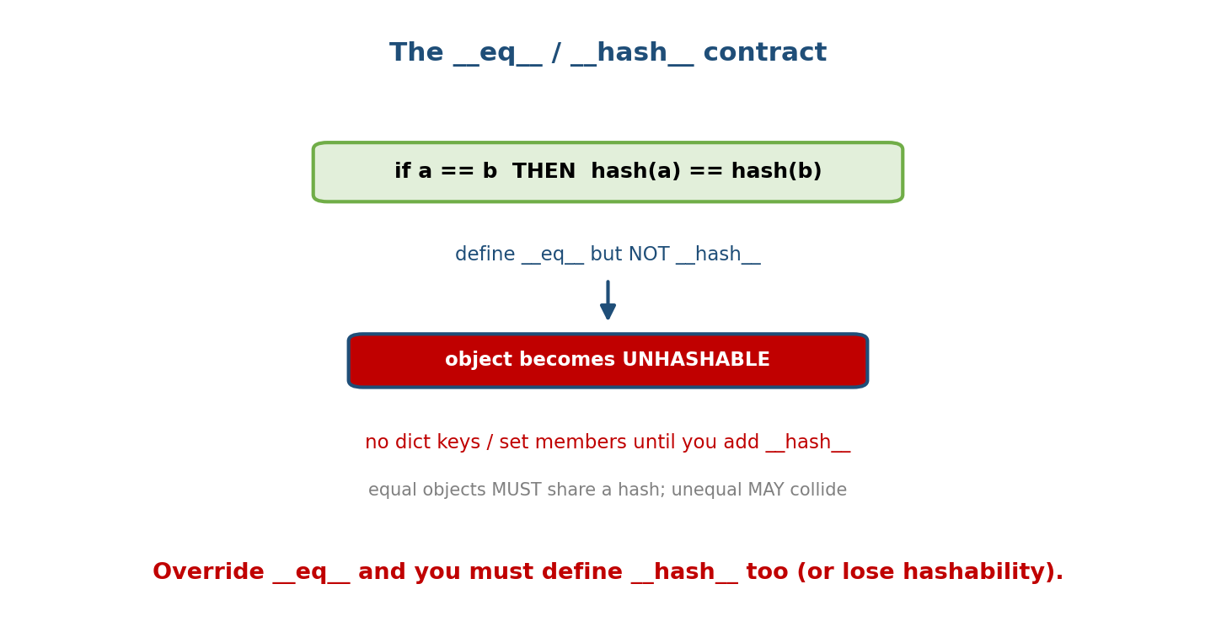
The contract: if a == b then hash(a) == hash(b). Defining eq without hash makes the object unhashable — no dict keys or set members.
The rules:
- If a == b then hash(a) == hash(b) (equal objects must hash equal).
- Unequal objects may share a hash (collisions are allowed).
- If you define __eq__, Python sets __hash__ = None → the object becomes unhashable (can’t be a dict key or set member) unless you also define __hash__.
class Point:
def __init__(self, x, y): self.x, self.y = x, y
def __eq__(self, other):
return isinstance(other, Point) and (self.x, self.y) == (other.x, other.y)
def __hash__(self):
return hash((self.x, self.y)) # base it on the SAME fields as __eq__
a, b = Point(1, 2), Point(1, 2)
print(a == b) # True
print(hash(a) == hash(b)) # True
s = {a, b}
print(len(s)) # 1 -> treated as equal, hashable
Interview trap: “You defined __eq__ and now your objects can’t go in a set — why?” → “Defining __eq__ drops the default __hash__; you must define __hash__ (over the same fields) to keep it hashable — or the object is intentionally mutable and should stay unhashable.” Only immutable-by-value objects should be hashable.

7.4 Comparison Operators & @total_ordering
Rich comparison dunders: __lt__ (<), __le__ (<=), __gt__ (>), __ge__ (>=), __eq__ (==), __ne__ (!=). Defining these makes objects sortable (sorted(), min, max).
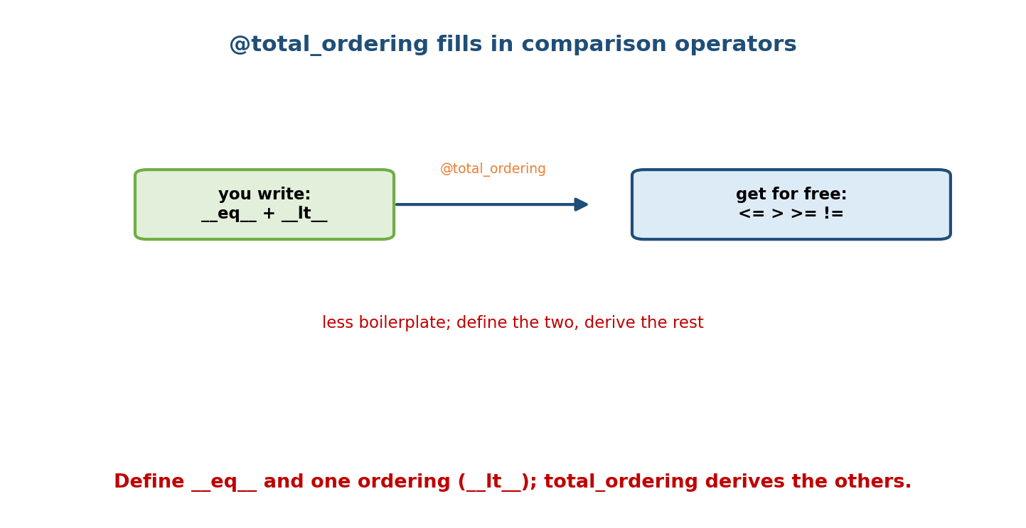
You write eq and lt; the @total_ordering decorator derives <=, >, >=, != for free, reducing boilerplate.
from functools import total_ordering
@total_ordering
class Version:
def __init__(self, major, minor): self.major, self.minor = major, minor
def __eq__(self, o): return (self.major, self.minor) == (o.major, o.minor)
def __lt__(self, o): return (self.major, self.minor) < (o.major, o.minor)
print(Version(1, 2) < Version(1, 5)) # True
print(sorted([Version(2, 0), Version(1, 9)], key=lambda v: (v.major, v.minor)))
@total_ordering derives the remaining operators from __eq__ + one of (__lt__/__le__/__gt__/__ge__). It trades a little speed for a lot less boilerplate.

7.5 Arithmetic Operators (and reflected/in-place variants)
__add__ (+), __sub__ (-), __mul__ (*), __truediv__ (/), etc. Two important companions:
- Reflected (__radd__): used when the left operand doesn’t know how to add the right — e.g. 3 + vector tries int.__add__ (fails) then vector.__radd__(3).
- In-place (__iadd__): used by += to mutate in place (falls back to __add__ if absent).
class Vector:
def __init__(self, x, y): self.x, self.y = x, y
def __add__(self, o): return Vector(self.x + o.x, self.y + o.y)
def __mul__(self, k): return Vector(self.x * k, self.y * k) # scalar
def __repr__(self): return f"Vector({self.x}, {self.y})"
print(Vector(1, 2) + Vector(3, 4)) # Vector(4, 6)
print(Vector(1, 2) * 3) # Vector(3, 6)
Arithmetic dunders should usually return a new object (immutability-friendly), not mutate self — except __iadd__ and friends, which may mutate.

7.6 Container Protocol — behave like a list/dict
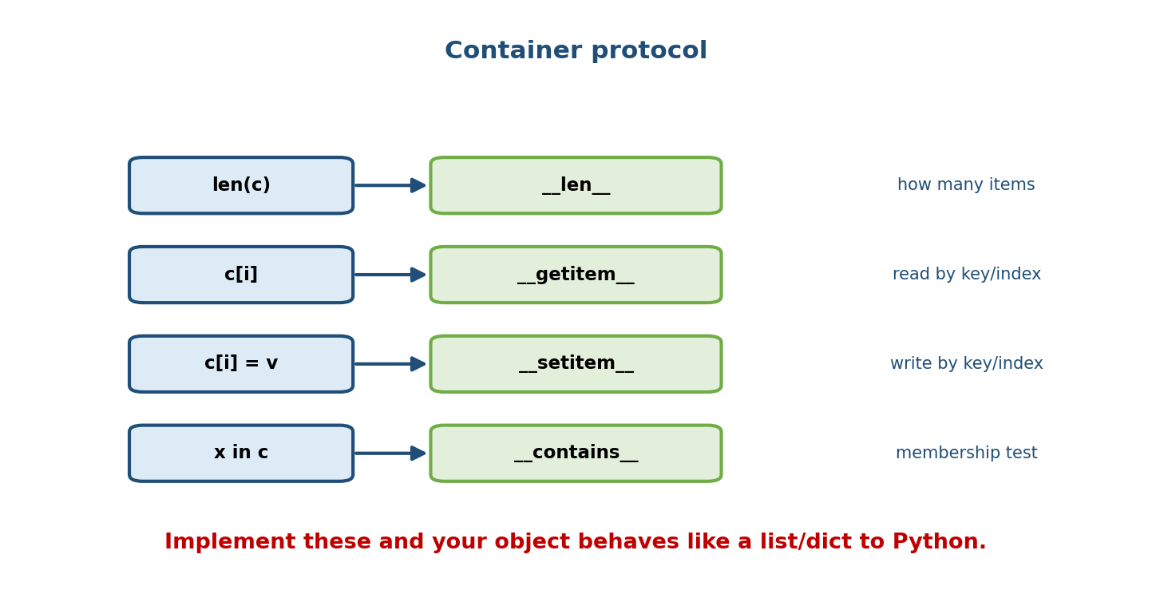
Container protocol: len(c) -> len, c[i] -> getitem, c[i]=v -> setitem, x in c -> contains.
class Playlist:
def __init__(self): self._songs = []
def add(self, s): self._songs.append(s)
def __len__(self): return len(self._songs) # len(pl)
def __getitem__(self, i): return self._songs[i] # pl[0], slicing, iteration!
def __setitem__(self, i, v): self._songs[i] = v # pl[0] = x
def __contains__(self, s): return s in self._songs # x in pl
pl = Playlist(); pl.add("A"); pl.add("B")
print(len(pl), pl[0], "A" in pl) # 2 A True
for song in pl: # __getitem__ alone enables iteration!
print(song)
Bonus: implementing just __getitem__ (with integer indexing from 0) gives you iteration and in for free — Python falls back to it when __iter__ is absent.

7.7 Iterator Protocol — power the for loop
A for loop calls iter(obj) (→ __iter__) to get an iterator, then calls next() (→ __next__) repeatedly until StopIteration is raised.
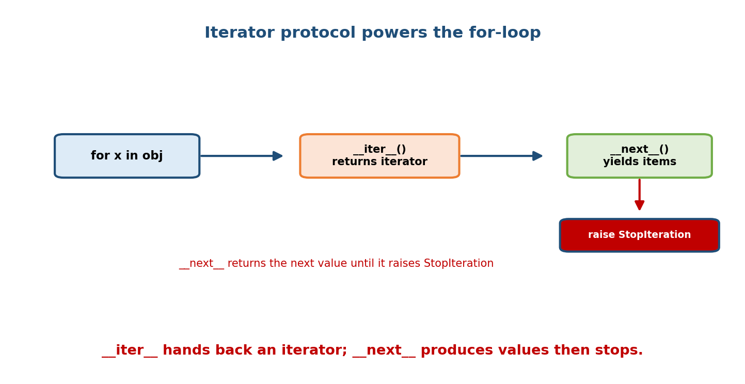
for x in obj calls iter() to get an iterator, then next() yields items until it raises StopIteration.
class Countdown:
def __init__(self, start): self.start = start
def __iter__(self): # return an iterator (here, self)
self.n = self.start
return self
def __next__(self):
if self.n <= 0:
raise StopIteration
self.n -= 1
return self.n + 1
for x in Countdown(3):
print(x) # 3, 2, 1
- Iterable = has __iter__ (can produce an iterator). Iterator = has __next__ (produces values, tracks position).
- For most cases a generator (yield) is simpler than a manual iterator:
class Countdown:
def __init__(self, start): self.start = start
def __iter__(self):
n = self.start
while n > 0:
yield n # generator: __iter__/__next__ built for you
n -= 1

7.8 Context Managers — with via __enter__/__exit__
A context manager guarantees setup and cleanup around a block, even if it raises. The with statement calls __enter__ on entry and __exit__ on exit.
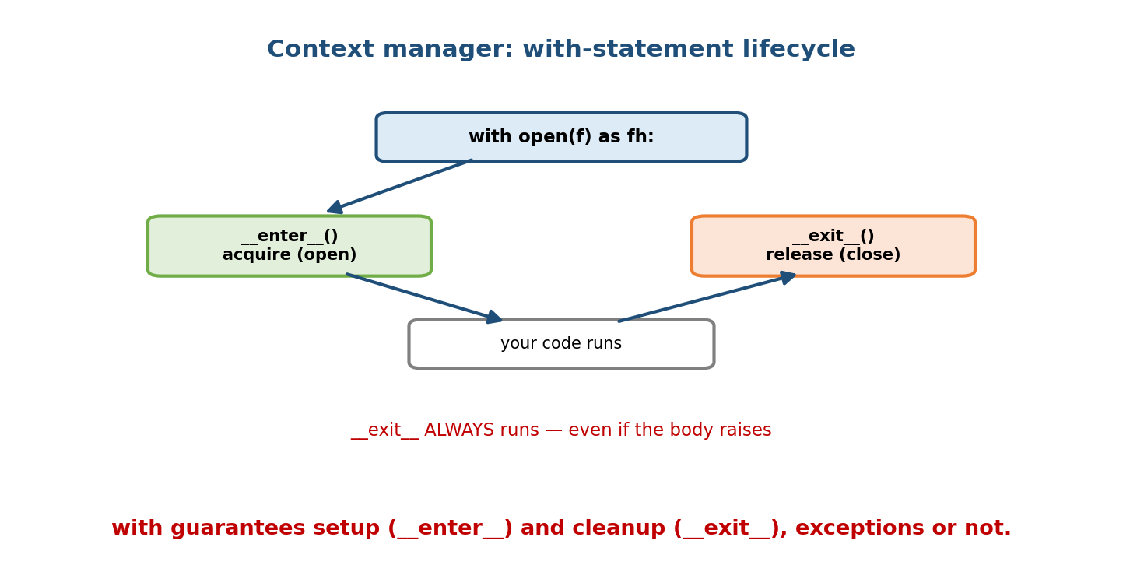
with open(f) as fh runs enter (acquire, e.g. open) before the body and exit (release, e.g. close) after — exit always runs, even on exceptions.
class Timer:
def __enter__(self):
import time; self.t0 = time.perf_counter()
return self # value bound to 'as'
def __exit__(self, exc_type, exc, tb):
import time; self.elapsed = time.perf_counter() - self.t0
print(f"took {self.elapsed:.4f}s")
return False # False -> propagate any exception
with Timer():
sum(range(1_000_000)) # prints "took 0.02s" afterwards
- __exit__(exc_type, exc, tb) receives exception info (or three Nones if the block succeeded). Return True to suppress the exception; False/None to let it propagate.
- The contextlib.contextmanager decorator turns a generator into a context manager, avoiding the class boilerplate.

7.9 __call__ — make an instance behave like a function
Defining __call__ lets you call an instance like a function while it keeps state — a “function object.”
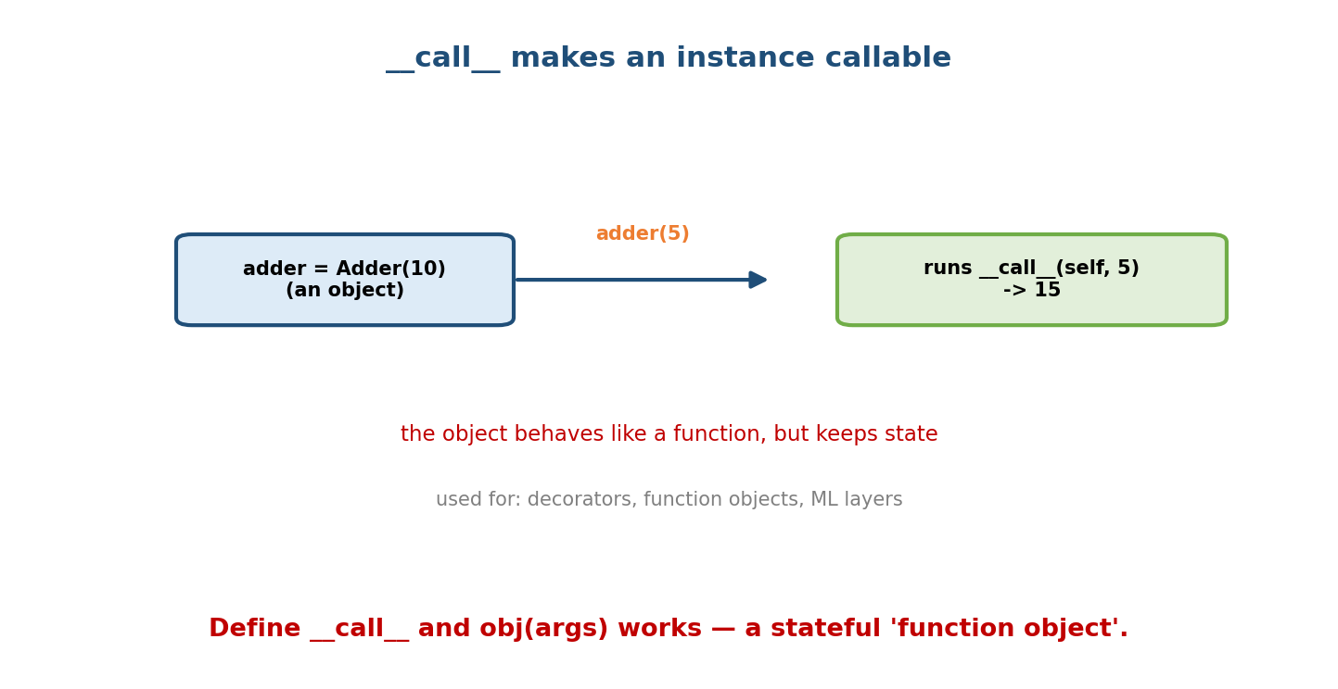
Adder(10) is an object; calling adder(5) runs call(self, 5) returning 15 — a callable that remembers state, used for decorators and ML layers.
class Adder:
def __init__(self, base): self.base = base
def __call__(self, x): return self.base + x # obj(x)
add10 = Adder(10)
print(add10(5)) # 15
print(callable(add10))# True
Used for stateful callbacks, class-based decorators, memoisers, and (in PyTorch) nn.Module layers where layer(x) runs forward.

7.10 Other Useful Dunders (quick reference)
Dunder | Triggered by | Purpose
__bool__ / __len__ | if obj: / bool(obj) | truthiness (len 0 → falsy)
__format__ | f"{obj:spec}", format() | custom formatting
__getitem__ | obj[k], slicing, iteration | indexing
__contains__ | x in obj | membership
__enter__/__exit__ | with | resource management
__del__ | garbage collection | finaliser (Module 12)
__getattr__/__setattr__ | missing/any attr access | dynamic attributes (Module 8)

Module 7 — Interview Mapping
Question | Junior answer | Senior answer
“__repr__ vs __str__?” | “repr for debug, str for print.” | Adds: repr should be unambiguous/recreatable; str falls back to repr; containers use repr; always define repr.
“Why unhashable after __eq__?” | (stuck) | “Defining __eq__ sets __hash__=None; must define __hash__ over the same fields (only for value-immutable objects) to stay hashable.”
“Make this class iterable?” | “Add a loop.” | Implements __iter__/__next__ (or a generator __iter__); notes __getitem__ fallback.
“How does with guarantee cleanup?” | “It closes files.” | “__enter__/__exit__; __exit__ runs even on exception; return True to suppress.”

Module 7 — Exam Mapping
- GATE CS: operator overloading via dunders; iterator vs iterable; special methods triggered by syntax.
- SEBI / RBI IT: basic magic-method definitions; __init__/__str__.
- FAANG: implement __eq__+__hash__, ordering, containers, context managers in live code; the hashability contract.

Module 7 — Common Mistakes & Misconceptions
- Only defining __eq__ → object becomes unhashable; add __hash__.
- Making a mutable object hashable with a hash over mutable fields → breaks sets/ dicts when it changes. Hash only value-immutable objects.
- Skipping __repr__ → unhelpful <obj at 0x...> in logs/debuggers.
- Calling dunders directly (x.__len__()) instead of len(x).
- Returning nothing from arithmetic dunders or mutating self in __add__.
- __exit__ accidentally returning True → silently swallows exceptions.

Module 7 — MCQs (with answers & explanations)
Q1. len(x) calls: a) x.length() b) x.__len__() c) x.size() d) len.__call__(x)
Answer
b. Built-ins delegate to dunders.
Q2. Defining __eq__ without __hash__ makes the object: a) faster b) immutable c) unhashable d) iterable
Answer
c. Python sets __hash__ = None; add __hash__ to keep hashability.
Q3. Which is used by the REPL/containers to show an object? a) __str__ b) __repr__ c) __format__ d) __show__
Answer
b. Containers and the REPL use __repr__.
Q4. A for loop first calls: a) __next__ b) __iter__ c) __len__ d) __getitem__
Answer
b. It obtains an iterator via __iter__, then calls __next__.
Q5. __next__ signals the end of iteration by: a) returning None b) returning -1 c) raising StopIteration d) returning False
Answer
c. StopIteration ends the loop.
Q6. In a context manager, __exit__ returning True: a) re-raises b) suppresses the exception c) closes twice d) is illegal
Answer
b. Truthy return suppresses the propagating exception.
Q7. @total_ordering requires you to define: a) all six operators b) __eq__ and one ordering method c) only __lt__ d) __cmp__
Answer
b. __eq__ plus one of __lt__/__le__/__gt__/__ge__.
Q8. __call__ lets you: a) delete an object b) call an instance like a function c) compare objects d) hash an object
Answer
b. obj(args) runs obj.__call__(args).

Module 7 — Design/Practice Exercises (easy → hard)
- (easy) Add __repr__ and __str__ to a Point class with distinct outputs.
- (easy) Make Point support == and be usable in a set (add __hash__).
- (medium) Use @total_ordering to make a Card class fully comparable from __eq__ + __lt__.
- (medium) Implement a Matrix supporting m[i, j] via __getitem__ and len(m).
- (hard) Write a FileLines iterable that yields lines, plus a Timer context manager; combine them.
- (hard, interview) Build a Money class with +, -, ==, <, __hash__, __repr__, and rejection of adding different currencies.

Module 7 — Concept Review (one page)
Python’s data model routes syntax and built-ins to dunder methods, letting your objects act like natives. Always define __repr__ (unambiguous, dev-facing; the fallback for str), and __str__ only when a user-facing form differs. Override __eq__ for value equality — but then you must define __hash__ (over the same fields, for value-immutable objects) or the object becomes unhashable. Comparison dunders make objects sortable; @total_ordering derives the rest from __eq__ + one ordering. Arithmetic dunders (__add__, reflected __radd__, in-place __iadd__) implement operators. The container protocol (__len__, __getitem__, __setitem__, __contains__) makes objects list/dict-like; the iterator protocol (__iter__/__next__, or a generator) powers for; context managers (__enter__/__exit__) guarantee cleanup; and __call__ makes instances callable.

Module 7 — Flash Cards (Q → A)
Front | Back
len(x) really calls | x.__len__()
__repr__ vs __str__ | dev/unambiguous vs user/readable; str falls back to repr
Always define which? | __repr__
Override __eq__ → must also | define __hash__ (or object is unhashable)
Hash contract | a == b ⇒ hash(a) == hash(b)
Make objects sortable | comparison dunders (__lt__, …)
@total_ordering needs | __eq__ + one ordering method
+ custom / reflected / in-place | __add__ / __radd__ / __iadd__
Iterable vs iterator | has __iter__ vs has __next__
End iteration by | raising StopIteration
with uses | __enter__ / __exit__ (exit always runs)
Callable instance | define __call__

Module 7 — Pattern Recognition
- See “objects print as <X at 0x..>” → add __repr__.
- See “can’t put my objects in a set/dict” → add __hash__ (with __eq__).
- See “need to sort my objects” → comparison dunders / @total_ordering.
- See “want obj[i] / for x in obj / x in obj” → container/iterator protocol.
- See “acquire then always release a resource” → context manager.
- See “a stateful thing that’s called repeatedly” → __call__.

Module 7 — Revision Notes / Mini Cheat Sheet
DATA MODEL: syntax -> dunders. len(x)->__len__, x+y->__add__, x[i]->__getitem__.
Don't call dunders directly; use the syntax.
__repr__ dev, unambiguous, recreatable (ALWAYS define; str() falls back to it)
__str__ user, readable (define only if different)
__eq__ (value ==). DEFINE __eq__ => also define __hash__ (same fields) or UNHASHABLE.
contract: a==b => hash(a)==hash(b). Hash only value-immutable objects.
ORDERING: __lt__ __le__ __gt__ __ge__ __ne__. @total_ordering: __eq__ + 1 ordering.
ARITH: __add__/__sub__/__mul__/__truediv__ ; reflected __radd__ ; in-place __iadd__.
CONTAINER: __len__ __getitem__ __setitem__ __contains__ (getitem alone -> iterate + in)
ITERATOR: __iter__ (returns iterator) + __next__ (StopIteration to end); or generator.
CONTEXT MGR: __enter__ (setup, returns 'as' val) / __exit__ (cleanup, ALWAYS runs;
return True to suppress exception). contextlib.contextmanager for gens.
CALLABLE: __call__ -> obj(args). __bool__/__len__ -> truthiness.
Next module: Module 8 — Descriptors, __slots__ & Attribute Access. We go one level deeper than dunders into how attribute access itself works: __getattr__/__getattribute__/__setattr__, the descriptor protocol (what actually powers @property, methods, and classmethod), and __slots__ for memory savings and locked attribute sets.

Module 7 — Summary
Dunder methods are the hooks of Python’s data model: implement them and your objects support the language’s syntax and built-ins natively. Define __repr__ always (and __str__ when a user form differs); override __eq__ together with __hash__ to preserve the hashability contract; add comparison dunders (or @total_ordering) for sorting, and arithmetic dunders (with reflected/in-place variants) for operators. The container and iterator protocols make objects behave like lists/dicts and drive for loops; context managers (__enter__/__exit__) guarantee cleanup; and __call__ turns instances into stateful callables. Together these let you build objects that feel exactly like Python’s own.
You have mastered this module when you can: implement __repr__, __eq__+__hash__, ordering, the container and iterator protocols, a context manager, and __call__ correctly — and explain the hashability contract and the repr/str fallback from memory.

