Module 8 — Descriptors, slots & Attribute Access
  - OOP with Python Mastery: FAANG Interviews / GATE / SEBI-RBI IT / Backend — In-Depth Notes (with visuals)
Prepared for nidhi.sharma@forensiccybertech.com
2026
Table of Contents

Module 8 — Descriptors, __slots__ & Attribute Access
Why this module matters. Module 7 showed dunders for operations. This module reveals the machinery under attribute access itself — the thing that happens every time you write obj.x. Understanding __getattribute__/__getattr__ and the descriptor protocol is what turns @property, methods, classmethod, and staticmethod from magic into mechanism (they are all descriptors). It also unlocks reusable validation and, via __slots__, real memory/speed wins. This is senior/staff-level Python — a strong differentiator in interviews.
Importance ratings (out of 5):
Exam / Use | FAANG Interview | GATE CS | SEBI/RBI IT | Backend Dev | LLD Rounds
This module | ★★★★ | ★ | ★ | ★★★★ | ★★★
Most-asked concepts: __getattr__ vs __getattribute__; the descriptor protocol (__get__/__set__/__delete__); data vs non-data descriptors and precedence; “how does @property work?” (it’s a data descriptor); __slots__ (memory savings + trade-offs); __set_name__.
What you must be able to do after this module: explain the full obj.x lookup order; write __getattr__ for defaults/proxies safely; implement a reusable validator descriptor; explain why @property beats an instance attribute; and use __slots__ with awareness of its trade-offs.

8.1 Attribute Access Hooks
When you access obj.x, Python calls __getattribute__ — unconditionally, on every access. Only if that raises AttributeError does Python fall back to __getattr__ (if defined).
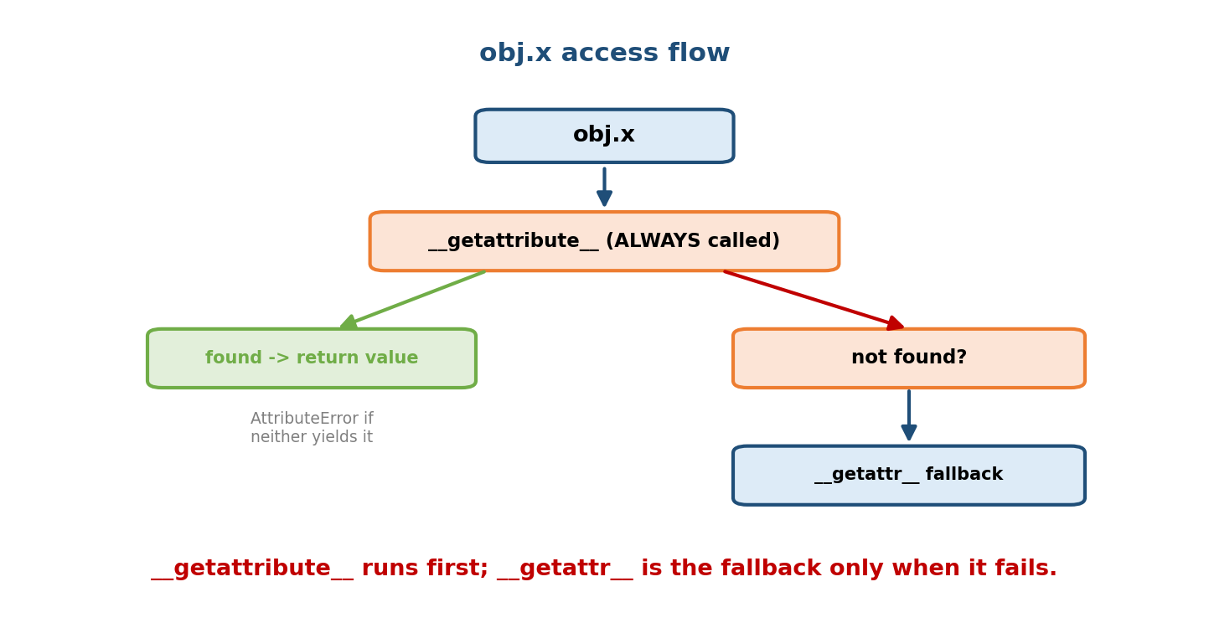
obj.x always calls getattribute first; if it succeeds you get the value, and only if it raises AttributeError does the getattr fallback run.
Hook | When called | Typical use
__getattribute__(self, name) | every attribute read | rarely overridden (easy to break; recursion risk)
__getattr__(self, name) | only when normal lookup fails | defaults, lazy attributes, proxies
__setattr__(self, name, value) | every attribute write | validation, logging, read-only objects
__delattr__(self, name) | every del obj.x | guard deletions
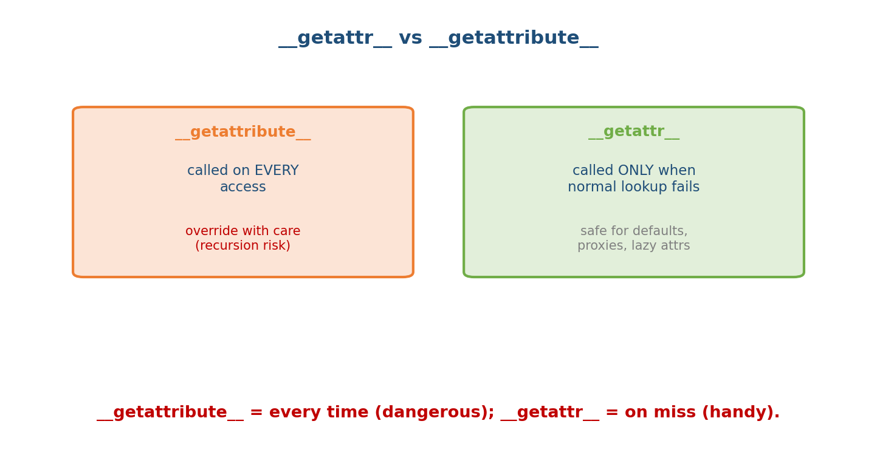
getattribute is called on every access (override with care — recursion risk); getattr is called only when normal lookup fails (safe for defaults/proxies).
class Config:
def __init__(self): self._data = {"host": "localhost"}
def __getattr__(self, name): # only for MISSING attributes
return self._data.get(name, "DEFAULT")
c = Config()
print(c.host) # __getattribute__ finds nothing normal... wait:
print(c.port) # 'DEFAULT' -> __getattr__ fallback (port not a real attr)
Danger: overriding __getattribute__ naively causes infinite recursion (accessing self.x inside it re-triggers it). Always delegate to super().__getattribute__(name). Prefer __getattr__ unless you truly must intercept every access.
__setattr__ for validation (note: also self-recursive — use super().__setattr__ or self.__dict__):
class Frozen:
def __init__(self, x): self.__dict__["x"] = x
def __setattr__(self, name, value):
raise AttributeError("immutable") # read-only object

8.2 The Descriptor Protocol
A descriptor is an object (assigned as a class attribute) that defines one or more of __get__, __set__, __delete__. When you access that attribute on an instance, Python routes the access through the descriptor’s methods.
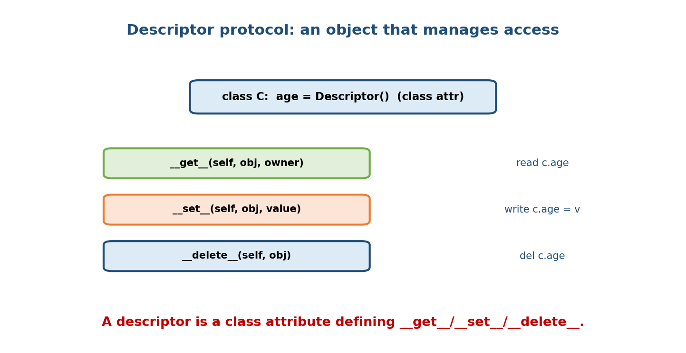
A descriptor placed as a class attribute defines get (read), set (write), and delete (del), intercepting access to that attribute on instances.
class Descriptor:
def __set_name__(self, owner, name): # Python tells us the attr name (3.6+)
self.name = "_" + name
def __get__(self, obj, owner):
if obj is None: return self # accessed on the class, not instance
return getattr(obj, self.name)
def __set__(self, obj, value):
setattr(obj, self.name, value)
class C:
x = Descriptor() # descriptor lives on the CLASS
- __get__(self, obj, owner) — obj is the instance (or None if accessed on the class); owner is the class.
- __set__(self, obj, value) — intercepts assignment.
- __set_name__(self, owner, name) — called automatically at class creation with the attribute’s name (so one descriptor knows where it lives).

8.3 Data vs Non-Data Descriptors (and precedence)
The kind of descriptor decides whether it beats the instance __dict__:
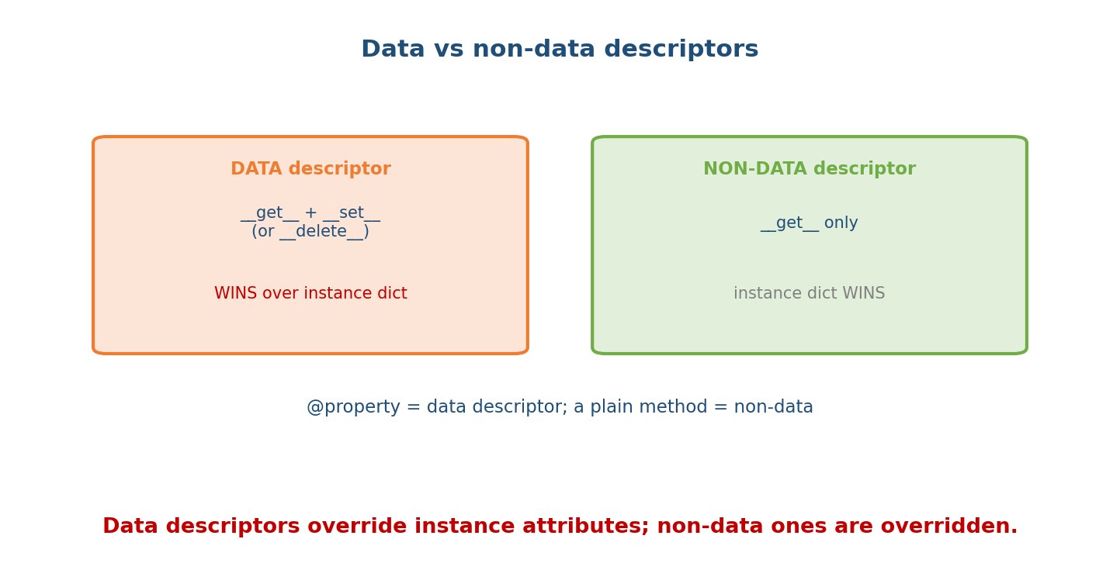
Data descriptors define get + set (or delete) and WIN over the instance dict; non-data descriptors define get only and are overridden by the instance dict.
- Data descriptor = defines __set__ (or __delete__). Takes priority over the instance dict. (@property is a data descriptor.)
- Non-data descriptor = defines only __get__. The instance dict wins over it. (A plain function/method is a non-data descriptor.)
The full read precedence:
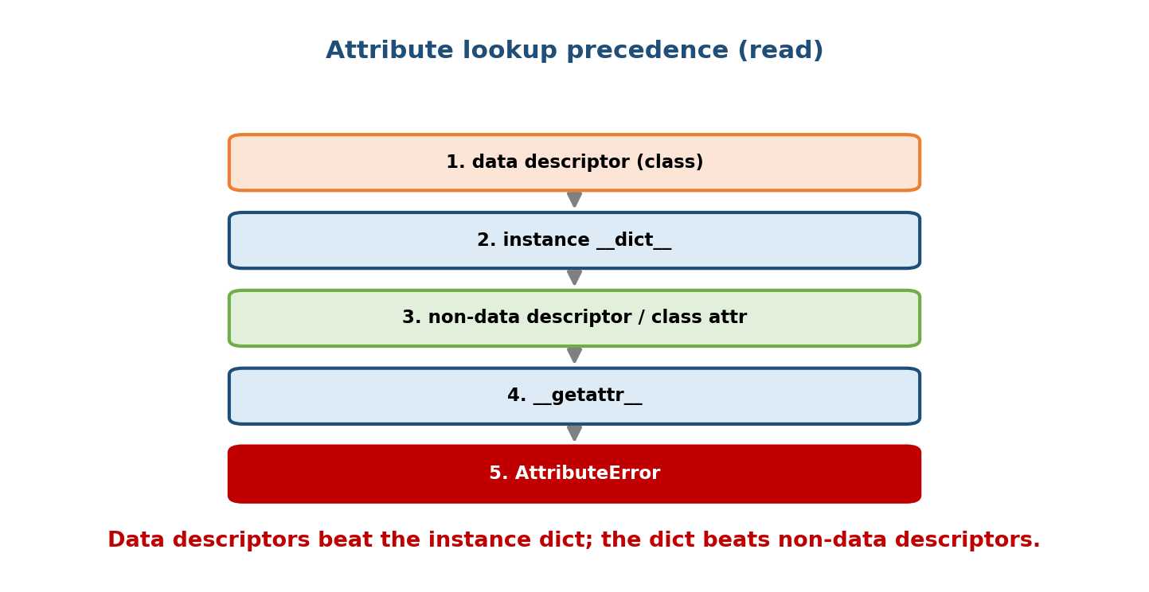
Read precedence: 1) data descriptor on the class, 2) instance dict, 3) non-data descriptor / class attribute, 4) getattr, 5) AttributeError.
1. data descriptor found on the class (e.g. @property)
2. instance __dict__ (normal instance attribute)
3. non-data descriptor / plain class attr (e.g. a method)
4. __getattr__ fallback
5. AttributeError
Why this matters: it explains why you can’t shadow a @property by setting an instance attribute of the same name (the data descriptor wins), but you can shadow a method by assigning an instance attribute (a non-data descriptor loses to the instance dict).

8.4 Everything Familiar Is a Descriptor
The features you already use are built on descriptors:
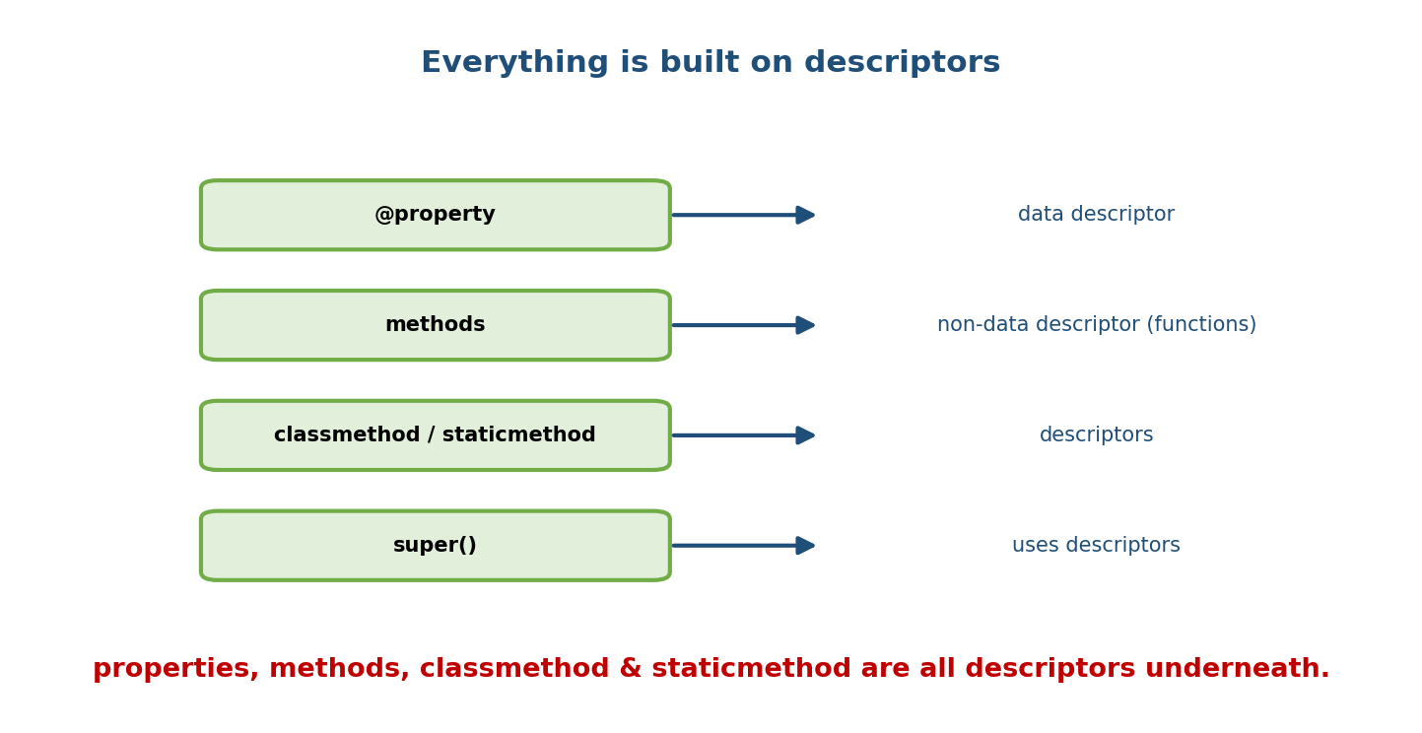
property is a data descriptor; methods are non-data descriptors (functions); classmethod and staticmethod are descriptors; even super() uses descriptors.
- @property → a data descriptor whose __get__/__set__ call your getter/setter. That’s why properties override instance attributes.
- Methods → functions are non-data descriptors; obj.method invokes the function’s __get__ to produce a bound method (binding self).
- classmethod / staticmethod → descriptors that adjust what gets passed (cls / nothing).
So Module 3’s method binding (acc.deposit → bound) and Module 4’s @property are the same descriptor mechanism. Learn it once, understand all of them.

8.5 A Reusable Validator Descriptor (the killer use case)
Descriptors shine when the same logic (validation, type-checking, logging) applies to many attributes. Write it once as a descriptor, reuse everywhere — DRY, unlike repeating @property setters.
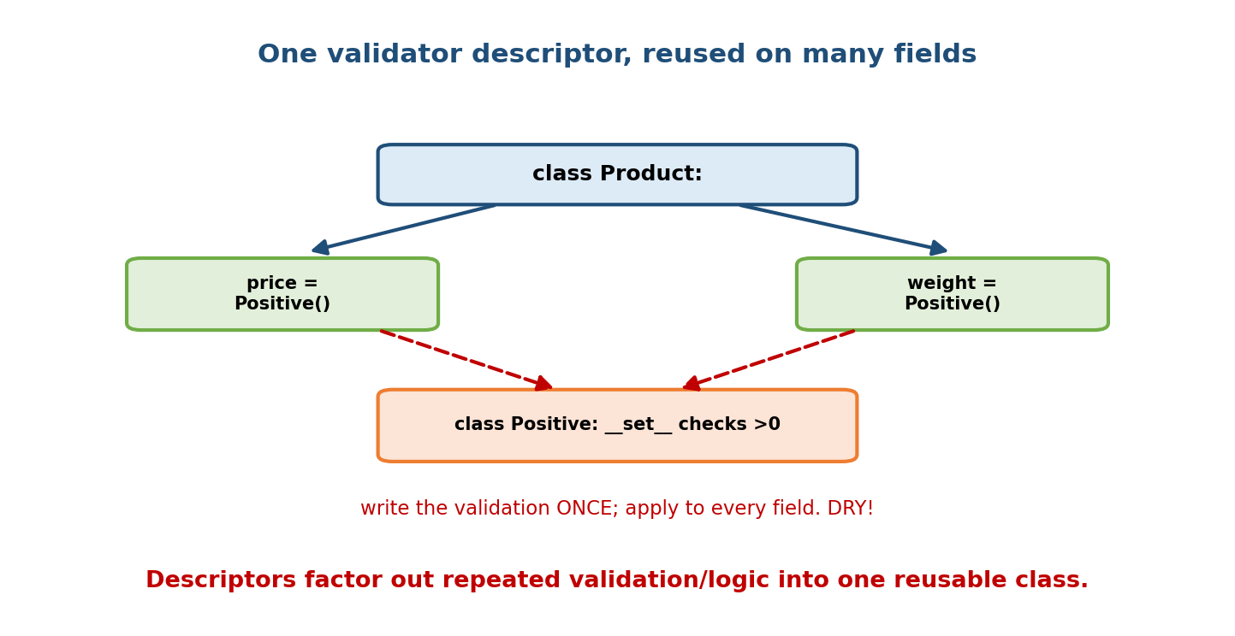
One Positive descriptor is assigned to both price and weight on a Product class; its set enforces value > 0 for every field, written once.
class Positive:
def __set_name__(self, owner, name):
self.name = "_" + name
def __get__(self, obj, owner):
if obj is None: return self
return getattr(obj, self.name)
def __set__(self, obj, value):
if value <= 0:
raise ValueError(f"{self.name[1:]} must be positive, got {value}")
setattr(obj, self.name, value)
class Product:
price = Positive() # same validation...
weight = Positive() # ...reused, zero duplication
def __init__(self, price, weight):
self.price = price # goes through Positive.__set__
self.weight = weight
p = Product(10, 2)
# Product(-5, 2) -> ValueError: price must be positive, got -5
Compare: doing this with @property would need a separate getter/setter pair per field. The descriptor collapses that into one class — this is the standard “why descriptors?” interview answer.

8.6 __slots__ — memory & speed
By default every instance has a __dict__ (a full dict) for its attributes — flexible but memory-heavy. __slots__ replaces it with a fixed, array-like layout: no per-instance __dict__, less memory, faster attribute access, and a locked set of allowed attributes.
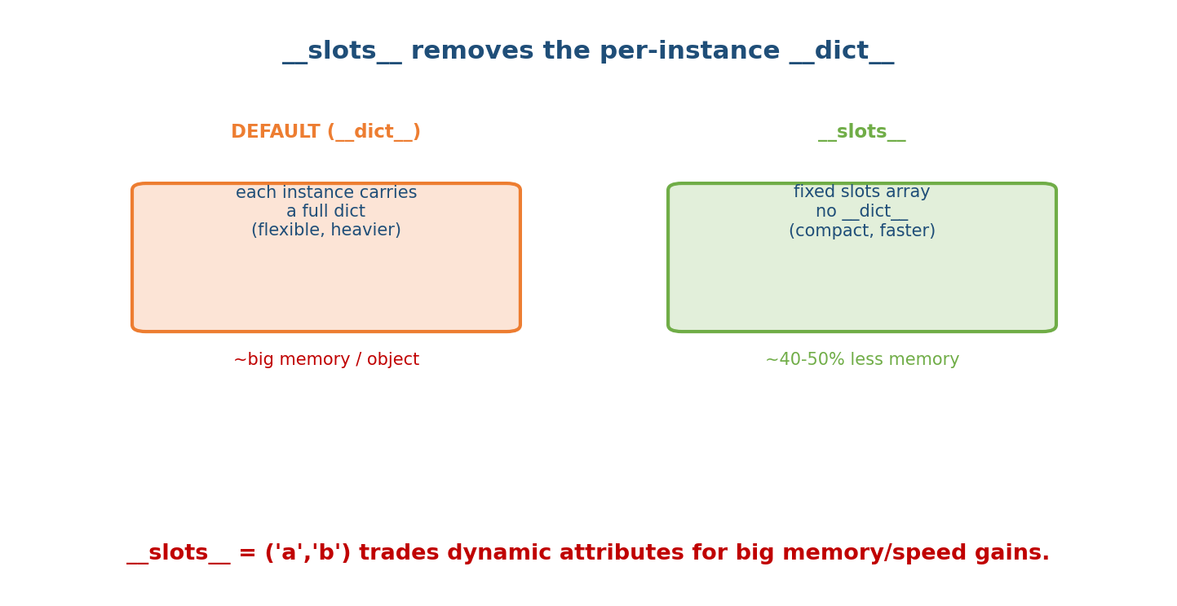
Default instances carry a full dict (flexible but heavier); slots uses a compact fixed slot layout with no dict, cutting memory ~40-50%.
class PointDict: # default: has __dict__
def __init__(self, x, y): self.x, self.y = x, y
class PointSlots:
__slots__ = ("x", "y") # no __dict__; only x and y allowed
def __init__(self, x, y): self.x, self.y = x, y
p = PointSlots(1, 2)
# p.z = 3 -> AttributeError: 'PointSlots' object has no attribute 'z'
Trade-offs:
Benefit | Cost
~40–50% less memory per instance | can’t add attributes not in __slots__
faster attribute get/set | no __dict__ (some tools/pickling assume it)
accidental-attribute typos become errors | subclasses need their own __slots__, else __dict__ returns
When to use: classes with many instances (millions of small objects — data points, tree nodes, game entities). For ordinary classes, the flexibility of __dict__ usually wins; don’t add __slots__ reflexively.

8.7 Putting It Together — a lazy/cached property
A classic descriptor use: compute an expensive value once, then cache it. (functools.cached_property does this for you since 3.8.)
class DataSet:
def __init__(self, rows): self.rows = rows
@property
def total(self): # recomputed every access
print("computing...")
return sum(self.rows)
from functools import cached_property
class DataSet2:
def __init__(self, rows): self.rows = rows
@cached_property
def total(self): # computed once, then stored in __dict__
print("computing once")
return sum(self.rows)
d = DataSet2([1, 2, 3])
d.total; d.total # "computing once" prints only ONCE
cached_property is a non-data descriptor, so after the first access it stores the result in the instance __dict__, which then wins on subsequent reads — a neat demonstration of §8.3’s precedence.

Module 8 — Interview Mapping
Question | Junior answer | Senior answer
“__getattr__ vs __getattribute__?” | “Both get attrs.” | “__getattribute__ runs on every access (dangerous, recursion-prone); __getattr__ runs only on miss (safe for defaults/proxies).”
“How does @property work?” | “Getter/setter.” | “It’s a data descriptor: its __get__/__set__ call your methods; being a data descriptor is why it overrides instance attributes.”
“Why use descriptors over properties?” | (unsure) | “To reuse the same access logic across many attributes without duplicating getter/setter pairs — one descriptor class, applied to many fields.”
“What does __slots__ do?” | “Saves memory.” | “Removes per-instance __dict__, cutting memory ~40–50% and speeding access, at the cost of dynamic attributes and some tooling compatibility; use for many-instance classes.”

Module 8 — Exam Mapping
- GATE CS: rarely deep here; attribute lookup order may appear.
- SEBI / RBI IT: minimal.
- FAANG / senior backend: descriptors, @property internals, __slots__ trade-offs, and the lookup-precedence rules are strong signal questions.

Module 8 — Common Mistakes & Misconceptions
- Infinite recursion in __getattribute__/__setattr__ (accessing self.x re-triggers the hook) — delegate to super() or use self.__dict__.
- Putting a descriptor on the instance — descriptors only work as class attributes.
- Expecting an instance attribute to shadow a @property — it can’t (data descriptor wins).
- Adding __slots__ but forgetting subclasses — a subclass without its own __slots__ regains a __dict__, erasing the savings.
- Using __slots__ on rarely-instantiated classes — needless rigidity for no real gain.

Module 8 — MCQs (with answers & explanations)
Q1. __getattr__ is called: a) on every access b) only when normal lookup fails c) on write d) never
Answer
b. It’s the fallback; __getattribute__ runs on every access.
Q2. A data descriptor defines: a) only __get__ b) __set__ (or __delete__), possibly with __get__ c) __call__ d) __slots__
Answer
b. Presence of __set__/__delete__ makes it a data descriptor.
Q3. Between a data descriptor and an instance attribute of the same name, the winner is: a) instance attribute b) data descriptor c) whichever is newer d) error
Answer
b. Data descriptors take precedence over the instance __dict__.
Q4. @property is implemented as a: a) metaclass b) function c) data descriptor d) mixin
Answer
c. That’s why it overrides instance attributes.
Q5. __slots__ primarily: a) speeds imports b) removes the per-instance __dict__ to save memory c) enforces types d) enables inheritance
Answer
b. Fixed layout, no __dict__; restricts attributes.
Q6. Descriptors must be assigned as: a) instance attributes b) class attributes c) globals d) module functions
Answer
b. The protocol triggers only for class-level descriptors.
Q7. A plain method is a: a) data descriptor b) non-data descriptor c) metaclass d) property
Answer
b. Functions define only __get__ (binding self), so they are non-data.
Q8. To avoid recursion when overriding __setattr__, use: a) self.x = v b) super().__setattr__ or self.__dict__[name] = v c) setattr(self, ...) d) a global
Answer
b. Direct dict access or the parent hook avoids re-triggering __setattr__.

Module 8 — Design/Practice Exercises (easy → hard)
- (easy) Write a class whose __getattr__ returns "N/A" for any missing attribute.
- (easy) Add __slots__ to a Point class and show that adding p.z fails.
- (medium) Implement a Typed descriptor that enforces a given type on assignment; use it for name: str and age: int.
- (medium) Implement a read-only object via __setattr__ that blocks all writes after construction.
- (hard) Write a LoggedAccess descriptor that prints every read/write, and attach it to two fields.
- (hard, interview) Explain, with a demo, why an instance attribute can shadow a method but not a @property.

Module 8 — Concept Review (one page)
Every obj.x read calls __getattribute__ first; only on failure does __getattr__ run (safe for defaults/proxies). Writes go through __setattr__ (mind recursion — delegate to super()/__dict__). A descriptor is a class attribute defining __get__/__set__/__delete__ that intercepts access; __set_name__ tells it its attribute name. Data descriptors (with __set__) beat the instance __dict__; non-data descriptors (only __get__) lose to it — giving the precedence: data descriptor → instance dict → non-data/class attr → __getattr__ → AttributeError. @property, methods, classmethod, and staticmethod are all descriptors; that’s why @property overrides instance attributes and methods bind self. Descriptors let you reuse access logic across many fields (validators), something @property can’t do without duplication. __slots__ removes the per-instance __dict__ to cut memory (~40–50%) and speed access, at the cost of dynamic attributes — ideal for many-instance classes.

Module 8 — Flash Cards (Q → A)
Front | Back
__getattribute__ runs when? | on every attribute read
__getattr__ runs when? | only when normal lookup fails
Descriptor = | class attribute with __get__/__set__/__delete__
Data descriptor | has __set__/__delete__; beats instance dict
Non-data descriptor | only __get__; instance dict beats it
@property is a | data descriptor
Methods are | non-data descriptors (bind self via __get__)
Read precedence | data desc → instance dict → non-data/class → __getattr__ → error
__set_name__ gives | the attribute’s name at class creation
__slots__ does | removes __dict__, saves memory, locks attribute set
Descriptor over property when | same logic reused across many fields
cached_property is a | non-data descriptor (caches into instance dict)

Module 8 — Pattern Recognition
- See “default value for any missing attribute / proxy object” → __getattr__.
- See “same validation on many fields” → a reusable descriptor (not N properties).
- See “instance attribute won’t override my property” → data-descriptor precedence.
- See “millions of small objects, tight on RAM” → __slots__.
- See “compute once, cache” → functools.cached_property.
- See “read-only object” → override __setattr__ to block writes.

Module 8 — Revision Notes / Mini Cheat Sheet
ACCESS HOOKS:
__getattribute__ every read (careful: recursion -> use super())
__getattr__ only on MISS (defaults, proxies, lazy)
__setattr__ every write (validate/log; avoid recursion)
DESCRIPTOR = class attr with __get__/__set__/__delete__ (+ __set_name__).
DATA descriptor (__set__/__delete__) -> beats instance __dict__
NON-DATA (__get__ only) -> instance __dict__ beats it
READ PRECEDENCE: data desc -> instance dict -> non-data/class attr -> __getattr__ -> error.
@property = data descriptor. methods = non-data descriptors. classmethod/staticmethod = descriptors.
USE descriptors to REUSE access logic across many fields (validators) — DRY vs many @property.
__slots__ = ('a','b'): no per-instance __dict__ -> ~40-50% less memory + faster,
but no dynamic attrs; subclasses need own __slots__ or __dict__ returns.
functools.cached_property: compute once, cache into instance dict (non-data desc).
Next module: Module 9 — Metaclasses & Class Creation. We climb one final level: if descriptors control attribute access, metaclasses control class creation itself. We’ll see that classes are objects too (instances of type), how type(name, bases, dict) builds a class, __new__/__init__ on metaclasses, __init_subclass__, and class decorators — plus when a metaclass is genuinely the right tool (and when it’s overkill).

Module 8 — Summary
Attribute access is not magic — it’s a defined pipeline. Every read runs __getattribute__, with __getattr__ as a miss-only fallback; writes run __setattr__. Descriptors — class attributes implementing __get__/__set__/__delete__ — sit at the heart of this pipeline and power @property, methods, classmethod, and staticmethod. The data vs non-data distinction sets the lookup precedence (data descriptor → instance dict → non-data → __getattr__), explaining why properties override instance attributes but methods don’t. Descriptors let you factor repeated access logic (like validation) into one reusable class, and __slots__ trades dynamic attributes for substantial memory and speed gains on high-instance-count classes. This is the machinery beneath Python OOP.
You have mastered this module when you can: state the full obj.x precedence; write safe __getattr__/__setattr__; implement a reusable validator descriptor; explain why @property overrides instance attributes; and weigh __slots__’ trade-offs.

