Module 9 — Metaclasses & Class Creation
  - OOP with Python Mastery: FAANG Interviews / GATE / SEBI-RBI IT / Backend — In-Depth Notes (with visuals)
Prepared for nidhi.sharma@forensiccybertech.com
2026
Table of Contents

Module 9 — Metaclasses & Class Creation
Why this module matters. This is the deepest layer of Python OOP — and the one that scares people. The key unlock: a class is itself an object, and just as objects are created by classes, classes are created by metaclasses (type by default). Once you see that class is sugar for a call to type(...), metaclasses stop being magic. They power frameworks you use daily (Django models, SQLAlchemy, ABCs, enums). But the senior lesson is restraint: modern Python (__init_subclass__, class decorators) covers most needs, so metaclasses are a last resort. Interviewers use this topic to separate “reads the docs” from “understands the model.”
Importance ratings (out of 5):
Exam / Use | FAANG Interview | GATE CS | SEBI/RBI IT | Backend Dev | LLD Rounds
This module | ★★★★ | ★ | ★ | ★★★★ | ★★★
Most-asked concepts: “classes are objects” / type(Dog) is type; type as the class factory (type(name, bases, dict)); what a metaclass is and when it fires; metaclass __new__/__init__/__call__; __init_subclass__ vs metaclass vs class decorator; real use cases (registries, ABCs, ORMs); when NOT to use metaclasses.
What you must be able to do after this module: explain the object→class→ metaclass chain; build a class dynamically with type(...); write a simple metaclass and an __init_subclass__ hook; and choose the lightest tool for a class-customisation task.

9.1 Classes Are Objects
In Python, a class is a first-class object — you can assign it to a variable, pass it to functions, and inspect its type. And its type is type.
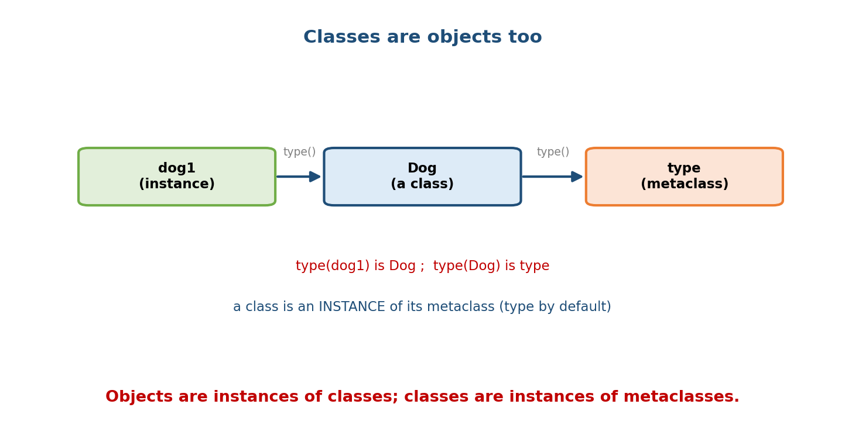
Chain: dog1 is an instance of Dog; Dog is an instance of type. type(dog1) is Dog and type(Dog) is type — a class is an instance of its metaclass.
class Dog: pass
d = Dog()
print(type(d)) # <class '__main__.Dog'> -> d is an instance of Dog
print(type(Dog)) # <class 'type'> -> Dog is an instance of type!
print(isinstance(Dog, type)) # True
Alias = Dog # classes are objects: assignable
print(Alias().__class__) # Dog
So there are two levels: objects are instances of classes; classes are instances of metaclasses. The default metaclass is type.

9.2 type — the Class Factory
type has two jobs. Called with one argument it returns an object’s type. Called with three arguments it creates a new class dynamically:
type(name, bases, namespace)
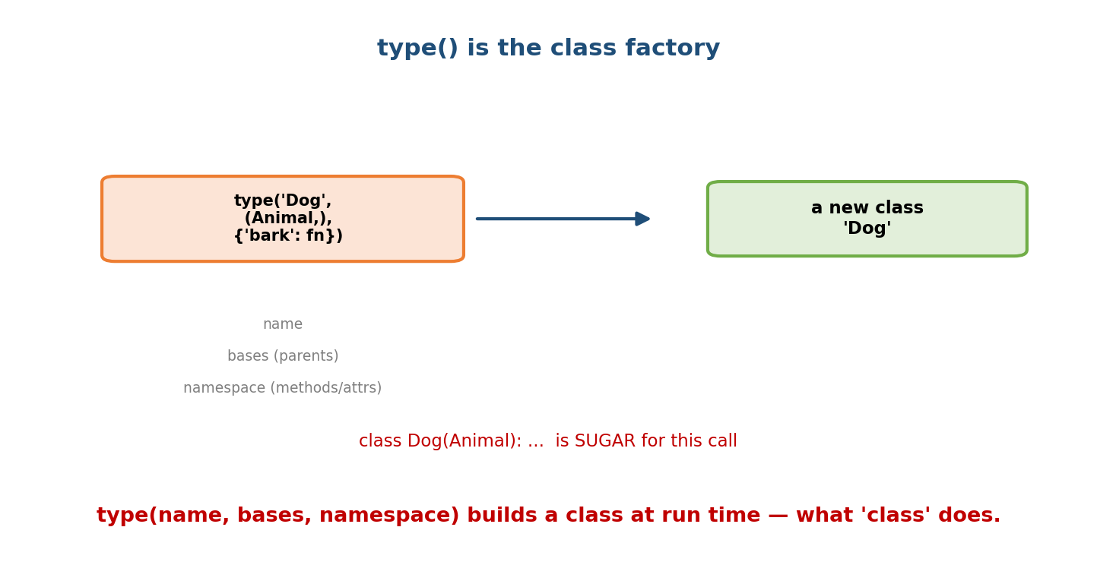
type(‘Dog’, (Animal,), {‘bark’: fn}) — name, tuple of bases, and a namespace dict — returns a brand-new class object; the class statement is sugar for this call.
def bark(self): return "Woof"
# These two are EQUIVALENT:
class Dog(Animal): # (A) the familiar statement
x = 1
def bark(self): return "Woof"
Dog = type("Dog", (Animal,), {"x": 1, "bark": bark}) # (B) the raw call
- name — the class’s __name__ (a string).
- bases — a tuple of parent classes.
- namespace — a dict of attributes/methods (the class body).
The big reveal: the class statement is syntactic sugar — Python executes the class body into a namespace dict, then calls the metaclass (type by default) to build the class object. Metaclasses hook that call.

9.3 What Is a Metaclass?
A metaclass is “the class of a class” — the thing that creates classes. Since type is the default, a custom metaclass subclasses type and overrides its creation hooks.
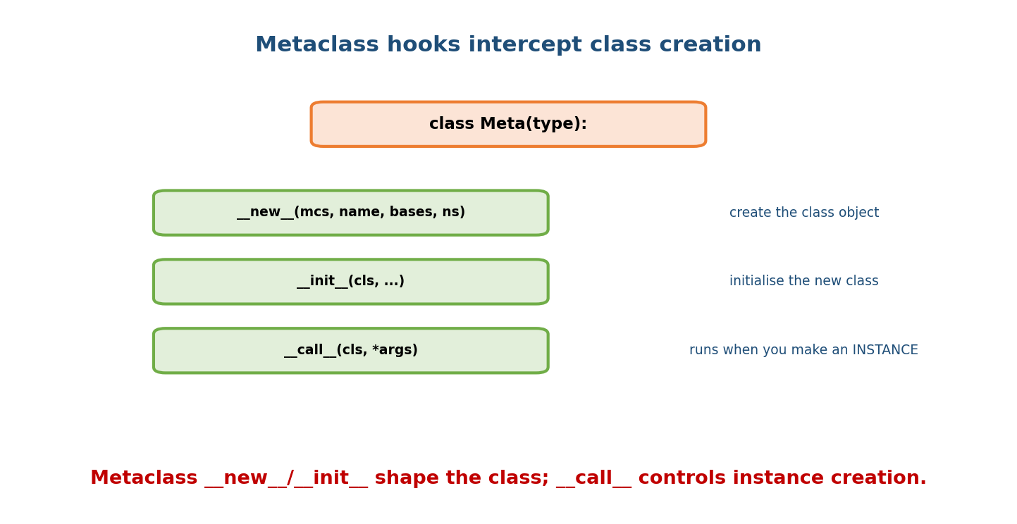
A metaclass Meta(type) can override new (create the class object), init (initialise the new class), and call (runs when you instantiate the class).
Hook | Fires when | Receives
__new__(mcs, name, bases, ns) | the class is created | metaclass, class name, bases, namespace
__init__(cls, name, bases, ns) | right after creation | the new class
__call__(cls, *args, **kw) | you instantiate the class (MyClass()) | the class + constructor args
class UpperMeta(type):
def __new__(mcs, name, bases, ns):
# force all method names to be recorded, add a marker, etc.
ns["created_by"] = "UpperMeta"
return super().__new__(mcs, name, bases, ns)
class Service(metaclass=UpperMeta):
pass
print(Service.created_by) # UpperMeta -> injected at class-creation time
The metaclass= keyword tells Python which metaclass to use to build the class.

9.4 The Class-Creation Flow
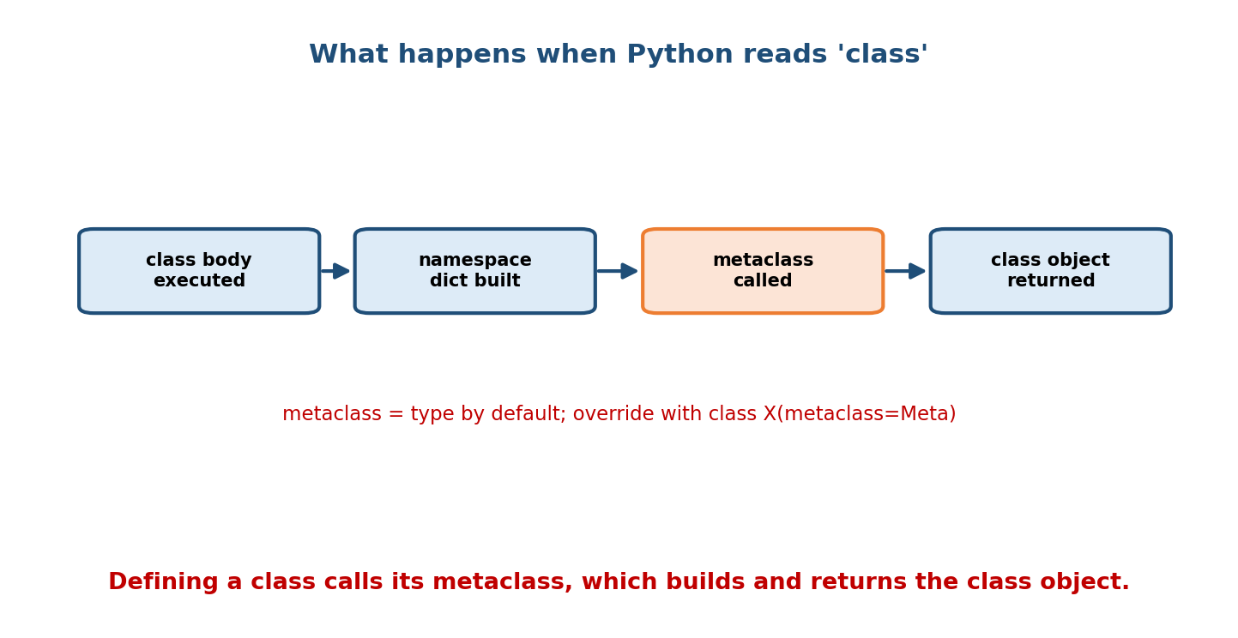
When Python reads a class statement: it executes the class body, builds the namespace dict, calls the metaclass (type by default) to create the class, and returns the class object.
Step by step, when Python encounters class X(Base, metaclass=Meta): ...:
- Determine the metaclass (Meta, or type, or inherited from bases).
- __prepare__ (optional) returns the namespace mapping to use for the body.
- Execute the class body into that namespace (methods, class attrs).
- Call the metaclass: Meta(name, bases, namespace) → runs __new__ then __init__.
- Bind the resulting class object to the name X.
All of this happens once, at definition time — not per instance. (Instance creation later goes through the metaclass’s __call__, which by default runs the class’s __new__ + __init__ — connecting back to Module 3.)

9.5 Real Use Cases
Metaclasses aren’t academic — they run real frameworks:
- ABCMeta (Module 4’s ABCs) is a metaclass that enforces abstract methods.
- Django ORM / SQLAlchemy: a model class’s fields are turned into columns/ descriptors by a metaclass at class-creation time.
- Enums (enum.EnumMeta): converts class attributes into singleton members.
- Registries / plugins: auto-collect subclasses.
- Enforcing constraints: require certain methods/attributes on every subclass.

Example: an auto-registering plugin registry
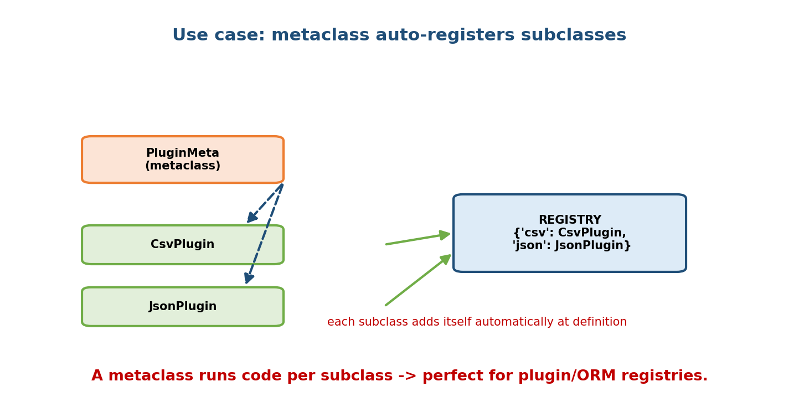
A PluginMeta metaclass causes each subclass (CsvPlugin, JsonPlugin) to add itself to a central REGISTRY dict automatically as it is defined.
class PluginMeta(type):
registry = {}
def __init__(cls, name, bases, ns):
super().__init__(name, bases, ns)
if bases: # skip the base class itself
PluginMeta.registry[cls.format] = cls
class Plugin(metaclass=PluginMeta):
format = None
class CsvPlugin(Plugin): format = "csv"
class JsonPlugin(Plugin): format = "json"
print(PluginMeta.registry) # {'csv': <CsvPlugin>, 'json': <JsonPlugin>}
Every subclass registers itself automatically at definition — no manual list to maintain. This is the canonical “why a metaclass” example.

9.6 The Lighter Alternatives (prefer these!)
Most “do something per subclass” or “tweak a class” needs don’t require a metaclass anymore.

__init_subclass__ — hook subclass creation
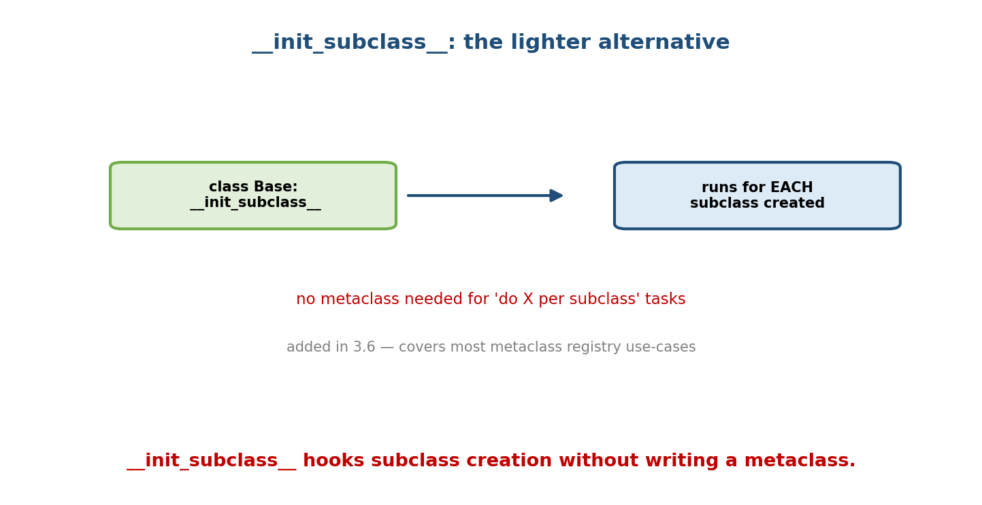
A Base class defining init_subclass runs that hook automatically for each subclass created — covering most registry use-cases without a metaclass.
class Plugin:
registry = {}
def __init_subclass__(cls, **kwargs): # runs for EACH subclass
super().__init_subclass__(**kwargs)
Plugin.registry[cls.__name__] = cls
class CsvPlugin(Plugin): pass # auto-registered, no metaclass!
print(Plugin.registry) # {'CsvPlugin': <CsvPlugin>}
Added in Python 3.6, __init_subclass__ covers the registry/validation cases that used to need a metaclass — with far less complexity.

Class decorators — post-process a finished class
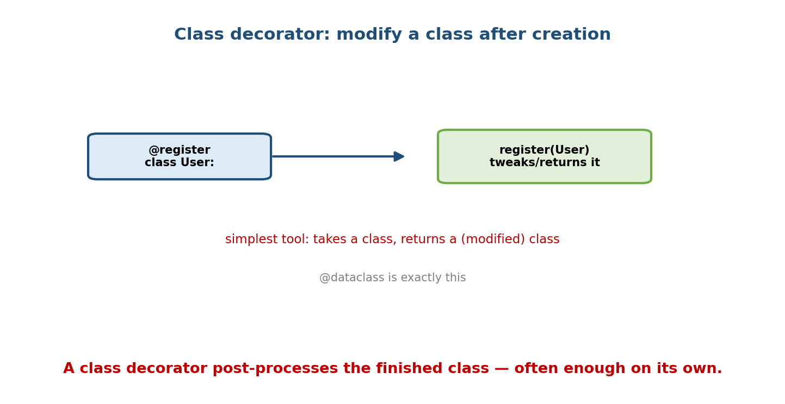
A class decorator like @register receives the User class after creation and can modify or wrap it, then return it — exactly what @dataclass does.
def register(cls):
REGISTRY[cls.__name__] = cls
return cls # return the (possibly modified) class
@register
class User: ...
@dataclass (Module 10) is exactly this pattern — a class decorator that rewrites the class to add __init__, __repr__, etc.

9.7 Which Tool? (choose the simplest)
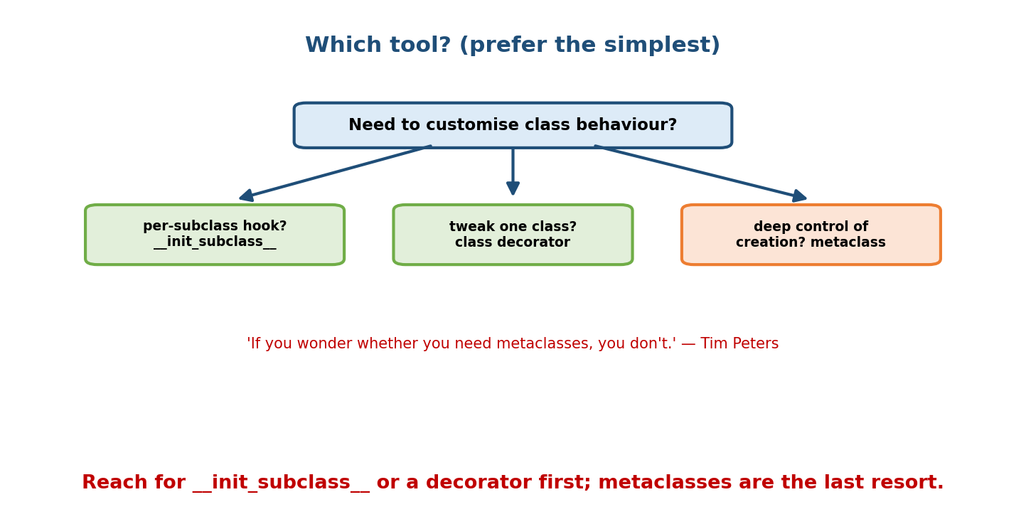
Decision: for a per-subclass hook use init_subclass; to tweak one class use a class decorator; only for deep control of class creation use a metaclass. Tim Peters: ‘If you wonder whether you need metaclasses, you don’t.’
Need | Tool
Run code for each subclass | __init_subclass__
Customise attribute at class level | __set_name__ descriptor (Module 8)
Modify one class after creation | class decorator
Deep control of the creation process for a family of classes | metaclass
Tim Peters’ rule: “Metaclasses are deeper magic than 99% of users should ever worry about. If you wonder whether you need them, you don’t (the people who actually need them know with certainty, and don’t need an explanation about why).”

Module 9 — Interview Mapping
Question | Junior answer | Senior answer
“What’s a metaclass?” | “A class of a class.” | “The type that creates classes — type by default. The class statement is sugar for type(name, bases, ns); a metaclass overrides __new__/__init__ to hook class creation.”
“type(Dog)?” | (unsure) | “type — because Dog is an instance of the metaclass type; objects→classes→metaclasses.”
“When would you use one?” | “Never?” | “Rarely — for framework-level auto-registration, enforcing subclass contracts, ORMs. But I’d try __init_subclass__ or a class decorator first.”
“__init_subclass__ vs metaclass?” | (unaware) | “__init_subclass__ (3.6+) hooks subclass creation without a metaclass and covers most registry/validation cases with far less complexity.”

Module 9 — Exam Mapping
- GATE CS: essentially untested at depth; “class is an object” may appear.
- SEBI / RBI IT: not tested.
- FAANG / senior backend: conceptual — “explain metaclasses,” “how does Django build models,” “class vs metaclass,” and the judgment to avoid them.

Module 9 — Common Mistakes & Misconceptions
- Reaching for a metaclass when __init_subclass__ or a decorator suffices.
- Confusing __new__ on a class (instance creation) with __new__ on a metaclass (class creation).
- Metaclass conflicts in multiple inheritance: all bases must have compatible metaclasses (metaclass conflict error).
- Thinking metaclass code runs per instance — it runs at class definition.
- Overriding __call__ incorrectly and breaking normal instantiation.

Module 9 — MCQs (with answers & explanations)
Q1. type(Dog) where class Dog: pass returns: a) Dog b) object c) type d) class
Answer
c. Dog is an instance of the metaclass type.
Q2. The class statement is essentially sugar for: a) object(...) b) type(name, bases, namespace) c) class(...) d) new(...)
Answer
b. Python builds the class by calling the metaclass with these three arguments.
Q3. A custom metaclass typically: a) inherits object b) inherits type c) uses @dataclass d) is a function
Answer
b. Metaclasses subclass type and override its hooks.
Q4. Metaclass __new__/__init__ run: a) per instance b) at class definition c) at import of any module d) never
Answer
b. They fire once when the class is created.
Q5. To run code for every subclass without a metaclass, use: a) __new__ b) __init_subclass__ c) __slots__ d) __call__
Answer
b. __init_subclass__ (3.6+) hooks subclass creation.
Q6. @dataclass is an example of a: a) metaclass b) class decorator c) descriptor d) mixin
Answer
b. It post-processes the class to add methods.
Q7. Which real feature is powered by a metaclass? a) list comprehension b) f-strings c) ABCs (ABCMeta) d) decorators
Answer
c. ABCMeta enforces abstract methods.
Q8. Instantiating a class (MyClass()) invokes the metaclass’s: a) __new__ b) __init__ c) __call__ d) __prepare__
Answer
c. type.__call__ orchestrates the class’s __new__ + __init__.

Module 9 — Design/Practice Exercises (easy → hard)
- (easy) Create a class dynamically with type("Cat", (), {"speak": lambda self: "Meow"}) and instantiate it.
- (easy) Show type(int), type(type), and isinstance(str, type).
- (medium) Write an auto-registry using __init_subclass__, then rewrite it using a metaclass — compare complexity.
- (medium) Write a metaclass that raises if a subclass forgets to define a handle() method.
- (hard) Write a metaclass that automatically wraps every method with timing logging.
- (hard, interview) Explain, with the object→class→metaclass chain, why type(type) is type, and why that isn’t an infinite regress.

Module 9 — Concept Review (one page)
A class is an object — an instance of a metaclass, which is type by default (so type(Dog) is type). The class statement is sugar for type(name, bases, namespace): Python runs the class body into a namespace dict, then calls the metaclass to build the class object — once, at definition time. A custom metaclass subclasses type and overrides __new__ (create class), __init__ (init class), and __call__ (control instantiation). Metaclasses power ABCs, ORMs, enums, and registries. But modern Python offers lighter tools: __init_subclass__ (per-subclass hook), __set_name__ descriptors, and class decorators (like @dataclass) — which cover most needs. Prefer the lightest tool; a metaclass is a last resort for deep, family-wide control of class creation.

Module 9 — Flash Cards (Q → A)
Front | Back
type(Dog) where Dog is a class | type (the metaclass)
A metaclass is | the class of a class; creates classes
Default metaclass | type
class statement ≡ | type(name, bases, namespace)
Custom metaclass inherits | type
Metaclass hooks | __new__, __init__ (class creation), __call__ (instantiation)
When metaclass code runs | at class definition time
Per-subclass hook without metaclass | __init_subclass__ (3.6+)
Post-process one class | class decorator (@dataclass)
Real metaclass users | ABCs (ABCMeta), Django/SQLAlchemy, Enum
Metaclass rule of thumb | if unsure you need one, you don’t

Module 9 — Pattern Recognition
- See “auto-collect all subclasses” → __init_subclass__ (or metaclass).
- See “enforce every subclass defines X” → __init_subclass__/metaclass check.
- See “rewrite a class to add methods” → class decorator (@dataclass).
- See “type(Dog) is type” → classes are instances of metaclasses.
- See framework “declare fields as class attributes → become columns” → metaclass/descriptors (ORM style).
- See a metaclass where a decorator would do → simplify.

Module 9 — Revision Notes / Mini Cheat Sheet
CLASSES ARE OBJECTS: type(obj)=Class ; type(Class)=metaclass (type by default).
type(name, bases, namespace) -> builds a class. 'class' statement is SUGAR for this.
METACLASS = subclass of type; overrides:
__new__(mcs, name, bases, ns) create class object
__init__(cls, ...) init the new class
__call__(cls, *a) runs on INSTANTIATION (MyClass())
Runs at CLASS DEFINITION time (not per instance). Set via class X(metaclass=Meta).
USE CASES: ABCMeta, Django/SQLAlchemy ORMs, Enum, plugin registries, subclass constraints.
PREFER LIGHTER TOOLS:
__init_subclass__(cls) -> per-subclass hook (3.6+) — covers most registries
__set_name__ -> descriptor knows its attr name (M8)
class decorator -> post-process one class (@dataclass)
RULE: metaclass is a LAST RESORT. "If you wonder if you need one, you don't."
Next module: Module 10 — Modern Python OOP Tooling. We come back down to earth with the classes you’ll actually write daily: @dataclass (auto __init__/__repr__/__eq__), NamedTuple, Enum, and attrs — all built on the descriptor/decorator/metaclass machinery of the last two modules, but packaged so you write almost no boilerplate.

Module 9 — Summary
The deepest layer of Python OOP rests on one fact: classes are objects, created by metaclasses — type by default, so type(Dog) is type. The class statement is sugar for type(name, bases, namespace), and a custom metaclass (subclassing type) can hook class creation via __new__/__init__ and instantiation via __call__, all at definition time. This machinery powers ABCs, ORMs, enums, and auto-registries. Yet the mark of a strong Python engineer is restraint: __init_subclass__, __set_name__ descriptors, and class decorators now handle most cases with far less complexity, leaving metaclasses as a rarely-needed last resort. Understanding the chain — objects → classes → metaclasses — completes your mental model of how Python OOP actually works.
You have mastered this module when you can: explain the object→class→metaclass chain and why type(type) is type; build a class with type(...); write a simple metaclass and an __init_subclass__ hook; and pick the lightest tool for a class-customisation task.

