Module 10 — Modern Python OOP Tooling (dataclasses, NamedTuple, Enum)
  - OOP with Python Mastery: FAANG Interviews / GATE / SEBI-RBI IT / Backend — In-Depth Notes (with visuals)
Prepared for nidhi.sharma@forensiccybertech.com
2026
Table of Contents

Module 10 — Modern Python OOP Tooling
Why this module matters. Modules 7–9 explained the machinery. This module is the payoff: the tools that let you write real-world classes with almost zero boilerplate. Instead of hand-writing __init__, __repr__, and __eq__ for the hundredth time, you declare typed fields and let @dataclass generate them. You’ll also meet NamedTuple (immutable records), Enum (named constants instead of magic numbers), and the third-party attrs. These are what modern Python code actually looks like — and interviewers expect you to reach for them.
Importance ratings (out of 5):
Exam / Use | FAANG Interview | GATE CS | SEBI/RBI IT | Backend Dev | LLD Rounds
This module | ★★★★ | ★ | ★ | ★★★★★ | ★★★★
Most-asked concepts: what @dataclass generates; field(default_factory=...) (the mutable-default fix); frozen=True (immutable + hashable); __post_init__; NamedTuple vs dataclass; Enum for constants; when to use which.
What you must be able to do after this module: replace a boilerplate class with a @dataclass; safely give a field a mutable default; make a frozen (value-object) dataclass; define an Enum; and choose between dataclass / NamedTuple / Enum / plain class for a given need.

10.1 The Boilerplate Problem @dataclass Solves
A simple “record” class by hand needs __init__, __repr__, and __eq__ — a dozen lines of repetitive, error-prone code:
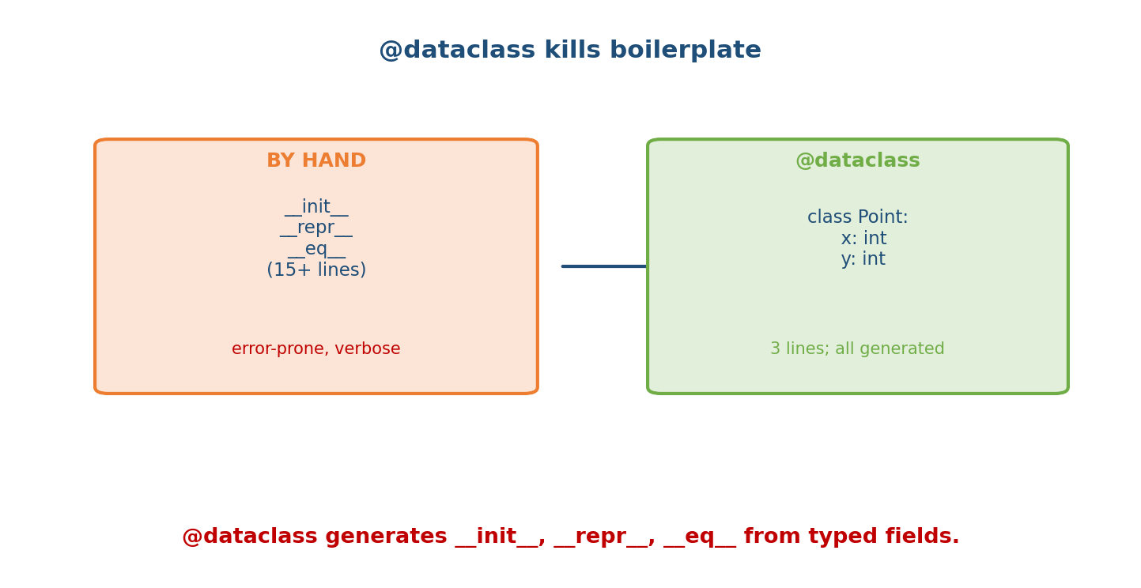
By hand a record class needs init, repr, eq (15+ lines, error-prone); @dataclass reduces it to 3 lines of typed fields with everything generated.
# By hand (verbose, easy to get __eq__/__repr__ wrong)
class Point:
def __init__(self, x, y): self.x, self.y = x, y
def __repr__(self): return f"Point(x={self.x}, y={self.y})"
def __eq__(self, o): return isinstance(o, Point) and (self.x, self.y) == (o.x, o.y)
# With @dataclass (declarative, generated)
from dataclasses import dataclass
@dataclass
class Point:
x: int
y: int
Both give the same behaviour — but the dataclass is 3 lines and can’t drift out of sync.

10.2 What @dataclass Generates
The decorator reads the type-annotated class attributes as fields and writes the dunders:
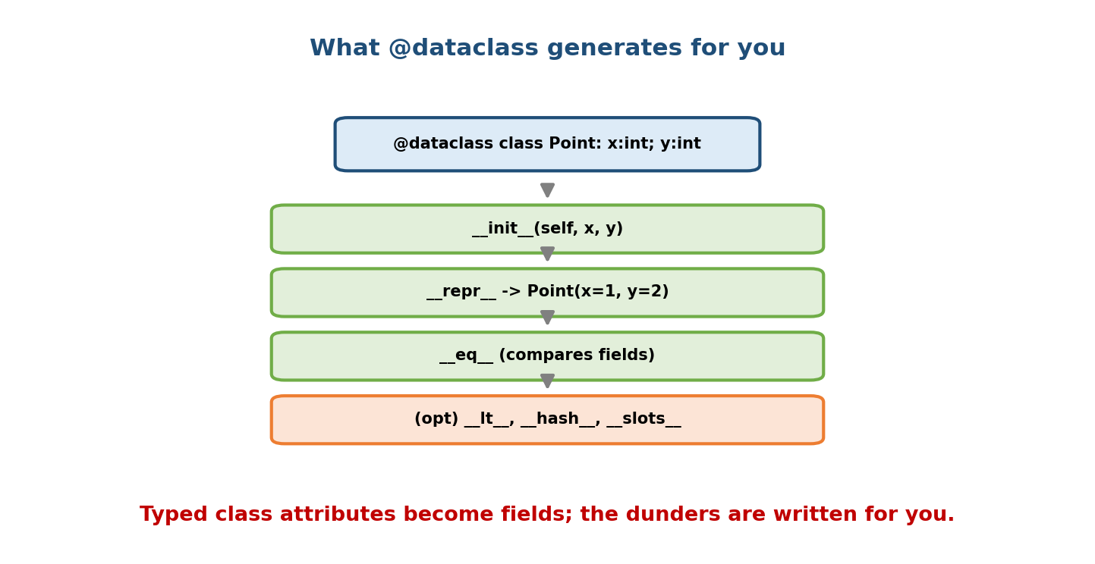
From @dataclass class Point with x:int, y:int, Python generates init(self, x, y), repr -> Point(x=1, y=2), eq comparing fields, and optionally lt, hash, slots.
@dataclass
class Point:
x: int
y: int
p = Point(1, 2)
print(p) # Point(x=1, y=2) <- generated __repr__
print(p == Point(1, 2)) # True <- generated __eq__
- Fields come from class-level type annotations (x: int). An attribute without an annotation is not a field.
- Defaults work like function defaults: y: int = 0. Non-default fields cannot follow default fields (same rule as function parameters).

10.3 field() and Decorator Options
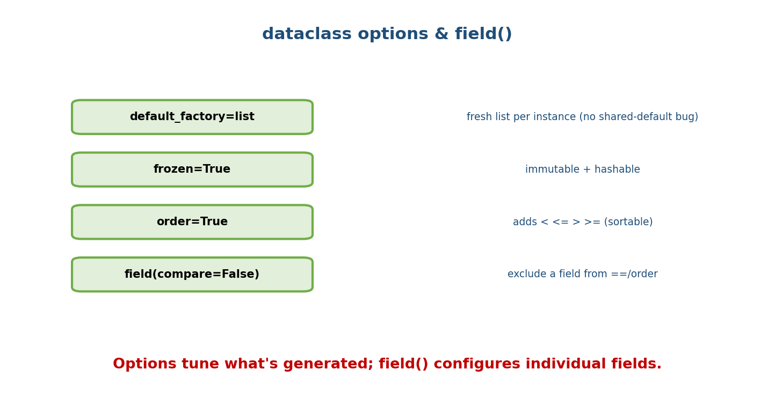
dataclass options: default_factory=list (fresh list per instance), frozen=True (immutable+hashable), order=True (adds comparisons), field(compare=False) (exclude a field from ==/order).

The mutable-default fix: default_factory
Recall Module 2’s mutable-default bug. A dataclass field forbids a mutable default directly and makes you use default_factory:
from dataclasses import dataclass, field
@dataclass
class Cart:
items: list = field(default_factory=list) # fresh list PER instance
# items: list = [] # ValueError: mutable default not allowed
a, b = Cart(), Cart()
a.items.append("apple")
print(b.items) # [] -> independent, bug avoided by design

Decorator options
Option | Effect
frozen=True | immutable instances + generates __hash__
order=True | generates __lt__/__le__/__gt__/__ge__ (sortable by field tuple)
eq=True (default) | generates __eq__
slots=True (3.10+) | uses __slots__ (memory savings, Module 8)
kw_only=True (3.10+) | all fields keyword-only

Per-field control with field()
@dataclass
class User:
name: str
password: str = field(repr=False) # hide from __repr__
id: int = field(compare=False, default=0) # exclude from ==/order
tags: list = field(default_factory=list)

10.4 __post_init__ — derived fields & validation
The generated __init__ only assigns fields. For computed values or validation, define __post_init__, which runs immediately after:
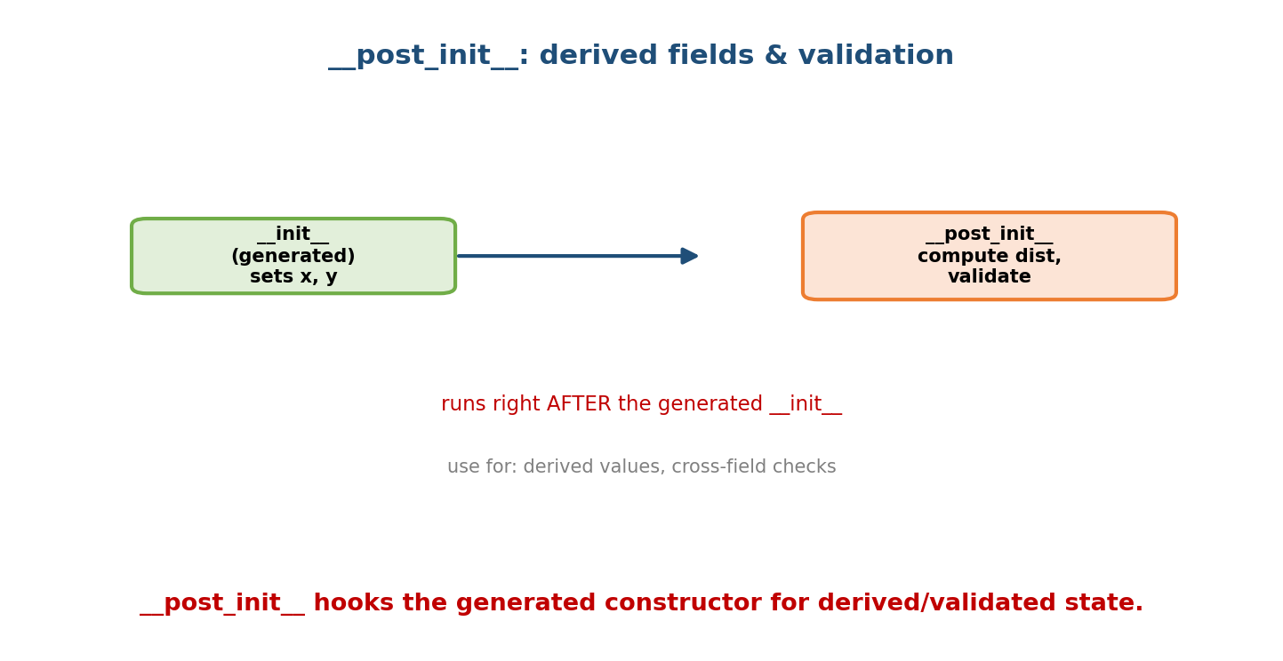
post_init runs right after the generated init set x and y, letting you compute a derived distance field or validate cross-field constraints.
from dataclasses import dataclass, field
import math
@dataclass
class Vector:
x: float
y: float
magnitude: float = field(init=False) # not a constructor argument
def __post_init__(self):
if self.x == self.y == 0:
raise ValueError("zero vector not allowed") # validation
self.magnitude = math.hypot(self.x, self.y) # derived field
v = Vector(3, 4)
print(v.magnitude) # 5.0
field(init=False) keeps magnitude out of the constructor signature; you compute it in __post_init__.

10.5 NamedTuple — immutable records
A NamedTuple is a tuple with named fields: immutable, hashable, memory-light, and both name- and index-accessible.
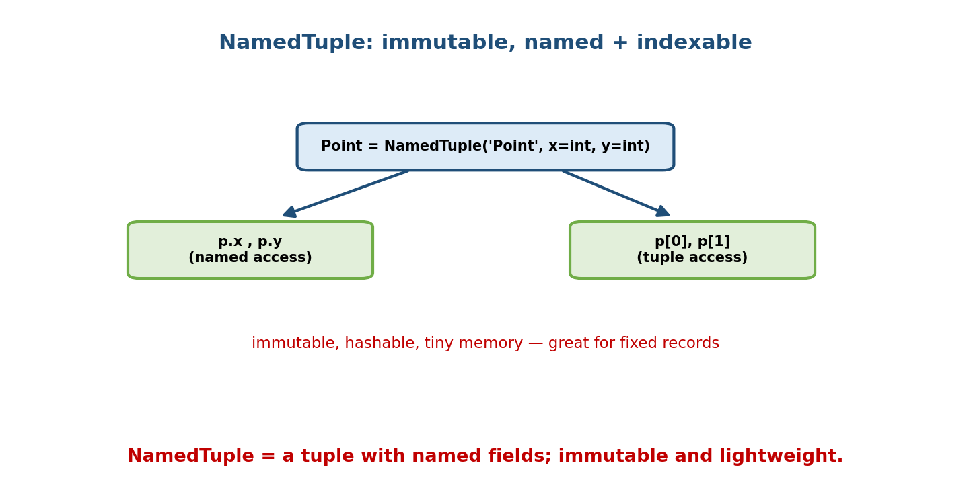
Point defined as a NamedTuple supports both named access (p.x, p.y) and tuple access (p[0], p[1]); it is immutable, hashable, and memory-light.
from typing import NamedTuple
class Point(NamedTuple):
x: int
y: int
p = Point(1, 2)
print(p.x, p[0]) # 1 1 -> named AND indexed access
print(p == Point(1, 2)) # True
# p.x = 9 # AttributeError: immutable
a, b = p # unpacks like a tuple
dataclass vs NamedTuple:
 | @dataclass | NamedTuple
Mutable? | yes (unless frozen=True) | no (always immutable)
Base | plain object | tuple (indexable, unpackable)
Methods | easy to add | can add, but tuple semantics
Memory | normal (or slots=True) | very small
Use when | a record you may mutate / add behaviour | a fixed, immutable value/record

10.6 Enum — named constants (no magic values)
An Enum defines a fixed set of named, singleton constants — replacing error-prone “magic numbers/strings”.
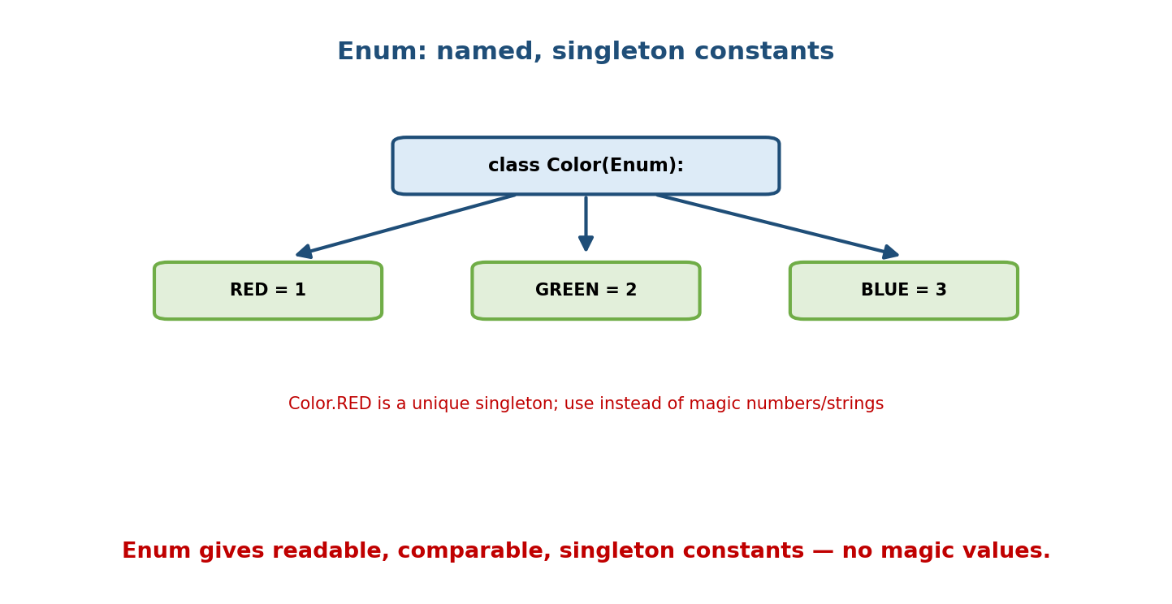
A Color Enum with RED=1, GREEN=2, BLUE=3: each member is a unique singleton, readable and comparable, used instead of magic numbers or strings.
from enum import Enum, auto
class Status(Enum):
PENDING = auto() # auto-numbered 1, 2, 3...
ACTIVE = auto()
CLOSED = auto()
print(Status.ACTIVE) # Status.ACTIVE
print(Status.ACTIVE.name) # 'ACTIVE'
print(Status.ACTIVE.value) # 2
print(Status.ACTIVE is Status.ACTIVE) # True (singletons)
def handle(s: Status): # type-safe, self-documenting
if s is Status.CLOSED:
...
Variants: IntEnum (members are ints, comparable to ints), Flag/IntFlag (bitwise-combinable), and StrEnum (3.11+, string members). Enums prevent bugs like passing "activ" (typo) or 2 (meaningless) where a status is expected.

10.7 Frozen Dataclasses = Value Objects
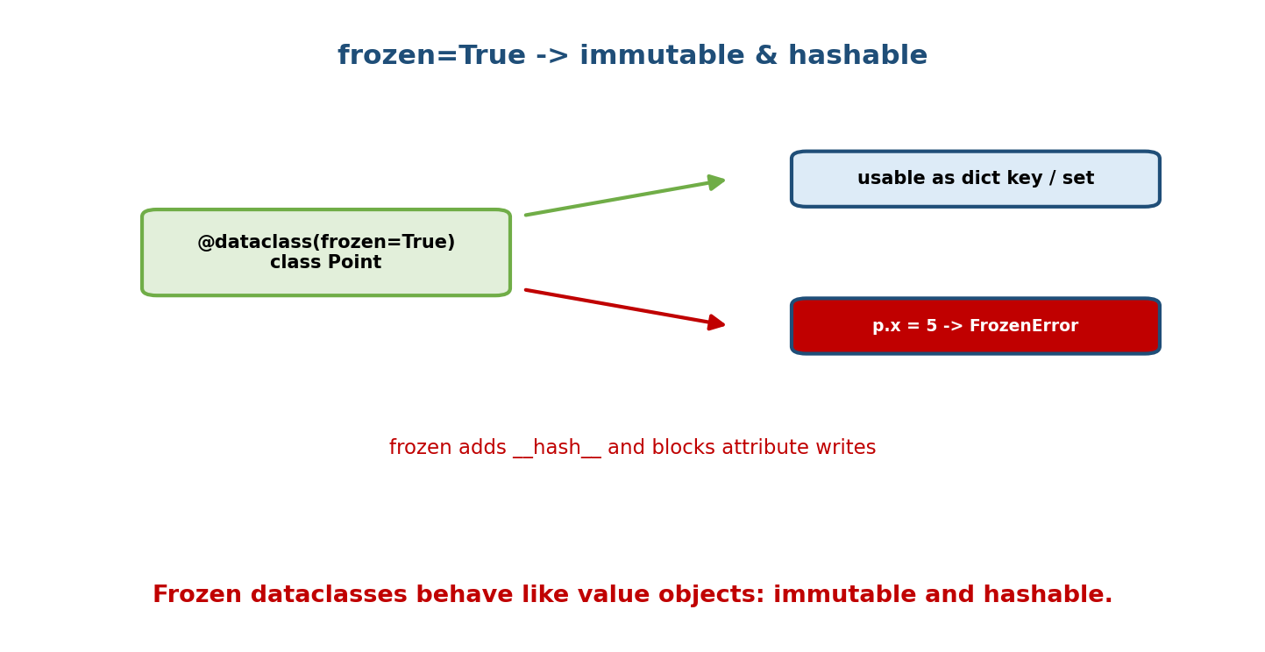
frozen=True makes a dataclass immutable and hashable: it can be used as a dict key or set member, and attribute writes (p.x = 5) raise FrozenInstanceError.
@dataclass(frozen=True)
class Money:
amount: int
currency: str
m = Money(100, "INR")
# m.amount = 200 # dataclasses.FrozenInstanceError
d = {m: "receipt"} # hashable -> usable as a dict key / set member
Frozen dataclasses model value objects (Module 17): identity is defined by value, they’re safe to share, and they’re hashable — the dataclass analogue of a NamedTuple but with object semantics and easy method addition.
attrs: the third-party library attrs inspired dataclasses and offers more (converters, richer validators, __slots__ by default). Use @dataclass for the standard-library default; reach for attrs when you need its extra power.

10.8 Which Tool When?
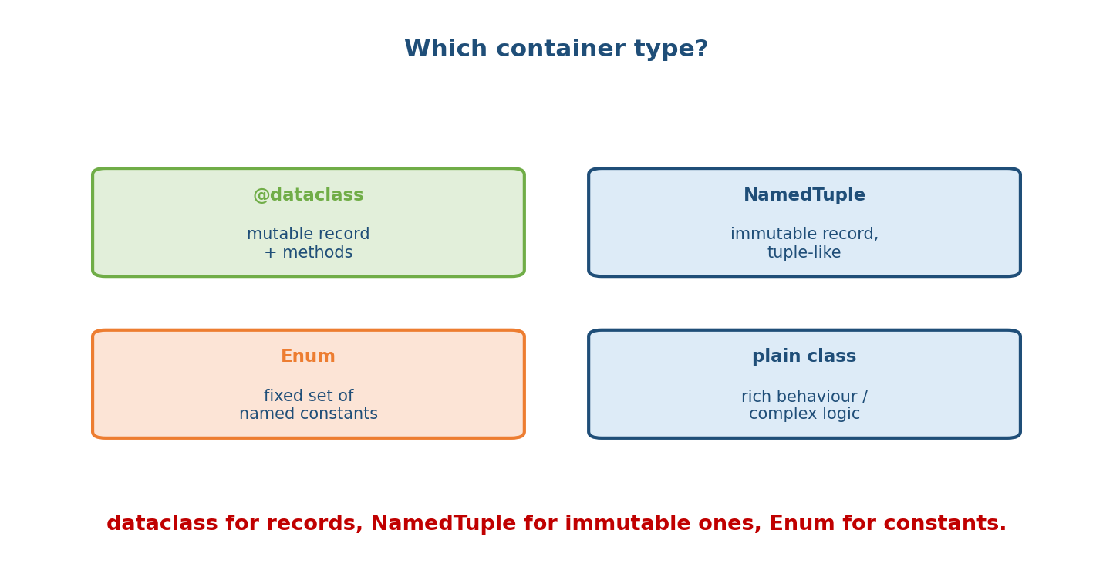
Decision: @dataclass for a mutable record with methods; NamedTuple for an immutable tuple-like record; Enum for a fixed set of named constants; a plain class for rich behaviour or complex logic.
Need | Use
A record you’ll mutate, maybe with methods | @dataclass
An immutable record, tuple-like, tiny | NamedTuple (or frozen dataclass)
A fixed set of named constants | Enum
A value object (hashable, immutable) | @dataclass(frozen=True)
Rich behaviour, complex invariants, inheritance-heavy | plain class
Millions of instances, memory-critical | dataclass with slots=True / NamedTuple

Module 10 — Interview Mapping
Question | Junior answer | Senior answer
“What does @dataclass do?” | “Auto __init__.” | “Generates __init__, __repr__, __eq__ (and optionally ordering/hash/slots) from typed fields; reduces boilerplate and drift.”
“Mutable default in a dataclass?” | (bug) | “Not allowed directly — use field(default_factory=list) for a fresh value per instance (fixes the shared-default bug).”
“dataclass vs NamedTuple?” | “Both hold data.” | “NamedTuple is an immutable tuple subclass (indexable, unpackable, tiny); dataclass is a mutable object (unless frozen) with easy methods; pick by mutability/behaviour.”
“Why Enum?” | “Constants.” | “Named singletons instead of magic values — type-safe, self-documenting, comparable by identity.”

Module 10 — Exam Mapping
- GATE CS: minimal (library feature).
- SEBI / RBI IT: minimal.
- FAANG / backend: expected fluency — refactor to dataclasses, know default_factory/frozen/__post_init__, choose the right container, use enums over magic values.

Module 10 — Common Mistakes & Misconceptions
- Mutable default without default_factory — raises at class definition (good!); always use the factory.
- Missing type annotation on a field — it won’t become a dataclass field.
- A non-default field after a default field — TypeError (parameter-order rule).
- Expecting NamedTuple to be mutable — it never is.
- Using magic numbers/strings where an Enum belongs.
- Comparing Enum members with == to raw values — use is/the member (unless IntEnum).
- Making a mutable dataclass hashable — only frozen=True gives a safe hash.

Module 10 — MCQs (with answers & explanations)
Q1. @dataclass automatically generates: a) only __init__ b) __init__, __repr__, __eq__ c) __hash__ always d) nothing
Answer
b. Plus optional ordering/hash/slots via options.
Q2. The correct way to default a list field: a) items: list = [] b) items: list = field(default_factory=list) c) items = [] d) items: list = None
Answer
b. default_factory creates a fresh list per instance; a literal [] is rejected.
Q3. @dataclass(frozen=True) makes instances: a) faster only b) immutable and hashable c) mutable d) abstract
Answer
b. Writes raise FrozenInstanceError; a __hash__ is generated.
Q4. A NamedTuple is: a) mutable b) a dict c) an immutable tuple subclass with named fields d) a metaclass
Answer
c. Immutable, indexable, unpackable, and name-accessible.
Q5. __post_init__ is used to: a) replace __init__ b) run validation / compute derived fields after init c) delete fields d) serialize
Answer
b. It runs right after the generated __init__.
Q6. Best replacement for magic strings like "pending", "active": a) constants module b) an Enum c) a dict d) a list
Answer
b. Enums give named, type-safe singletons.
Q7. field(compare=False) on id means: a) id is hidden from repr b) id is excluded from __eq__/ordering c) id is required d) id is frozen
Answer
b. The field won’t participate in equality/comparison.
Q8. For millions of small records, memory-critical, choose: a) plain class with __dict__ b) dataclass with slots=True or NamedTuple c) dict of dicts d) list of lists
Answer
b. Slots/NamedTuple avoid per-instance __dict__.

Module 10 — Design/Practice Exercises (easy → hard)
- (easy) Rewrite a hand-written Point class as a @dataclass.
- (easy) Add a safely-defaulted tags: list field using default_factory.
- (medium) Make a frozen Money dataclass usable as a dict key; add a method that returns a new Money with a different amount.
- (medium) Add __post_init__ validation to reject negative prices.
- (hard) Model a card game: a Suit/Rank Enum, a frozen Card dataclass, and a mutable Deck dataclass; make cards hashable and sortable.
- (hard, interview) Given a class using magic status strings and manual dunders, refactor it to dataclass + Enum and explain each improvement.

Module 10 — Concept Review (one page)
Modern Python replaces record boilerplate with declarative tools. @dataclass reads type-annotated fields and generates __init__, __repr__, and __eq__ (plus optional ordering, hashing, and __slots__), keeping code short and in sync. Mutable defaults are handled safely with field(default_factory=...), and __post_init__ adds validation/derived fields. frozen=True yields immutable, hashable value objects. NamedTuple is an immutable, tuple-based record (indexable, unpackable, tiny); Enum provides named singleton constants that eliminate magic values. Choose dataclass for mutable records, NamedTuple or frozen dataclass for immutable ones, Enum for constant sets, and a plain class for rich behaviour — all built atop the descriptor/decorator/ metaclass machinery of Modules 8–9.

Module 10 — Flash Cards (Q → A)
Front | Back
@dataclass generates | __init__, __repr__, __eq__ (opt: order/hash/slots)
Fields come from | type-annotated class attributes
Mutable default fix | field(default_factory=list)
Immutable + hashable dataclass | @dataclass(frozen=True)
Post-construction hook | __post_init__
Exclude field from __init__ | field(init=False)
NamedTuple is | immutable tuple subclass with named fields
dataclass vs NamedTuple | mutable object vs immutable tuple
Enum gives | named singleton constants (no magic values)
Auto-number enum members | auto()
Memory-critical records | slots=True dataclass / NamedTuple
attrs is | third-party lib that inspired dataclasses (more features)

Module 10 — Pattern Recognition
- See a class that’s “just data” with manual dunders → @dataclass.
- See = []/= {} as a field default → field(default_factory=...).
- See “must be immutable / hashable / dict key” → frozen=True or NamedTuple.
- See magic numbers/strings for a fixed set → Enum.
- See “compute a field from others at construction” → __post_init__.
- See millions of tiny records → slots=True / NamedTuple.

Module 10 — Revision Notes / Mini Cheat Sheet
@dataclass: typed fields -> auto __init__/__repr__/__eq__.
y: int = 0 default (non-default cannot follow default)
field(default_factory=list) fresh mutable default (fixes shared-default bug)
field(init=False / repr=False / compare=False) per-field control
OPTIONS: frozen=True (immutable+hashable), order=True (comparisons),
slots=True (3.10, memory), kw_only=True (3.10).
__post_init__: validation + derived fields after generated __init__.
NamedTuple (typing): immutable tuple subclass; p.x AND p[0]; tiny; unpackable.
Enum: named singleton constants. .name/.value; auto(); IntEnum/Flag/StrEnum.
use instead of magic numbers/strings; compare by identity (is).
CHOOSE: dataclass(mutable record) | NamedTuple/frozen(immutable) |
Enum(constants) | plain class(rich behaviour) | slots/NT(memory).
attrs = 3rd-party, richer superset that inspired dataclasses.
Next module: Module 11 — Object Typing & Protocols. We add type safety to our objects: type hints, Generics (list[T], TypeVar), and Protocol — structural typing that formalises duck typing so tools like mypy can check “has the right methods” without inheritance. Dataclasses and Protocols together are how modern typed Python OOP is written.

Module 10 — Summary
Modern Python OOP is declarative: @dataclass turns type-annotated fields into a full record class — generating __init__, __repr__, and __eq__, with options for ordering, frozen immutability/hashability, and __slots__ — while field(default_factory=...) safely handles mutable defaults and __post_init__ adds validation and derived state. NamedTuple offers a tiny, immutable, tuple-based record; Enum replaces magic values with named singleton constants; and the third-party attrs provides a richer superset. Knowing which to reach for — dataclass, NamedTuple, Enum, or a plain class — is the practical skill this module builds, and it’s exactly the fluency modern Python interviews and codebases expect.
You have mastered this module when you can: convert a boilerplate class to a dataclass; use default_factory and frozen correctly; add __post_init__ validation; define an Enum; and justify dataclass vs NamedTuple vs Enum vs plain class for a given requirement.

