Module 11 — Object Typing & Protocols
  - OOP with Python Mastery: FAANG Interviews / GATE / SEBI-RBI IT / Backend — In-Depth Notes (with visuals)
Prepared for nidhi.sharma@forensiccybertech.com
2026
Table of Contents

Module 11 — Object Typing & Protocols
Why this module matters. Python is dynamically typed, but modern professional Python is gradually typed — real codebases (and interviewers) expect type hints. For OOP the key ideas are Generics (a Stack that works for any element type while staying type-safe) and Protocol — which turns Module 6’s duck typing into something a checker like mypy can verify without inheritance. Understanding ABC (nominal) vs Protocol (structural) typing is a modern-Python differentiator and directly shapes how you design flexible, checkable interfaces.
Importance ratings (out of 5):
Exam / Use | FAANG Interview | GATE CS | SEBI/RBI IT | Backend Dev | LLD Rounds
This module | ★★★★ | ★ | ★ | ★★★★★ | ★★★★
Most-asked concepts: are type hints enforced at runtime? (no); Generics and TypeVar; Protocol / structural typing; ABC vs Protocol; Optional/ Union/|; ClassVar, Final, Self; what mypy does.
What you must be able to do after this module: annotate a class fully; write a generic class with TypeVar; define a Protocol and explain how it formalises duck typing; and choose ABC vs Protocol for an interface.

11.1 Type Hints — for tools, not the interpreter
Type hints annotate variables, parameters, and returns. Crucially, Python does not enforce them at run time — they’re for IDEs, static checkers (mypy/pyright), and human readers.
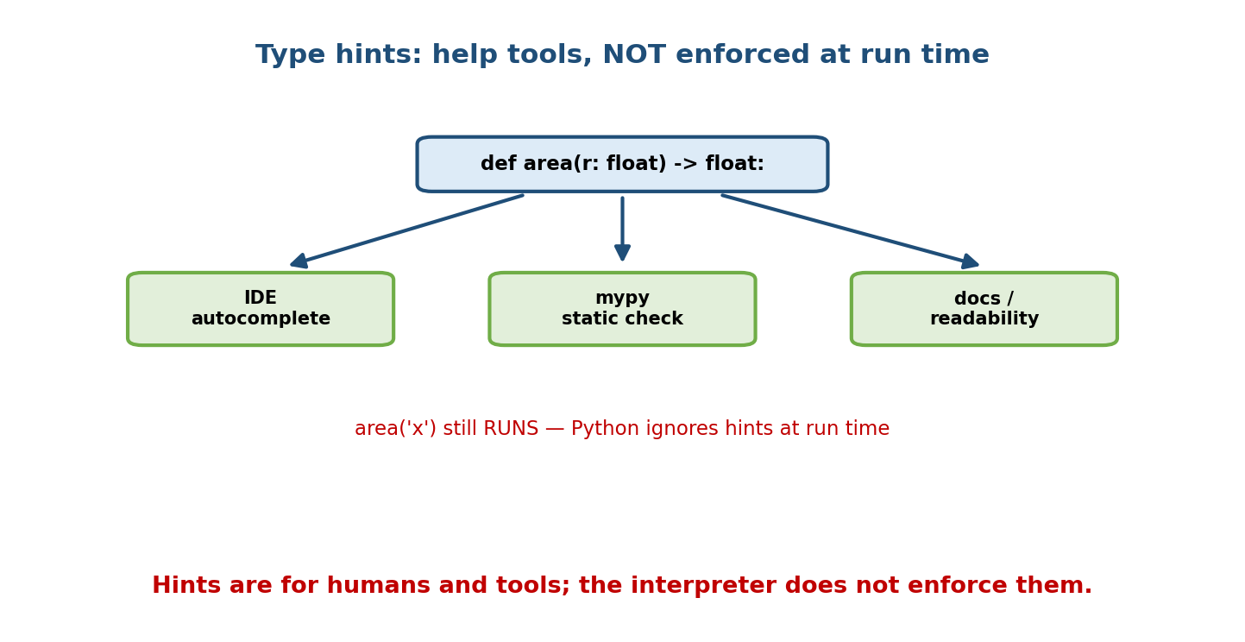
A type-hinted function feeds three benefits — IDE autocomplete, mypy static checking, documentation — but calling it with a wrong type still runs, because Python ignores hints at run time.
def area(r: float) -> float:
return 3.14159 * r * r
area("oops") # RUNS anyway (then crashes on *) — Python ignores the hint
Benefits: autocomplete, early error detection (via mypy), self-documenting code, and safer refactoring. Costs: some verbosity; hints can drift if not checked. The consensus in professional Python: hint public APIs and non-trivial code.

11.2 Annotating a Class
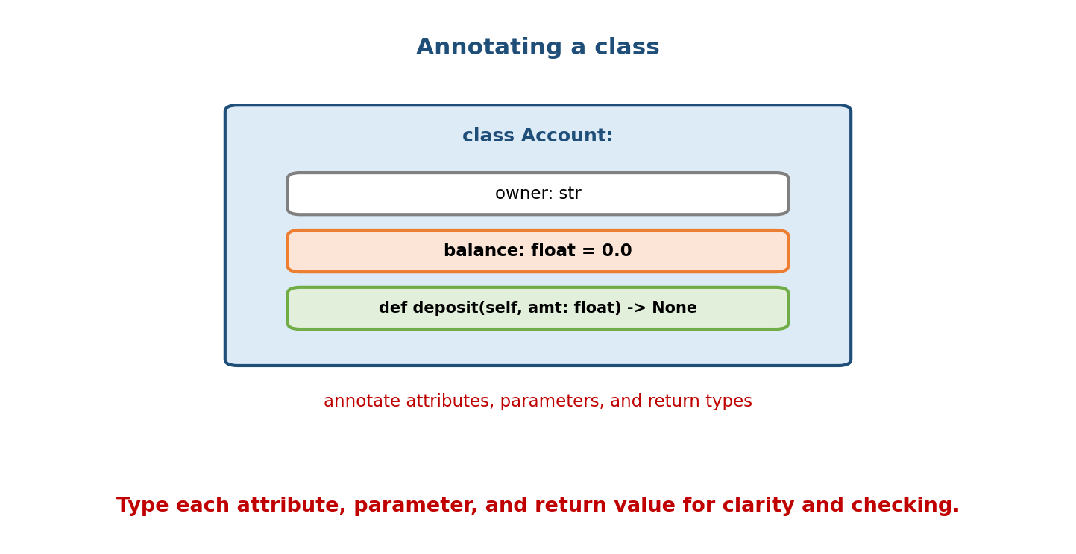
Annotating class Account: owner: str, balance: float = 0.0, and def deposit(self, amt: float) -> None — attributes, parameters, and returns all typed.
class Account:
owner: str # annotated attribute
balance: float = 0.0
def __init__(self, owner: str, balance: float = 0.0) -> None:
self.owner = owner
self.balance = balance
def deposit(self, amount: float) -> None: # param + return typed
self.balance += amount
def is_rich(self) -> bool:
return self.balance > 1_000_000
Common building blocks: list[int], dict[str, float], tuple[int, ...], Optional[str] (= str | None), Union[int, str] (= int | str), Callable[[int], str].

11.3 Generic Classes & TypeVar
A generic class is parameterised by a type variable so it works with any element type while the checker still tracks which type.
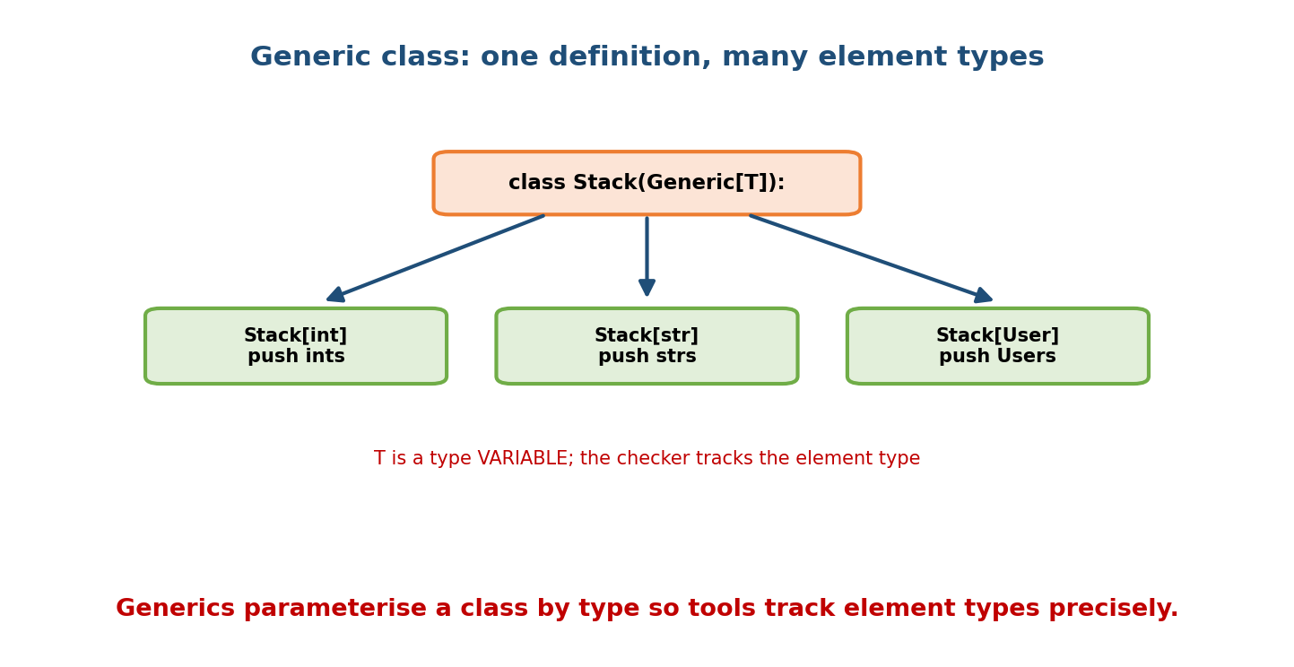
A generic class Stack(Generic[T]) can be used as Stack[int], Stack[str], or Stack[User]; T is a type variable the checker tracks per usage.
from typing import Generic, TypeVar
T = TypeVar("T") # a type variable
class Stack(Generic[T]):
def __init__(self) -> None:
self._items: list[T] = []
def push(self, item: T) -> None:
self._items.append(item)
def pop(self) -> T:
return self._items.pop()
s: Stack[int] = Stack()
s.push(1) # OK
# s.push("x") # mypy error: expected int
x: int = s.pop() # checker knows pop() returns int
(In Python 3.12+ you can write class Stack[T]: directly — the same idea, cleaner syntax.)

TypeVar bounds link and restrict types
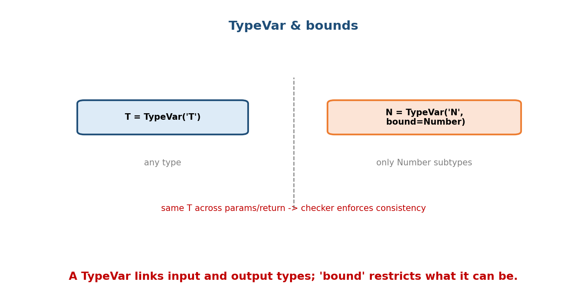
A plain TypeVar(‘T’) stands for any type; a bounded TypeVar(‘N’, bound=Number) accepts only Number subtypes; reusing the same T links parameter and return types.
from typing import TypeVar
N = TypeVar("N", bound=int | float) # only numbers
def double(x: N) -> N: # returns the SAME type it received
return x * 2
reveal = double(3) # type is int
reveal2 = double(3.0) # type is float
Reusing one TypeVar across parameters/return links them — the checker enforces that double(int) returns int, not just “a number”.

11.4 Protocol — structural typing (static duck typing)
Module 6’s duck typing says “if it has draw(), it’s drawable.” A Protocol lets a type checker verify that statically — no inheritance required.
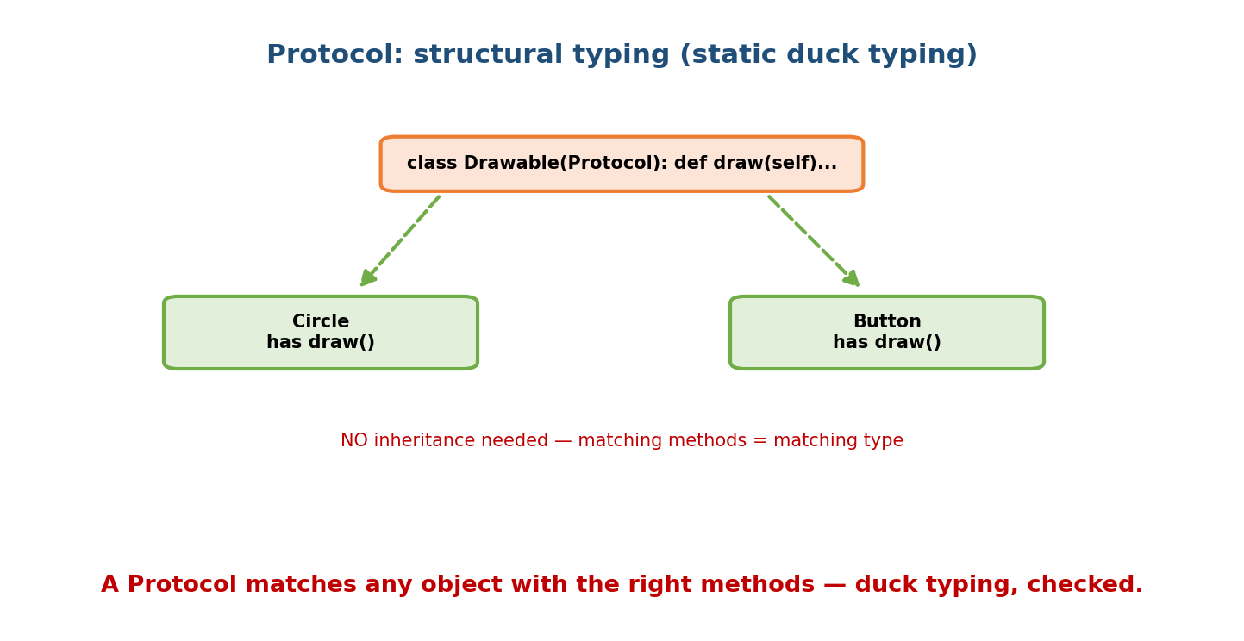
A Drawable Protocol declares def draw(self); any class with a matching draw() method (Circle, Button) satisfies it, with no inheritance — matching methods = matching type.
from typing import Protocol
class Drawable(Protocol): # a structural interface
def draw(self) -> None: ...
class Circle: # does NOT inherit Drawable...
def draw(self) -> None: print("O")
class Button:
def draw(self) -> None: print("[OK]")
def render(item: Drawable) -> None: # accepts anything with draw()
item.draw()
render(Circle()) # OK — structural match
render(Button()) # OK — no inheritance needed
Add @runtime_checkable to allow isinstance(x, Drawable) at run time (checks method presence only). Protocols are how the standard library types things like “anything iterable” (Iterable, Sized, SupportsInt).

11.5 ABC vs Protocol — nominal vs structural
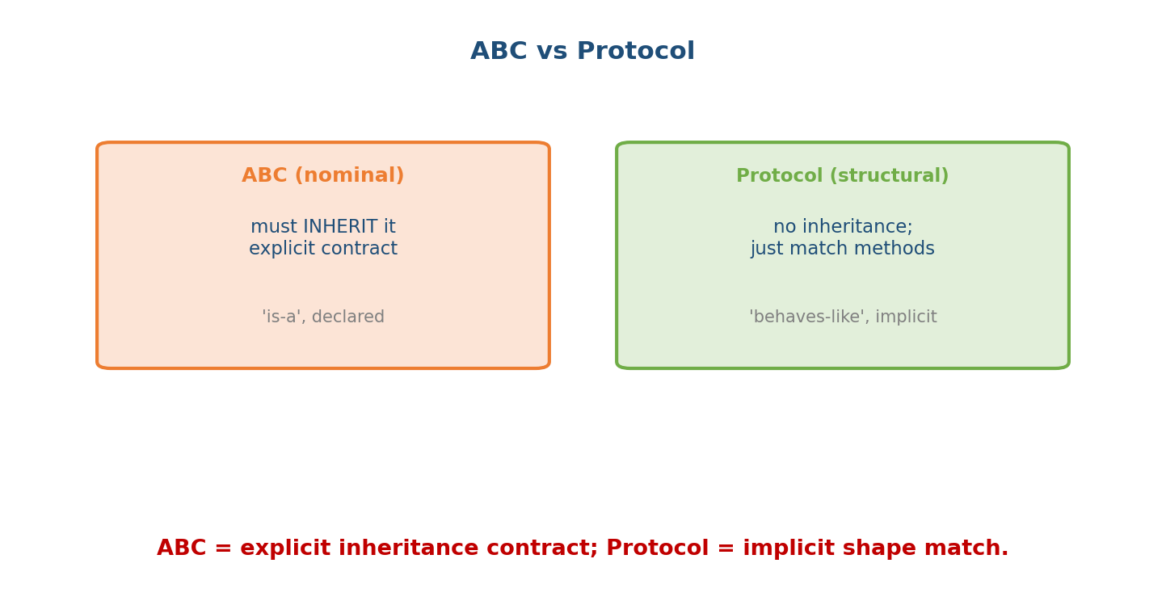
ABC is nominal typing: a class must explicitly inherit it (an ‘is-a’, declared contract). Protocol is structural typing: any class with matching methods qualifies (a ‘behaves-like’, implicit contract).
 | ABC (Module 4) | Protocol
Typing style | nominal (by name/inheritance) | structural (by shape)
Must inherit? | yes (class C(MyABC)) | no — just match the methods
Contract | explicit, declared | implicit, duck-typed
Enforced at | instantiation (missing methods) | static check (mypy); runtime with @runtime_checkable
Use when | you control the classes and want an explicit hierarchy | you want to accept any compatible object, including third-party classes you can’t modify
Rule of thumb: use a Protocol to type “accepts anything that behaves like X” (great for decoupling and for third-party objects); use an ABC when you want a shared base with concrete helper methods and an explicit is-a relationship.

11.6 mypy — static checking
mypy (or pyright) reads your hints and flags type mismatches before the code runs — turning a class of runtime bugs into check-time errors.
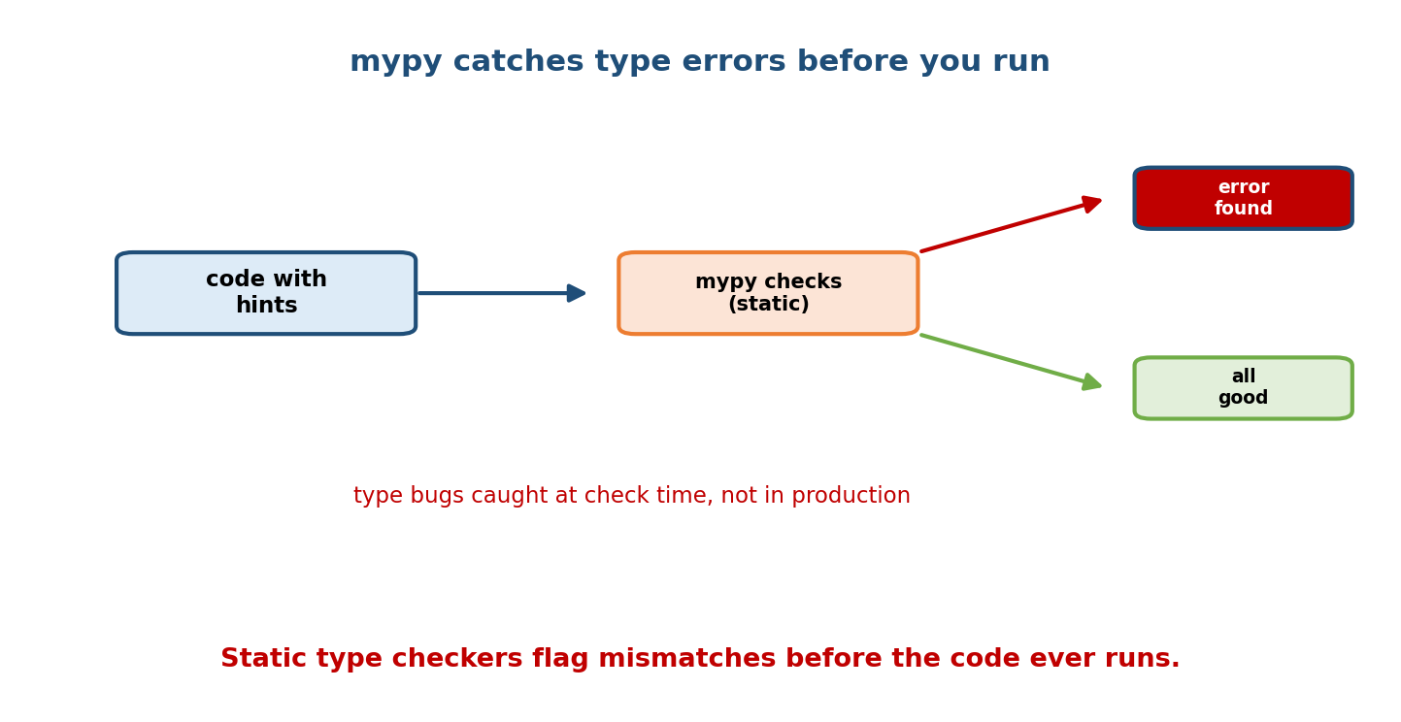
Code with hints feeds into mypy’s static check; it either reports an error (caught before running) or passes — type bugs are caught at check time, not in production.
$ mypy account.py
account.py:12: error: Argument 1 to "deposit" has incompatible type "str";
expected "float"
This is especially valuable in large OOP codebases: refactors, interface changes, and None-handling bugs are caught early. CI pipelines routinely run mypy as a gate.

11.7 Useful Typing Constructs for OOP
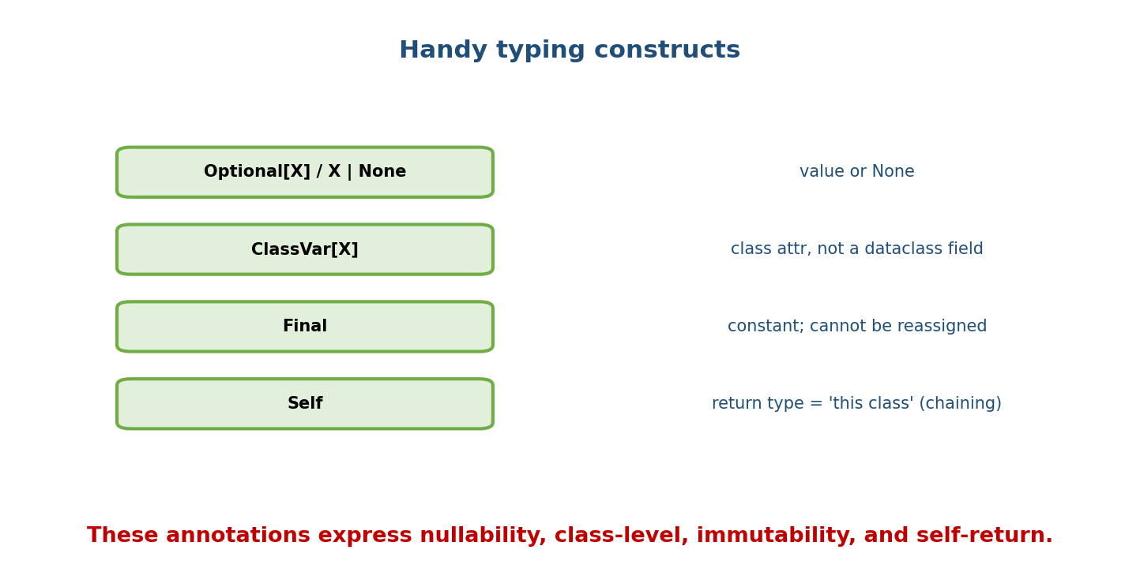
Handy constructs: Optional[X] / X | None (value or None), ClassVar[X] (class attribute, not a dataclass field), Final (constant, no reassignment), Self (return type meaning ‘this class’, for chaining).
from typing import ClassVar, Final, Optional
from typing import Self # 3.11+ (or typing_extensions)
class Config:
VERSION: Final = "1.0" # constant; reassigning flagged
instances: ClassVar[int] = 0 # class-level, NOT a per-instance field
name: Optional[str] = None # str or None
def set_name(self, n: str) -> Self: # returns "this class" -> enables chaining
self.name = n
return self
Config().set_name("a").set_name("b") # fluent chaining, correctly typed
- Optional[X] / X | None — may be None (forces you to handle it).
- ClassVar[X] — a class attribute; tells dataclasses it’s not a field.
- Final — must not be reassigned/overridden.
- Self — the return type is the current class (subclass-correct for chaining/ factories).

Module 11 — Interview Mapping
Question | Junior answer | Senior answer
“Are hints enforced at runtime?” | (unsure) | “No — Python ignores them at run time; they exist for mypy/IDEs/docs. Use pydantic/manual checks if you need runtime validation.”
“What’s a Protocol?” | “An interface.” | “Structural typing — static duck typing: any object with the right methods satisfies it, no inheritance; @runtime_checkable allows isinstance.”
“ABC vs Protocol?” | “Both interfaces.” | “ABC = nominal (must inherit, explicit is-a, can carry concrete methods); Protocol = structural (matches by shape, works with third-party classes). Prefer Protocol for ‘accepts anything that behaves like X’.”
“Why Generics?” | “Reuse.” | “Type-safe reuse: Stack[int] vs Stack[str] while the checker tracks element types via a TypeVar.”

Module 11 — Exam Mapping
- GATE CS: not tested (Python-library topic).
- SEBI / RBI IT: not tested.
- FAANG / backend: strong signal — Generics, Protocols, ABC-vs-Protocol, mypy in CI, and correct Optional/Self usage.

Module 11 — Common Mistakes & Misconceptions
- Believing hints are enforced at runtime — they aren’t; use validation libs if needed.
- Using an ABC (forcing inheritance) when a Protocol (structural) would decouple better.
- Mutable/Optional confusion — annotating x: str but assigning None.
- Forgetting ClassVar on a dataclass class-attribute → it becomes a field.
- Overusing Any — erases the benefit of typing.
- Not running mypy — hints without a checker only document, they don’t catch bugs.

Module 11 — MCQs (with answers & explanations)
Q1. Python type hints are enforced: a) at runtime b) not at runtime (tools only) c) at import d) by the GIL
Answer
b. They’re for static checkers/IDEs/docs; the interpreter ignores them.
Q2. A Protocol uses which kind of typing? a) nominal b) structural c) dynamic only d) none
Answer
b. Structural — matches by method shape, no inheritance needed.
Q3. To make a class satisfy an ABC you must: a) match methods only b) inherit the ABC c) use @runtime_checkable d) nothing
Answer
b. ABCs are nominal — explicit inheritance is required.
Q4. Stack(Generic[T]) lets you: a) store only ints b) parameterise the element type (Stack[int], Stack[str]) c) subclass type d) skip hints
Answer
b. Generics track element types per usage.
Q5. Optional[str] is equivalent to: a) str b) list[str] c) str | None d) Any
Answer
c. Optional means “this type or None”.
Q6. @runtime_checkable on a Protocol allows: a) enforcing types at runtime fully b) isinstance checks (method presence) c) faster code d) inheritance
Answer
b. It enables isinstance, checking that methods exist (not signatures).
Q7. ClassVar[int] on a dataclass attribute means: a) it’s a field b) it’s a class-level variable, not a field c) it’s frozen d) it’s private
Answer
b. Dataclasses skip ClassVar-annotated names as fields.
Q8. Best type for accepting “any object with a .read() method (incl. third-party)”: a) a concrete class b) an ABC they must inherit c) a Protocol d) Any
Answer
c. A Protocol matches by shape without requiring inheritance.

Module 11 — Design/Practice Exercises (easy → hard)
- (easy) Fully annotate an Account class (attributes, params, returns).
- (easy) Write first(items: list[T]) -> T using a TypeVar.
- (medium) Implement a generic Pair(Generic[K, V]) with typed key/value.
- (medium) Define a Comparable Protocol with __lt__ and a max_of(items) that accepts anything comparable.
- (hard) Refactor a function that takes a concrete FileReader into one that takes a Readable Protocol; show a third-party object satisfies it.
- (hard, interview) Explain, with code, when you’d choose a Protocol over an ABC for a Serializer interface, and vice versa.

Module 11 — Concept Review (one page)
Type hints annotate attributes, parameters, and returns but are not enforced at run time — they serve IDEs, static checkers (mypy), and readers. Generic classes (Generic[T] with a TypeVar) give type-safe reuse: Stack[int] vs Stack[str] while the checker tracks element types; a TypeVar reused across signature positions links them, and bound= restricts it. Protocol brings structural typing — static duck typing — so any object with the right methods qualifies without inheritance (@runtime_checkable enables isinstance). This contrasts with ABCs, which use nominal typing (explicit inheritance, concrete helper methods, an is-a contract). Use a Protocol to accept “anything that behaves like X” (great for decoupling and third-party objects), an ABC for a shared, declared base. Supporting constructs — Optional/|, ClassVar, Final, Self — express nullability, class-level attributes, constants, and self-returning methods.

Module 11 — Flash Cards (Q → A)
Front | Back
Are hints enforced at runtime? | No — tools/docs only
Benefits of hints | IDE autocomplete, mypy checks, readability
Generic class | Generic[T] + TypeVar — type-safe reuse
TypeVar bound | restricts the type (bound=Number)
Protocol typing style | structural (static duck typing)
ABC typing style | nominal (must inherit)
Protocol vs ABC | shape-match, no inheritance vs explicit inheritance
@runtime_checkable | enables isinstance on a Protocol (method presence)
Optional[X] | X | None
ClassVar[X] | class attribute, not a dataclass field
Final | cannot be reassigned/overridden
Self | return type = current class (chaining/factories)

Module 11 — Pattern Recognition
- See “accept anything with method X (incl. third-party)” → Protocol.
- See “a container/algorithm that works for any element type” → Generics + TypeVar.
- See “shared base with concrete helpers + explicit is-a” → ABC.
- See “a value that might be missing” → Optional/| None.
- See “fluent builder returning self” → -> Self.
- See hints but bugs still ship → wire mypy into CI.

Module 11 — Revision Notes / Mini Cheat Sheet
HINTS: annotate attrs/params/returns. NOT enforced at runtime (tools/docs/IDE only).
list[int], dict[str,float], Optional[X]==X|None, Union[a,b]==a|b, Callable[[int],str].
GENERICS: class Stack(Generic[T]) -> Stack[int], Stack[str]. (3.12: class Stack[T].)
TypeVar('T') any type
TypeVar('N', bound=X) only X-subtypes ; reuse same T -> links in/out types.
PROTOCOL (structural / static duck typing): match methods, NO inheritance.
@runtime_checkable -> isinstance(x, Proto) (presence only).
ABC (nominal): must inherit; explicit is-a; can carry concrete methods.
Protocol = "behaves-like X (incl third-party)"; ABC = "declared base".
mypy/pyright: static check hints -> catch type bugs before running (use in CI).
EXTRAS: ClassVar (class attr, not field), Final (constant), Self (return this class).
Next module: Module 12 — Object Lifecycle & Memory. We follow an object from birth to death: reference counting and the cyclic garbage collector, __del__ finalisers (and why they’re tricky), weakref for caches/observers without keeping objects alive, and copy/deepcopy internals (__copy__/__deepcopy__).

Module 11 — Summary
Modern Python OOP is gradually typed. Type hints document intent and power static checkers and IDEs, but Python does not enforce them at run time. Generics (Generic[T]/TypeVar) deliver type-safe reuse so one class serves many element types while the checker tracks each. Protocol formalises Module 6’s duck typing as structural typing — objects match by shape, not inheritance — which contrasts with the nominal, inheritance-based ABC. Choosing Protocol vs ABC (behaves-like vs is-a) is a core modern-design decision, and constructs like Optional, ClassVar, Final, and Self round out expressive, checkable OOP. Wiring mypy into CI turns these hints into real bug prevention.
You have mastered this module when you can: fully annotate a class; write a generic class with TypeVar and a bound; define and use a Protocol; explain ABC vs Protocol and pick correctly; and describe what mypy buys you.

