Module 12 — Object Lifecycle & Memory
  - OOP with Python Mastery: FAANG Interviews / GATE / SEBI-RBI IT / Backend — In-Depth Notes (with visuals)
Prepared for nidhi.sharma@forensiccybertech.com
2026
Table of Contents

Module 12 — Object Lifecycle & Memory
Why this module matters. Objects are born, live, and die — and Python manages that for you. But “for you” doesn’t mean “invisibly”: knowing reference counting, the cyclic garbage collector, __del__’s pitfalls, and weakref is the difference between code that leaks memory / holds files open and code that’s clean. This is also a classic interview area (“how does Python manage memory?”, “what’s a reference cycle?”) and essential for backend services that run for weeks without restarting.
Importance ratings (out of 5):
Exam / Use | FAANG Interview | GATE CS | SEBI/RBI IT | Backend Dev | LLD Rounds
This module | ★★★★ | ★★ | ★★ | ★★★★ | ★★
Most-asked concepts: how Python manages memory (reference counting + cyclic GC); reference cycles; what del really does; __del__ and why it’s unreliable; weakref (and WeakValueDictionary); shallow vs deep copy hooks; why context managers beat __del__ for cleanup.
What you must be able to do after this module: explain reference counting and cycles; describe when the cyclic GC runs; state what del x does; list __del__’s pitfalls and use a context manager instead; and use weakref for a cache.

12.1 The Object Lifecycle
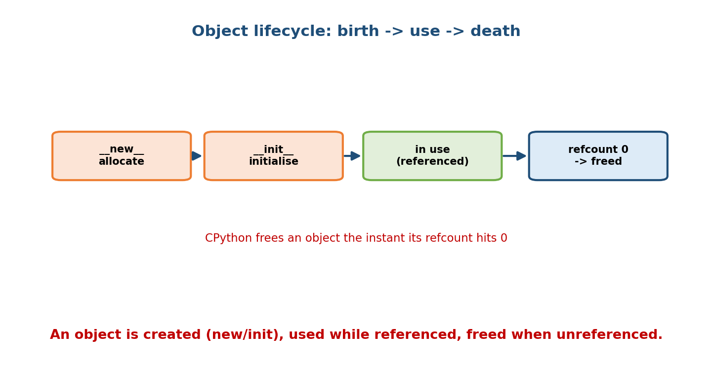
Lifecycle: new allocates, init initialises, the object is used while referenced, and when its refcount hits 0 it is freed.
Every object goes through: creation (__new__ allocates, __init__ initialises — Module 3), use (while something references it), and destruction (freed when unreachable). In CPython, destruction is immediate the moment the last reference goes away (via reference counting) — plus a periodic sweep for cycles.

12.2 Reference Counting (CPython’s primary mechanism)
CPython gives every object a reference count: how many references point to it. Creating a reference increments it; deleting/rebinding one decrements it. When it hits 0, the object is freed instantly.
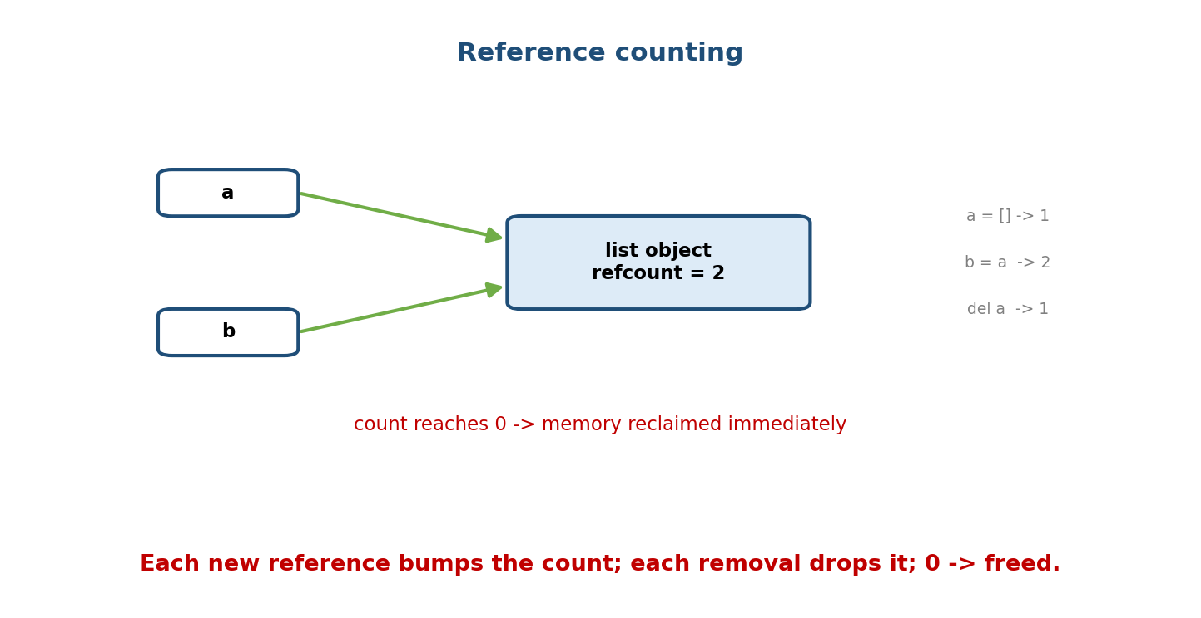
A list object with refcount 2: a = [] makes it 1, b = a makes it 2, del a drops it to 1; when the count reaches 0 the memory is reclaimed immediately.
import sys
a = [] # refcount 1
b = a # refcount 2
print(sys.getrefcount(a)) # shows 3 (getrefcount's own temp arg adds 1)
del b # refcount back to 1
- Pros: deterministic, immediate reclamation; memory freed as soon as possible.
- Con: cannot free reference cycles (below) — hence a second mechanism.
Note: sys.getrefcount(x) reports one extra because passing x to it creates a temporary reference.

12.3 Reference Cycles & the Cyclic Garbage Collector
If two objects reference each other, their counts never reach 0 even when nothing outside points to them — a reference cycle that pure refcounting can’t reclaim.
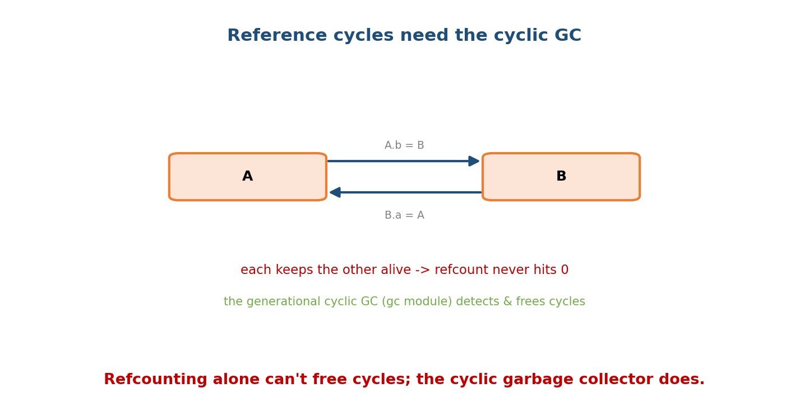
Objects A and B reference each other (A.b = B, B.a = A); each keeps the other’s refcount above 0, so the cyclic generational garbage collector is needed to detect and free them.
class Node: pass
a, b = Node(), Node()
a.other = b
b.other = a # cycle: a <-> b
del a, b # outside refs gone, but they still reference each other
import gc
gc.collect() # the cyclic GC detects & frees the unreachable cycle
Python adds a generational, cyclic garbage collector (gc module) that periodically finds unreachable cycles and frees them. It runs automatically based on allocation thresholds; you can gc.collect() manually or gc.disable() in special cases. Avoiding cycles (or using weakref) reduces GC pressure.

12.4 What del x Actually Does
del x removes the name x from its namespace and decrements the object’s refcount. It does not directly destroy the object — the object dies only if that was its last reference.
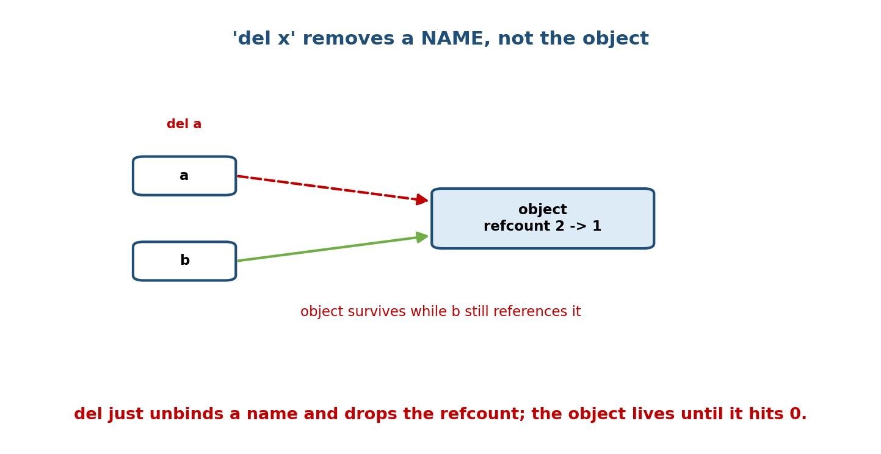
del a unbinds the name a and drops the object’s refcount from 2 to 1; the object survives because b still references it.
a = [1, 2, 3]
b = a
del a # name 'a' gone; object refcount 2 -> 1
print(b) # [1, 2, 3] -> object still alive via b
Interview one-liner: “del unbinds a name and drops a reference; the object is collected only when its refcount reaches 0 (or the cyclic GC reclaims it).”

12.5 __del__ — the finaliser and its pitfalls
__del__ is called when an object is about to be destroyed. It’s tempting to use it for cleanup (closing files, releasing locks) — but it’s unreliable:
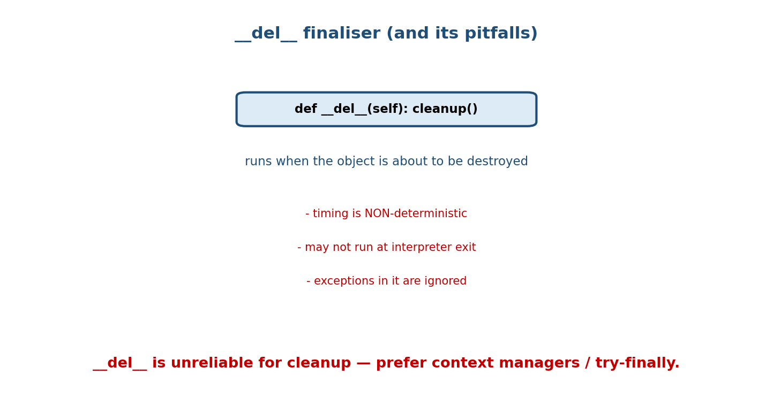
del runs when the object is about to be destroyed, but has pitfalls: non-deterministic timing, may not run at interpreter exit, and exceptions inside it are ignored.
- Non-deterministic timing — you don’t control when (or if) it runs.
- May not run at interpreter exit — pending finalisers can be skipped.
- Exceptions inside __del__ are ignored (only printed) — bugs hide.
- Cycles historically delayed collection of objects with __del__ (improved in modern Python but still a smell).
class Bad:
def __del__(self):
self.file.close() # DON'T rely on this for critical cleanup
Rule: never depend on __del__ for releasing important resources. Use a context manager or explicit close()/try-finally.

12.6 weakref — reference without keeping alive
A weak reference lets you refer to an object without increasing its refcount — so it can still be garbage-collected. Perfect for caches, observers, and back- references that must not keep objects alive.
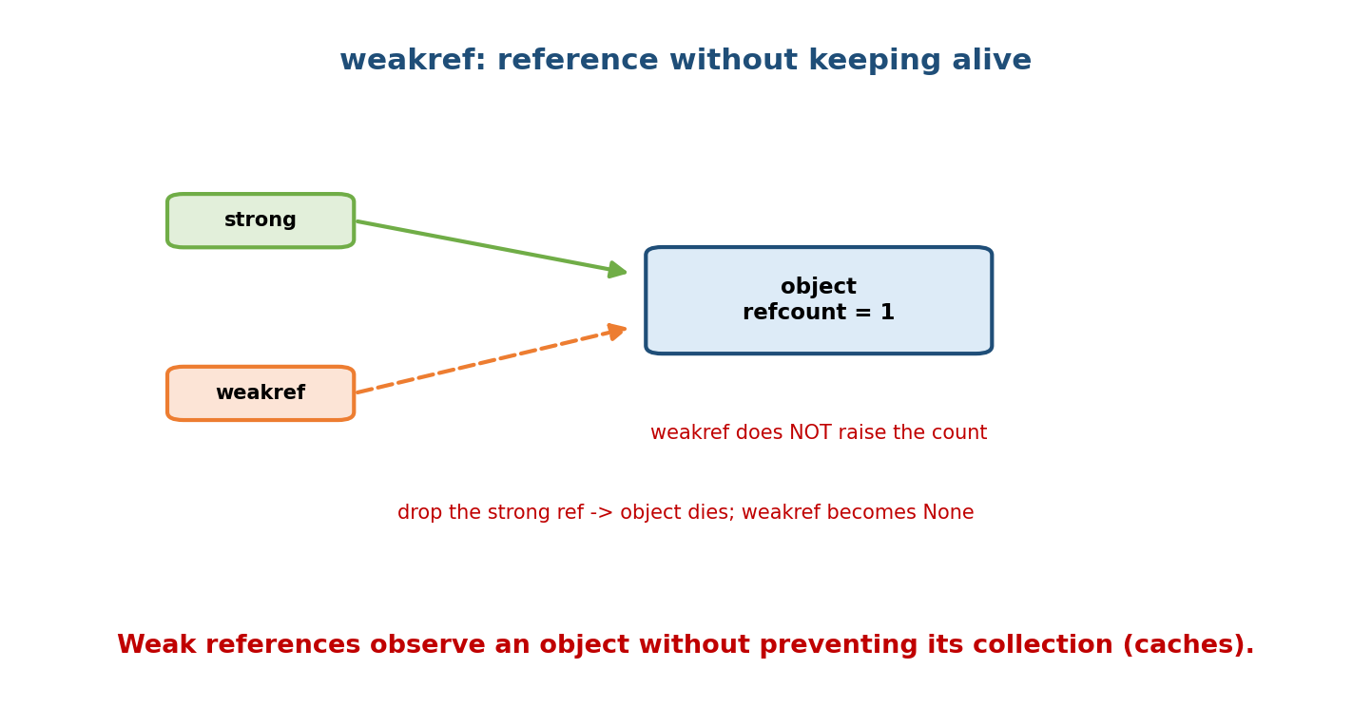
A weakref points at an object without raising its refcount; once the last strong reference is dropped, the object dies and the weakref becomes None.
import weakref
class Data: pass
d = Data()
r = weakref.ref(d) # weak reference — does NOT keep d alive
print(r() is d) # <Data ...> (dereference with r())
del d # last STRONG ref gone
print(r()) # None -> object was collected
# A cache that doesn't leak: entries vanish when values are no longer used elsewhere
cache = weakref.WeakValueDictionary()
- weakref.ref(obj) → call it (r()) to get the object or None.
- WeakValueDictionary / WeakKeyDictionary → auto-pruning caches.
- Use case: the Observer pattern (Module 15) uses weak refs so a subject doesn’t keep dead observers alive.

12.7 Copying Objects — copy / deepcopy hooks
Recall Module 2’s shallow-vs-deep distinction. Classes can customise how they’re copied via __copy__ and __deepcopy__.
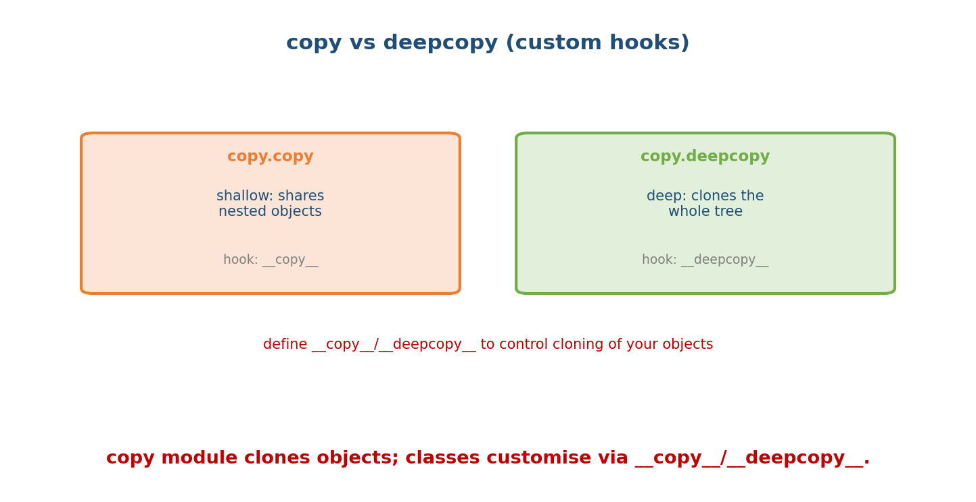
copy.copy is shallow (shares nested objects; customise with copy); copy.deepcopy clones the whole object tree (customise with deepcopy).
import copy
class Cache:
def __init__(self, data):
self.data = data
self._conn = "db-connection" # should NOT be copied
def __deepcopy__(self, memo):
clone = Cache(copy.deepcopy(self.data, memo))
clone._conn = self._conn # reuse the same connection, don't clone it
return clone
c2 = copy.deepcopy(Cache([1, 2, 3]))
- __copy__(self) → return a shallow copy.
- __deepcopy__(self, memo) → return a deep copy; memo avoids infinite recursion on cycles (it caches already-copied objects).

12.8 Cleanup: Context Managers, not __del__
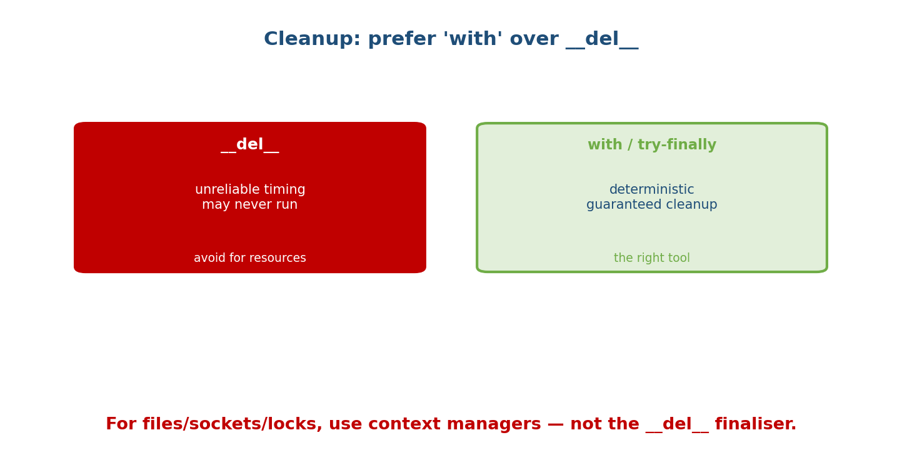
For releasing resources, del is unreliable (non-deterministic timing, may never run); a with-statement / try-finally is deterministic and guarantees cleanup — the right tool.
# WRONG: relying on __del__
class FileWrapper:
def __del__(self): self.f.close() # may run late or never
# RIGHT: a context manager (deterministic)
class FileWrapper:
def __enter__(self):
self.f = open("data.txt")
return self.f
def __exit__(self, *exc):
self.f.close() # guaranteed, immediately after the block
with FileWrapper() as f:
data = f.read()
# file is definitely closed here
For files, sockets, locks, and DB connections: always use with / contextlib, or explicit close() in a finally. __del__ is a last-ditch safety net, never the primary plan.

Module 12 — Interview Mapping
Question | Junior answer | Senior answer
“How does Python manage memory?” | “Garbage collection.” | “Primarily reference counting (immediate free at count 0), plus a generational cyclic GC for reference cycles refcounting can’t reclaim.”
“What’s a reference cycle?” | (unsure) | “Objects referencing each other so their counts never hit 0; the cyclic GC detects and frees them; weakref can avoid creating them.”
“What does del x do?” | “Deletes the object.” | “Unbinds the name and decrements the refcount; the object is freed only if that was the last reference.”
“Use __del__ for cleanup?” | “Sure.” | “No — non-deterministic, may not run, swallows exceptions. Use a context manager / try-finally.”

Module 12 — Exam Mapping
- GATE CS: garbage collection concepts, reference counting vs tracing, cycles.
- SEBI / RBI IT: basic memory-management terms.
- FAANG / backend: reference counting + cyclic GC, weakref for caches/observers, __del__ pitfalls, context managers for cleanup.

Module 12 — Common Mistakes & Misconceptions
- Thinking del x frees memory directly — it drops a reference; freeing happens at count 0.
- Relying on __del__ for closing files/sockets.
- Creating reference cycles unknowingly (parent↔child, observers) — use weakref for back-references.
- Assuming GC is purely tracing (like Java) — CPython is refcount-first + cyclic GC.
- Expecting sys.getrefcount to match your mental count — it adds one for its own argument.
- Copying an object that holds a connection/handle with deepcopy — customise __deepcopy__ to avoid duplicating non-copyable resources.

Module 12 — MCQs (with answers & explanations)
Q1. CPython’s primary memory-management mechanism is: a) tracing GC only b) reference counting c) manual free() d) arena allocation
Answer
b. Reference counting, supplemented by a cyclic GC.
Q2. A reference cycle is a problem because: a) it’s slow b) the objects’ refcounts never reach 0 c) it uses __del__ d) it’s illegal
Answer
b. Mutual references keep counts above 0; the cyclic GC handles it.
Q3. del x primarily: a) frees memory b) unbinds the name and decrements the refcount c) calls __del__ always d) collects cycles
Answer
b. The object is freed only when the count hits 0.
Q4. __del__ is: a) reliable cleanup b) non-deterministic; avoid for critical cleanup c) a constructor d) required
Answer
b. Timing is unpredictable; use context managers.
Q5. A weakref: a) increments refcount b) references without keeping the object alive c) prevents GC d) copies the object
Answer
b. It doesn’t raise the count; the object can be collected.
Q6. The best way to guarantee a file is closed: a) __del__ b) with open(...) / try-finally c) gc.collect() d) hope
Answer
b. Context managers give deterministic cleanup.
Q7. copy.deepcopy uses memo to: a) speed up b) avoid infinite recursion / duplicate copies on cycles c) log d) skip fields
Answer
b. memo caches already-copied objects.
Q8. WeakValueDictionary is useful for: a) permanent storage b) caches that auto-prune when values are unused c) ordering d) hashing
Answer
b. Entries disappear when their values are otherwise unreferenced.

Module 12 — Design/Practice Exercises (easy → hard)
- (easy) Use sys.getrefcount to observe a count change across b = a and del b.
- (easy) Create a two-object reference cycle and free it with gc.collect().
- (medium) Implement a context-manager Resource and prove cleanup runs even on exception.
- (medium) Build a weakref-based cache; show entries vanish when the strong reference is dropped.
- (hard) Write a Node tree where children hold weak back-references to parents to avoid cycles; verify no leak.
- (hard, interview) Explain, with an example, why __del__ is a poor cleanup mechanism and rewrite it as a context manager.

Module 12 — Concept Review (one page)
Python objects are created (__new__/__init__), used while referenced, and destroyed when unreachable. CPython’s primary mechanism is reference counting: each reference increments a count, each removal decrements it, and hitting 0 frees the object immediately. Because refcounting can’t reclaim reference cycles, Python adds a generational cyclic garbage collector (gc). del x merely unbinds a name and drops a reference — the object dies only at count 0. __del__ finalisers are unreliable (non-deterministic, may not run, swallow exceptions), so use context managers / try-finally for resource cleanup. weakref refers to objects without keeping them alive — ideal for caches (WeakValueDictionary) and observer back-references, and for breaking cycles. Copying is customised via __copy__/__deepcopy__ (with memo guarding cycles).

Module 12 — Flash Cards (Q → A)
Front | Back
CPython memory mechanism | reference counting + cyclic GC
Object freed when | refcount reaches 0 (or cyclic GC reclaims it)
Reference cycle | objects referencing each other; counts never hit 0
Who frees cycles | the generational cyclic garbage collector (gc)
del x does | unbinds the name, decrements refcount
__del__ reliability | non-deterministic; avoid for cleanup
Cleanup best practice | context manager / try-finally
weakref | reference that doesn’t keep the object alive
Auto-pruning cache | WeakValueDictionary
Copy hooks | __copy__ / __deepcopy__ (memo for cycles)
sys.getrefcount quirk | reports +1 (its own argument)
Break a cycle | use a weak reference for the back-link

Module 12 — Pattern Recognition
- See “memory grows over time in a long-running service” → a leak: cycles or lingering references; consider weakref.
- See “file/socket sometimes stays open” → move cleanup from __del__ to a context manager.
- See parent↔child references → weak back-reference to avoid a cycle.
- See “cache that shouldn’t keep objects alive” → WeakValueDictionary.
- See deepcopy duplicating a DB connection → custom __deepcopy__.
- See “why didn’t my object get freed after del?” → another reference exists.

Module 12 — Revision Notes / Mini Cheat Sheet
LIFECYCLE: __new__ (allocate) -> __init__ (init) -> in use -> freed at refcount 0.
MEMORY = reference counting (immediate free at 0) + generational CYCLIC GC (gc module).
REFCOUNT: new ref ++ ; drop/rebind -- ; 0 -> freed now. sys.getrefcount reports +1.
CYCLE: A.b=B, B.a=A -> counts never 0 -> cyclic GC frees. gc.collect() to force.
del x = unbind NAME + decrement refcount (NOT destroy). Dies only if last ref.
__del__ finaliser: NON-deterministic, may not run at exit, swallows exceptions.
-> DO NOT use for resource cleanup. Use 'with' / try-finally / close().
weakref.ref(obj) -> r(); does NOT keep obj alive; becomes None when obj dies.
WeakValueDictionary/WeakKeyDictionary = auto-pruning caches; break cycles (observers).
COPY: copy.copy (shallow, __copy__) / copy.deepcopy (deep, __deepcopy__ + memo).
Next module: Module 13 — SOLID Principles. We shift from mechanics to design: the five principles (Single Responsibility, Open/Closed, Liskov Substitution, Interface Segregation, Dependency Inversion) that turn working OOP into maintainable OOP — each with a Python before/after and the pillars we’ve built (abstraction, polymorphism, composition) put to work.

Module 12 — Summary
Python manages object lifetimes with reference counting (freeing an object the instant its count hits 0) plus a generational cyclic garbage collector that reclaims reference cycles refcounting can’t. del x removes a name and decrements a reference — it doesn’t directly destroy anything. The __del__ finaliser is unreliable (unpredictable timing, possibly skipped, swallows errors), so resource cleanup belongs in context managers / try-finally. weakref lets you reference objects without keeping them alive — powering non-leaking caches and observer back-references and helping break cycles — while __copy__/__deepcopy__ customise cloning. Understanding this keeps long-running OOP systems leak-free and correct.
You have mastered this module when you can: explain reference counting and the cyclic GC; state exactly what del does; list __del__’s pitfalls and replace it with a context manager; and use weakref to build a cache or break a cycle.

