Module 13 — SOLID Principles
  - OOP with Python Mastery: FAANG Interviews / GATE / SEBI-RBI IT / Backend — In-Depth Notes (with visuals)
Prepared for nidhi.sharma@forensiccybertech.com
2026
Table of Contents

Module 13 — SOLID Principles
Why this module matters. So far you can write OOP. SOLID is how you write OOP that survives change. These five principles (coined by Robert C. Martin) are the single most-cited design framework in interviews and code reviews. They’re not academic: each one fixes a concrete pain (the god class, the shotgun edit, the broken subtype, the fat interface, the un-testable dependency). And in Python they lean directly on the pillars you’ve built — abstraction, polymorphism, composition — often with less ceremony than in Java. Expect “tell me about SOLID / apply SRP here” in nearly every OOP design interview.
Importance ratings (out of 5):
Exam / Use | FAANG Interview | GATE CS | SEBI/RBI IT | Backend Dev | LLD Rounds
This module | ★★★★★ | ★★ | ★★ | ★★★★★ | ★★★★★
Most-asked concepts: what each SOLID letter stands for + a one-line example; SRP (“one reason to change”); OCP (extend without modifying); LSP (subtype substitutability + the Penguin/Rectangle-Square examples); ISP; DIP + dependency injection; how SOLID relates to the four pillars.
What you must be able to do after this module: name and define all five; give a Python before/after for each; spot which principle a piece of bad code violates; and apply DIP via constructor injection.

13.1 SOLID at a Glance
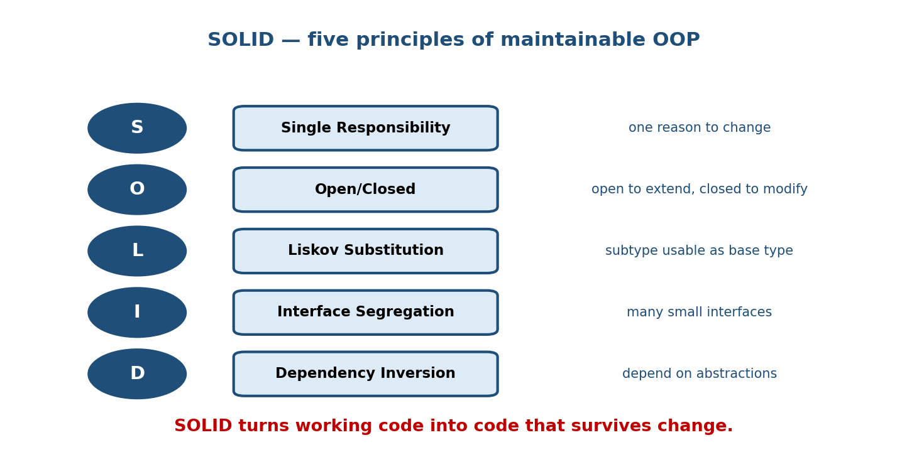
The five SOLID principles: S Single Responsibility (one reason to change), O Open/Closed (open to extend, closed to modify), L Liskov Substitution (subtype usable as base), I Interface Segregation (many small interfaces), D Dependency Inversion (depend on abstractions).
Letter | Principle | One line
S | Single Responsibility | a class should have one reason to change
O | Open/Closed | open to extension, closed to modification
L | Liskov Substitution | a subtype must be usable wherever its base is
I | Interface Segregation | prefer many small interfaces over one fat one
D | Dependency Inversion | depend on abstractions, not concretions

13.2 S — Single Responsibility Principle (SRP)
A class should have one, and only one, reason to change. If a class does parsing and validation and persistence and emailing, four different concerns can force edits to it — and they’ll step on each other.
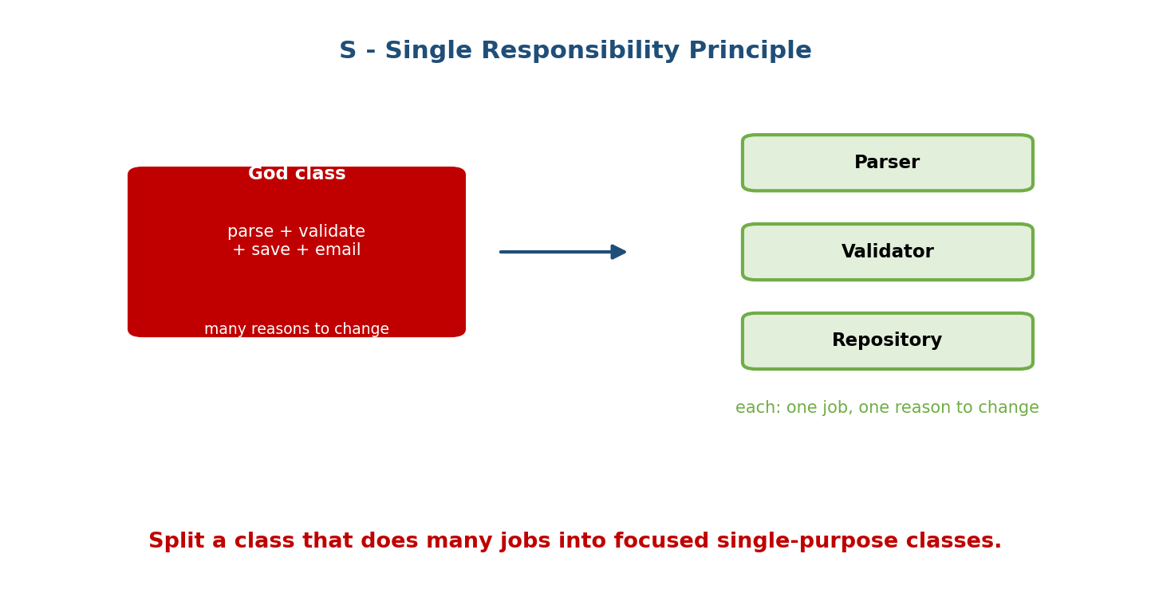
A god class that parses, validates, saves, and emails (many reasons to change) is split into focused Parser, Validator, and Repository classes, each with one job.
# VIOLATION: one class, many reasons to change
class Report:
def parse(self, raw): ...
def validate(self): ...
def save_to_db(self): ...
def email_to(self, addr): ... # persistence, I/O, formatting all mixed
# SRP: one responsibility each
class ReportParser: ...
class ReportValidator: ...
class ReportRepository: ... # each changes for exactly one reason
Test: describe the class in one sentence without using “and”. If you need “and”, it likely has multiple responsibilities.

13.3 O — Open/Closed Principle (OCP)
Software entities should be open for extension but closed for modification. You should add new behaviour by adding code (new subclass/strategy), not by editing tested code with more if/elif.
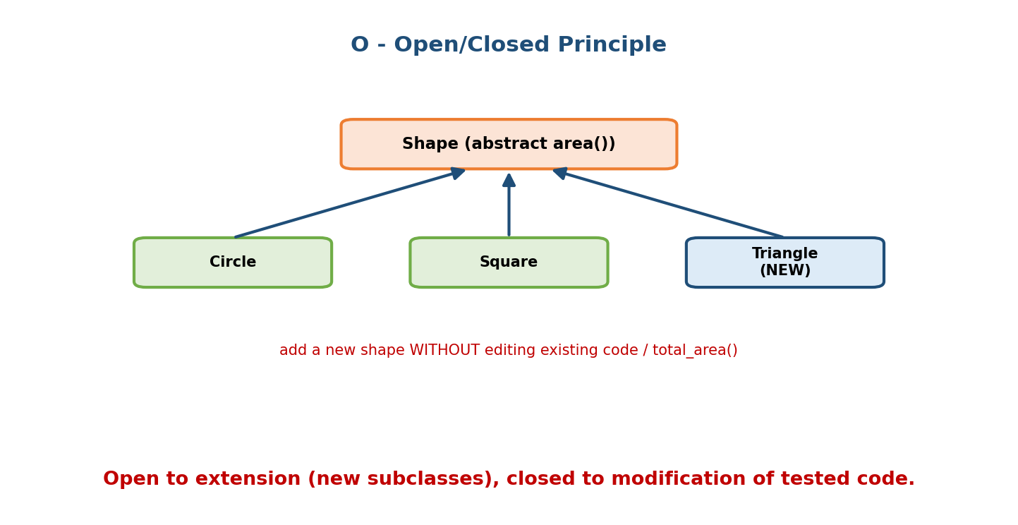
A Shape abstraction with area(); Circle, Square, and a NEW Triangle all subclass it, so total_area() gains support for a new shape without editing existing code.
# VIOLATION: adding a shape means editing this function every time
def area(shape):
if shape.type == "circle": ...
elif shape.type == "square": ...
# elif ... (edit forever)
# OCP: polymorphism — add a subclass, touch nothing existing
from abc import ABC, abstractmethod
class Shape(ABC):
@abstractmethod
def area(self) -> float: ...
class Circle(Shape): ...
class Triangle(Shape): ... # NEW — total_area() below is untouched
def total_area(shapes): return sum(s.area() for s in shapes)
OCP is polymorphism (Module 6) applied as a design rule. The abstraction (Shape) is the stable “closed” part; subclasses are the “open” extension points.

13.4 L — Liskov Substitution Principle (LSP)
Objects of a subtype must be substitutable for their base type without breaking the program. A subclass must honour the base’s contract — same expected behaviour, no stricter inputs, no weaker outputs, no surprise exceptions.
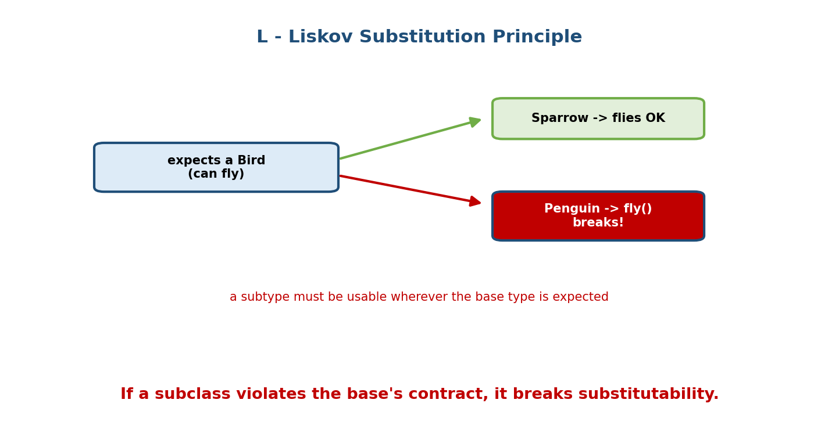
Code expecting a Bird that can fly works with Sparrow (flies) but breaks with Penguin, whose fly() cannot fulfil the contract — a Liskov violation.
class Bird:
def fly(self): ...
class Sparrow(Bird):
def fly(self): return "flap flap"
class Penguin(Bird):
def fly(self):
raise NotImplementedError # VIOLATION: breaks code expecting Bird.fly()
The classic fixes: model the hierarchy honestly — e.g. split Bird into FlyingBird / FlightlessBird, or use composition (Bird has-a movement strategy). The famous Rectangle/Square example is another LSP trap: a Square that inherits Rectangle breaks code that sets width and height independently.
Rule: inheritance must be a true is-a with behavioural compatibility, not just shared attributes. If a subclass has to weaken/break a base method, it shouldn’t inherit.

13.5 I — Interface Segregation Principle (ISP)
Clients should not be forced to depend on methods they don’t use. Prefer several small, role-specific interfaces over one big “do everything” interface.
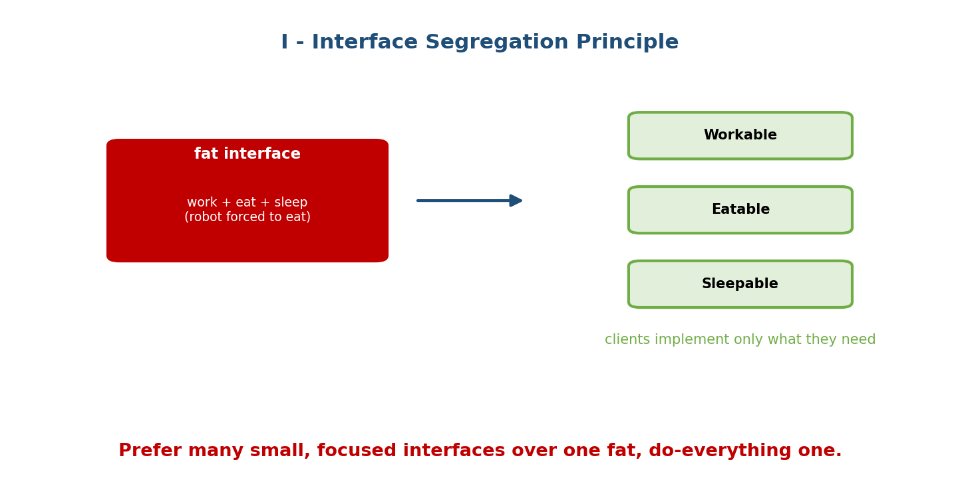
A fat interface with work + eat + sleep forces a robot to implement eat(); splitting into Workable, Eatable, and Sleepable lets each client implement only what it needs.
# VIOLATION: fat interface forces irrelevant methods
class Worker(ABC):
@abstractmethod
def work(self): ...
@abstractmethod
def eat(self): ... # a RobotWorker has no business eating
# ISP: small, focused protocols/ABCs
class Workable(Protocol):
def work(self) -> None: ...
class Eatable(Protocol):
def eat(self) -> None: ...
class Human: # implements both
def work(self): ...
def eat(self): ...
class Robot: # implements only Workable
def work(self): ...
In Python, Protocols (Module 11) make ISP cheap: define small structural interfaces and let each class satisfy only the ones it needs.

13.6 D — Dependency Inversion Principle (DIP)
High-level modules should not depend on low-level modules; both should depend on abstractions. Don’t hard-wire a service to a concrete class — depend on an interface, and let the concrete implementation be supplied.
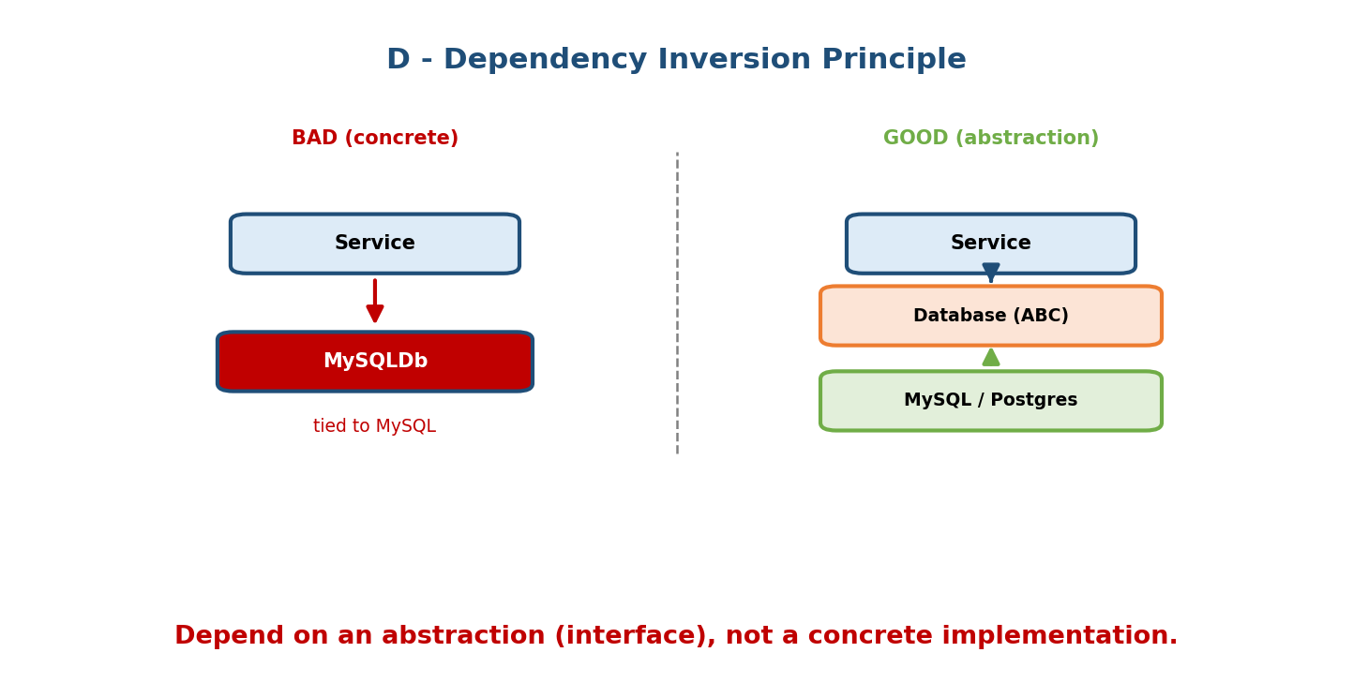
Bad: a Service depends directly on a concrete MySQLDb (tied to MySQL). Good: Service depends on a Database abstraction, and MySQL/Postgres implement it — the concrete detail is swappable.
# VIOLATION: high-level Service welded to a concrete database
class Service:
def __init__(self):
self.db = MySQLDatabase() # can't swap; hard to test
# DIP: depend on an abstraction
class Database(ABC):
@abstractmethod
def save(self, data): ...
class MySQLDatabase(Database): ...
class PostgresDatabase(Database): ...
class Service:
def __init__(self, db: Database): # depends on the ABSTRACTION
self.db = db

Dependency Injection — how DIP is applied
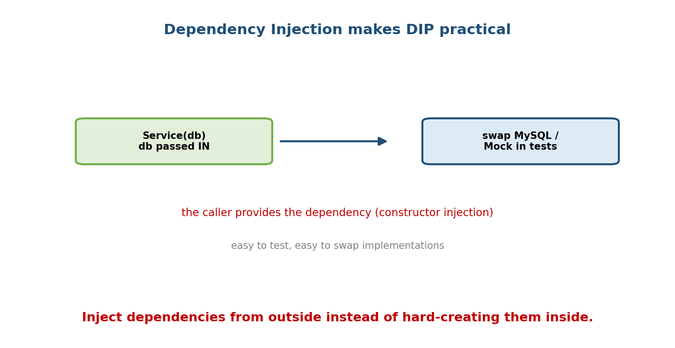
Dependency injection: Service(db) receives its database from the caller, so you can swap MySQL, Postgres, or a Mock in tests — decoupled and testable.
Dependency Injection (DI) is the technique: the dependency is passed in (constructor injection) rather than created inside. This makes code testable (inject a mock) and flexible (swap implementations). It’s the composition-over-inheritance idea (Module 5) applied to collaborators.
Service(MySQLDatabase()) # production
Service(MockDatabase()) # tests — no real DB needed

13.7 The Payoff — and SOLID ↔ the Four Pillars
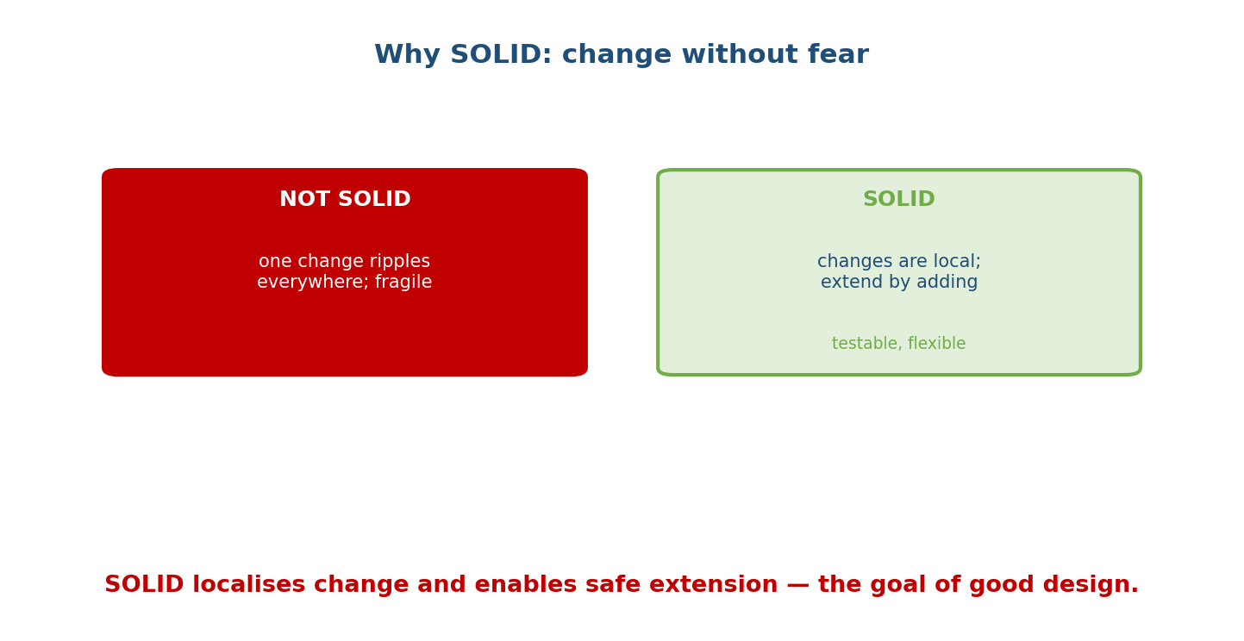
Non-SOLID code: one change ripples everywhere, fragile. SOLID code: changes are local, extend by adding, testable and flexible.
SOLID isn’t separate from the pillars — it’s the pillars used with intent:
Principle | Leans on
SRP | encapsulation (cohesion)
OCP | polymorphism + abstraction
LSP | inheritance done honestly
ISP | abstraction (small interfaces)
DIP | abstraction + composition (injection)
Balance: SOLID is guidance, not law. Over-applying it (an interface for every class, indirection everywhere) is its own anti-pattern (M19). Apply it where change is likely; keep simple things simple.

Module 13 — Interview Mapping
Question | Junior answer | Senior answer
“Explain SOLID.” | Lists the five words. | Defines each with a one-line Python example and the pain it fixes; connects OCP→polymorphism, DIP→injection.
“Apply SRP to this class.” | (splits vaguely) | Identifies distinct reasons-to-change and extracts a class per concern.
“LSP example?” | “Subtype works as base.” | Penguin/fly() or Square/Rectangle; explains the broken contract and the honest-hierarchy fix.
“DIP vs DI?” | (conflates) | “DIP = principle (depend on abstractions); DI = technique (pass dependencies in). DI enables DIP and testing.”

Module 13 — Exam Mapping
- GATE CS: occasionally definitional (what SRP/OCP mean).
- SEBI / RBI IT: rarely, as software-engineering theory.
- FAANG / LLD rounds: heavily used — you’ll be asked to apply SOLID while designing, and to critique code against it.

Module 13 — Common Mistakes & Misconceptions
- SRP = “one method” — no; it’s one reason to change (a class may have many cohesive methods).
- OCP = “never edit code” — you edit for bugs; OCP is about not editing for new variations you could add via extension.
- LSP = “shares attributes” — it’s about behavioural substitutability, not data.
- DIP = “use interfaces everywhere” — it’s about direction of dependency (toward abstractions), applied where it pays.
- Over-engineering — abstractions/injection for code that never varies (YAGNI).
- Confusing DIP and DI — principle vs technique.

Module 13 — MCQs (with answers & explanations)
Q1. “A class should have one reason to change” is: a) OCP b) SRP c) LSP d) DIP
Answer
b. Single Responsibility Principle.
Q2. Adding a new shape by writing a subclass, not editing total_area(), follows: a) SRP b) OCP c) ISP d) LSP
Answer
b. Open for extension, closed for modification.
Q3. A Penguin(Bird) whose fly() raises breaks: a) SRP b) OCP c) LSP d) ISP
Answer
c. It’s not substitutable for Bird — a Liskov violation.
Q4. Splitting a fat Worker interface into Workable/Eatable follows: a) DIP b) ISP c) SRP d) OCP
Answer
b. Interface Segregation Principle.
Q5. Service(db: Database) receiving a Database abstraction follows: a) SRP b) LSP c) DIP d) ISP
Answer
c. Depend on an abstraction, not a concrete class.
Q6. Dependency Injection is: a) a principle b) a technique to supply dependencies from outside c) a pattern only for DBs d) inheritance
Answer
b. It’s how DIP is realised (e.g. constructor injection).
Q7. OCP is most directly enabled by: a) encapsulation b) polymorphism c) __slots__ d) metaclasses
Answer
b. Overriding/duck-typing lets you extend without modifying callers.
Q8. The Rectangle/Square problem illustrates: a) SRP b) OCP c) LSP d) DIP
Answer
c. A Square subtype breaks code relying on Rectangle’s width/height contract.

Module 13 — Design/Practice Exercises (easy → hard)
- (easy) Identify the responsibilities in a User class that logs in, sends email, and writes to a DB; split it.
- (easy) Refactor an area() function with an if/elif type ladder into an OCP design with Shape subclasses.
- (medium) Fix an LSP violation where Square(Rectangle) breaks a resize test.
- (medium) Split a fat Machine interface (print/scan/fax) using ISP so a simple printer isn’t forced to fax.
- (hard) Apply DIP + DI to a NotificationService so it can send via Email, SMS, or a Mock, chosen by the caller.
- (hard, interview) Given a 60-line “god” class, refactor it against all five SOLID principles and explain each change.

Module 13 — Concept Review (one page)
SOLID is five design principles for change-resilient OOP. SRP: a class should have one reason to change (split mixed concerns). OCP: open to extension, closed to modification — add behaviour via new subclasses/strategies (polymorphism) rather than editing tested code. LSP: a subtype must be substitutable for its base without breaking the base’s behavioural contract (Penguin/fly, Square/Rectangle) — model hierarchies honestly. ISP: prefer many small, focused interfaces so clients depend only on what they use (cheap in Python via Protocols). DIP: depend on abstractions, not concretions, realised through Dependency Injection (pass collaborators in) for testability and flexibility. SOLID is the four pillars applied with intent — powerful, but to be applied where change is likely, not everywhere (avoid over-engineering).

Module 13 — Flash Cards (Q → A)
Front | Back
S | Single Responsibility — one reason to change
O | Open/Closed — extend without modifying
L | Liskov Substitution — subtype usable as base
I | Interface Segregation — small, focused interfaces
D | Dependency Inversion — depend on abstractions
OCP enabled by | polymorphism + abstraction
LSP is about | behavioural substitutability (not shared data)
Classic LSP examples | Penguin/fly, Square/Rectangle
DIP vs DI | principle vs technique (inject dependencies)
ISP in Python | small Protocols
SRP test | describe the class without “and”
SOLID risk | over-engineering / needless abstraction

Module 13 — Pattern Recognition
- See a class described with “and…and…” → SRP; split it.
- See a growing if/elif on a type field → OCP; use polymorphism.
- See a subclass that overrides a method to raise/no-op → LSP smell; rethink the hierarchy.
- See classes implementing methods they leave empty → ISP; split the interface.
- See self.x = ConcreteThing() inside a class → DIP; inject an abstraction.
- See “hard to unit test because of a real DB/HTTP call” → DI a mock.

Module 13 — Revision Notes / Mini Cheat Sheet
SOLID = maintainable OOP.
S Single Responsibility one reason to change (split mixed concerns; no "and").
O Open/Closed extend via subclass/strategy; don't edit tested code (polymorphism).
L Liskov Substitution subtype substitutable for base; honour the CONTRACT.
smells: Penguin.fly() raises; Square(Rectangle).
I Interface Segregation many small interfaces; clients depend only on what they use.
D Dependency Inversion depend on ABSTRACTIONS not concretions.
realise via Dependency Injection (pass collaborators in).
MAP: SRP->cohesion/encapsulation, OCP->polymorphism, LSP->honest inheritance,
ISP->small abstractions, DIP->abstraction+composition (injection).
BALANCE: apply where change is likely; over-abstracting is its own anti-pattern (M19).
Next module: Module 14 — Design Patterns I (Creational & Structural). With SOLID as the “why”, patterns are proven “how”s. We’ll cover creational patterns (Singleton, Factory, Builder, Prototype) and structural patterns (Adapter, Decorator, Facade, Proxy, Composite) — each with a Pythonic implementation and a note on when Python’s features make the classic version unnecessary.

Module 13 — Summary
SOLID — Single Responsibility, Open/Closed, Liskov Substitution, Interface Segregation, Dependency Inversion — is the canonical framework for OOP that absorbs change gracefully. SRP keeps classes cohesive; OCP uses polymorphism so new variations are added, not edited in; LSP demands honest, behaviour-compatible subtyping; ISP favours small interfaces; and DIP points dependencies at abstractions, applied through Dependency Injection for testable, swappable code. These principles are the four pillars wielded deliberately — and knowing them, with crisp Python examples and the ability to apply them under questioning, is central to every serious OOP and low-level-design interview.
You have mastered this module when you can: define all five principles with a Python example each; identify which principle a bad snippet violates; refactor a god class against SOLID; and apply DIP via constructor injection to make code testable.

