Module 14 — Design Patterns I (Creational & Structural)
  - OOP with Python Mastery: FAANG Interviews / GATE / SEBI-RBI IT / Backend — In-Depth Notes (with visuals)
Prepared for nidhi.sharma@forensiccybertech.com
2026
Table of Contents

Module 14 — Design Patterns I (Creational & Structural)
Why this module matters. If SOLID is the why, design patterns are proven hows — named solutions to recurring design problems (from the “Gang of Four”). Knowing them gives you a shared vocabulary (“let’s use a Factory here”) and battle-tested structures for LLD interviews. But there’s a Python twist: several classic patterns exist to work around limitations Python doesn’t have, so the Pythonic version is often simpler (a module is a Singleton; @decorator/first-class functions replace much ceremony). This module covers creational (how objects are made) and structural (how they’re composed) patterns.
Importance ratings (out of 5):
Exam / Use | FAANG Interview | GATE CS | SEBI/RBI IT | Backend Dev | LLD Rounds
This module | ★★★★★ | ★★ | ★★ | ★★★★ | ★★★★★
Most-asked concepts: Singleton (and Pythonic alternatives); Factory Method / Abstract Factory; Builder; Adapter; Decorator (pattern vs Python @); Facade; Proxy; Composite; when a pattern is overkill in Python.
What you must be able to do after this module: implement Singleton, Factory, Builder, Adapter, Decorator, and Facade in Python; recognise the problem each solves; and say when Python’s features make the classic version unnecessary.

14.1 What Are Design Patterns?
A design pattern is a reusable, named solution template for a common design problem. The GoF book groups 23 patterns into three families:
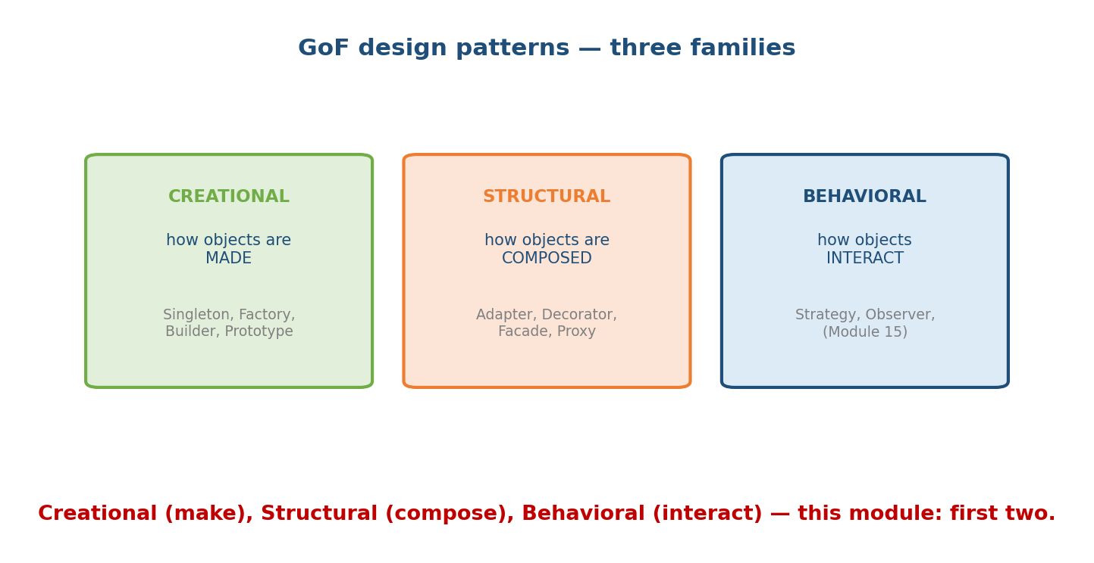
The three GoF families: Creational (how objects are made — Singleton, Factory, Builder, Prototype), Structural (how objects are composed — Adapter, Decorator, Facade, Proxy), Behavioral (how objects interact — Strategy, Observer).
- Creational — object creation mechanisms (this module).
- Structural — how objects/classes are composed into larger structures (this module).
- Behavioral — how objects communicate/interact (Module 15).
Patterns are a vocabulary and a toolkit, not a checklist. Use one when it solves a real problem — forcing patterns everywhere is itself an anti-pattern.

14.2 Singleton (creational)
Intent: ensure a class has exactly one instance and provide a global access point (config, logger, connection pool).
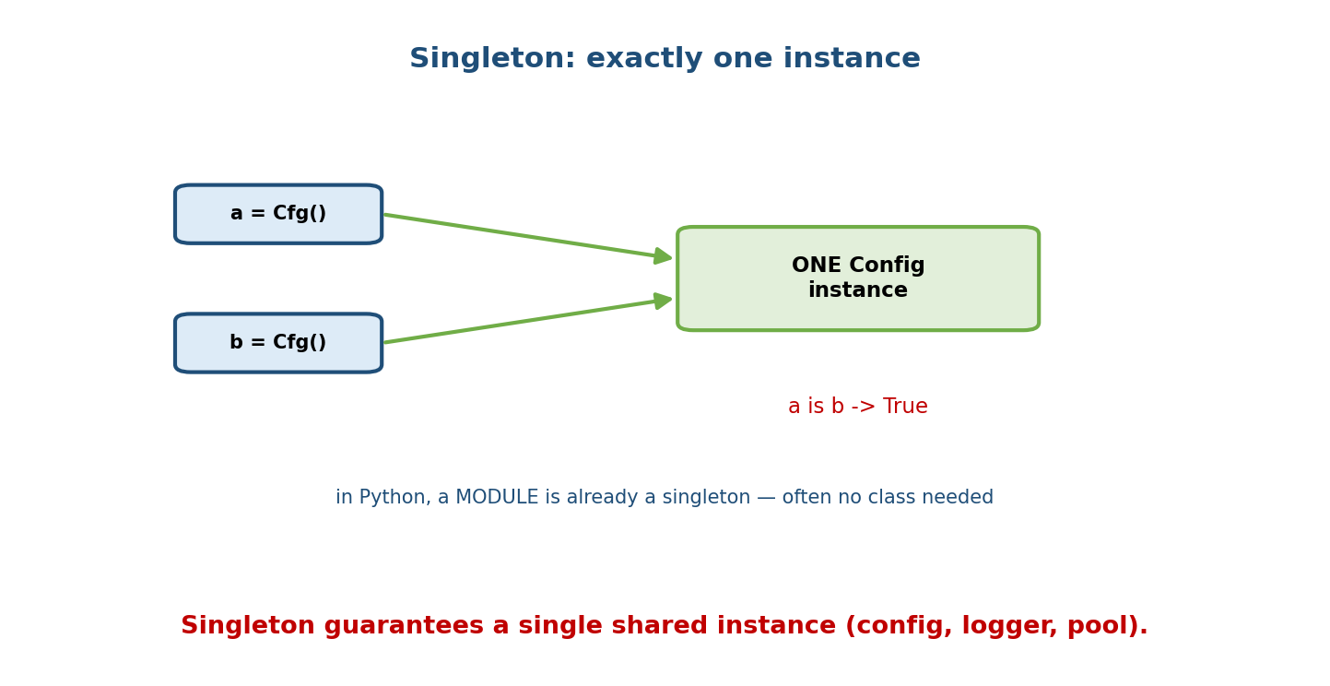
Two calls Cfg() both return the one shared Config instance, so a is b is True; in Python a module is already a singleton, so often no class is needed.
class Singleton:
_instance = None
def __new__(cls, *args, **kwargs):
if cls._instance is None:
cls._instance = super().__new__(cls)
return cls._instance
a, b = Singleton(), Singleton()
print(a is b) # True — same object
Pythonic alternatives (usually better):
- A module is already a singleton — import it and its state is shared. Often you need no class at all.
- A @lru_cache-decorated factory or a module-level instance.
- Overusing Singleton is controversial (hidden global state, hard to test); prefer dependency injection (Module 13) where possible.

14.3 Factory Method & Abstract Factory (creational)
Intent: create objects without exposing the concrete class to the client — the client asks for what it wants; the factory decides how to build it.
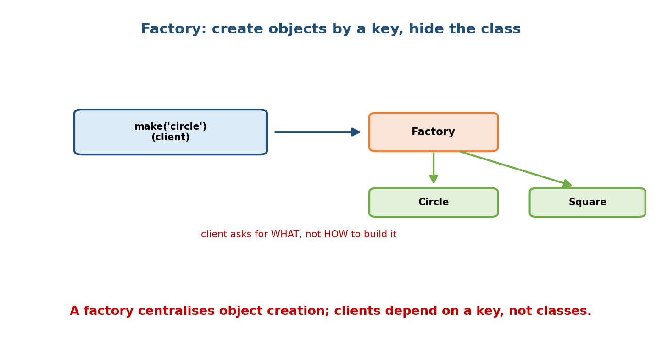
A client calls make(‘circle’); a Factory maps the key to the concrete Circle or Square class and returns an instance — the client depends on a key, not on the classes.
from abc import ABC, abstractmethod
class Shape(ABC):
@abstractmethod
def draw(self) -> str: ...
class Circle(Shape):
def draw(self): return "O"
class Square(Shape):
def draw(self): return "[]"
def shape_factory(kind: str) -> Shape: # Factory
registry = {"circle": Circle, "square": Square}
return registry[kind]() # client never names the class
s = shape_factory("circle")
- Factory Method — a method (often on a base class) that subclasses override to choose the product (@classmethod from_... in Module 3 is a Pythonic factory).
- Abstract Factory — a factory that produces families of related objects (e.g. WindowsUIFactory vs MacUIFactory, each making matching buttons/menus).
Why: decouples creation from use → supports OCP/DIP (swap products without touching clients).

14.4 Builder (creational)
Intent: construct a complex object step by step, separating construction from representation — great when there are many optional parameters.
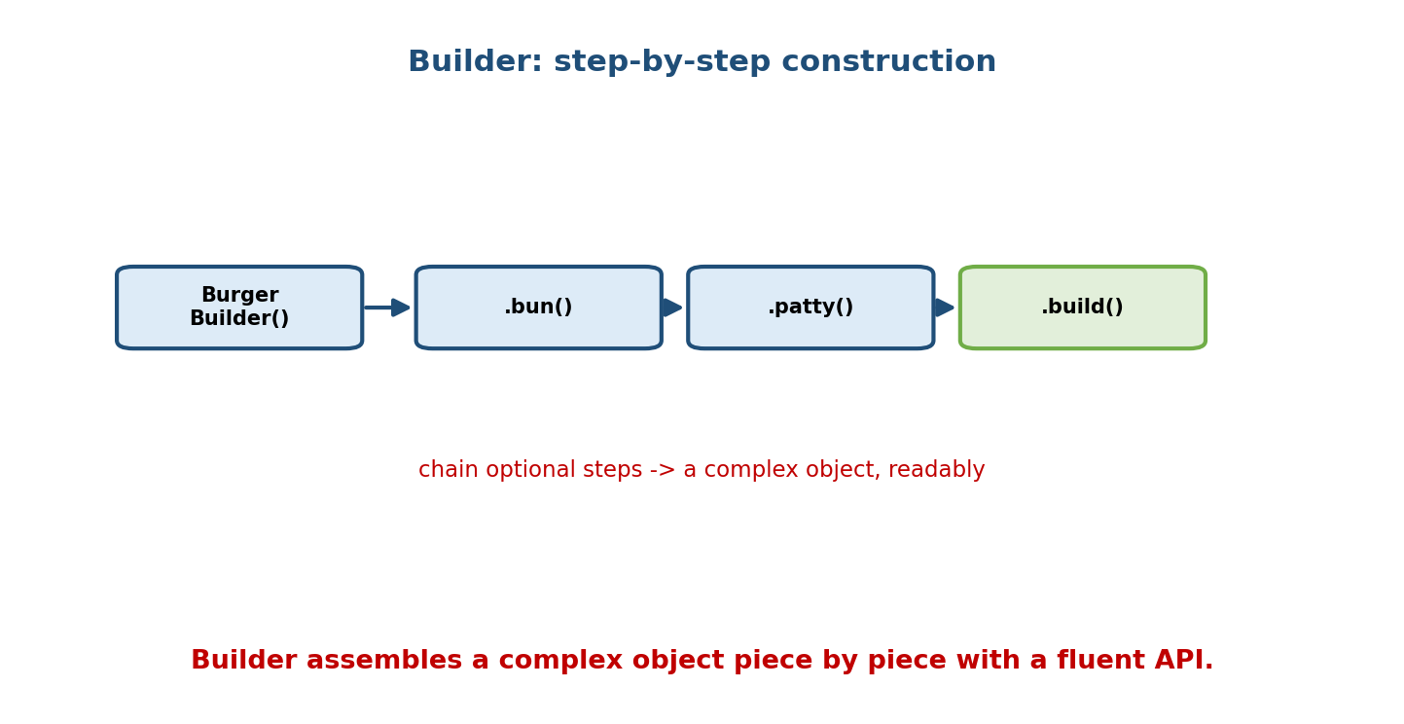
A fluent chain BurgerBuilder().bun().patty().build() assembles a complex object step by step, ending in a build() that returns the finished product.
class Burger:
def __init__(self):
self.parts = []
class BurgerBuilder:
def __init__(self):
self._burger = Burger()
def bun(self): self._burger.parts.append("bun"); return self # fluent
def patty(self): self._burger.parts.append("patty"); return self
def cheese(self):self._burger.parts.append("cheese");return self
def build(self): return self._burger
burger = BurgerBuilder().bun().patty().cheese().build()
When to use: avoids “telescoping constructors” (__init__ with 10 optional args). In Python, keyword arguments + dataclasses often replace Builder — reach for it mainly when construction has ordered steps or validation stages.

14.5 Adapter (structural)
Intent: convert one interface into another so incompatible classes can work together — the “power plug adapter” pattern.
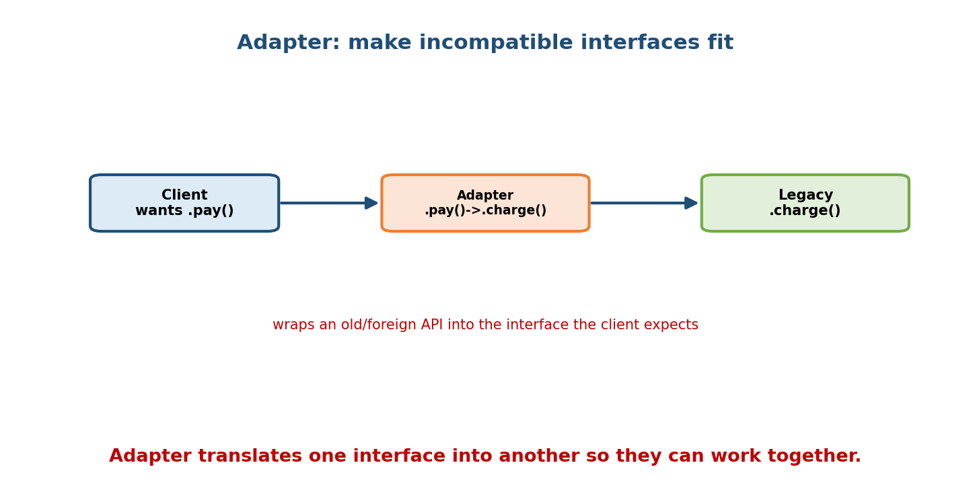
A Client wants .pay(); an Adapter exposes .pay() and internally calls a Legacy object’s .charge(); the adapter bridges the mismatched interfaces.
class LegacyPayment: # the class you can't change
def charge(self, amount): return f"charged {amount}"
class PaymentAdapter: # adapts it to the interface you want
def __init__(self, legacy): self._legacy = legacy
def pay(self, amount): # the interface the client expects
return self._legacy.charge(amount)
client_api = PaymentAdapter(LegacyPayment())
client_api.pay(100) # -> "charged 100"
When: integrating third-party/legacy code whose interface you can’t (or shouldn’t) modify. Adapter uses composition to wrap and translate.

14.6 Decorator (structural) — pattern vs Python @
Intent: attach new behaviour to an object dynamically, by wrapping it in another object with the same interface — a flexible alternative to subclassing.
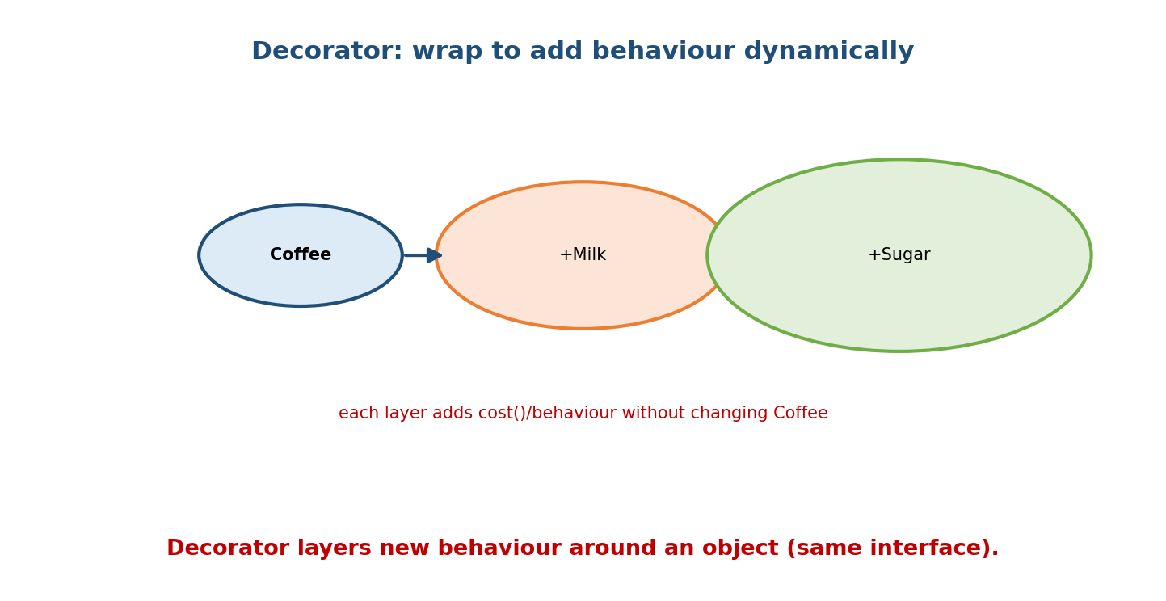
Coffee wrapped by +Milk, then +Sugar: each layer adds cost/behaviour around the object while keeping the same interface, without modifying Coffee.
class Coffee:
def cost(self): return 5
def desc(self): return "coffee"
class MilkDecorator: # same interface, wraps a Coffee-like object
def __init__(self, drink): self._drink = drink
def cost(self): return self._drink.cost() + 2
def desc(self): return self._drink.desc() + " + milk"
drink = MilkDecorator(Coffee())
print(drink.cost(), drink.desc()) # 7 'coffee + milk'
Don’t confuse the Decorator pattern (wrapping objects) with Python’s @decorator syntax (wrapping functions/classes). They share a name and spirit (adding behaviour by wrapping), but Python’s @ is a language feature for functions/classes, while the GoF Decorator is an object-composition pattern.

14.7 Facade (structural)
Intent: provide a single, simplified interface to a complex subsystem — hide the moving parts behind one easy method.
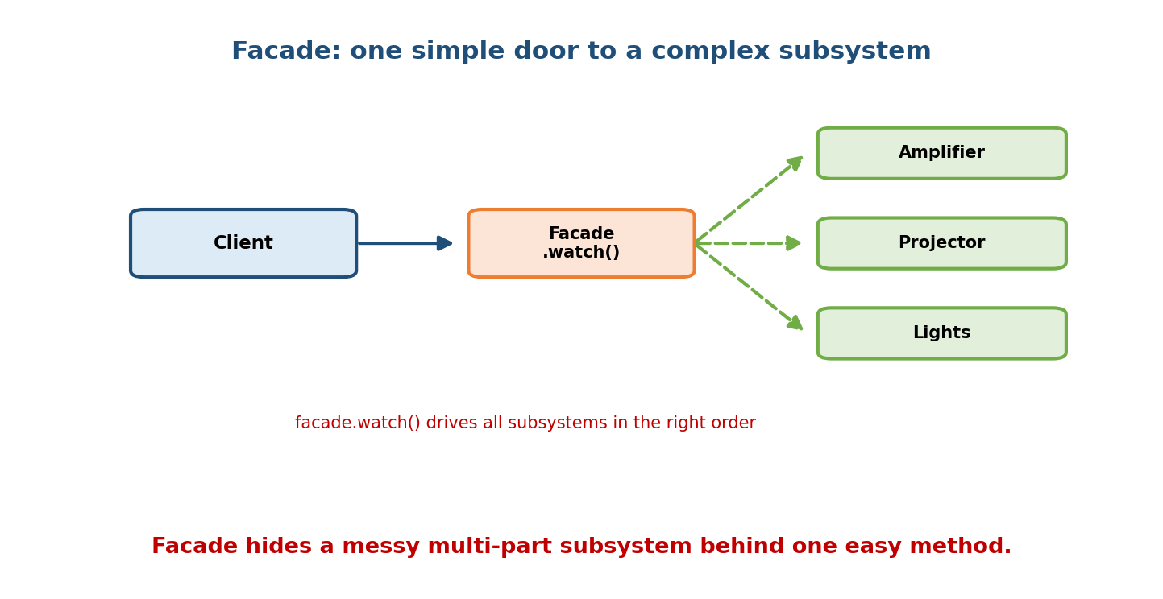
A Client calls Facade.watch(); the Facade orchestrates the Amplifier, Projector, and Lights in the right order, hiding the subsystem’s complexity.
class Amplifier:
def on(self): ...
class Projector:
def on(self): ...
class Lights:
def dim(self): ...
class HomeTheaterFacade: # one simple door
def __init__(self):
self.amp, self.proj, self.lights = Amplifier(), Projector(), Lights()
def watch_movie(self):
self.lights.dim(); self.proj.on(); self.amp.on() # orchestrates the mess
HomeTheaterFacade().watch_movie() # client does ONE call
When: you want to expose a clean API over a complicated set of collaborating classes (libraries, subsystems). Facade reduces coupling between client and subsystem.

14.8 Proxy & Composite (structural)
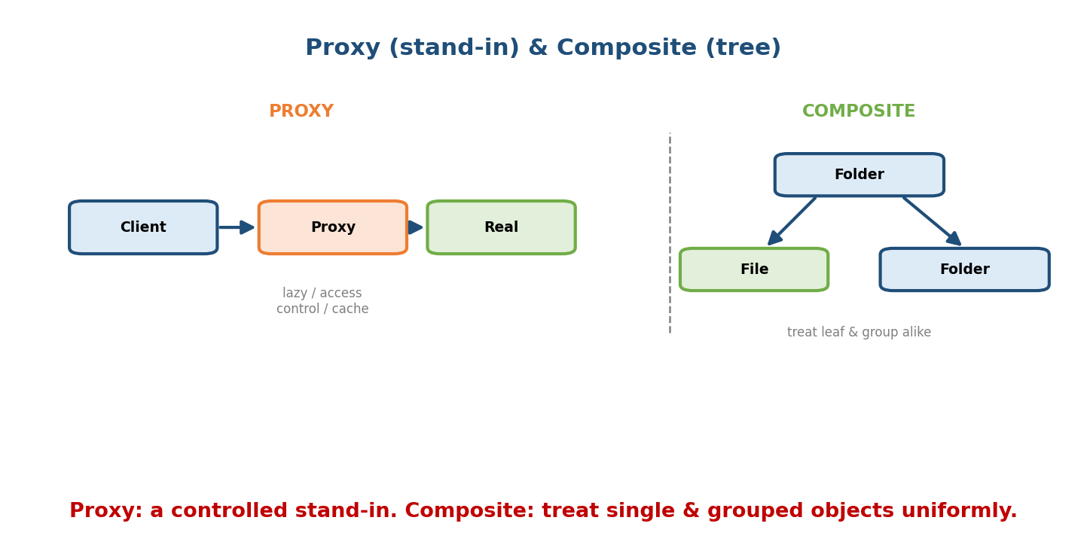
Proxy: Client -> Proxy -> Real object; the proxy is a controlled stand-in (lazy loading, access control, caching). Composite: a Folder contains Files and other Folders, letting you treat single and grouped objects uniformly in a tree.
Proxy — a stand-in that controls access to a real object (same interface). Uses: lazy loading (create the heavy object only when needed), access control, caching, remote objects.
class ExpensiveImage:
def __init__(self, path): self._load(path) # heavy
def display(self): ...
class ImageProxy:
def __init__(self, path): self.path, self._img = path, None
def display(self):
if self._img is None:
self._img = ExpensiveImage(self.path) # load on first use
self._img.display()
Composite — compose objects into tree structures and treat individual objects and groups uniformly (files/folders, UI widgets, org charts).
class File:
def __init__(self, size): self.size = size
def total(self): return self.size
class Folder:
def __init__(self): self.children = []
def total(self): return sum(c.total() for c in self.children) # same method!
(Bridge, Flyweight are also structural — Bridge separates an abstraction from its implementation; Flyweight shares common state across many objects to save memory.)

Module 14 — Interview Mapping
Question | Junior answer | Senior answer
“Implement a Singleton.” | Overrides __new__. | Shows __new__/metaclass and notes Python alternatives (module, DI) + downsides of global state.
“Factory vs Builder?” | (blurs) | “Factory chooses/creates which object; Builder assembles one complex object step-by-step. In Python, kwargs/dataclasses often replace Builder.”
“Adapter vs Decorator?” | “Both wrap.” | “Adapter changes an interface to fit; Decorator keeps the interface and adds behaviour.”
“Decorator pattern vs @decorator?” | (conflates) | “Same spirit (wrap to add behaviour); the pattern wraps objects, @ is Python syntax for wrapping functions/classes.”

Module 14 — Exam Mapping
- GATE CS: occasionally definitional (name the pattern/category).
- SEBI / RBI IT: rarely.
- FAANG / LLD rounds: very common — implement/choose patterns during design, and justify Pythonic simplifications.

Module 14 — Common Mistakes & Misconceptions
- Overusing Singleton → hidden global state, test pain; prefer DI/modules.
- Building a class Singleton where a module would do.
- Confusing Adapter (change interface) with Decorator (add behaviour) with Facade (simplify subsystem) with Proxy (control access) — all “wrap”, different intents.
- Reaching for Builder when keyword args/dataclasses suffice.
- Pattern-itis — applying patterns to trivial code; patterns add indirection.
- Confusing the Decorator pattern with @ syntax.

Module 14 — MCQs (with answers & explanations)
Q1. Ensuring only one instance exists is the: a) Factory b) Singleton c) Builder d) Proxy
Answer
b. Singleton.
Q2. Creating objects without naming their concrete class is the: a) Factory b) Adapter c) Facade d) Composite
Answer
a. The factory hides which concrete class is instantiated.
Q3. Converting an incompatible interface to the expected one is: a) Decorator b) Adapter c) Proxy d) Builder
Answer
b. Adapter translates interfaces.
Q4. Adding behaviour by wrapping while keeping the same interface is: a) Adapter b) Decorator c) Facade d) Singleton
Answer
b. Decorator keeps the interface and layers behaviour.
Q5. A single simplified entry point to a complex subsystem is: a) Proxy b) Facade c) Composite d) Builder
Answer
b. Facade.
Q6. A stand-in that adds lazy loading / access control is: a) Adapter b) Facade c) Proxy d) Builder
Answer
c. Proxy controls access to the real object.
Q7. Treating individual objects and groups uniformly (files/folders) is: a) Composite b) Decorator c) Singleton d) Adapter
Answer
a. Composite models part-whole trees.
Q8. In Python, the simplest Singleton is often: a) a metaclass b) __new__ c) a module d) a global list
Answer
c. Modules are singletons — shared state without a class.

Module 14 — Design/Practice Exercises (easy → hard)
- (easy) Implement a Singleton Logger two ways: via __new__ and via a module.
- (easy) Write a shape_factory(kind) returning Circle/Square/Triangle.
- (medium) Build a fluent QueryBuilder (.select().where().build()).
- (medium) Adapt a third-party XmlParser.parse_xml() to a Parser.parse() interface via an Adapter.
- (hard) Implement beverage pricing with Decorators (Milk, Sugar, Whip) over a base Coffee.
- (hard, interview) Design a file-system size calculator using Composite, then add a caching Proxy over an expensive total().

Module 14 — Concept Review (one page)
Design patterns are named solutions to recurring problems, grouped into creational, structural, and behavioral. Creational: Singleton (one instance — but a Python module or DI is often better), Factory (create objects by key without naming concrete classes → supports OCP/DIP), Builder (assemble a complex object step-by-step — often replaced by kwargs/dataclasses), and Prototype (clone). Structural: Adapter (convert an interface to fit), Decorator (wrap to add behaviour, same interface — distinct from Python’s @ syntax), Facade (one simple entry to a complex subsystem), Proxy (a controlled stand-in for lazy loading/access/caching), and Composite (treat single and grouped objects uniformly in a tree). Patterns give shared vocabulary and proven structure — used where they solve a real problem, not applied reflexively (Python’s features often make the classic form unnecessary).

Module 14 — Flash Cards (Q → A)
Front | Back
Singleton | exactly one instance (Python: a module often suffices)
Factory | create objects by key, hide concrete class
Abstract Factory | create families of related objects
Builder | assemble a complex object step-by-step (fluent)
Adapter | convert one interface into another
Decorator (pattern) | wrap to add behaviour, same interface
Decorator vs @ | object-wrapping pattern vs Python function/class syntax
Facade | one simple interface over a complex subsystem
Proxy | controlled stand-in (lazy/access/cache)
Composite | uniform treatment of leaf & group (tree)
Pattern families | Creational / Structural / Behavioral
Pattern risk | pattern-itis / needless indirection

Module 14 — Pattern Recognition
- See “must have exactly one shared X” → Singleton (or a module).
- See a if kind == ...: return SomeClass() creation ladder → Factory.
- See a constructor with many optional params / staged build → Builder.
- See “third-party API doesn’t match my interface” → Adapter.
- See “add features in combinations without subclass explosion” → Decorator.
- See “expose a simple API over a messy subsystem” → Facade.
- See “delay/guard/cache access to a heavy or remote object” → Proxy.
- See “part-whole hierarchy, treat both the same” → Composite.

Module 14 — Revision Notes / Mini Cheat Sheet
PATTERNS = named solutions. Families: Creational / Structural / Behavioral(M15).
CREATIONAL:
Singleton one instance (__new__/metaclass). Python: a MODULE is a singleton; prefer DI.
Factory build by key; hide concrete class -> OCP/DIP. (@classmethod = Pythonic factory)
Abstract Factory families of related objects.
Builder step-by-step fluent build. Python: kwargs/dataclasses often replace it.
STRUCTURAL:
Adapter CHANGE interface to fit (wrap + translate).
Decorator ADD behaviour, SAME interface (wrap). != Python @ syntax.
Facade ONE simple door to a complex subsystem.
Proxy controlled STAND-IN (lazy/access/cache/remote).
Composite tree; treat leaf & group uniformly.
(Bridge = split abstraction/impl; Flyweight = share state to save memory.)
RULE: use a pattern to solve a REAL problem; avoid pattern-itis.
Next module: Module 15 — Design Patterns II (Behavioral). We cover the patterns about interaction: Strategy (swap algorithms — often the answer that replaces inheritance), Observer (publish/subscribe), Command, Iterator (already in Module 7), State, Template Method, and Chain of Responsibility — each with a Pythonic take.

Module 14 — Summary
Design patterns are proven, named solutions grouped into creational, structural, and behavioral families. Creational patterns govern object creation — Singleton (one instance; often a module in Python), Factory (create by key, hide the class; supports OCP/DIP), and Builder (stepwise assembly; frequently replaced by kwargs/dataclasses). Structural patterns compose objects — Adapter (convert an interface), Decorator (wrap to add behaviour, same interface — distinct from @), Facade (simplify a subsystem), Proxy (a controlled stand-in), and Composite (uniform part-whole trees). Patterns give you shared vocabulary and tested structure for design and LLD interviews — applied judiciously, with awareness that Python’s own features often make the classic version leaner.
You have mastered this module when you can: implement Singleton, Factory, Builder, Adapter, Decorator, and Facade in Python; state the problem each solves; distinguish Adapter/Decorator/Facade/Proxy by intent; and identify when Python makes a pattern unnecessary.

